Filosofiska Nepal

Monthly Progress Report of March 2016.

Operation of the month:
This month we were all busy in exam preparation. As our final exam was started from 27th March till 2nd April, we gave more focus on study. Most of the time we provided them with positive speeches and thoughts and in the morning time teachers started their class with positive thinking. The main aim of this is to have positive vibes between teachers and students. Positive thinking just means delivering more positive things in a productive way.
The first week, students from playgroup and nursery participated in Vitamin A supplementation program. In that program they were given Vitamin A capsules and “de worming tablets” to the children who were under 5 years old. The program was held in the community hall. The students who were participating in the programs were as follows:
- Arjun Shrestha
- Bikash Jirel
- Pawan Neupane
- Purnima Katuwal
- Siddhartha Nepali
- Rabina Khadka
In the second week, another six students joined Filosofiska Nepal. They are earthquake victims and brought here from the Chuchhepati Camp. They all live in a hostel. Most of them are school dropouts and the last ten months they stayed in camp and did not go to school. They spent their time playing with their friends. At first it was really hard to keep them inside the class. Slowly we have taught them school manners and kept them in the same class for one week. Then, we analyzed their potential. For new session they were then kept in their respective class as per capacity/level of development.
The new students who were admitted in month of March are as follows:
- Santosh Katuwal
- Purnima Katuwal
- Sandesh Rai
- Sangit Shrestha
- Kushal Gubaju
- Jenish Gubaju
In the third week, we had most waited festival of the year holi- festival of color. Holi is celebrated with great enthusiasm and gaiety on the full moon day in the month of falgun which is the month of March as per the Gregorian calendar.
Great excitement could be seen in children. Children took special delight in spraying colors on one another with their pichkaris and throwing water over each other. On this occasion we also provided sweets to them. They really had a great and joyful time.
The fourth week of March, Yours Humanly team from USA visited our school. Sunny Singh, yours humanly founder and executive director, and Ms. lla A. Jain, another director of yours Humanly Texas, with their team members visited our school for the lunch programs. They spent almost two and half hours with the kids. They interacted with the kids and teachers as well and had lunch together with the students.
Photographs:
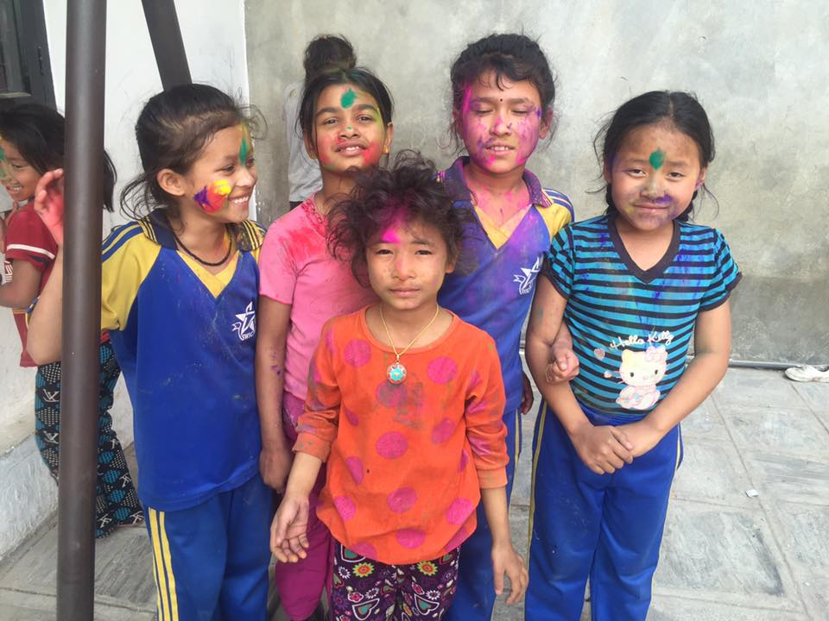
Holi celebration 2016 at Filosofiska Nepal.

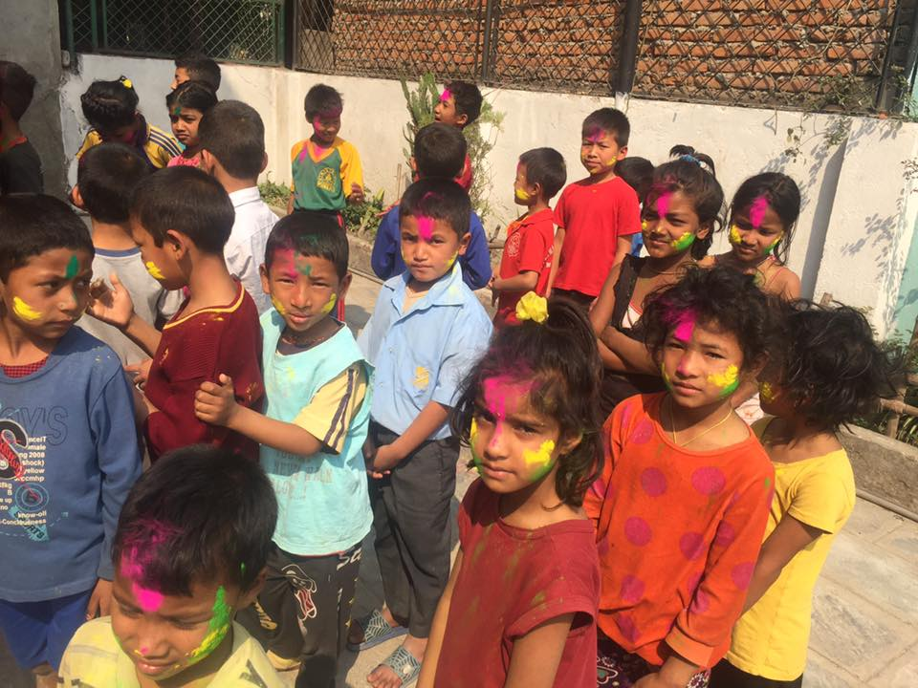
Children waiting for their turn on holi celebration.

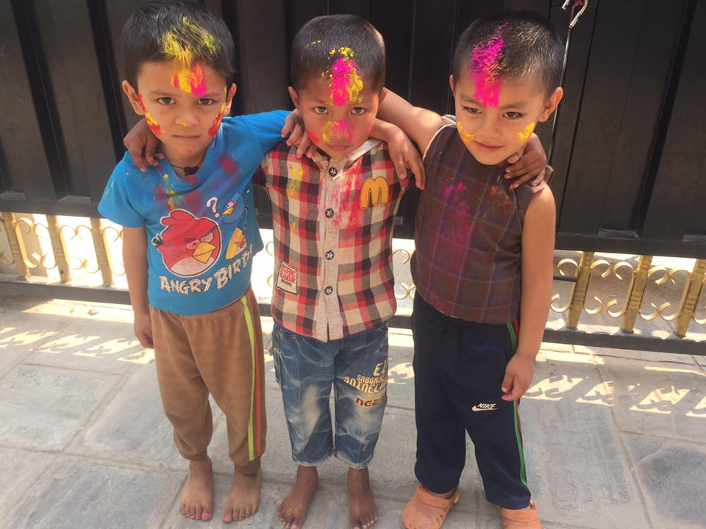
Pawan, Arjun and Bikash from class Nursery after playing holi.
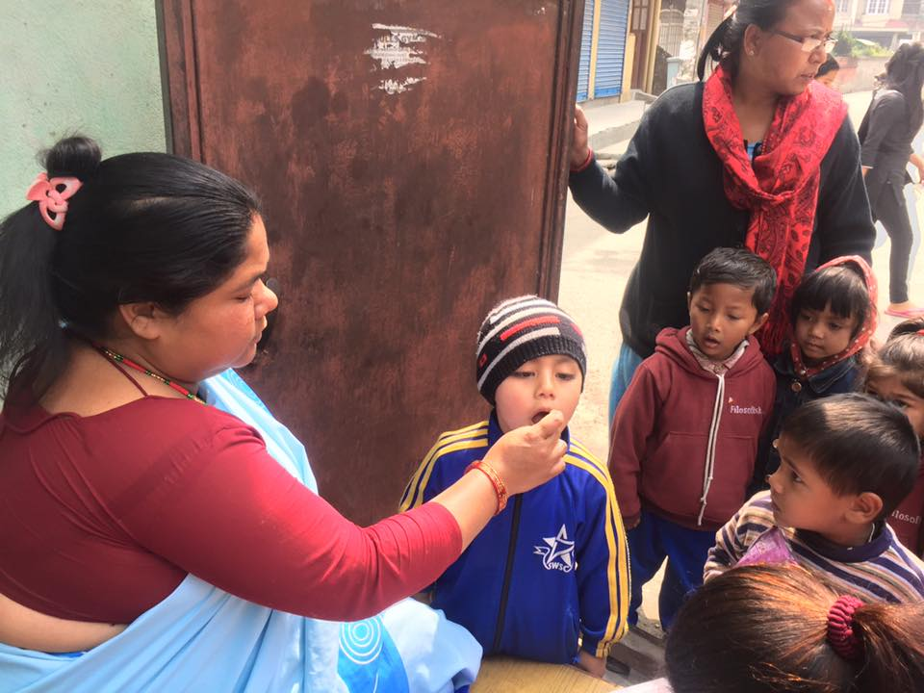
Children having Vitamin A supplement at community hall.
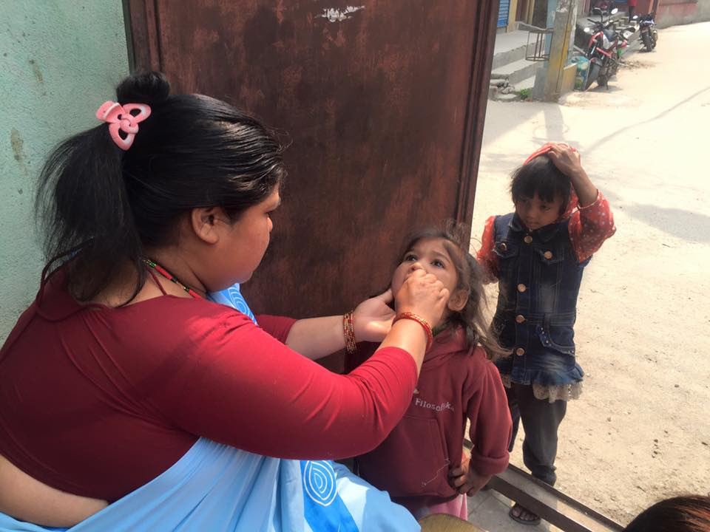
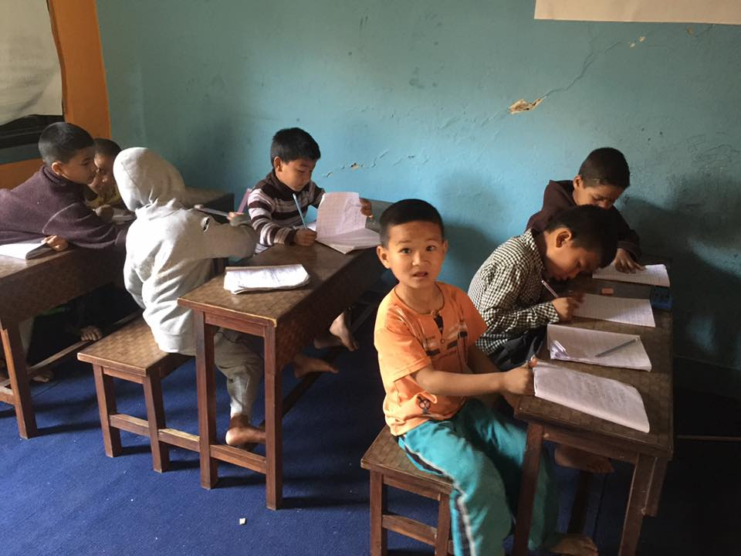
New students in their class room.
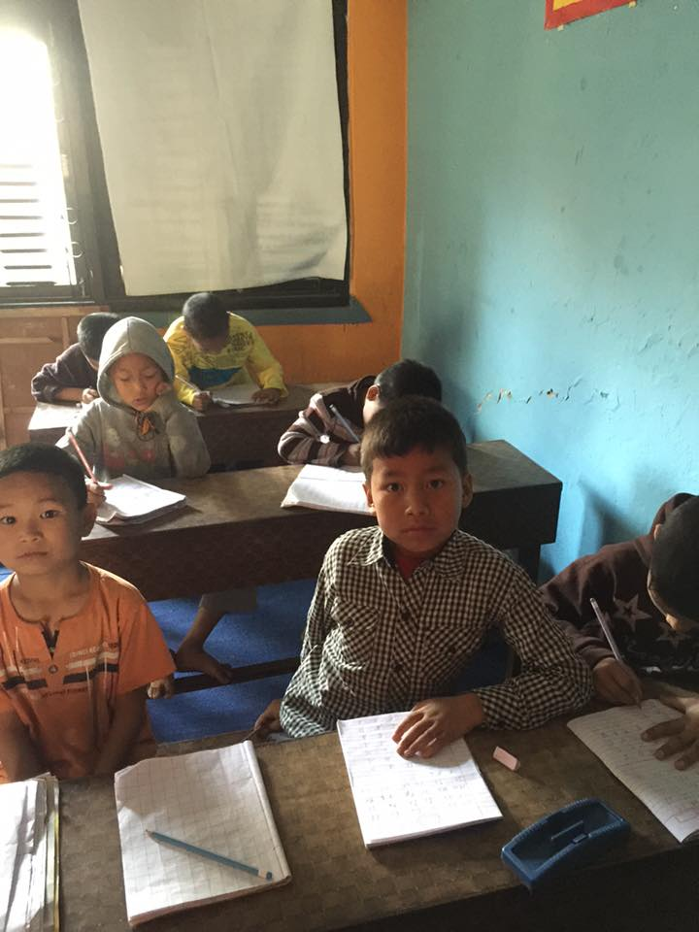

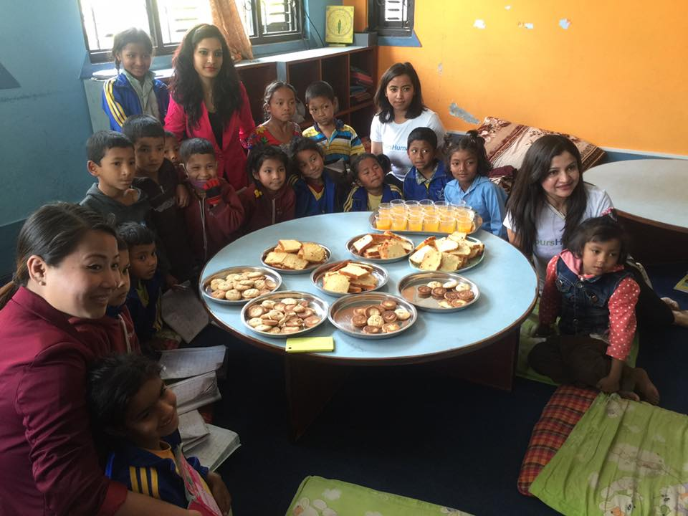
Lunch time with Yours Humanly Team.
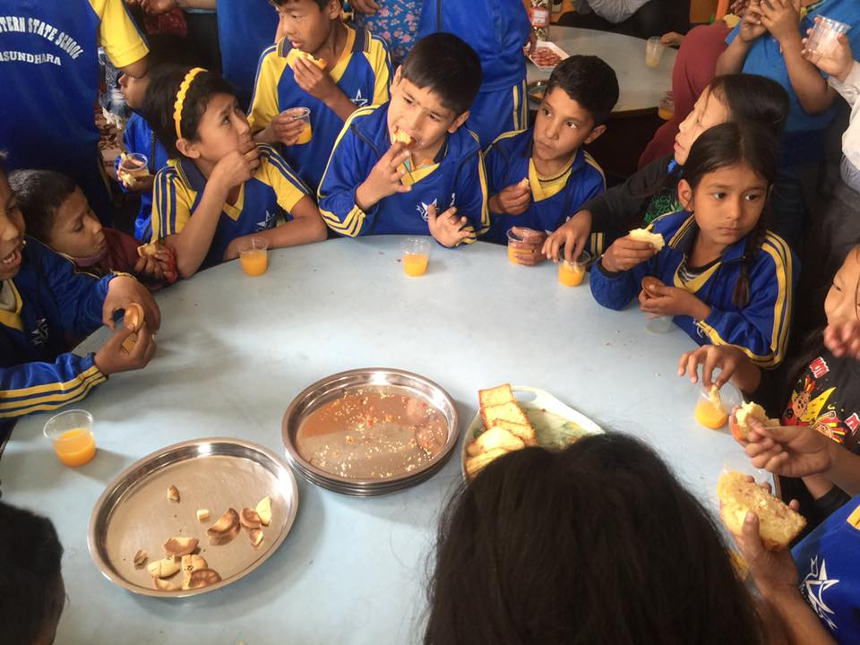
Conclusion:
This month we had very busy and fun time. But more focus is given on the study.

