Monthly Progress Report of July 2016.
Operation of the month:
Students as well as teachers were busy with experimenting new things and preparing for our first term exam of this session. Mean while we enjoyed our one week summer break. This month we did henna art, which all the children really liked. We celebrated teacher’s day and Bhanu Jayanti this month. We distributed uniform, shoes and socks to all the students.
Teacher’s performance evaluation:
On regular basis teachers were evaluated. This month we celebrate teacher’s day so on behalf of students and school management we provided them small token of love. As we believe that if teachers were happy and motivated they will perform their 100 %.
Special programs:
- Bhanu Jayanti Celebration:
Nepalese people celebrated Asar 29 i.e. July 13 as a Bhanu Jayanti the birth day of great poet Bhanu Bhakta Acharya, who is popularly known as Nepal’s original and first poet.
Bhanu Bhakta poem was the first poet who wrote an understanding of inner essence of poetry. All his ideas and experiences were derived from his native land. This lent such a strong nepali flavor to his writing that few poets have been able to content, a sense of religion, a sense of simplicity, and the warmth of his country are the strongest features of his poetry.
Students from class one to four participated in Bhanu Jayanti celebration. They recited their beautiful poems. The topics are nationality, flowers, animals, friends and many more.
- Henna Art:
As henna is a natural cooling propriety, people of the desert for centuries have been using henna to cool down their bodies. In Nepal also we believe that if we apply henna on palms and soles of the feet it provide cooling sensation throughout the body for as long as the henna stain remains on their skin. On 15th July, we applied henna on all the students’ hands with beautiful designs.
- Teacher’s day :
“A good teacher can inspire hope, ignite the imagination and instill a love of learning” a beautiful words by Brad Henry.
Teachers play very important roles in shaping the future of a child. Activities for teacher’s day celebrations are a way to celebrate the unparallel contribution of the teachers in child’s life. Teachers love the activities performed and the fun games hosted by students on this day. It gives an opportunity to child to come closer to her teacher and develop a strong bonding.
On this auspicious day, teachers gave blessings to all the students. This year students bring flowers and sweets for the students. Teachers were provided gifts as well. Students performed beautiful dancing while some performed nice songs. On snacks time, both students and teachers had snacks together.
Progress of the month:
This month all the students improved their study as well as handwriting. Some of the students who were weak in some subjects were given more attention.
We celebrated birthday of Chandani Shah of class upper kindergarten.
Conclusions:
On this month of July, we had summer vacation for one week. In summer break students did preparation for the first term exam as our exam will be start from August 7 to 12th August 2016.
On July 8th students wrote their own imaginary story and recited in front of their friends and teachers. Among all of that the best one is hang on the notice board for month of July.
This month for movie time we showed them their favorite cartoons show “Doremon” on 22nd July, Friday. They had a wonderful time. On that day we provide them pop corn and juice.
Photographs:
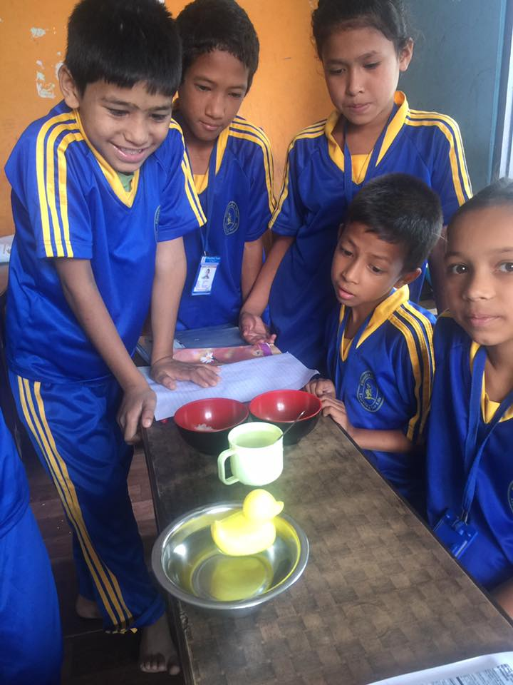
Grade three students doing their science experiment in classroom about floating and non floating.
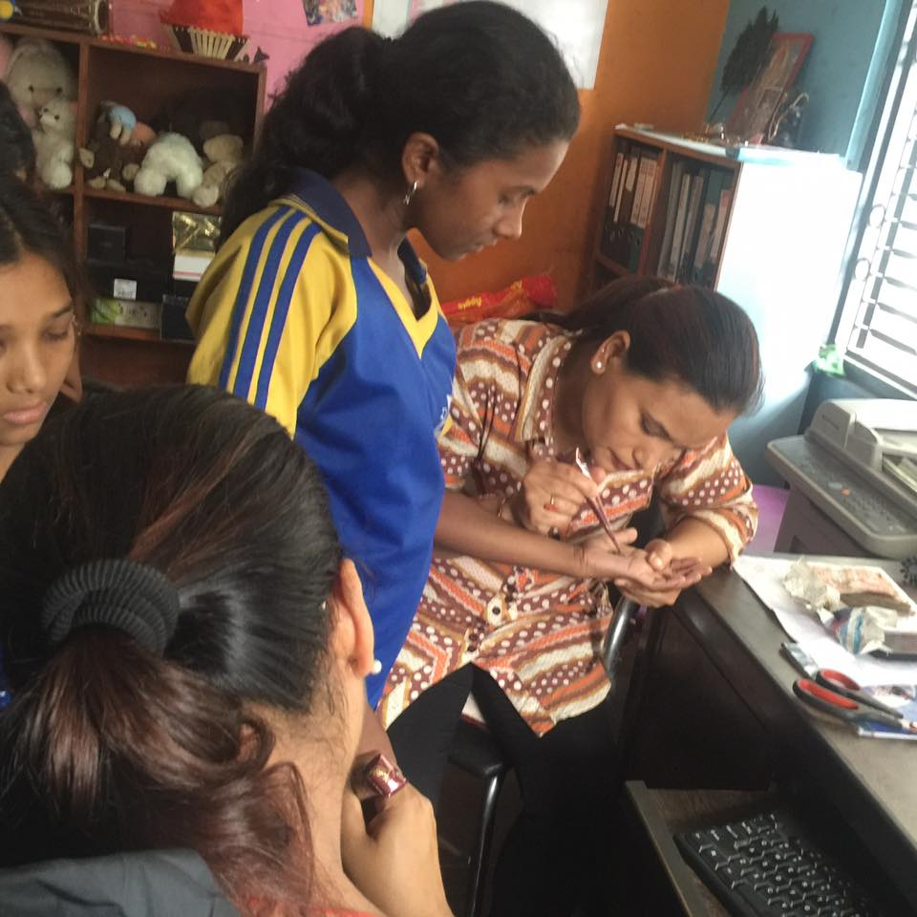
On July 15th students enjoy their henna art in their palm by their teachers.
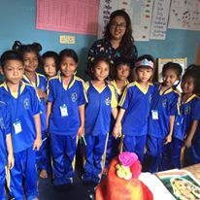 Chandani Shah from class upper kindergarten celebrating her birthday with her friends and grade teacher.
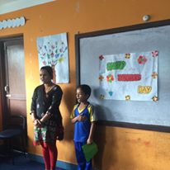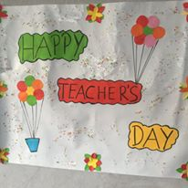
Celebrating Teachers day 2016.

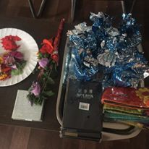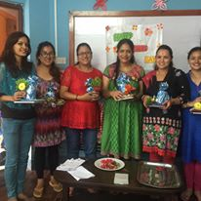
Gifts for the teachers on auspicious occasion on Teachers Day 2016.
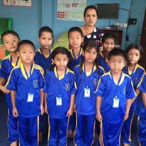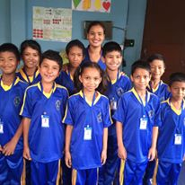
Happy faces of students after receiving uniform, shoes, socks and Identity card.

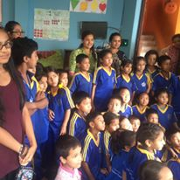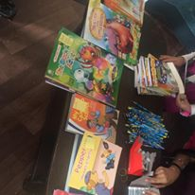
Upasana Lamsal from USA provided some interesting story books and stationeries items and of course sweets for our students.

