Filosofiska Nepal

Monthly Progress Report April 2016

This month we like to welcome all the students and teachers to the new session and to the next new class. There will be new books, new activities, new assemblies and new victories. From last few years experiences we have learned many things. So, let’s make this year better. We like to congratulate all the students for the progress. Cheers to those who have kept ranks and also for those who have improved their grades. If you have not improved your performance, this is the time to buckle up. It is never too late to start moving upwards. We always teach them to succeed in life they don’t have to be genius. Everybody is unique and born with some extraordinary qualities within. Therefore there is no point in comparing, compete with yourself.
We had the third parents meeting with the parents and guardians. This month we had parents meeting before the final examination. The main objective is to inform parents about the progress of the students. Another motive is to make parents involvement in whole process which means that parents should provide support to the students to get desired results. Most of the parents were presented and provided feedback as well. On that day both teachers and parents had very good interaction.
We had final term result distribution on 8th of April, Friday on school premises. The students did really appreciating job. They all got good marks and upgraded to next class. Hira lal Moktan and Abhishek Nepali from class upper KG are upgraded to class two based on their performance. In class two they performed as per expectation. Muskan Nepali from class Lower KG is also upgraded to class one. These students are on special guidance of the teachers.
On 20th April, we distributed books and stationeries to all the 60 students from class nursery till class four. They were really excited to get their new books and stationeries.
This month we celebrated the birthday of Bikash Jirel from class nursery. He distributed sweets to his friends and students. We all sang birthday song for him and he was very happy.
We attended ritual program at Gorakhaya Nikhil School in our neighborhood. On that day all the students participate in cultural program and had delicious lunch.
This month we had two teachers training. One was held before our new session began and next one was on first day of the session. All the teachers were participated in the training. First one was on the topic “how to motivate and encourage the weak students. “ And second one is about “how to prepare yearly lesson plan “. This year we prepared a format for the yearly lesson plan and all the teachers they already filled the format for the whole year. Because of earthquake last year we couldn’t continue our Friday as fun day, so from this year we will continue that with more activities and fun.
The new students who join Filosofiska Nepal this year were:
- Sapana Subedi, Age: 6, Class: One
- Aayushma Bhattarai, Age: 6, Class: One
- Priti Nepali, Age: 9, Class: Three
- Anish Darji, Age: 8, Class: Three
- Unika Shrestha, Age:4, Class: Nursery
- Supriya PAriyar, Age: 6, Class: Nursery
- Chandani Shah, Age:5, Class: U.K.G
The old students who drop out from Filosofiska Nepal are:
- Ranjita Tamang: Ranjita Tamang is student of U.K.G of Filosofiska Nepal. She has left school because her father is really ill. He cannot move from his bed and work. Her mother is working as housemaid, now she has to take care of her husband and in laws as well. So, they went back to their village.
- Kabita Gurung: Kabita gurung is student of U.K.G of Filosofiska Nepal. She has to drop out because they moved to another place. Her mother got work in another place where they don’t have to pay for rent and food. Their landlord will look after them. Kabita is adopted by one kind lady, whom is now her mother. She was found on the garbage bin.

Activities of April in photographs:
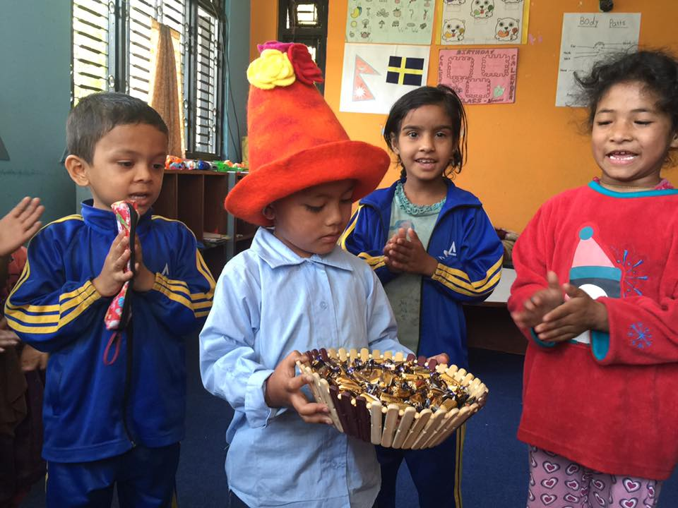
Bikash Jirel from class Nursery celebrates his 4th birthday with his school friends. He wears birthday hat and distributes sweets to his teachers, sisters and friends. Happy 4th birthday Bikash. May god bless you.
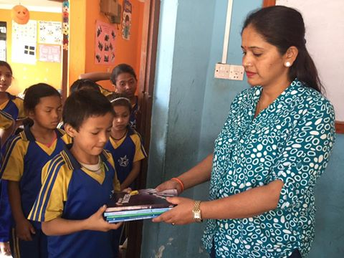
Grade Teacher Laxmi Adhikari of Class four distributes books to all the students from class four. In the beginning of the session we distribute books to all the students.
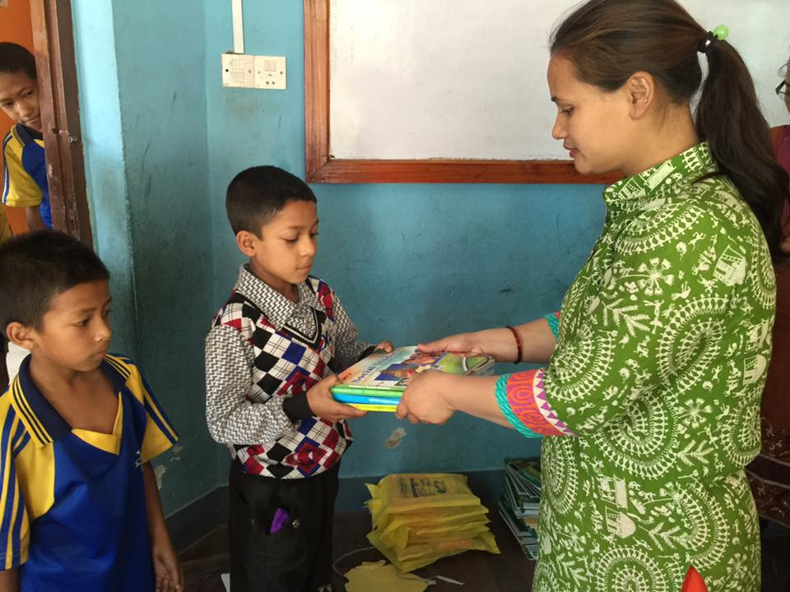
Grade teacher of class three Gauri Shrestha distributes books to all the students of Class three.
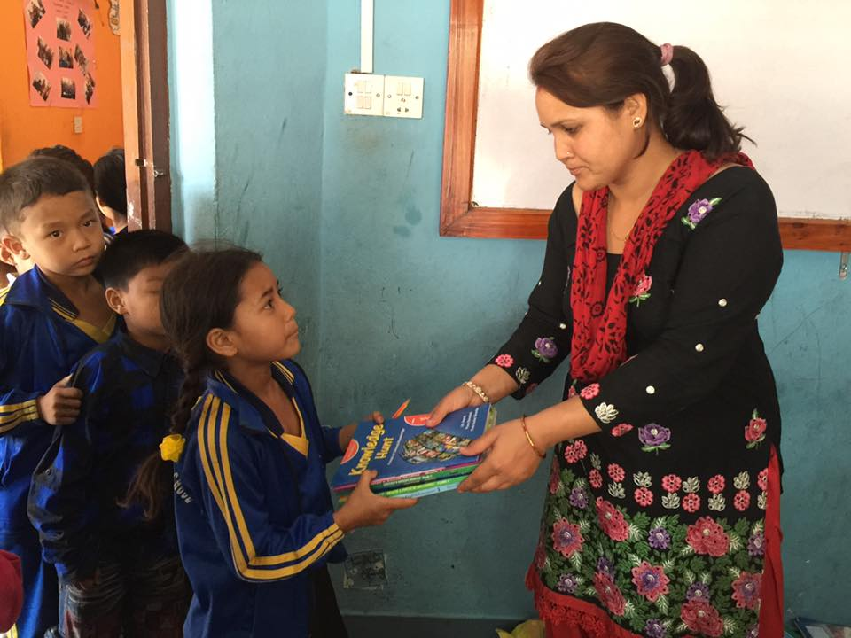
Grade teacher of class one Sushma Pokherel distributes books to the students from class one.

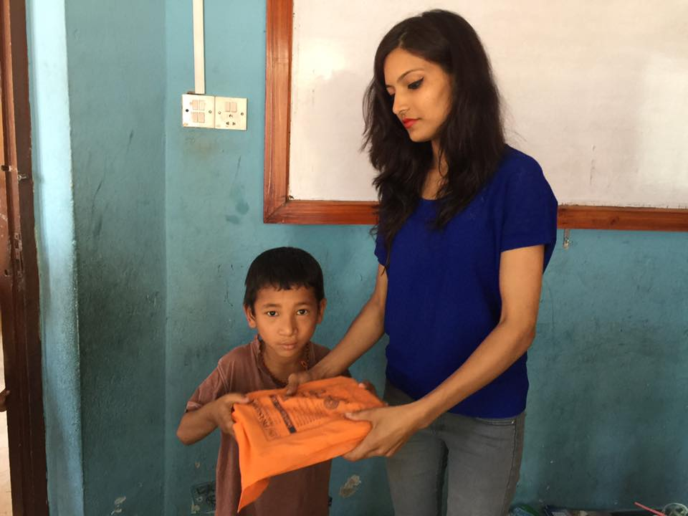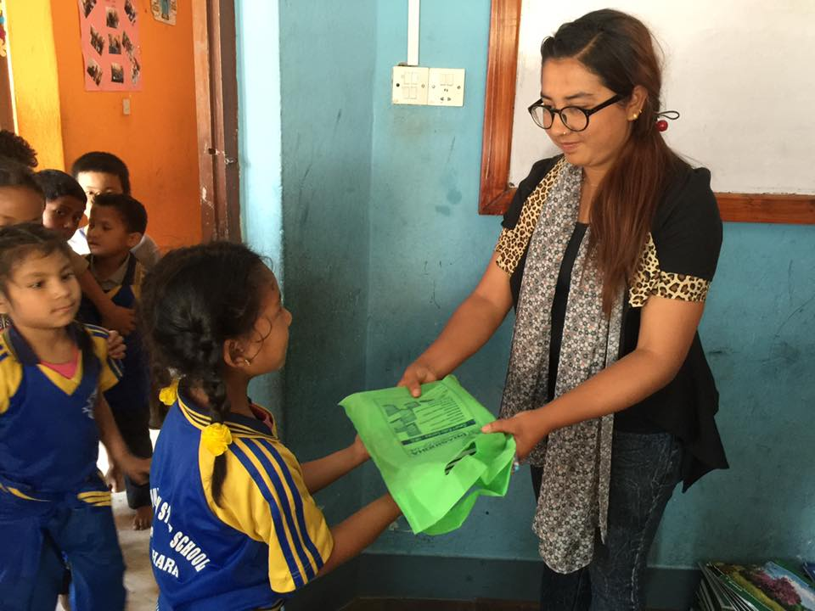
Grade teacher of Lower KG Sanju K.C and grade teacher of Upper KG Ulina Thapa distributing books to the students.

Conclusion:
This month we had more holidays. Students spent more time with their families whereas staffs worked hard for the new session. They are more focused and spend more time for the betterment of the students as well as themselves and school.
Students and teachers know more about Sweden. This month they learnt more about Sweden. Now they know that currency of Sweden Swedish Krona, official language is Swedish and total population of Sweden is 9.593 million. The neighboring countries are Denmark, Norway and Finland.
New students were adjusting slowly and old students take care of new ones. They teach them school manners and other manners as well. From this year we will start yoga and meditation as well in full phase. Last year we have to stop in the middle of the session. This year we are more focusing on extra curriculum activities as well.

