Filosofiska Nepal
Monthly Progress Report of MAY 2016
This year monsoon starts early in Kathmandu. On May 5th all the students danceed in the rain and enjoyed the first monsoon of 2016. On 6th of May, we celebrated mother’s day program in school. All the children made a special card for their mother. Some of them also wrote beautiful poems and some draw beautiful drawings. They all expressed their feelings towards their mother. In preschool we taught simple and basic yoga postures for kids.
On 27th May, we had drawing session for the students. We taught them basic techniques about the drawing so that they will draw with fun. Even small children actively participated in the drawing session.
This month we celebrated the birthday of Bijay Bamjam from class three. We provided him sweets and wished him happy and prosperous life ahead.
Teacher’s performance evaluation:
We have monthly staff meetings. In case of emergency, we call up emergency meeting and solve out the problem. Teachers were evaluated on the regular basis.
Teachers were provided in-house training on “Personal hygiene in school and home”.
Progress of the month:
The students who studies in different school in class five were upgraded to class six in the same school. Their last year´s performances were satisfactory. This year we also provided them uniform, books and stationeries.
This month we welcomed our new staff member Ulina Thapa as grade teacher of class Upper Kinder garden. She is experienced and well trained.
Special Programs:
- Mother’s Day Celebration
- Lord Buddha Birthday Celebration
- Free drawing session
- Handwriting competition of each class
- Central Zoo Visit by preprimary students
- Narayanhiti Palace museum visit by primary students
- Personal hygiene class for all the students.
Central Zoo:
Central Zoo is the only zoo in Nepal. The National Trust for nature conservation (NTNC) in December 1995 started to developed plans and policies to maintain the zoo and improve the living conditions of animals.
The central zoo is located at Jawalkhel of Laitpur district. It covers an area of six hectares. It houses more than 700 animals of 108 different species. Among them 34 are mammals, 51 are birds, 9 are reptiles and 14 are fishes.
Altogether 26 students from nursery to upper kinder garden along with five teachers, two sisters and coordinator visited the zoo in 22nd May, 2016.
Children observed different kinds of animals, birds and fishes that are found in Nepal. Some of the animals, birds and fishes are: white pelican, sarus crane, lady Amherst pheasant, Royal Bengal Tiger, Guinea Pig, White eyed Buzzard, Common Crane, Golden Pheasant, Leopard Cat, One horned Rhinoceros, Lorikeet, Clouded Leopard, Crimson Horned Pheasant, Sulphur crested Cockatoo, common Peacock, Bear, Black Kite, Yellow headed Turtle, Aldabra Tortoise, Himalayan Black Bear, Eurasian Eagle Hyena, Sun Conure, Assamose Macaque, Wild water buffalo, Spotted Deer, fan tailed pigeon, Crocodile.
Besides that children played in the children’s Park. They played slide, swing, mug go around, Uranus, funny temple and so on. They really enjoyed the outdoor play. After that we had picnic we shared food with each other. It was a fun filled day in Zoo.
Grade three students need little more attention in their study and hygiene as well. They are facing different kind of illness nowadays. Some of them have lice on their head, some have allergy on skin whereas some have eye infection. So now onwards we take more care of personal hygiene in school and teach them to take care at home as well. We show them lots of informative documentary, songs and video on personal hygiene.
Narayanhiti Palace Museum:
Narayanhiti Palace museum is the former royal palace in the centre of the Nepalese capital, Kathmandu. It is the palace which long served as a primary residence for the country’s monarchs. Museum has three wings; the guest wing, the state wing and the private wing each consisting of approximately 30 rooms. Nepal has 14 zones and 75 districts. Every room is named after the districts. Among them only 19 rooms from all state wings are open to the public visitors, while the main doors are named after the mountains of Nepal.
The palace as previously discussed in Kathmandu’s history was the scene of a gruesome tragedy, termed “Nepal greatest tragedy” on June 1st, 2001. The then King Birendra, Queen Aishwarya and his family members were killed in a massacre. The massacre of the the Royal family is still mysterious. Now it has been turned into a museum and is open for all to see.
On 23rd of May, 2016 students from class one to four went to museum. Altogether there were 32 students with staff members. It was rainy day and everyone enjoyed the rain and visit as well. They wrote down the confusing things and asked the teachers. They observed things in detail. As before they only heard different stories about the royal palace, but now they got opportunity to observe, so they were really curious. We went to royal garden where we saw different kinds of flowers and decorations. What children really like is revolving house where one can sit and have cup of coffee. After that children had snacks with their friends and staff.
Conclusion:
On the month of May students and teachers both explore different kinds of things. We have educational tour to museum and zoo. At both places we gathered lots of information. Even grade three and four students presented what they learned and observed at the museum.
Besides that we taught the students about the personal hygiene. We celebrated mother’s day and Lord Buddha´s birthday.
On Friday, we had free drawing class and spelling contest. In free drawing we taught them basic technique of drawing. In spelling contest we divided all the students in different groups and one group leader represented that group. The winner group was awarded with reward.
This month they learn to draw a flag of Nepal and Sweden. They draw flags and stick at their classroom walls. They can recognize both flags.
From preprimary level we started cursive writing to make their handwriting nice and clear. It is hard in the beginning but slowly they are trying their best.

Photographs:
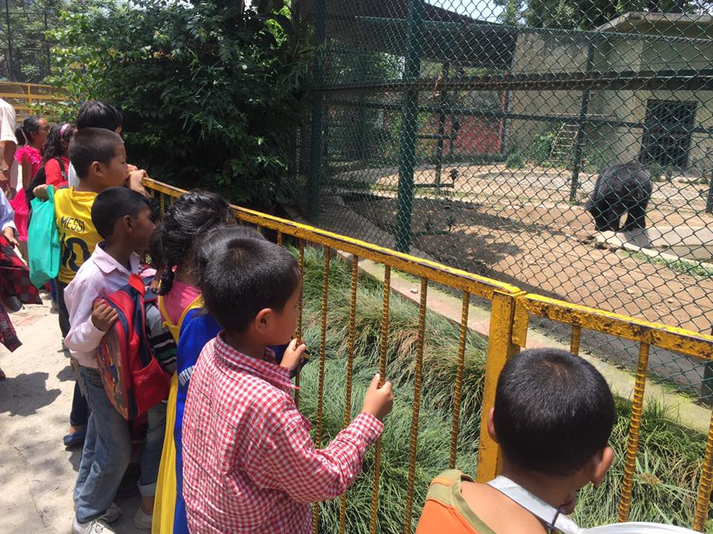
The students were excitedly watching bear in central zoo.
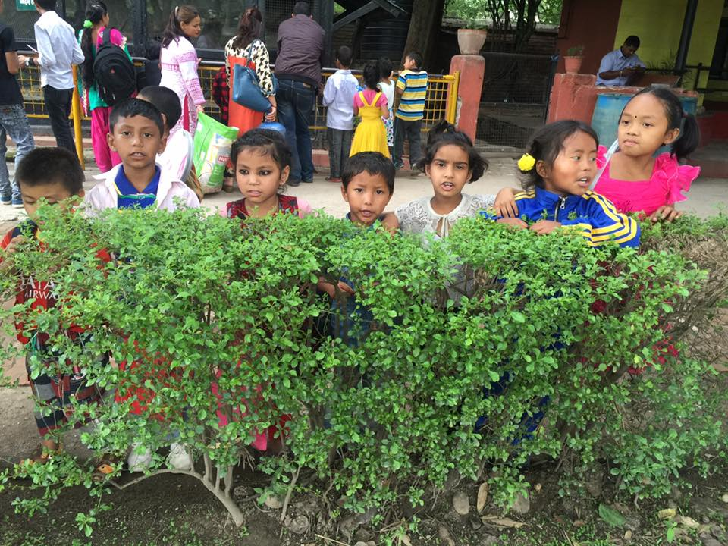
The students were posing in Central zoo.
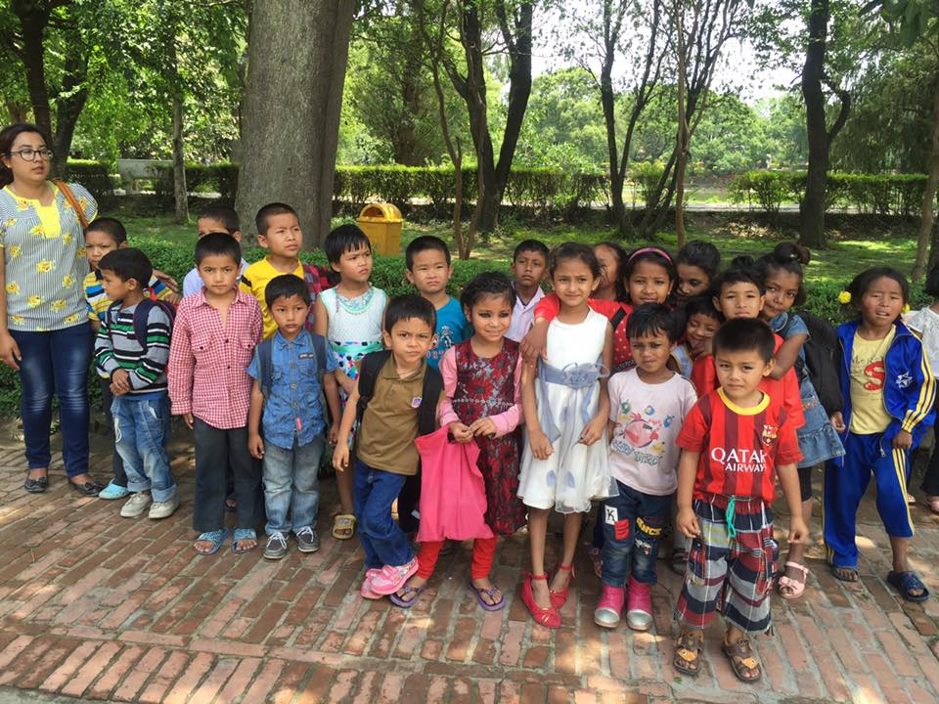
The preprimary students with their teacher in Central zoo. They had great time.
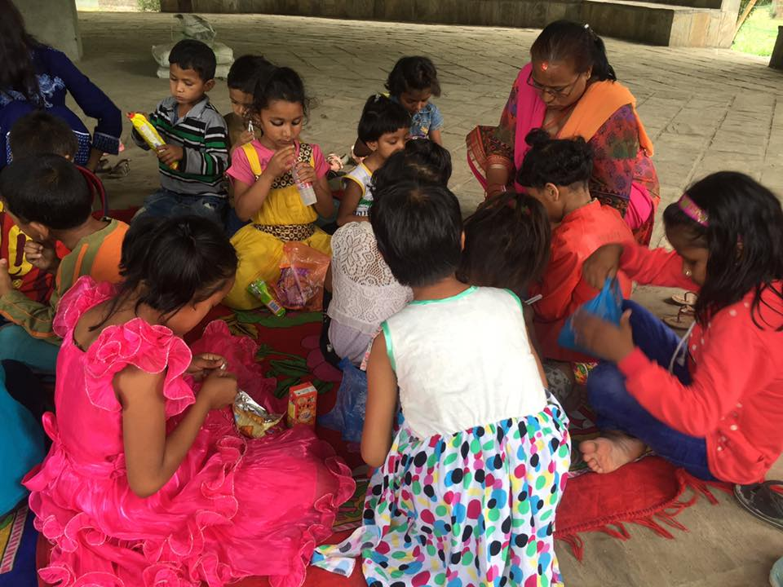
The students having their snacks with their friends, on that time they share their snacks with each other.

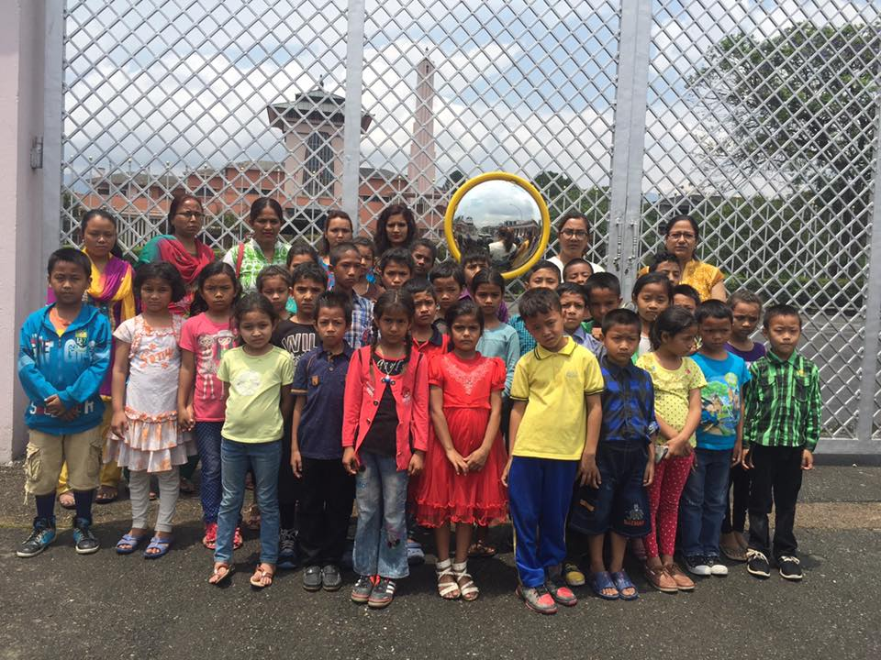
The students in front of the Narayanhiti Palace Museum.
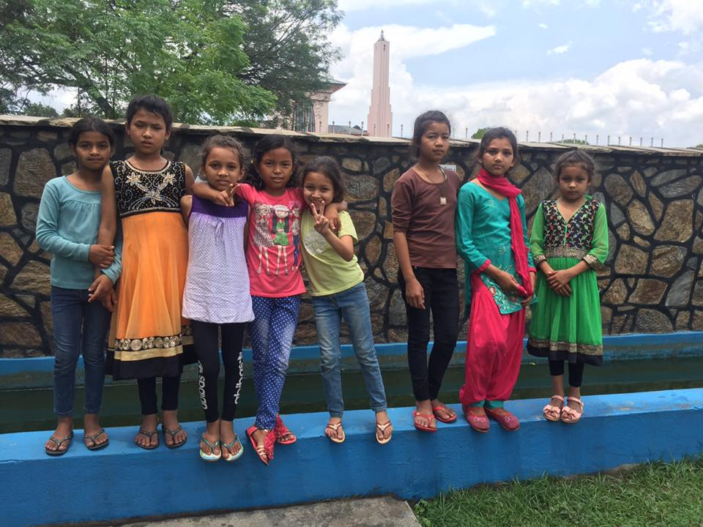
Our beautiful girls posing for camera in front of Narayanhiti Palace Museum.
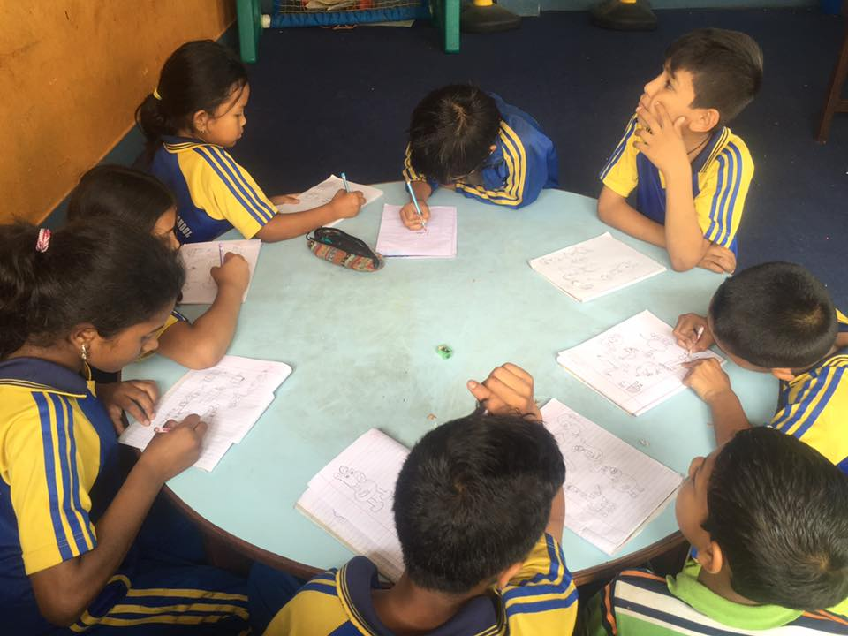
Students were learning basic drawing session with their teacher.

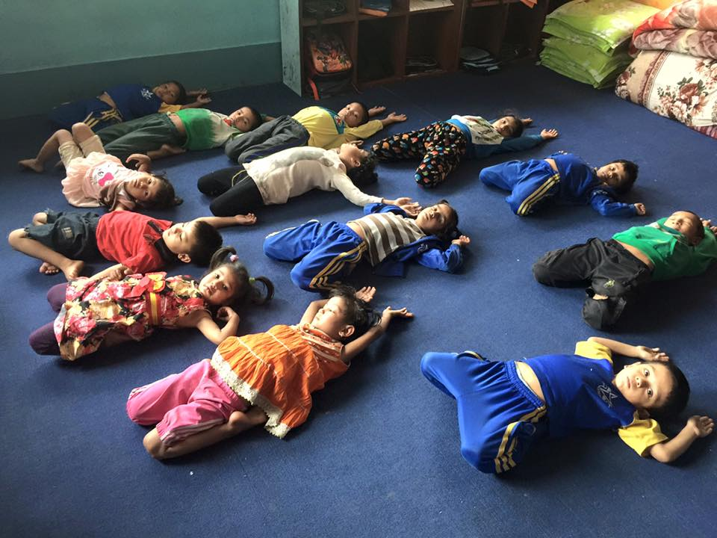
Our preprimary students practicing basic yoga positions.
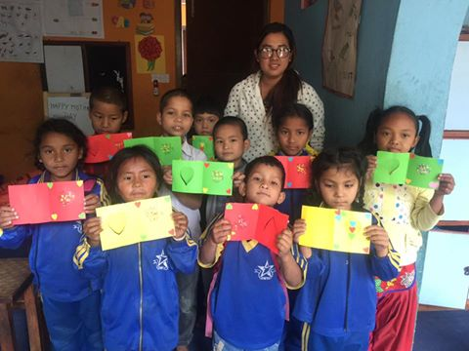
Students prepare mother day card for their mothers.
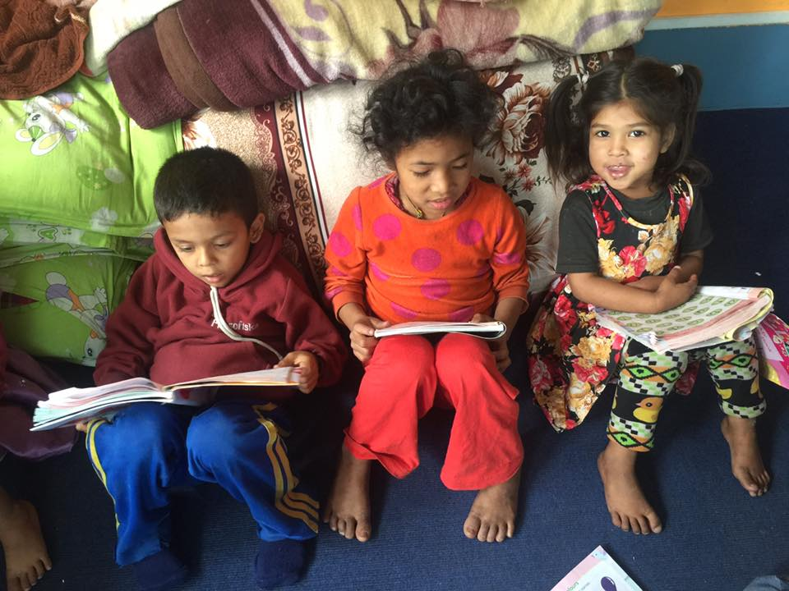
Studying is fun our preprimary students reading their course books.
