Monthly Progress Report of August 2016
Operation of the month:
This month we were busy in more study as first terminal examination was held on 7th to 12th August, 2016. All the students participated in the exam. Sencha Gurung , Samjana Tamang and Siddhartha Nepali were sick in between exam and they appeared in exam in next day. This time all the students work hard to achieve good marks. On 26th of August first term result was published and on same date we had our first parents meeting. This time parents gave more time at home. Students coming from hostel are also provided special classes in exam. The result of the students of each class are as follows:
Class Nursery:
S.N | Name of Students | Position
1. | Bikash Jirel | First
2. | Purnima Katuwal | Second
3. | Rabina Khadka | Third

Class L.K.G:
S.N | Name of Students | Postion
1. | Santosh Magar | First
2. | Udiya Yadav | Second
3. | Pawan Sherpa | Third

Class U.K.G:
S.N | Name of students | Position
1. | Santosh katuwal | First
2. | Siwani Pariyar | Second
3. | Siddhartha Nepali | Third

Class One:
S.N | Name of students | Position
1. | Sapana Subedi | First
2. | Kushal Shrestha | Second
3. | Pemba Sherpa | Third

Class Two:
S.N | Name of students | Position
1. | Pratichya Tamang | First
2. | Laxmi Gautam | Second
3. | Abhishek nepali | Third

Class Three:
S.N | Name of students | Position
1. | Bijay Bamjam | First
2. | Sunil Koirala | Second
3. | Puja Nepali | Third

Class Four:
S.N | Name of Students | Position
1. | Rejin Sundas | First
2. | Rabita Yadav | Second
3. | Kumari Tamang | Third

This month we celebrated birthday of Unika Shrestha from class nursery and Priti Nepali from class three. They distributed sweets to their friends and staffs as well. We wished all their wishes come true.
Conclusions:
This month we were more focus on the study. Students were more responsible and attentive in classroom and playing area as well.

Photographs:
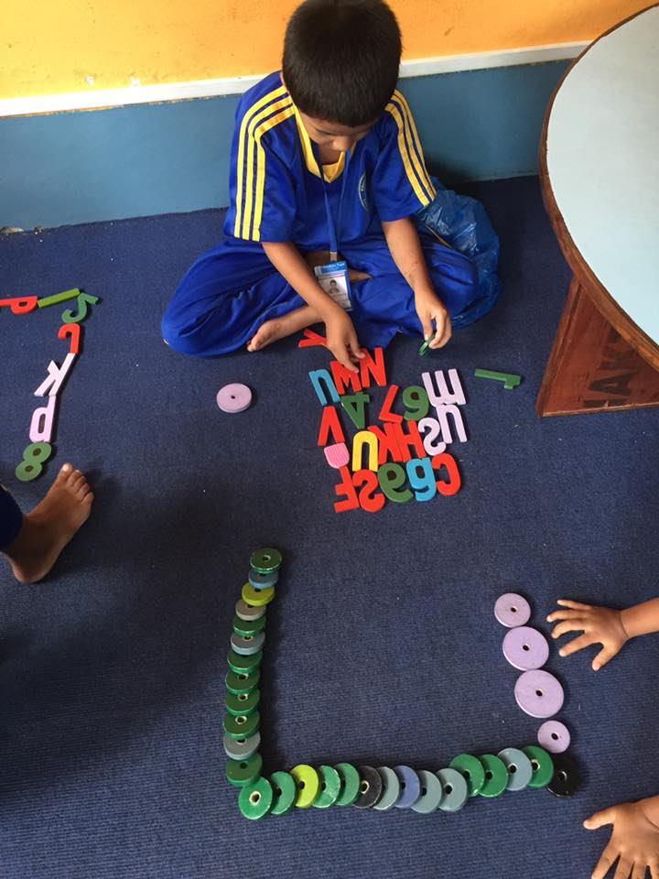
Play time of nursery students with numbers and wooden blocks.
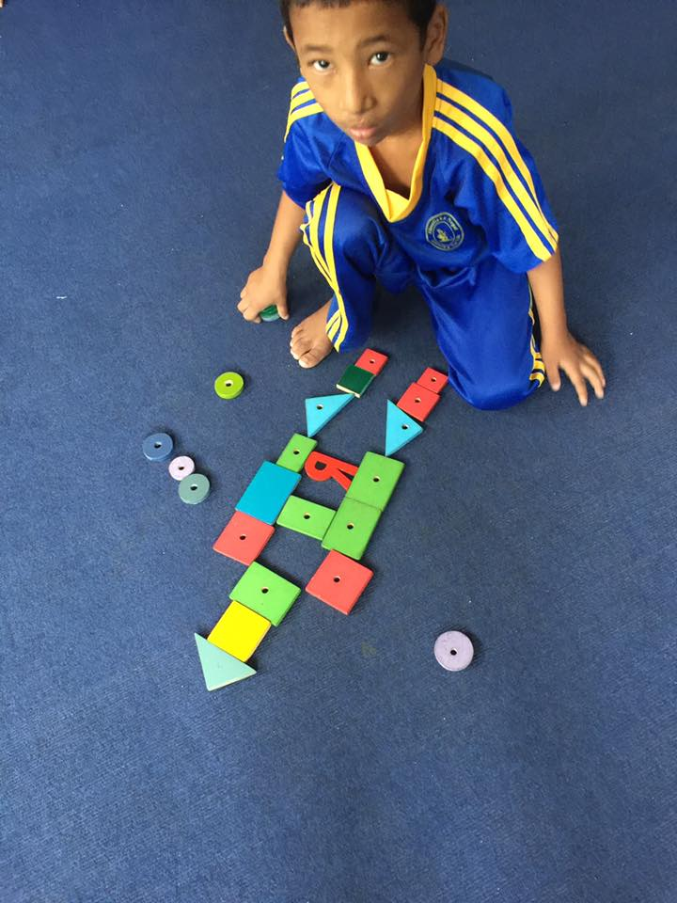
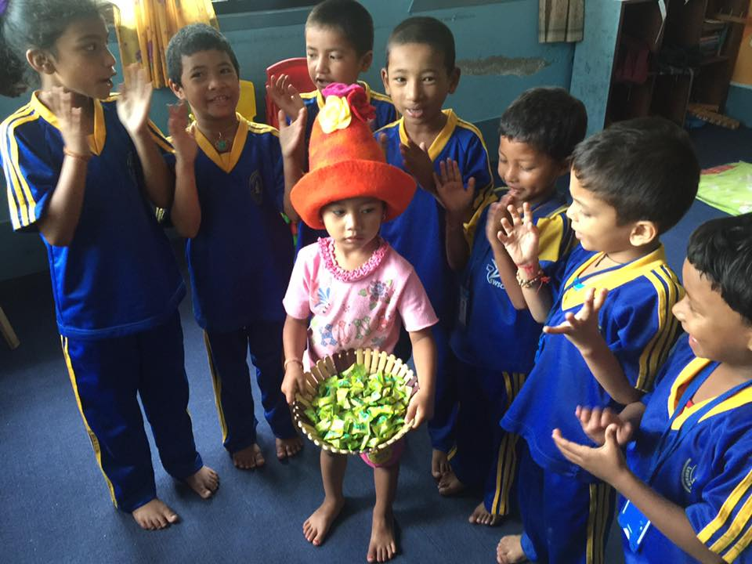
Birthday celebration of Unika Shrestha of class Nursery and Preeti Nepali from class three with their friends and teachers.
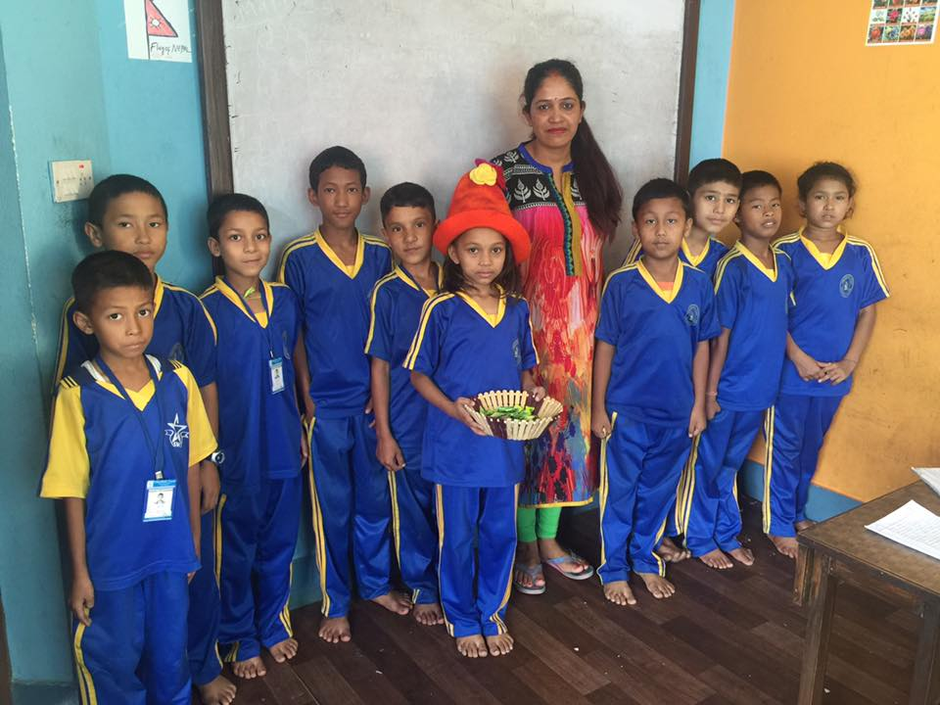

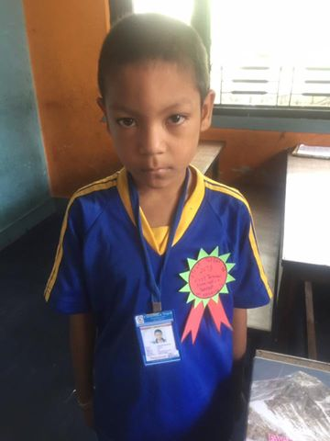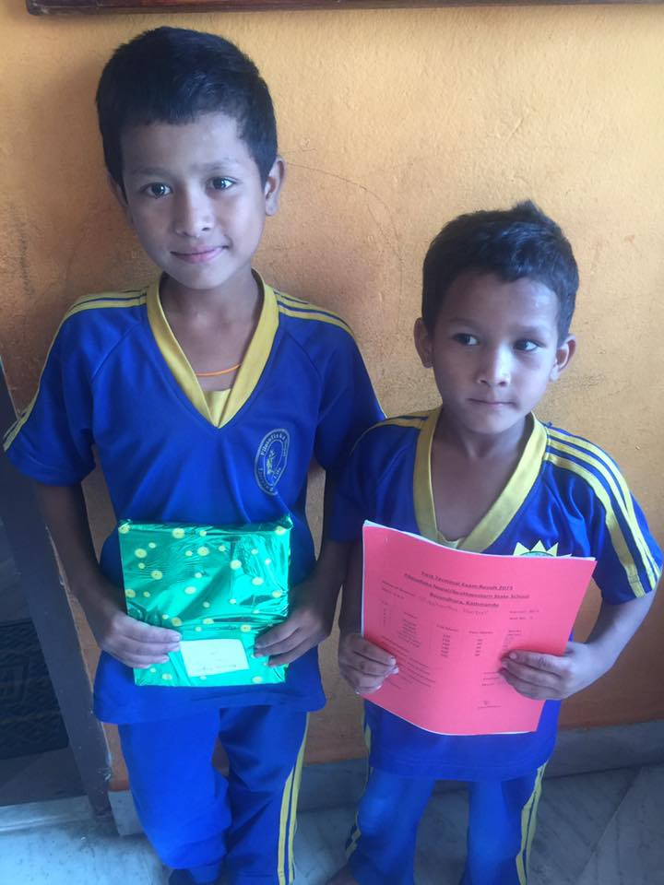

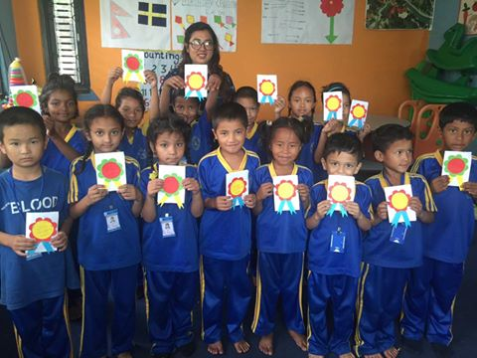
Father’s Day Card for their respective father made by themselves with the guidance of their teachers.
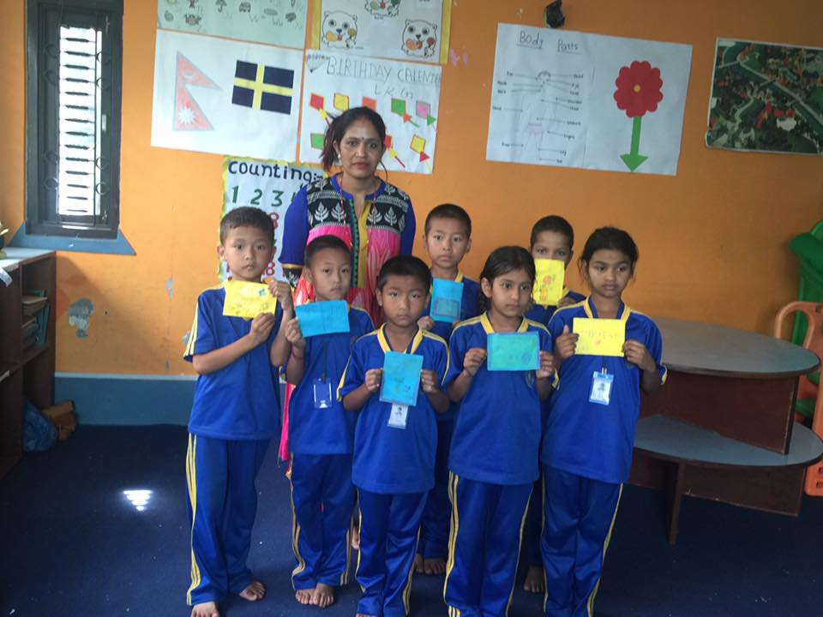

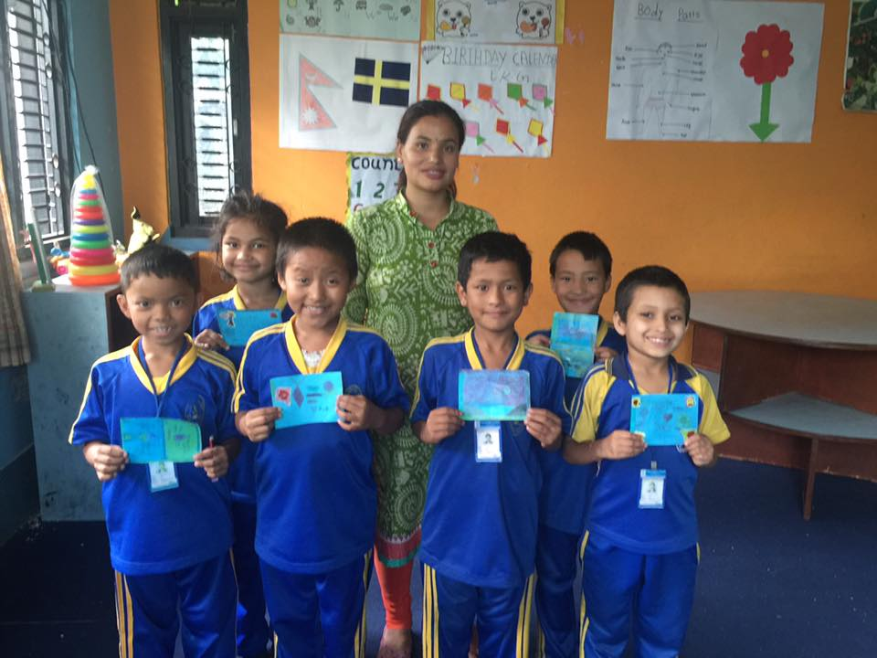

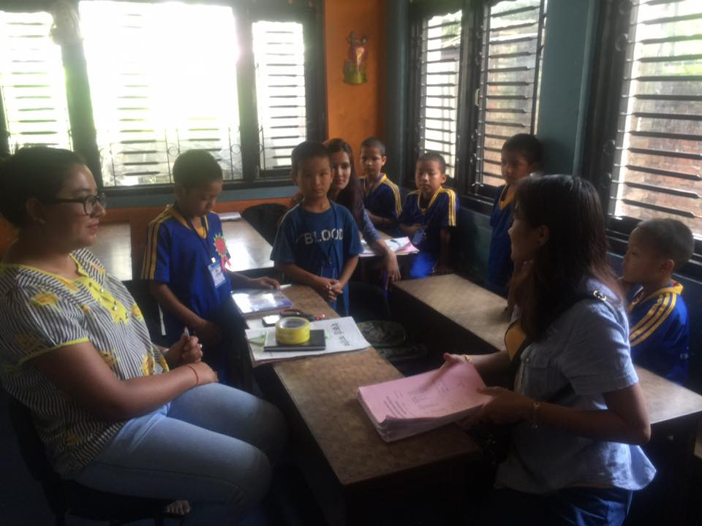
Grade teacher of class UKG discuss about the performance of the students with the guardian of Transit Home/ Child Rescue Centre 104.

Thank You.

