Monthly Progress Report of January 2017
In the month of January we had our long winter vacation which starts from 4th January to 21st January 2017. Children stay at home and enjoy warm sun with their families. They had vacation assignment.
Progress of the month:
Sara from Sweden starts her volunteering from 30th of January. On 31st January we celebrate goddess saraswati birthday by worshiping her.
Special Programs:
- Worshiping goddess Saraswati
- Welcoming Sara from Sweden
- Winter Vacation
Birthdays:
- Apechya Thing-Grade Four
- Rejina Kunwar- Grade One
Teacher’s Performance Evaluation:
Last month we don’t have any monthly meeting that’s why we have meeting this month. We discuss about the students performance in class and how we can motivate them.
This month also staffs were provided training on how to increase the performance of the students in an effective way.
Conclusions:
Over all this month students spend more time with the families as we had long winter vacation. Teachers were more focused on study materials. They collect more information and materials which they deliver in classroom.
From this month Sara is also helping in classroom and children will get more information about Sweden. She will start project with grade four students.

Photographs:
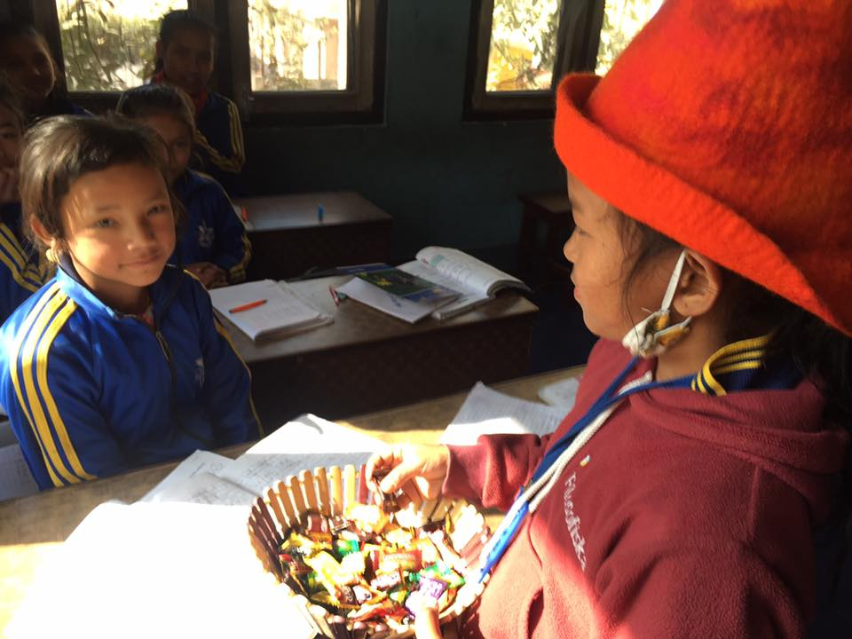
Apechya Thing celebrating her birthday with her friends.

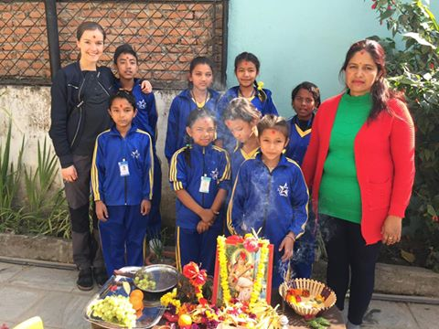 Children celebrating Saraswoti Puja with great enthusiasm.
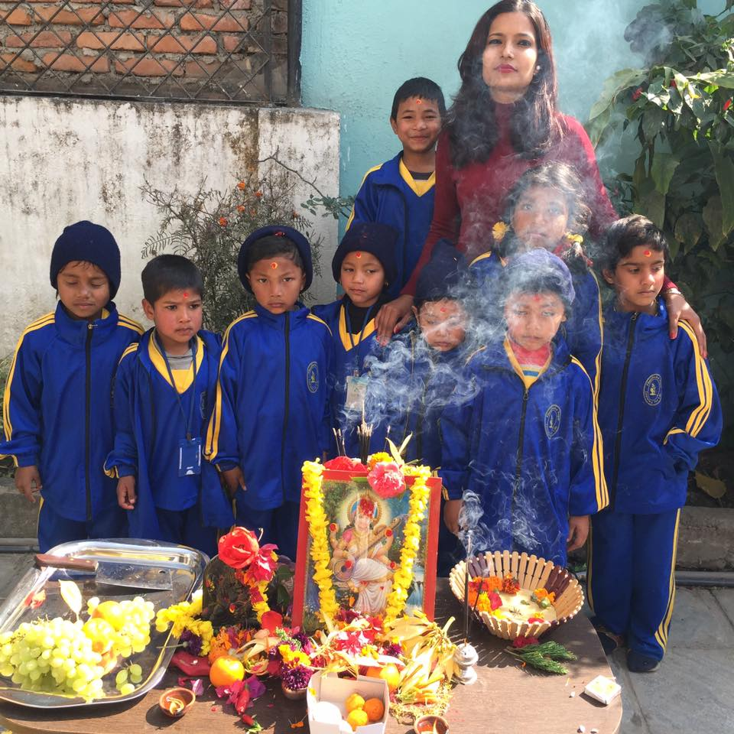

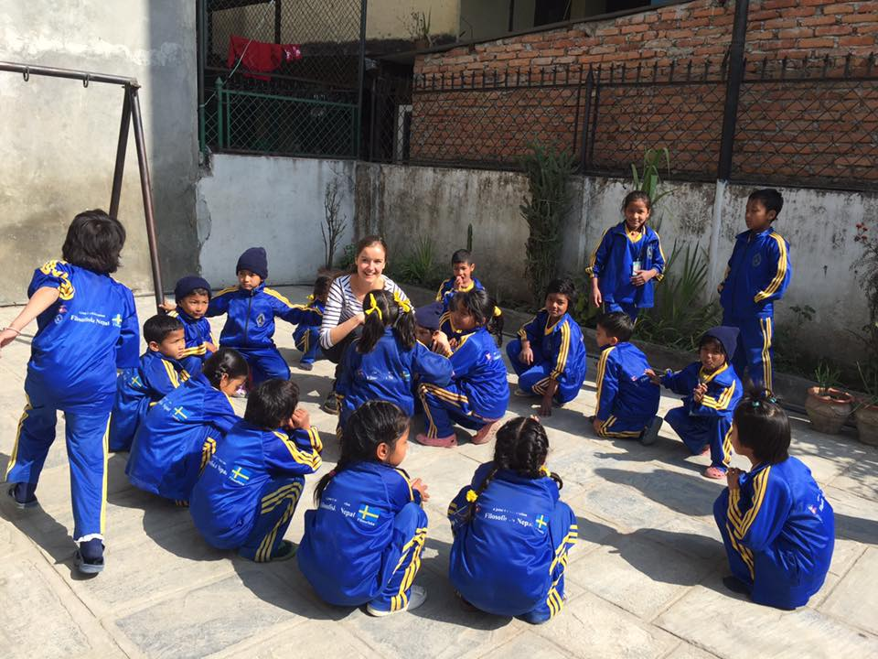
Sara havimg fun time with children in the ground.
