Monthly progress report of February 2017

Operation of the month:
Month of February we have lots of exciting things going on. We went to field trip, hiking and of course we made Swedish chocolate balls which was really tasty. Children from grade four were involve in making the chocolate balls. We all enjoy chocolate balls. We went to visit both girls and boys hostel. The man focus of this month is on project work with Filosofiska Sweden. Actually grade four and three children were involved in the process. Sara is always there to help children to understand more about project. Children were busy in studying for last terminal examination that will be held in the end of March.

Progress of the month:
Students were more close to Sara as Sara start to spend more time in the classroom. They all try to speak English with her and express their feelings. Other things are we gave them more exposure to new things.
As new session is going to start soon we are going on screening of the new students.

Teacher’s performance evaluation:
Of course this month also we had staff meeting which was ended up with great enthusiasm. More positive things are coming up and all the staffs are working on their best.

Special programs:

- Science exhibition at SouthWestern State Collage
In the first week of February, we were invited to a science exhibition held at South Western state Collage. Some of our girls performed with a dance, dressed in Sari’s. The rest of the students and teachers were there to support them. After that we did exhibition tour and got fascinated by the work of the college students. The exhibition was really informative and creative as well.

- Visit to temples and monastery with grade four
On 10th of February we went on a field trip with students of grade four to Budhanilkantha and Buddhist monastery. Budhanilkantha is situated below the Shivapuri hills at the northern end of the Kathmandu valley. The main statue is considered as the largest stone carving in Nepal. The Buddhist monastery is Sang Sang Rinpoche –Chiwang monastery. It is really peaceful and from where we can see nice view. Children stay there for few minutes and get fresh and pure air.

- Celebrate Valentine’s Day
On 14th of February we celebrated Valentine’s Day for the first time at Filosofiska Nepal. As we are planning to celebrate last year also because of some reason we did not but this year we celebrate it with love. Sara explained how it is celebrated in the western part of the world and the importance of showing love to our beloved ones. Students and staff enjoyed being creative and making beautiful Valentine’s decorations. Among other things, we made a big poster where the students pinned one heart each. On this heart they had write down what is important for them in their life.

- Visit to Swayambhunathwith grade UKG
On 17th of February we did another field trip, this time with the students from UKG. We went to the monkey temple called “Swayambhunath” which is situated at northwest of the kathamndu valley. Swayambhu sits atop its hills overlooking most parts of the valley. This is good place to catch panoramic view of the city. The glory of Kathmandu valley said to have started from this point. Behind the hilltop is a temple dedicated to Manjushree or Saraswati the goddess of learning. Chaityas, statues and shrines of buddist and hindu fill the stupa complex. The base of the hill is almost entirely surrounded by prayer wheels that were recently installed.

- Cooking “Swedish chocolate balls”
One day, Sara took the initiative to cook some popular Swedish sweets. Together with staff and students from grade four we made “Swedish chocolate balls” which we in the afternoon enjoyed for snacks.

- Cooperating project with Filosofiska Sweden
Throughout the month, Sara and students in grade three and four have worked with a cooperating project with Filosofiska Sweden. In this way their knowledge about their sister school will rise and they will develop their view of the world and differences between countries. The students learned about some of the disparities between Sweden and Nepal, such as political system, geography, population and religion. They watched some movies about Sweden on YouTube and also wrote friendly letters to their friends in Sweden.

- Holidays
In the month of February we had two public holidays, Shivaratri and GyalpoLhosar. Shivaratri we celebrate in the honor of God Shiva and GyalpoLhosar is the Tibetan New Year. The staff and students celebrated in their on ways.

- Free painting on board with grade three
One day we brought out a painting board at the schoolyard and let the students in grade three draw some beautiful paintings of their own with colors that Sara brought from Sweden. The students really seemed to enjoy it.

- Visit to Filosofiska girls hostel
Last but not least, Sara and Rashmi visited Filosofiska girls hostel. The girls proudly showed us their home and Sushma welcomed us with open arms. We spend about hour with the girls.

Birthday Celebration:
- Rejin Sundas- Grade Four
- Shreejana Basnet- Yours humanly Volunteer
- Sapana- Grade one

In conclusion, we had a nice month filled with good studies and fun activities. Weather is getting warmer and we are all in good mood.

Photographs:

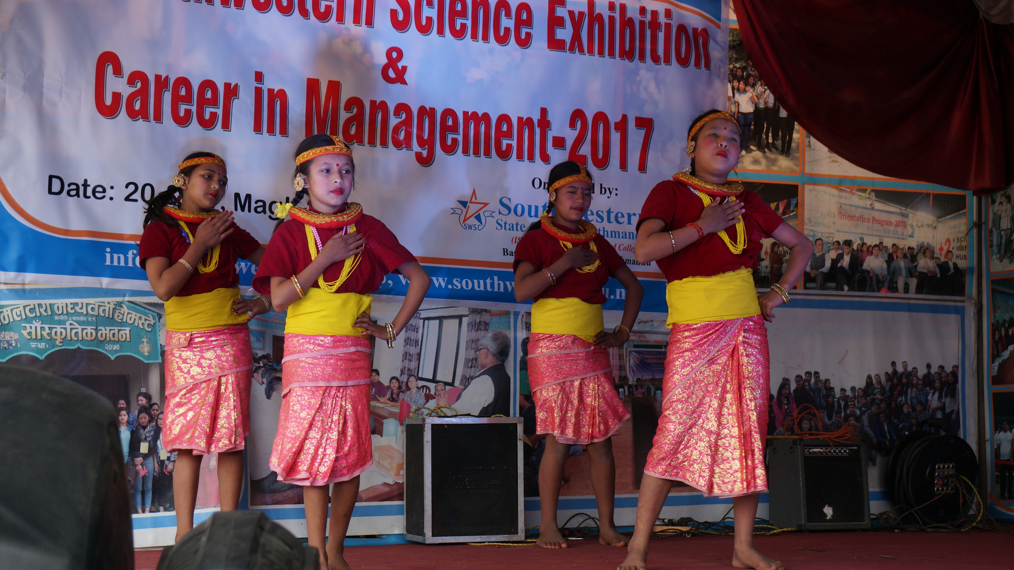
Girls performing at South Western College’s Science Exhibition

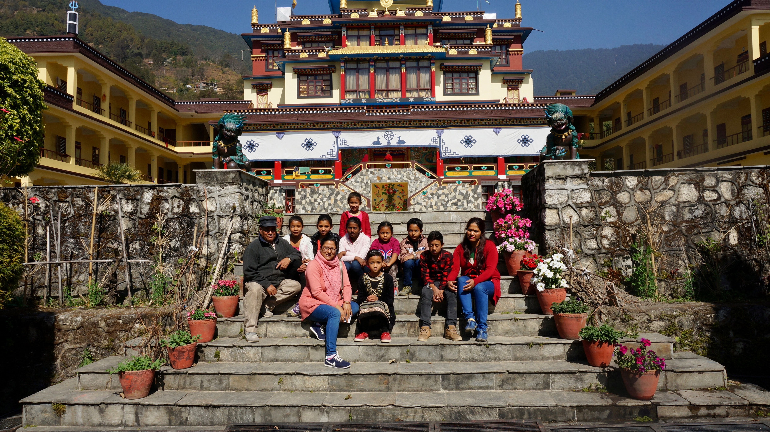
Field trip to Sang Sang Rinpoche Chiwang monastery with grade four

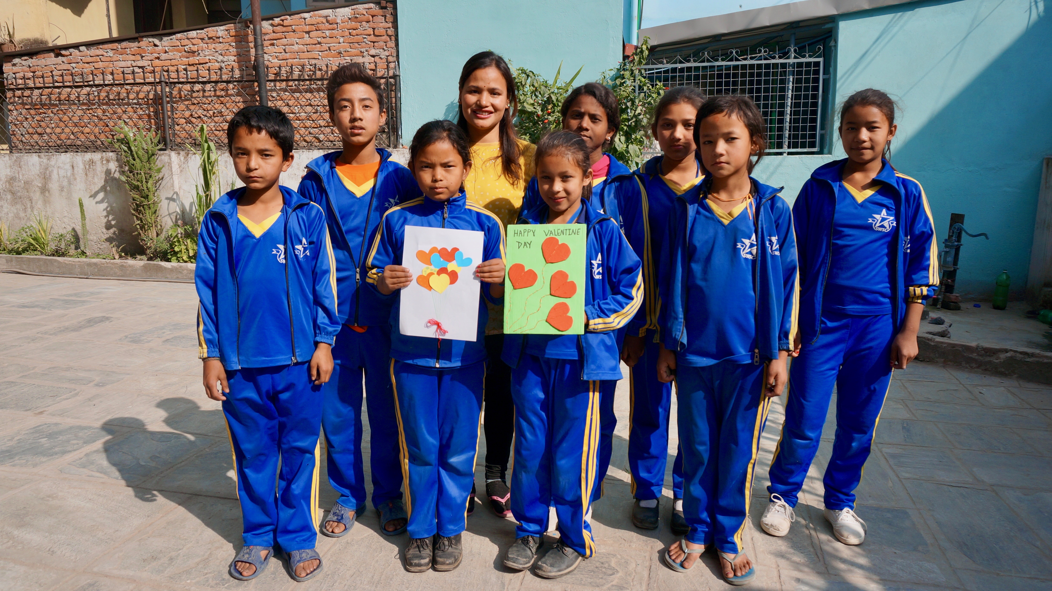
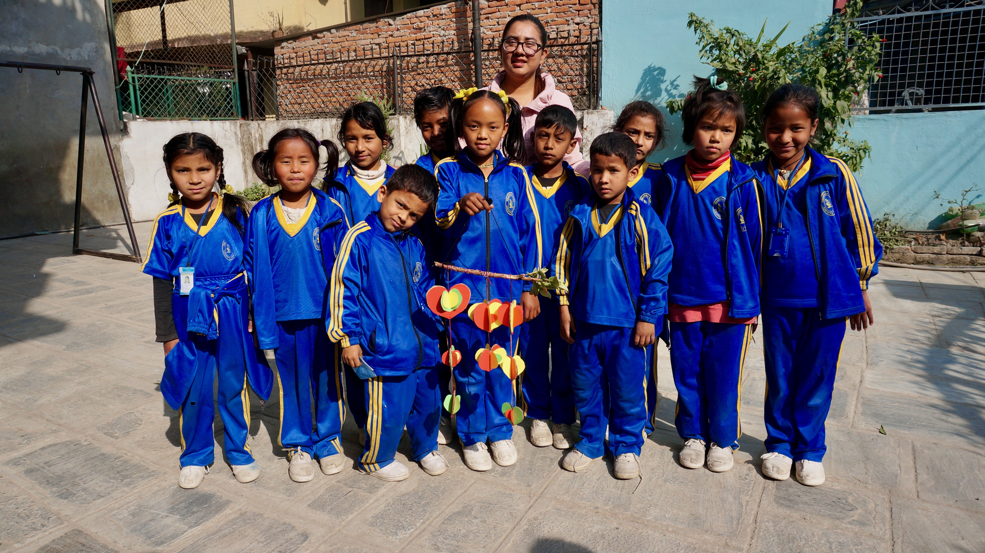Valentine’s Day Celebrations

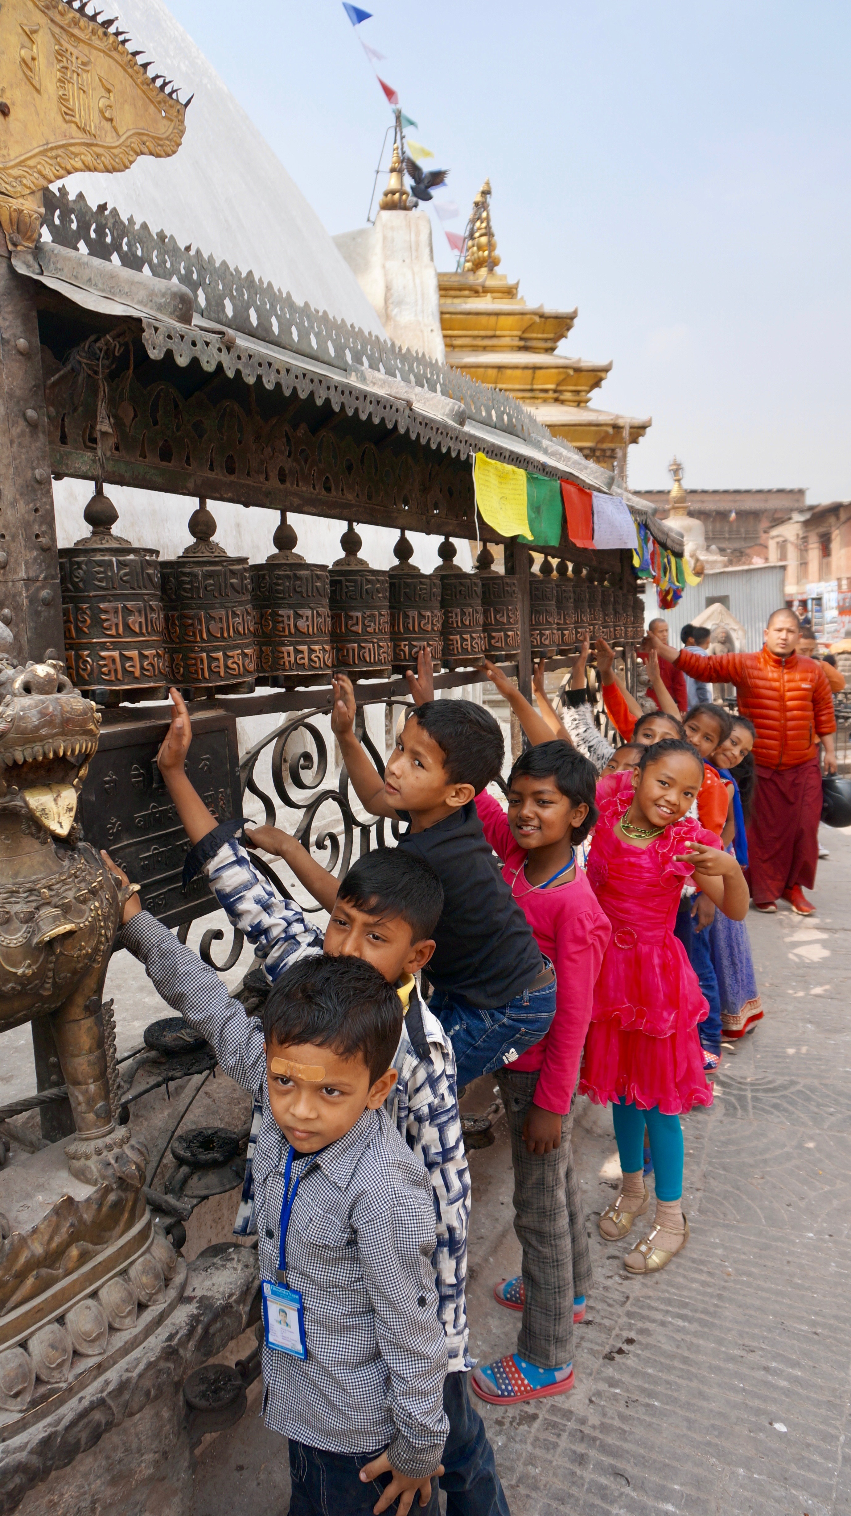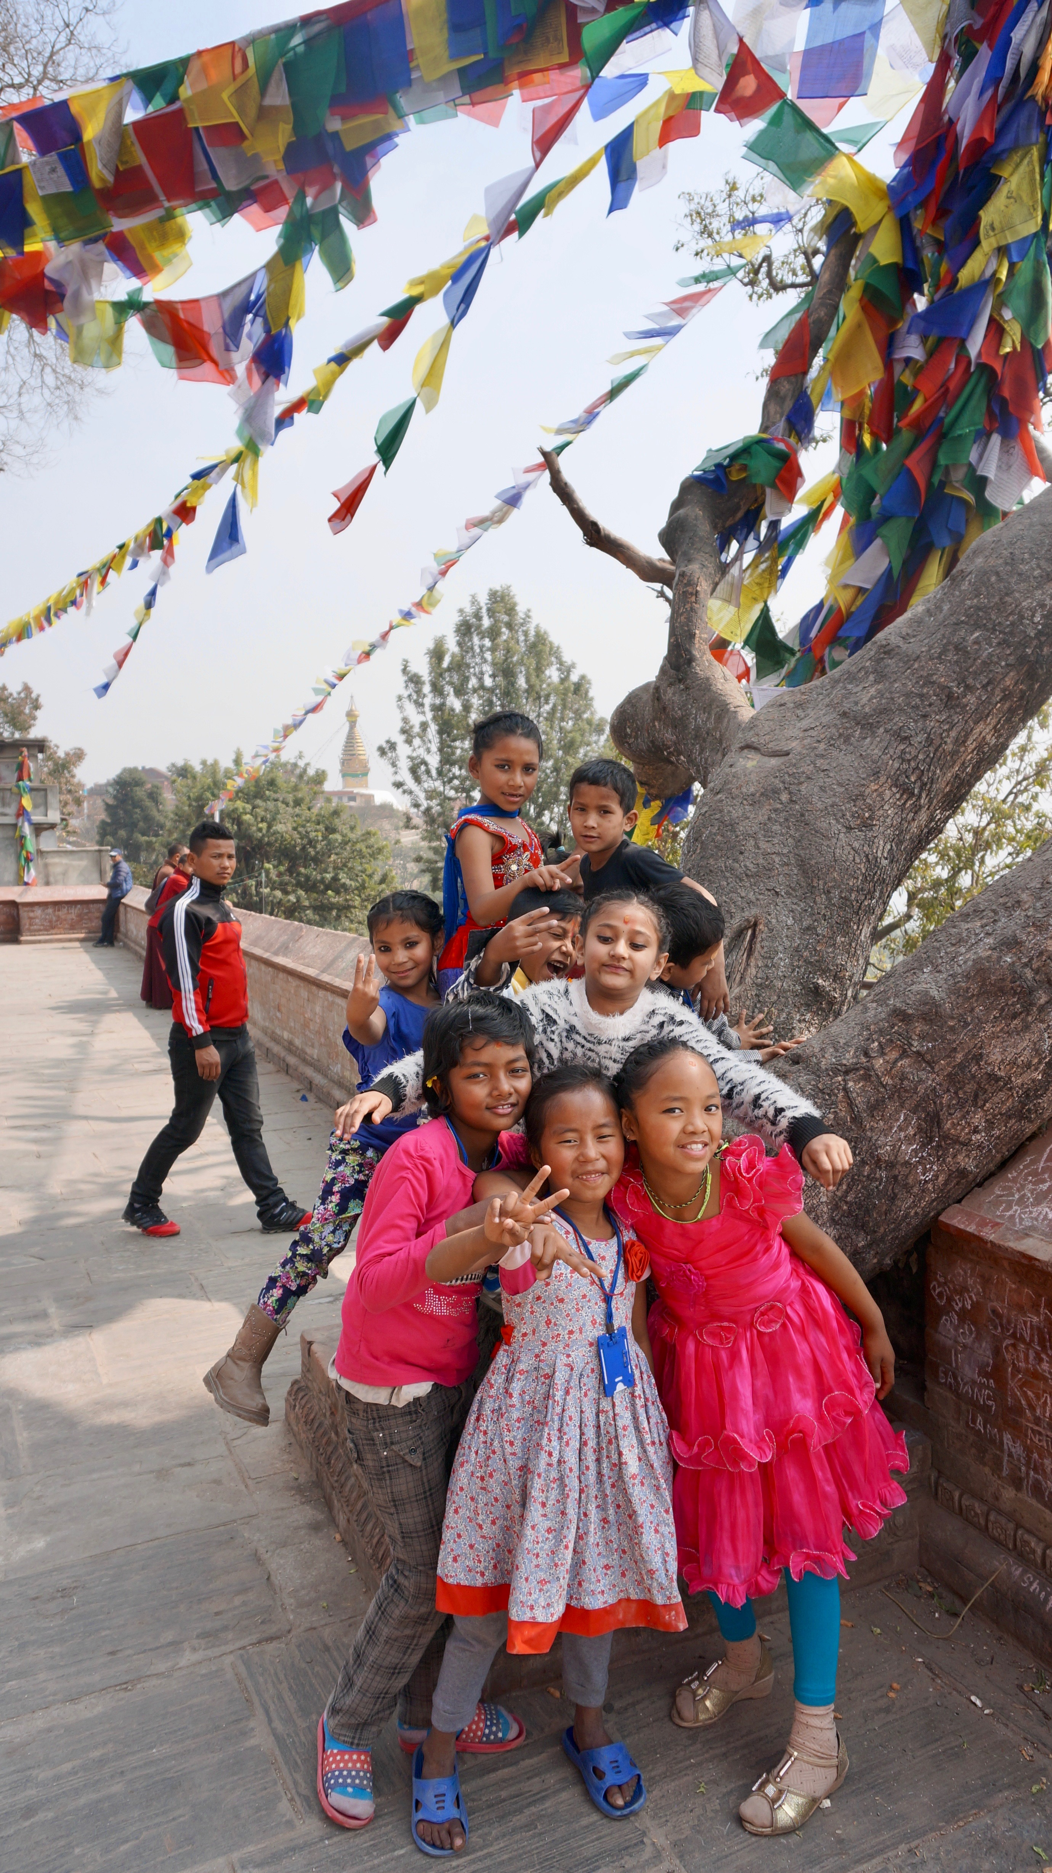
Field trip to Swayambhunath with UKG
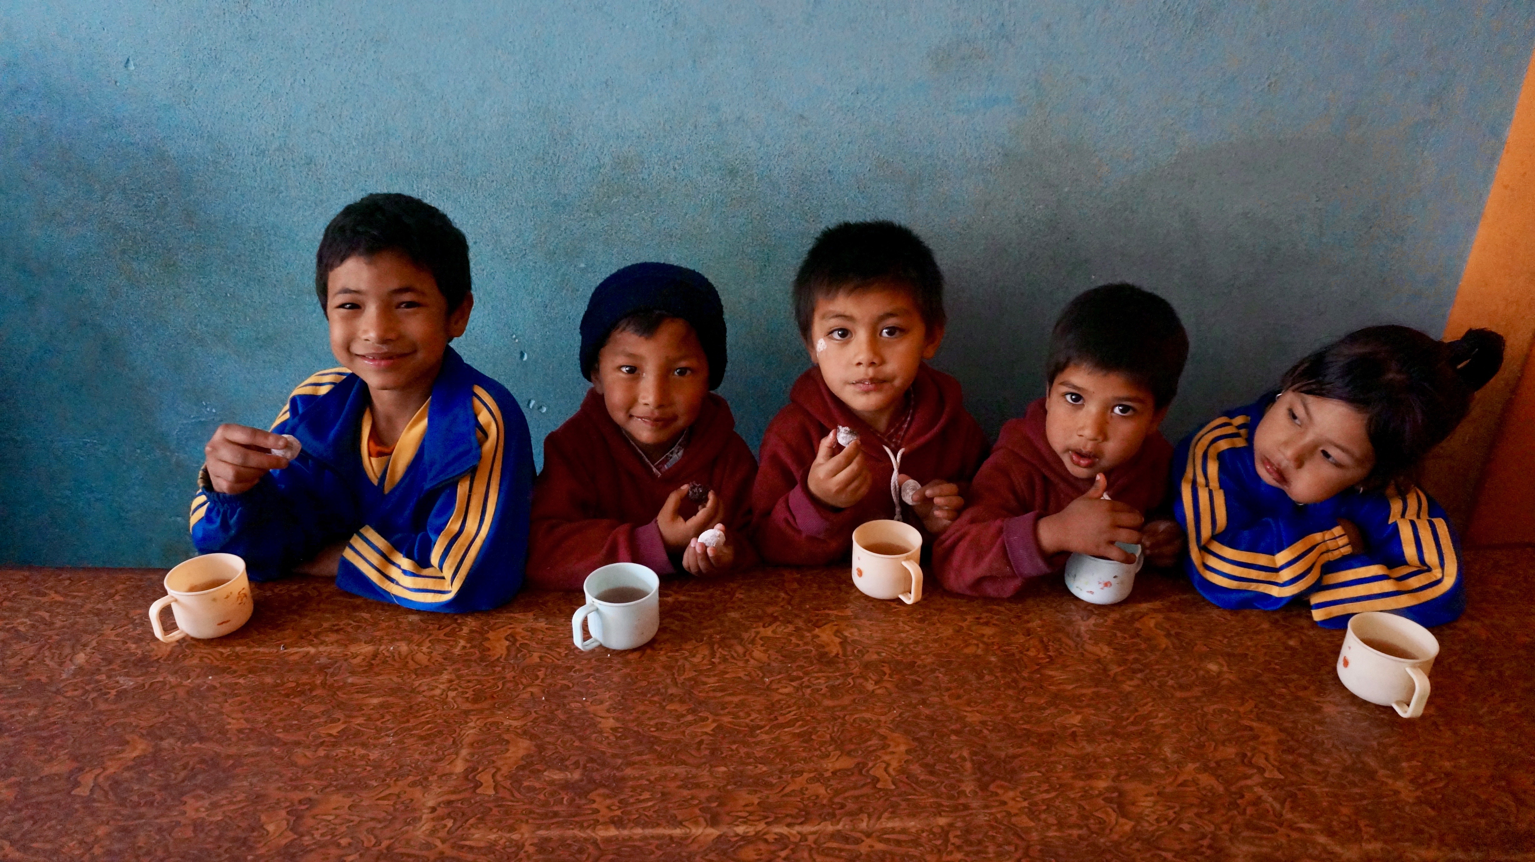Students enjoying Swedish chocolate balls
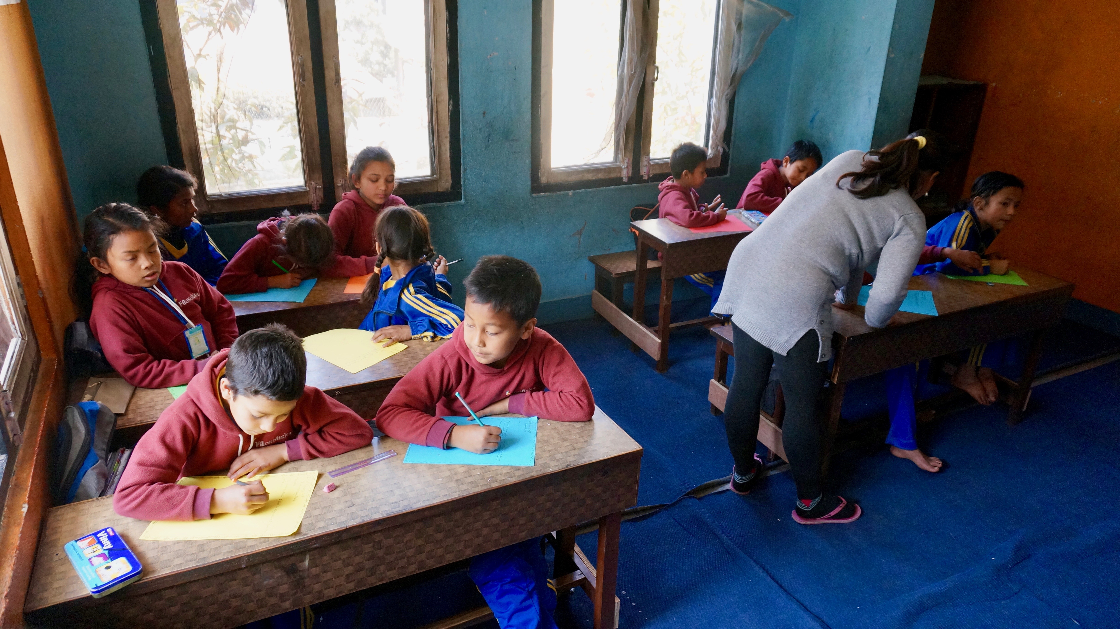Students from grade three and four working with the cooperating project with Filosofiska Sweden
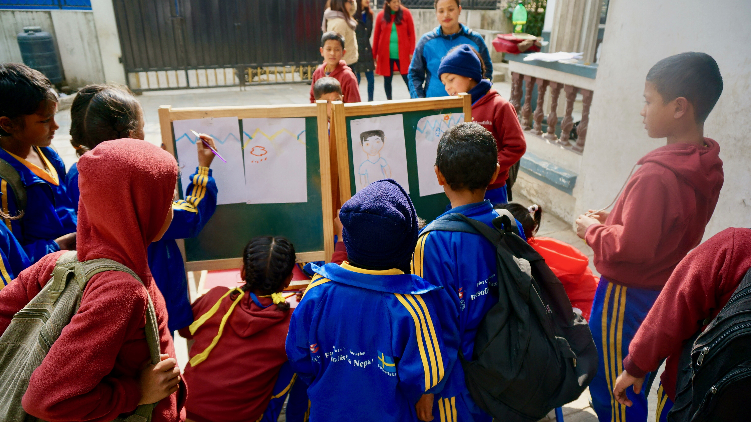Students in grade three making beautiful drawings at the schoolyard

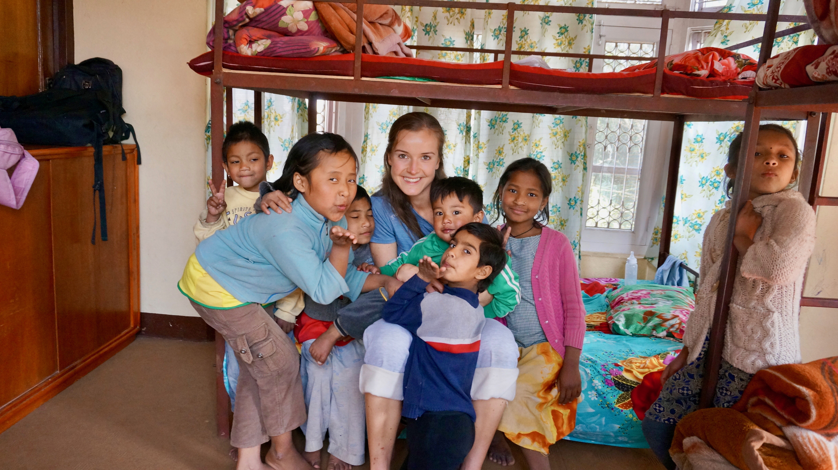

Thank you.

