Monthly Progress Report of September and October 2016
In the month of September and October we celebrate different kind of festivals. In these months we did lots of funs. These months both students and teachers were busy in their own way.
Progress of the month of September and October:
In this both months students and teachers make beautiful cards and pictures to decorate their classrooms. Students celebrates different kind of festivals which give lots of knowledge to them like making cards, respect to elders helping each other etc.
Special programs:
- Mothers Day
- Teej celebration
- Birthday of Celebration of Smriti, Pratichya and Rejina.
- Dashain celebration
- Tihar celebration
- Holidays(students went home for biggest festivals)
Dashain:
Dashain is the longest and most and moat celebrated festival in Nepal. Dashain has its different names like Vijay dashmi, Durga pooja. This way of celebration and name different but most Nepali celebrates it for 15 days with same enthusiasm.

How do we celebrate Dashain:
Dashain has its own stories and importance. It is regarded as victory of truth over the evils. Dashain is the celebration of victory of good and bad. Dashain remains us every year that the evil may be strong for a time. The truth and good will always prevail over it.
Good always wins over the evil. Every year we all Nepalese celebrate Dashain.
Nepalese people wherever they live, they try to reach home to see their family in Dashain. Take blessings, tika, jamara etc from their elders.
Tihar:
Tihar is also known as deepawali. Tihar is the five days celebration. It is second big festivals after Dashain in Nepal. It is celebrated in late autumn. It has its unique ways of celebration.
The five days of Tihar are as follows:
- Kaag Tihar – Crow pooja
- Kukur Tihar – Dog pooja
- Gai Tihar / pooja - Cow or goddess of wealth pooja
- Gouru Tihar / Maha pooja (soul pooja) – Ox pooja
- Bhai Tika – Brother and sister pooja.

Photographs:

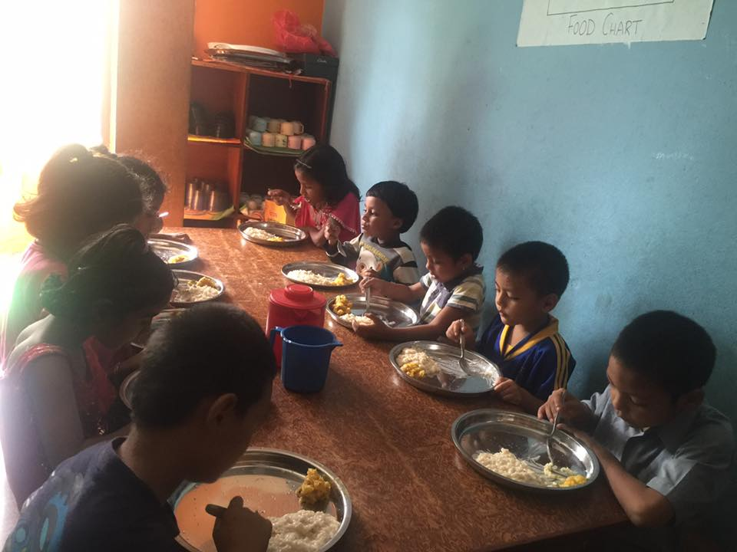
Rice Pudding Feast on Teej Day 2016.
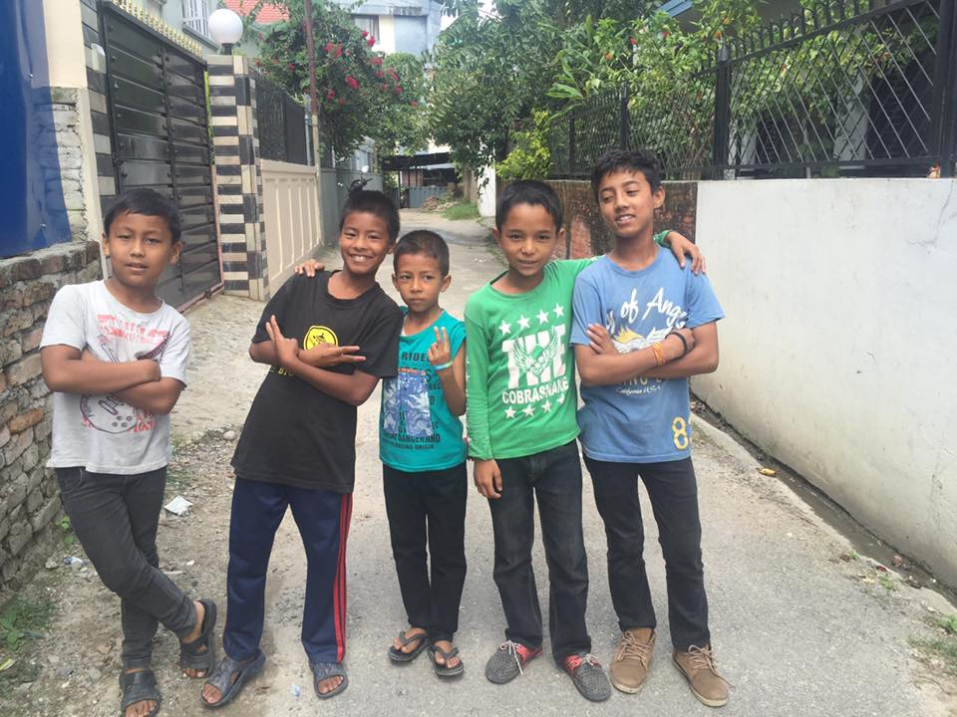 Boys posing on Fancy dress day 2016
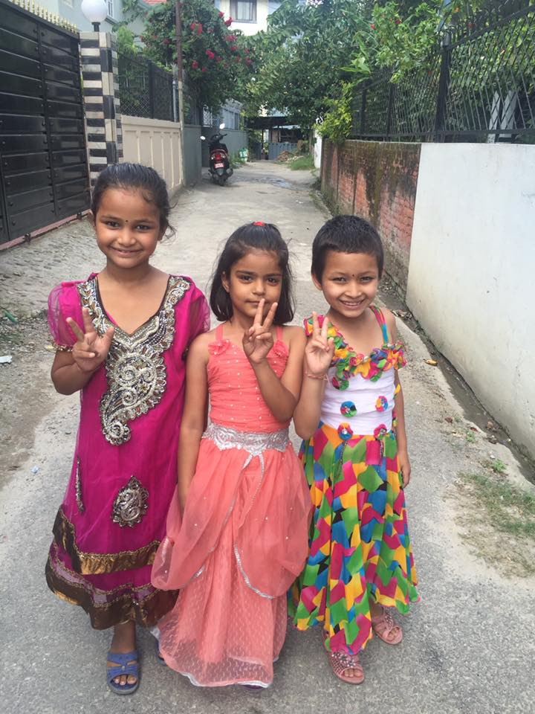
Beautiful girls on fancy dress day.

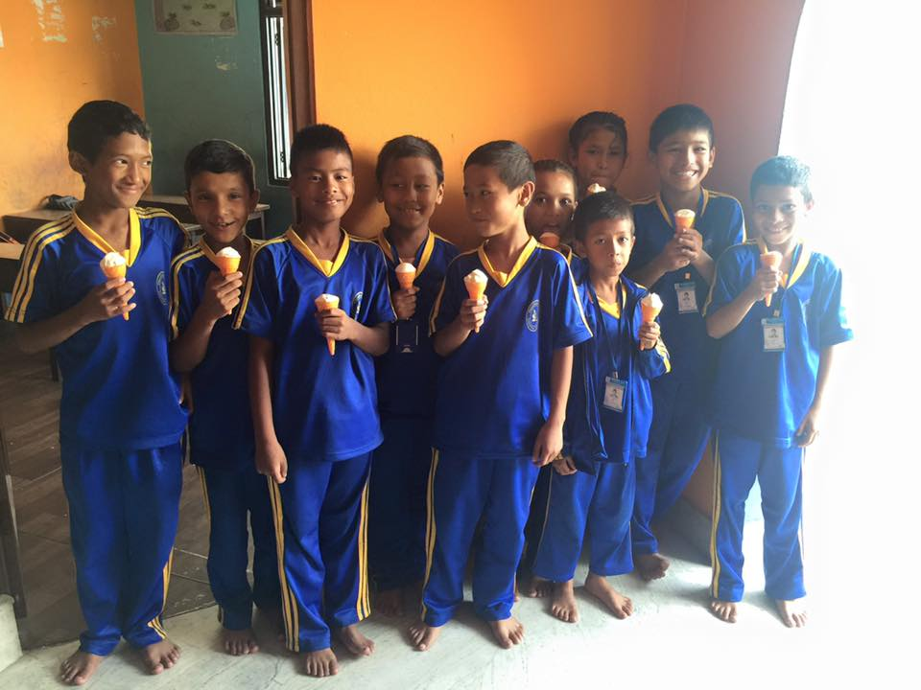
Children having fun beating the hot day of summer.
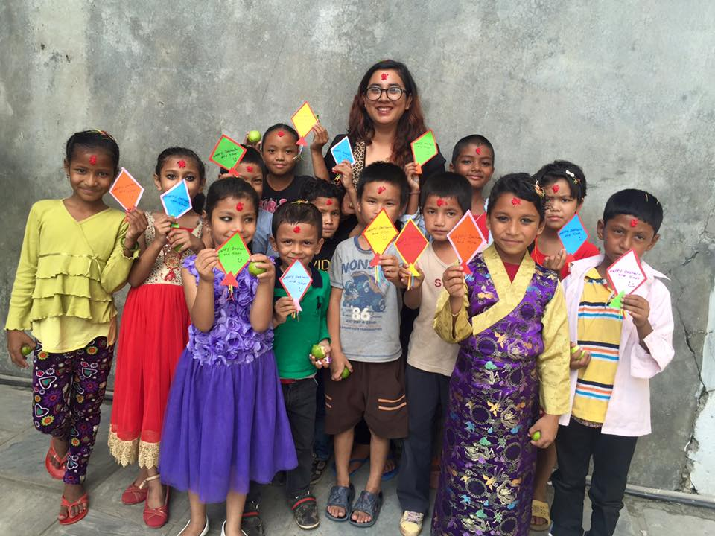
Pre dahsain celebration and also they made beautiful greeting cards.

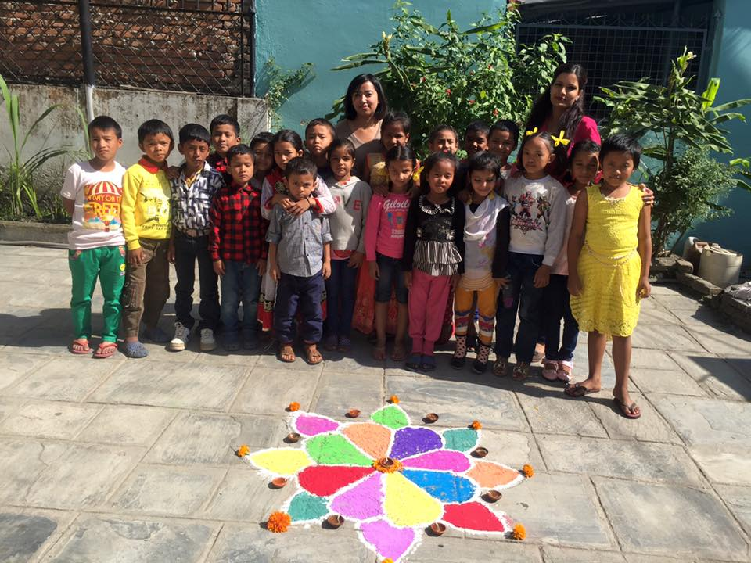
Tihar celebration with great enthusiasm.
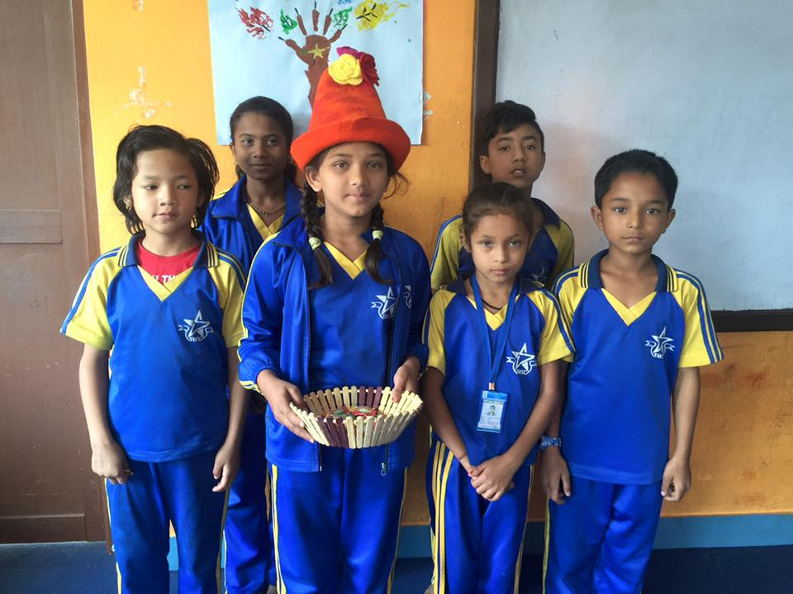
Birthday celebration of Smriti from grade four.

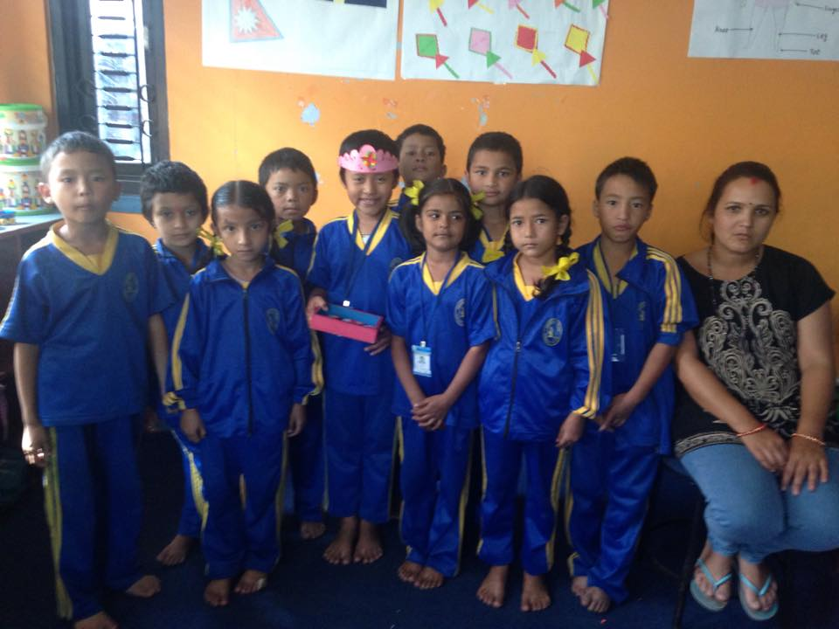
Birthday celebration of Pratichya from grade two.

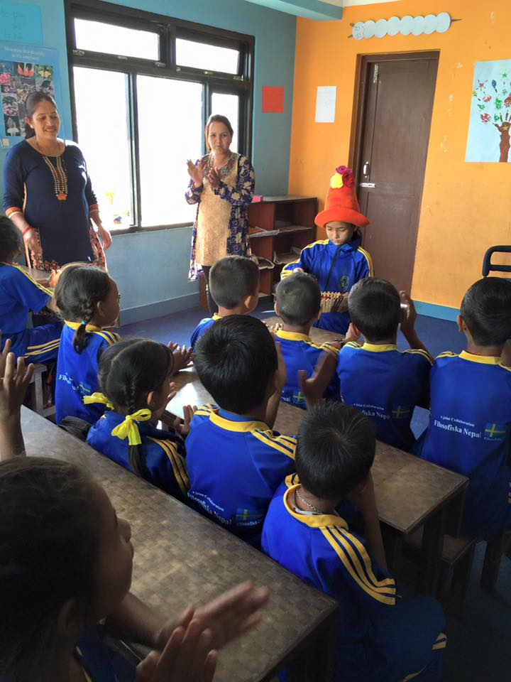
Birthday celebration of Rejina from grade one.

