Monthly Progress Report of June 2017
Hello June….. dry and withered. June is named after Juna, the goddess of spring and growth. Children were excited to know the meaning about the June.
From this year in Filosofiska Nepal we start to teach dance for the children by our own teacher Ulina Thapa. The class was started form 4th June 2017. As we all know that dance is most beautiful art and it helps to be healthy. We get really surprised when we hear children’s opinion.
Ashmita Nepali from grade three says that she dance to live, she dance to breathe, she dance to be free and she dance to be herself.
Abhimanyu Thing, grade four student thinks dance isn’t something that can be explained in words. It has to be danced.
In our opinion to dance is to be out of yourself, larger, more beautiful, more powerful.
This is month of June so its rainy season so most of time children they have to stay inside. So for this month we gave more focus on indoor activities. For morning assembly also they have to stay inside. They do their morning routine inside the classroom.
On 5th June we celebrate World environment day this year theme was connect with nature. The theme itself tells us to get outdoors and into nature, to appreciate its beauty and its importance, and to take forward the call to protect the earth that we share. It takes place on June 5th. This year host country Canada got chance to choose the theme and will be at the centre of celebrations around the planet.
In the age of Smartphone and among the distraction of modern life, connections with nature can be fleeting. But with our help world environment day can make cleaner that ever that we need harmony between humanity and nature so that both are able to thrive.
On 21st June we celebrate World Yoga Day. The only way to experience true well being is to turn inward. This is what yoga means not up, not put, but in. The only way out is in.
Yoga can contribute in a holistic way to achieving equilibrium between mind and body. On this day we did some child friendly yoga posters. As we also do yoga thrice a week they all are well trained.
On 29th June we celebrate International Mud Day. There are countless ways to celebrate international mud day, but all of them have one thing in common you have to get dirty. This year we plan to celebrate in a little different ways. The most creative and fun activities that would perfect to do on international mud day is making mud sculptures or mud cakes. Children have their own imaginations and they made whatever they want to with the mud.
In the month of June as soon as it start to rain, mud is everywhere and it literally gets all over everything. Plenty of research has shown that coming into contacts with a certain amount of bacteria is good for us as it helps us to build immunity, as opposed to living in a virtually sterile environment. As our children are come from same environment that really had fun playing with mud and getting dirty.
On 30th of June children did nice handprint on the chat paper. They really enjoys playing with different colors.
This month we enjoy samosa- a triangular savory pastry fried in ghee or oil, containing spiced vegetables or sometimes meat. Then next week we had fresh corn form the farm.
Birthdays of students:
- Aayusha Bhattarai-Grade one.
- Elisha Bardewa- Grade one.
- Nikesh Koirala-Grade UKG.
As from this year we have started to celebrate staffs birthday. To treat them special we organize to give them special gifts.
Birthdays of staffs:
- Srijana Shrestha- Sister
- Indira Thing-Cook
Photographs:
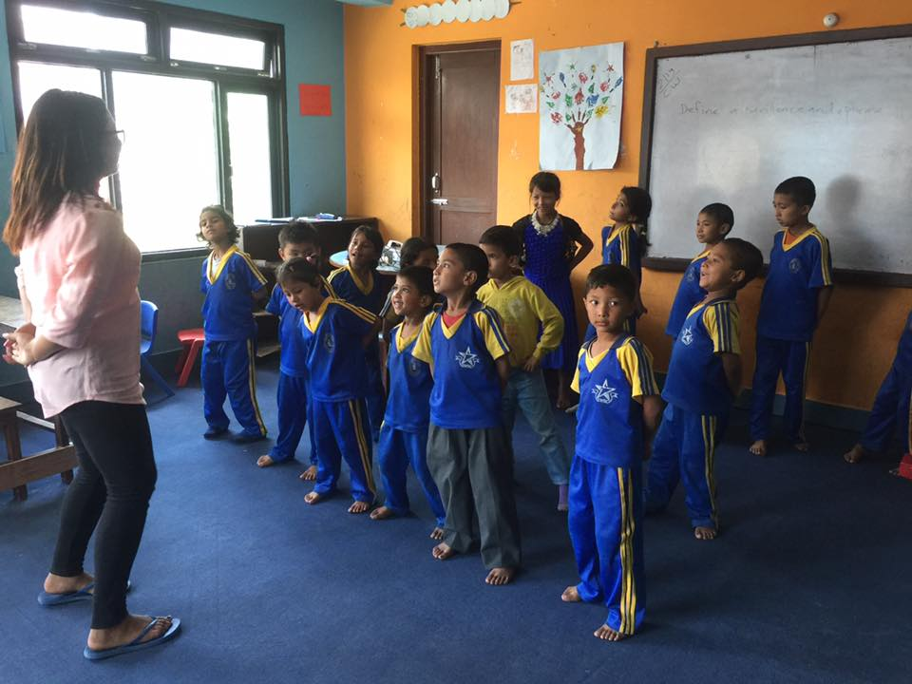
Children learning dancing steps with Ulina.

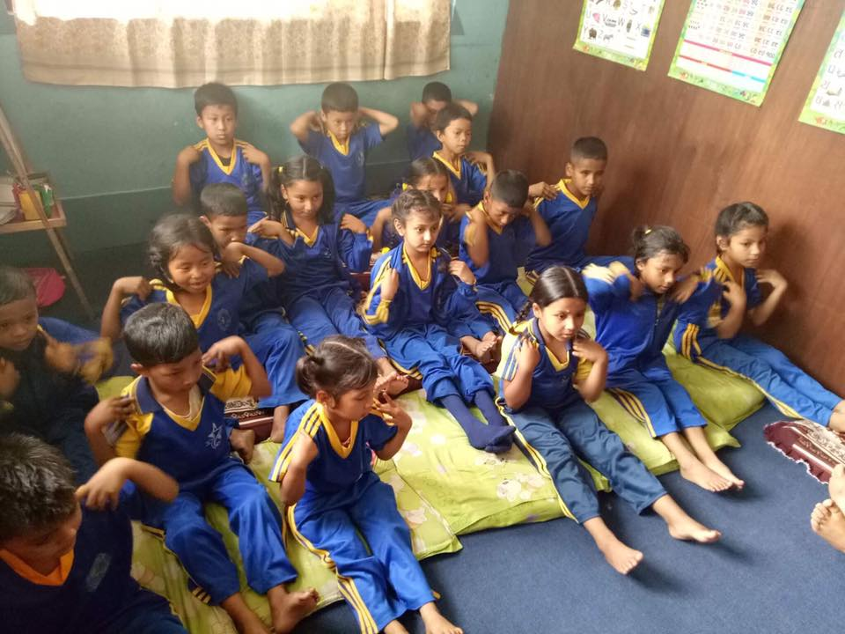
Celebrating on international yoga day 2017.

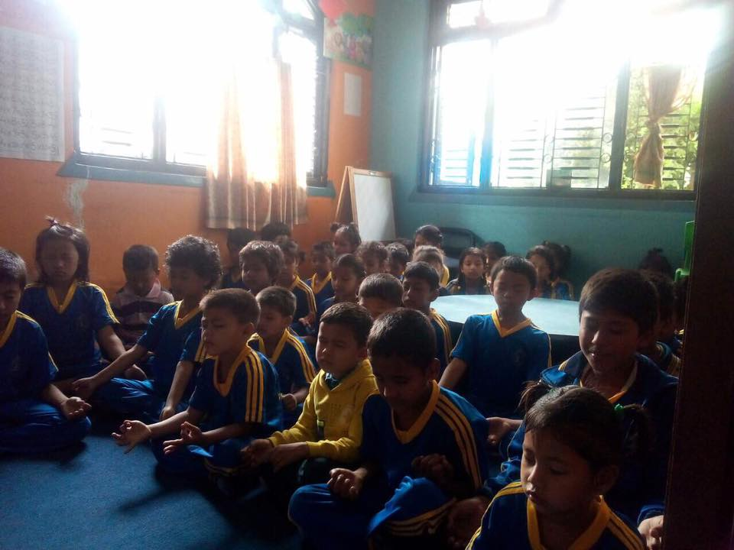

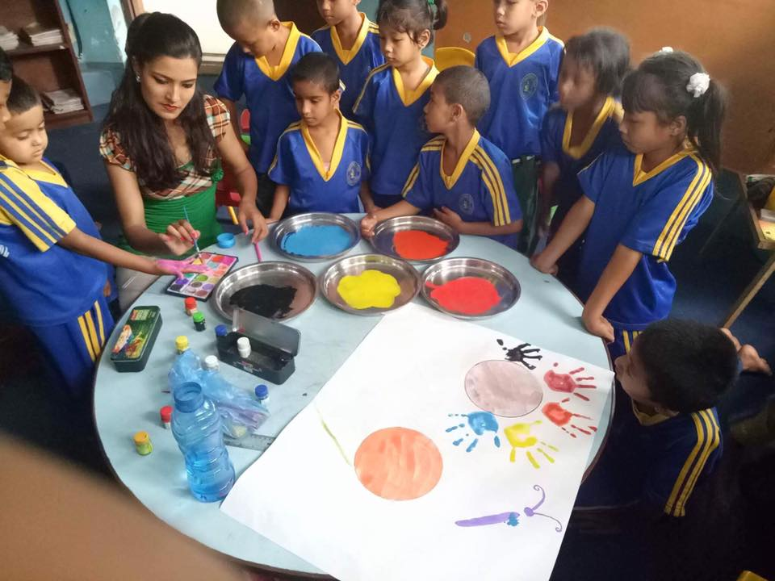

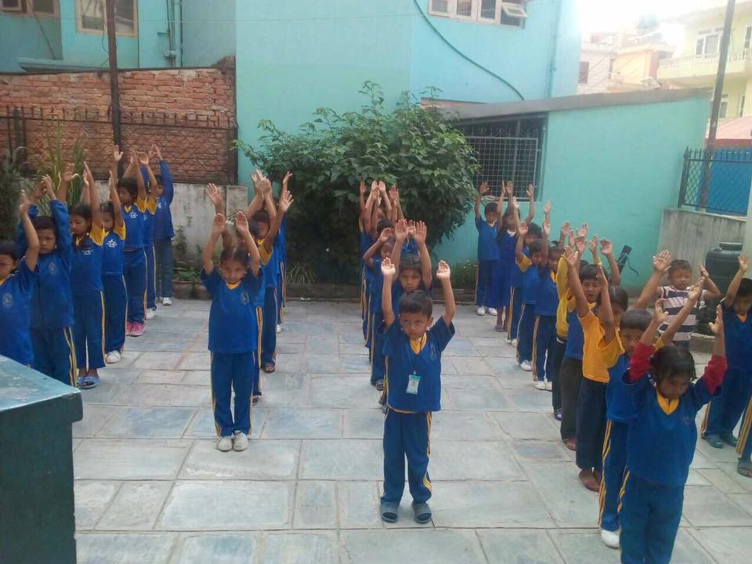

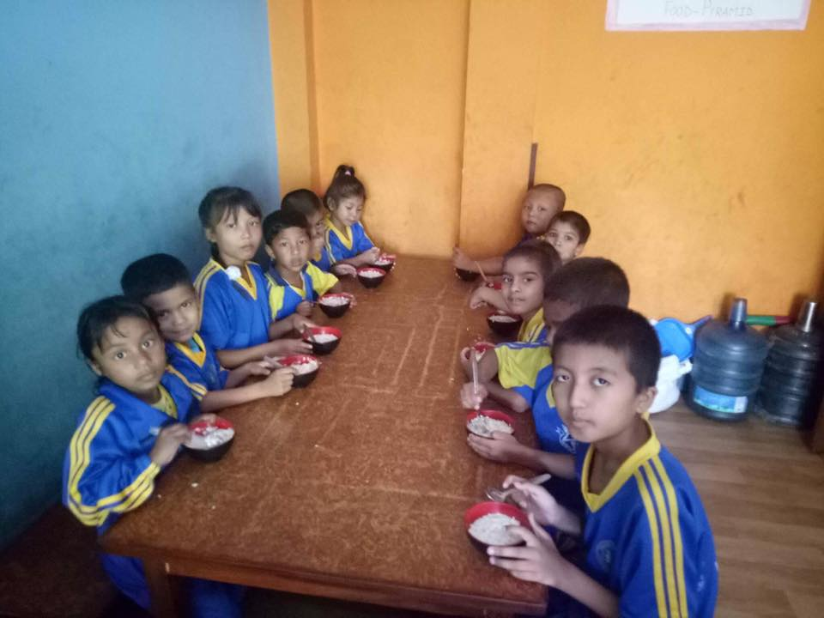

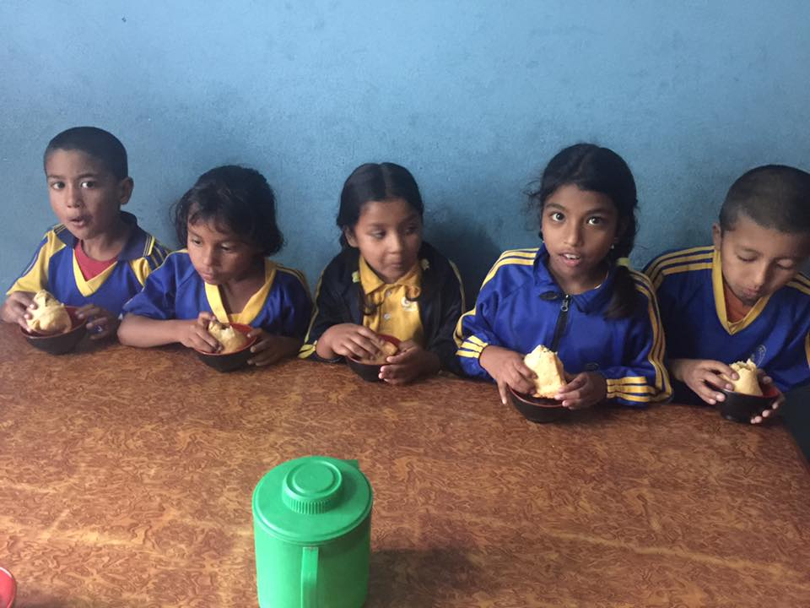

Thanking for your support.

