Monthly Progress Report of March and Monthly April 2017
Operation of school:
Month of March and April we have many more fun filled activities. Sara brought Europe puzzle from Sweden and grade three students made it in few minutes which was amazing. Then we had basketball match between grade three and four in which grade three students win. And on second half we have match between grade one and two in which grade one students win. On month of March we celebrate the festival of colors holi with Sara which was magnifying. At the end of March together with preschool children we went to visit Garden of Dreams because on some reason we cannot take them inside so we made immediate plan to visit Gahana Pokhari where we had small picnic. We all eat our lunch together then children visit nearby temple.
From 26th March to 2nd April 2017 we had our final terminal exam. All the students appeared in exam. They all put their effort to get nice marks in their exam.
Viveka from Norway with her boys visit Filosofiska Nepal. It was short visit but really worthwhile visit. She talks about her experience from different field and share with us.
Australian couple with their daughter also visit Filosofiska Nepal and distribute some beautiful cloths and footy for our students.
Teams of Yours humanly also visit our school and they donate us five desktop computers with printer so that our students will learn more about computer. And another good motive is staffs also learn more about computer and they will get access to internet.
Christino from Sweden visit our school and brought chocolate for us. He also brought some football for our students and nice Swedish flag for office. He had great time in Filosofiska Nepal. He played with children and spend whole day with us.
On April 15, we gave farewell to Sara. Sara stayed with us for almost two and half month. Children were really attached with her. When we told them that Sara is going to leave they feel really sad so as Sara. But we have to say goodbye to her to meet again. She brought cake and we enjoy tasty cake.
On April 26, Jenny and Miriam form Norway start to volunteer in our school. They were helping in the classroom and spend time with the students. They spend almost one month volunteering with us.
On 7th of April, we distribute final exam result where all the parents were present to collect their children progress report. Then we had term break for two weeks when children get break and all the staffs were present to prepare for new session.
On 23rd April, new session starts with new enthusiasm. This year we admit thirteen new students from underprivileged and vulnerable families.
Class Three:
- Suman Khadka
- Roshan Khadka
- Milan Maharjan
- Ashmita Nepali
Class Two:
- Suzuka Karki
Class UKG:
- Alisha Nepali
- Raj Maharjan
- Prabin Khadka
- Rabin Khadka
- Nikesh Koirala
- SumitraGhalang
Class LKG:
- Sandesh Ghimire
- Dikesh Ghalang
Birthday Celebration:
- Kumari Tamang- March 19
- Sonam Nagarkoti- March 26
- Dinesh Thapa Magar- March 15

Progress of the month:
In these two months children as well as staff members got opportunity to meet new people from different countries. The visitor shares so many informative things with them. Children can now speak English with the visitors.
In this time period we did so many screening of the new students for new session.
Special Programs:
- Holi celebration
- Gahana Pokhari Visit
- Farewell to Sara
- New session start
Photographs:
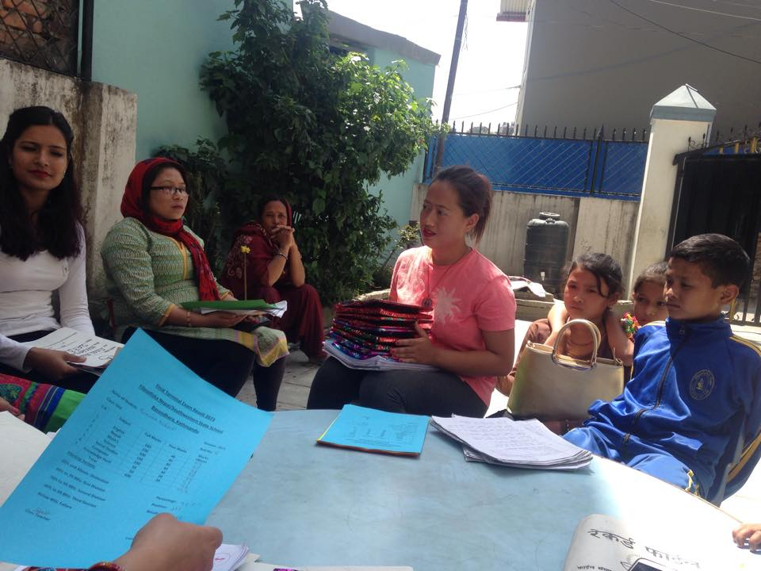
Parents participate in final terminal Exam result distribution 2017.

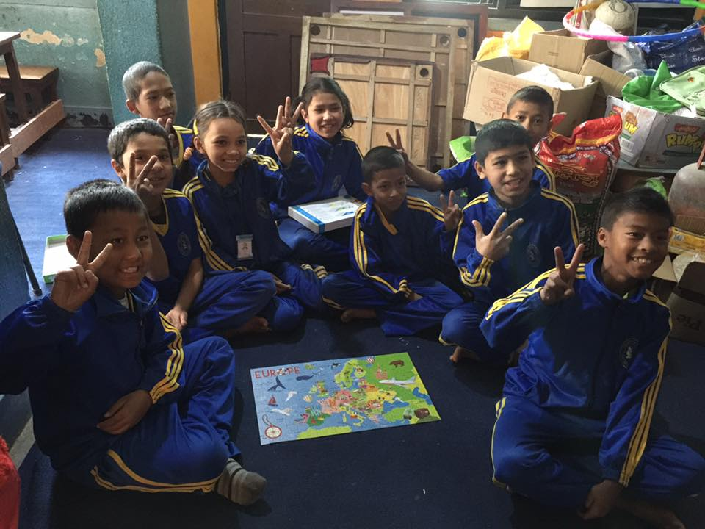
Children were happy when they make Europe puzzle by themselves.
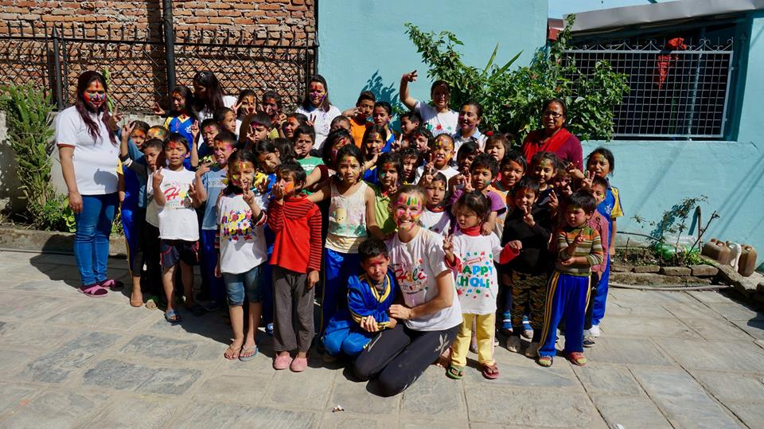
Children celebrate holi 2017 with Sara.
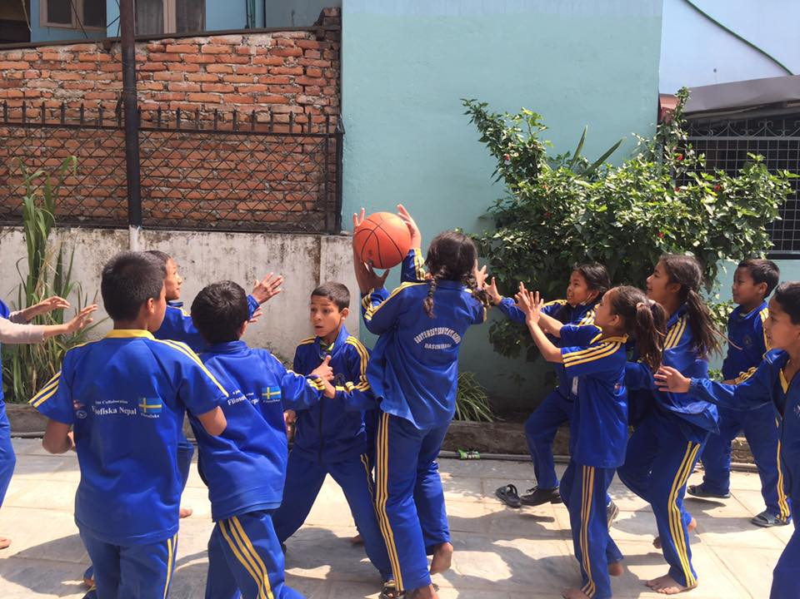

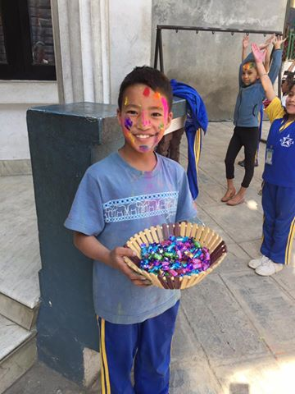
Dinesh Thapa Magar celebrates his birthday in school with his friends.

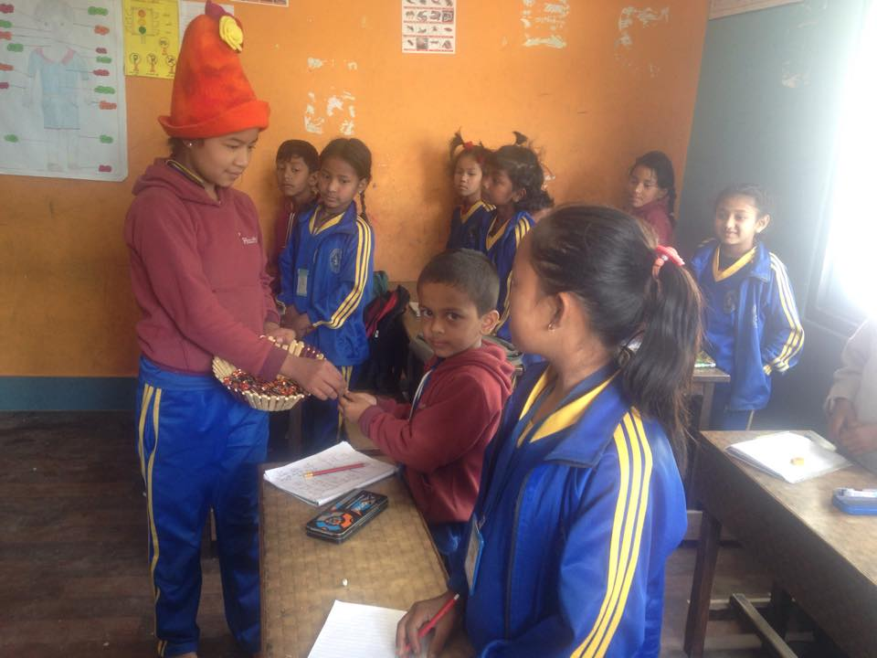
Kumari distributing sweets to her friends on her birthday.
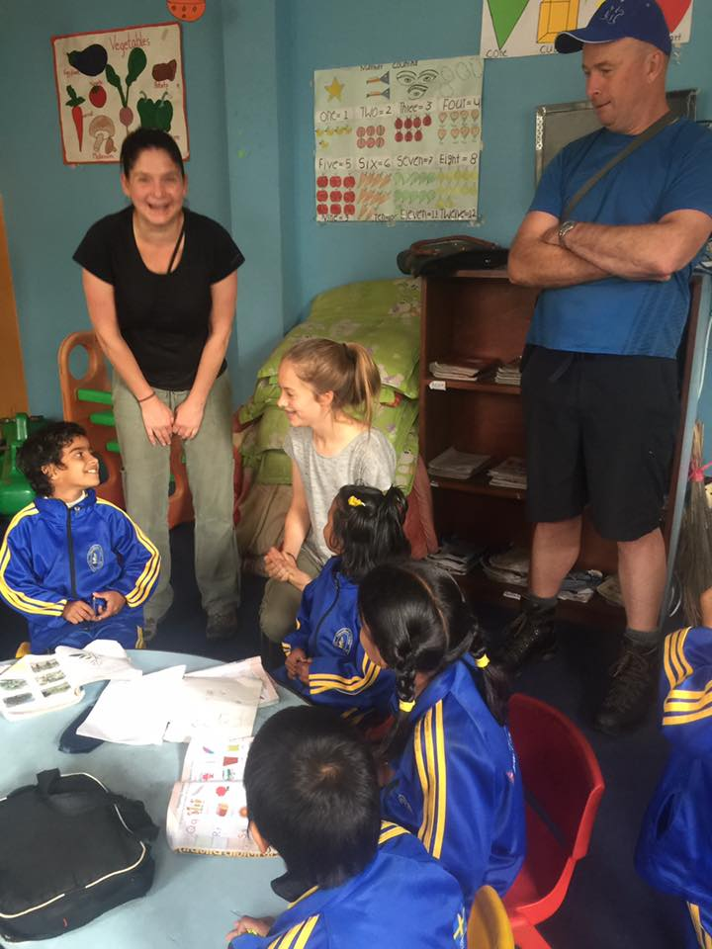
Thank you for your visit from Australai.

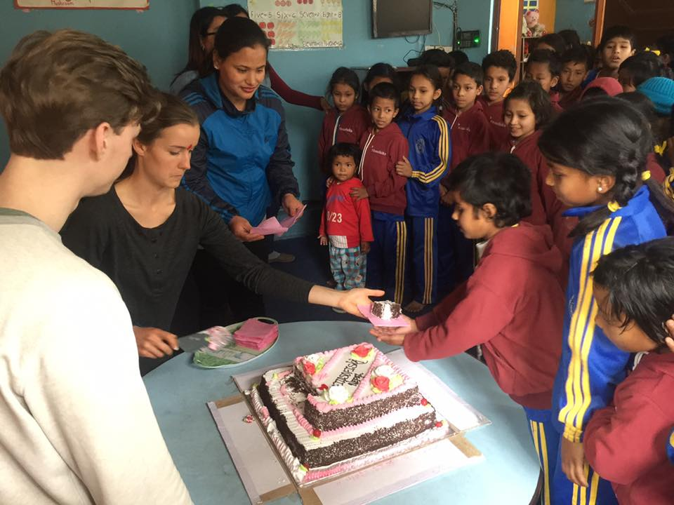
Farwell to Sara.
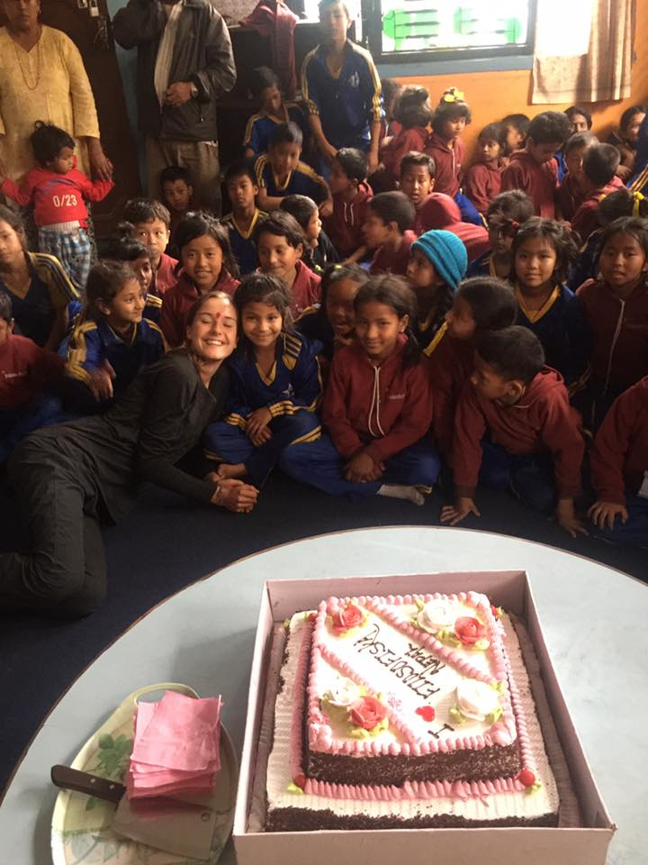
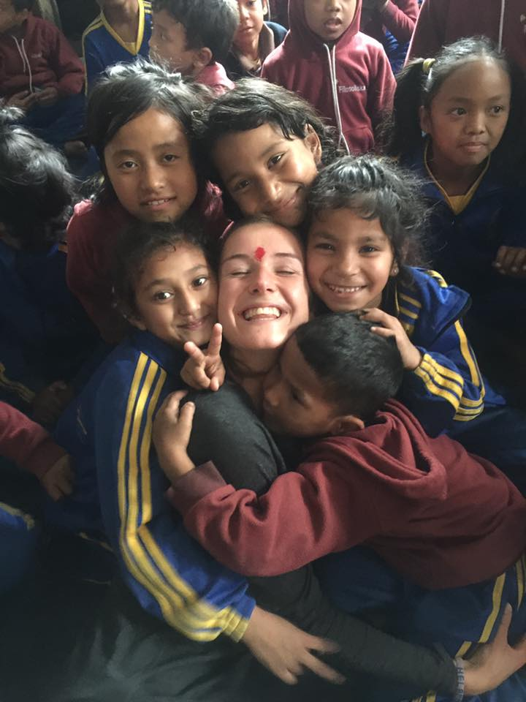
Thank you.

