Monthly Progress report of May 2017
As we know that the school progress report is an innovative tool designed to help us support, respond to, and improve our school activities. School progress report enables us to see whether we are meeting this standard and to track programs and growth of students. It puts the most emphasis on student growth, reflecting our focus on and commitment to ensuring that all of our students are learning.
Progress of the month:
This month we gave more focus on the new student’s behavior and study.
Special Programs:
- Quiz competition
- Buddha Jayanti celebration
- Indoor games
- Story writing and telling (English and Nepali)
- Paper tearing, cutting and pasting
- Classroom decoration
- Prepare birthday calendar of students and staffs.
Teacher’s performance Evaluation:
This month we had staff meeting. This time we talk about their personal hygiene and health. In summer most of the children were affected by diahorea, fever and eye infections. Because of hot days some of the girls were fainted in the afternoon as well. So in meeting we discuss about how we can overcome the problems.
As a part of motivation to staffs from this year we provide them surprise birthday gift.

Photographs:
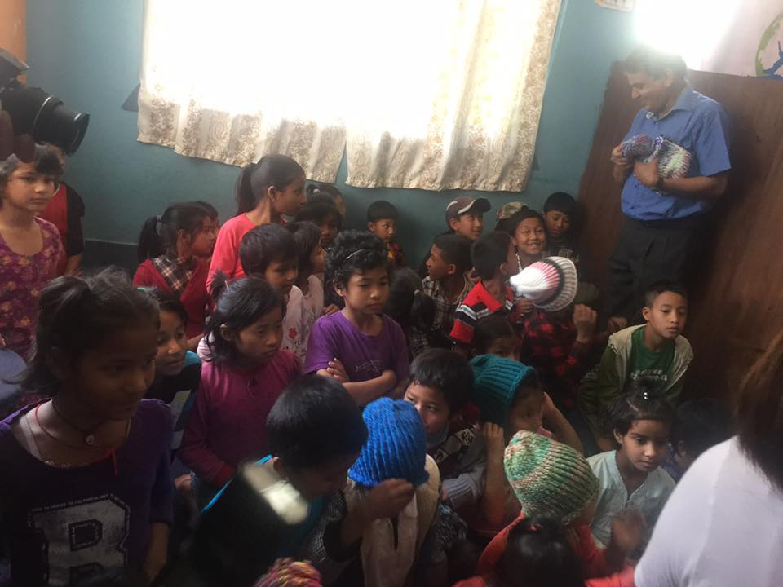
Mr.Laxman Khanal one of our board member distributing woolen hat for our students. All the hats were knit by one lady for our children.
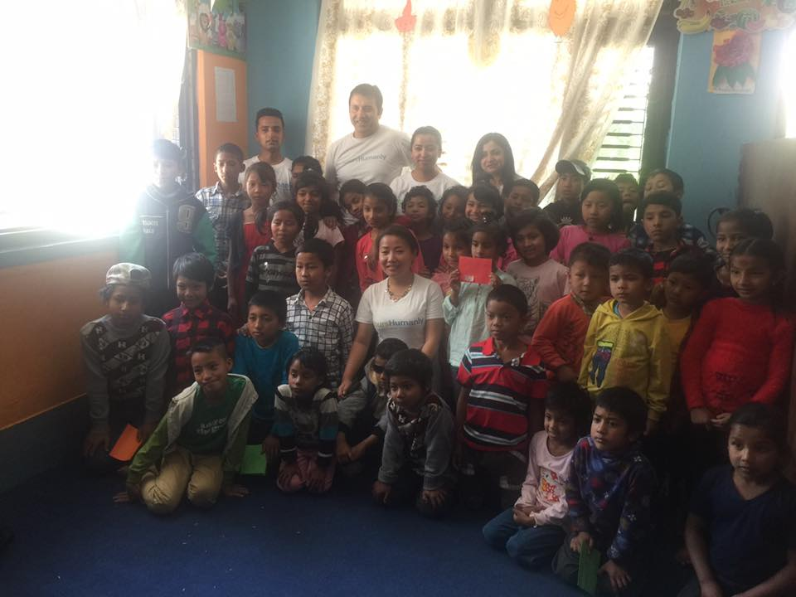
Yours Humanly team with students after distributing computers to our school.
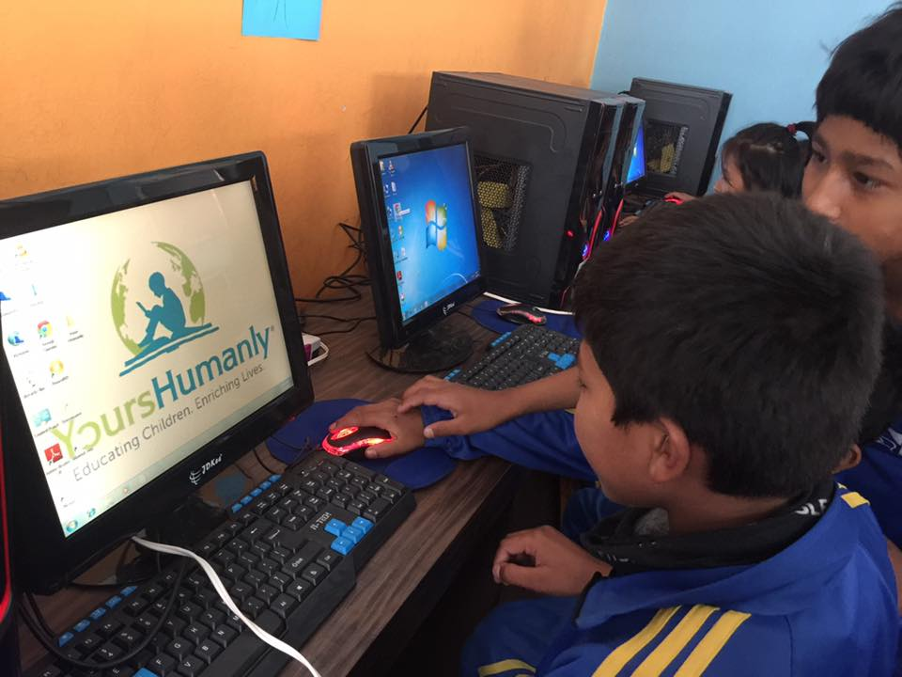
Children started to learn more about the computers.
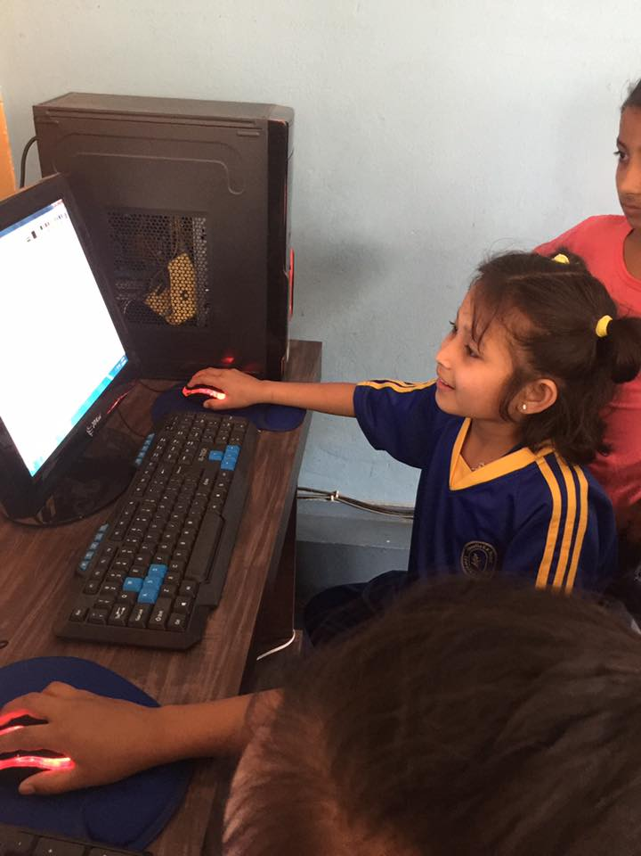
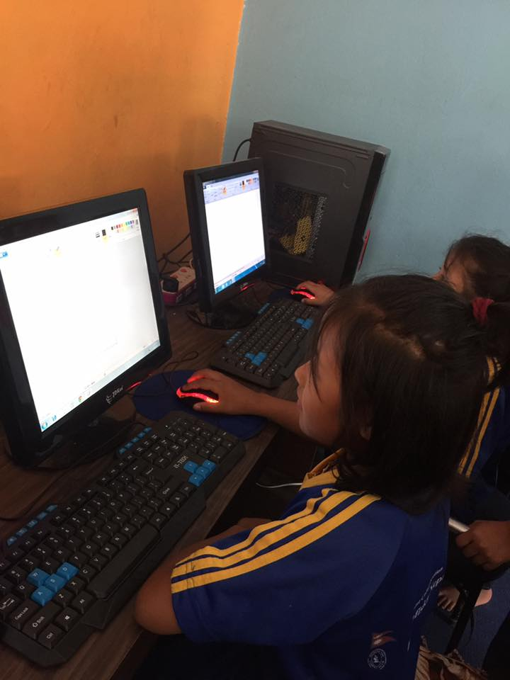
Conclusion:
We had a nice month filled with good studies and fun activities. More on that we got five computers to learn more and explore the world.

Thank you

