Monthly Progress Report of July and August 2017
July and August were the month where we create lots of memories together. In these months we had a home visit and had bond with family members which were amazing. Even though their situations is really hard they were so happy and living their life fullest. They welcome us with great enthusiasm and share their personal talk with us. In that point we feel that we are helping the right person for right cause. By analyzing their conditions we conclude that this is not enough we need to generate more funds to uplift their life and give them more happiness they deserve.
Vibeka Andrea Sefland works from United Nation from Norway visit our school and spend quality time with children. She is hard working and loves to be with children. Children also like her company. This is her second visit in school before she came with her two boys and boyfriend. She visits to Filosofiska Girls hostel as well.
Special Programs:
- Home visit and Hostel visit: We need to analyze the situation on regular basis. It was just regular visit. We had very good bond with parents and care taker in hostel so that we will be update about the situation.
- Friendship Day: We celebrate friendship day on first Sunday of August. On this special day we share chocolate with each other and had lunch together. We made big hand printed collage to show our bond and caring for each other. We paste that collage on the corridor so that we can see it every day when we are in school.
- Teacher’s Day: Teacher’s Day is celebrate as a mark of tribute to the contribution made by teachers to the society. We believe in “teaching is not a profession, a way of life”. A teacher is a friend, philosopher and guide who holds our hand, opens our mind and touches our heart. In Filosofiska Nepal, we celebrate teachers day to say thank you for the contribution they made in children life. Teaching is most influential job in the world. Teacher impacts good value in children and turn them into responsible citizens.
- Teej Celebrations: Teej festival is celebrated by hindu women throughout the country. Teej is social, religious and cultural festival in Nepal. Women as well as children enjoy teej festival by dancing and singing songs at home, temples and public places nearby. In school we had teej feast and we dance and lots of fun.
- First parents meeting and Result distribution:
We had first parents meeting of this year. All the parents came to collect results. Children did their best in exam still they need to progress a lot.
- Mehandi Art: Mehandi is popular form of body art among hindu. It was used mostly to decorate women’s palm. On special day in Nepal we apply mehandi in our palm for both girl and boy. Some children created their own design and some explains to teacher and make design on palm.
Birthday of students:
- Chandani Shah from Grade one.
Birthday of Staffs:
- Gauri Shrestha
- Ulina Thapa
- Sanju K.C
- Sushma Luitel
Teachers performance Evaluation:
A teacher is a person who helps others to acquire knowledge, competences or values. In Filosofiska Nepal teachers works hard for their children future. On regular basis we have staff meeting to overcome our weakness and strengthen our strength. We always work as team not as single person.
Photographs:
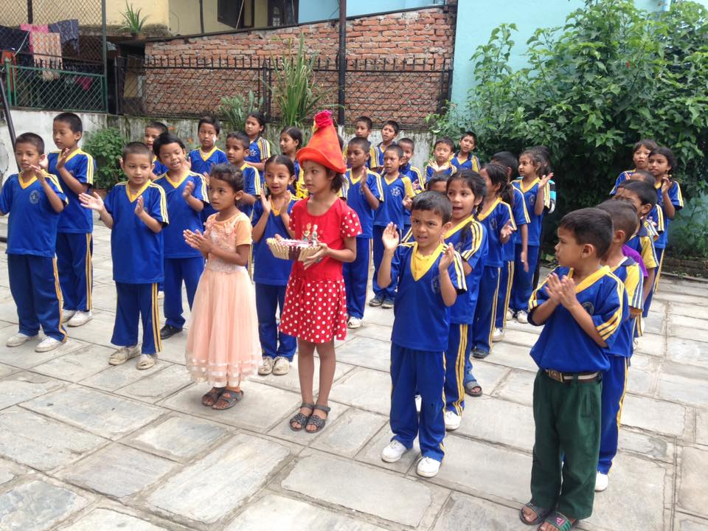

Chandani Shah celebrates her birthday with her friends from school.
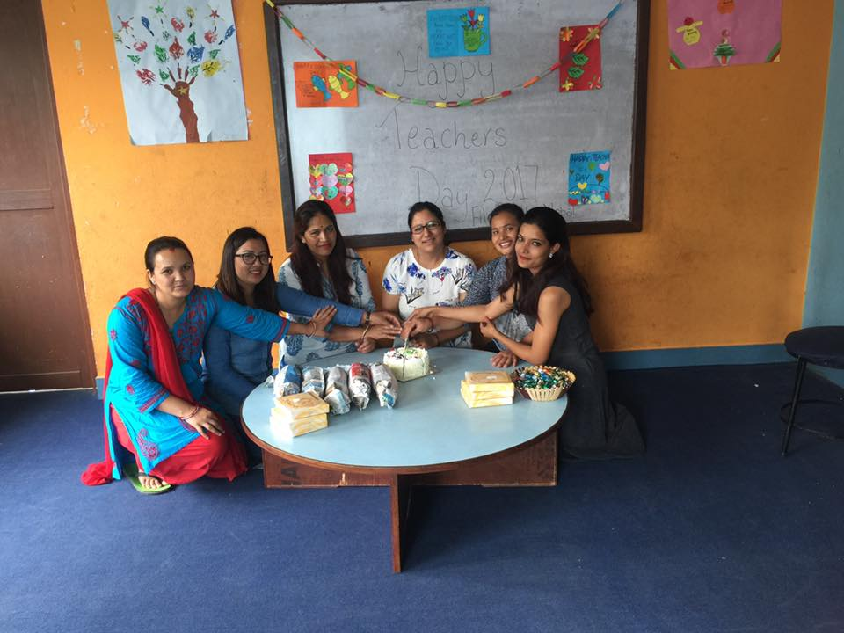
Teachers of Filosofiska Nepal Celebrates teacher’s day.
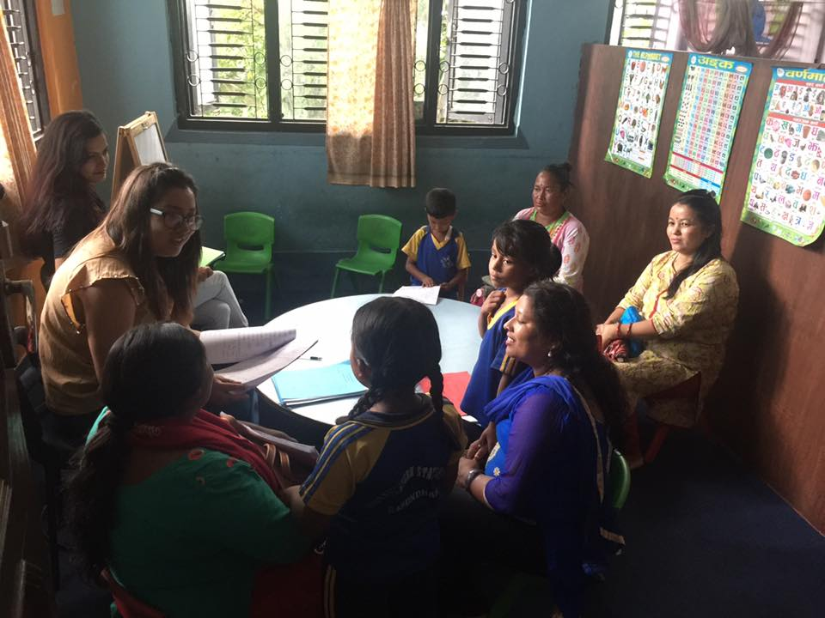
Parents and teachers interaction program on First Parent meeting.
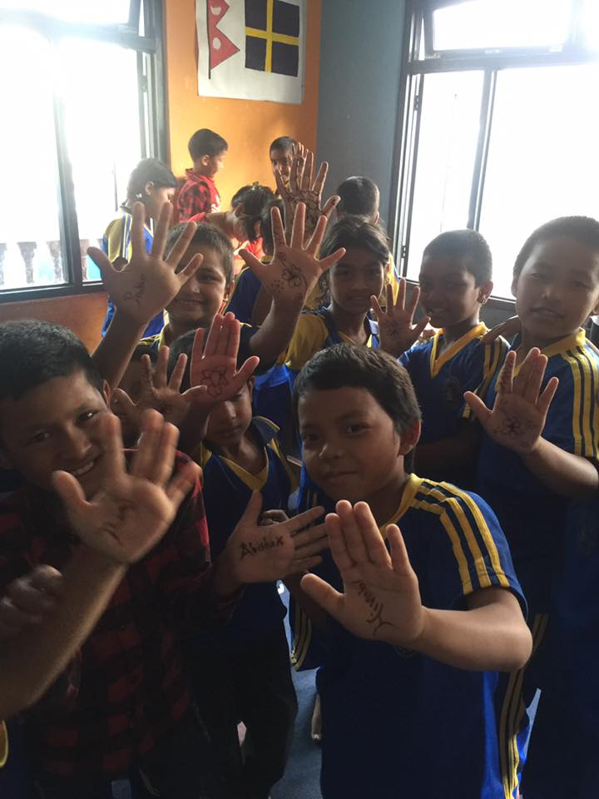
Henna art on their palm.
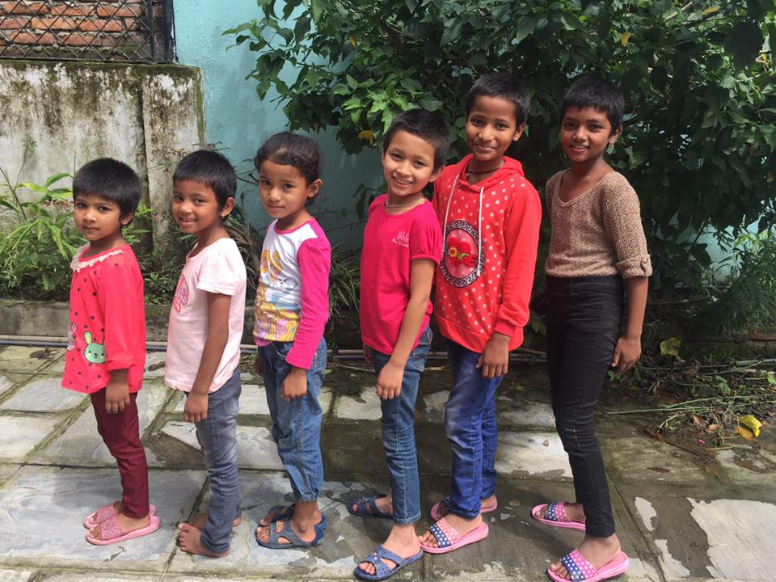
Teej program celebrations.

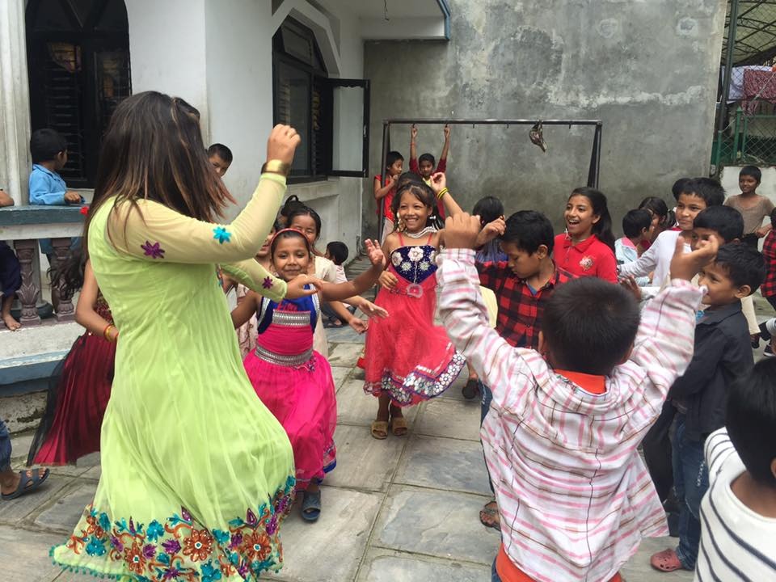
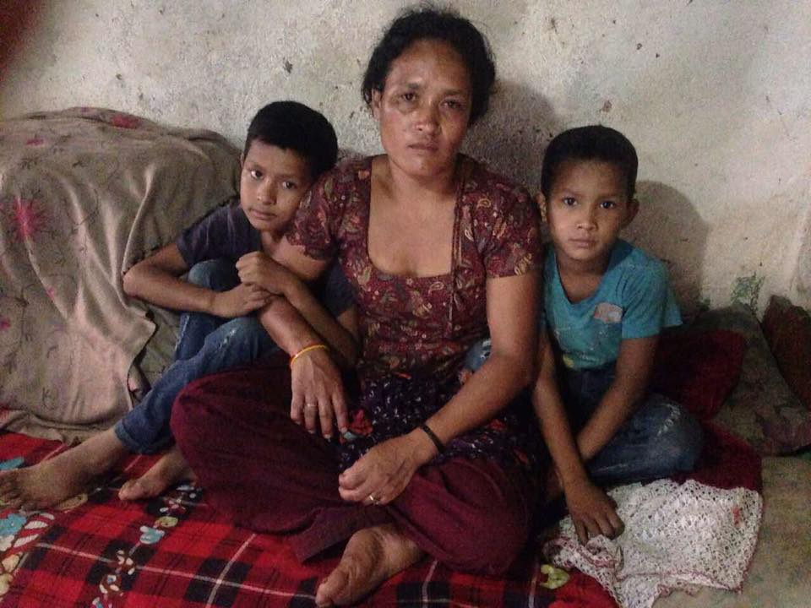
Home visit: Our students with their parents.
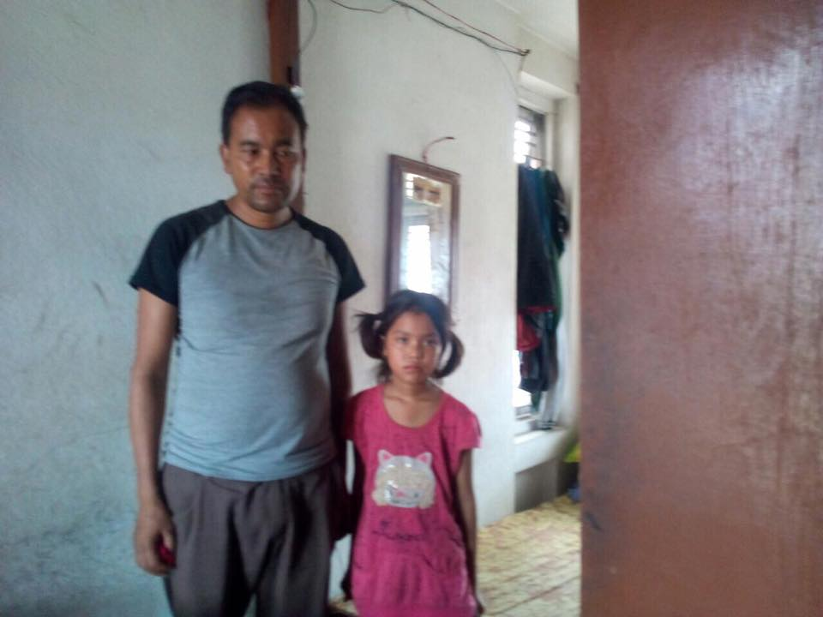
Thank You for your kind support.

