Monthly Progress Report of September 2017
Goodbye AUGUST and Hello Autumn. This month the climate is very pleasant. Our big festival is celebrated in this month.
Welcome to the month of September monthly progress report of our beautiful children, who were really kind hearted.|
Special Days in Filosofiska Nepal:
Father’s Day:
On the month of September we celebrate father’s day in Filosofiska Nepal. Father’s day is celebrated honoring father and celebrating fatherhood, paternal bonds and the influence of father in society. For the children of Filosofiska Nepal they came from different background. Some of them have father and some of them are from street while some of them are from even worse conditions. But while celebrating father’s day at school all participate in the program with very enthusiasm. Those who have father they want to celebrate this day with their father because of lots of situation they cannot celebrate together. Those who don’t have father remember their father and wish them wherever be they are they will be happy. All the children with the help of teacher make nice and beautiful card for father.
Children’s Day:
Children’s day or bal diwas is celebrated on Bhadra 29 or September 14th according to the nepali calendar after signing the child rights agreement with UN earlier during the children’s day on bhadra 4th on the birthday of His majesty Queen mother Ratna Rajya Laxmi Devi Shah. It is celebrates by conducting various programs on various institutions around Nepal.
According to survey, the population of children below 18 years of age is 12.2 million which around 48% of population. Every week 2000 children or every day children lose their lives due to the country’s indifference towards them. Out of 3.6 million children less than five years of age-62% don’t have access to basic health services. Every year 39% children don’t get to finish primary education.
On this special day we did face painting. Children choose design from the booklet and had face painting of their choice. Some had ice-cream, flowers, fish, ladybug, rainbow, butterfly, rocket, honey bee, heart shape, snow white, help kitty and many more. Then in afternoon we had small picnic to our near place. They really had fresh air, they ran from here to there and they play hide and seek. After some time they had picnic. The school provide them food and juice. After spending some time we came back to school. All the teacher and staff wishes children a very Happy children’s Day and we distribute them sweets.
On one fine afternoon we had a treat from Southwesten State college canteen. As in Nepal almost all of people like momo (dumplings) our children also like momo so canteen provide momo to the children. They were happy and enjoy the momo. Filosofiska Nepal is thankful for Southwestern State college canteen.
Dashain:
Dashain is the longest and the most auspicious festival in the Nepalese annual calendar, celebrated by Nepalese of all caste and creed thought out the country. The fifteen days of celebration occurs during the bright lunar fortnight ending on the day of the full moon. In preparation for dashain every home is cleaned and beautifully decorated, painted as an invitation to the mother goddess so that she may visit and less the house with good fortune. During this time the reunion of distant and nearby relations occurs in every household.
Our children also celebrate dashain festival with their family and relatives. Some of them stay here in Kathmandu while others visit their family members in village. In a year this is a time when all family members meet together and enjoy festival. The children who stays in hostel were also visit their family members. In school we celebrate dashain festival before our holiday. Children were provided food; we put tika and jamara as blessings in their forehead.
Photographs:
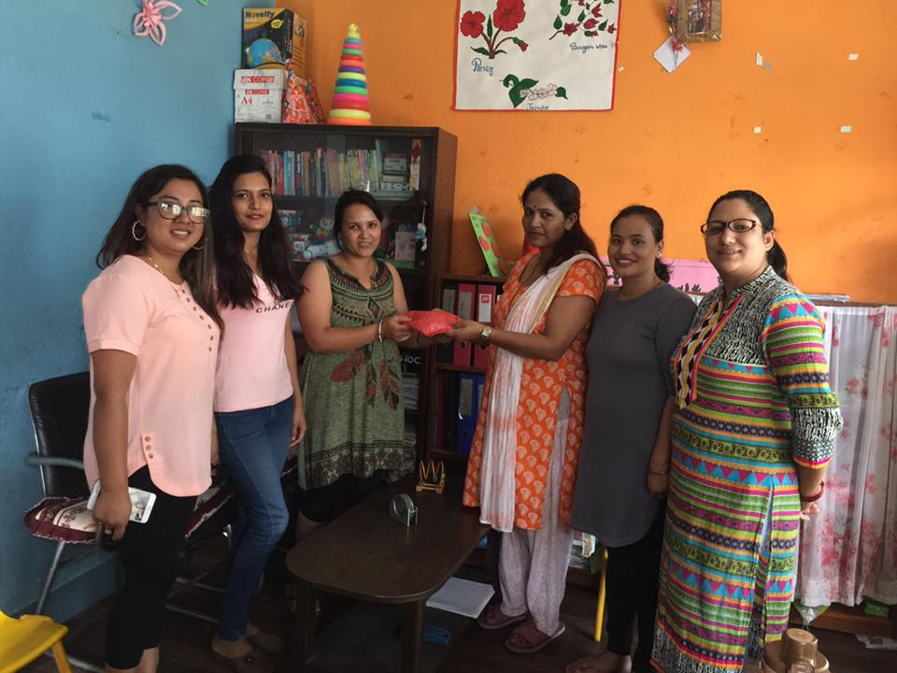

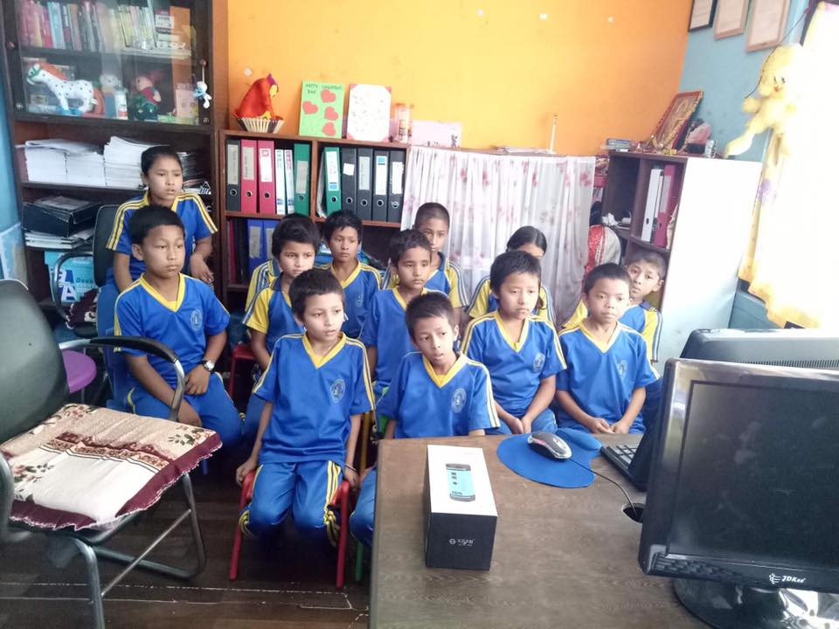
Children having fun while watching Cinderella cartoon on Friday.
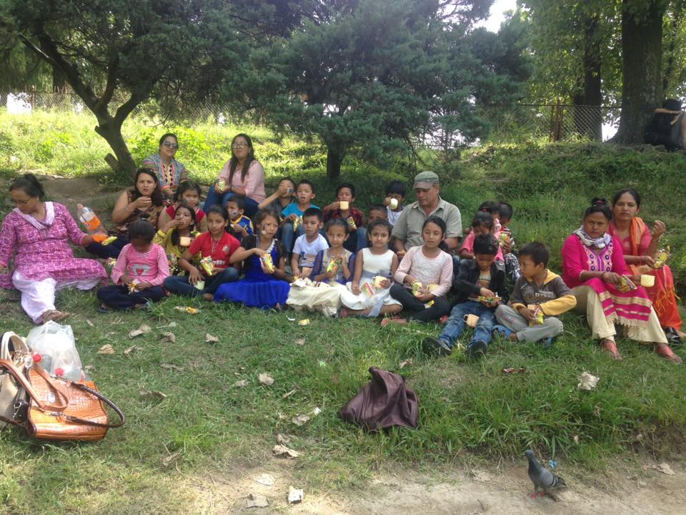
Children enjoying their snacks at Shanka park on children’s day.
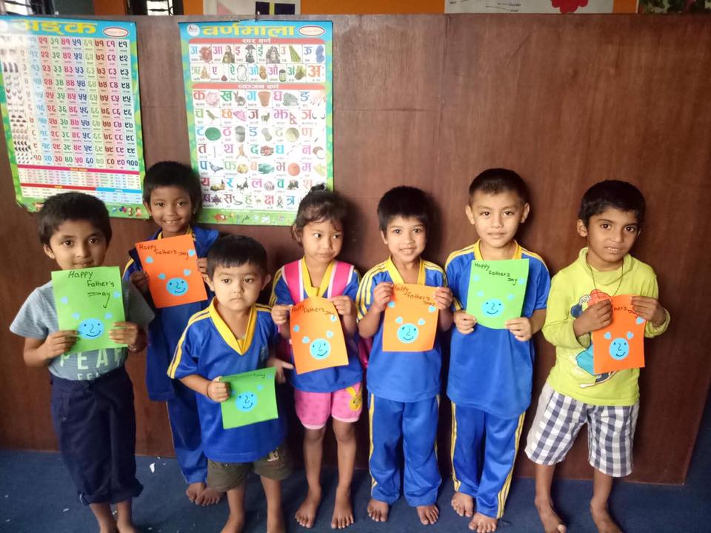
Children made nice and beautiful card for their father on father’s Day.

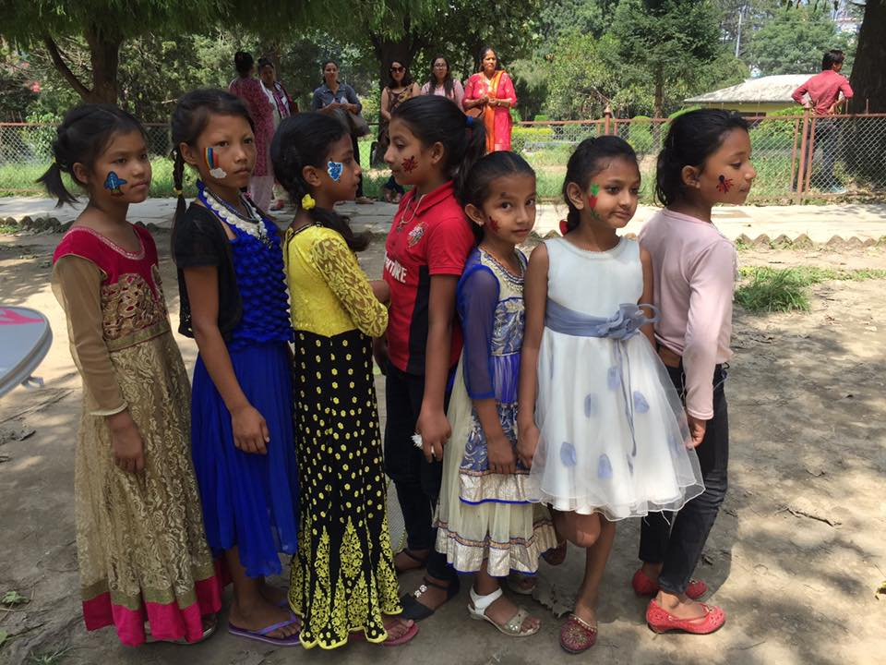

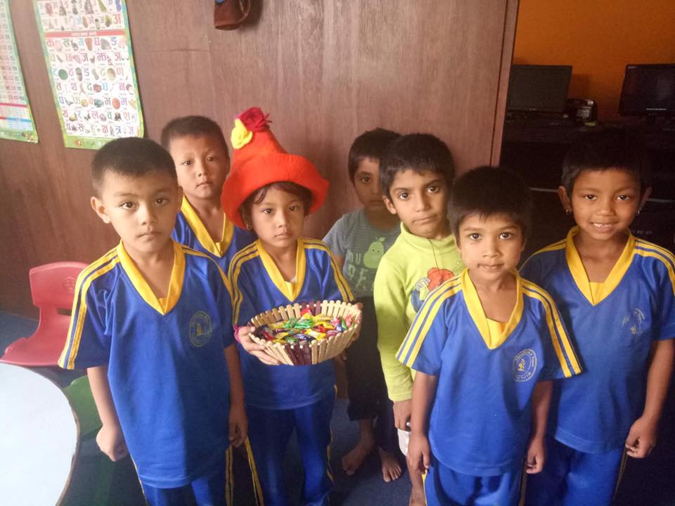

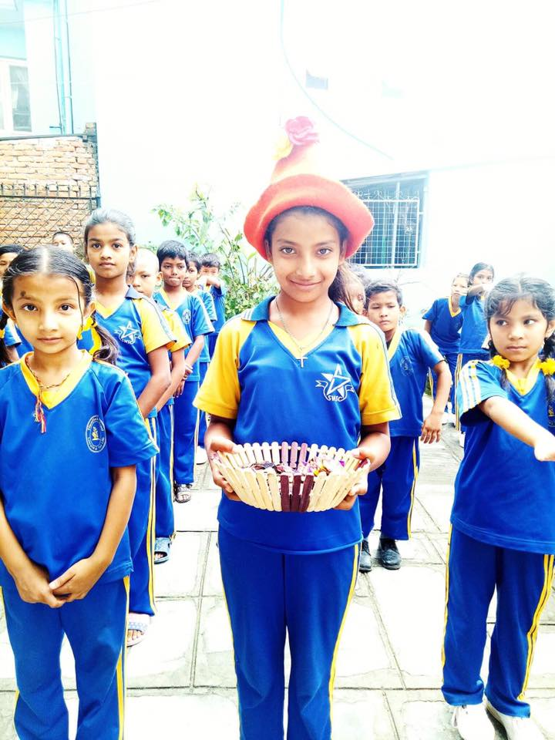

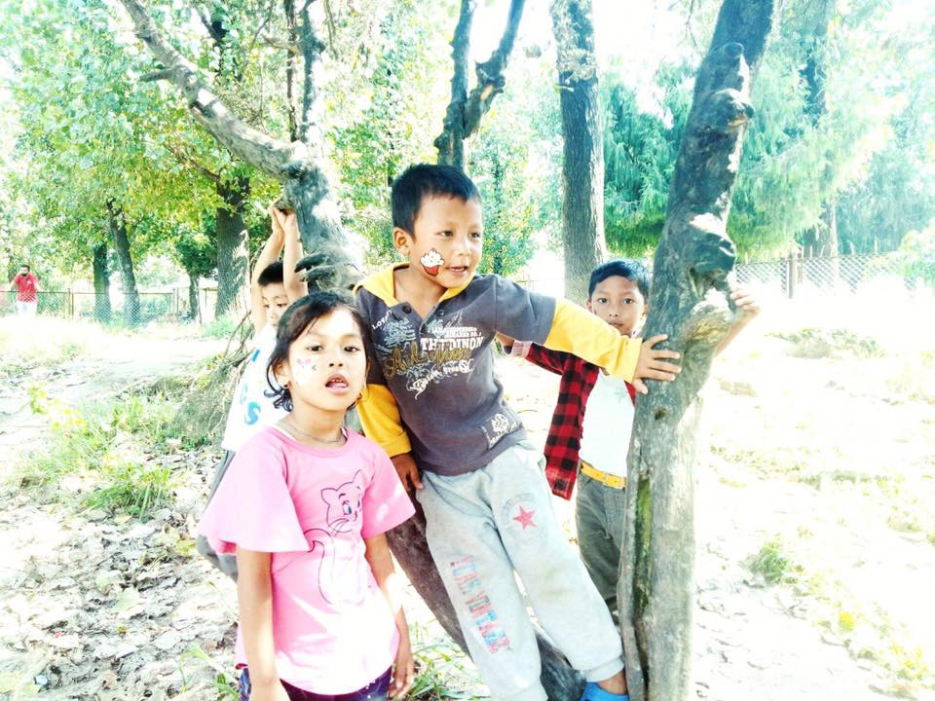

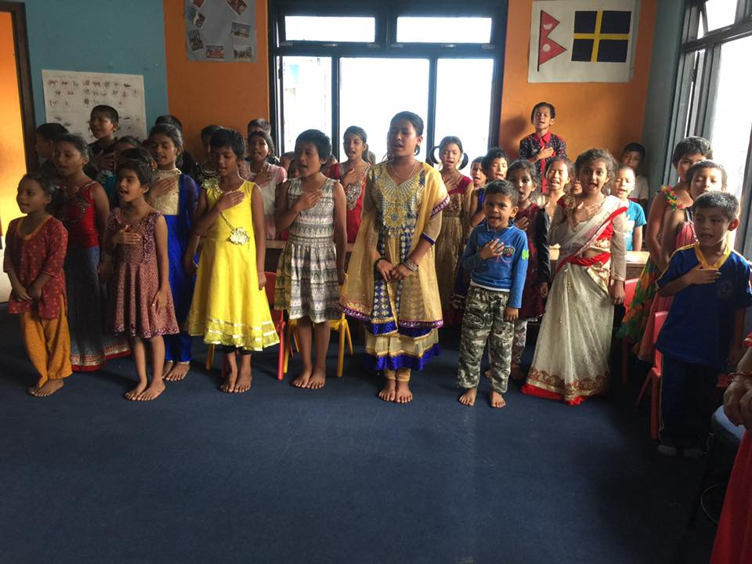

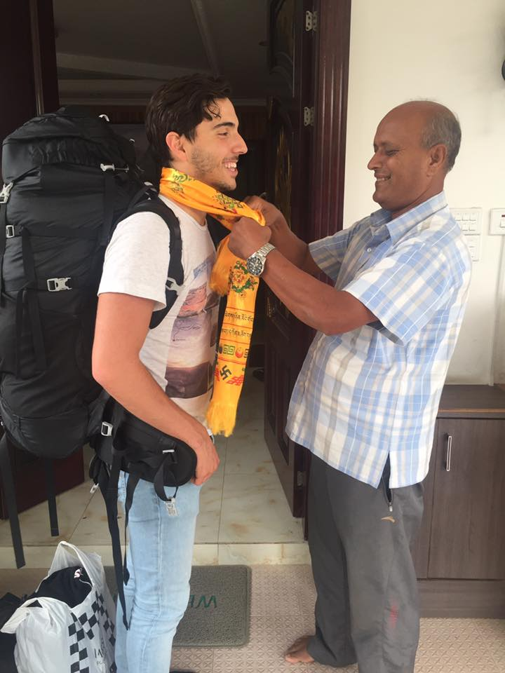

Thank you.

