Monthly Progress Report of October 2017

This month we welcome season of autumn. As we celebrate our biggest festival Dashain we were close from 21st September to 7th October. Again we had school for few days and we were close from 17th to 22nd October to celebrate our second festival Tihar or Deepwali. So on the month of October we did few things only. As Adam from Sweden is with us children spend most of the time with him.
Tihar:
Tihar is most celebrated festival after Dashain in Nepal. It is a five day festival celebrated in late autumn. It has its unique ways of celebrations. The festival is celebrated for five days each day has its own importance.
In Filosofiska Nepal we always celebrate our festival to teach our children about the tradition and culture. They are from different background but they follow same tradition. All the staffs and children celebrate the festival in enthusiastic way. Before our holiday start we celebrate Deepwali the festival of lights in our school. Children perform dance and sang beautiful song. Then children and staffs made beautiful rangoli.
Halloween:
This year Halloween falls on a Tuesday. The eve of the western Christian feast of All Halloween’s day, also known as All Saint’s Day. The evening before was known as All Hallows Eve, and later Halloween. Over time, Halloween evolved into a day of activities like trick-or-treating and carving jack-o-lanterns. Around the world, as days grow shorter and nights get colder, people continue to usher in the season with gatherings, costumes and sweet treats. In school also we paint our face with different character and we learn about the Halloween. Children get chocolate and sweets as treat.
Teacher performance Evaluation:
This month we had staff meeting where we discuss about the performance of the students in classroom. And the more focus is given on their behavioral with their teacher and friends. They came from different background so we conclude that some of them need more counseling and love care from school as well as parents. Children need to explore and let them grow. We need to support them to take responsibilities when they are ready. They need to follow certain rules and regulations of school. School days are long and tiring for children so this time we came up with certain plans to make them interesting in classroom activities.
Children came to school calm, relaxed, fed and ready. The morning time is the best time for children to learn. In Filosofiska Nepal we plan to utilize that time in maximum way.
We believe that if we groom teacher and staff then they provide best of them to school so sometimes we provide them birthday gift and sometime we treat them with good food.
Performance of students:
This month students had lots of fun. They celebrate festival with lots of passion and enthusiasm. They really enjoy the company of Adam who is volunteer from Sweden for almost three months.

Photographs
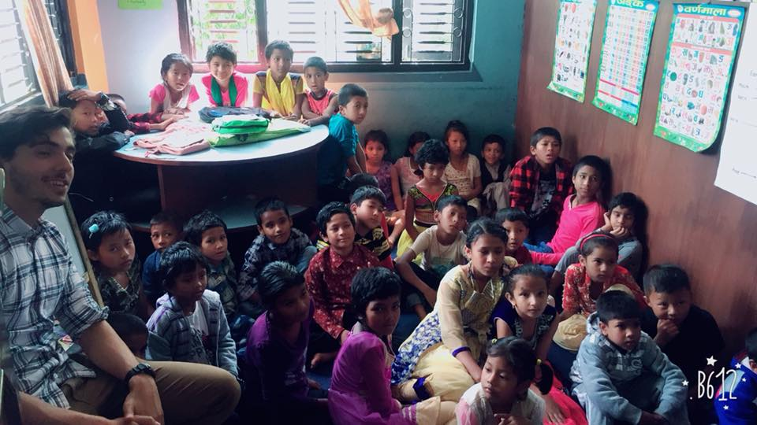

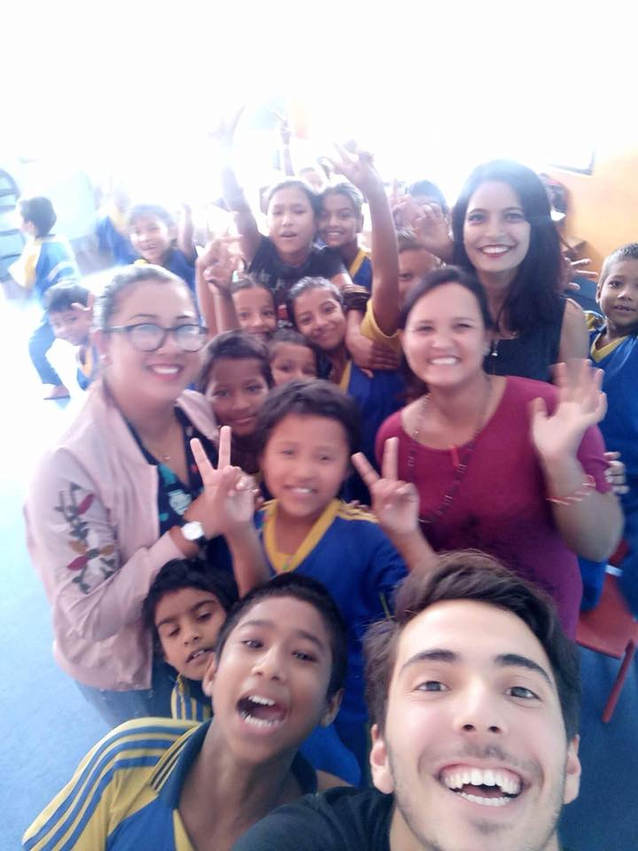
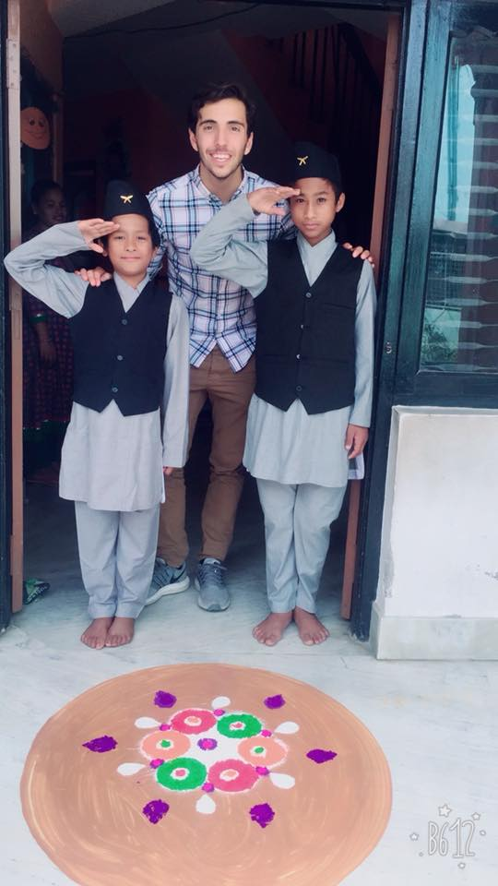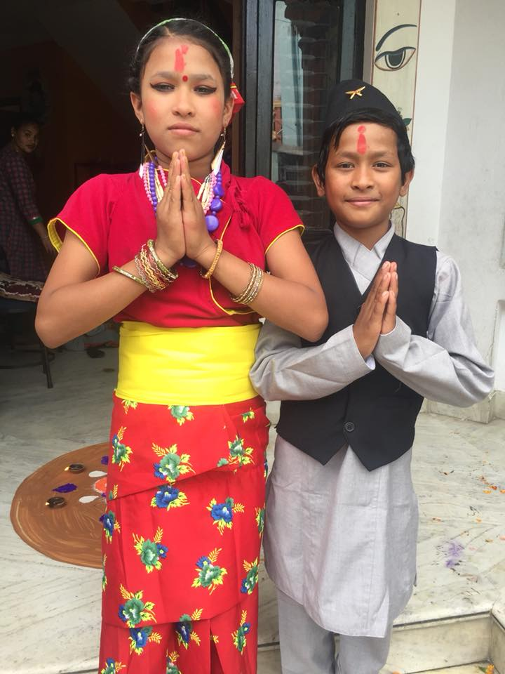
Thank you for your continuous support.

