Monthly Progress Report of February and March 2018
In these two months we experience many different things in Filosofiska Nepal. In the month of February we spread love and care everywhere in school. We ask children to learn some beautiful phase and they present it such a beautiful way. Those phases are as follows:
“ i will take care of you if you feel down”
“We will have lunch together and we will share”
“ I will wait for you my friend and we will play together”
We teach them playground manners which is very important in school. Especially elder one is feeling responsible towards younger ones. Some of the playground manners they learn are as follows:
- Can I play with you?
- Excuse me let’s play turn wise.
- I am waiting for my turn.
- Watch out for the smaller kids
- Don’t throw sand or small piece of the stone
- Don’t point stick on people’s face
- Apologize for accidents and misdeeds
- Be kind to others
- Don’t force kids to share.
Children need to share the swings and monkey bar and to invite others to play with them. Young kids need to learn that pushing, pulling and bullying are not appropriate.

Special Programs:
- Valentine day
- Festival of color-Holi
- Central zoo visit
- Interaction program between two different school
- Parents Day
- Farewell program to Sushma
- Lunch at outdoor
Birthday Celebration:
On March 21st Bisistitha celebrate her birthday with our children. She brings lunch box and distribute to the children. She is a nurse in Om Hospital. Children had fun time with her.
On March 28th, Mr. Bichitra Magar police officer from Ranibari Police station celebrates his birthday with our children. He provides both lunch and snacks and lots of chocolate to our children. He came to visit us in his police uniform. At first children were afraid and did not want to go infornt of him. But after sometime they feel comfortable and sing and dance with police man.
Volunteer from Southwestern State college spend their 2OO hours with the children and helping teachers in their respective areas. The students are Ashmita K.C, Dipsa and Sushmita. They are doing their Bachelor in social work. They are hard working and always be there to help us.
Central Zoo Visit:
As a part of curriculum we took students of class UKG, LKG and Nursery to Central zoo. They read about wild animal, domestic animal, different birds and water animals. They were always curious about seeing animals. So on March 3rd we took them to zoo, which is located on jawalkhel, patan. It is managed by National Trust for Nature Conservation (NTNC). There are so many species of animals. We watch almost 108 species and 708 animals and birds altogether. After observing we had picnic under picnic shed. Children enjoy their lunch with their friends. Then, children play in children park where they play swing, funny temple, merry go round, Uranus etc. The most exciting part is when they saw big elephant walk freely on the park.
Interaction Program between Filosofiska Nepal and Kasthamandap Vidhalaya:
On March 13th, Kasthamandap Vidhalaya brings their grade one students in Filosofiska Nepal. Kathamandap Vidhalaya seeks to provide students a congenial and positive yet challenging environment that will support their all round developmental needs and help children get in touch with their inner awareness. It is situated in Malikatar, which is nearby us. They spend almost two hour with our students. On that time they had interaction with the students of Filosofiska Nepal. They first introduce themselves with each other, share their interests and hobbies. They also bring handmade friendship card and some sweets. They play, sing and dance together. Children had great time. For next session they invite us to visit their school. The program went really well. Children get excited to meet their friends from different school.
First Parents Day :
This year we celebrate our first parent’s day which was organized in excellent way. Parents were very happy to see their children performing on the stage. Some of the children presents dance, some children sang a song, and some children perform drama and some children deliver dialogue which was mesmerizing.
Parents are active partners with the school to contribute to the student’s growth. We encourage parents to share their talents and interests with the children. Close communication is maintained between the school and home through regular contact on phone, home visit and meetings when necessary.
Parents teacher conference scheduled every team ensures aloes follow up students progress and mutual consultation.
On this special day we honor parents for the hard work they do for raising the next generation. This day people are encouraged to recognize the importance contributions of responsible, committed parents in their communities. Our children deliver a beautiful speech for their parents. Parents provide different kinds of feedback about parent’s day. They were very happy to see their children progress. They suggest us to continue to have parent’s day every year.
Farewell to Sushma:
On March 3rd we gave farewell to our teacher Sushma. She is associate with Filosofiska Nepal for almost four years. She is kind hearted, loving and hard working staff. She is close to children heart. Filosofiska Nepal wishes her bright future and success in every step of her life.
Lunch Program:
On March 19th the students of Golden Gate Hospitality College brings food, prepare by them and serve food for our children, which is different experience for our children. They are having lunch outdoor in beautiful weather. They have lunch in buffet system.
Photographs:
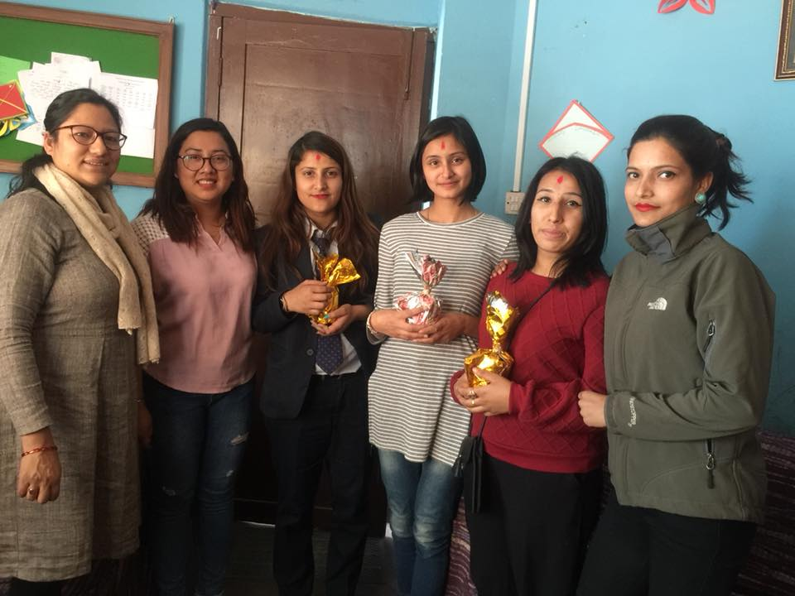
Goodbye to our volunteer from Southwestern State College.

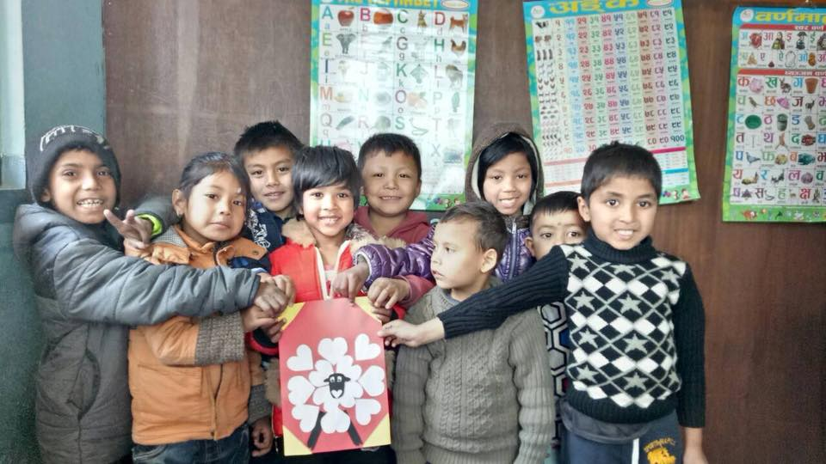
Happy valentine day from Filosofiska Nepal.
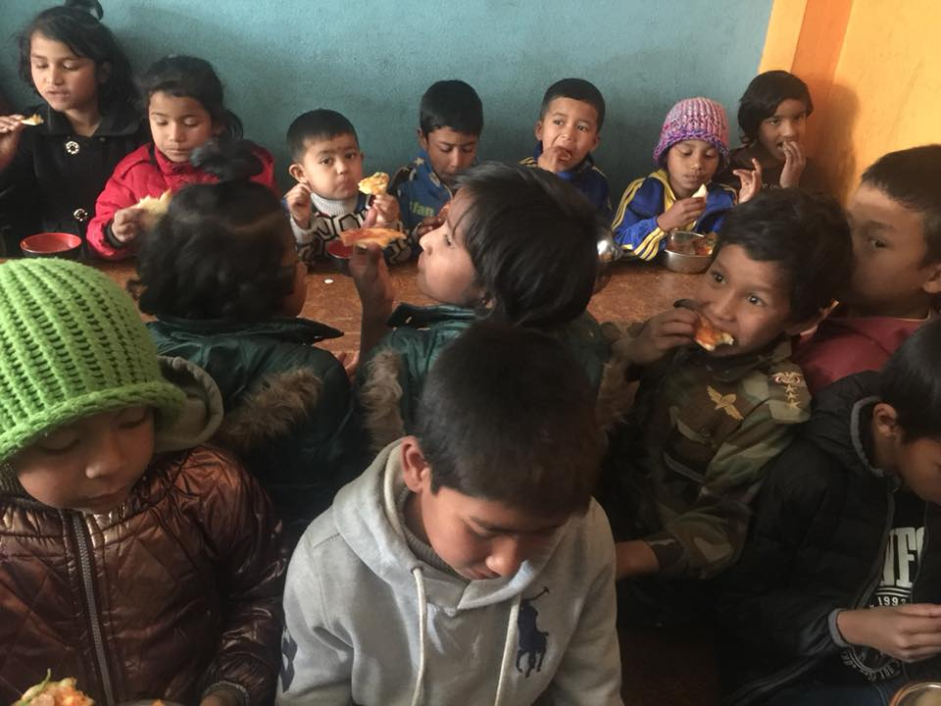
Thank you so much Aditya Sharma for providing us pizza for our snacks.

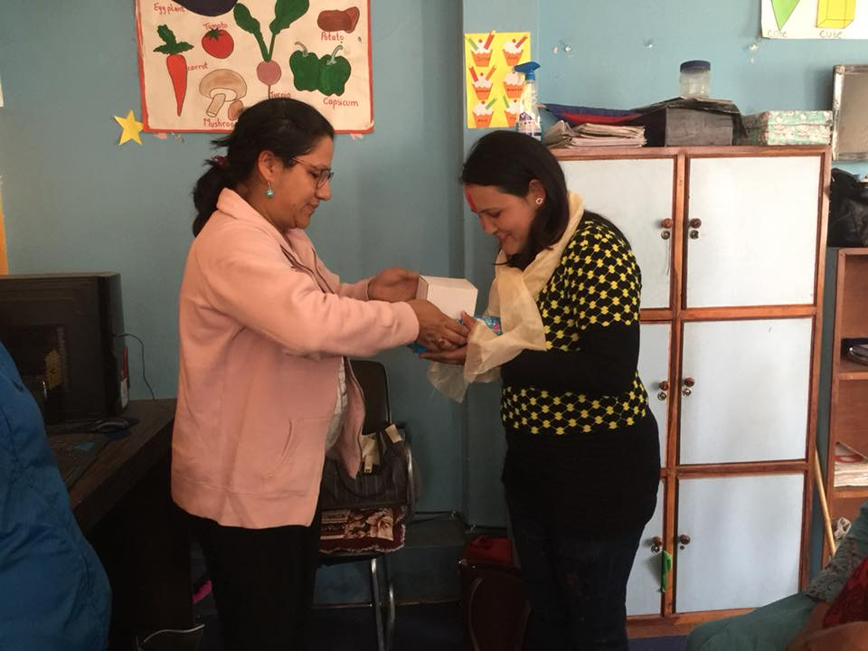
Farewell program of Sushma.
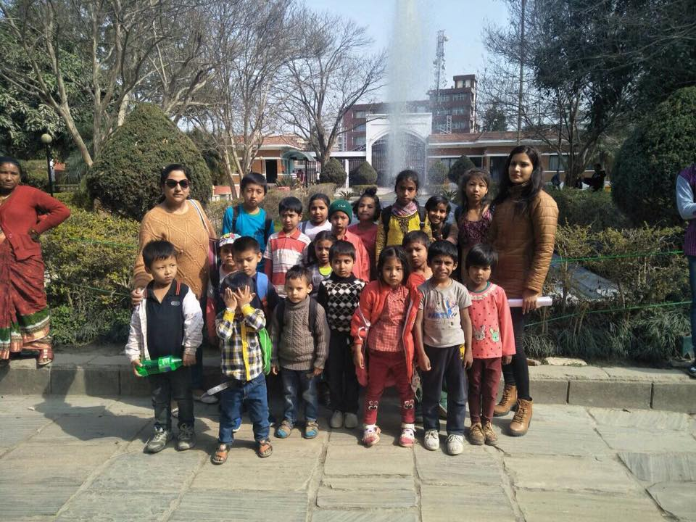
A visit to Central zoo by our preschoolers.

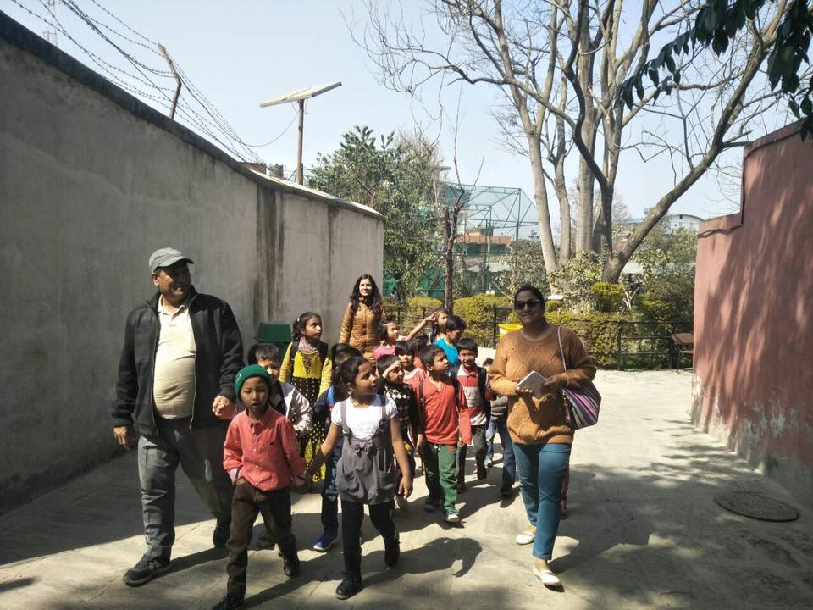
Children were excited to see wild animal, domestic animal and water animals.
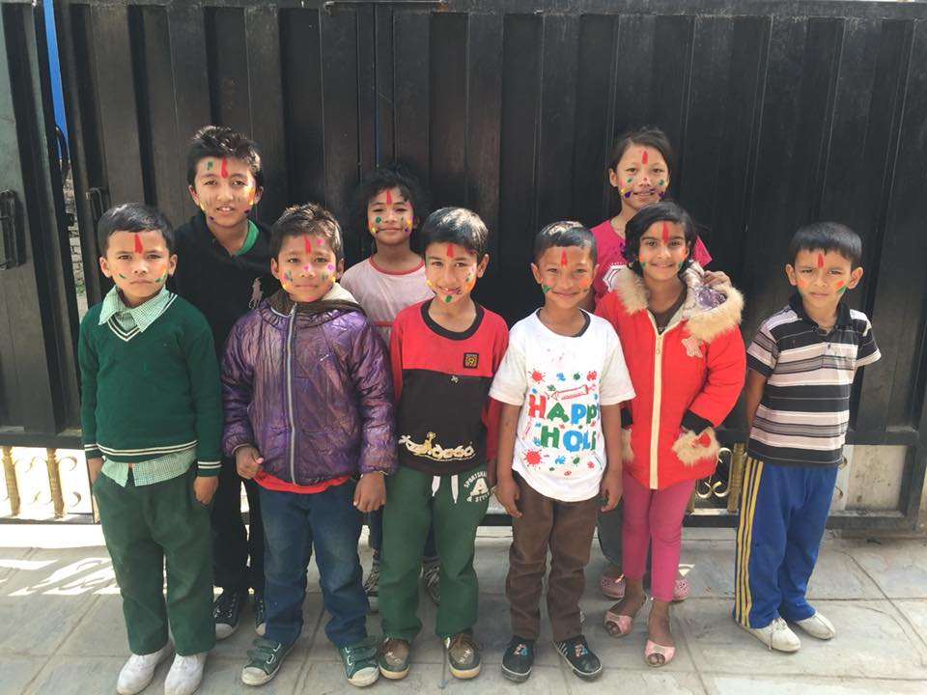
We celebrate festival of color in Filosofiska Nepal.

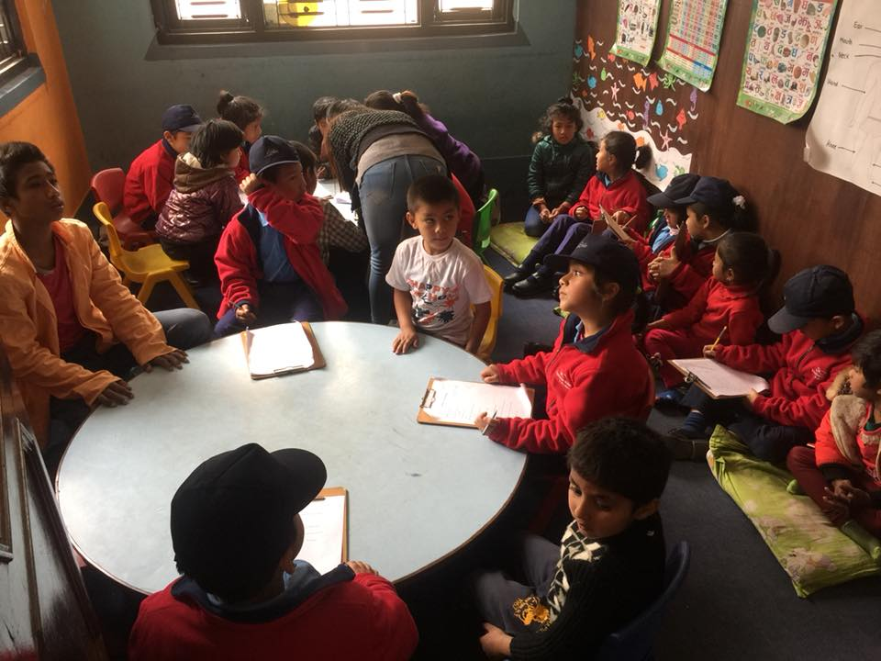
Interaction program between Filosofiska Nepal and Kasthamandap Vidhalaya.

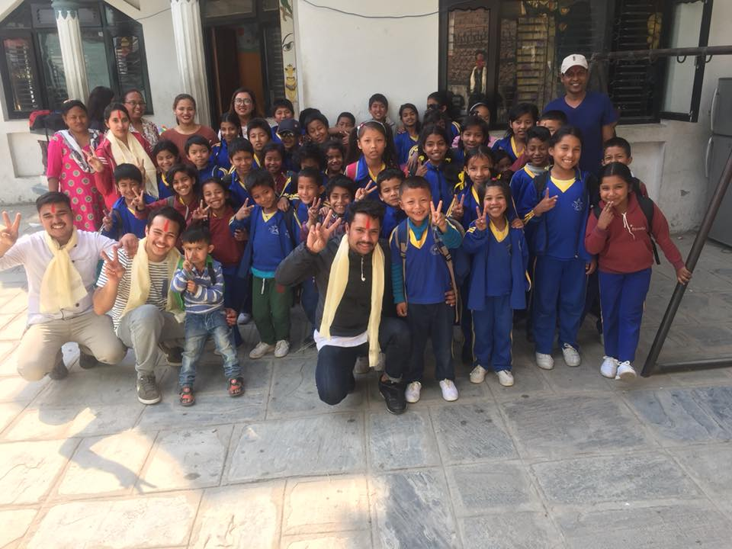

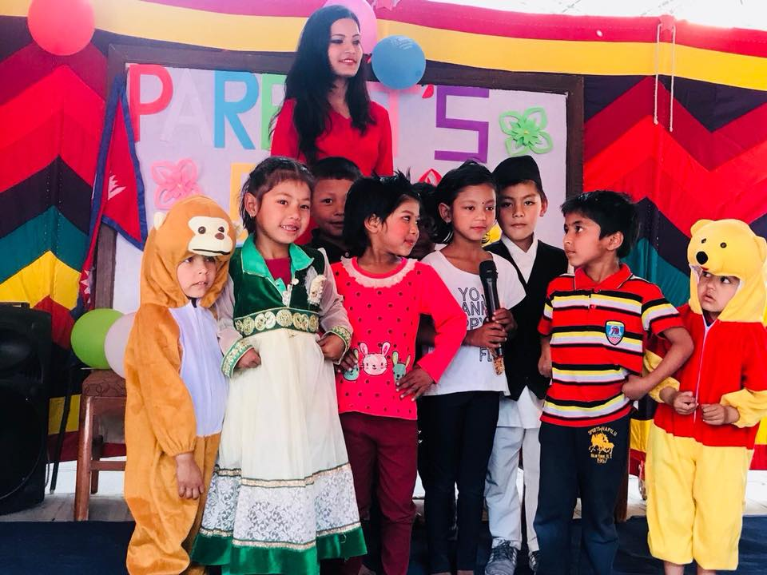
Our little philosopher performing on Parents Day 2018.
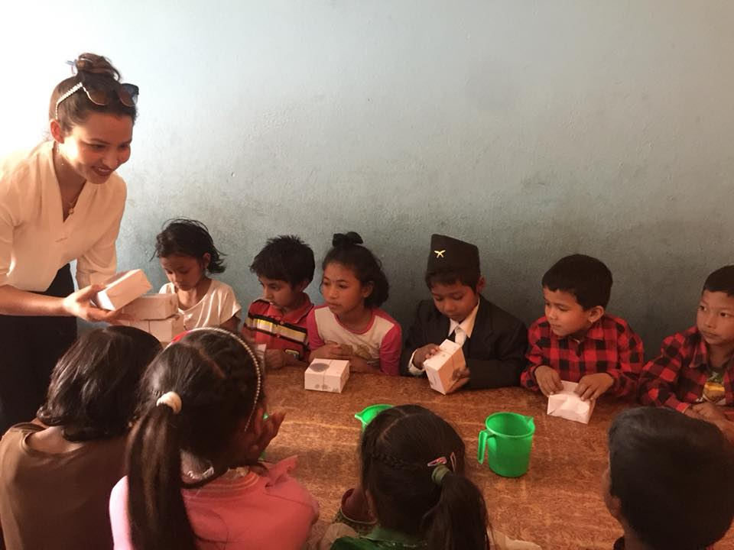
Birthday wishes for Bisistha from OM Hospital.
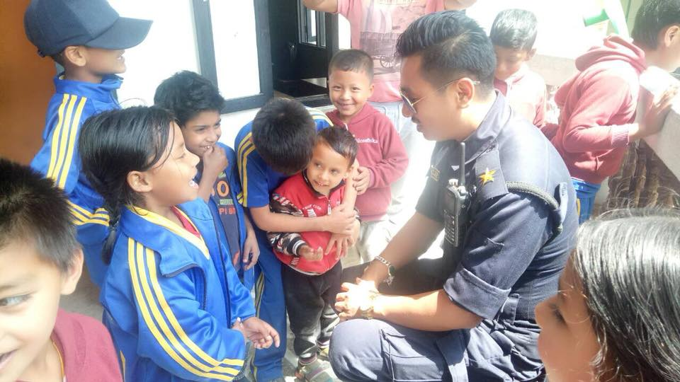
Birthday wishes for Bichitra magar Police Officer.
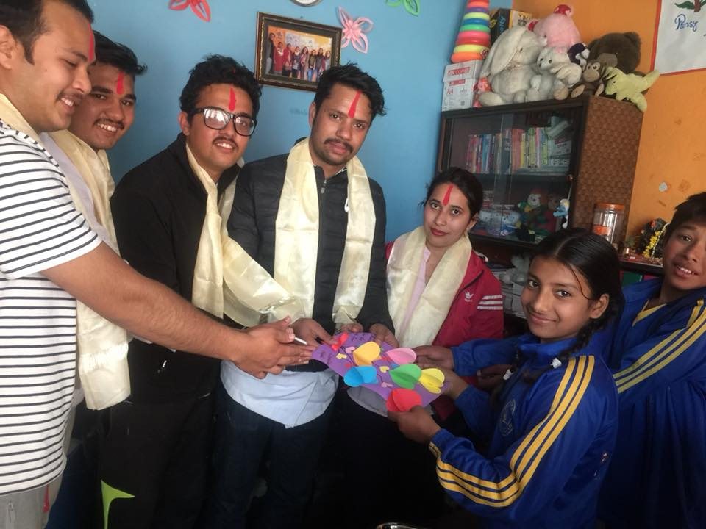
Thank you so much for providing us lunch.

