Monthly Progress Report of November 2017
November is fun filled month for the children. They engage in more activities and meet new people. This month children get closer to Adam. He spends maximum time with children. And children love his teaching and understand what he teaches in class. They have nice bond with each others.
In afternoon, we play machharina song and they perform really amazing. Children dance with full enthusiasm with Adam. Though they heard this song for first time they enjoy it fullest. They learn the new steps from Adam.
Our preschooler’s scrabbles kite paper and paste it on fruit shape. They paste in mango, apple and papaya shape. From this they learn about the shapes and colors. The children who did it nicely get gifts.
One fine day we clean our surroundings and classroom. All the staffs and children were involved in their work. With their team work they clean their classroom and decorate in beautiful way. We must say children had lots of enthusiasm.
On November 6th, grade four students visit to Adam’s place early morning. Adam shows them his house, room and beautiful garden. Children were really excited to visit Adam. They had sweets as a treat. They walk back to school with Adam.
On November 7th, as project our children write letter to children of Filosofiska Sweden. Grade one and two wrote letter about themselves, their favorite food, animal, person and many more. And interesting thing is that they draw very beautiful drawing for their friends who lives far away from them.
On November 8th we prepare newari dish for Adam to introduce about the multi culture cuisine. Food is very important part of the rituals and religious life of the Newars. The food items served to the guests during festivals and feasts have own symbolic significance. Different sets of rituals dishes are placed in a circle around the staple rice flakes to represent and honor different sets of deities depending on the festival or life cycle ceremony. Adam and all the staffs enjoy the newari dish which was prepared in school itself.
Adam visit to girls hostel and had fun filled time with the children. He loves to spend time with the children.
The most waited day of the year. Picnic to lakure bhanjyang. In picnic day we take our favorite meal taken outdoor ideally in scenic surroundings. Lakuri Bhangyang it’s a paradise located 13 kilometer up from the Gwarkho(Lalitpur). It is one of the most scenic spot in lalitpur district and is renowned for its spectacular sunrise can be seen much closed to the eyes. The visitors often travel lakuri to spend the night so that they can be there for the breath taking sunrise. The views of cities i.e Kathamndu, laitpur and Bhaktapur can be seen by sitting at lukari. So that Lakuri also offers a panoramic view of valley. Himalaya range at the same time mainly Lakuri is popular for the view, short treks, picnic spot etc. The environment i.e fresh air, cool water, forest, views and the cooperative local people which make the visitor to stay whole life at the Lakuri. Most of them define lakuri as heaven.
We wrote a letter to our friends who live far away from us that is in Sweden. Class one and two wrote letter to their friends of same age. While class three and four had face time with their friends. They talk about the name, age, favorite food, animals and many more. They sang a song and perform dance as well, which was amazing.
On November 16th 2017, we celebrate world philosophy day. Philosophy is an inspiring discipline as well as an everyday practice that can transform societies. By enabling us to discover the diversity of the intellectual currents in the world, philosophy stimulates intercultural dialogue. By awakening minds to the exercise of thinking and reasoned confrontation of opinions, philosophy helps to build tolerant, more respectful society. By celebrating world Philosophy day in Filosofiska Nepal we underline the enduring value of philosophy for the development of human thought, for each culture and for each individual. The main theme of World Philosophy Day is it belongs to everyone, everywhere, who cares about philosophy.

On 17th November 2017, we went to CG electrical showroom which is located in Minbhawan, Kathmandu. CG electronics, a division of Chaudhary group, has been the market leader in the country for the last 30 years in the electronics segment. They organize one day programs mainly focusing on the children. They welcome children by providing smiley batch to them. Then they have introduction session while children speak on the mike. After that children were provided change to look around the showroom and they can ask questions whatever they want. Our children asked so many questions some are relevant while some are funny. Children had snacks and they enjoy 3D movie name “The Jungle Book.”in big screen. After watching movie children had lunch and they provide gifts for all the children. At end we give them Thank you and goodbye speech. Overall children had fruitful day in CG showroom.
On 19th November 2017, we had visitor from Sweden. Karin and her two friends had short visit to Filosofiska Nepal. They spend some time with the child which was nice.
On 22nd November 2017, we had visitor from yours humanly team. This is their second visit. At this time yours humanly team Nepal also visit our school. Last time when they visit they provide us five computers. From those computers students were taking benefits.
Together with Adam we went to Narayanthan temple and Chabad House in Thamel. Narayanthan is Hindu temple while Chabad House is a secret place where Jewish people pray. Adam is Jewish and he explains many things about Jewish to our children. Children enjoy Jewish food as well. This day we had exchange of culture.

Photographs:
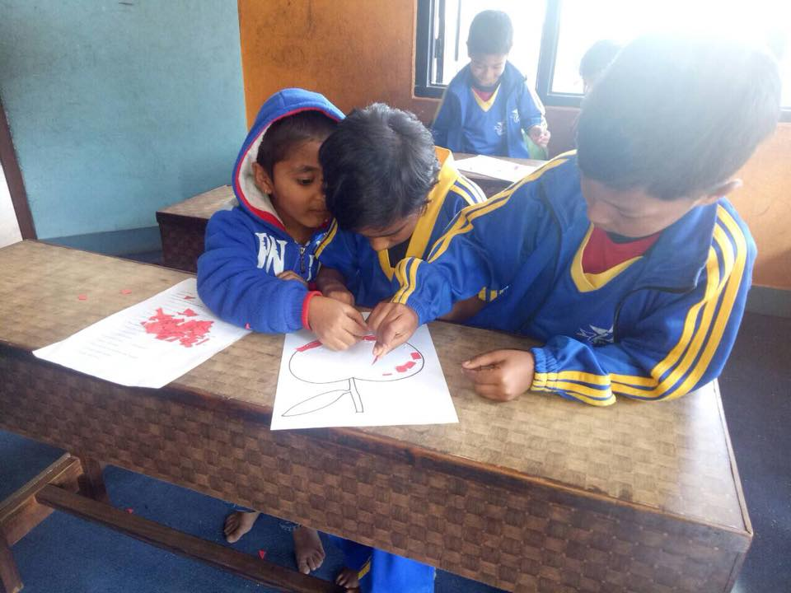
Our preschooler did cut and paste of the kite papers which is nice.
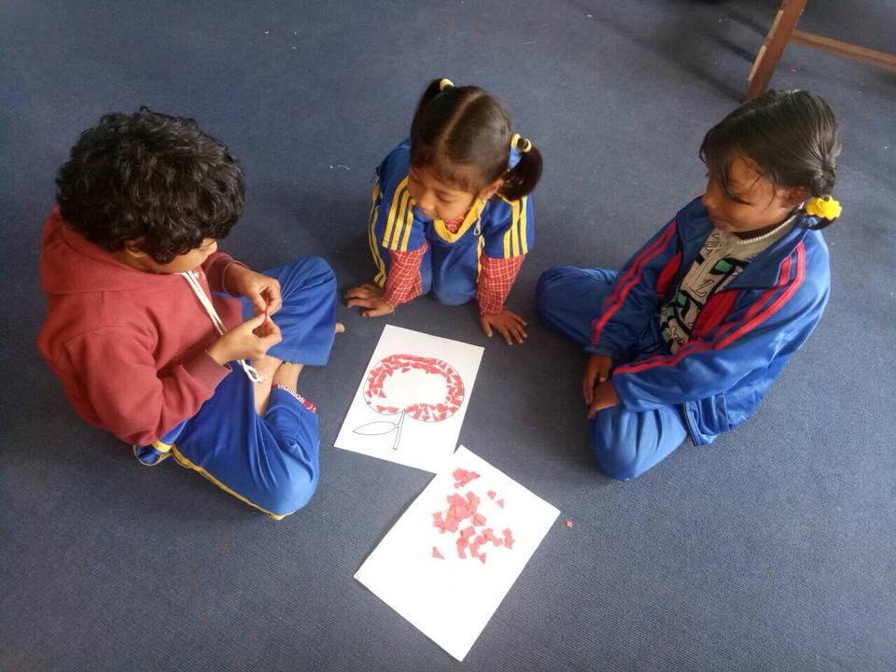

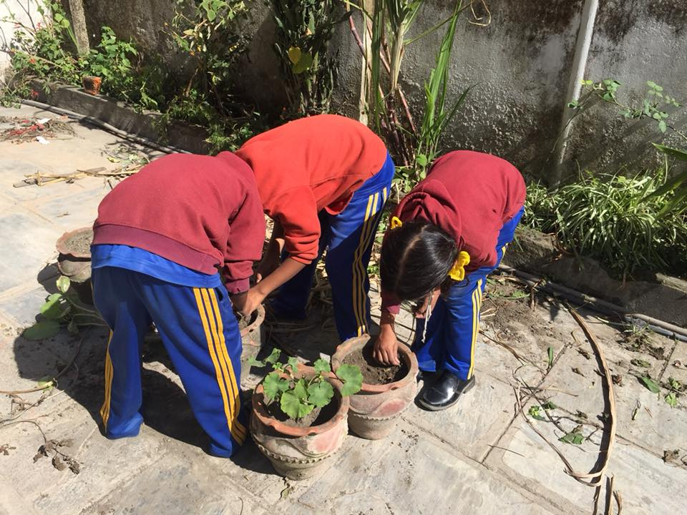
We clean our surroundings by ourselves.
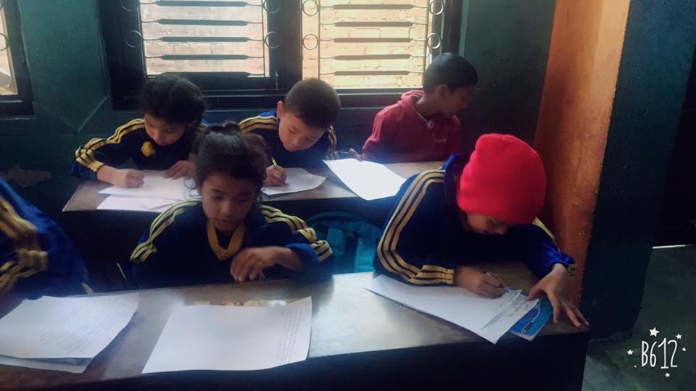
We write a letter to our friends who live in Sweden.

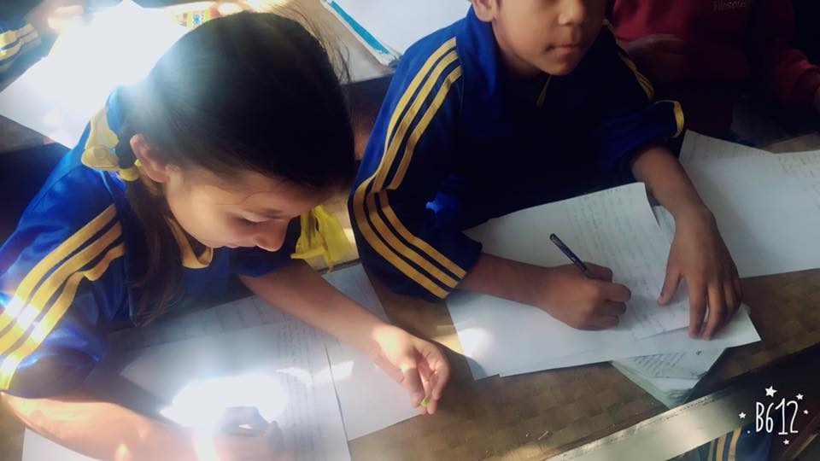

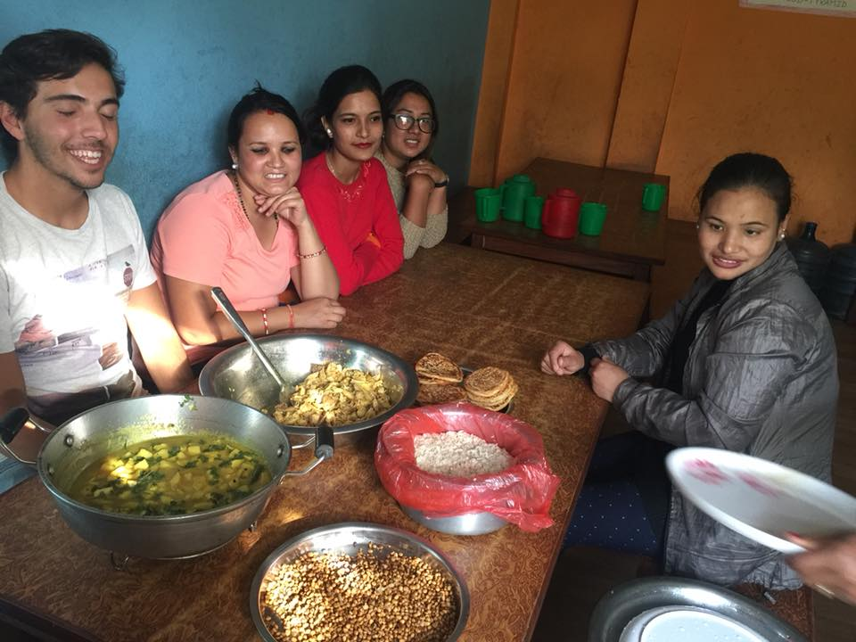
We made typical newari food specially for Adam.

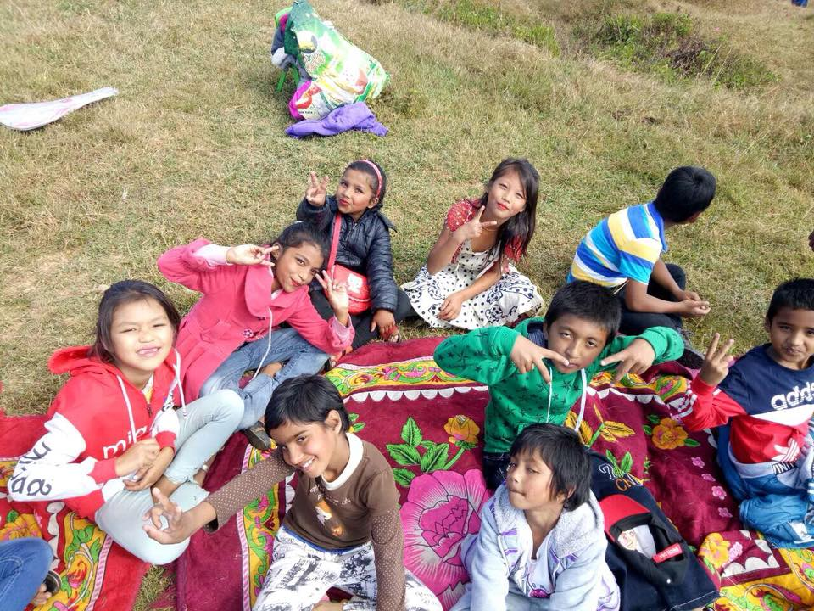
Picnic to Lakure Bhnajang 2017.

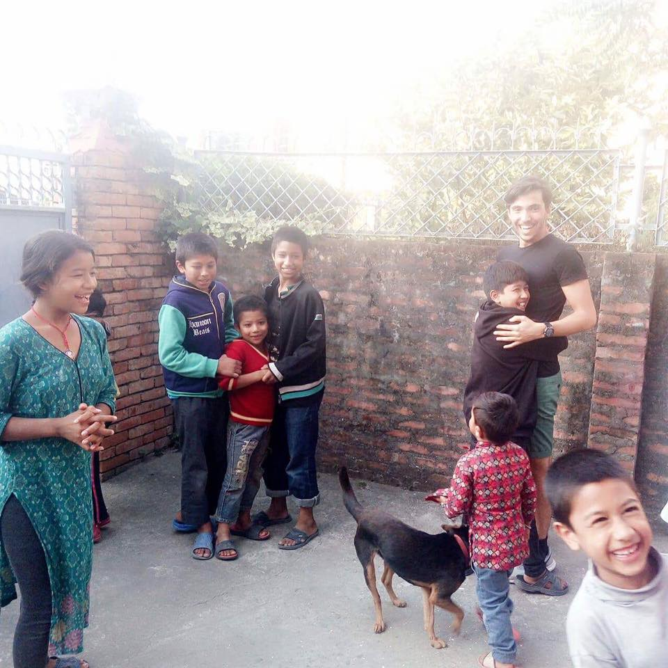
Adam visit to Filosofiska Girls hostel, Dhapasi.

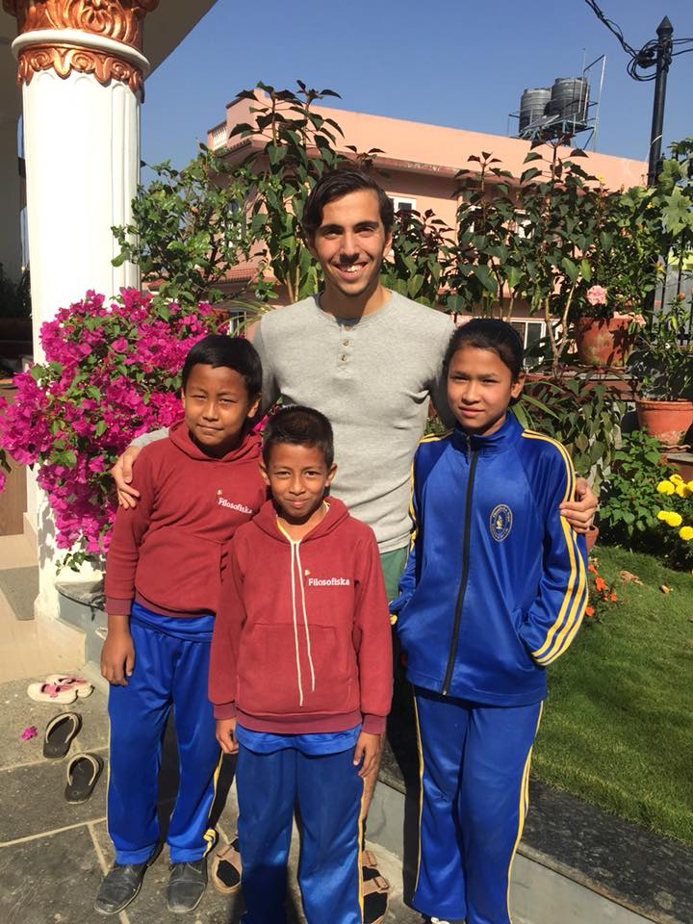
Grade four children visit to Adam’s place on one fine day.
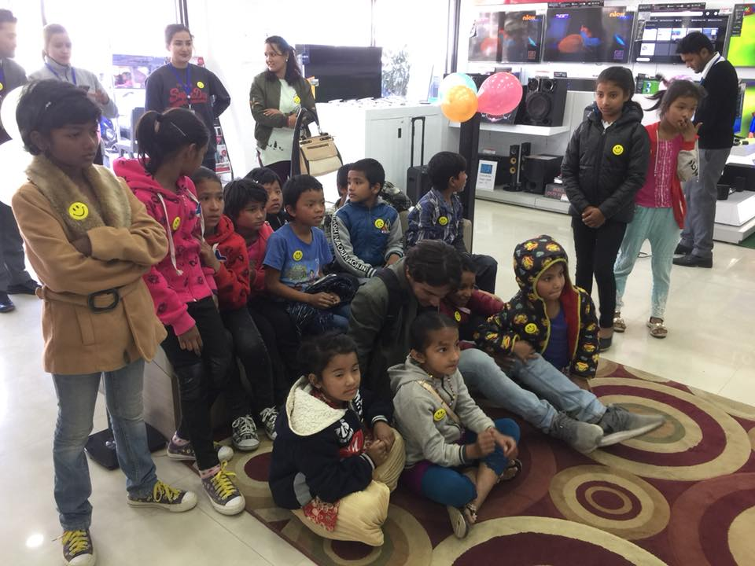
CG electronics showroom visit by our little philosophers.
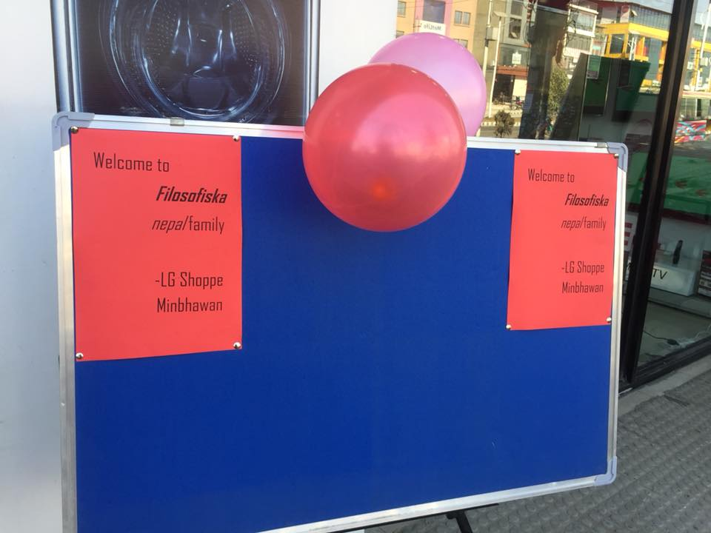

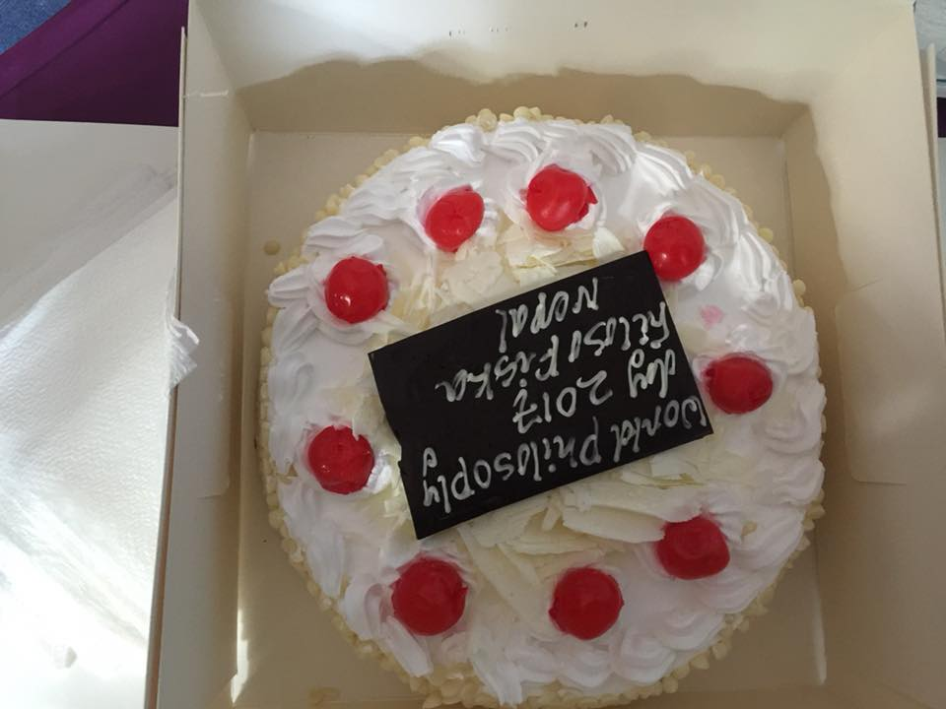
World Philosophy Day 2017 celebration in Filosofiska Nepal.
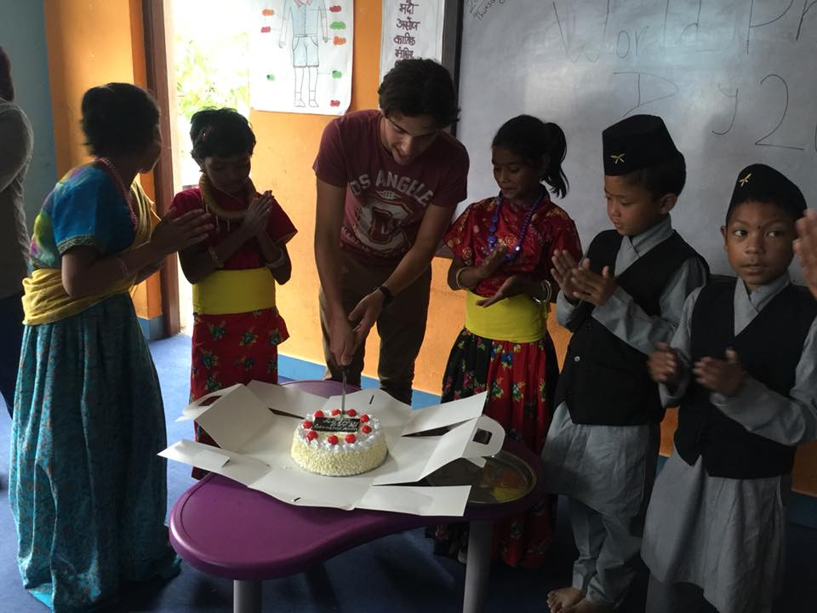

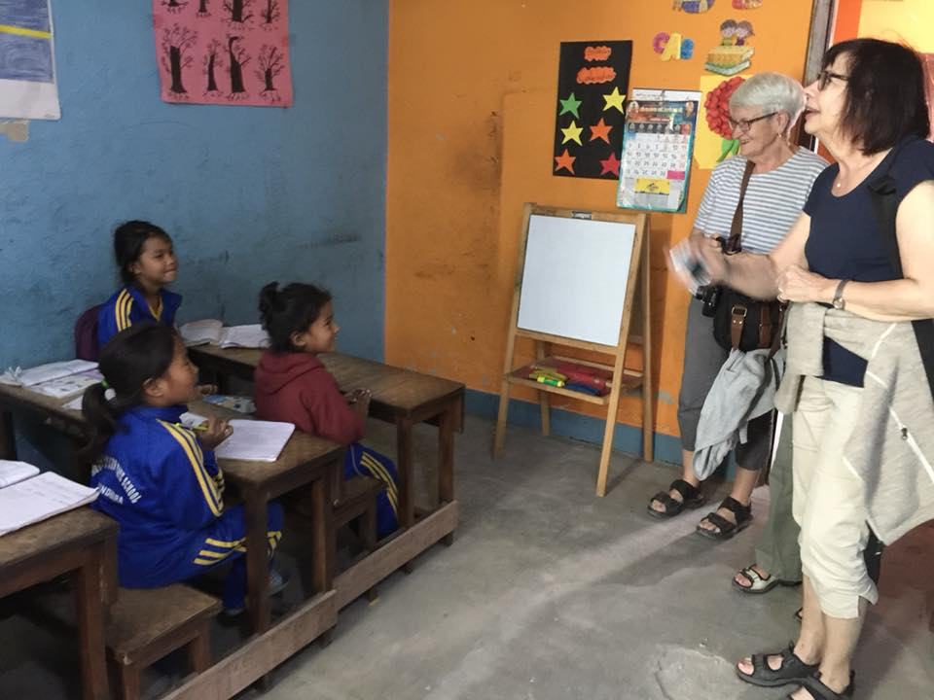
Kerin and her friends visit usfrom Sweden.
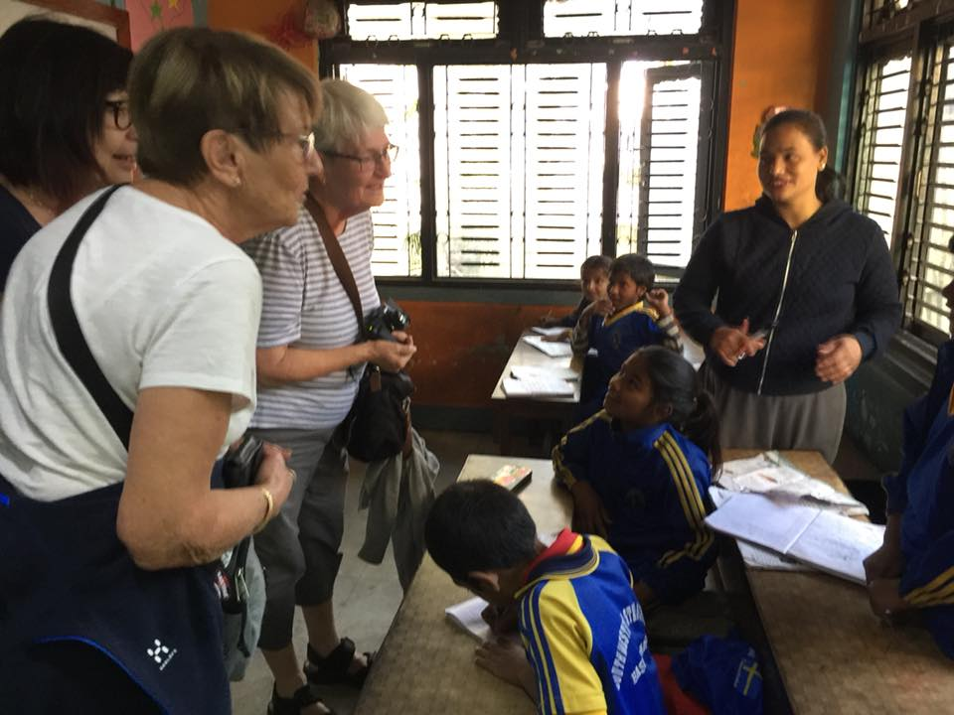
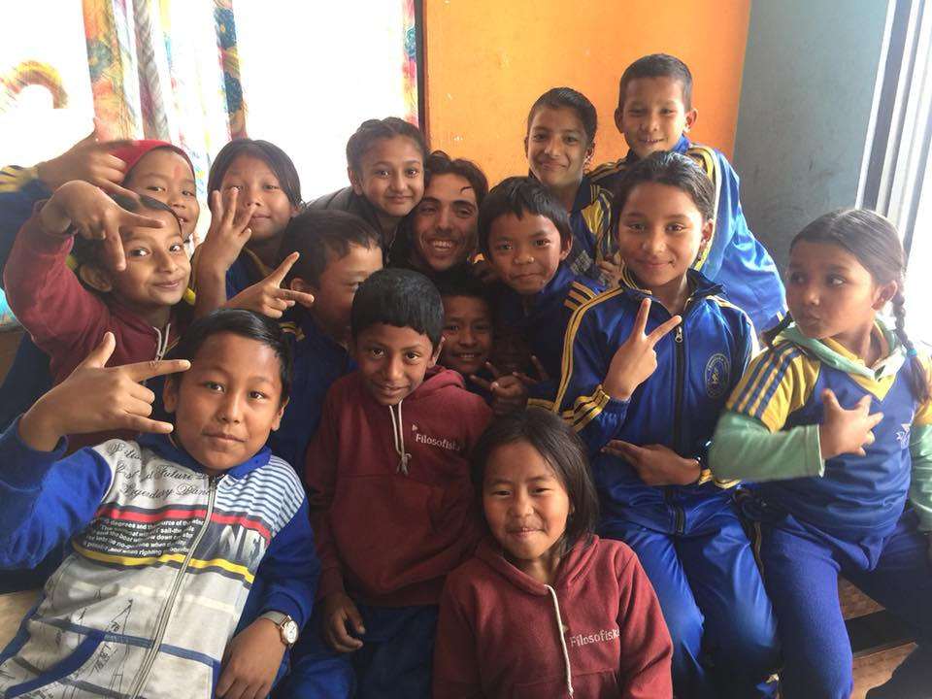

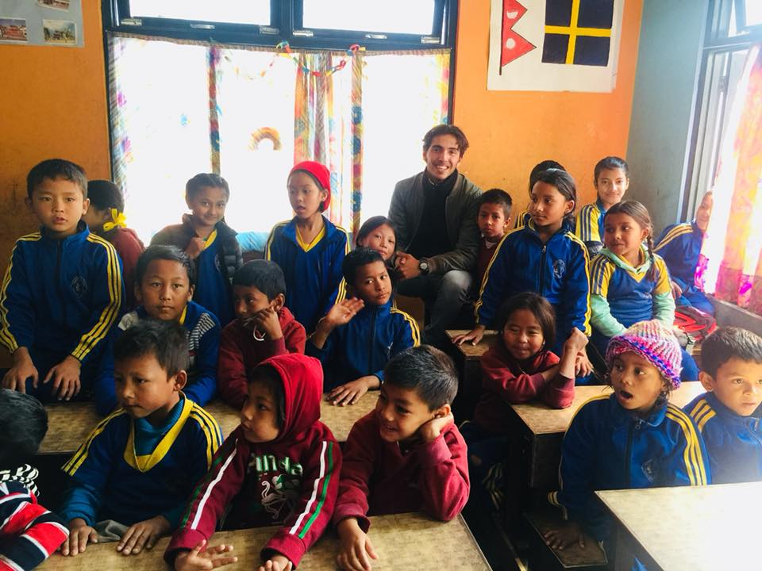

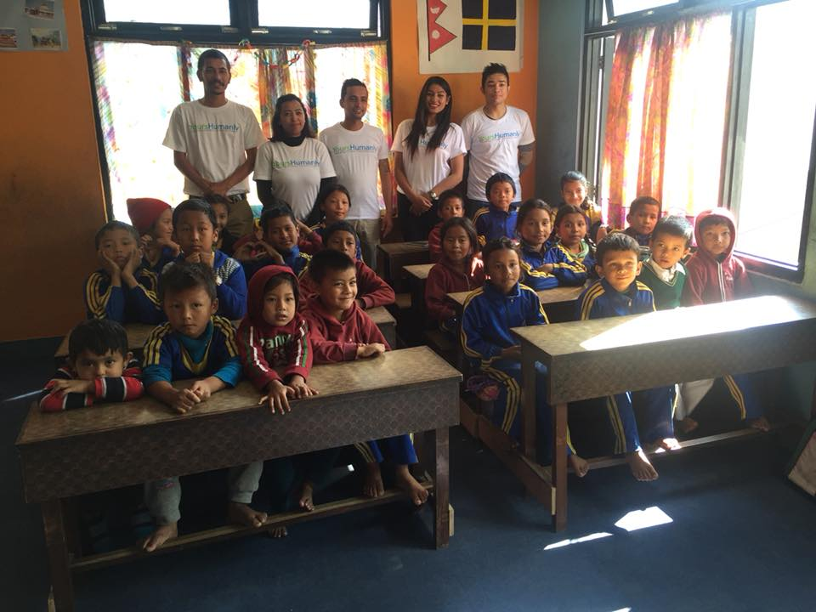
Yours Humanly team visit our school.

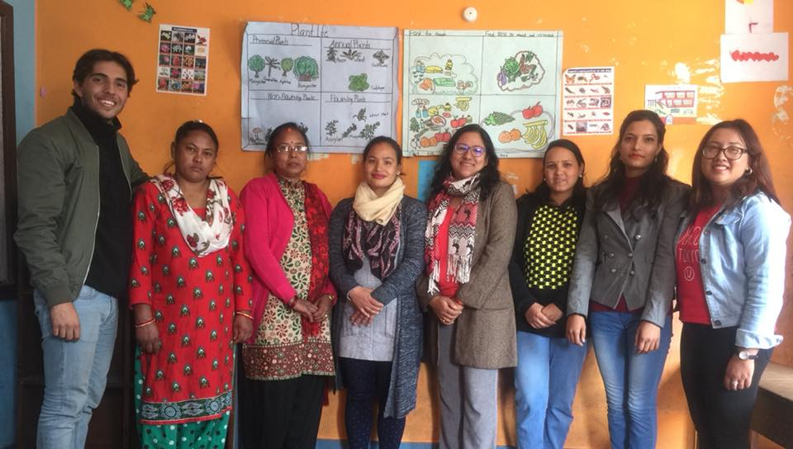
Team members of Filosofiska Nepal with Adam.
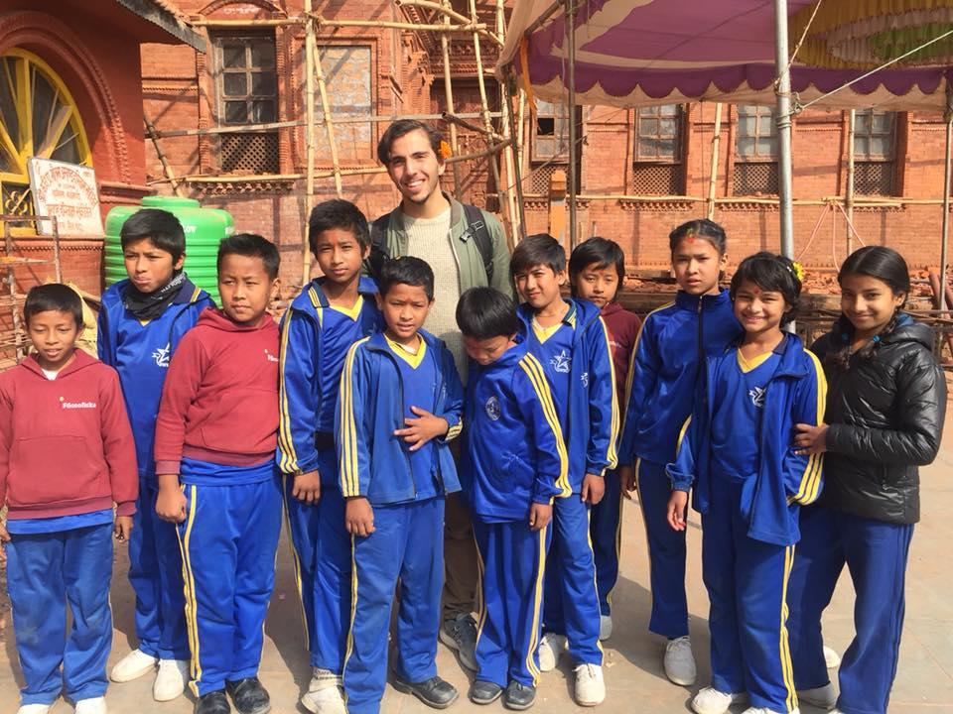
Narayanthan temple visit with Adam.

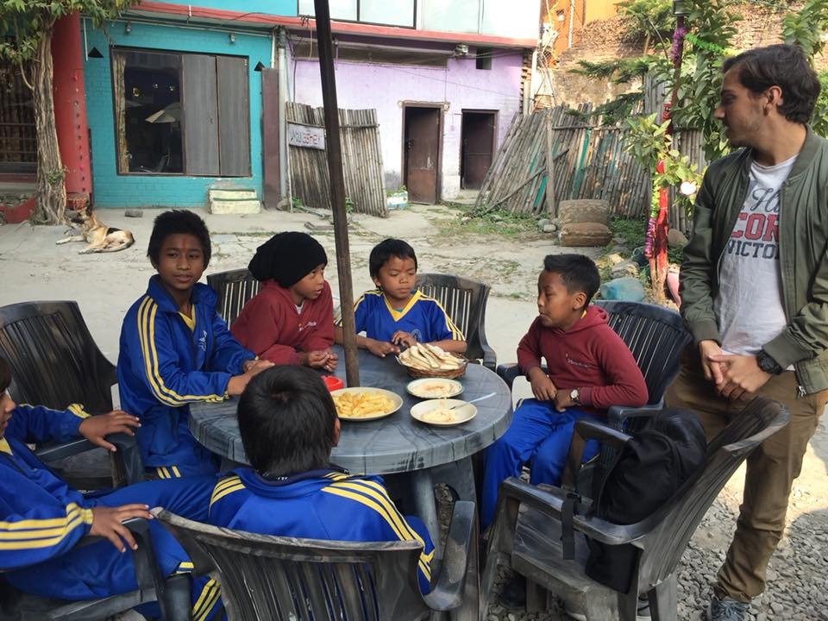
The Chabad House visit by our children.

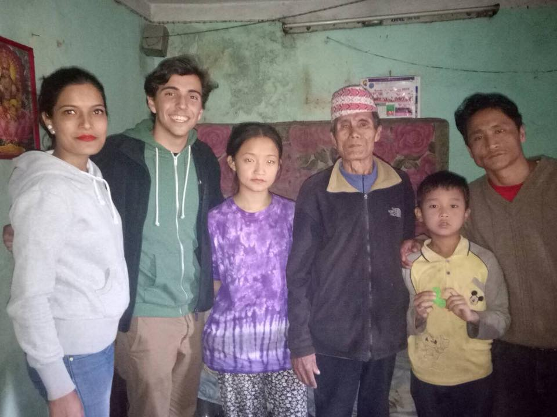
Home visit of Buddha by Adam.
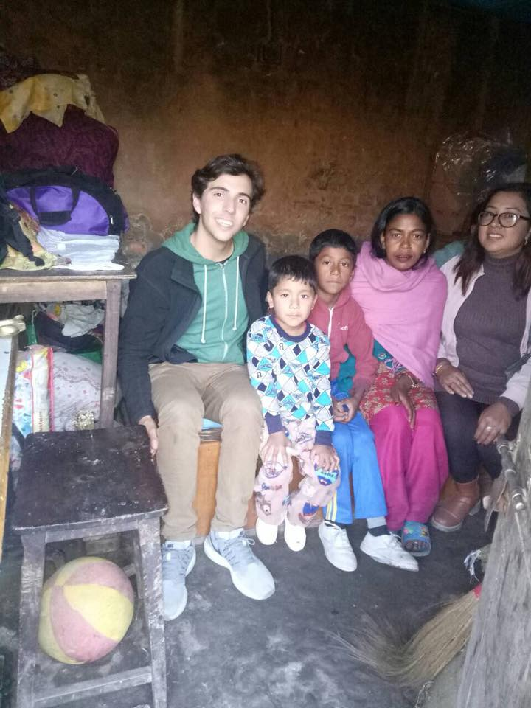
Home visit of Pradip by Adam.

Thank you for your continuous support.
Filosofiska Nepal.

