Monthly progress Report of December 2017
December is last month of the year. Winter stays in our country for about three months. Nights are long and days are short. The sky remains clear. There is fog in the morning. In this winter season children really enjoy playing in sun and drinking hot soups.
Christmas is celebrated on the 25th December every year. It is Christian festival celebrating the birth of Jesus Christ and is traditionally characterized by tinsel decorated trees, mince pies, present giving and a turkey dinner. Families come together to eat, drink, be merry and argue over xmas tree, whereas children look forward to visit from Santa Claus and his sack of presents.
On 12th December 2017 we had visitor from Sweden. They were Swedish couple Manuela and Mat who spend afternoon with our children. Together with children they made Swedish chocolate balls. This is second time children made chocolate balls. They love the taste of chocolate balls.
“Memories may be beautiful and yet what’s too painful to remember we simply choose to forget. So it’s laughter we’ll remember the way we were.” The day has finally come where we have to say goodbye to Adam Zippis who came to our school as volunteer on 8th of October till 17th of December. He loves to spend his most of time with children. He always makes them engage in many activities. Children love his company. All the time children want him in their classroom. On 17th of October we had farewell program for Adam which was really hard for the children and staff as well. At last, we all say goodbye to him with courage. Children will always remember him.
This month Adam went to some of the children home. He meet parents and observe the condition of the children. He visit Buddha (2), Lajima (1), Sumitra (UKG), Dikesh (LKG), Pradip (1), Samjana (1), Abhishek (3) and Siddhartha (1) .
Sujal nepali from class four celebrates his birthday on 1oth December with his friends and teacher.
Bhupati Bhandari, 4 years join Filosofiska Nepal from December 6th 2017. He is in toddler’s class. He is in adjusting phase.
Staff Progress Report:
On this month we did yearly performance review. We discuss both positive performance and areas for improvements regularly even daily or weekly basis. We aim to make the contents of the performance review discussion a re-emphasis of critical points. In the interest of providing regular feedback performance review should be on quarterly basis. The main focus is that the employee knows exactly what is expected of his or her performance.
When we meet with the employee, we spend more time on the positive aspects of his or her performance because it has direct impact on the children. In most cases, the discussion of the positive components of the employee’s performance should take up more time than that of the negative components. The performance review can enhance relationship with employees, improve performance for the school and work relationship.
On the monthly staff meeting from this year we include these points, they are:
- Define performance issues early
- Provide feedback
- Build skills and confidence
- Set clear performance measures
- Keep staff motivated and accountable.

Photographs:
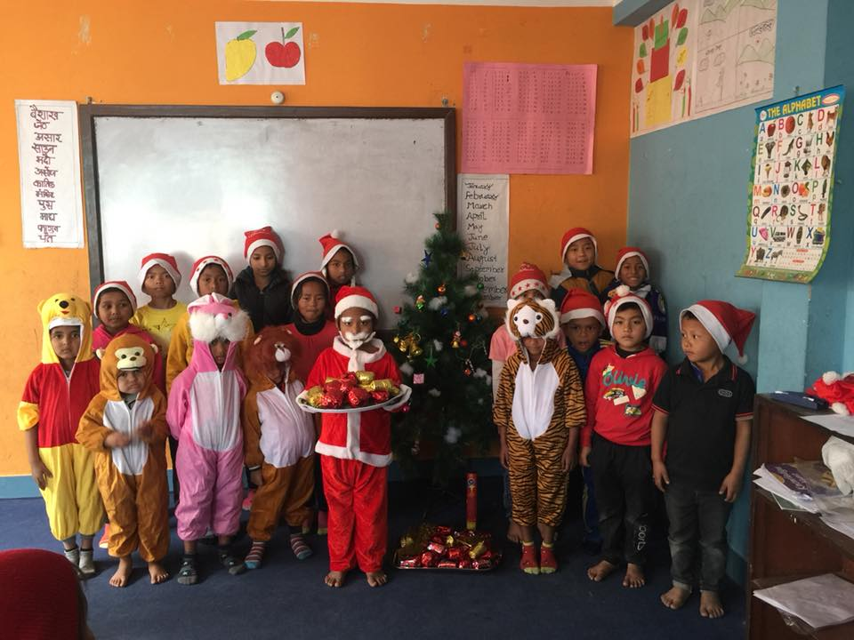
Christmas celebration with our little santa Clause.

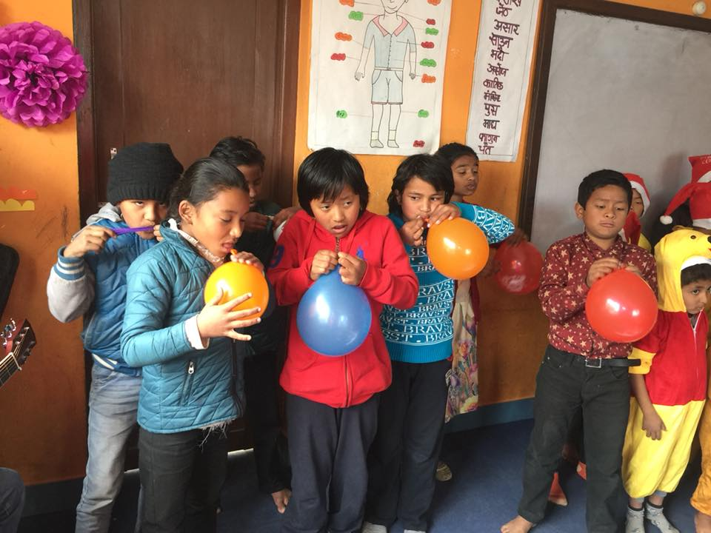
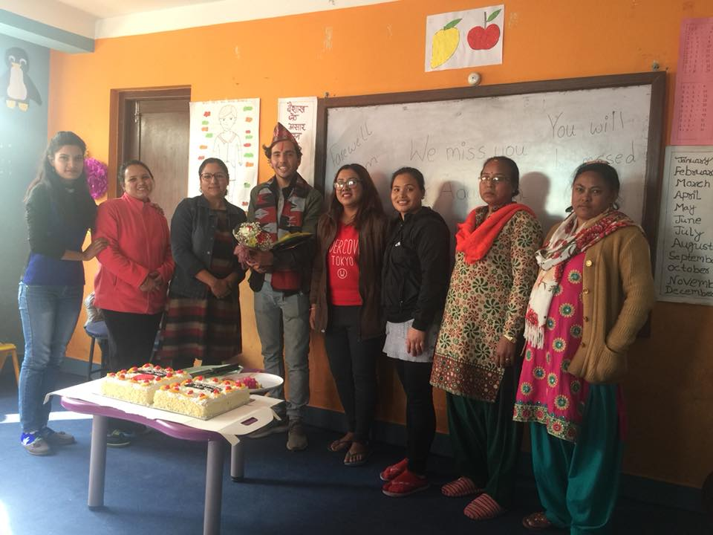
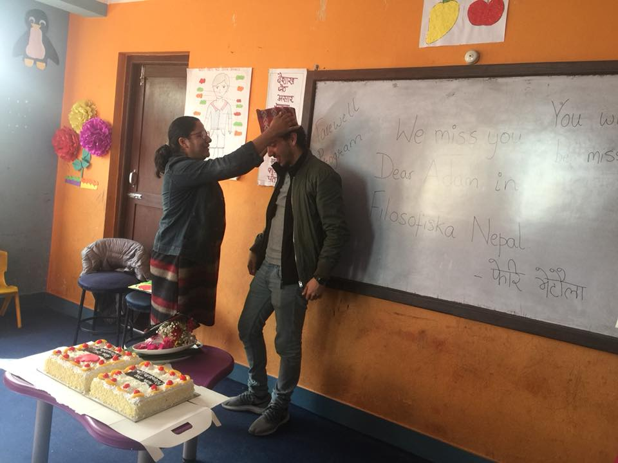
Farewell program to our dear Adam.
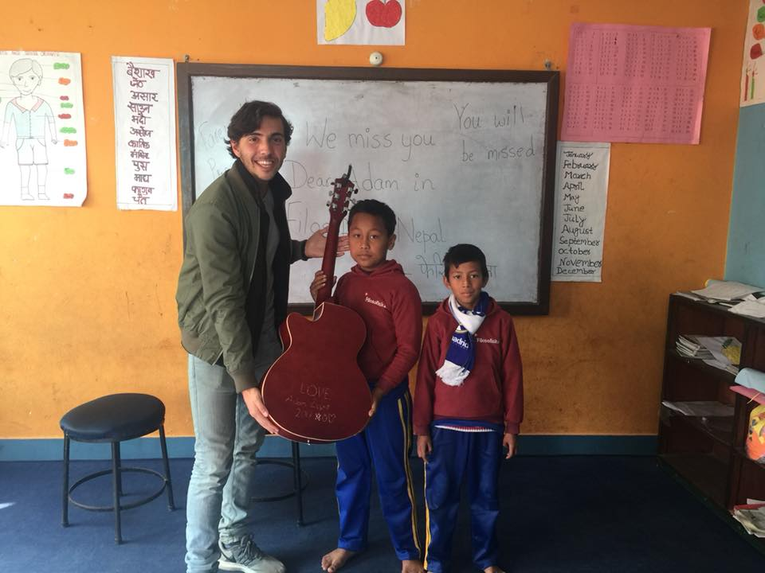
Adam gifted guitar to our children.
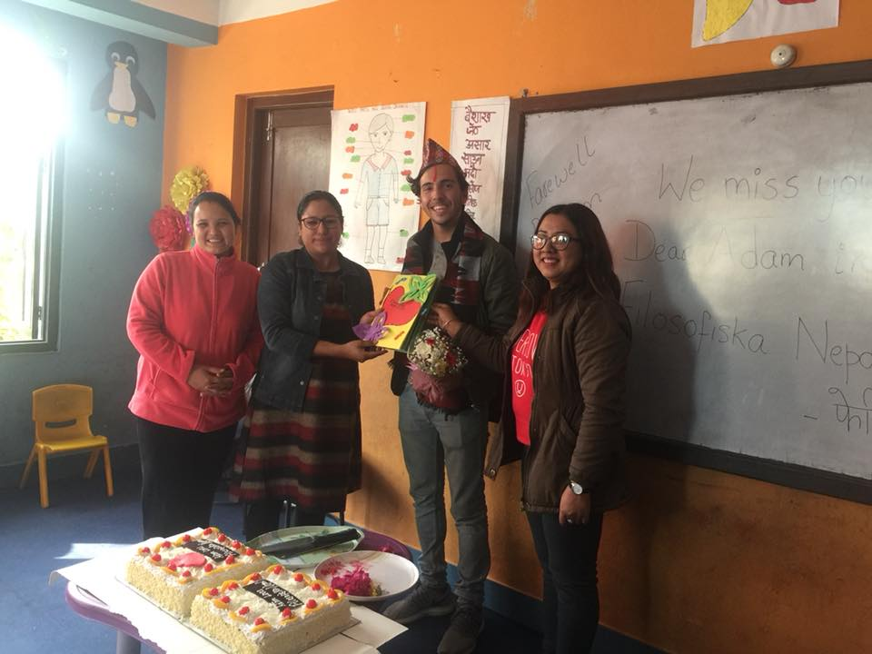
We handed beautiful card to Adam on his farewell.
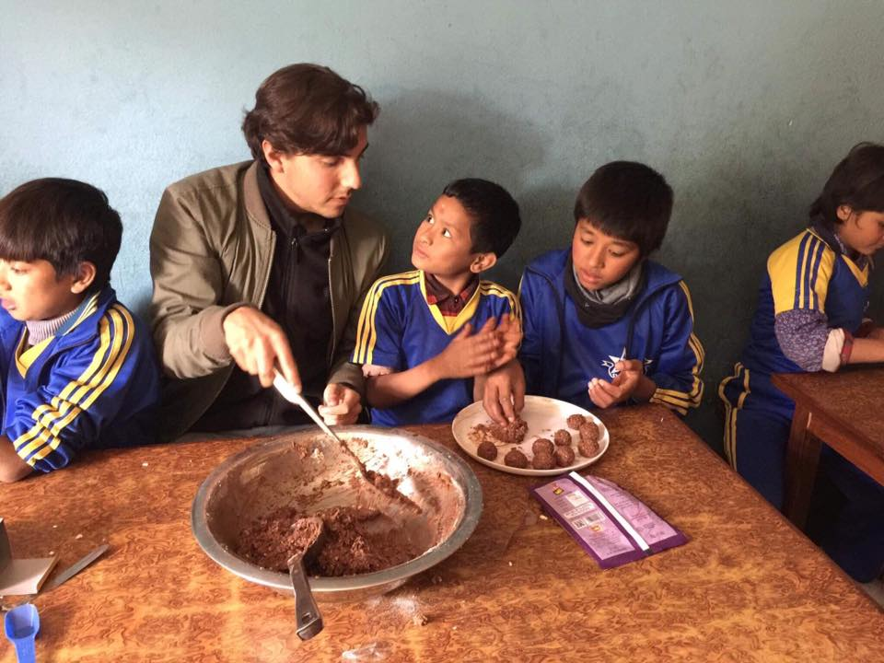
Making Swedish chocolate balls is always fun.
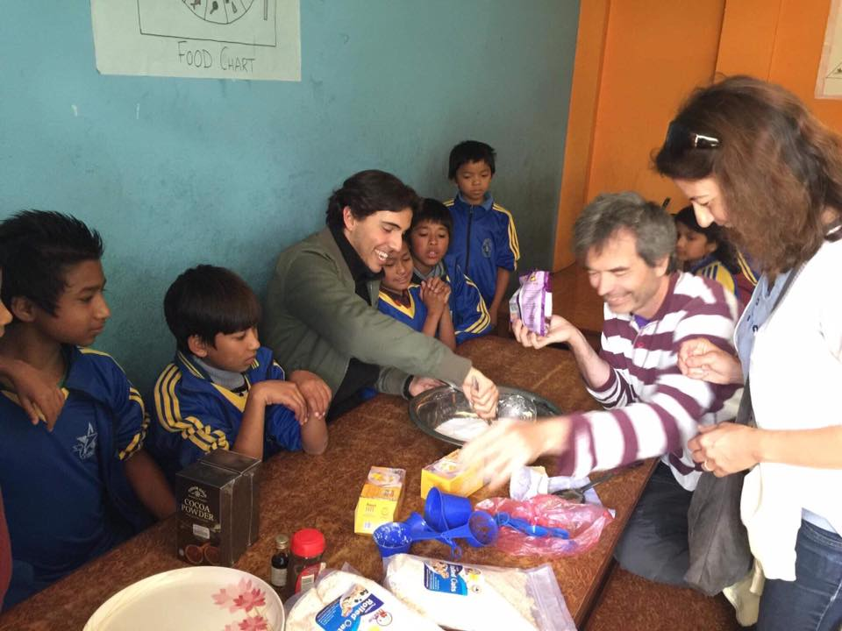

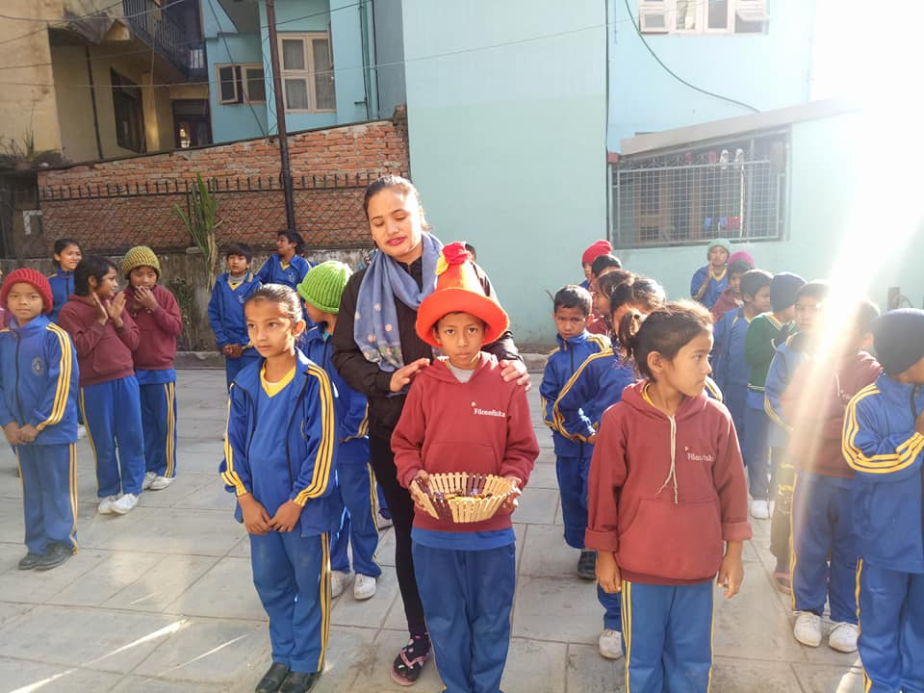
Happy birthday to our dear Sujal from class four.
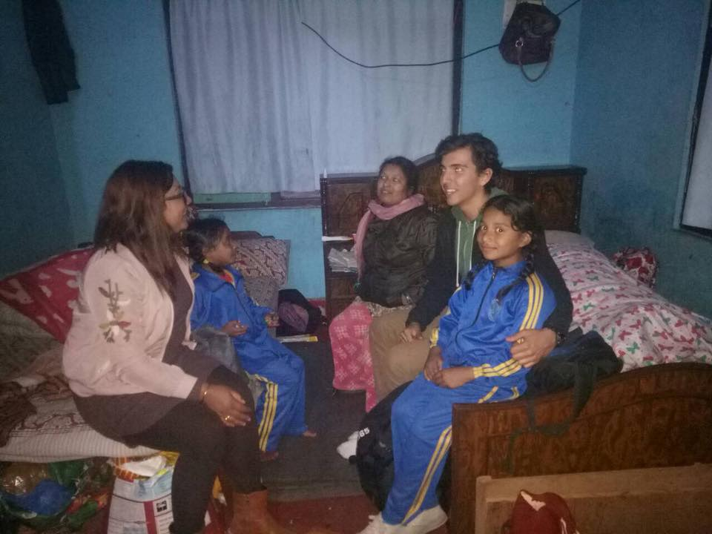
Thank you for your continuous support-Filosofiska Nepal.
Happy New Year 2018.

