Monthly Progress Report April 2018
This month we came to end of the session. The final exam held’s from 1st April to 6th April. All the children appeared in the examination. They all did their best to secure good marks in exam.
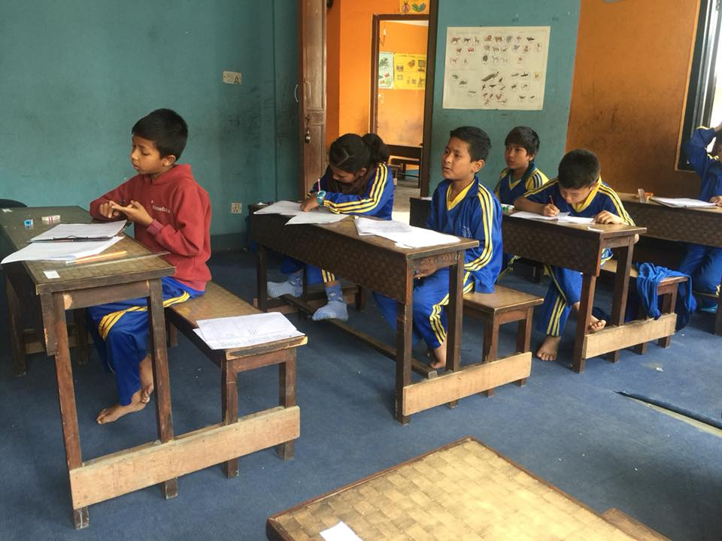
One of the generous Nepalese lady Anshu who stays in America for more than fifteen years came to Nepal with her six years old son Aayan and spend whole day with our children. She distributes stationery item and biscuits. At the time of earthquake also she sends some money to buy necessary things for our children family. Thank you so much Anshu and Aayan. Children had great time with you and your son.
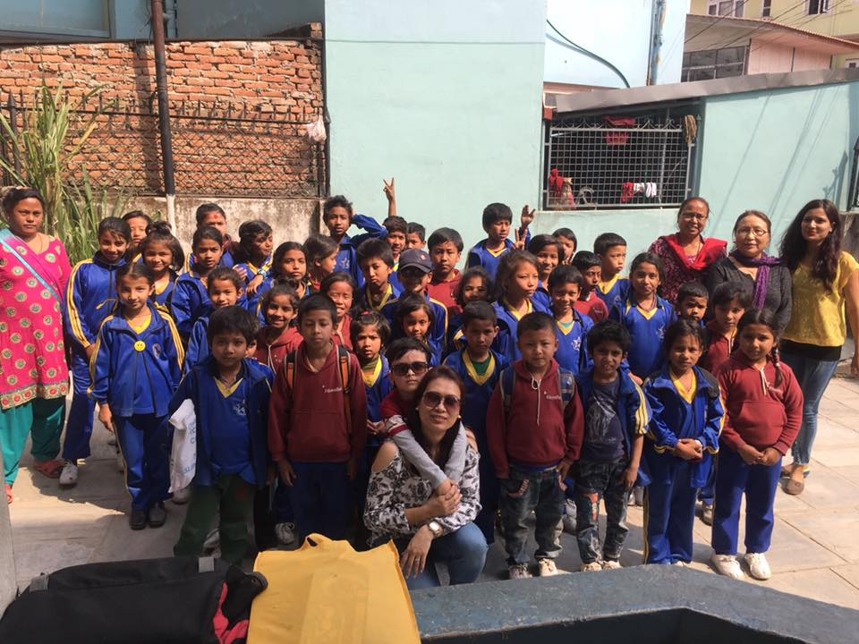

Children love to have visitors in school. Some of students from Egypt were doing their exchange program in Southwestern state College so they came to visit our school. They spend some time with the children. They also sang their national song and show some dance move. Our children also sang national anthem and perform dance infront of the visitors. Children enjoy their company.
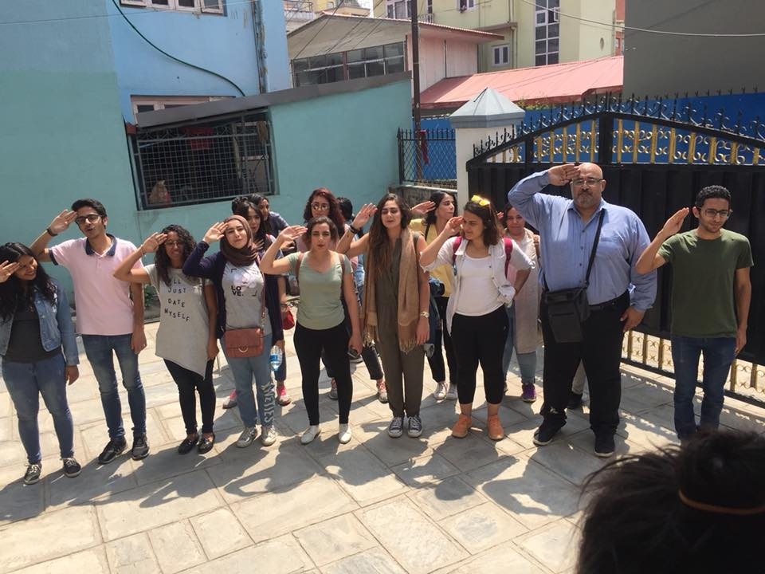
On April 23rd we had carpet and curtains in our classroom. Thank you so much Annette Zippas for all the support from Sweden. She collects money on her birthday and sends it to us to have carpet and curtains in our school. Children were surprise and really happy when they saw carpet and curtains in their classroom.
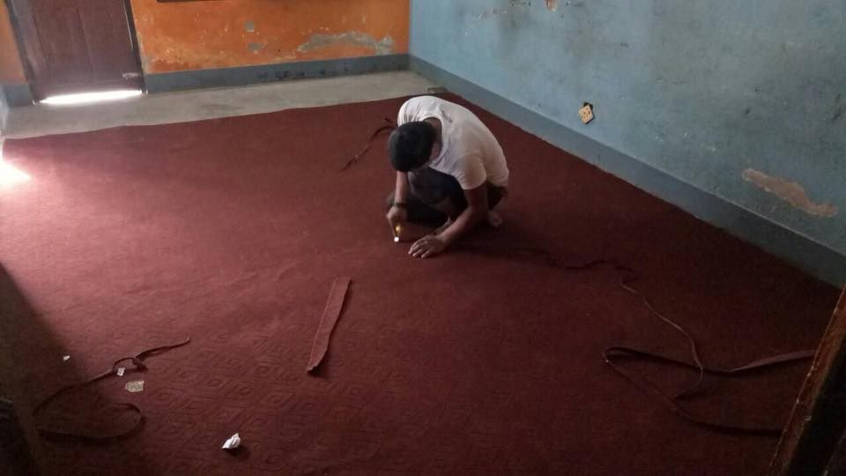
On April 23rd we distribute final exam result to our students. All the children pass with good marks. Three of our children passed out from the grade four. They all were admitted in school near by their home. The students who passed out from grade four were as follows:
- Sujal Nepali
- Puja Nepali
- Abhimanyu Thing
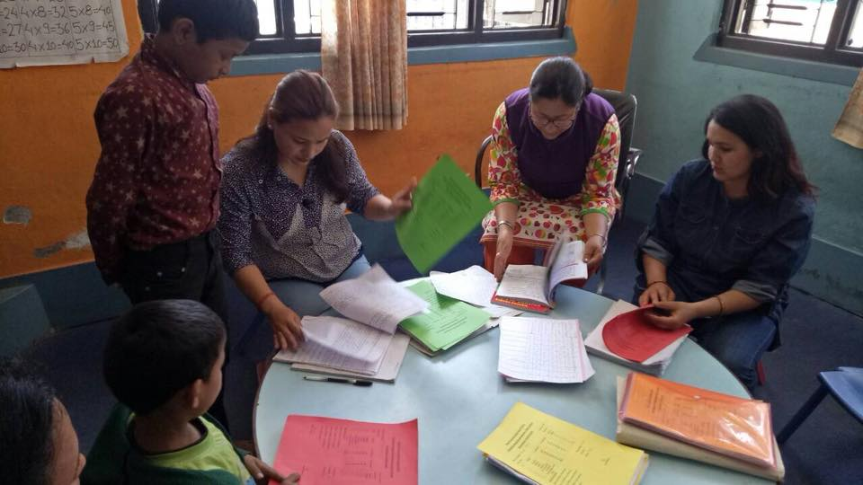
It is good news that some of the parents living standard upgrade so they want to keep their children in private school and gave chance to other children who are in need. So the name of the children who left school for good reason is as follows:
- Kristina Dhaka- Grade 2
- Pradip Nepali- Grade 1
- Pawan Neupane-Grade UKG
- Sudin Adhikari-Grade 3.
This month we celebrate birthday of Bikash in school. It is first birthday celebration for this session. Happy birthday Bikash from grade UKG.

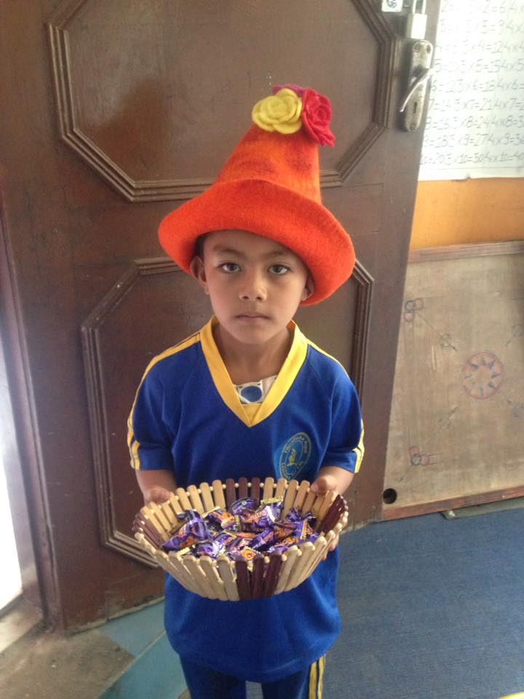
Thank you so much for supporting. Keep supporting to Filosofiska Nepal.

