Monthly Progress Report May 2018
This month we welcome Emma from Sweden on May 1st. She is doing her volunteering for three months. On May 2nd we distribute course book to all the students. All the students were excited about getting new book. We have visitor from Nepal Astrology Council to provide information about the universe and solar system. At the end of the program they have art competition children draw very nice pictures of solar system. They distribute chocolates and pencil for the winners. All the students get chocolate for the participation.
Thank you so much for providing lunch for the children Jyoti, Nabin and Brahmin. They also distribute mufflers and shirt for the children.
Ramila distribute chocolates to our students. She visits us from Bhaktapur and she enjoy some time with children. Thank you so much.
On May 15th grade three students and Emma went to visit Kathmandu Darbur Square. Kathamandu Durbar square in front of the old royal palace of the former Kathmandu kingdom is one of three durbar (royal palace) squares in the Kathmandu valley in Nepal all of which are UNESCO world heritage sites.
Several buildings in the square collapsed due to a major earthquake on 25th April 2015. Durbar square was surrounded with spectacular architecture and vividly showcases the skills of the Newar artists and craftsmen over several centuries.
We went to most of the places in durbar square. Emma is amazed with the art and crafts of temple and buildings. Children from grade three enjoy playing with pigeons. Later on, we had snacks together. Children got chance to taste the local food like samosa (potato stuffed inside) and sweets.
On May 22nd one of our new board members Janaki Parajuli visits us for first time. He is fun loving person and likes to spend his time with the children. He cracks lots of joke and tells stories. He and his friends Eva Wardzala, Krzysztof Cramy, Anna, Maydelina, Arcicz provide us rice, lentil, beaten rice, biscuits, oil, cumin powder, salt. They also provide bags, dress, bottles and dolls for the children.
On May 23rd Emma brought giant colorful chalk from Sweden. So on that Friday children draw a very beautiful drawing.
On May 24th we prepare Swedish pan cake for the children. Emma help us to make pancake. Children put mixed jam and enjoy their pan cake. Some of them are tasting pancake for the first time. They told us they like the taste of pancake.
On May 25th children of grade one and two went to Ichnagu Narayan temple and different religious places.
About 3km northwest of Swayambhunath , Ichangu Narayan is one of several important temples dedicated to Vishnu in his incarnation as Narayan, the “eternal man”. Build in the two tiered pagoda style, the temple was founded in around AD 1200 and its courtyard is dotted with ancient Garuda statues and other Vaishnative symbols. The complex was shaken by the 2015 earthquake, but most structures have been stabilized and repaired.
The scenery and view is really amazing. Children climb the single tree which is really popular in that area from where you can see amazing view of Kathmandu valley. After that we had lunch so overall it is fun day.
Teachers performance Evaluation:
Teacher are evaluating on their performance basis. This month we had staff in-house meeting. The main agenda we discuss about is the performance of new admitted children. The main challenge for teacher is to how to handle new students. This year we admitted mostly toddler’s children.
Progress of the month:
This month we were more focus on the newly admitted children. It takes time to understand their behavior and they also need time to understand school’s rules and regulations.
Photographs:
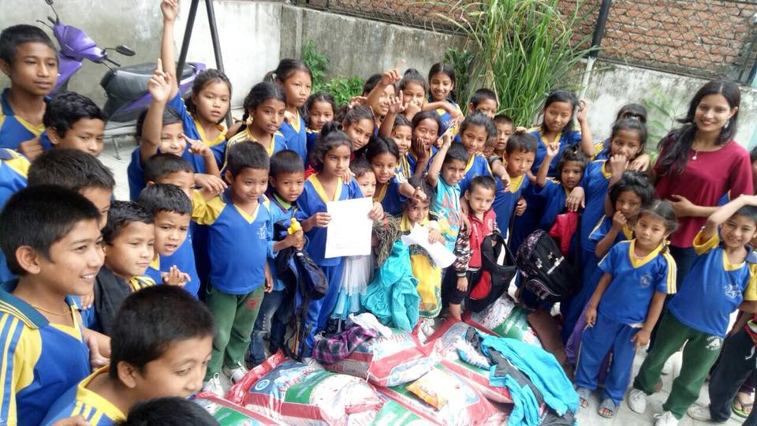

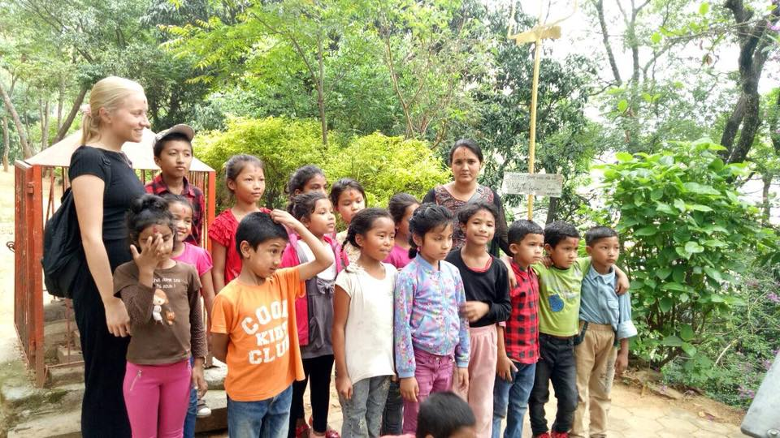
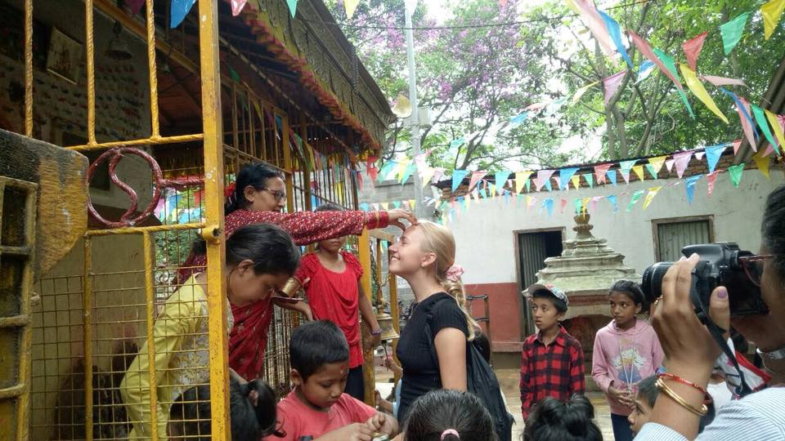
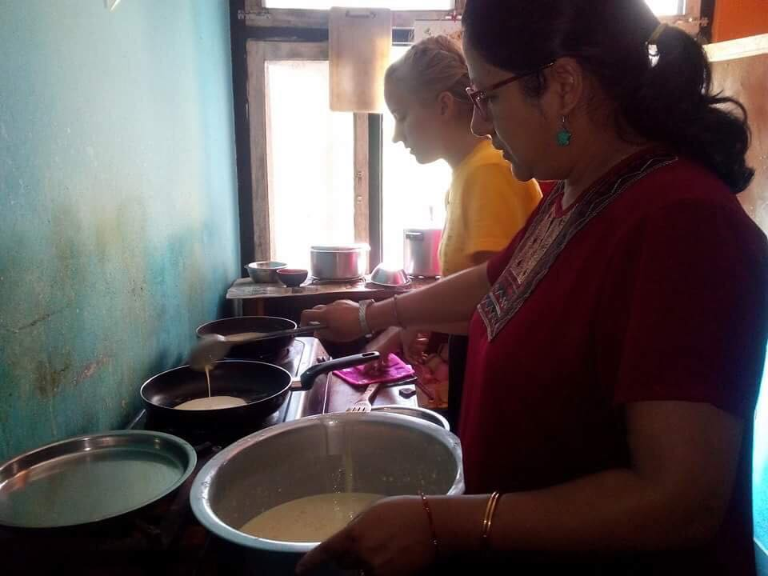
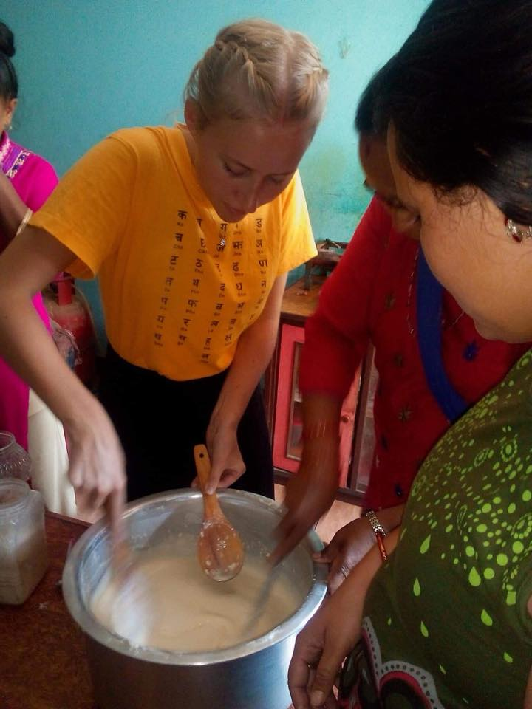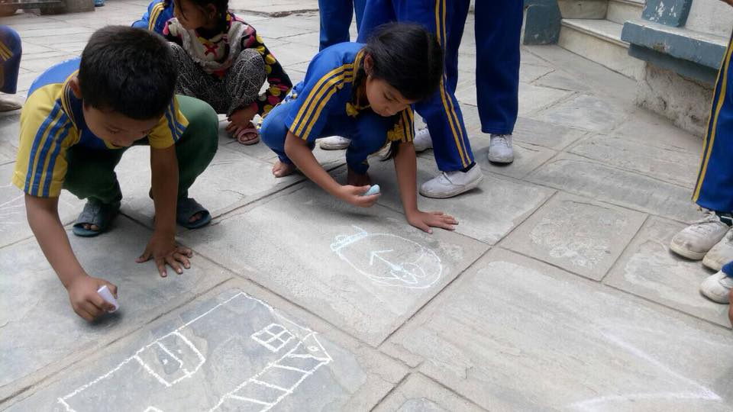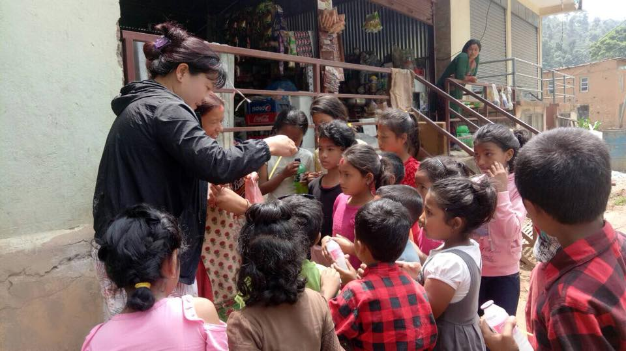

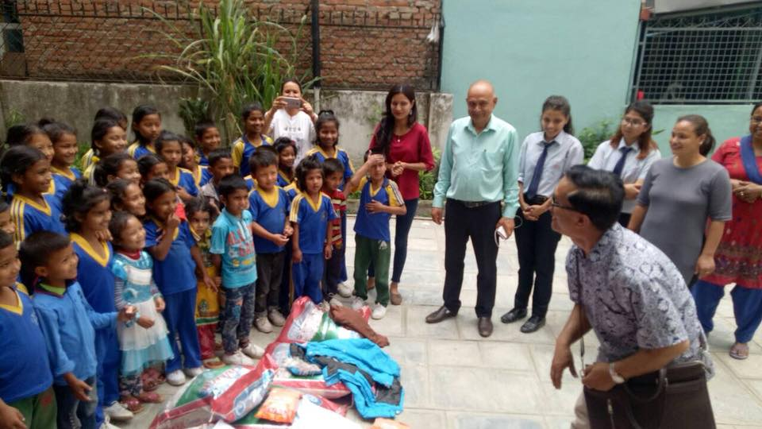

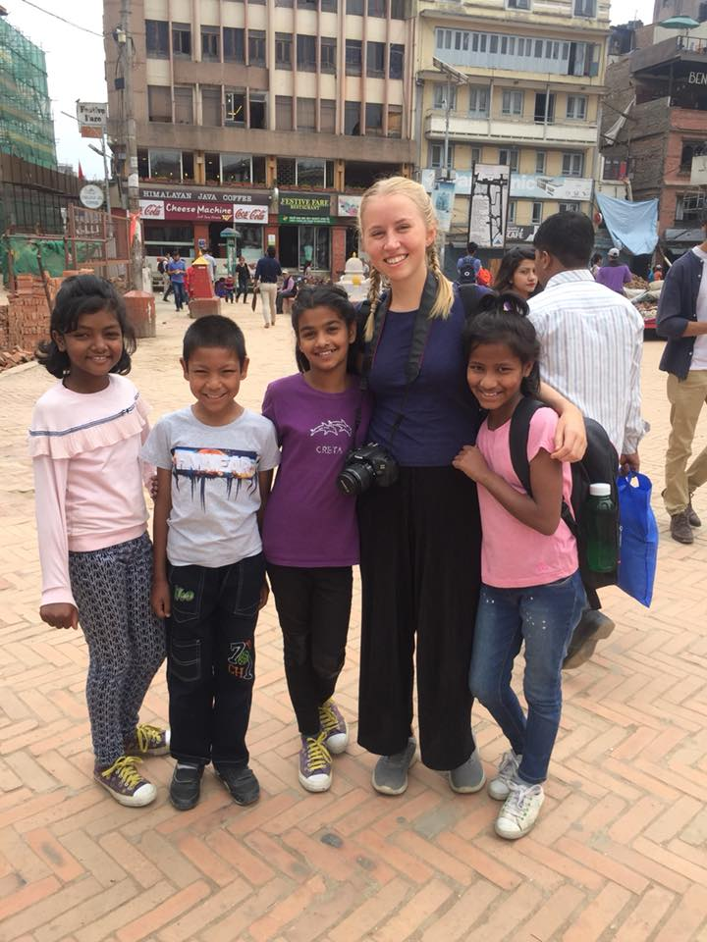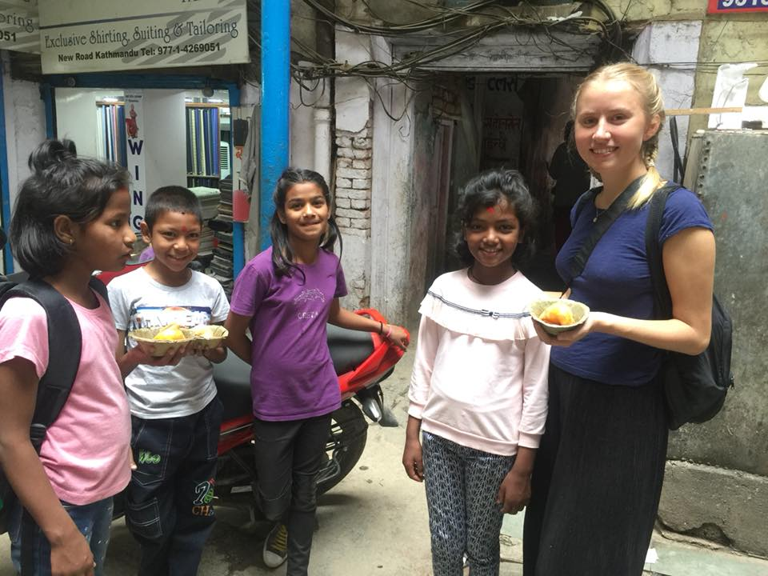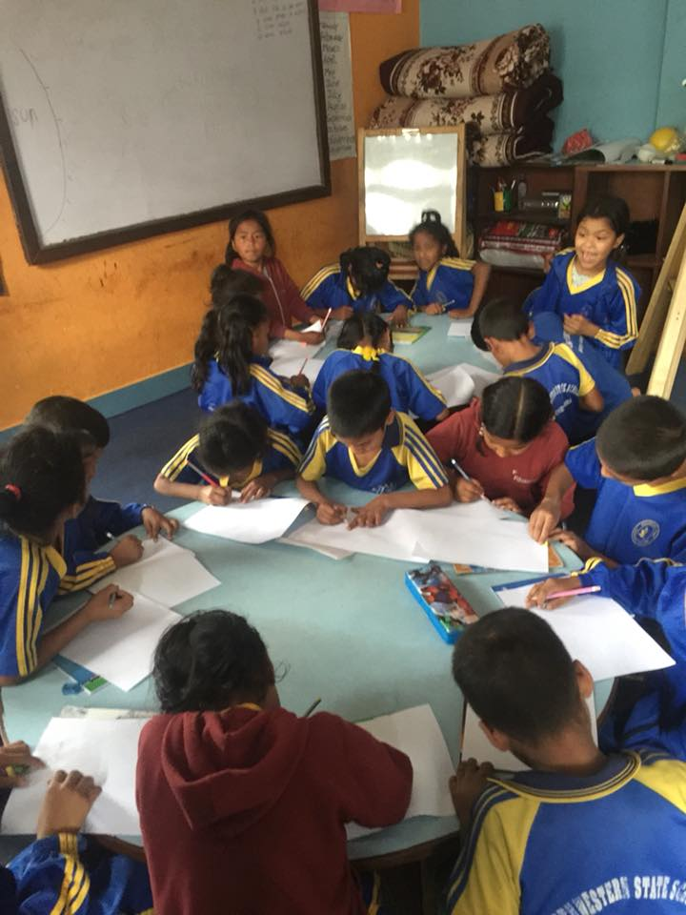

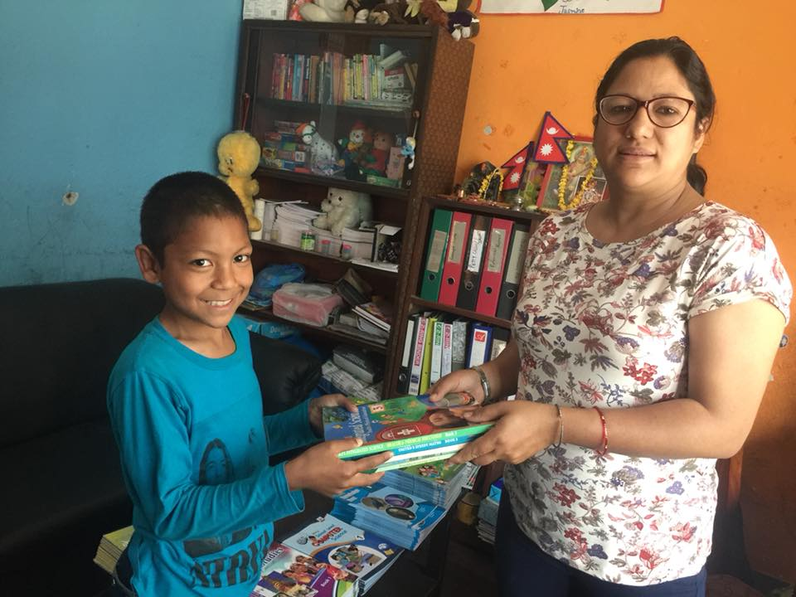
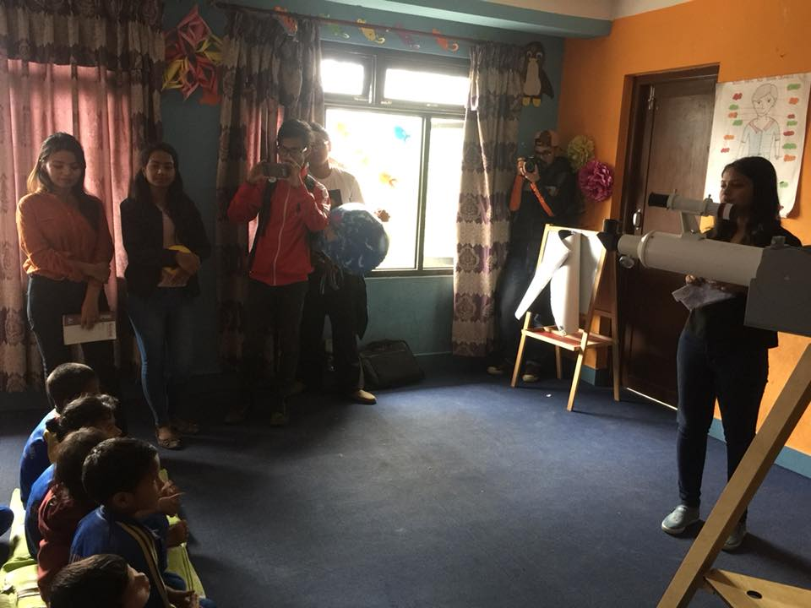
Conclusions:
This month we did many exploring things. All the children got chance to go outdoor and explore something new.

Thank you for your support.

