Monthly Progress Report of July 2018
Chirag bandel is artist, poet, musician, entertainer, radio moderator. He is most versatile character, not only is he an accomplished visual artist with his signature style painting and collage works; he also has been hosting a weekly radio show for many years, has worked for television and many events as a presentator and moderator and published a book of poems.
On July 8th 2018 he organizes art exhibition on the title “Love in colors” which as inaurguted by Mrs. Maggie Shah, celebrated industrialist and social worker at GG Mechaan Restaurant and Gallery Jhamsikhel. This is program organized to raise a fund for the children’s of Filosofiska Nepal.
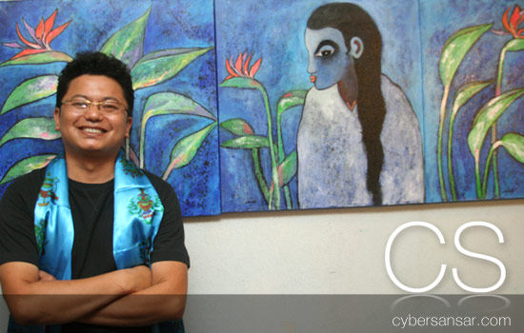
One of the popular Artist of Nepal Mr. Chirag Bandel with his art collection.
Farewell programs of Emma, Anna and Naomi:
Emma Fondelius is from Stockholm, Sweden. Before starting her university she wants to volunteer with us. So she was here for almost three months. She enjoys everyday in school with the children. She helps in classroom, kitchen and even in office with some documentations. She enjoys her stay in Nepal.
Anna and Naomi from London, they were with Filosofiska Nepal for three weeks. They promise that they will come back next summer because three weeks is not enough time to spend with children.
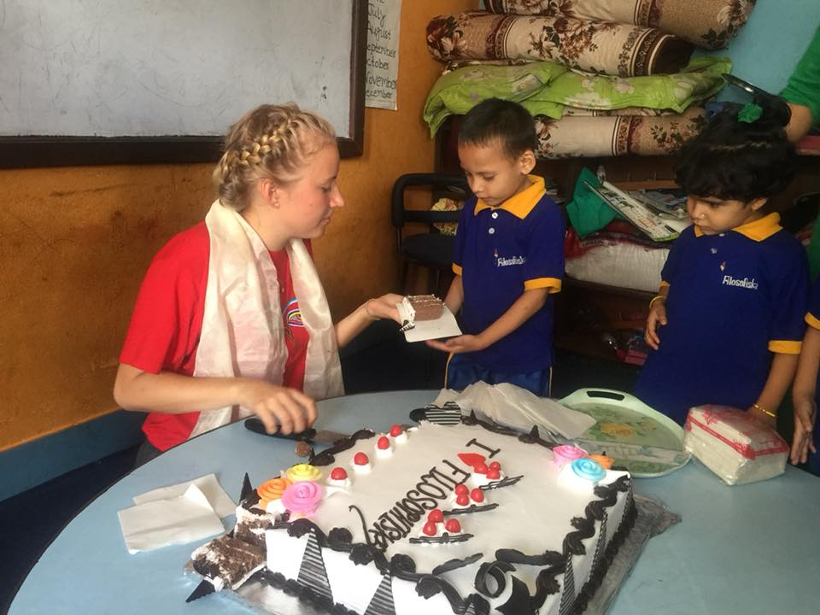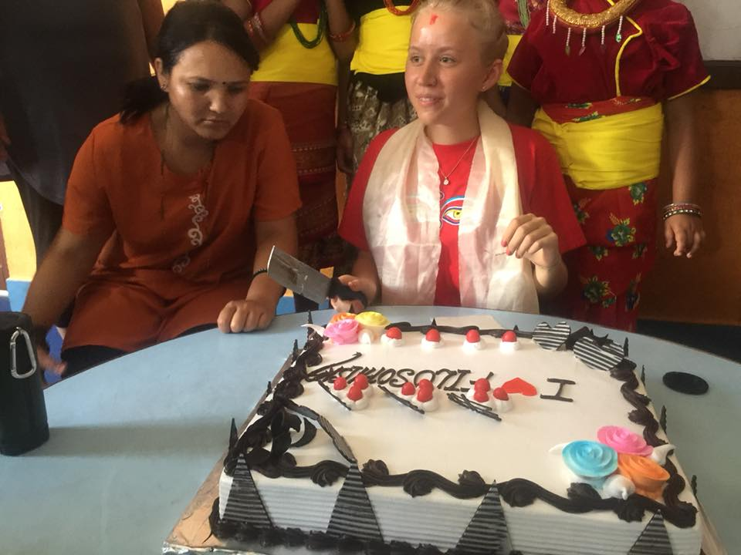
Emma distributing her farewell cake to students of Filosofiska Nepal.
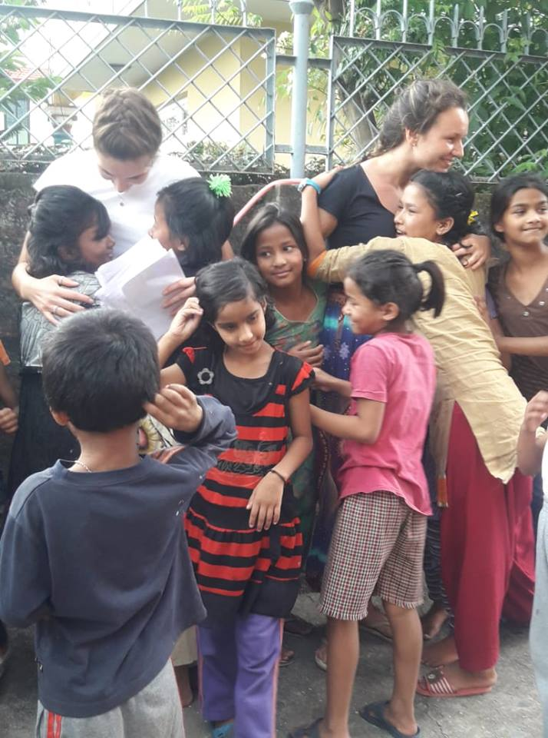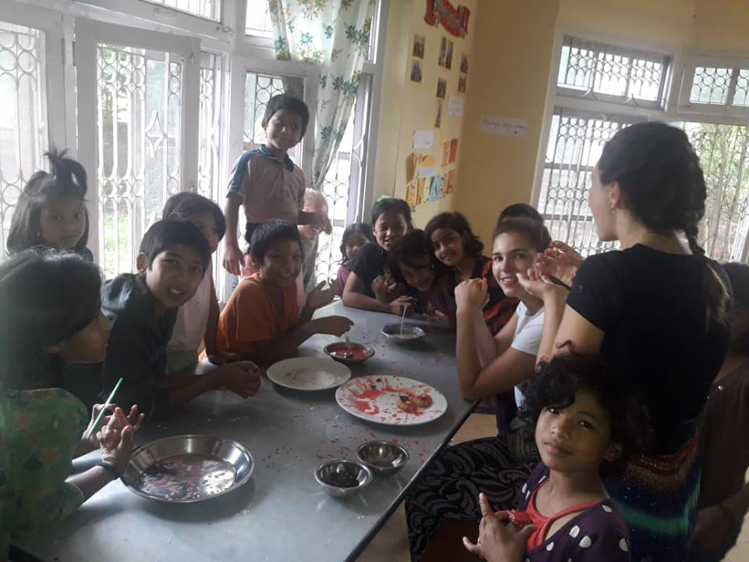
Anna and Naomi says goodbye to our children. At that time school was close so they cannot meet all the students. So they had farewell program at hostel.

Shrawan 15 celebration:
It is popular holy offering made during the religious rituals and rites. And also the 15th day of the nepali month of Shrawan is considered as the day to eat Kheer, locally know as “Kheer khane din”. It is also used as sweet dish during the family gatherings and get-togethers. Some people like to eat it while it still is warm but it tastes best when it is chilled. Children like it when it is chilled with Potato curry. Kheer is everyone favorite dish in school.
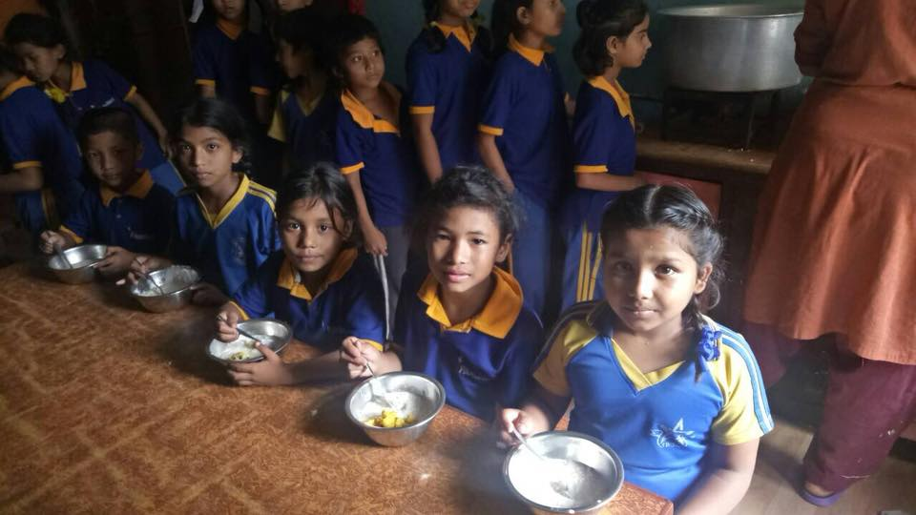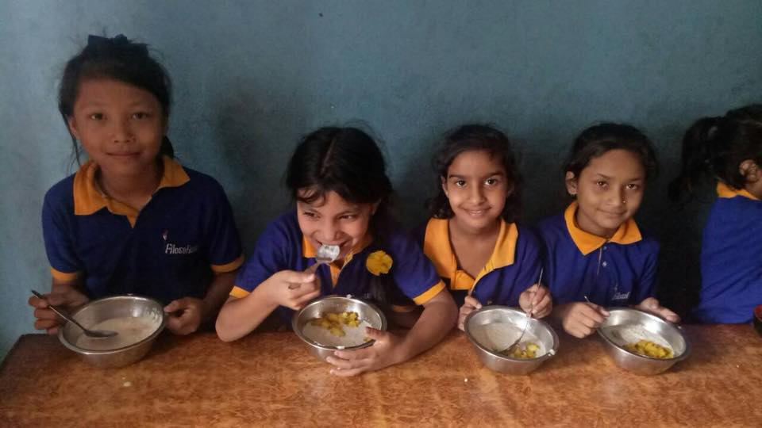

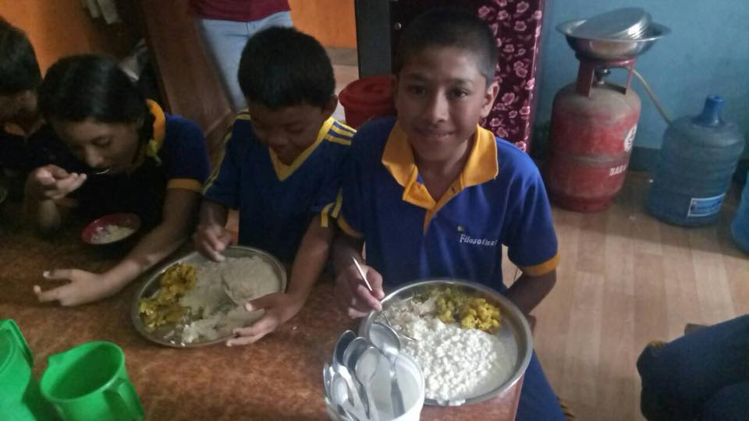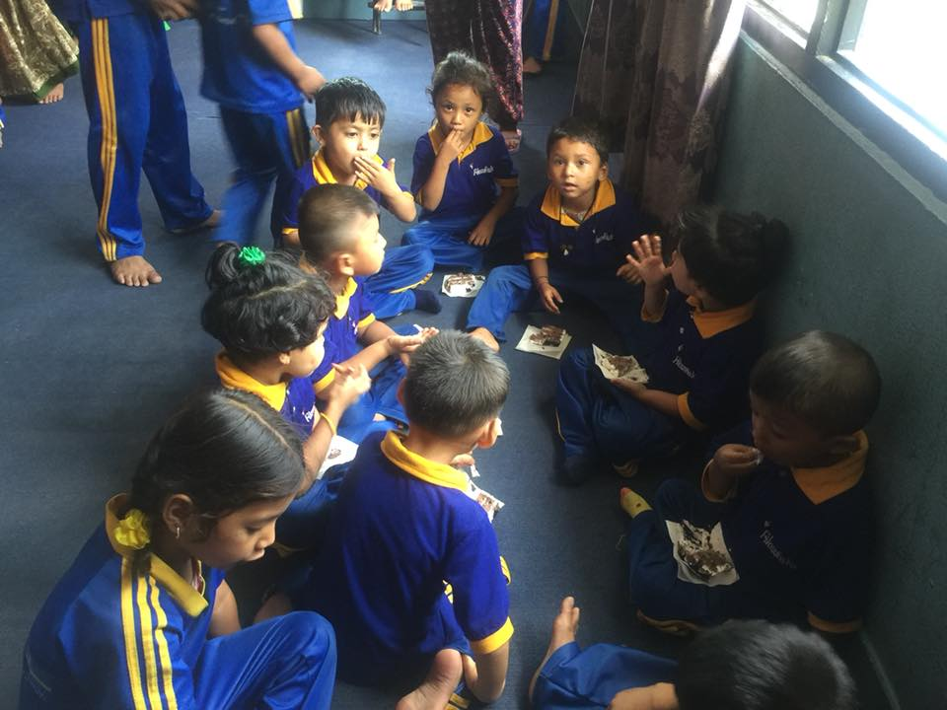

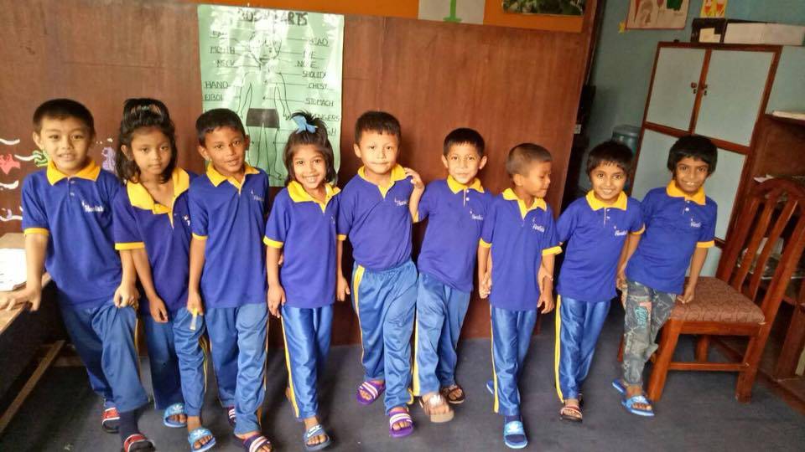
Children from upper kinder garden were happy to get their slippers that they use in school.
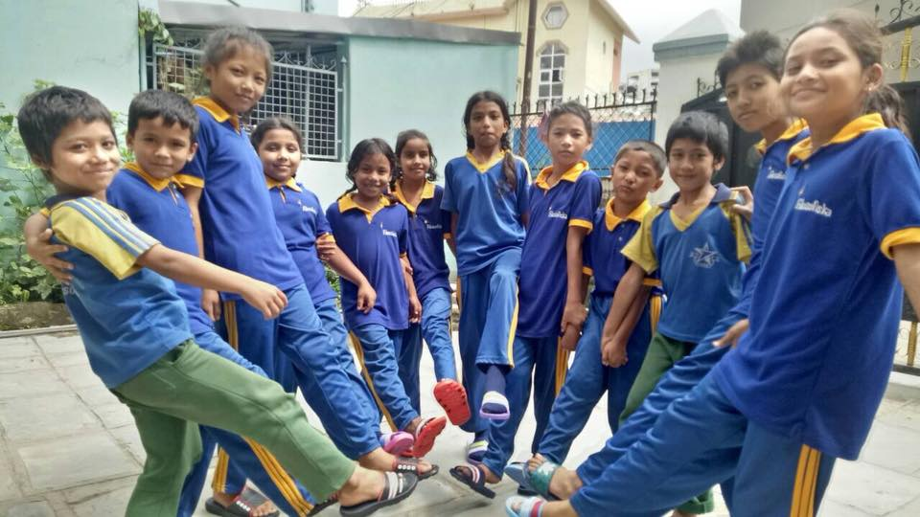
Children from grade one was happy to get their slippers that they use in school.
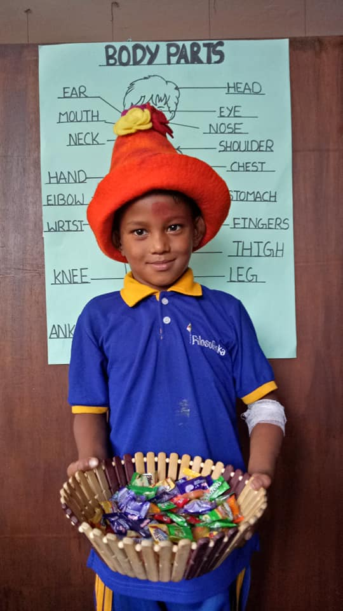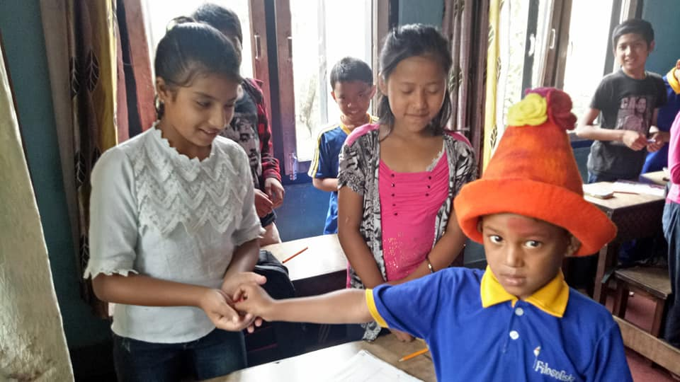
Sushant Pyakurel from upper kinder garden celebrates his birthday with his friends.

