Monthly Progress Report of June 2018
All the staffs along with Emma and grade four students went for hiking in Badeli which is near Kathmandu valley and granary of flora and fauna in this region make a sense to visit there.
Sol Voran from Sydney, Australia visit in Filosofiska Nepal. He spends about an hour with the children. He distributes chocolates to our students. He really likes to spend time with the children.
Grade three students went to Emma house and there they prepare Swedish cookies called “chokladsnittar” for all the students.
We distribute uniform for all the students. They were very happy to receive uniform.
Grade three and four students learned about United Kingdom from volunteer from Anna and Naomi. They know about the neighboring countries, language, food, national animal and many more. They even draw a map and write few lines about United Kingdom.
Swedish Midsummer traditions are thought to have their roots in pre-Christian, sun-worshipping cultures. The time of year around the summer solstice, when the darkness of night is replaced by a magical twilight, would have held special significance for people in northern climes.
Despite later attempts by the church to transform Midsummer into an entirely Christian festival, it’s the pagan symbols that have stood the test of time. Women and young children still put wild flowers in their hair, and communities across the country still decorate phallic midsommarstänger, or maypoles, for people to sing and dance around.
The best known of all the songs performed is Små Grodorna (Small Frogs). Its lyrics (The little frogs, the little frogs, are funny to observe/No ears, no ears, no tails) have very little to do with Midsummer, but nobody seems too worried.
Dancing, feasting, drinking and seemingly endless supply of sunlight, there is lot to like about midsummer in Sweden. This is another big festival on the Swedish calendar after Christmas.
This month we celebrate mid summer on June 22. We went to Raniban community forest to celebrate mid summer. Emma from Sweden explain about mid summer and they play, dance, eats and drinks. Anna and Naomi from London also went with them.

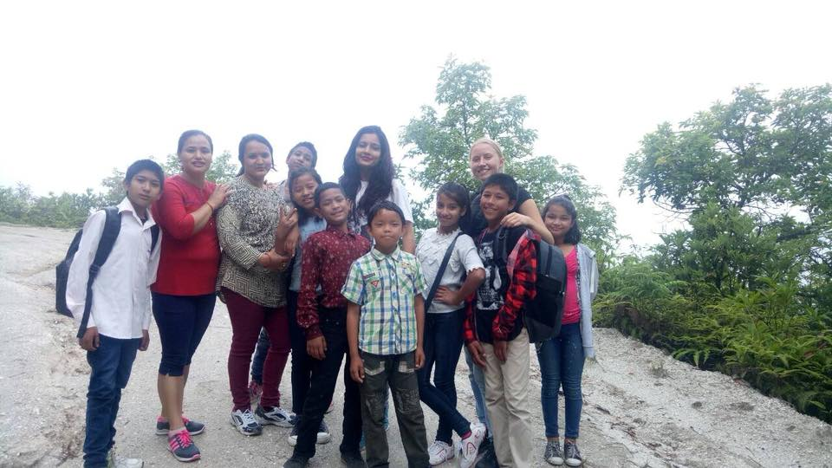
Emma, teachers went to Hiking to Badheli Hills for hiking with grade four students.

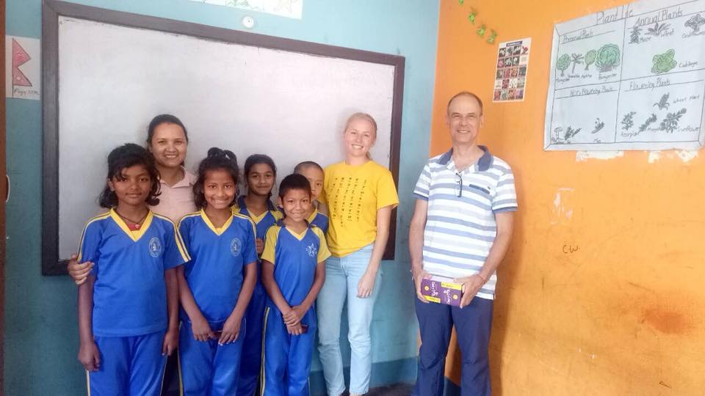
Sol Voran from Sydney, Australia visit Filosofiska Nepal on June 6, 2018.

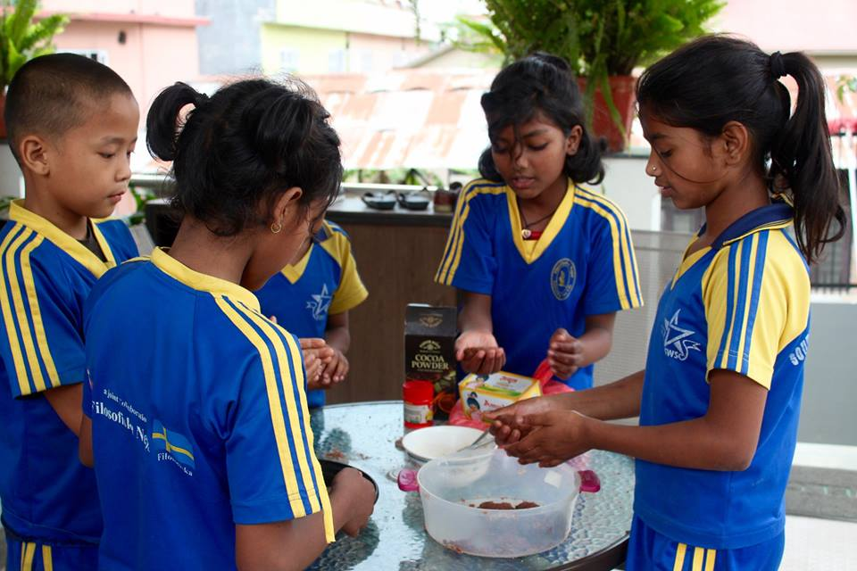
Grade three students went to Emma house and there they prepare Swedish cookies called “chokladsnittar” for all the students.
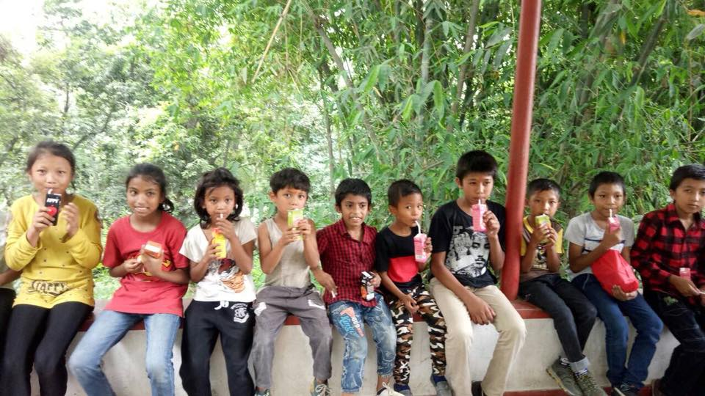
Mid summer celebration at Ranibari Community forest on June 22, 2018.

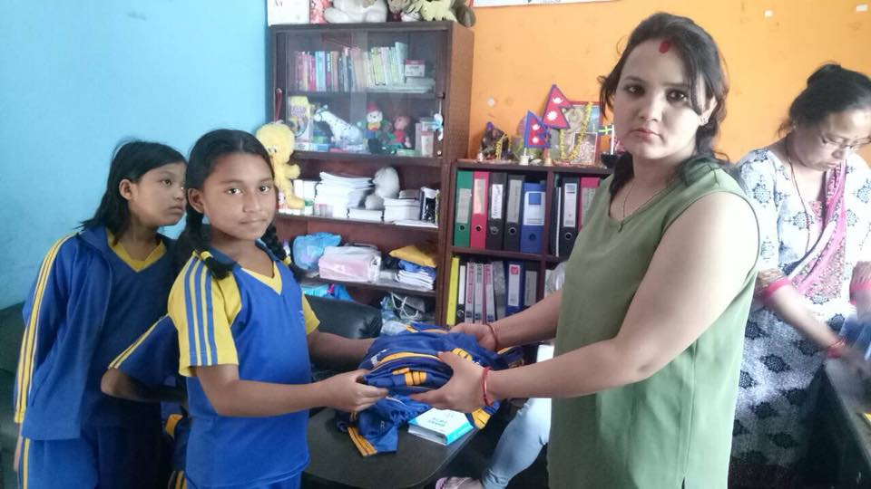
Uniform distribute by Sushma for the students. Thank you so much who has supported us to make it possible.
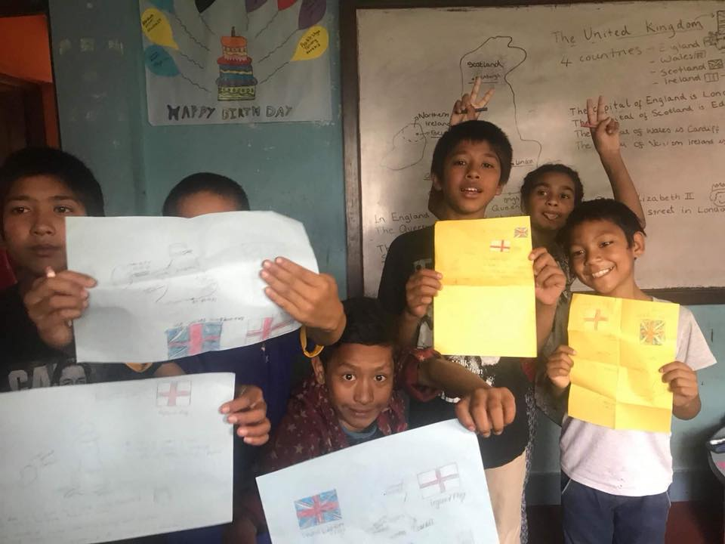
Grade four students learn more about United Kingdom from Anna and Naomi.

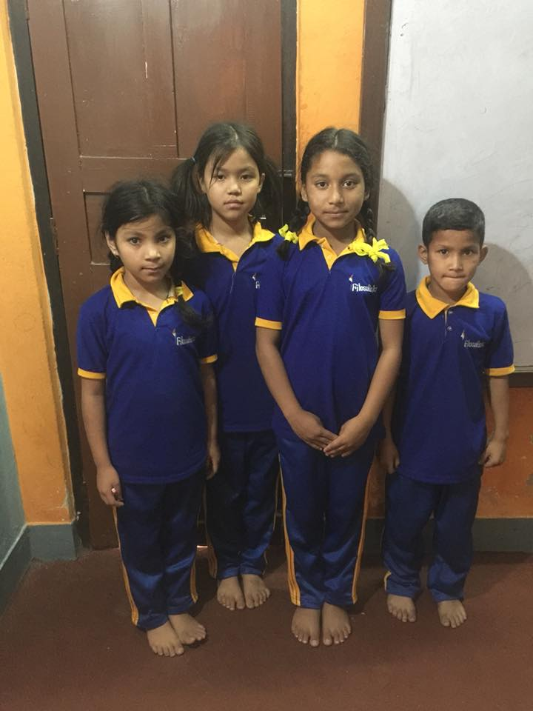
Thank you so much for your continuous support.
Filosofiska Nepal family.

