Monthly Progress Report of September 2018
This month we demonstrate our activities through photos. Sometimes photo speaks more than words. Based on Chinese proverb “one picture is worth ten thousand words” we came to realize that for this month monthly progress report we will share our children beautiful photos.
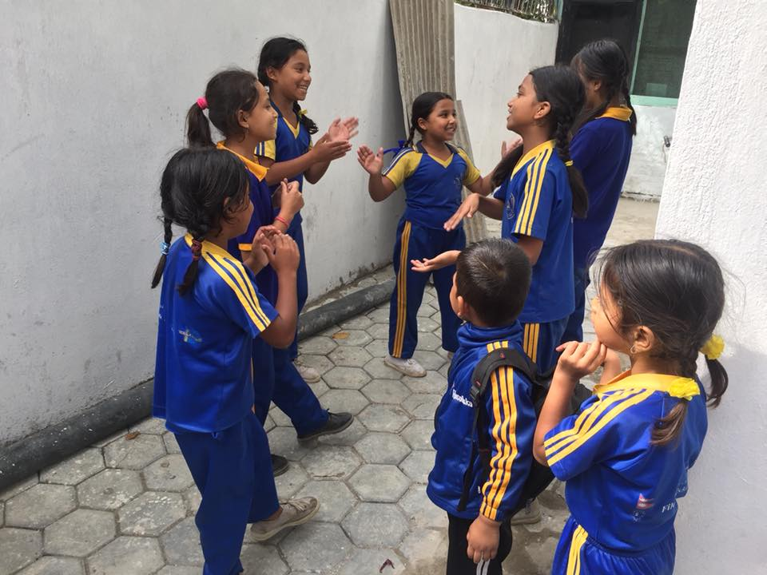
Friendship all about trusting each other, helping each other, loving each other and being crazy together. 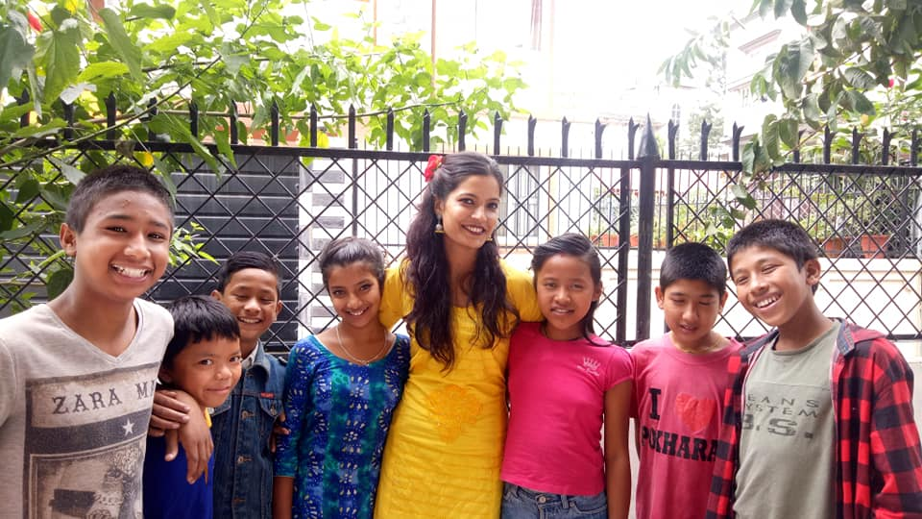

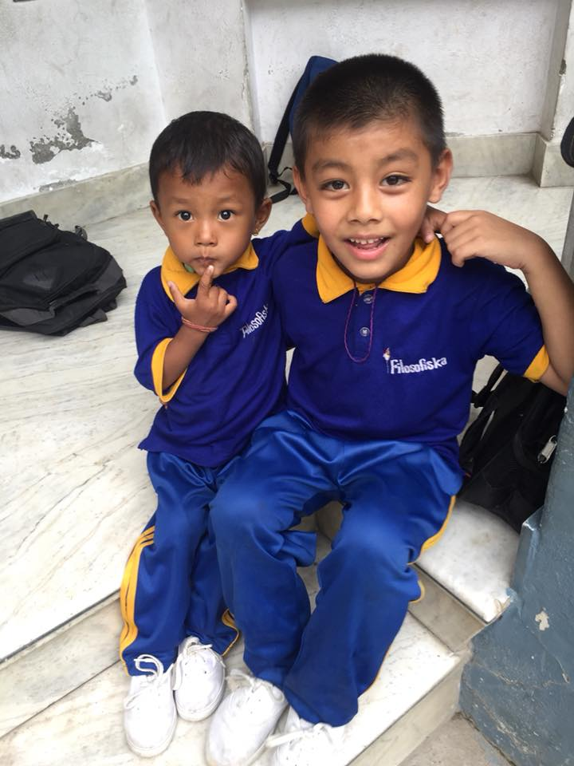

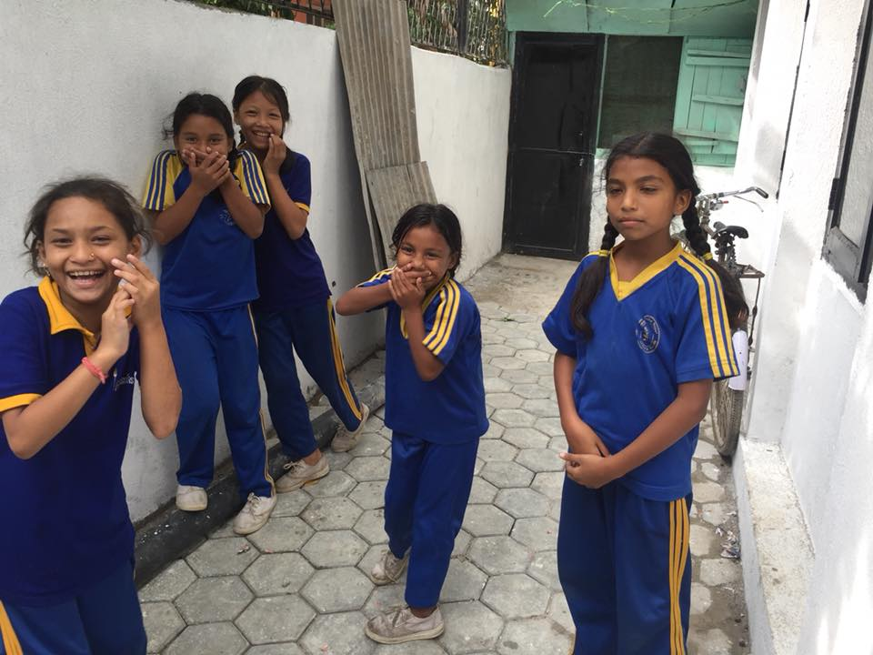
A sweet friendship refreshes the soul, so true saying for these wonderful children.

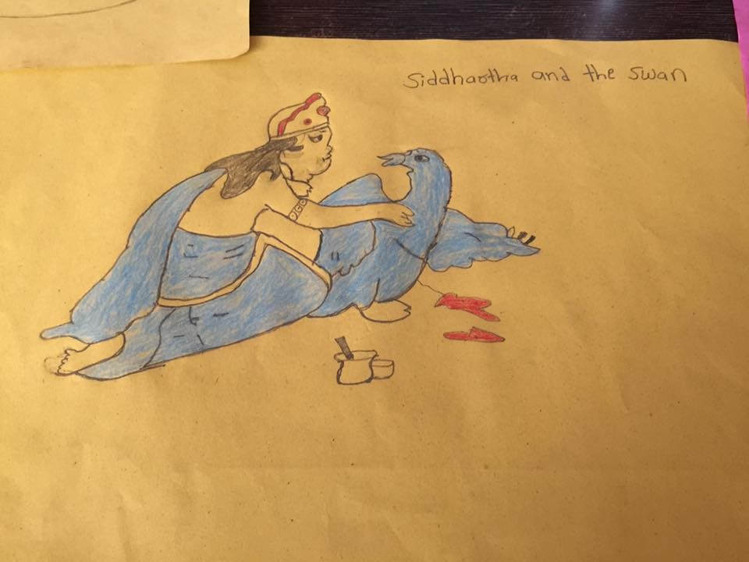
“Siddhartha and Swan” Suman Khadka of class four draw a beautiful drawing.
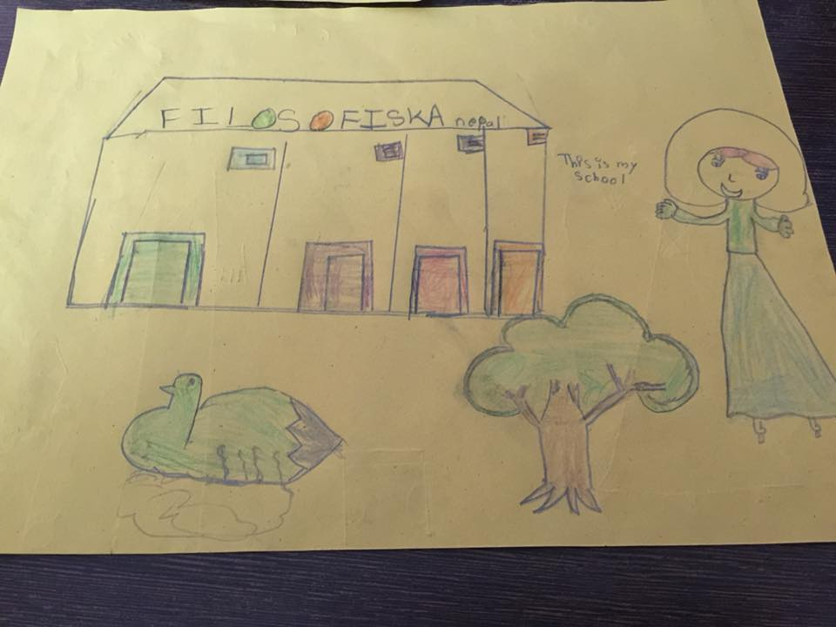
Samjana Tamang from class two draws a beautiful school.
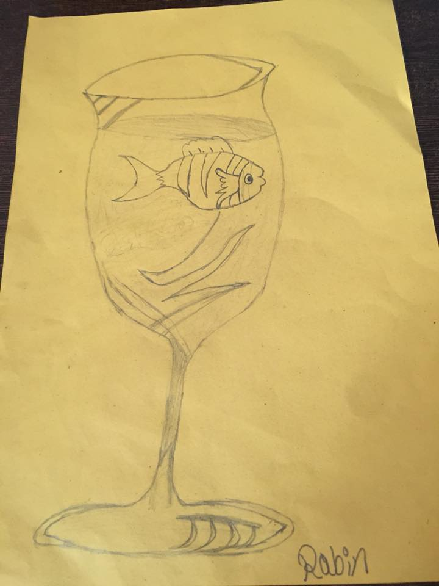
And the winner is Rabin Khadka from class one.
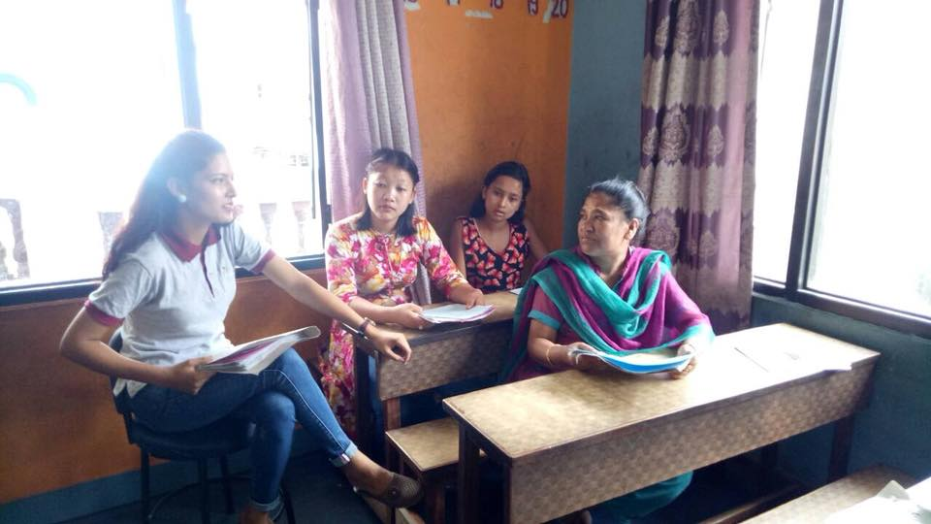
First Term Exam Result distribution 2018. Parents Teacher meeting was also held on this day.
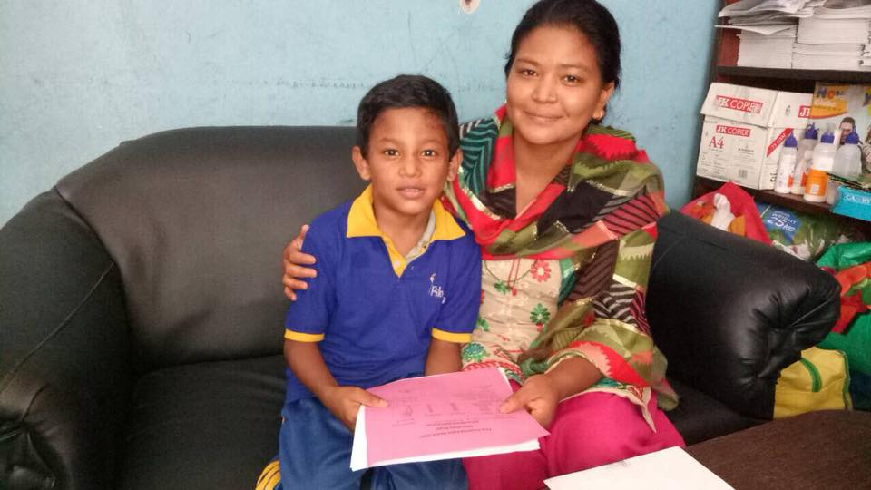

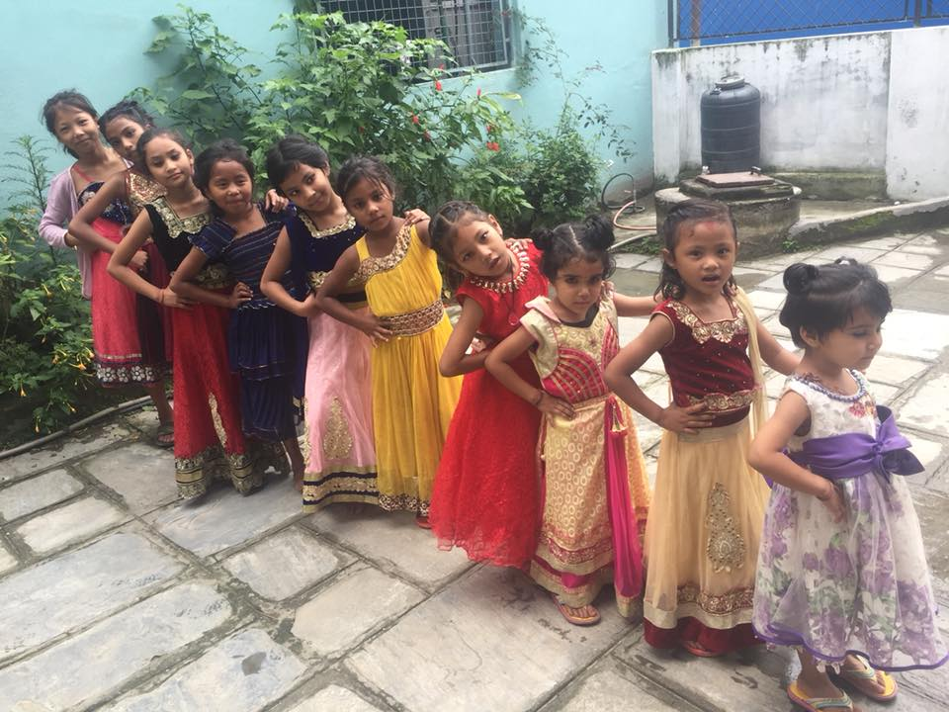
Teej celebration by our beautiful children.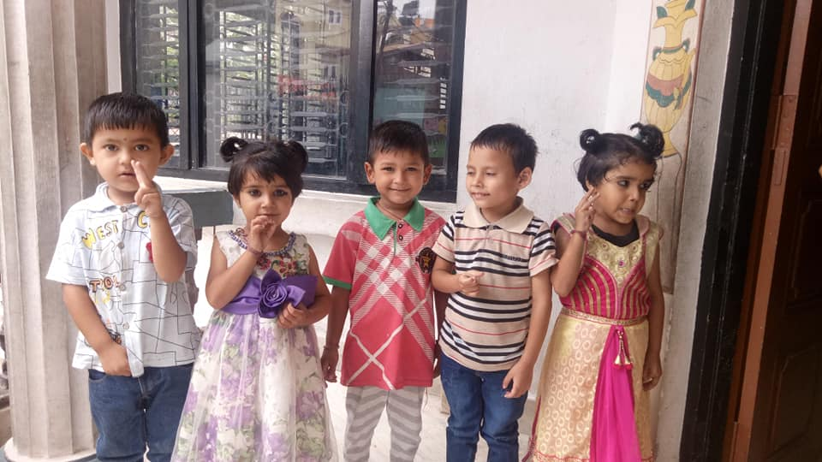

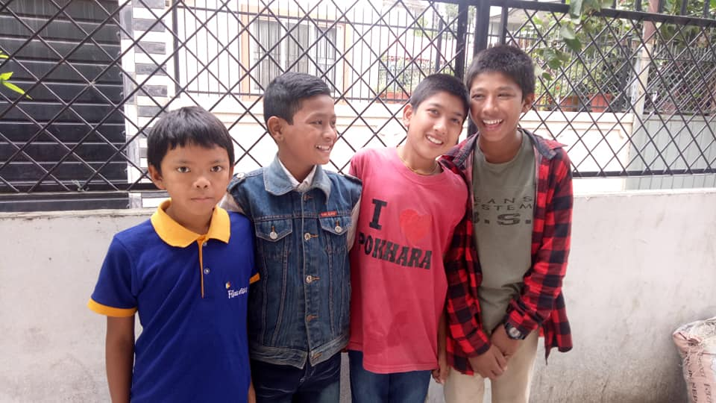
Children sharing beautiful bond with each other.

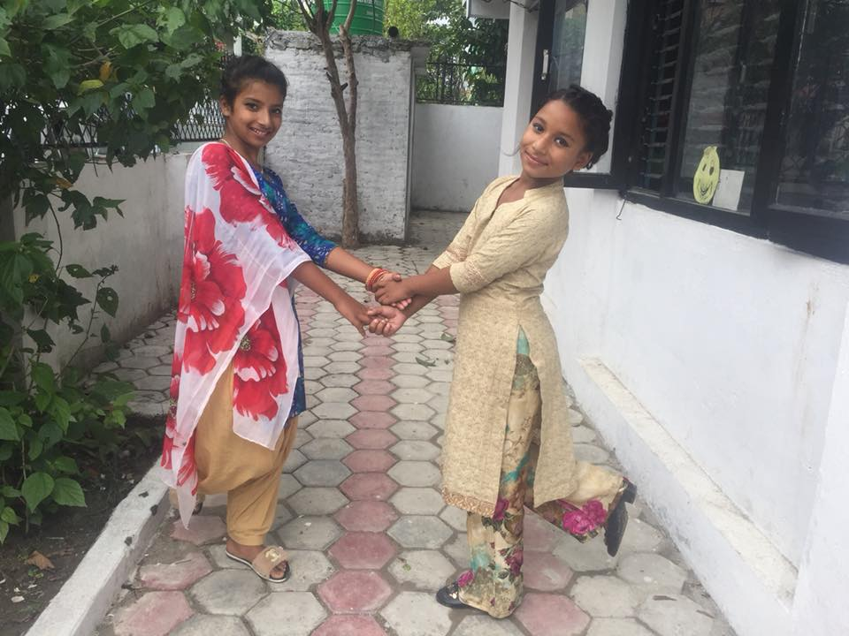

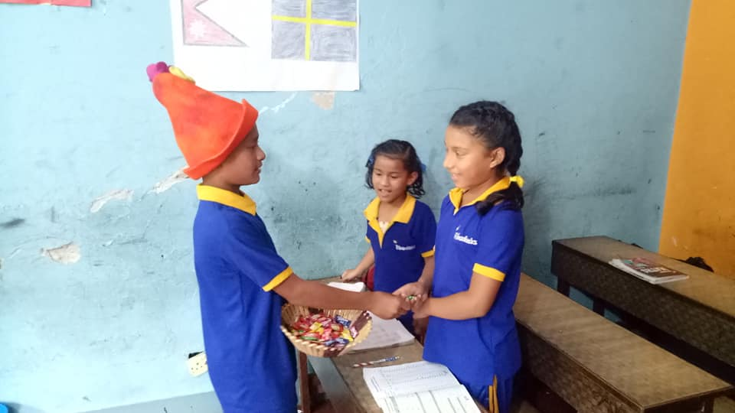
Abhishek Nepali celebrates his birthday with his friends. (Grade four)
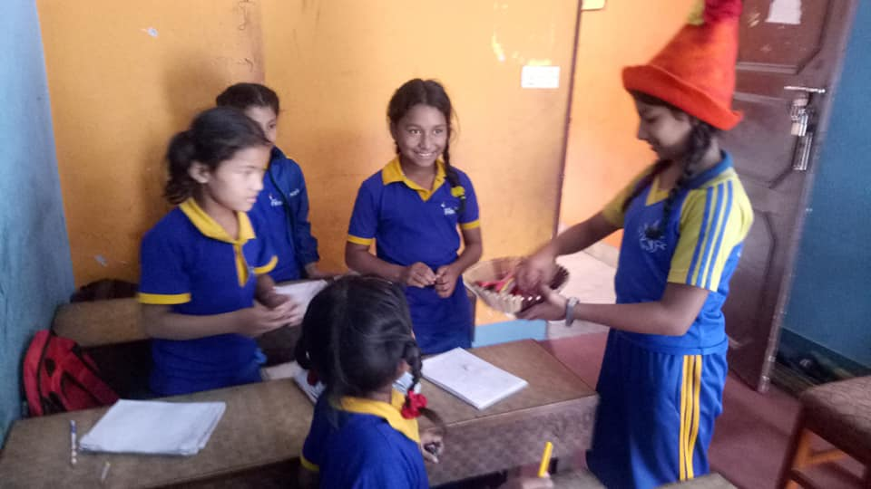
Ashmita Nepali celebrates her birthday with her friends.(Grade four)

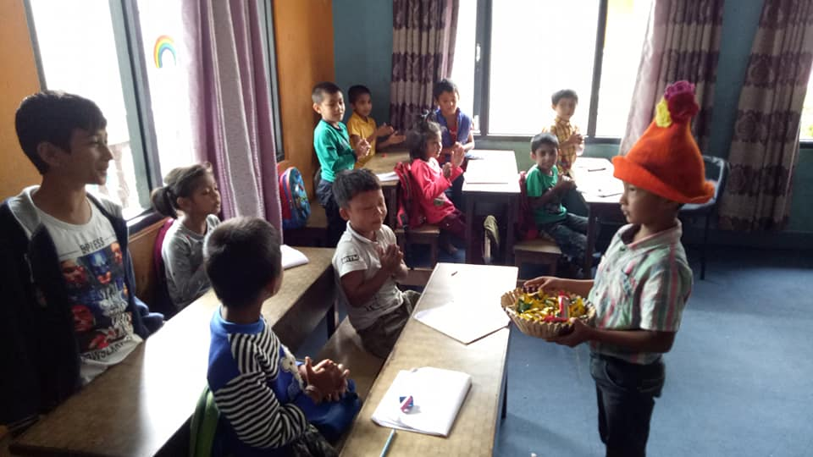
Arjun Nepali celebrates his birthday with his friends. (Grade one)
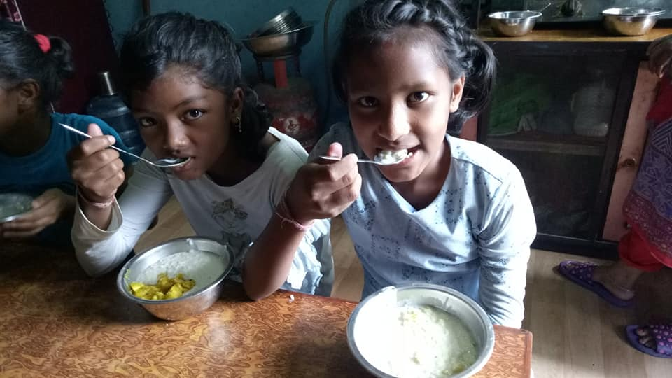
Children had rice pudding and potatoes curry on TEEJ celebrations.

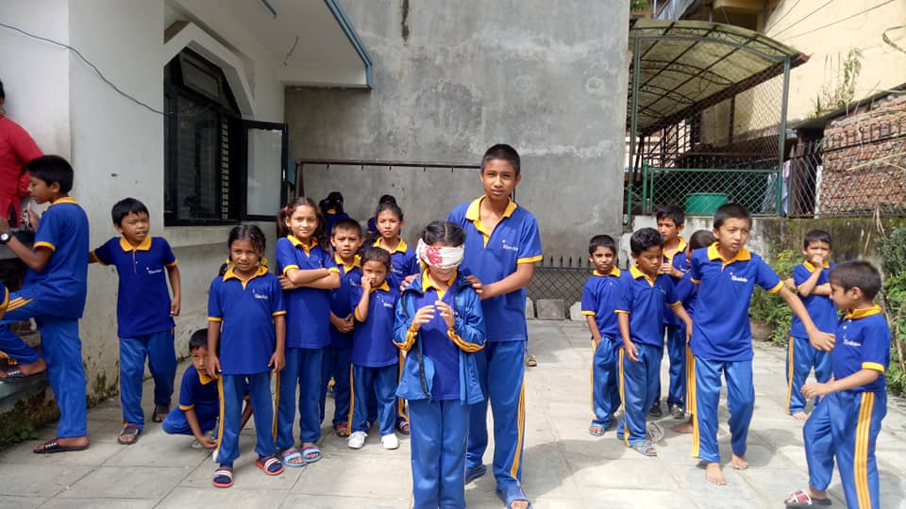
Children day is celebrates in September 14th in order to honor the children and minor. It is celebrates in Nepal and all over the kingdom. This is a day that children get full freedom to enjoy a play. It is a very special day for the children. In Filosofiska Nepal we organize different events according to child age group. At snack time they get delicious food.
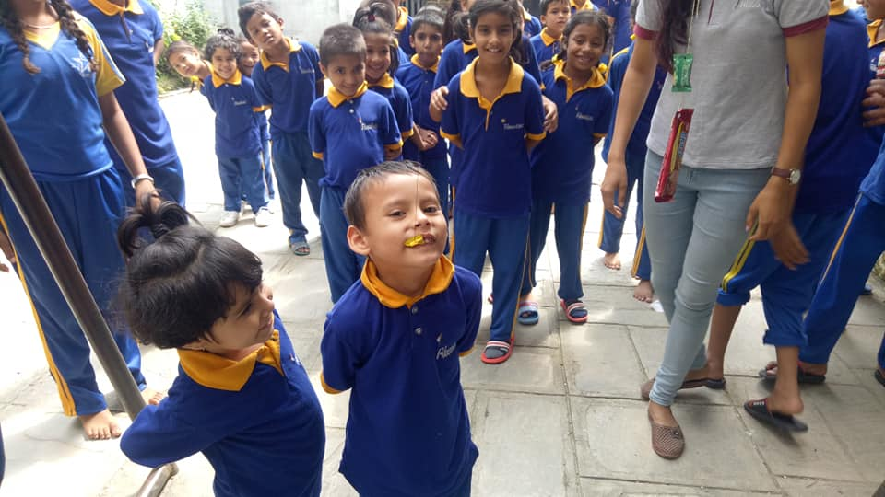

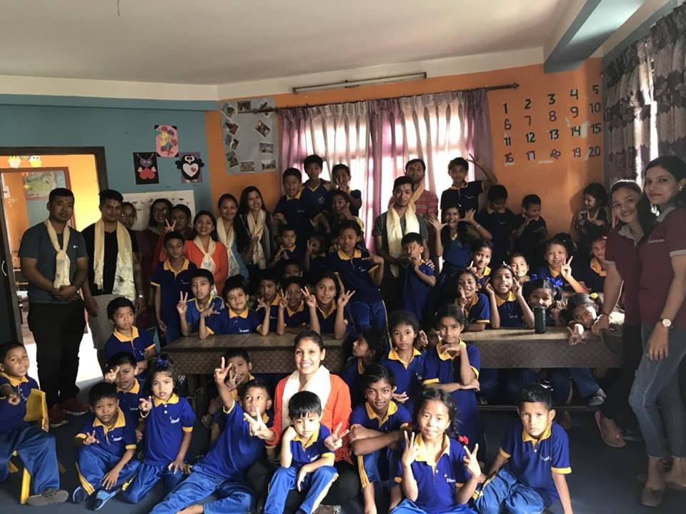
Thank you Haneem, Sandesh,Zaysmin, Suraj, Suren, Bijay, Ramila, Bima , Niru and Ranju for your precious time and the way you serve the delicious food, children enjoyed your games, thank you Ranju for your motivational class, hope to see you all soon.

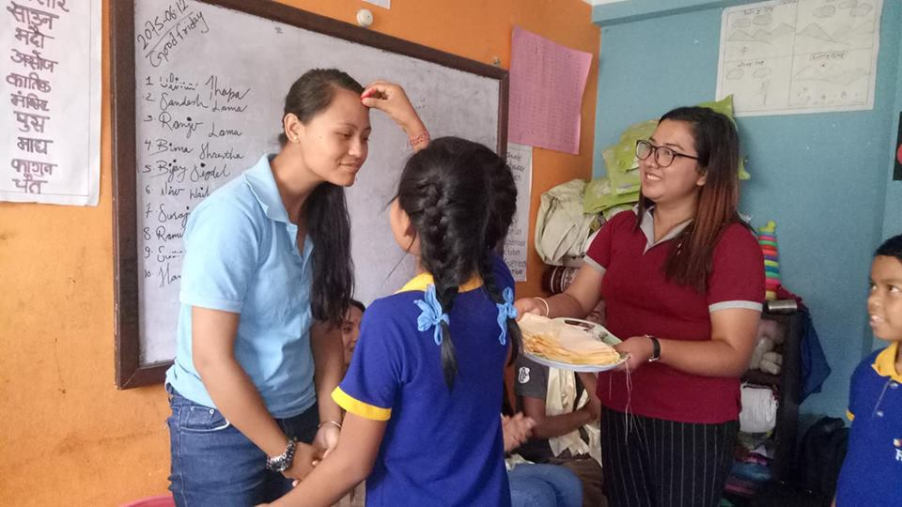
Thank you so much for your continuous support.

