Monthly Progress Report of August 2018
Once again, it is our pleasure to present our monthly reports. The month of August is celebrated as friendship month. Human beings are social creature and have always valued the importance of friends in their lives. To celebrate this noble feeling it was deemed fit to have a day dedicated to friends and friendship. So first Sunday of august was declared as World friendship day. The children in Filosofiska Nepal express love for their friends and cherish their presence in life. On this special day they share their lunch and snacks together. They hug each other and shake their hands.
Our staffs member continue enjoy their full complement of children. The children are continuing to pursue an active interest in our gorgeous outdoor environment. The stamina of the children comes into play and they have risen to occasion very well.
A definite highlight for everyone this month is new toilet and pathway. When children come back from summer vacation they were surprise to see new toilet with more facilities than before. We like to thank you Emma and her family and friends who support us to make it possible.
This month our first terminal exam is also held. Children did their best to get good marks in the exam. After exam we have summer vacation at that time we rebuilt toilet and pathway.
We continue to reflect in our own beliefs about how children learn, what our role is within their learning and how we can best facilitate what we believe to be their individual explorations of their own identify and all that this entails.
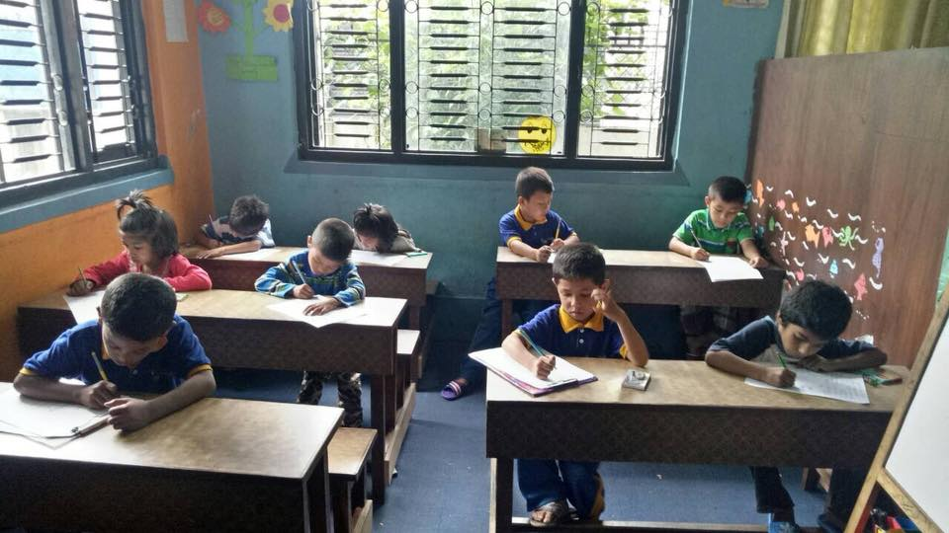
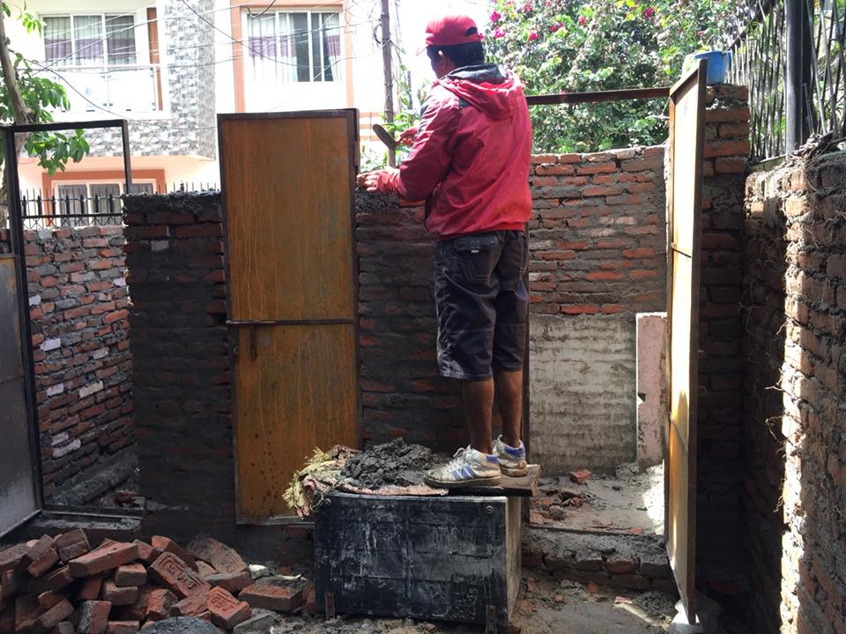
The new toilet was rebuilt with generous effort of people from Sweden. Thank you so much Emma and family and friends for all the support. The children were very happy to use new toilet with more facilities. They feel comfortable and safe in their new toilet.

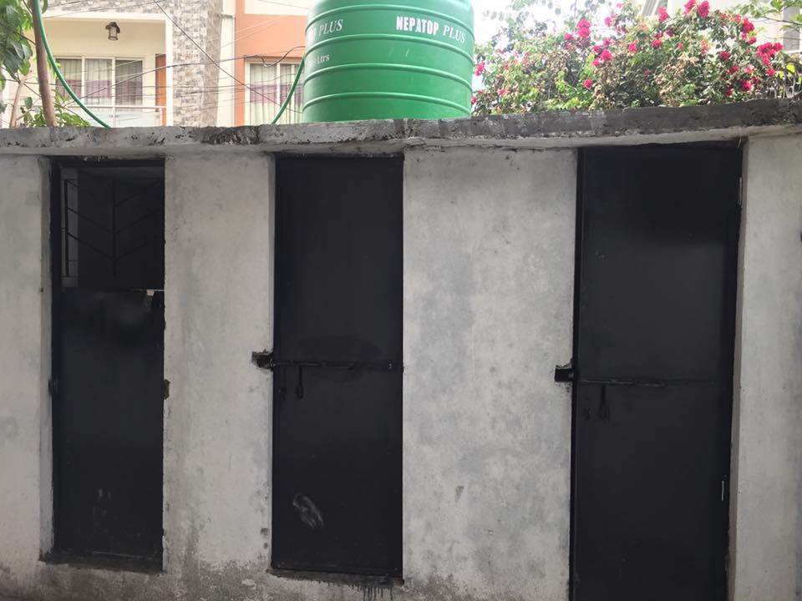

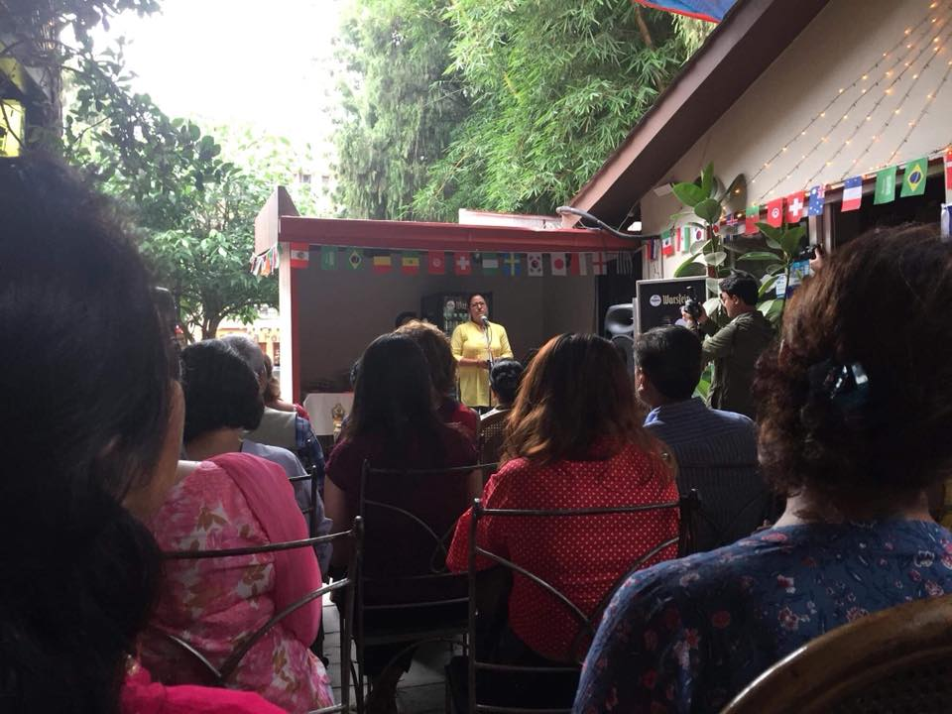
Our coordinator Ms.Rashmi Sharma giving speech about the Filosofiska Nepal in Art exhibition by most popular Artist Mr. Chirag Bandel. The theme was “Love In Colors”. Chirag is artist, writer and poet based in Kathmandu.
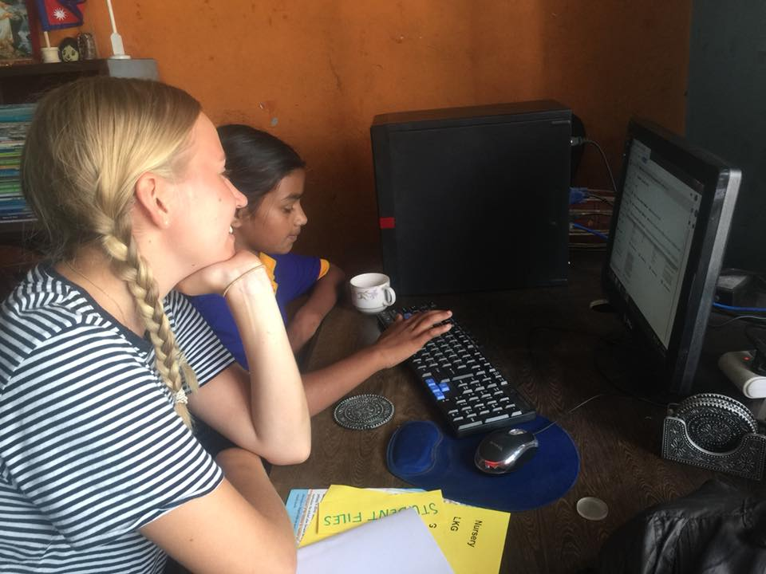
Emma teaches children to have their own email address so that they can write their feelings and thoughts as well. Each of child from class Three and Four have their own email address. They have written to Adam one of the volunteer from Sweden. They feel very excited with Adam reply them back.
Thank you everyone for your generous support.
Filosofiska Family.

