Monthly Progress Report of November 2018
Once again, it is our pleasure to present our monthly reports. November 11 is the first school day after long Dashain and Tihar holidays. In this day Students came to school with great smiles. November is fun month for children. They engage in more activities and meet new people. Children play lots of indoor and outdoor games. One fine day we clean our surrounding and classroom. All the staffs and children were involved in their work.
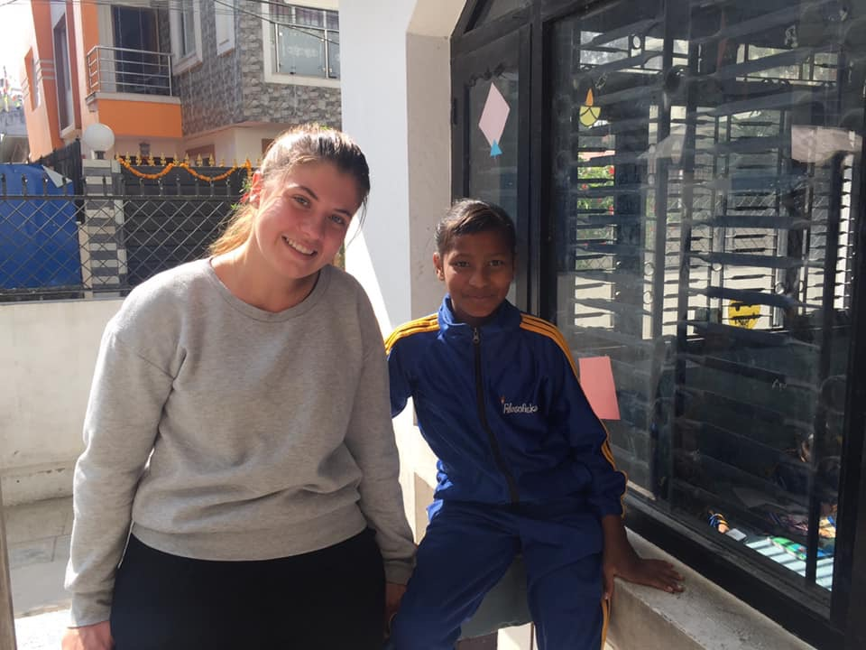
This month we welcome to Mikaela Malmstrom. She is doing her volunteering for two months. She spends maximum time with children. Children are happy to see their new volunteer teacher.
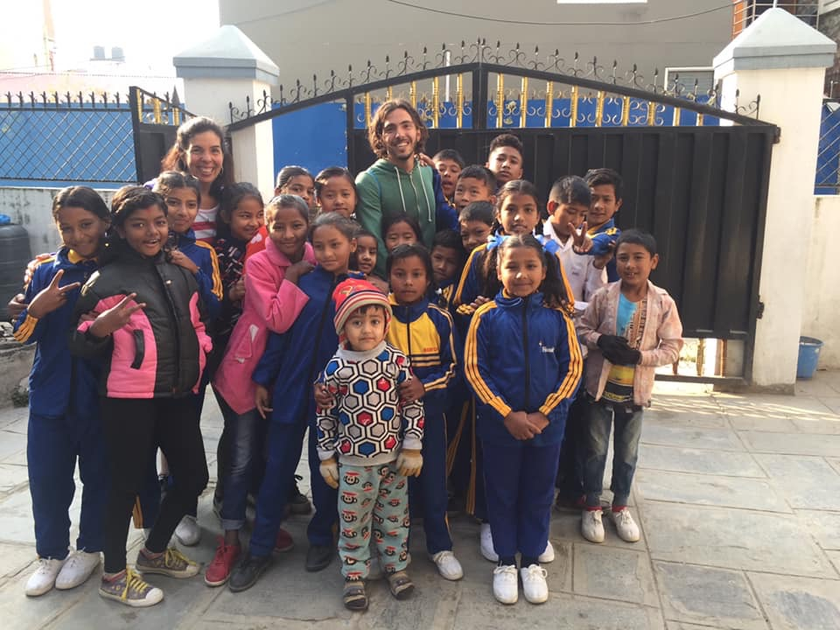
In November we also welcome to Annette and Adam zippis. Students were very happy to see Adam back. It was priceless moment for children. It was really a good bonding between children and Adam. They spend lots of time with children. Children also get closer to them. They learn new things from Annette and Adam. Annette care to students like her children. Children share every thing with her. She stay with us for one week.
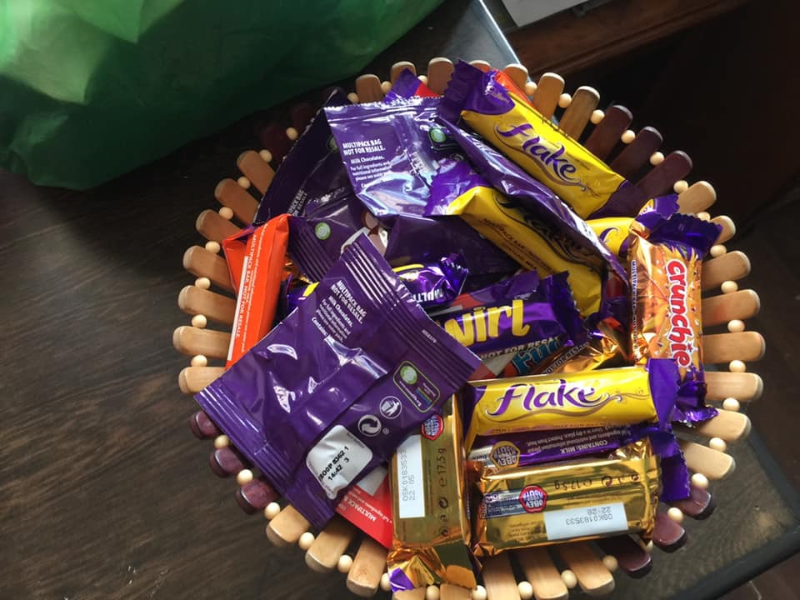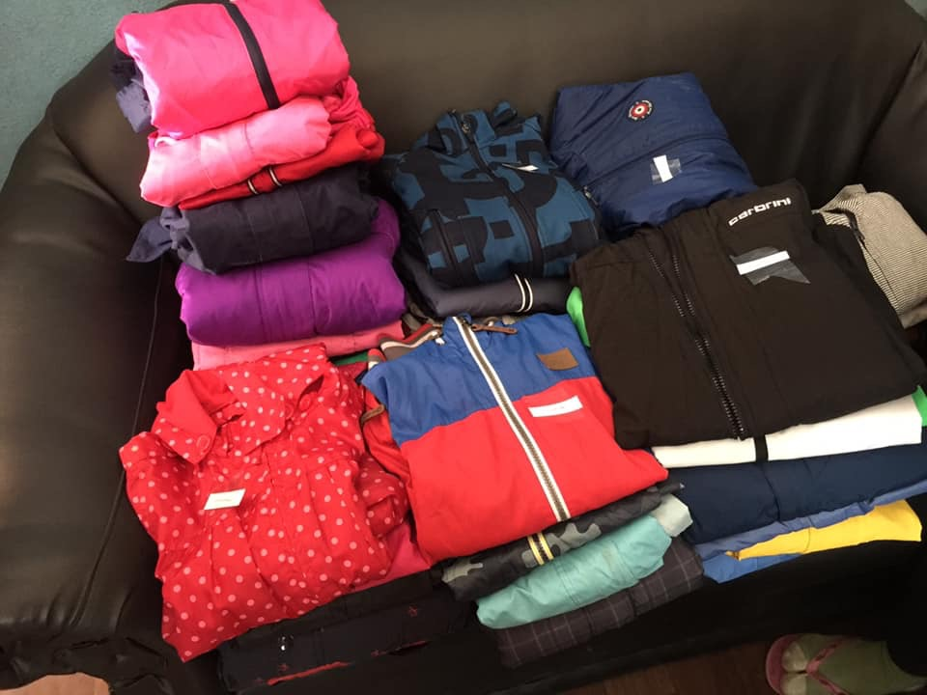
Thank you so much Annette and Adam for warm jackets chocolates.
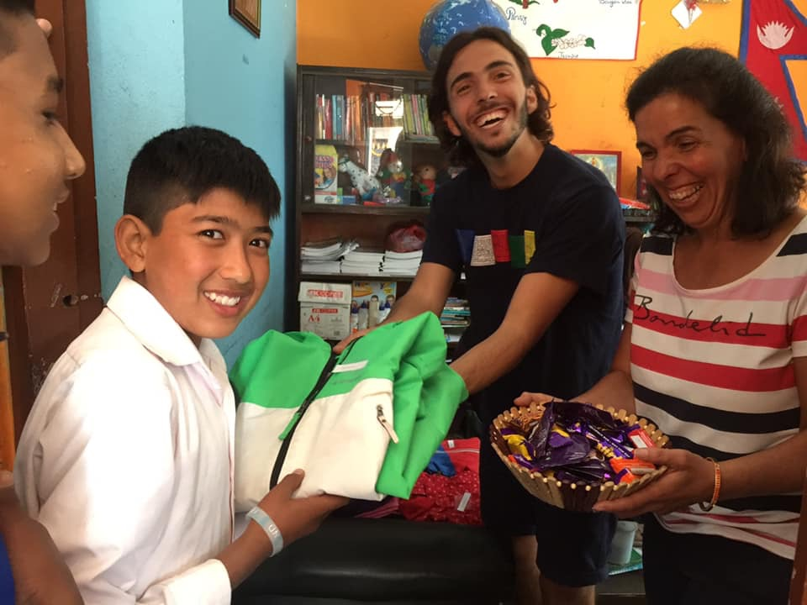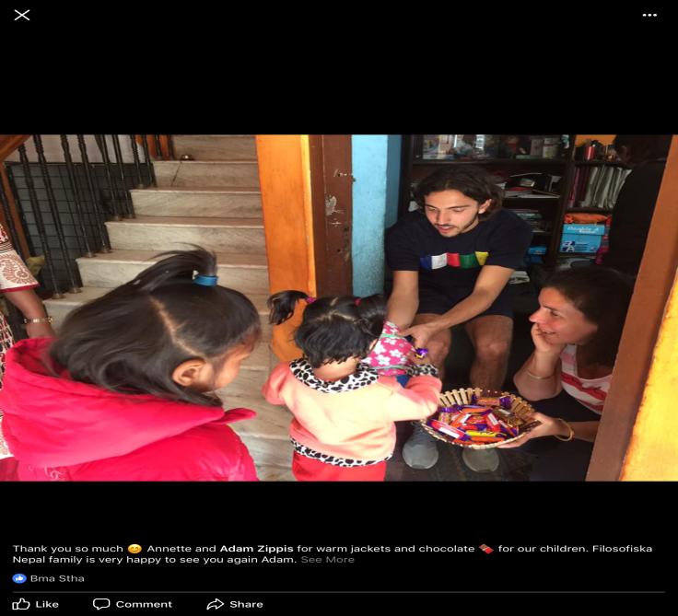
Annette and Adan are distributing jackets and yummy chocolates to children.
November is the fun month for the children. All the Filosofiska Nepal family went to picnic in Nagarkot. Nagarkot is a lovely place where children had lot of fun. We prepare food by our self. Children play swing and different kind of games like hot potato, musical chair etc. Children did lot of dance with their teachers. Annette, Adam and Mikaela spend lovely time with children and support us.
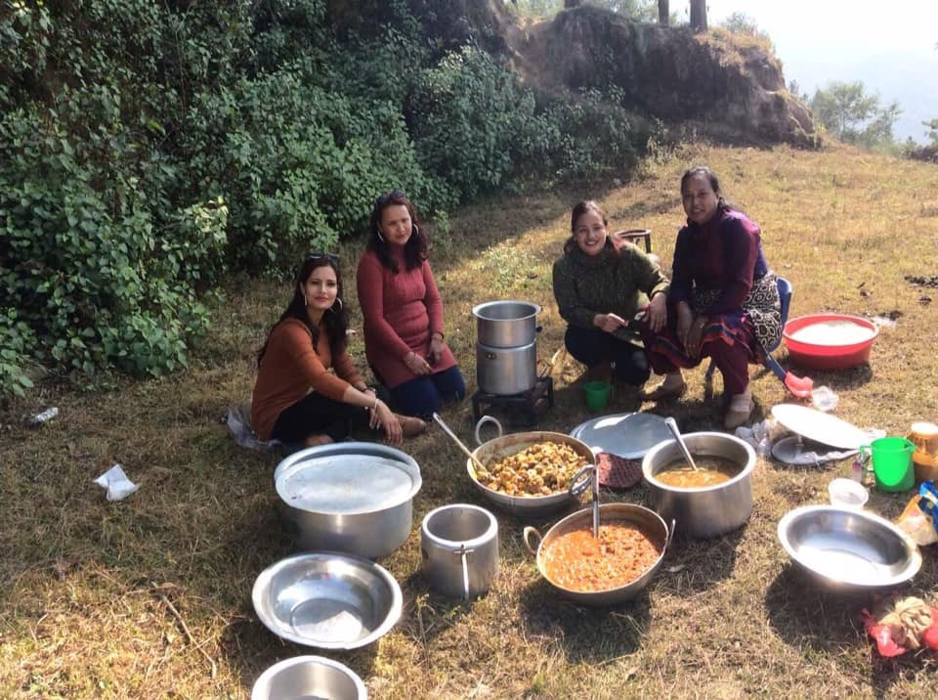Staffs are preparing yummy food in picnic at Nagarkot.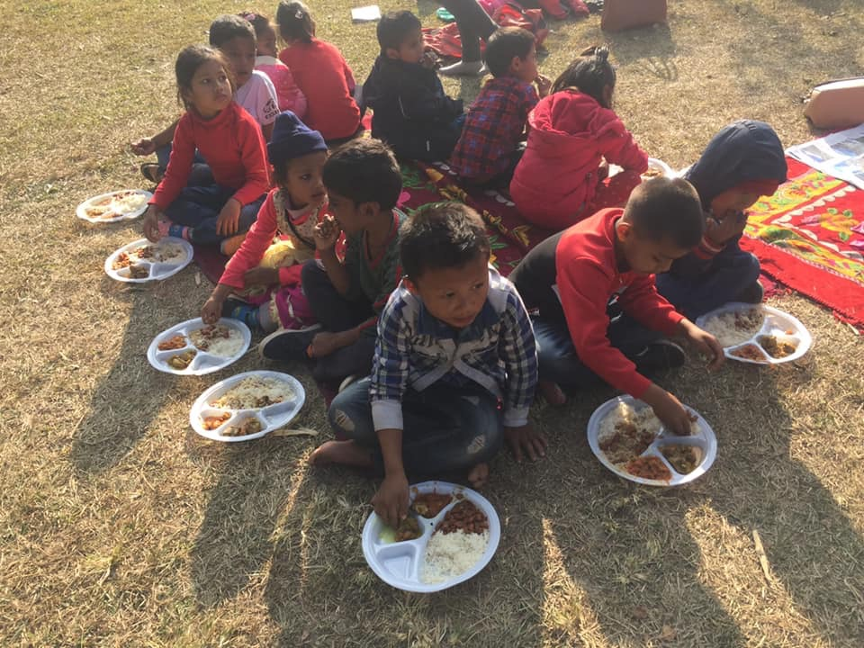Children are having their lunch in picnic.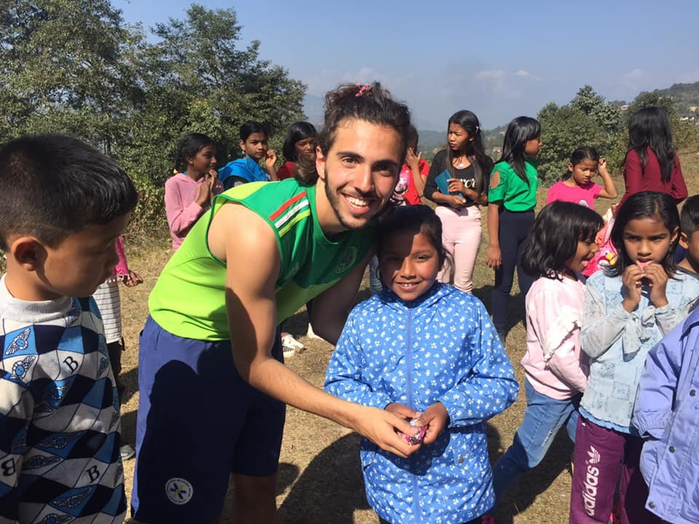
Adam is distributing prize to Alisa from class -2 after won the game. Thank you Annette and Adam for sponsoring this much enjoyed picnic.
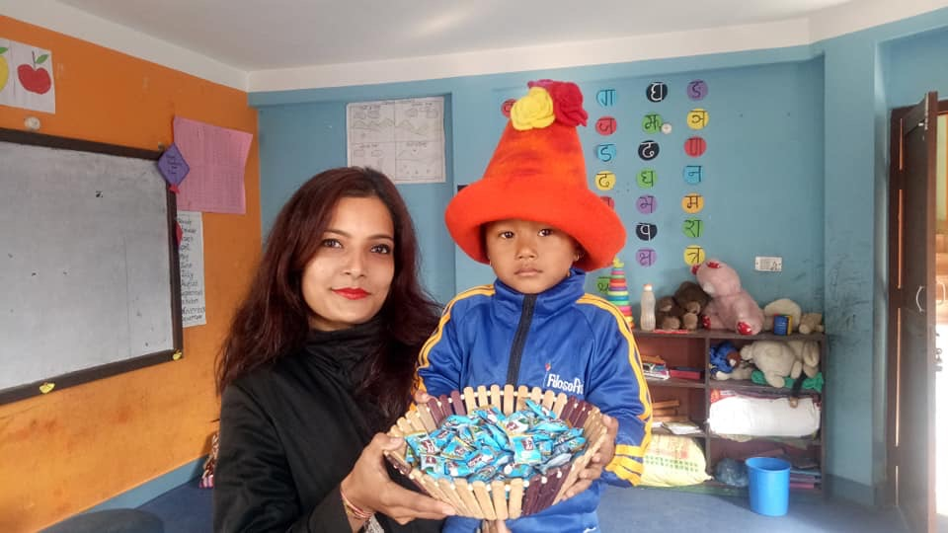
Happy birthday Samir Chaudhary from play group.

Home visit with Annette zippis, Adam zippis and Mikaila Malmstrom . we spend a beautiful day with lovely children and their parents.
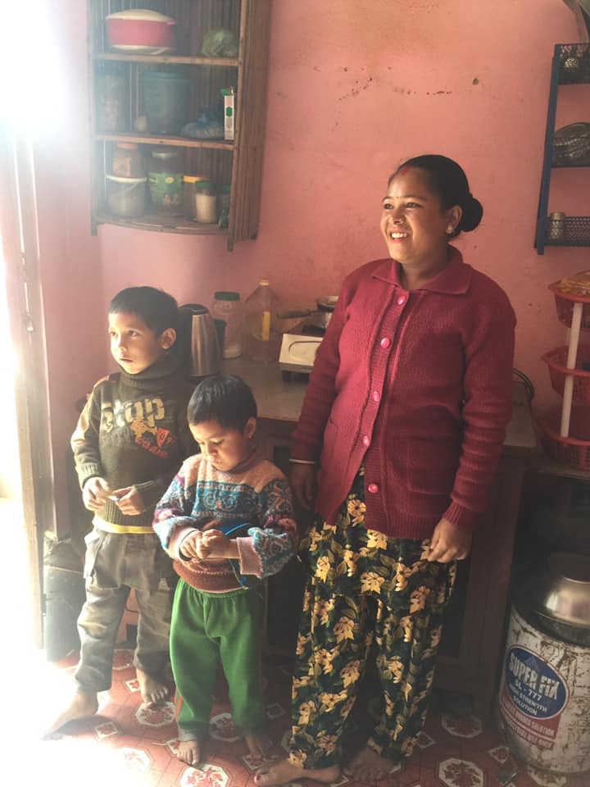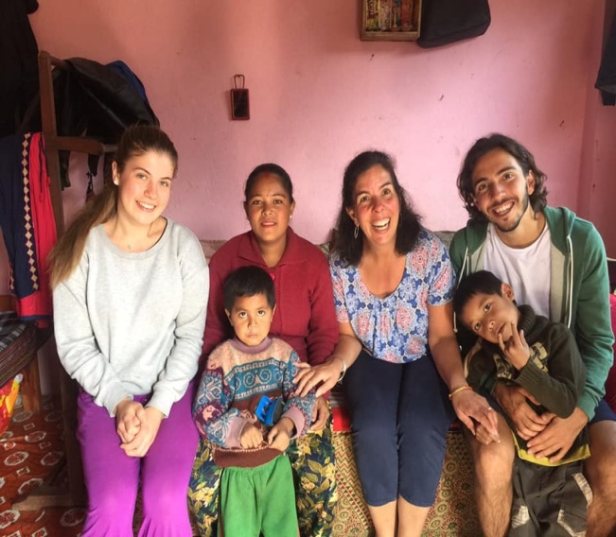
Buddha and his brother Sadin Bayalkoti with her lovely mother.
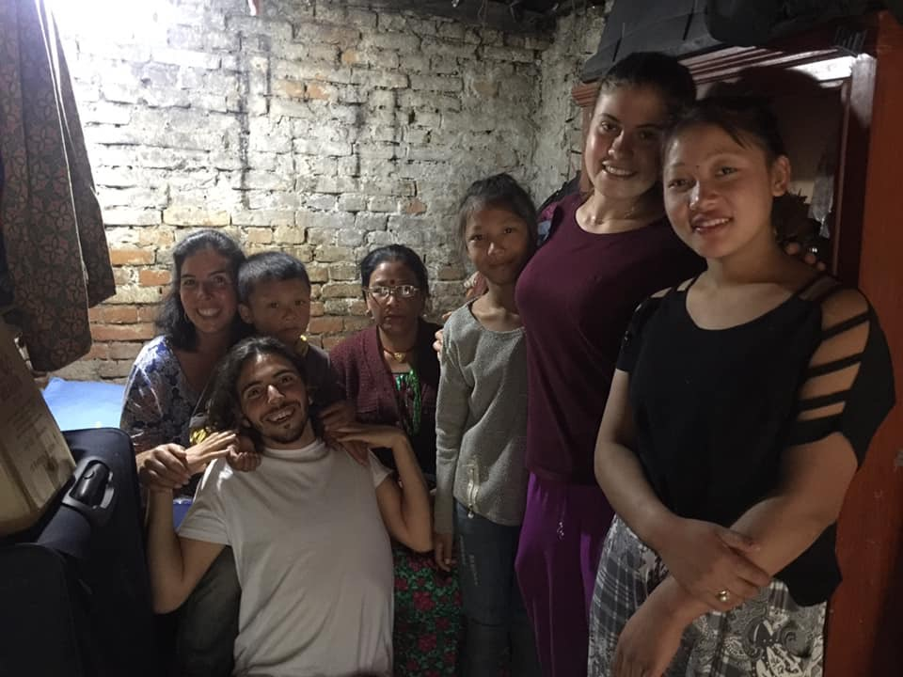
Sumitra and Dikesh Ghalang with their mother and elder sister.
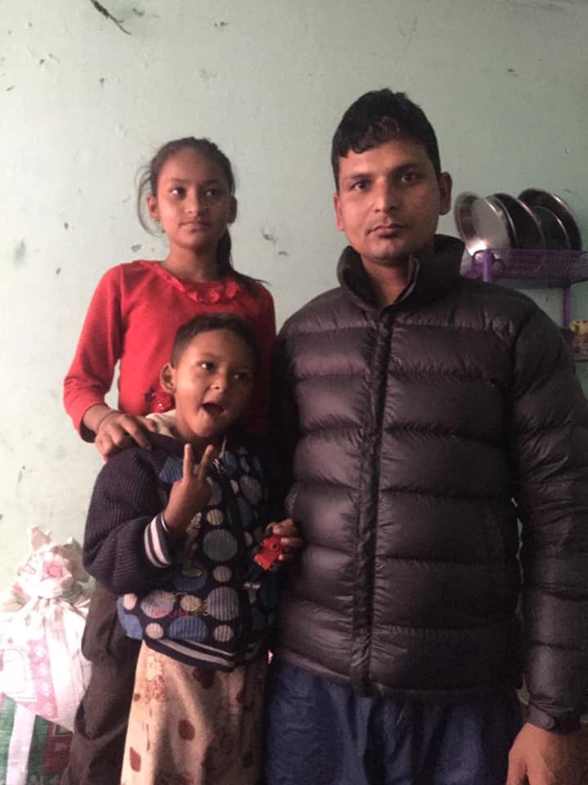
Sujina and samir Nepali with their father.

Students from grad four and three made Swedish chocolate ball with help of Annette and Mikaela. This is the third time children made chocolate ball. They love the taste of chocolate balls. Making chocolate ball is always fun for them.
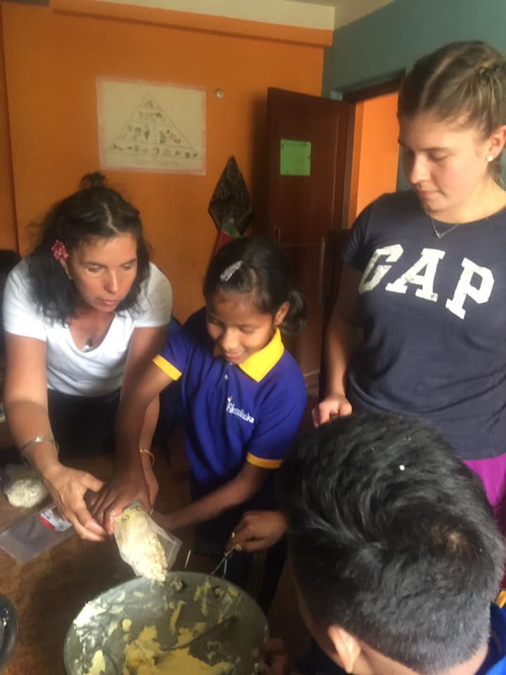
Siwani and Milan are making Swedish chocolate balls with the help of Annette and Mikaela.
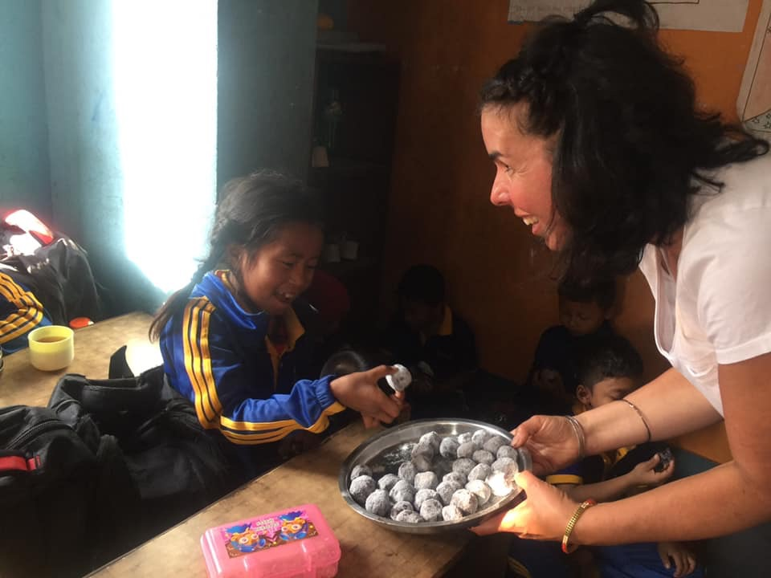
Wow! Swedish chocolate balls again. Annette is distributing chocolate balls to Samjhana Tamang.
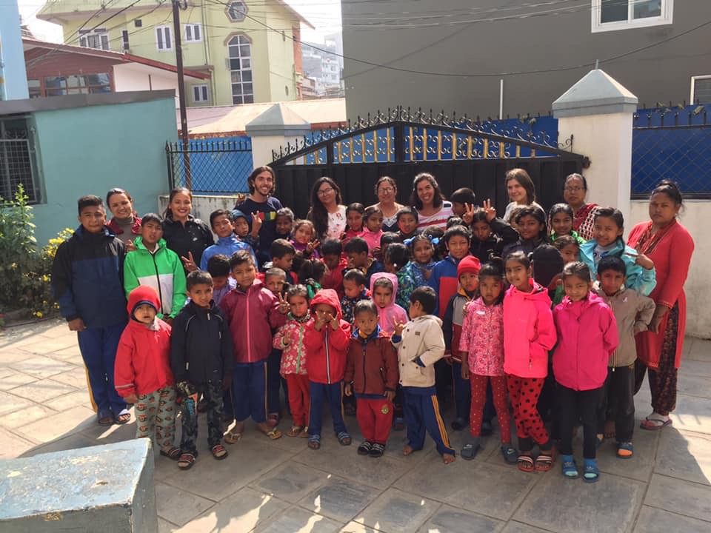
Bye! bye! Annette and Adam hope to see you both again.

