Monthly Progress Report of October 2018

The first parents' teacher meeting of this session was held on October following by tea program. Meeting is held between parents and teachers of students to discuss a child's progress at school and find solutions to academic or behavioral problems. This is great opportunity for parents to meet the person their child is spending a large portion of their time with.
In Filosofiska Nepal at present we have five teaching staffs member who were actively teaching the child about behavioral and academic problems. We believe that strong partnership between the home and school will help and succeed in school. In meeting our teacher welcomes inputs from the parents about their children such as information about what the children likes to do or what they are good at. We conduct meeting class wise and focus more on the students who were weak and need some counseling.
On request of parents this year we gave one month holiday in school. Most of the parents went to their hometown to celebrate festival. Dashain festival is one of the most important Hindu festival which is celebrated all over Nepal delightfully. This festival usually falls in the month of September or October and actually celebrates 15 days. It starts from bright lunar fortnight and ends on the day of full moon according to Nepalese annual calendar. Hindus greatest festival, Dashain honors a great conquest of the gods over the evil dreams. The symbol of power goddess Durga is worshiped during this festival.
The festival is in fact the ceremony of reunion and fun. People living far away from home or homeland revisit their home and get together with their families. Similarly, parents buy new clothes to their children. People enjoy eating mouth watering foods and playing a lot of games including cards. People invite guests, organize feast, visit their relative's houses, fly kites, build bamboo swings and get involved in various entertaining activities.
The school remains close from 10th October to 11th of November. Teachers prepare home assignment for the children so that they will enjoy festival as well as give some time for the study. Before dashain holiday we teach them about our culture and tradition. We also celebrate dashain in school as well.
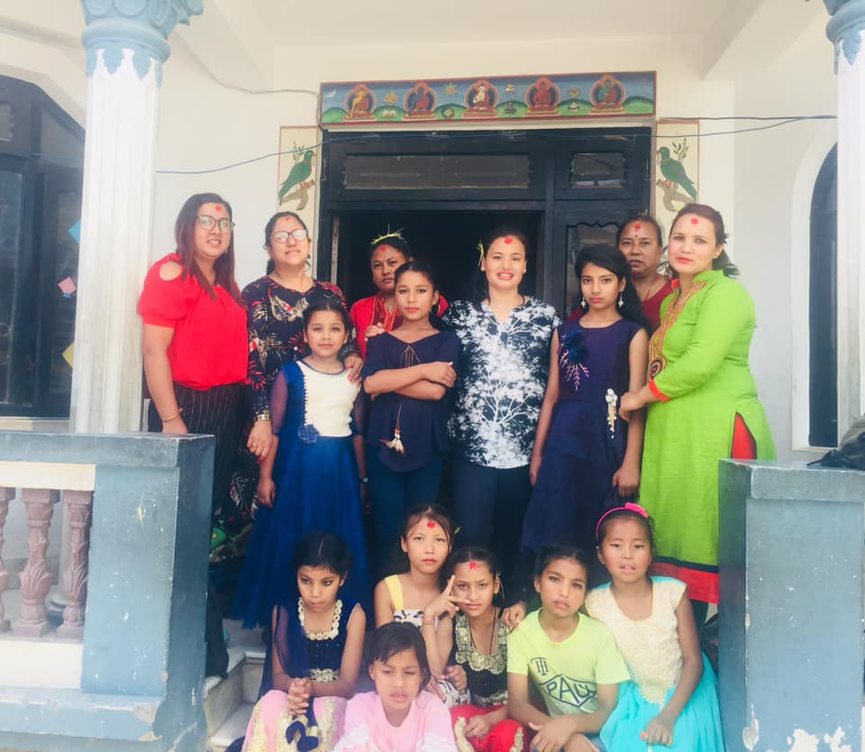
Students celebrate Dashain and Tihar celebration in school with teachers.

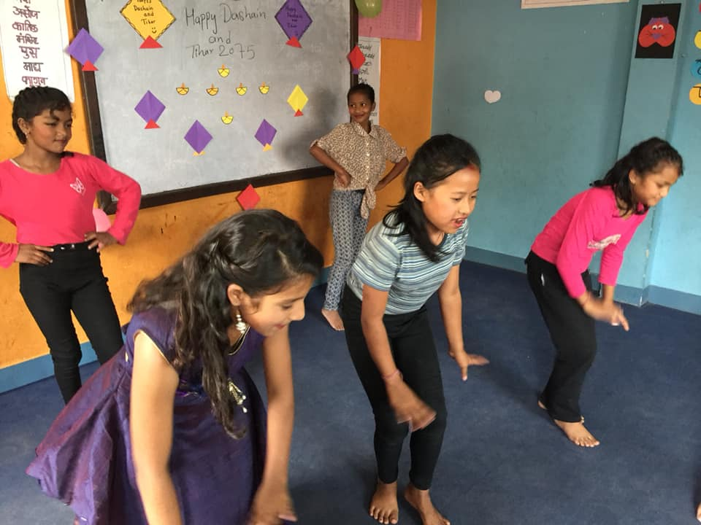
Our beautiful girls performing dance in dashain and tihar celebration in school.

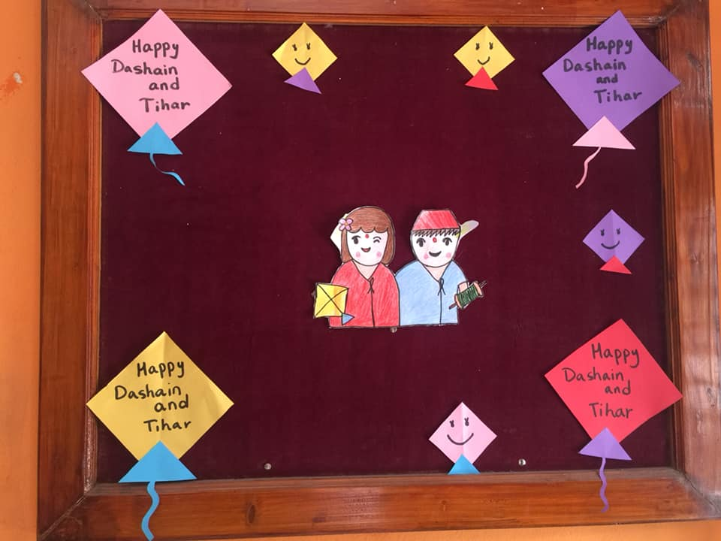
Teachers decorate the notice board with wonderful greetings of dashain and tihar 2018.
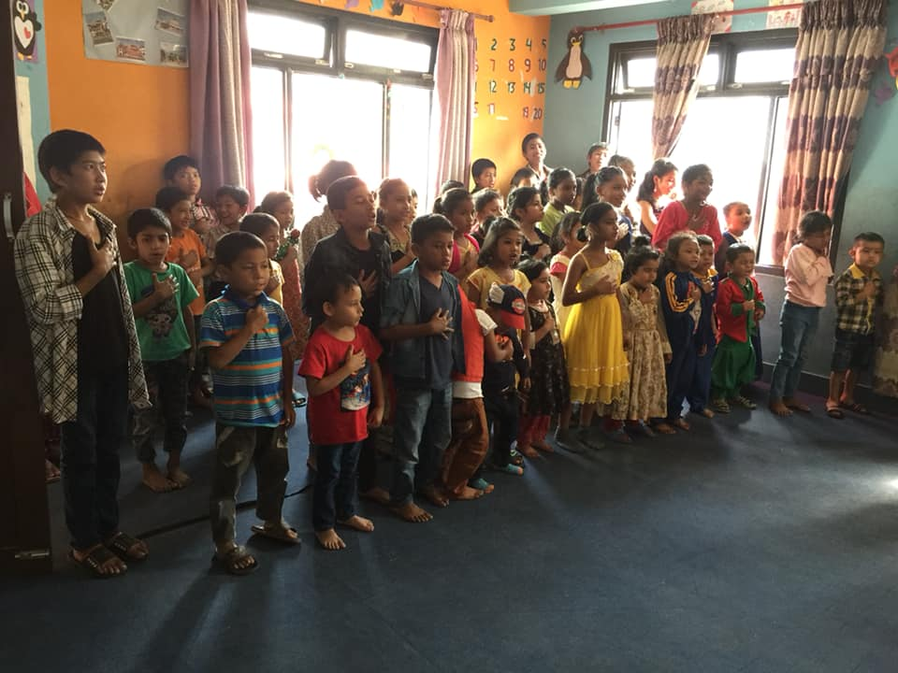
Our Progressive nation, our nation, our pride. Nepal's new national anthem represents the entire nation and all that is proud and glorious in it. Every morning our student sing national anthem which usually speaks of the history of the country, its traditions and the struggles of its people. National anthem celebrates the diversity and unity of the people who follow the nation with pride and confidence.

