Monthly Progress Report of April 2019
This month we came to end of the session. The final exams were hold from 31st of March to 5th of April. All the children appeared in the examination. They all did their best to secure good marks in the exam. They all concentrated during the exams and filled out their papers in silent. These were the last exams for our class four since they all were graduating from Filosofiska Nepal and are moving on to other schools.

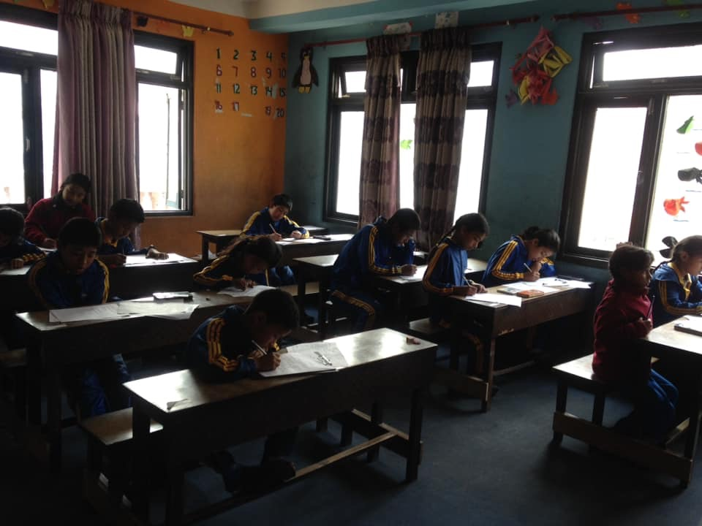

Students are concentrating during the exams.

The students are examined in the subject Computer. Ten marks out of 50 are practical. In the practical examination the students made pictures in the program “Paint” and wrote texts in “Word”. 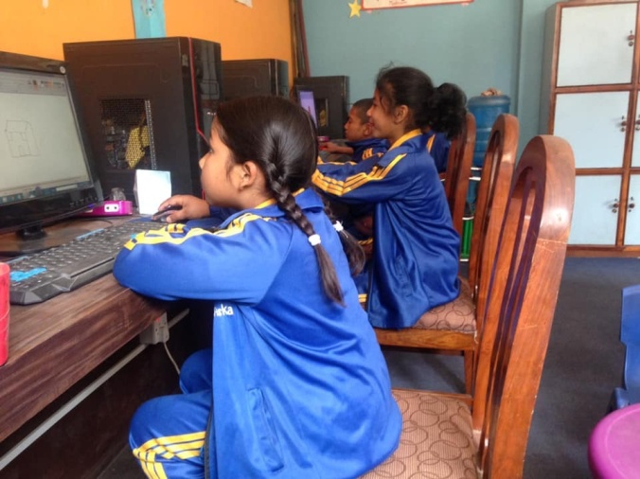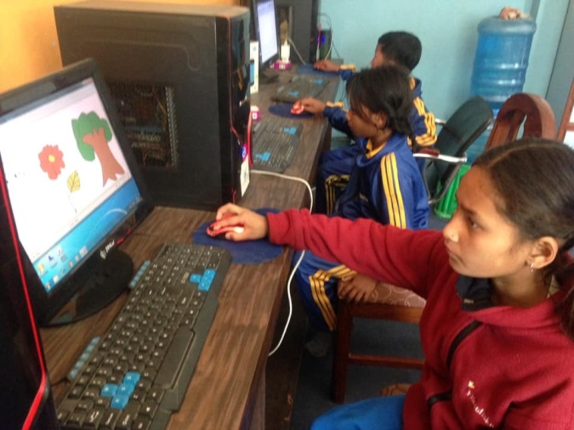
Pictures of students from class one doing their practical exam.

After the exams we said farewell to our students from class four. Saying goodbye is always painful but we wish them all the best by putting tikas on their forehead. We also took some group photos with them and the teachers. That day class four got to decide what all students were to eat for lunch and snack. For lunch all students were served chicken, pickles, papad, potato curry, lentils and rice. For snacks class four and the staff made chatpate for all students. When our students from lower grades were saying their last goodbyes tears were forming in their eyes.

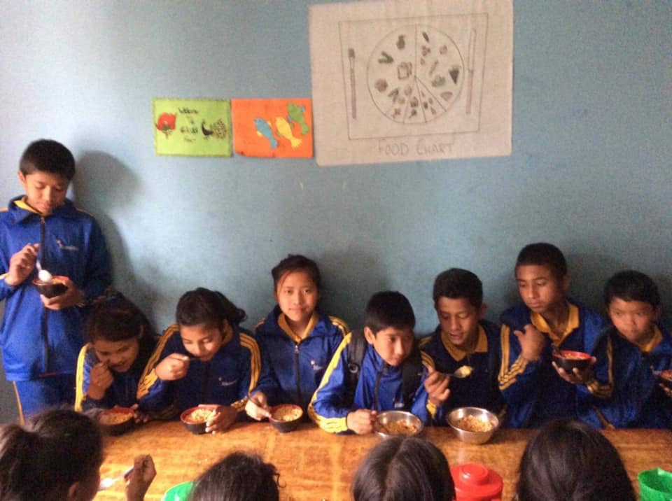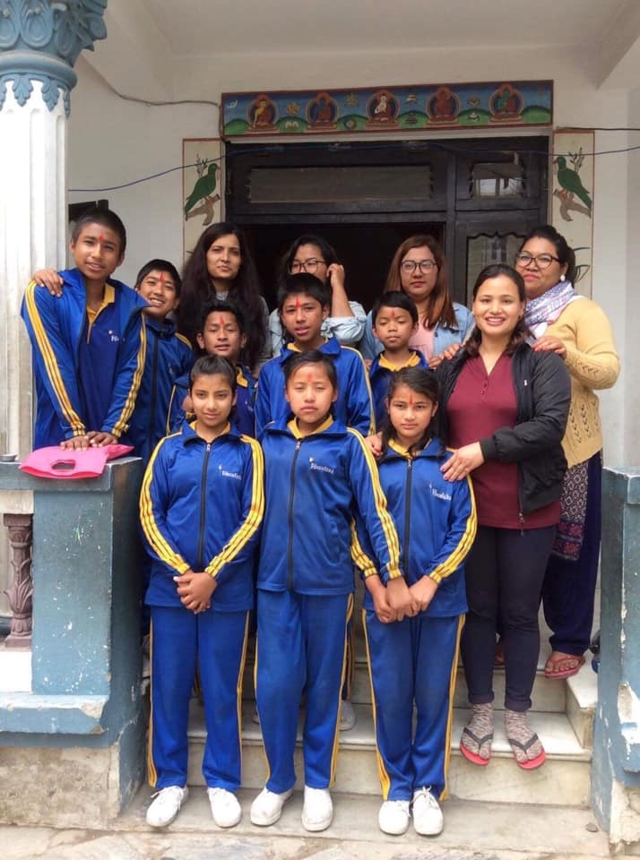
The students are having their snacks: chatpate. Group photo session of class four with teachers.

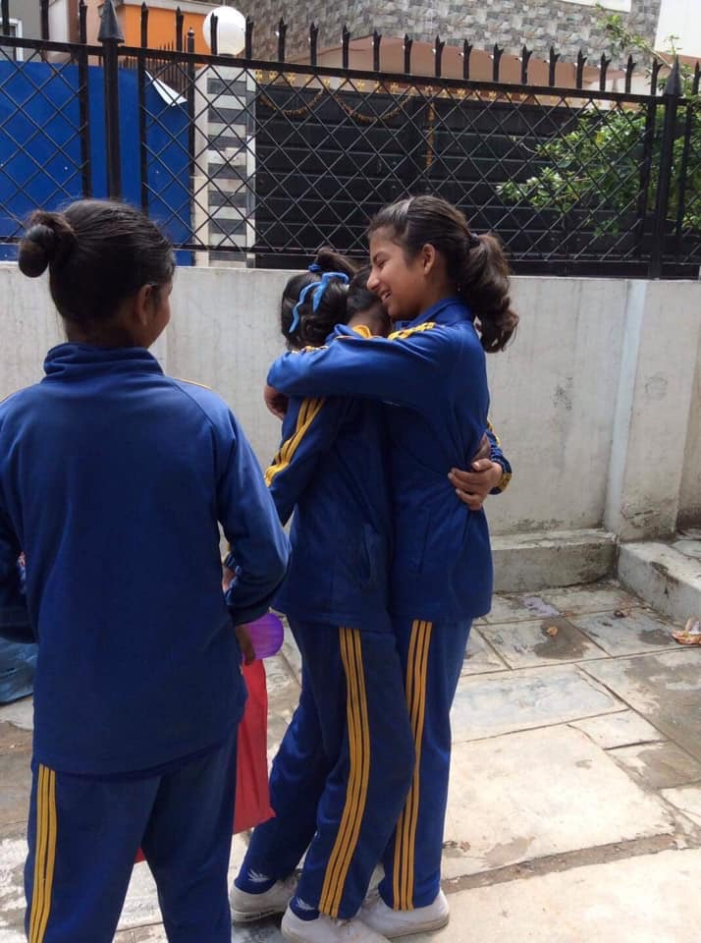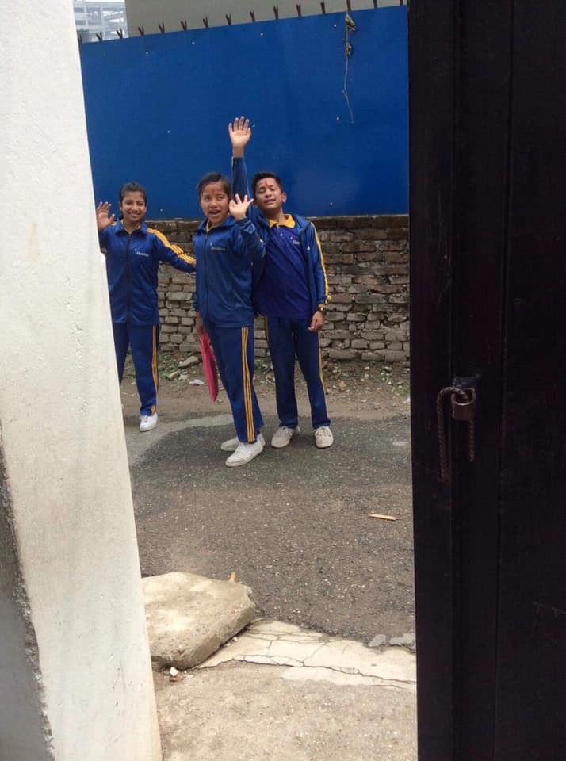
Final goodbye between lower grades and class four. Goodbye class four!

On April 11 we distributed final exam result to our students. All children passed with good marks. This time parents gave more time at home for studying. Students coming from hostel were also provided help from the hostel for studying. The results of the students from each class are as follows.
Class Nursery:
S.N | Name of student | Position
1. | Anita Poudel | First
2. | Bikram Gahatraj | Second
3. | Sugam Karki | Third
Class L.K.G:
S.N | Name of student | Position
1. | Anju Poudel | First
2. | Unika Shrestha | Second
3. | Simran Bamjan | Third

Class U.K.G:
S.N | Name of student | Position
1. | Ankit Chaudhari | First
2. | Shusant Pyakurel | Second
3. | Purnima Katuwal | Third

Class one:
S.N | Name of student | Position
1. | Rabin Kadka | First
2. | Rojina Lama | Second
3. | Udiya Yadav | Third

Class two:
S.N | Name of student | Position
1. | Samjhana Taman | First
2. | Bibbisha Ghimire | Second
3. | Elisha Burdewa | Third

Class three:
S.N | Name of student | Position
1. | Muskan Nepali | First
2. | Gudiya Yadav | Second
3. | Siwani Pariyar | Third

Class four:
S.N | Name of student | Position
1. | Pratikshya Tamang | First
2. | Milan Maharjan | Second
3. | Roshan Khadka | Third

Eight students graduated from grade four which was everyone from that class. They were all admitted in schools near their homes. The students who graduated from grade four were as follows:
- Pratikshya Tamang
- Milan Maharjan
- Roshan Khadka
- Hira Lal Moktan
- Asmita Pariyar
- Sadikshya K.C
- Abhishek Nepali
- Suman Khadka

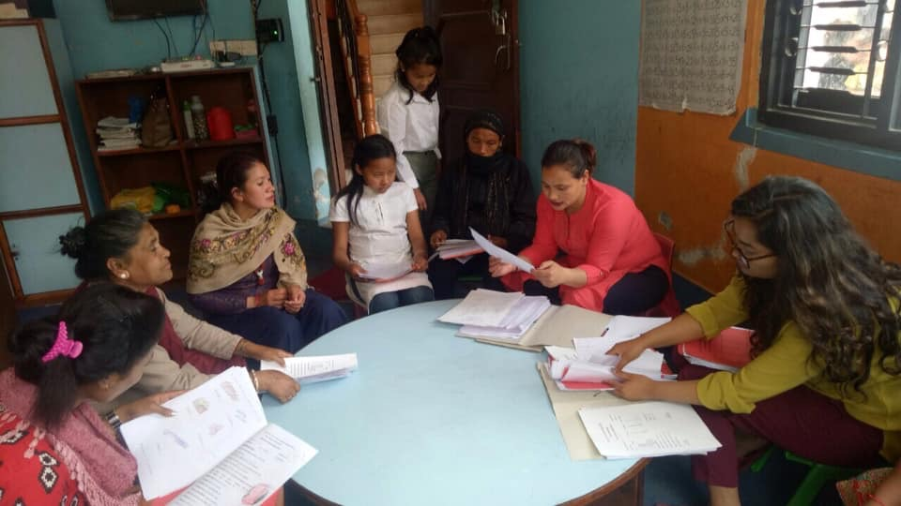
Parents of some students collecting their children’s report cards.
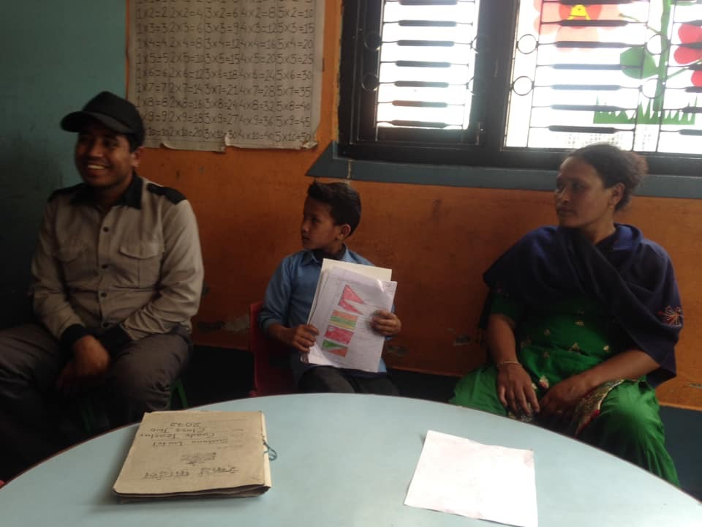
Siddharth from class two is collecting his report card with his mother.

It is good news that some of the parents living standard has upgraded so that they want to keep their children in private school or government school and therefore giving other children in need a space at Filosofiska Nepal. So the name of the children who left school for this reason is as follows:
- Alisha – Class 1
- Krishan Oli – Nursery
- Shusant Pyakurel – Class UKG
Some students left because of other reasons. Two of the students wanted to leave their hostel and live with their families instead and since both of their new homes are too far away they could no longer go to Filosofiska Nepal. And two boys also left because they left their hostel and moved back to their village, Dhading. Another boy did not want to continue here after his brother graduated from class four. The names of these students are as follows:
- Siwani Pariyar – Class 3
- Bibisha Ghimire – Class 2
- Shiv Ram Dhakal – Class UKG
- Bibek Lamichhane – Class UKG
- Siddharth Nepali – Class 2
Before the new session of year 2076 started, the classrooms were decorated, by our teachers, with beautiful art work.
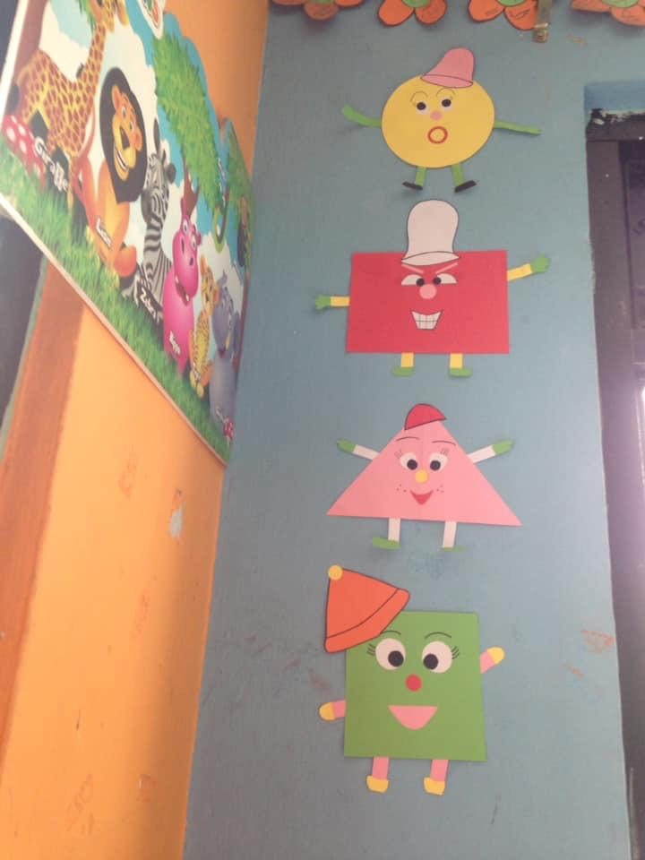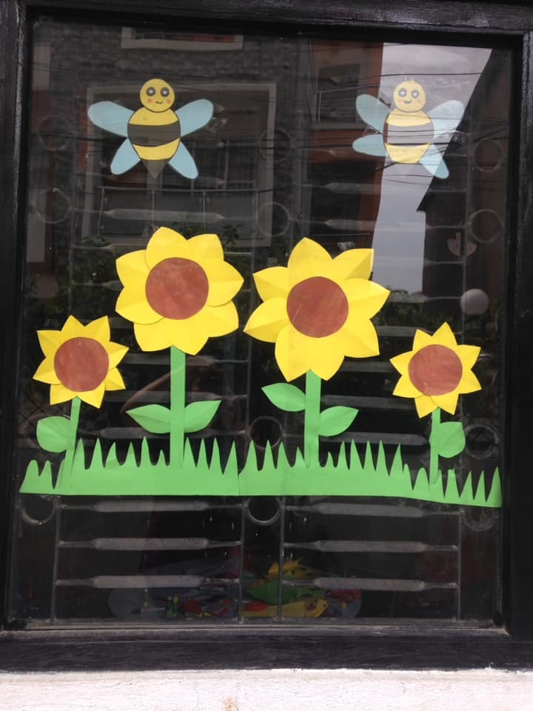

New session 2076 started from 21st April. We like to welcome all students and teachers to the new session and to the next new class. There will be new books, new activities, new assemblies and new victories. From last few years experience we have learned many thing so let’s make this year better. We like to congratulate all students for their progress. Cheers to those who have kept their ranks and to those who have improved their grades. And for those who did not improve their grades this is the time to buckle up. It is never too late to start moving upwards. But remember, the most important thing is not to be a genius. Do not compare yourselves with others, instead compete with yourself and try your best! Everybody is unique and born with some extraordinary qualities within.
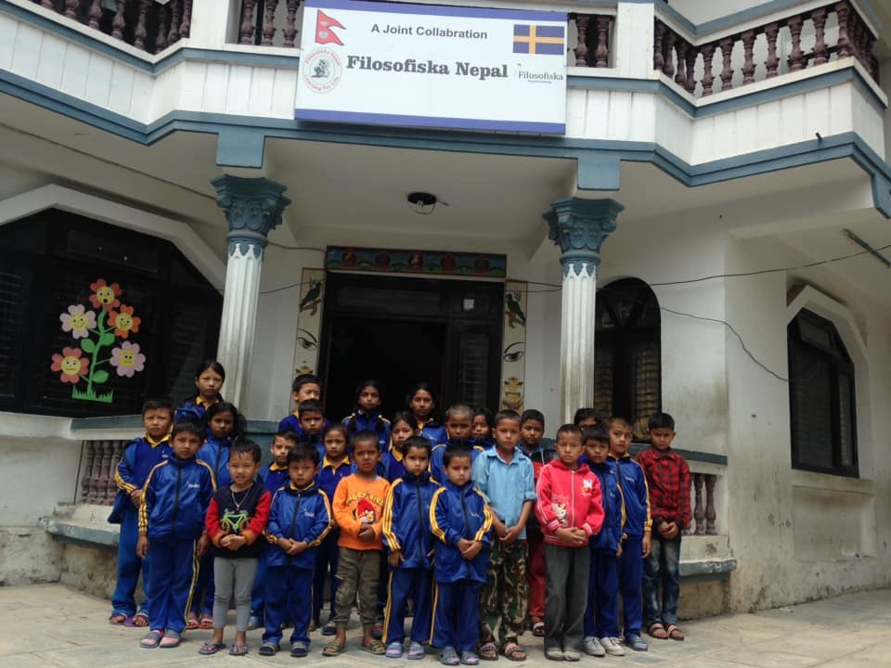
First day of the new session 2076.

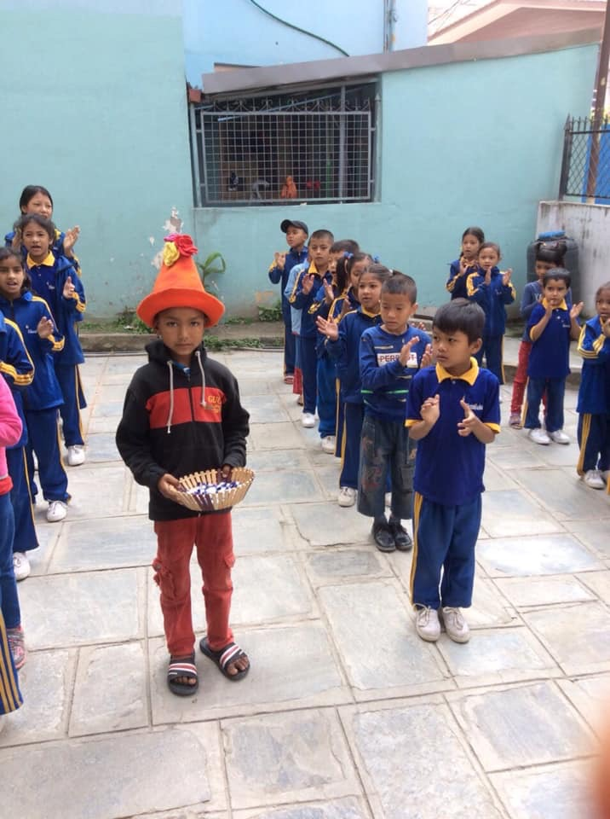
Our new student Subash Nepali from U.K.G celebrated his 6th birthday! Wearing the birthday hat and distributed sweets to all of his new friends and teachers. Happy birthday Subash! We wish you the best!

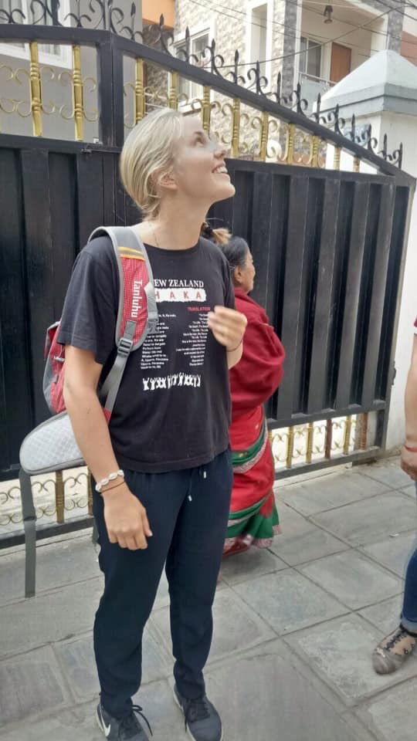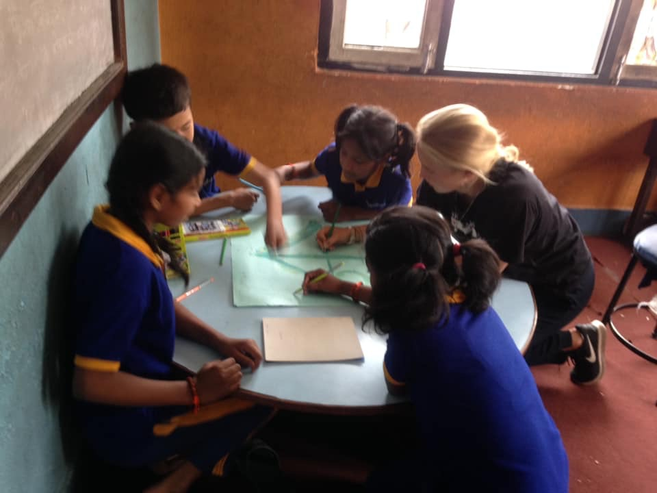
We welcomed Alexandra Haglund from Sweden. She will stay with us for two months. On the first day she introduced herself to all classes and together with class four she made a drawing of “Swedish midsummer” which is now on the wall in their classroom.

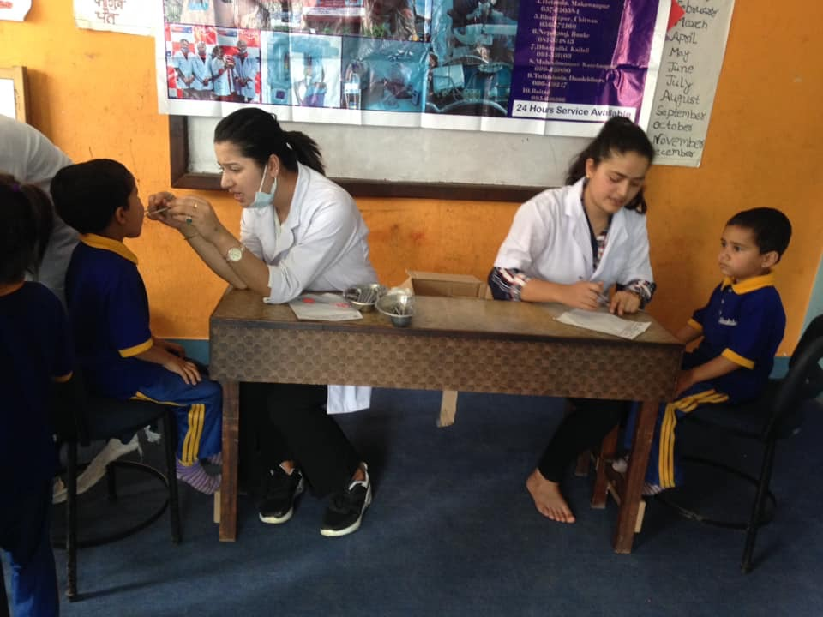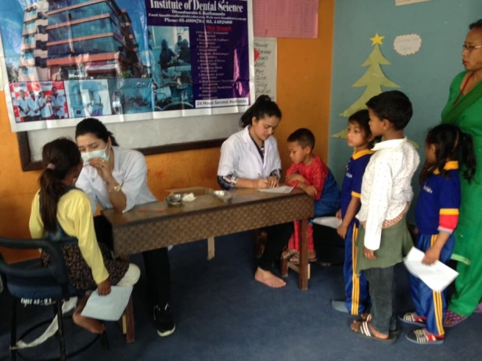
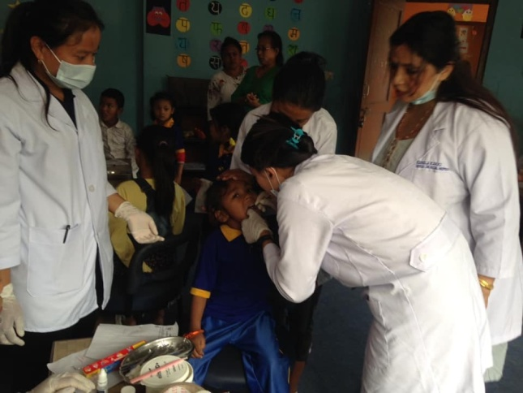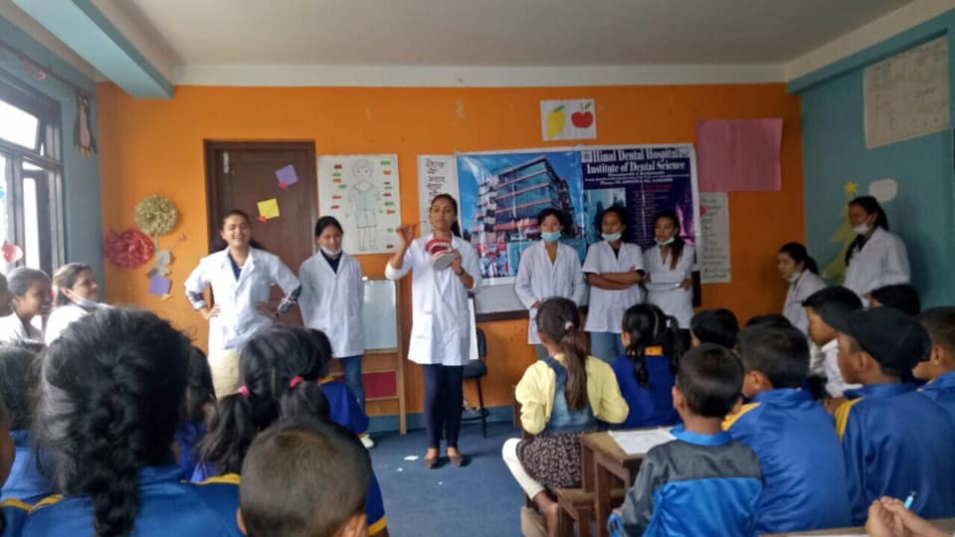
On April 28 students and staff of Himal Dental Hospital and Institute of Dental science provided free dental hygiene information and checkups to all our students. They also provided all students with a toothbrush and toothpaste. The initiative for this came from Ulina (staff of Filosofiska) since her sister is one of the students of the Dental College. They did not only do check-ups, they also filled the teeth of some students and sent some of our students to the Dental Hospital for more advanced treatment. A big thank you to all the students and staff of Himal Dental Hospital and Institute of Dental science for coming to our school and helping our students!

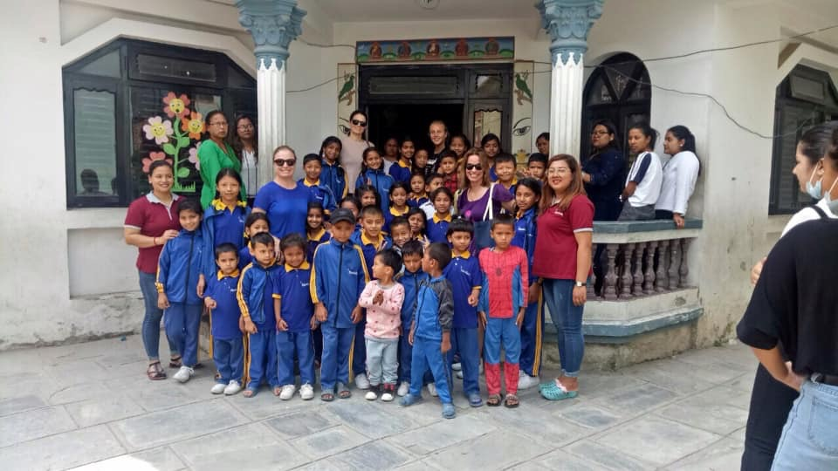
Karine Raoufinia, Ebba Ljungerud and Cecilia Dahlstrom from Sweden visited our school!

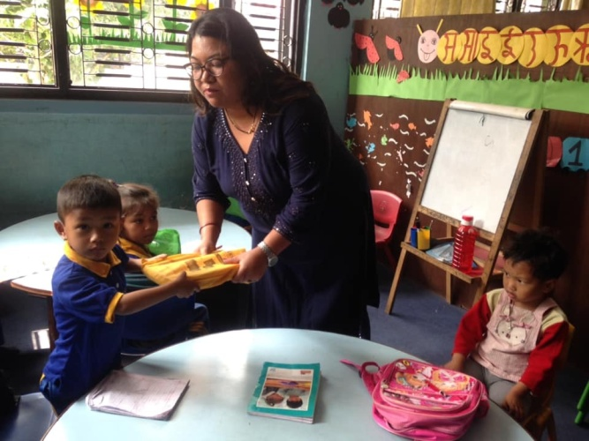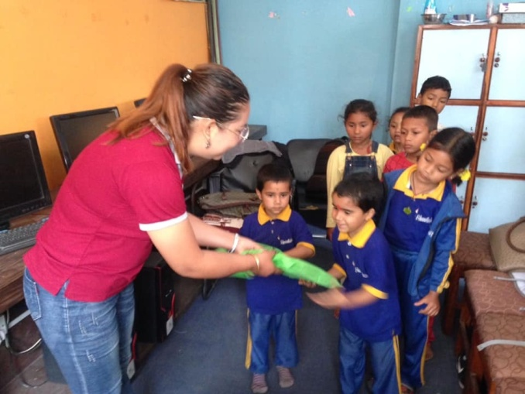
Class Nursery and L.K.G receiving new books for new session. Ulina distributing new books for class U.K.G.
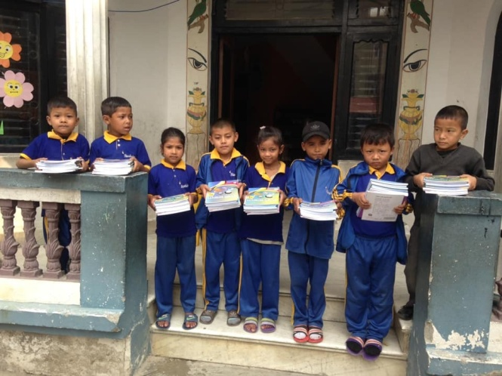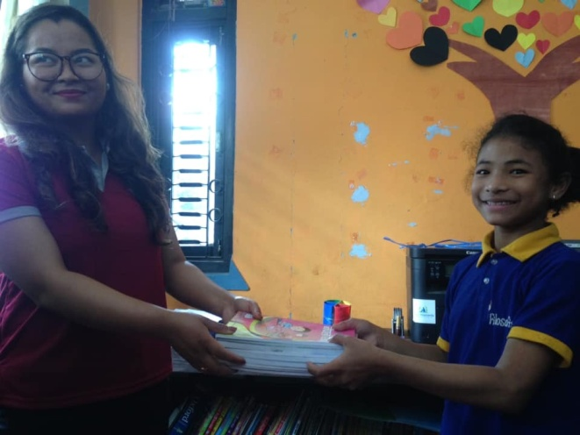
Class one with their new books. Rajani (teacher of class one and two ) distributing books to students of class two.
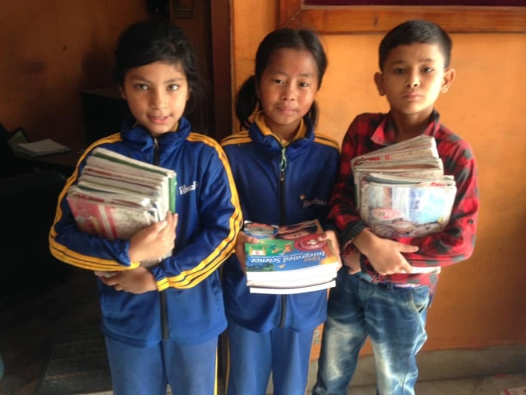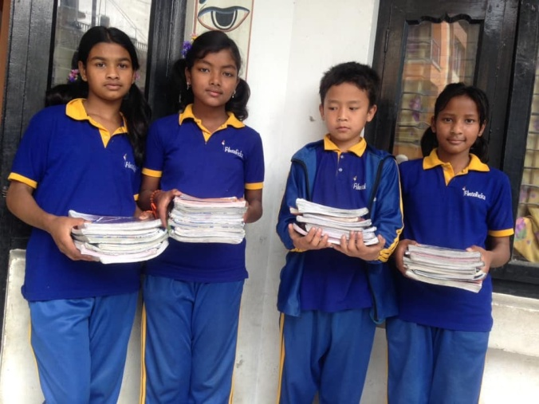
Students of class three and four with their new books.

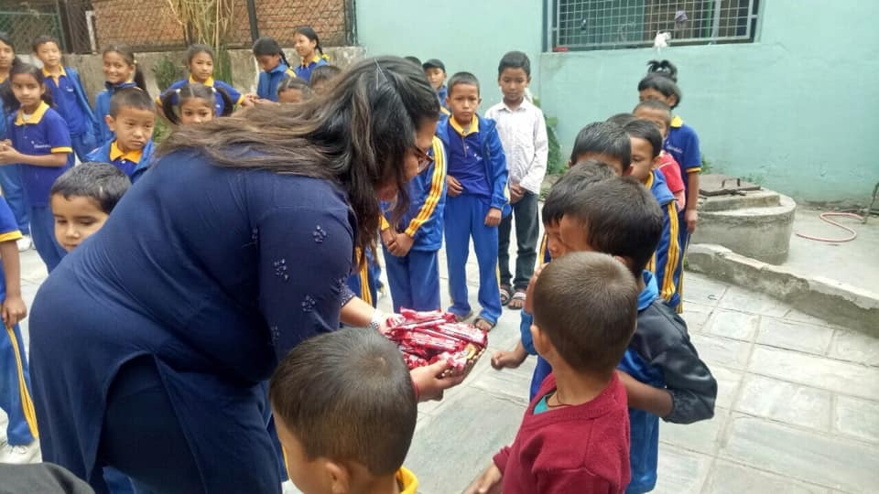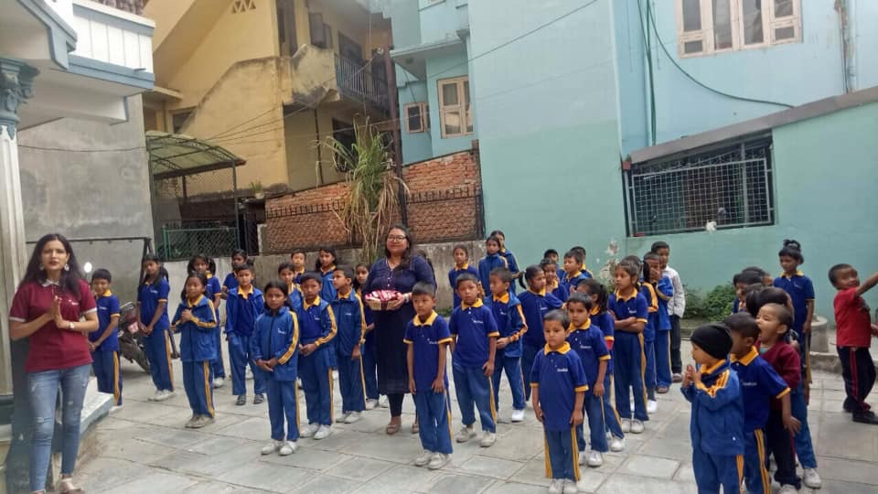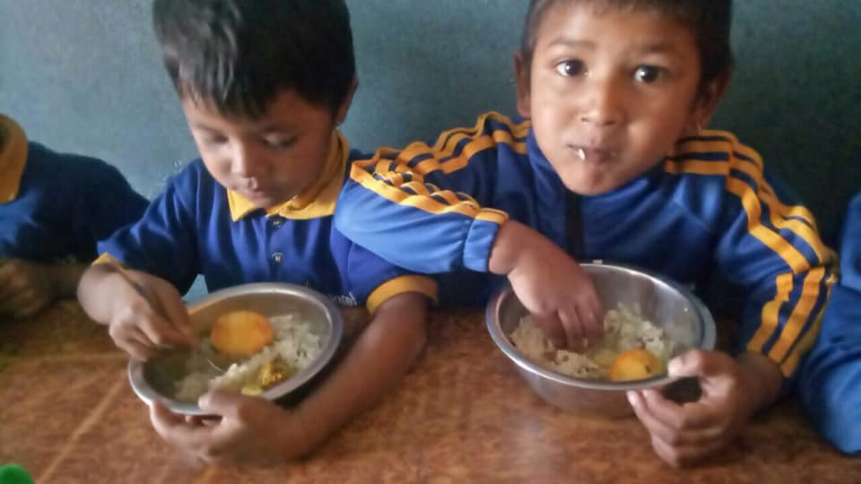
Birthday celebration of Rashmi (grade teacher of Nursery and L.K.G). The children sang “Happy birthday” and after the song she gave all students chocolates and provided a delicious lunch. Once again, Happy birthday Rashmi!

