Monthly Progress Report of December 2018
December is the last month of the year. It is the beginning of winter season. Nights are longs and days are short in winter in Nepal. This month we were busy in more study as second terminal examination held on 16st to 21st December. All the students participate in the exam. This time all the students work hard to achieve good marks. In this month teachers and Mikaela also used more effort for making change in their children behaviors and good attitude in regular studies. All the staffs were busy with exam question preparation. In this month Mikaela spends lots of time with children. She also teaches different kinds of games to students. Children had lots of fun with her by playing, dancing, learning etc with her. Mikaela also visited different palaces of Kathmandu with staffs after school.
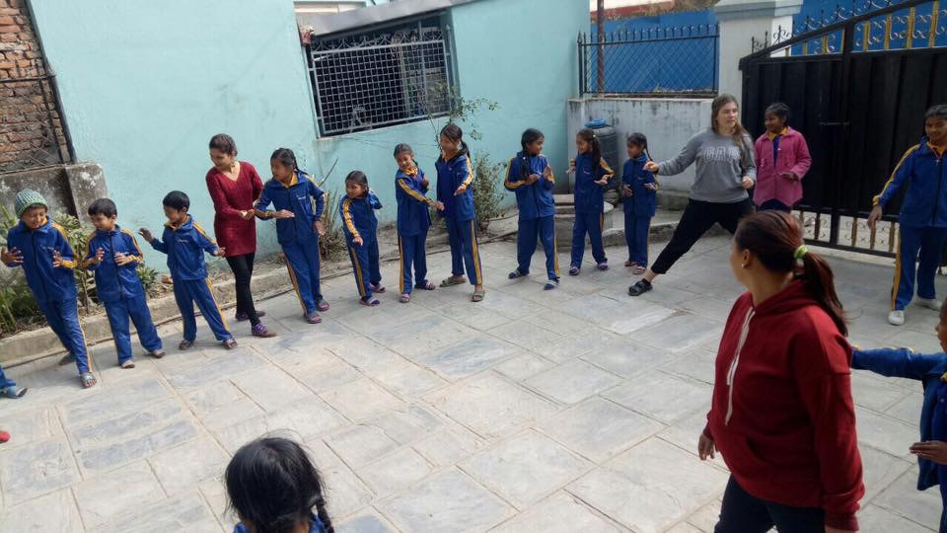
Mikaela Malmstrom is playing new game with children and staffs of Filosofiska Nepal.
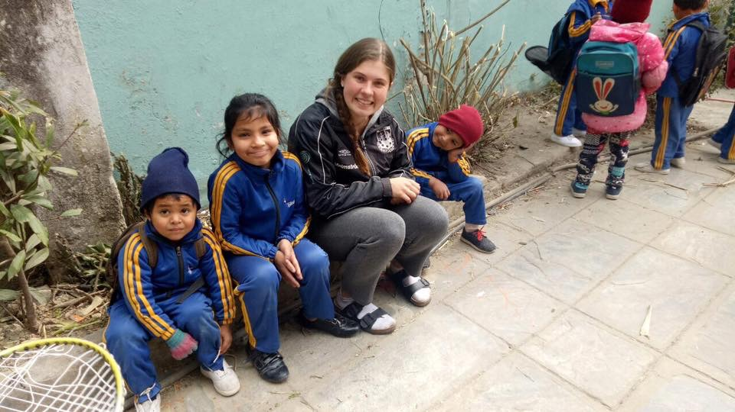
Mikaela Malmstrom spends her quality time with little philosophers. They played games, danced in Nepali songs and visited different places in this month.
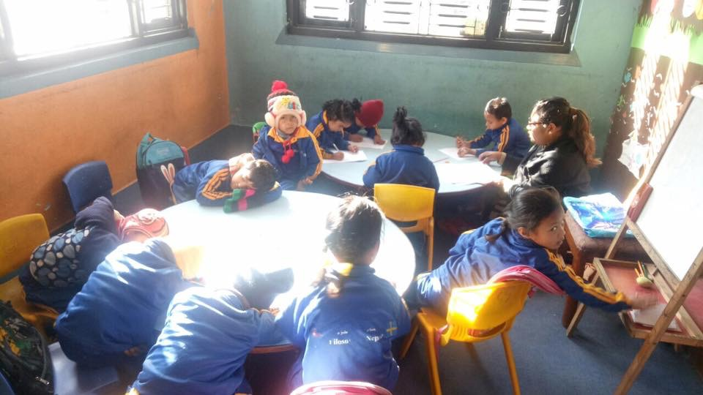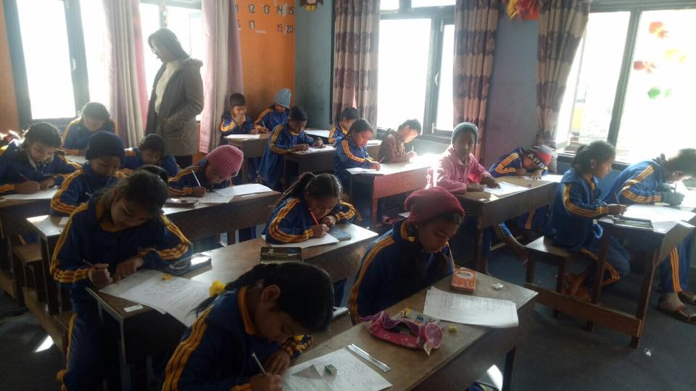
All the students from nursery to class four are attending their exam. They filled their paper very silently.
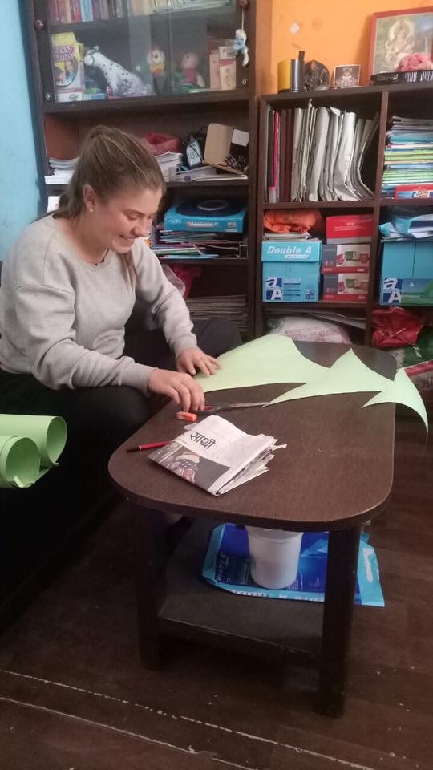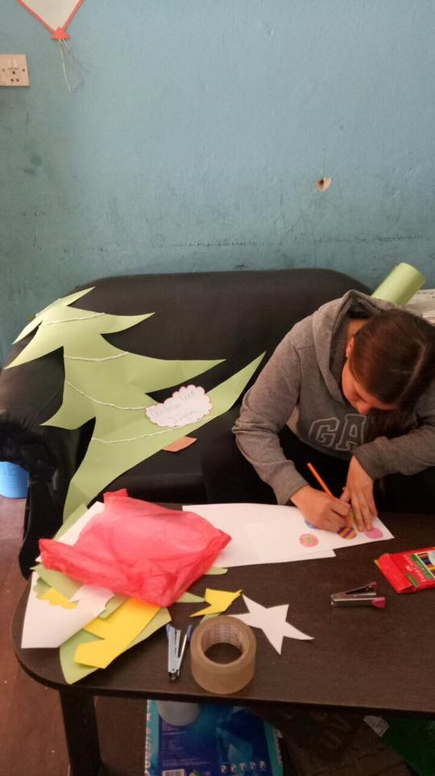
Preparation for Christmas. Mikaela Malmstrom is making Christmas tree for Christmas celebration. Thank you Mikaela for your great efforts.
Christmas is an annual festival . It is the Christian festival celebrate the birth of jesus christ . Neap has a population of over 25 million, and over 80% of Nepalese are Hindu. Around 10% are Buddhist,4.5% Muslim, and only 1.5% christian. Many Nepaleses Christian communities and youngerester of other communitis people celebrated Chirstmas on Nepal. Chismas is traditionally characterized by tinsel decorated tree, mince pies, present giving and turkey dinner. In Kathmandu Nepal ,most of the families went to the Thamel and celebrated it happily. Children look forward to visit fromSanta Claus and his sack of present . After second term exam is finished we also celebrate Chrismas day with grate enthusiasm.From the early morning children were eagerly waiting for Santa. When little Santa arrives in the middle of program,their experience was speechless. Childern were dress up as Santa, rabbit, tiger,etc. Christmas program went very well. We made MoMos in filosofiska Nepal on the occessin of Christmas. Our lovely children and staffs made moons together.Children enjoyed the special day.
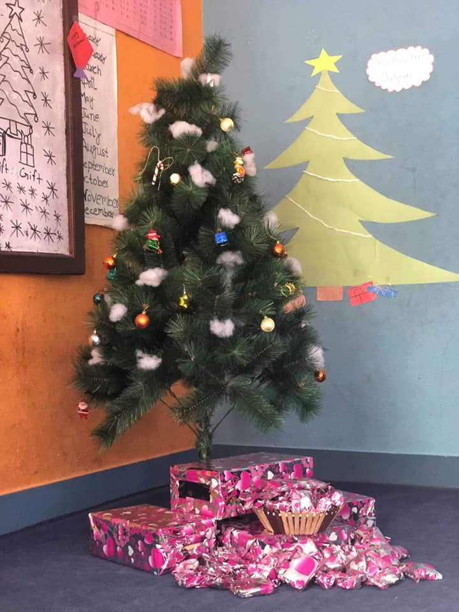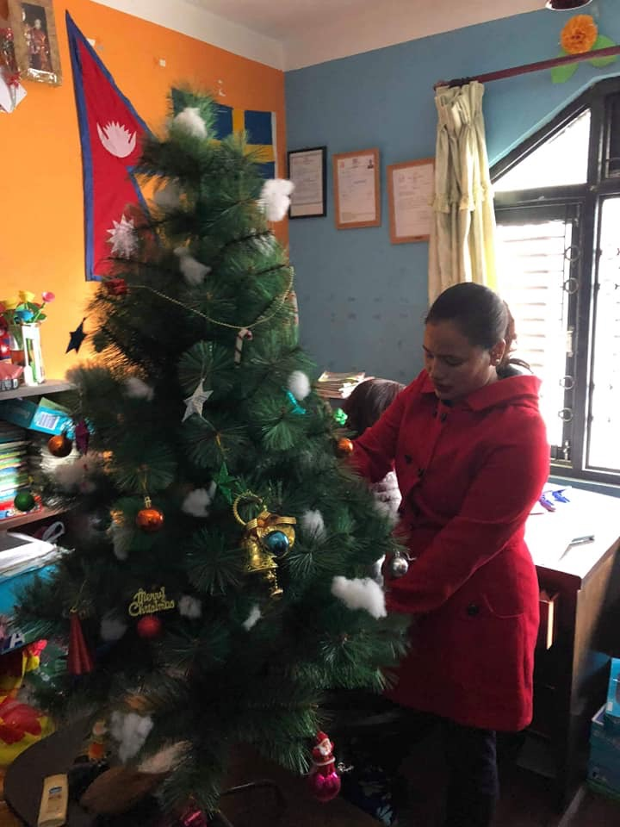Wow Christmas tree is ready for Christmas celebration.
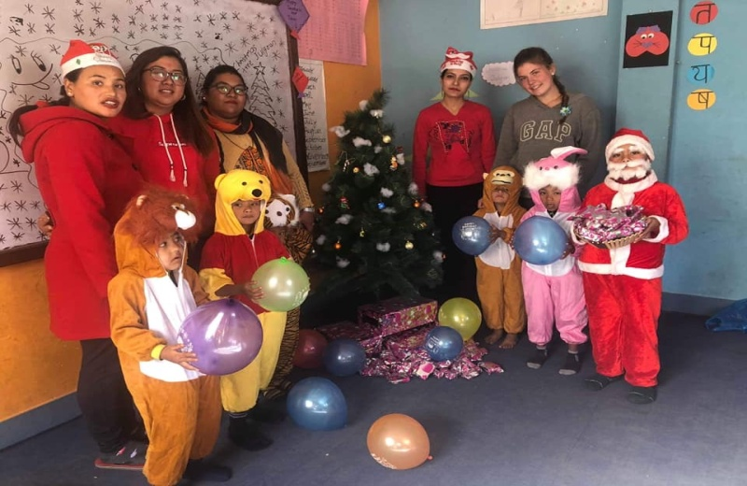
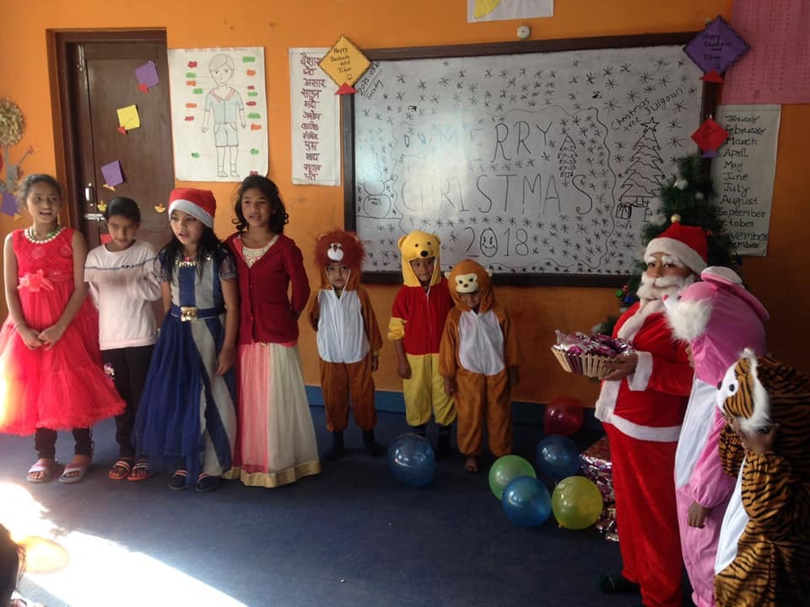Children are standing with little Santa on Christmas day.
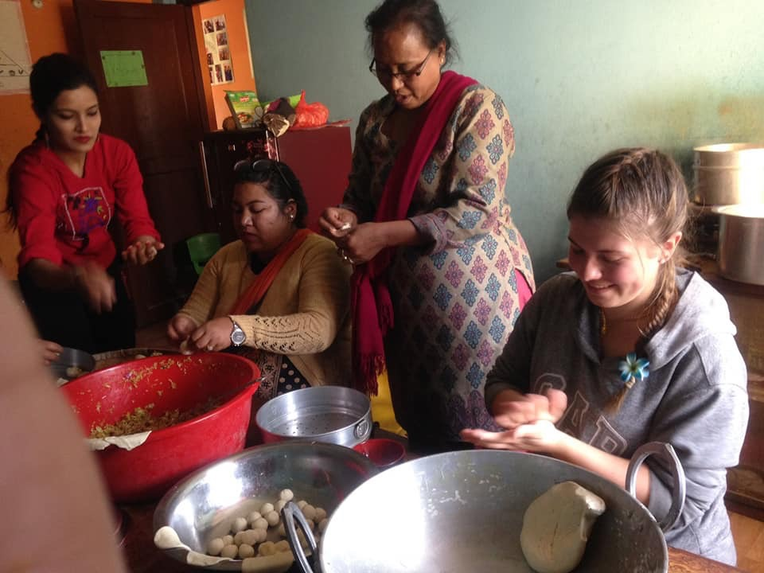 Mikaela, students and staffs were making momos for children. 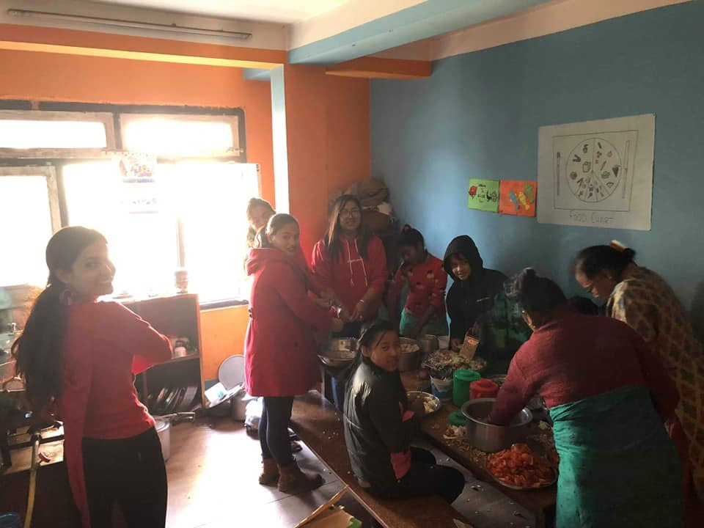Our lovely children and staffs are helping their kitchen staffs. They enjoyed the special day together.
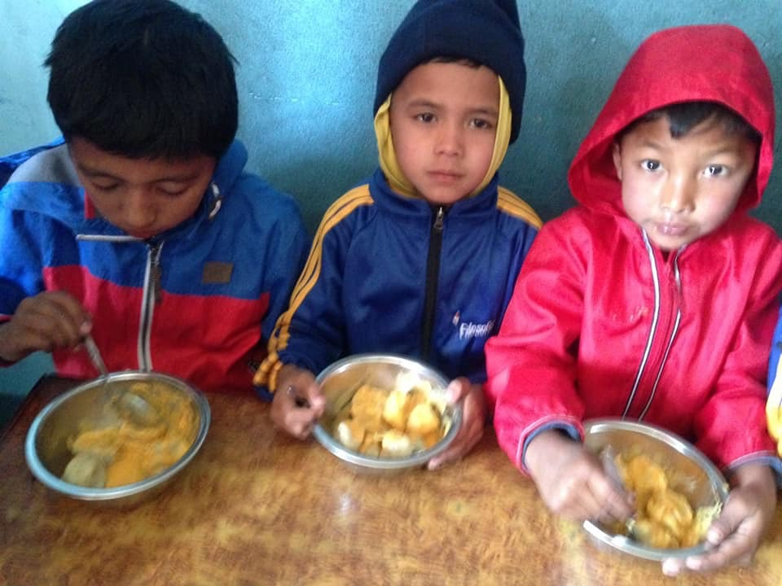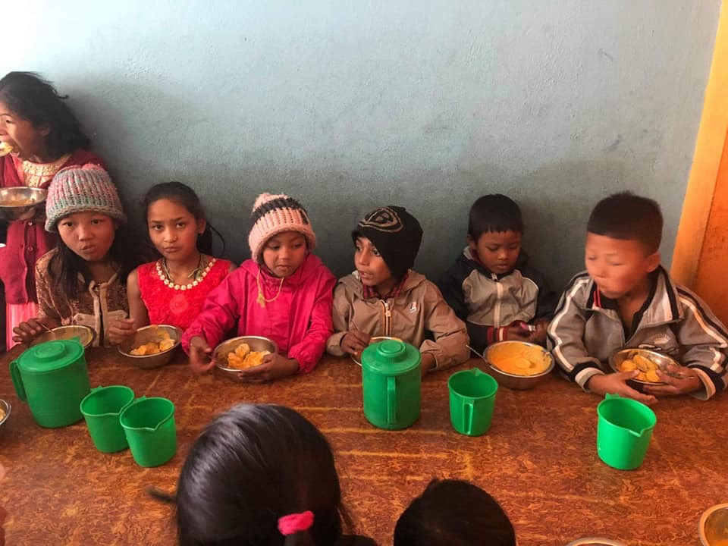Yummy yummy momos in our school. Children are having mooms and had lots of fun that day.
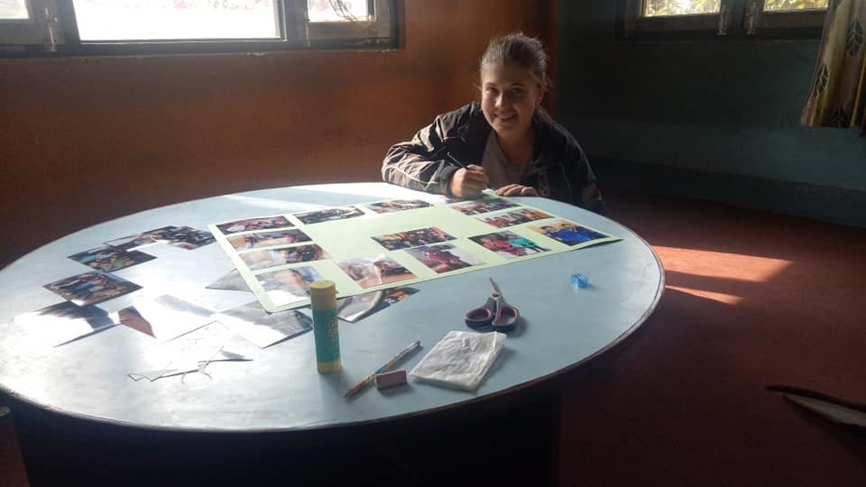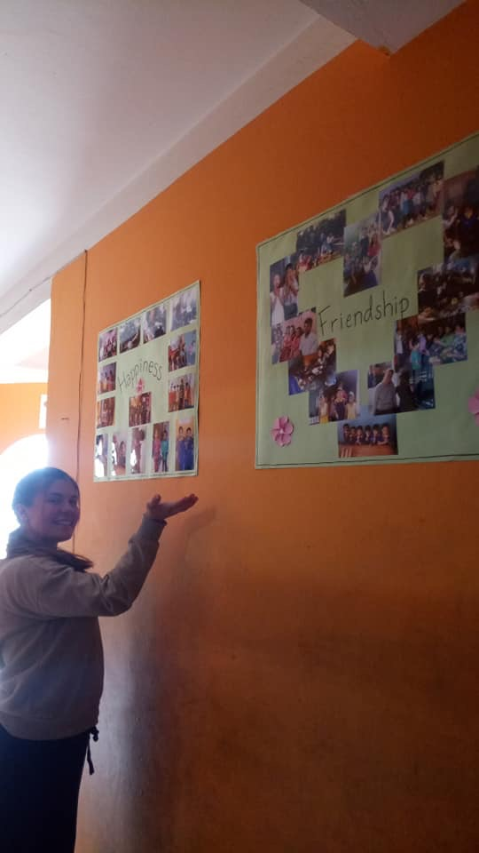Thank you Mikaela for your great efforts for makimg this picture collage.
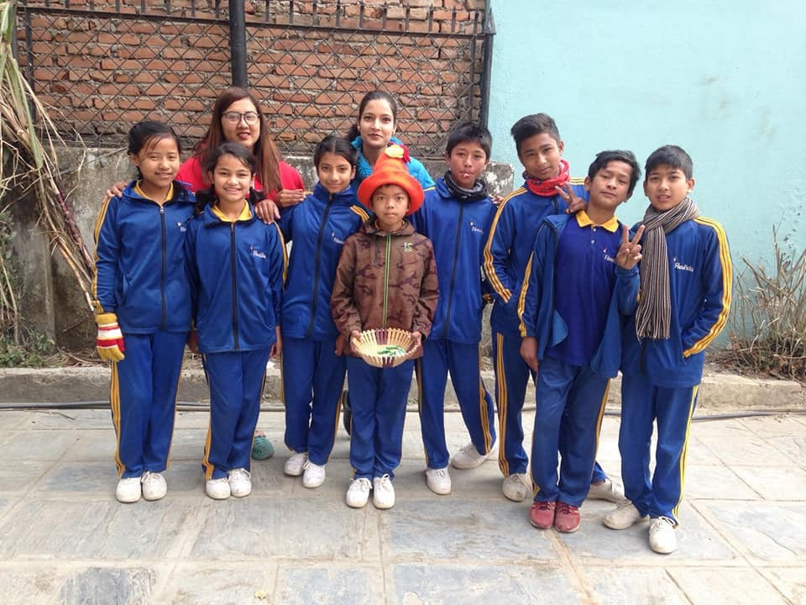Happy birthday Hira Lal from class four. God bless you.
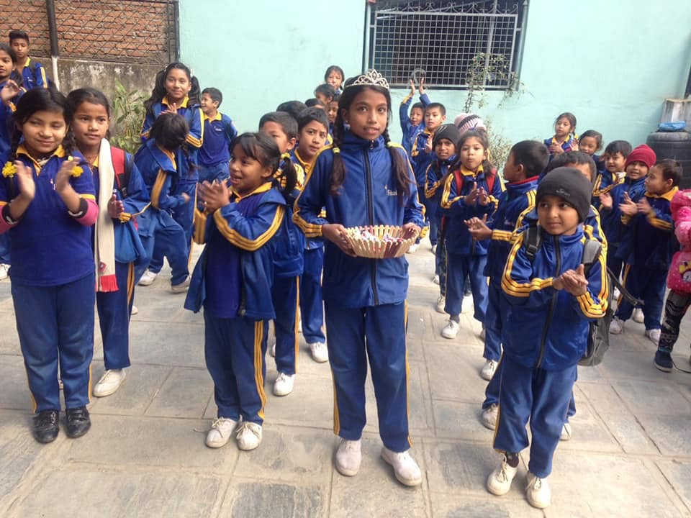Happy birthday Supriya from class one. She is distributing her birthday chocolates on morning assembly.
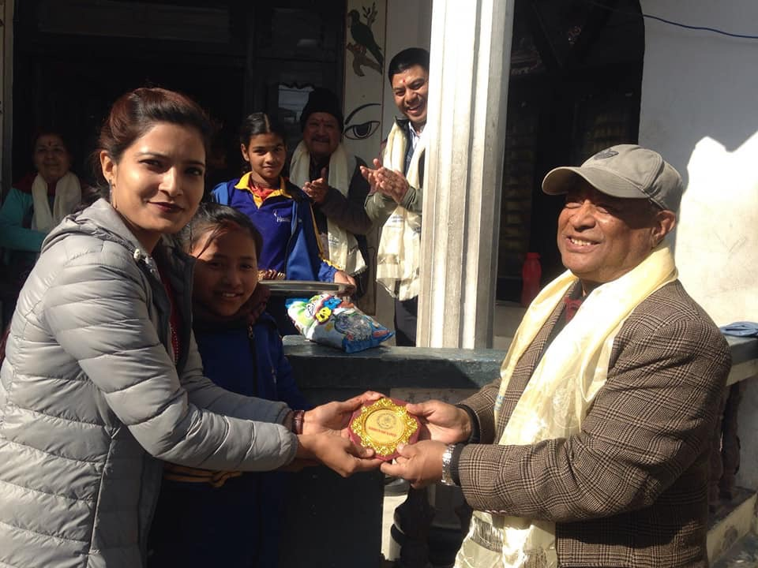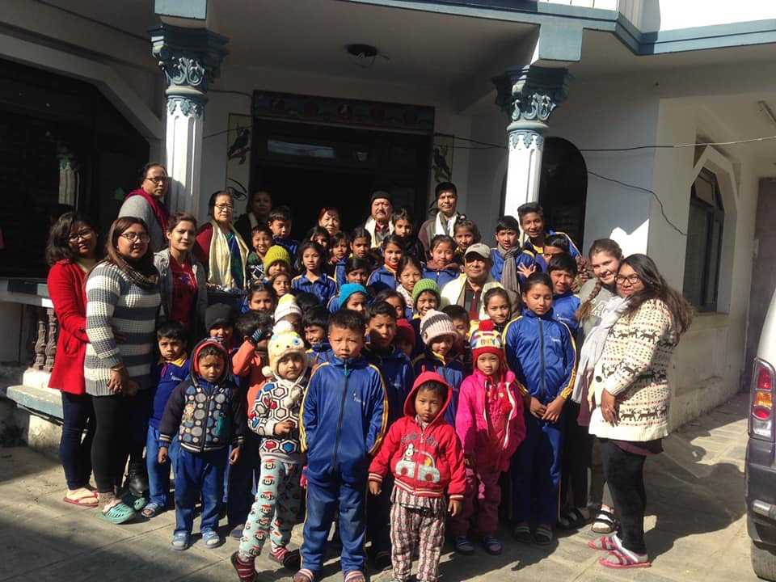Thank you Kamal Tuladhar and his family for good lunch and snacks to our little children.
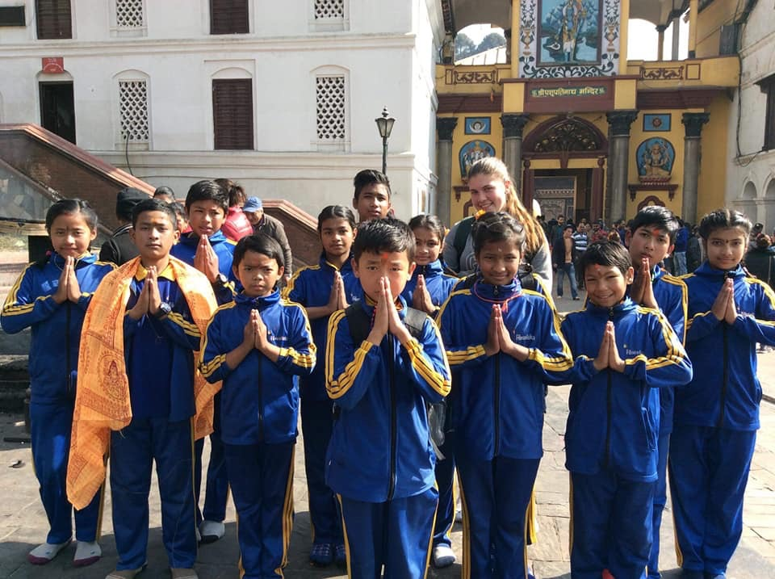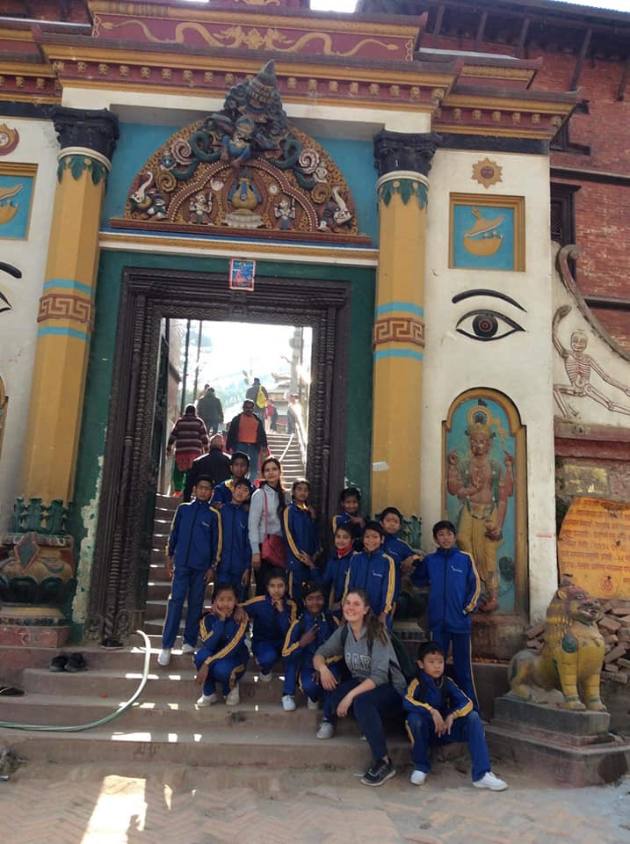Field visit at Pashupatinath and Guheshwori . Nameste to all from Pashupatinath and Guheshwor temple.
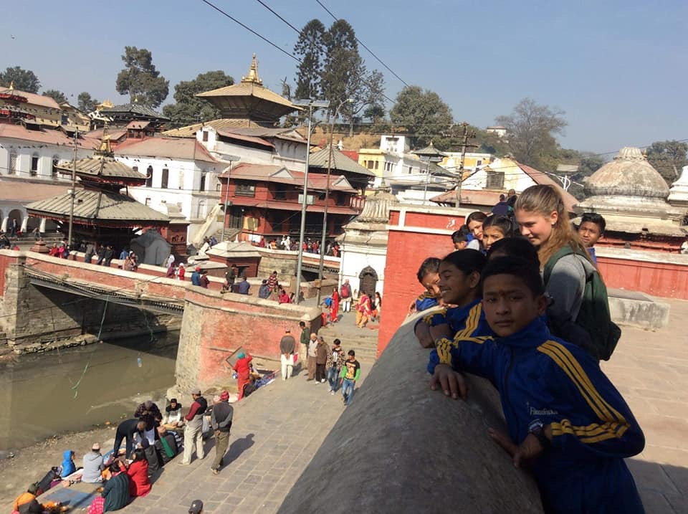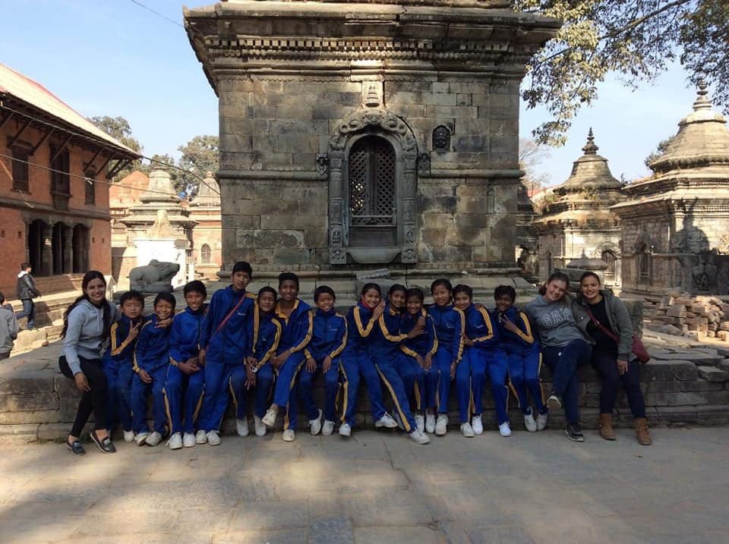 Students of Class three and four were having their wonderful time with their class teachers and Mikaela at Pashupatinath and Guheshwori.
Pashupatinath Temple is a famous and sacred Hindu temple complex that is located on the banks of Bagmati River. It is the eastern part of Kathmandu Valley, the capital of Nepal. Only Hindus are allowed inside the gates of the main temples. There are hundreds of Shiva lingam and the largest statue of Nandi the bull inside the Pashupatinath temple. The big Maha Shivaratri festival in spring attracts hundreds of thousand devotees from within Nepal and from India.
Guheshwori is another famous temple in Kathmandu. It is nearby Pashupatinath temple. This temple is dedicated to Adi Shakti. It is also located near the banks of the Bagmati River.Guheshwori temple is visited before the main Pashupatinath temple. This tradition is still followed by member of the earlier Royal family. The Guheshwori Temple is worshipped first and then other temples are visited. It is the because of the belief of worshipping Shakti before Shiva. 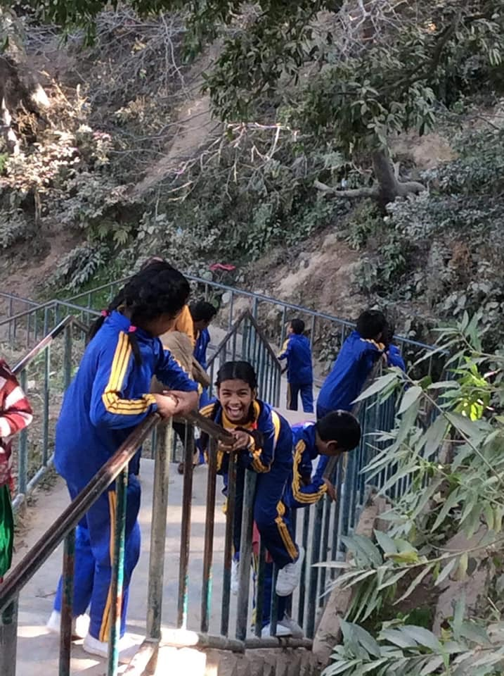 Gudiya and her friends playing slide on the way of Guheshwori. Students enjoyed their field visit.
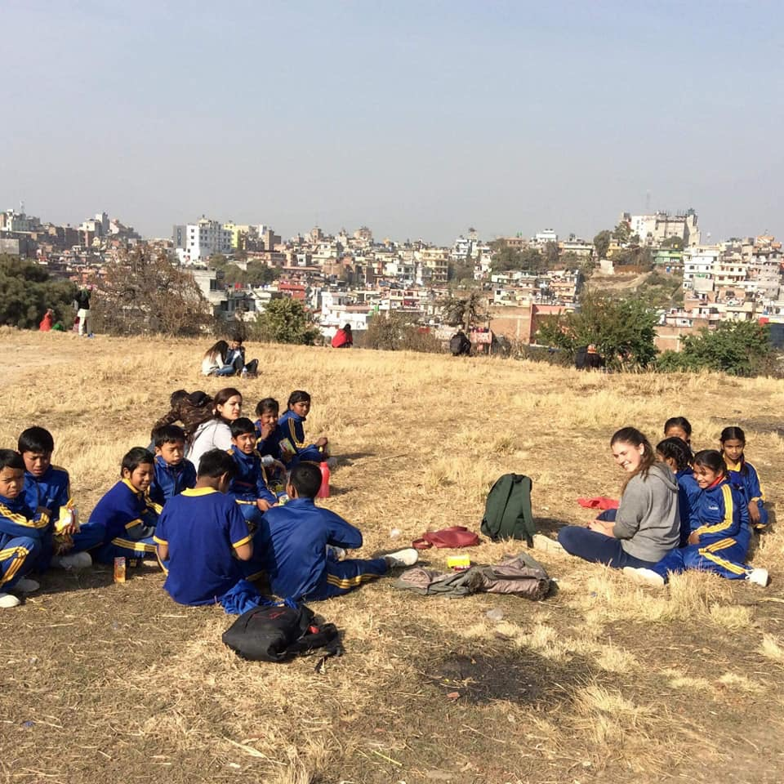 Mikaela, teachers and students taking rest and having their snacks after visited the both temples. 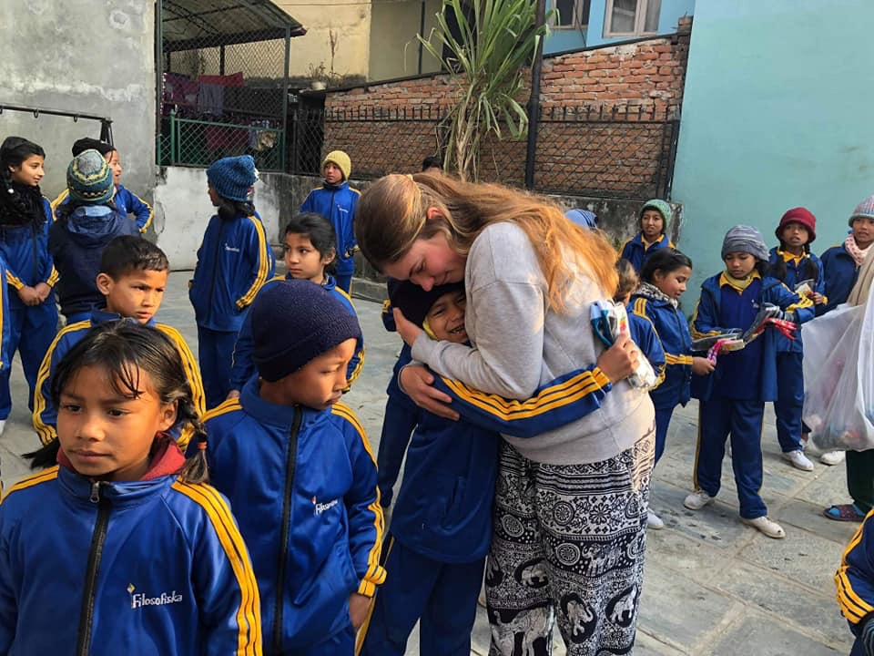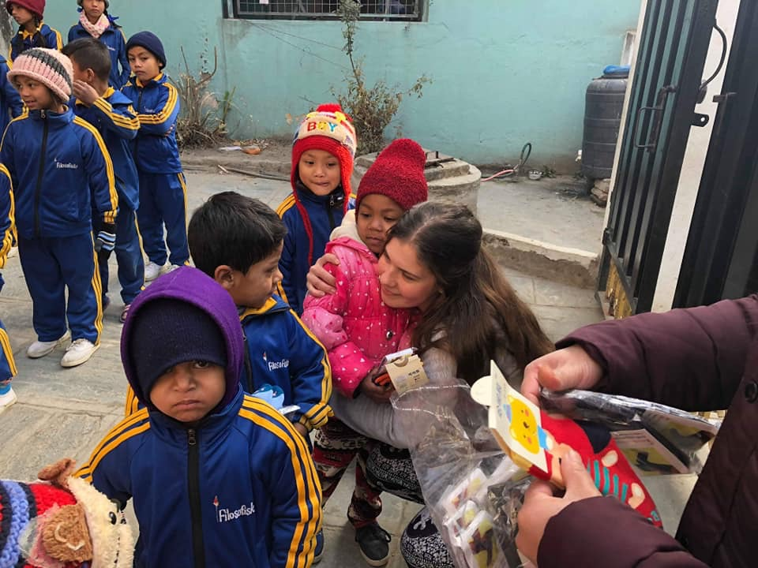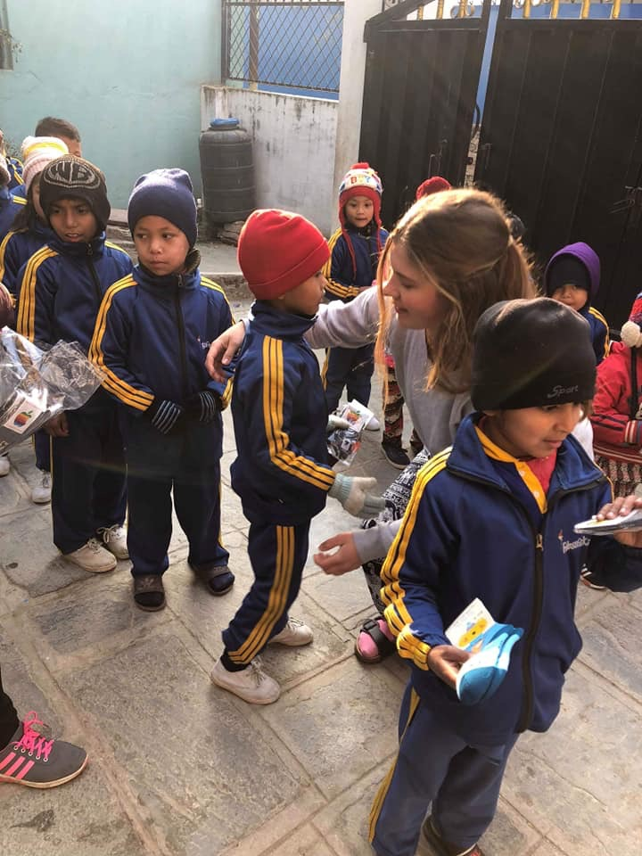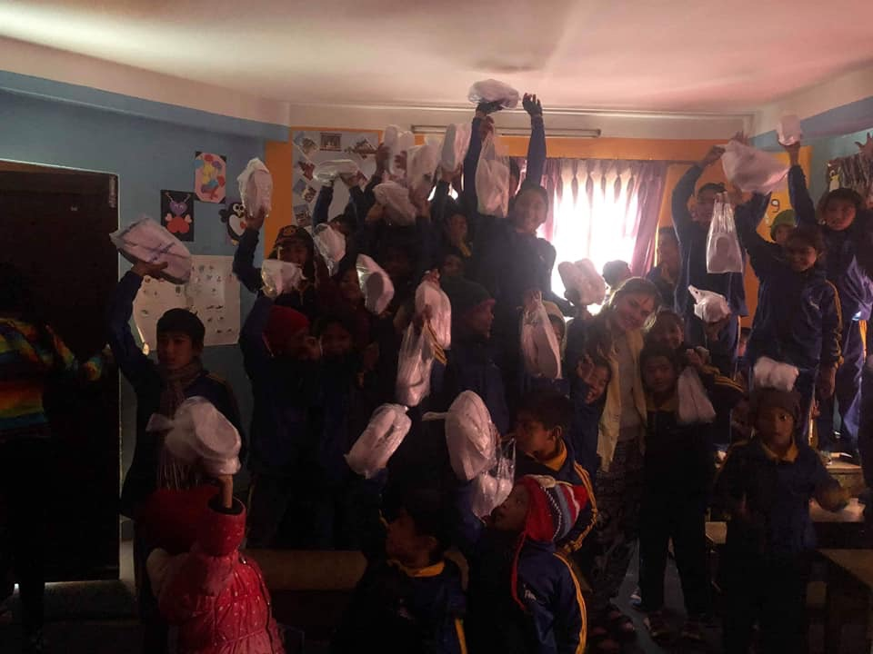Mikaela is distributing pair of shoes and sock to all students of Filosofiska Nepal.

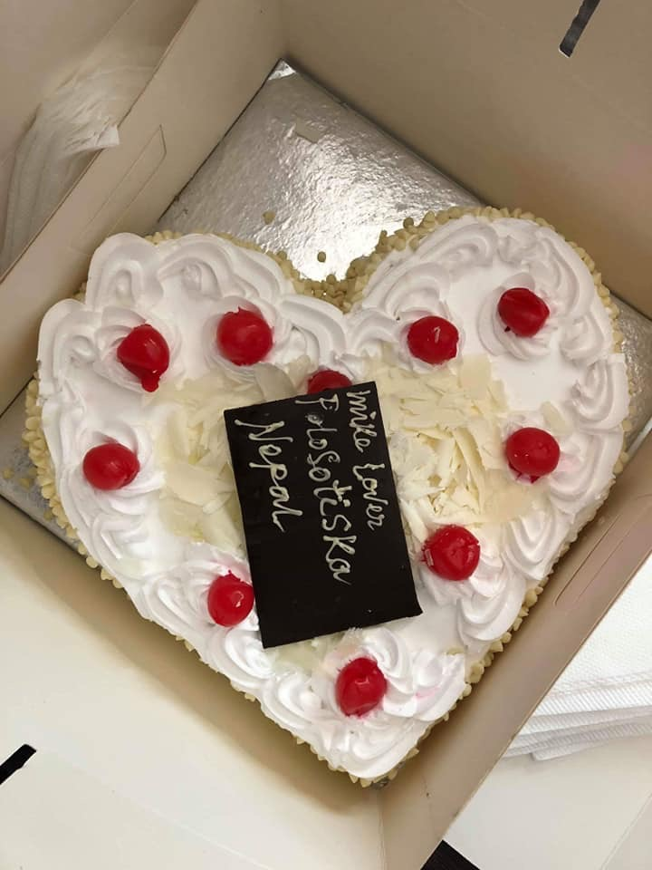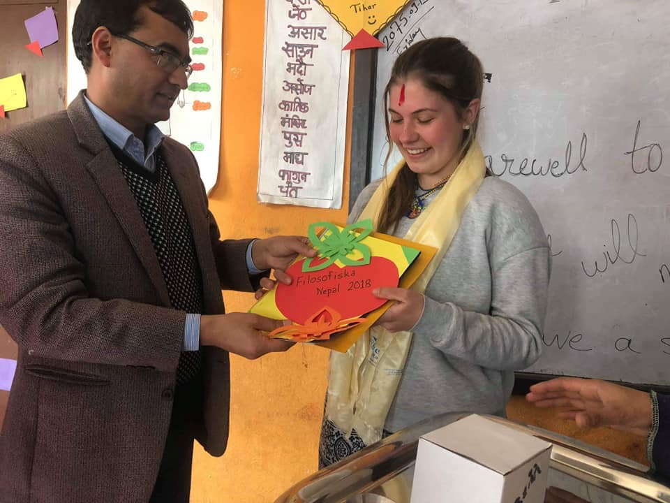 Farewell to our dear Milaela. It was giving by vice principal of South Western state collage.
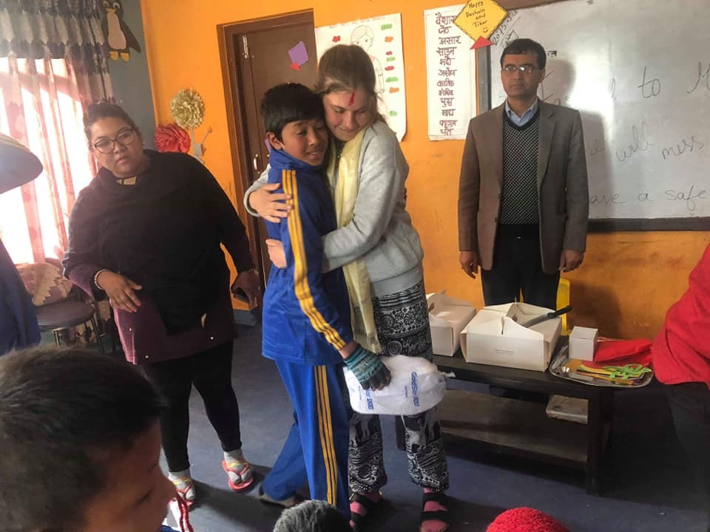Loves between mikaela and Roshan.
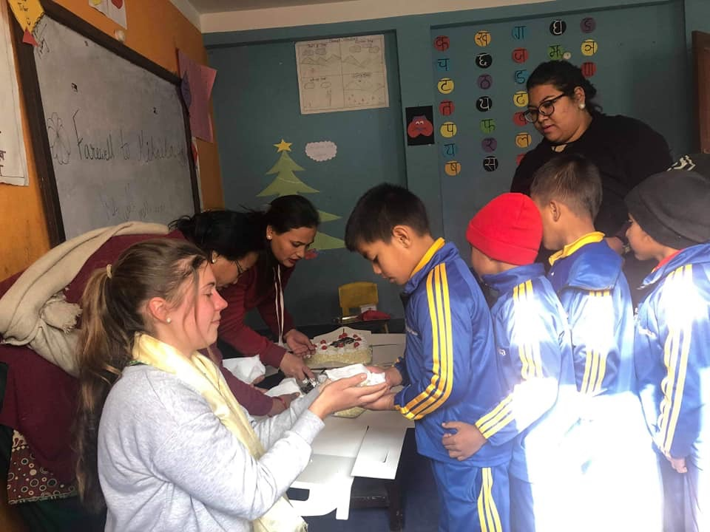Mikaela distributing her farewell cake to students of Filosofiska Nepal.
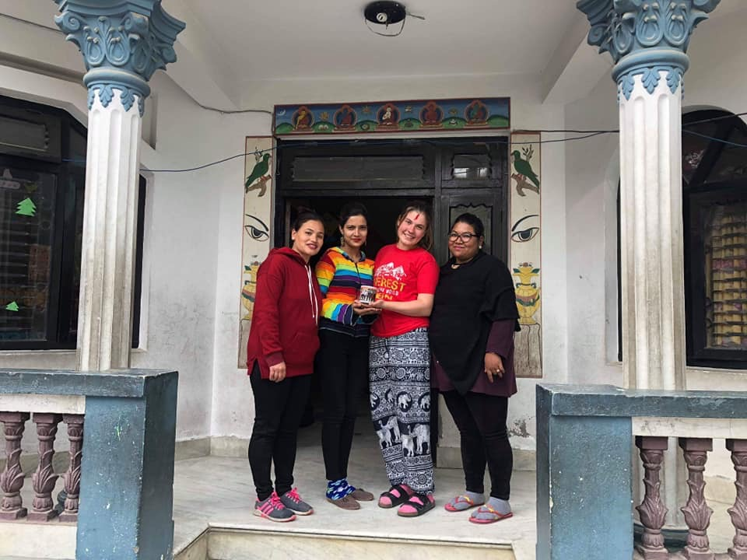We handed beautiful memory to Mikaela on her farewell.
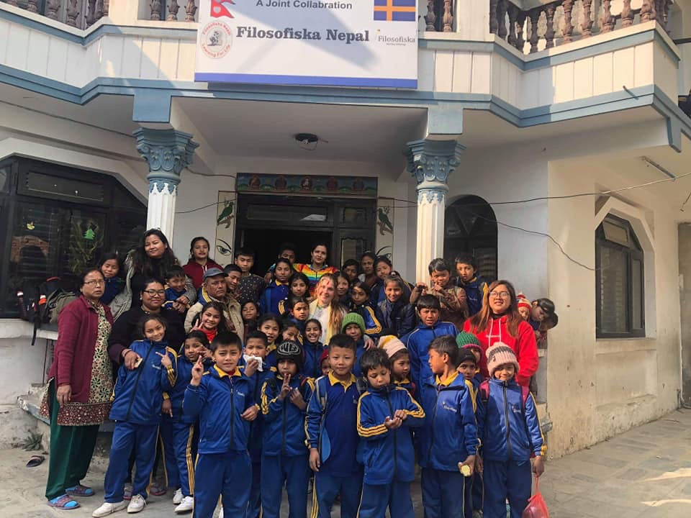Group photo session at the end of the farewell day. This is the good memory for us. Once again thanks to Mikaela for her valuable time and support. Hope to see her again.
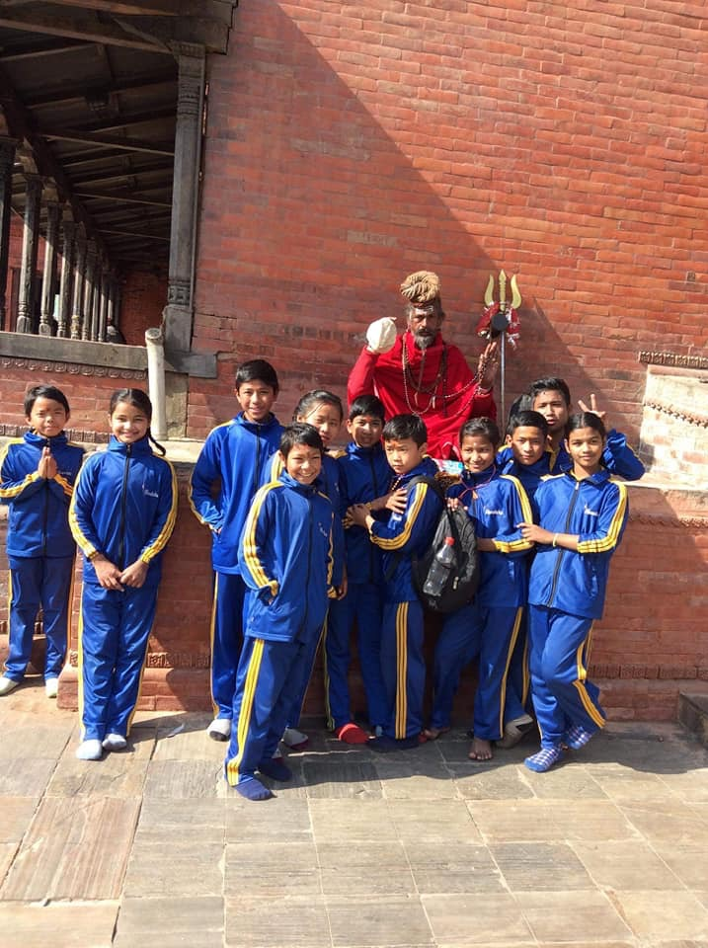Thank you for your continuous support –Filosofiska Nepal.
Happy New Year 2019.

