Monthly Progress Report of February 2019
February is the second and shortest month of the year in the calendar with 28 and 29 days in the leap years. In this month children were really busy in studying for last terminal examination that will be held in the end of March. We give more focus on reading and writing. Students of grade three and four again stared to read new books from school library. They read lots of books and sharing knowledge with their friends after reading books. They used break times for read extra books. Annette zippis was provided fifteen new story books for children. Theses all books are very interesting so, students spend lots of time to read new book. In this month we also conduct parents meeting for the final term examination. All the parents participate in the meeting and provide us the useful suggestions. Teachers also share their experience in class and update about students. Grade four students are upgrading to the grade five. So, we also discuss about that topic in the meeting with the students of class four parents. 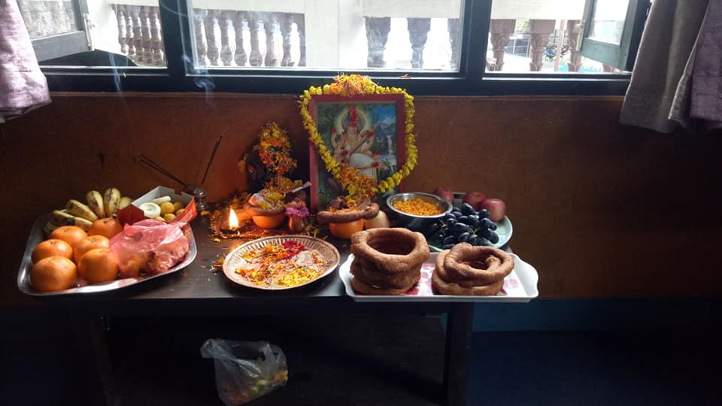
Saraswati puja is one of the most important festivals celebrated in Nepal. It is usually falls in the month of February. Saraswati puja is also known as Shree Panchami or Basanta Panchami. Saraswati is a four-handed Hindu goddess, seated on a white lotus. Her bahan (vehicle) is a white swan, She hold the Veena(a plucked string instrument), a book and a garland in her hand. On this day, Saraswati, the goddess of education, knowledge, music, art and culture is worshipped. We all Hindus are believed, Saraswati puja is the best day to start learning new things. The day is very auspicious, especially for students. The wall of Saraswati temples exhibit Nepali and English alphabets and numbers. Children are given their first writing and reading lessons at the temple during this festival in the belief that the goddess of education. Saraswati will help them excel in education. In Filosofiska Nepal we worship goddess Saraswati and offer her different sweets, flowers and incense sticks. On this auspicious occasion we pray for goddess Saraswati to enlighten our children.
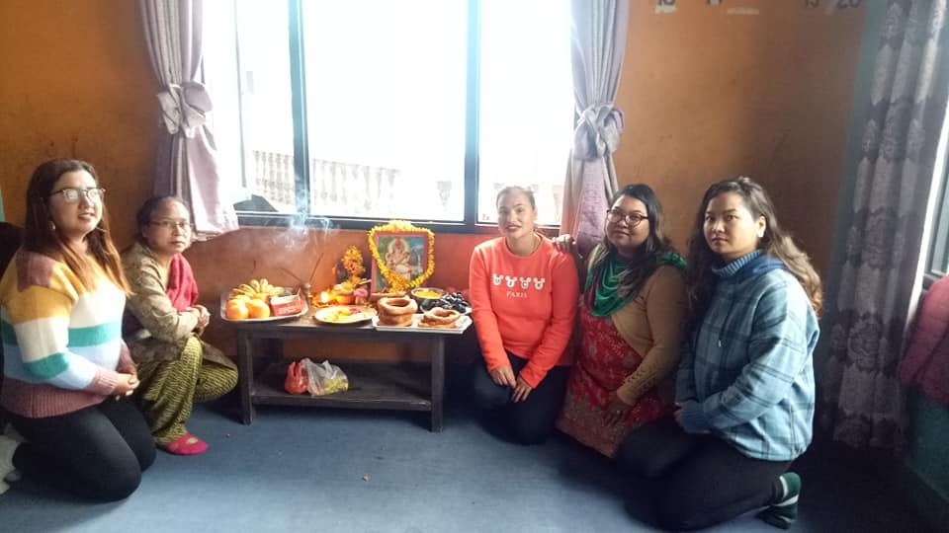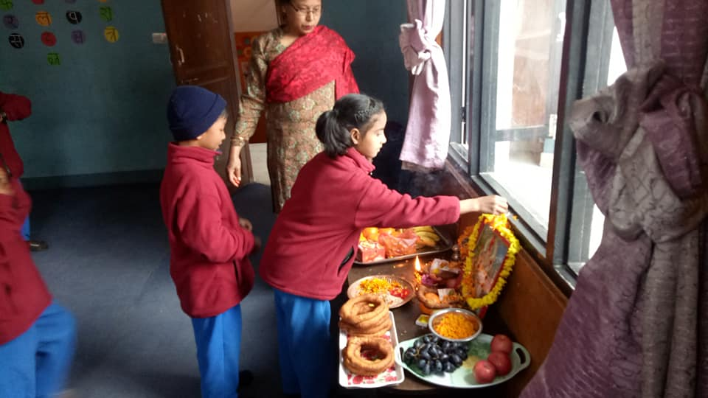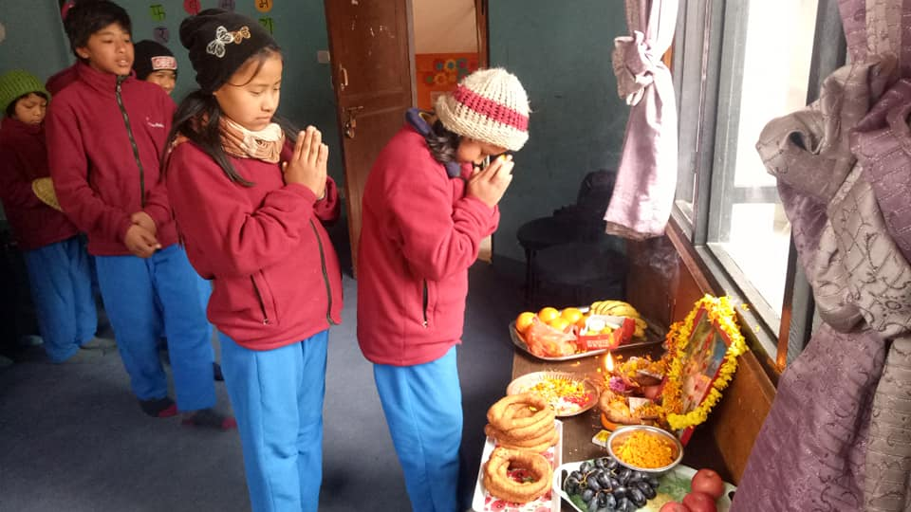Our staffs and students also worship goddess Saraswati in our school with a great respect by offering varitey of sweets, fruits, garlands and tika. We worship books,pens,notebooks and instruments.
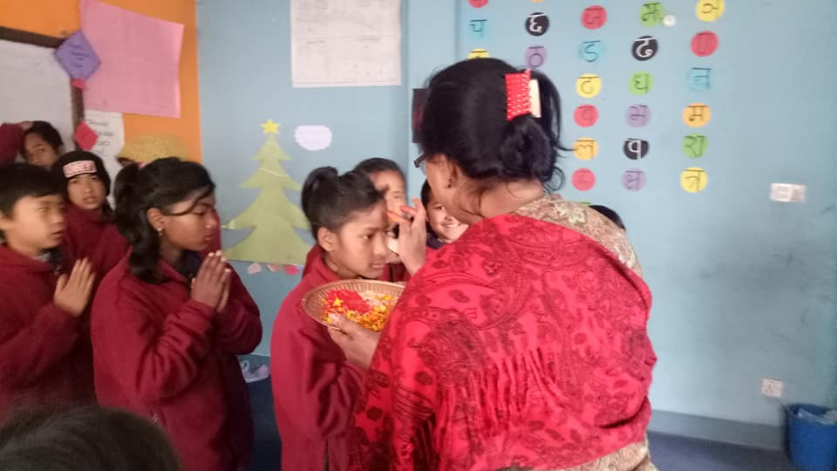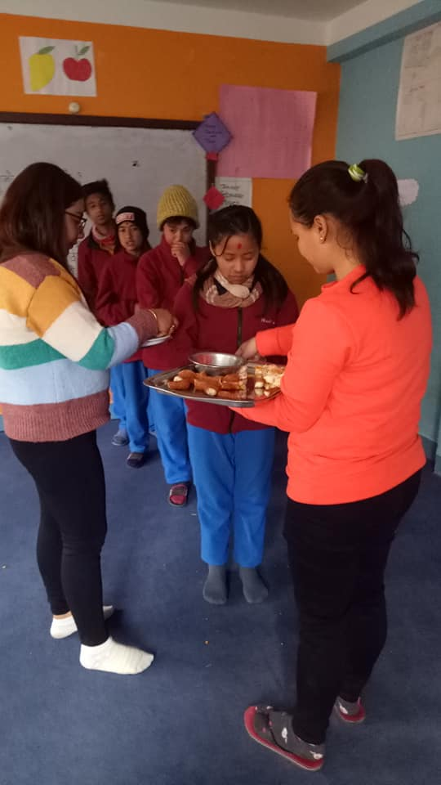Children are receiving tika and blessing from Srijana Shrestha . Teachers are serving sweets, fruits on the auspicious occasion of Saraswati puja.
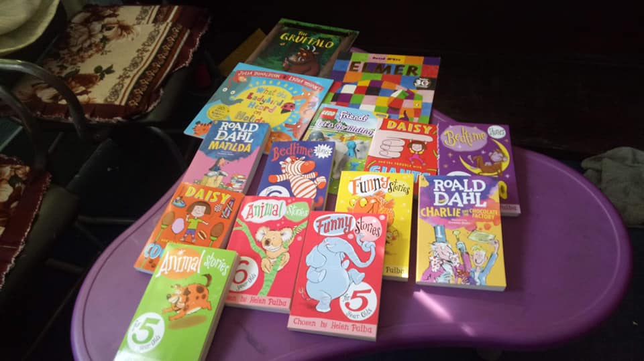
Thank you so much Annette for interesting story books.
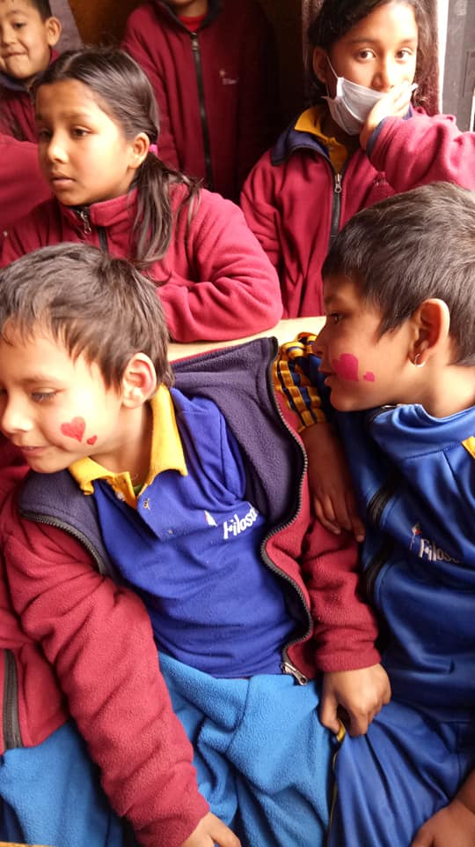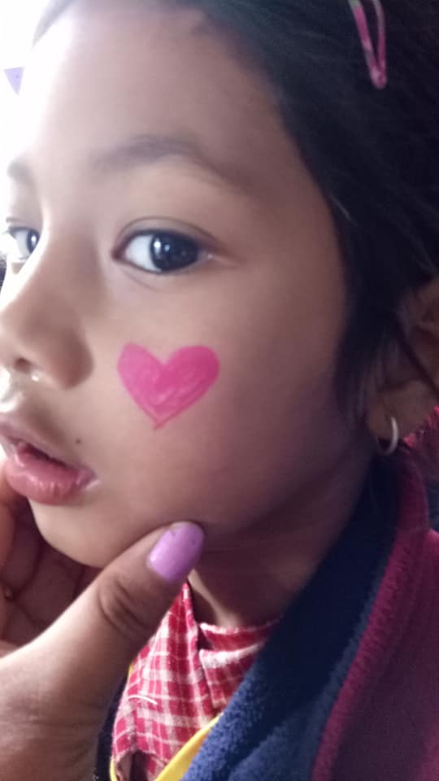
Happy valentine day from Filosofiska Nepal. On this special day, we did face painting, dancing and singing.

The central zoo is located at Jawalakhel of Lalitpur district. It is home to some 870 animals in 109 species, and is operated by the National Trust for Natural Conservation. Although it was originally a private zoo, it was opened to the public in 1956.
Altogether 21 students from class Nursary to class U.K.G and three staffs of Filosofiska Nepal visit zoo in 15th February, 2019. In zoo, children really had fresh air, they ran here to there. Children observed different kinds of animals, birds and fishes. They play in the children park. They play slide, swing, merry- go- round, funny temple,Uranus and so on. They really enjoy the out games. After that we had picnic, we sharefood with each other. It was very fun filled day in zoo.
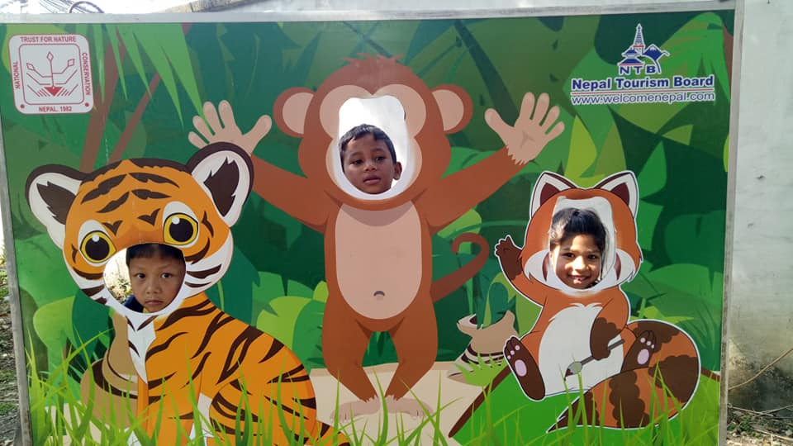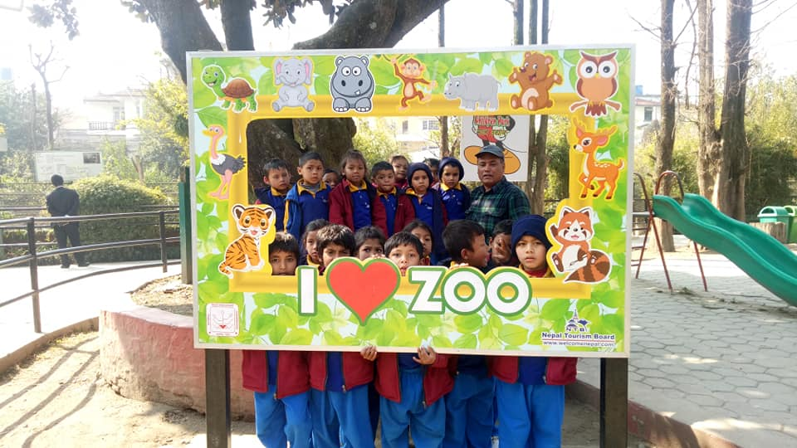
It is the first outing of grade Nursary. Children are posing for pictures in the zoo.
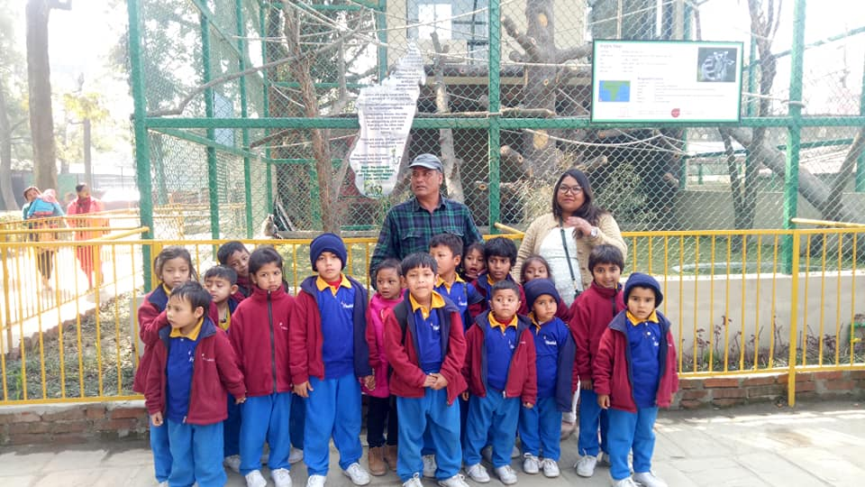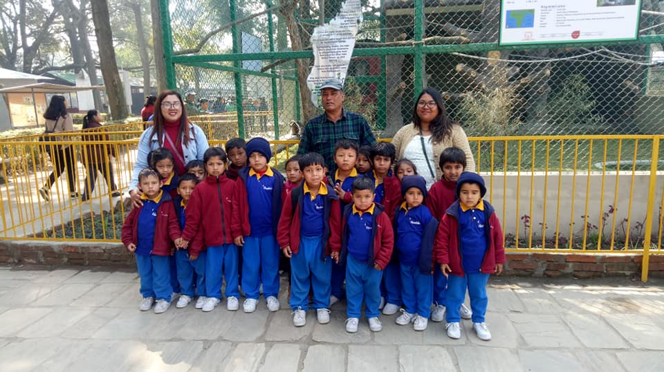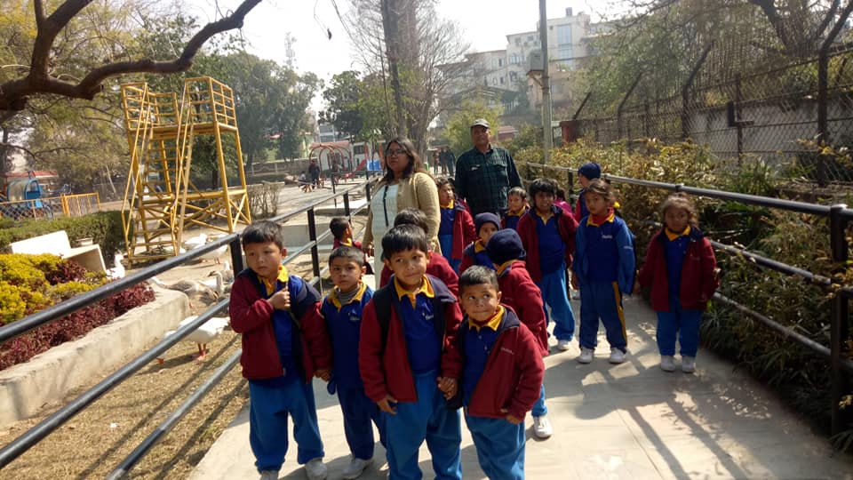
The pre primary students with their techer in central zoo. They had great time.
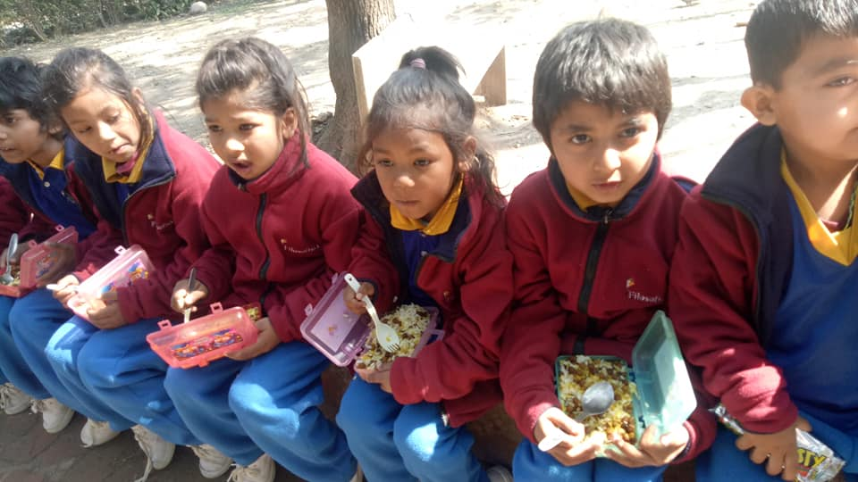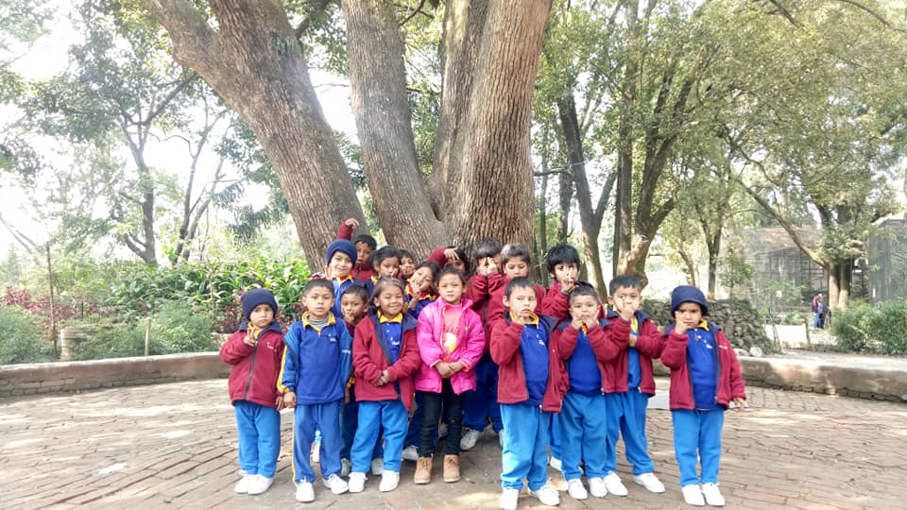
Children are having their snacks with their friends. After snacks our beautiful children are posing for camera inside the zoo again.
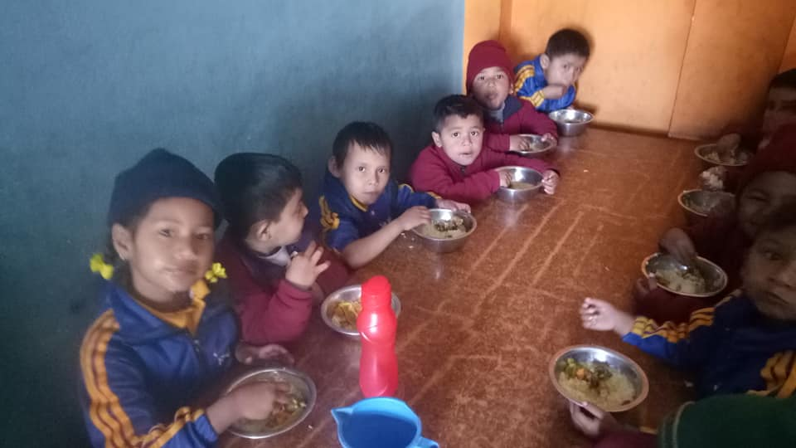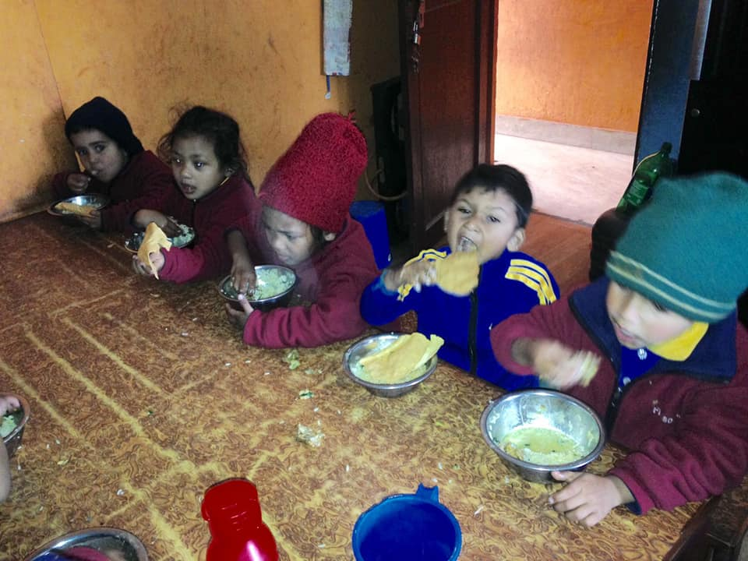
Children having their delicious lunch. It is providing by Radhika Shrestha. She was celebrate her son’s 1st birthday with our little philosopher. 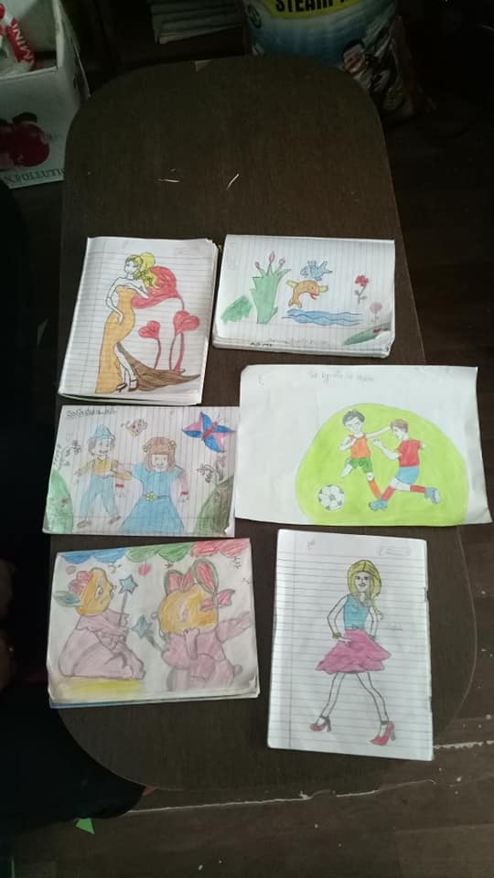
Drawing competition in Filosofiska Nepal. It was held on 24th February 2019. It was the last drawing competition of session 2075. These five drawing are most selected drawing of this competition. The names of the winner of this competition are follows:-
- Hira Lal moktan
- Udiya Yadav
- Robin Khadka
- Sadikshya K.C
- Asmita Nepali
- Sujina Nepali
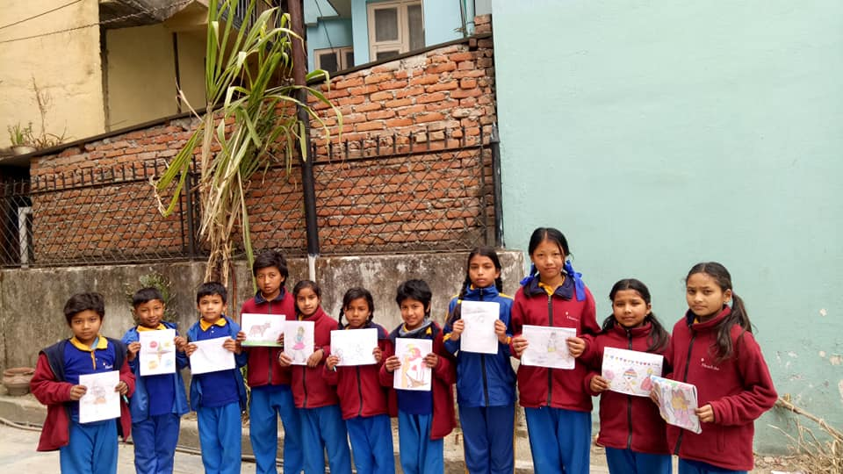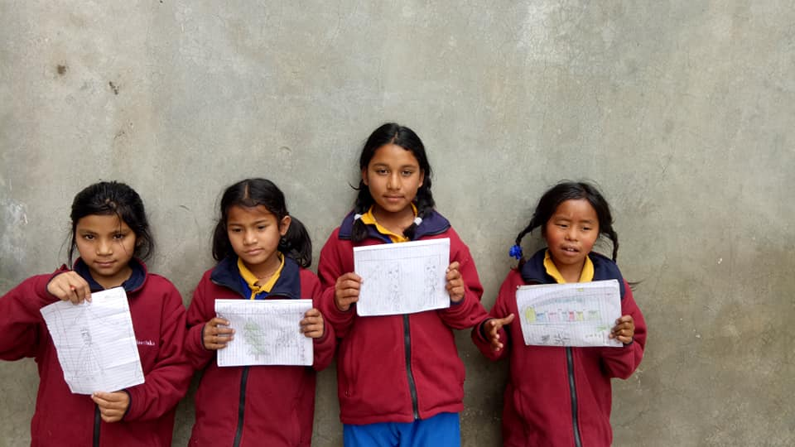
Drawing by grade one and two.
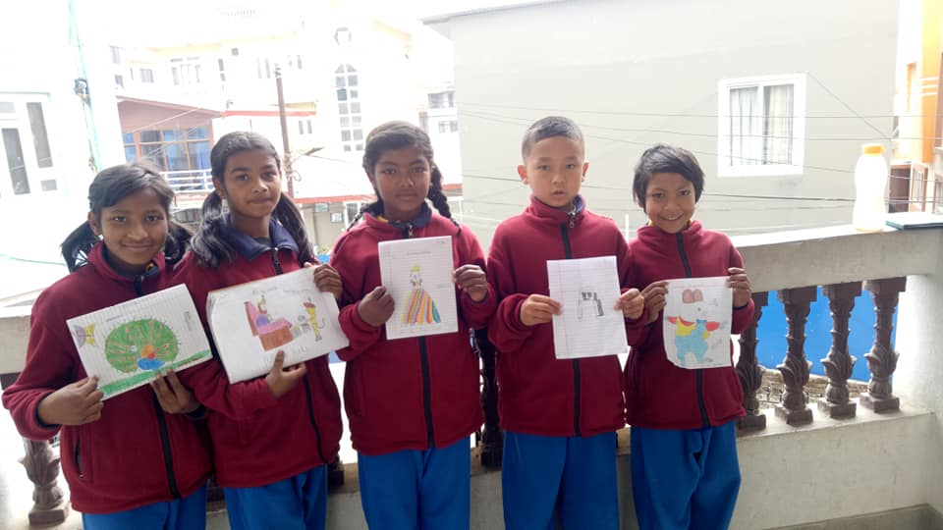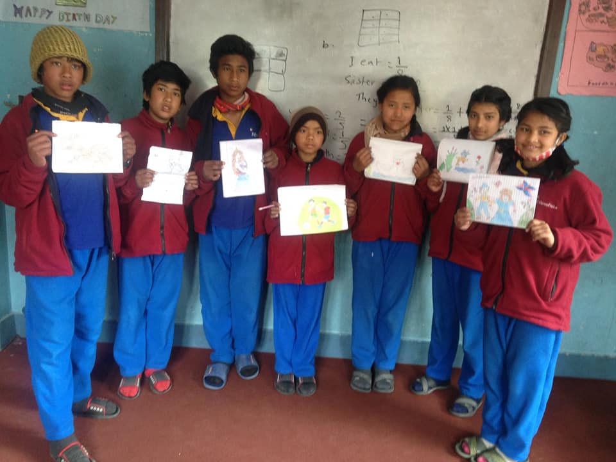
Drawing by class three and four.
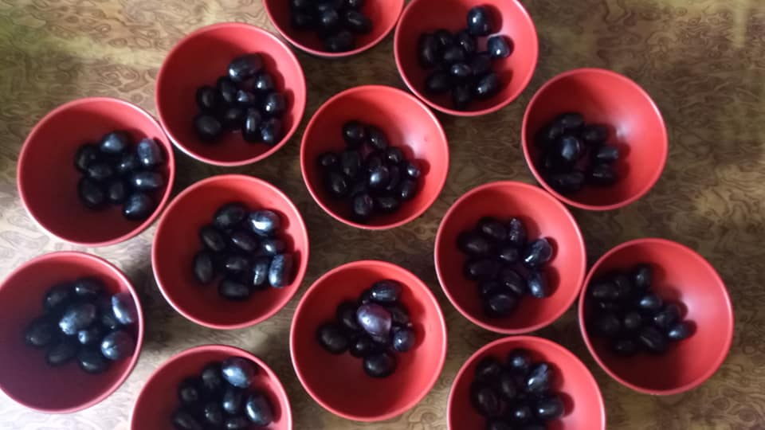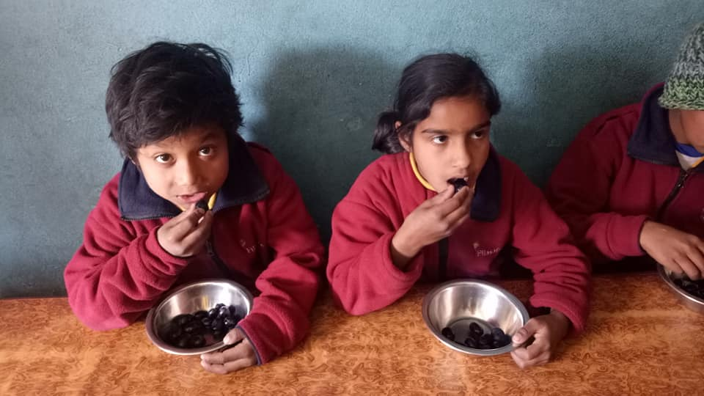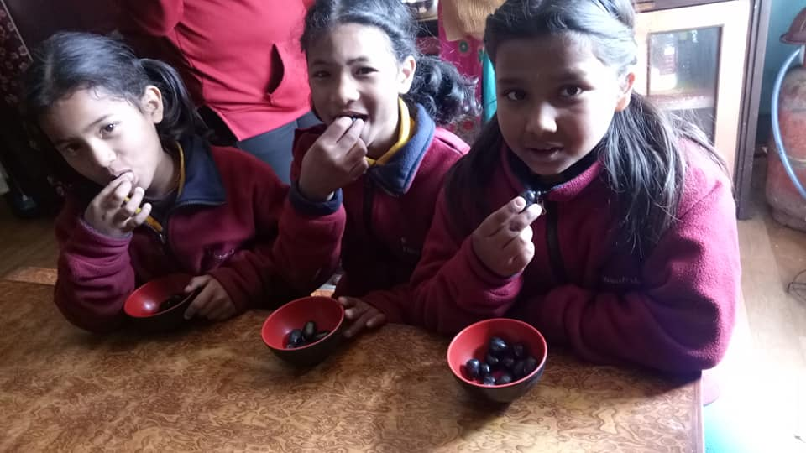
Children having seasonal fruits .Thank you Mikaela for fruits.

