Monthly Progress Report of January 2019
New Year is the time or day at which a new calendar year begins and the calendar’s year count increments by one. Many cultures celebrate the event in some manner and the first day of January is often marked as a national holiday. Global New Year day traditions include making resolutions and calling one’s friends and family. Filosofiska Nepal wishes a very Happy New Year to all of our students, parents and staff and well wishers.
In Filosofiska Nepal we celebrate different festivals with great enthusiasm. Even we have our Nepalese New Year in April. We celebrate English New Year as well.
A game is something that people do for fun. In many game, people play against other people. Game in school encompasses more than just the benefit of physical activity. Increase in self –esteem and mental alertness make school sports and games necessary for every school age child. In this month we Filosofiska Nepal organized sport meet 2019. All students are participated in different games. They enjoyed their days a lot. The list of the games and name of the winners are giving below:-
Lists of the games: Class Winner of the student
a.Football 3 and 4 Milan,suman,sadikshya,Pratikshya,Muskan HiraLal,
b.Kabbadi 3 and 4 Roshan,Buddha,Abhishek,Sadikshya,Pratikshya,
Santosh
c. Musical chair 1 and 2 Alisha Pariyar
1 and U.K.G Rabina Khadka
3 and 4 Pratikshya Tamang
L.K.G and Nursary Shamjhana Katuwal
d. Shoes less tide and run U.K.G Purnima Katuwal
1 and 2 Raj Maharjan
3 and 4 Santosh Katuwal
e. Tough of war 1 Prabin,Sujina,Sumitra, Rojina,Raj,Rabin
2 Bibisha,Elisha ,Lazima
3 and 4 Milan,Suman, Gudiya, Sadikshya,Hira Lal
f. Caterpillar Race U.K.G Buddha,Purnima, Ankit
1 Raj,Sujina,udiya
2 Bibisha,Siddharth,Samjhana
3 and 4 Abhishekh,Santosh,Buddha
g. Sack Race L.K.G and Nursery Anita Paudel
U.K.G Purnima Katuwal
1 Udiya yadav
2 Elisha Pariyar
3 Siwani Pariyar
4 Abhishek Nepali
h. Passing the ball Nursery Anju Paudel
L.K.G Unika Shrestha
U.K.G Bibek Lamichhane
1 Smriti Nepali
2 Elisha Pariyar
3 Muskan Nepali
4 Roshan Khadka
i. Relay Race Nursery and L.K.G Bikram Gahatraj
U.K.G Dikesh Ghalang
1 Rabin Khadka
2 Siddharth Nepali
3 Gudiya Yadav
4 Milan Maharjan
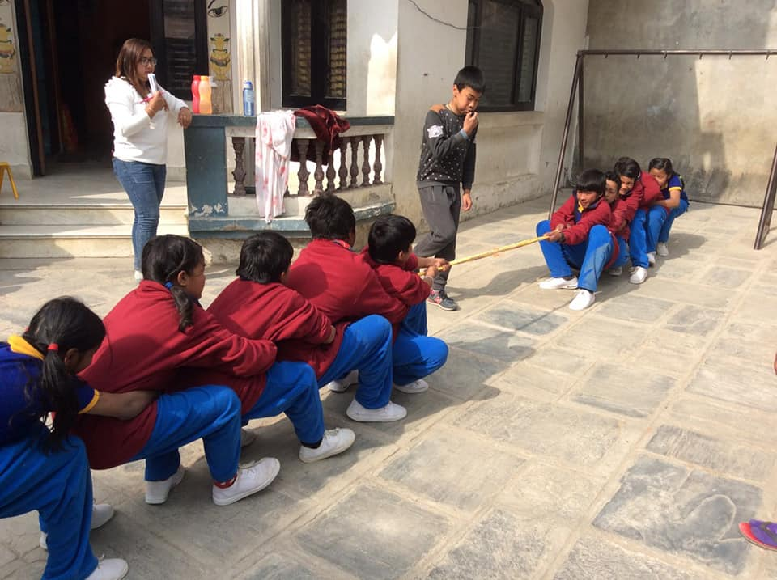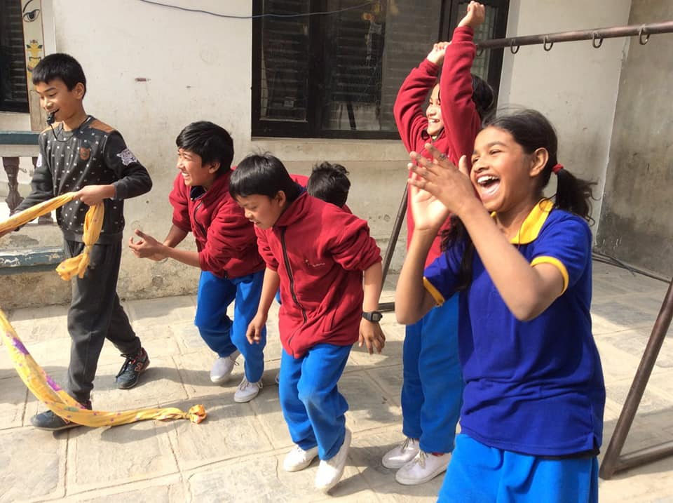
Students are playing Tough of war game. Gudiya and their team members are very happy after won the game.
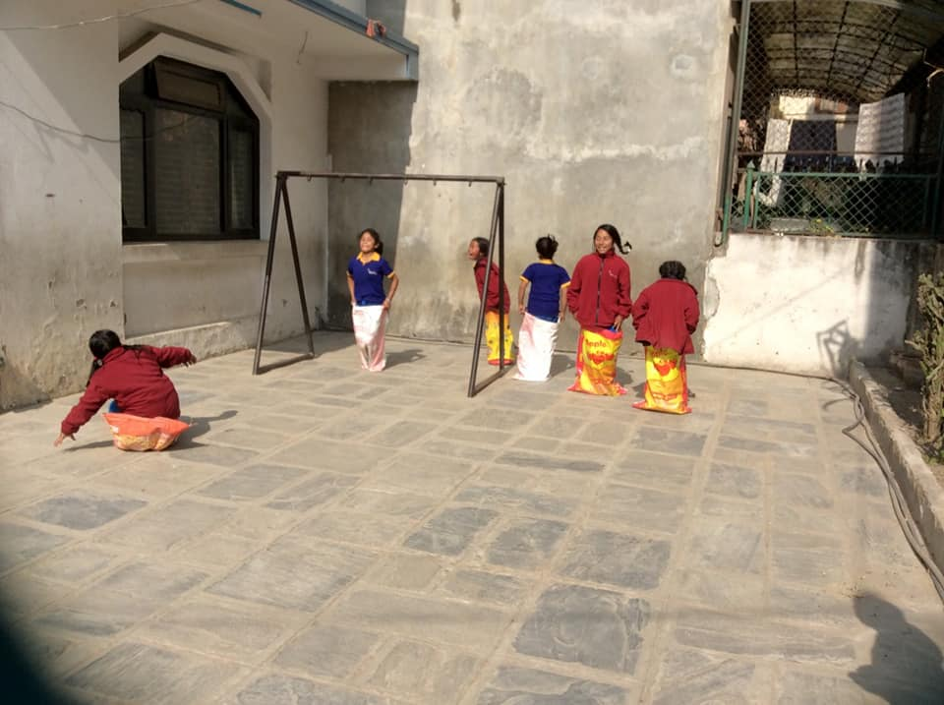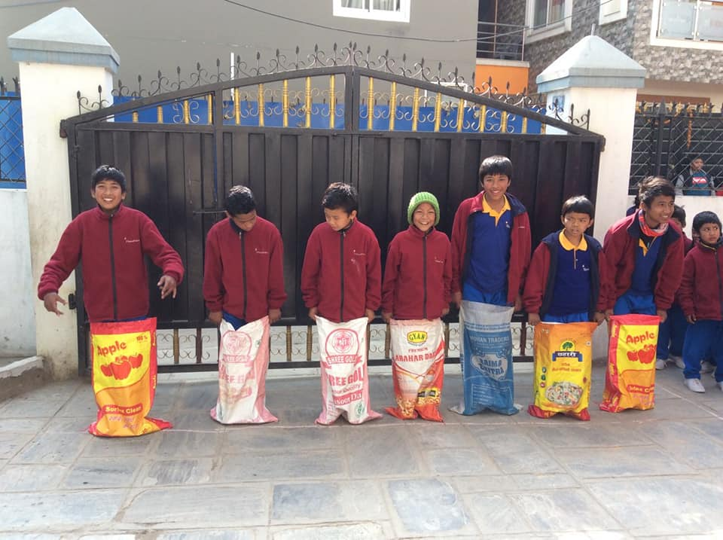
Children of class two are performing their sack Race game. Boys of class four and three are waiting for their turn.
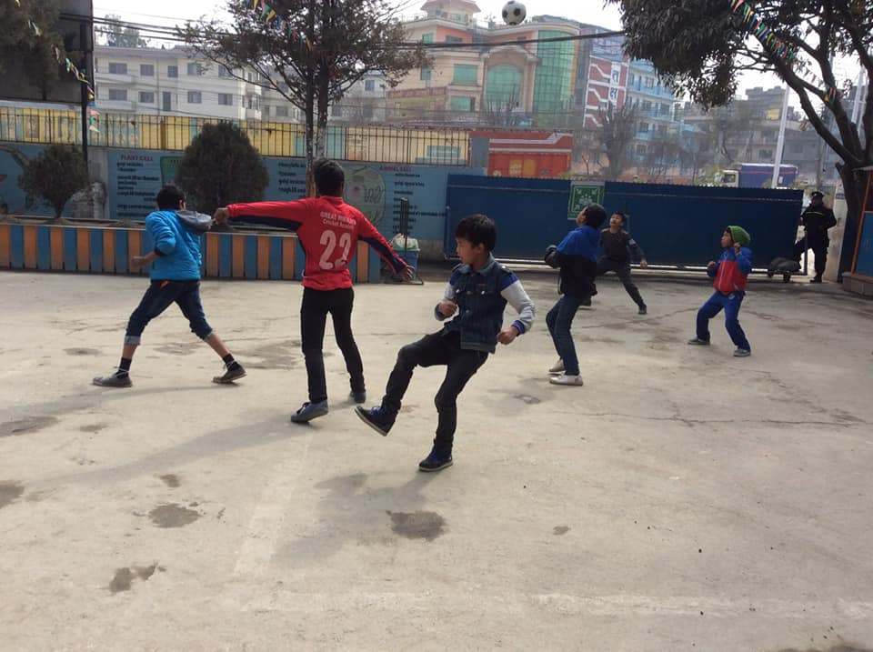
Our little football players are playing game in ground of southwester school. 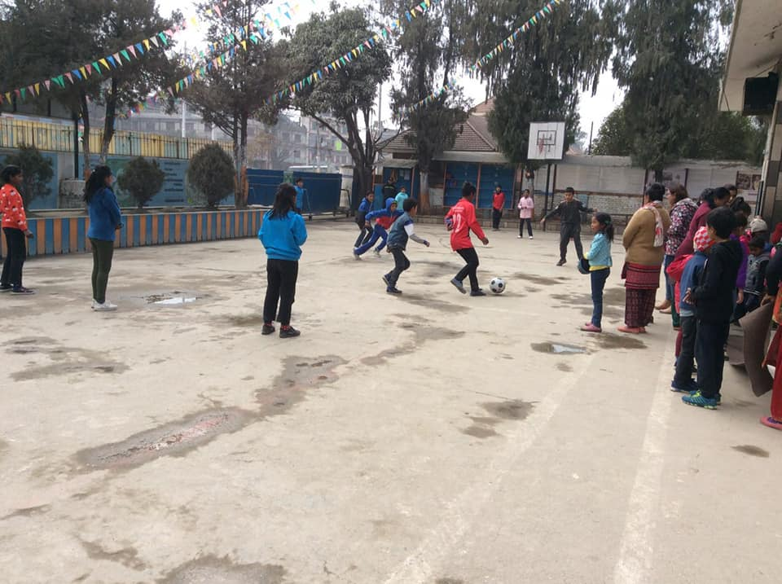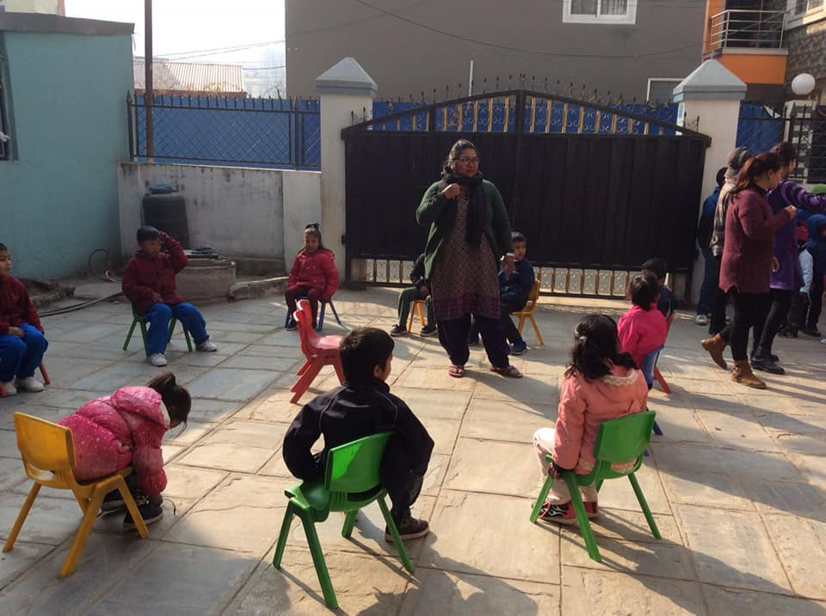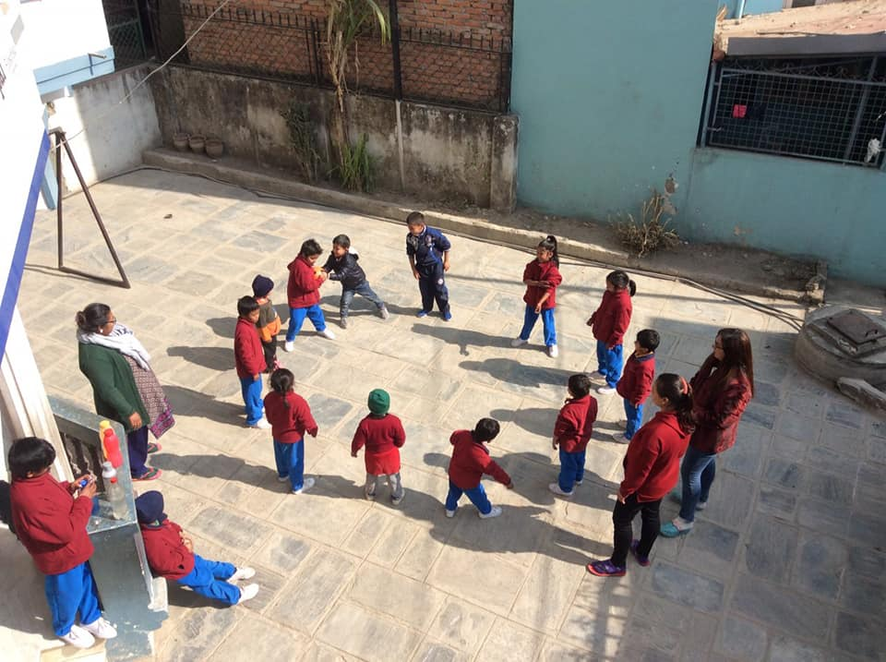
All our students were get lots of fun on their sport days.
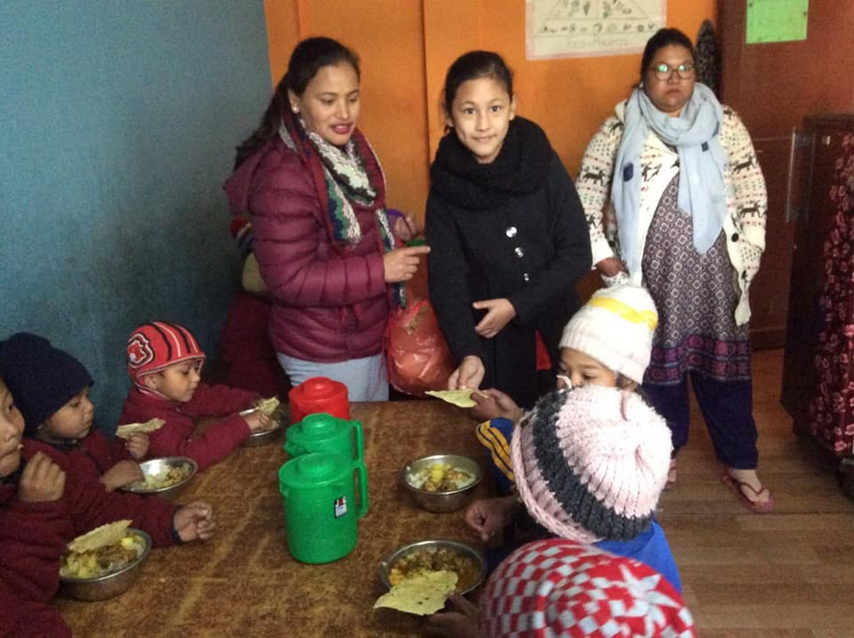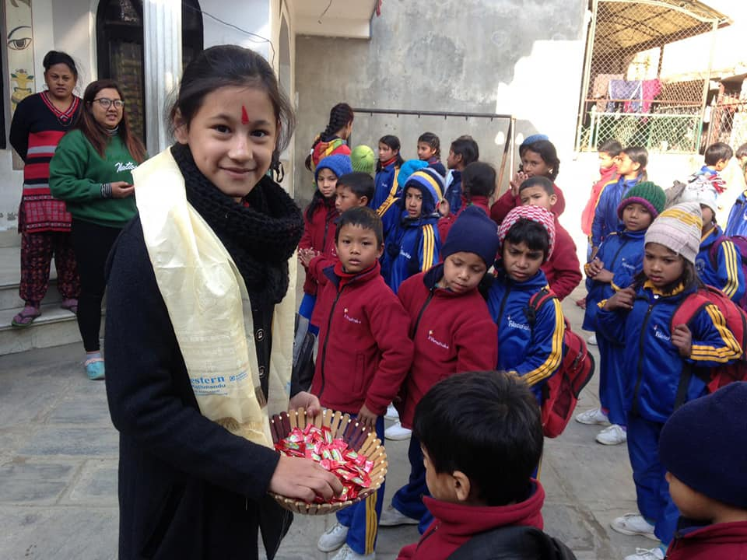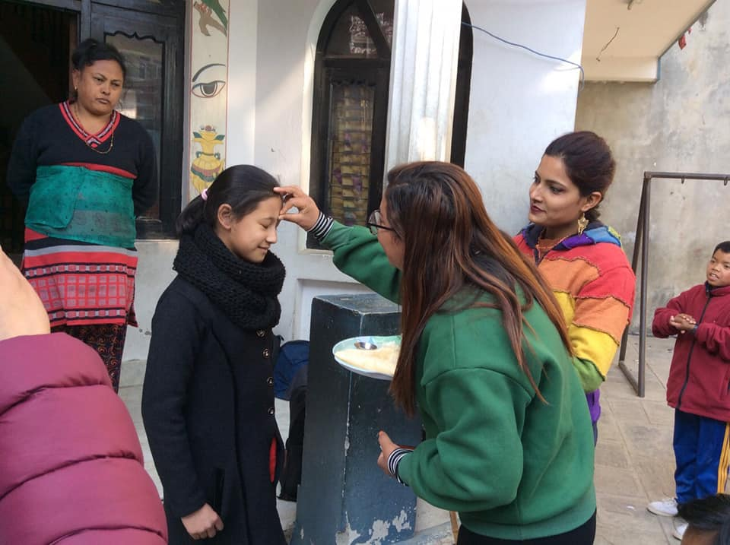
Darshika Shrestha celebrated her 10th Birthday with our litter filosofers. Her family provided mummy lunch and chocolates to our children. Once again Happy Birthday Darshika. Hope to see her again in Filosofiska NEAPL.
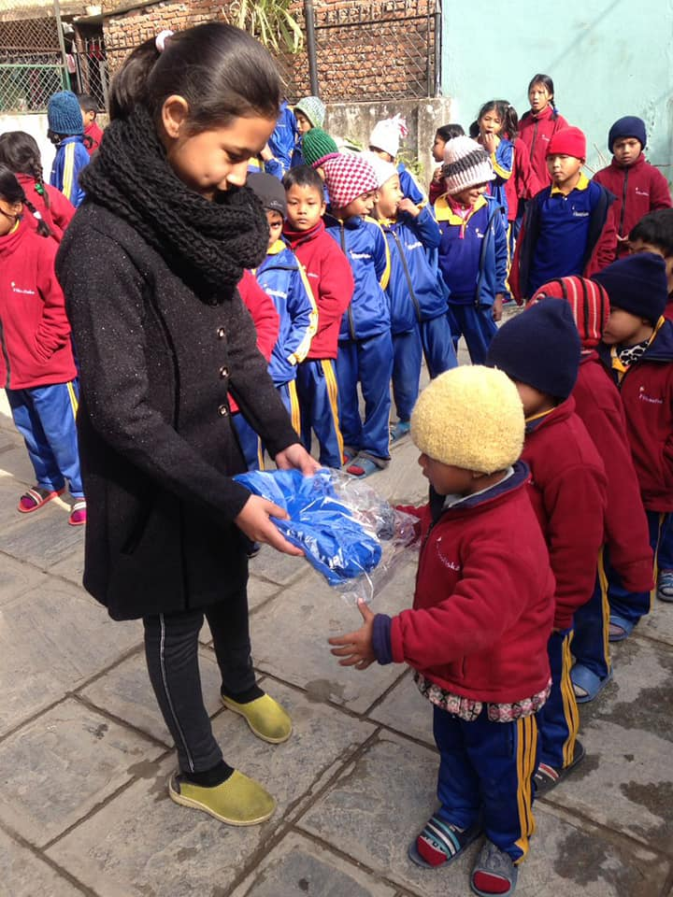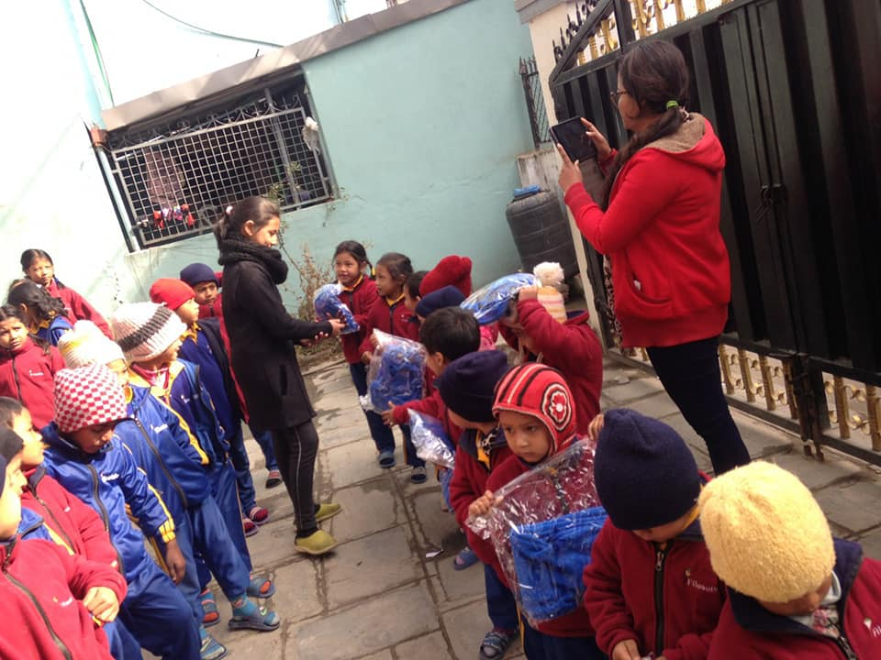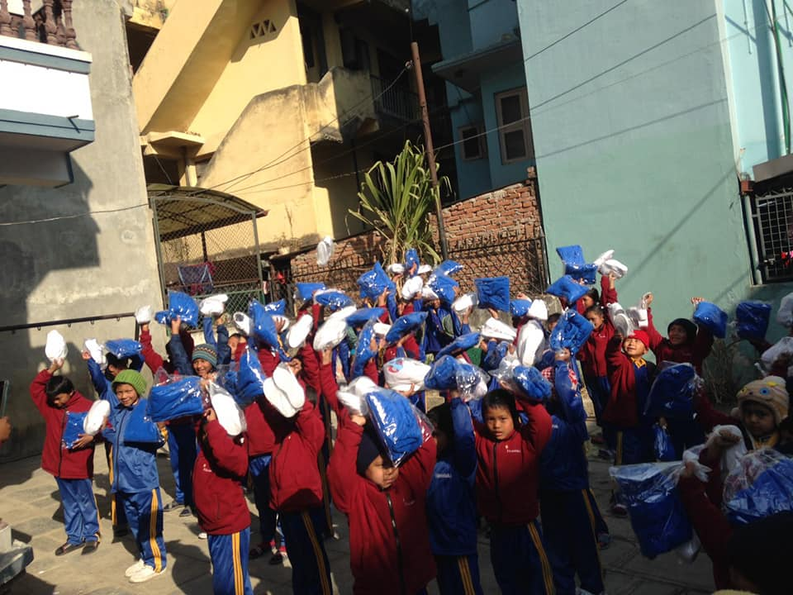
Thank you very much Kapila Shrestha (Mother of Darshika), her team member of Nepal bank, New road Branch, samita, lata, sujata and Guna Keshari for warm trousers. Darshika is distributing winter uniform
to all of the students in her birthday.
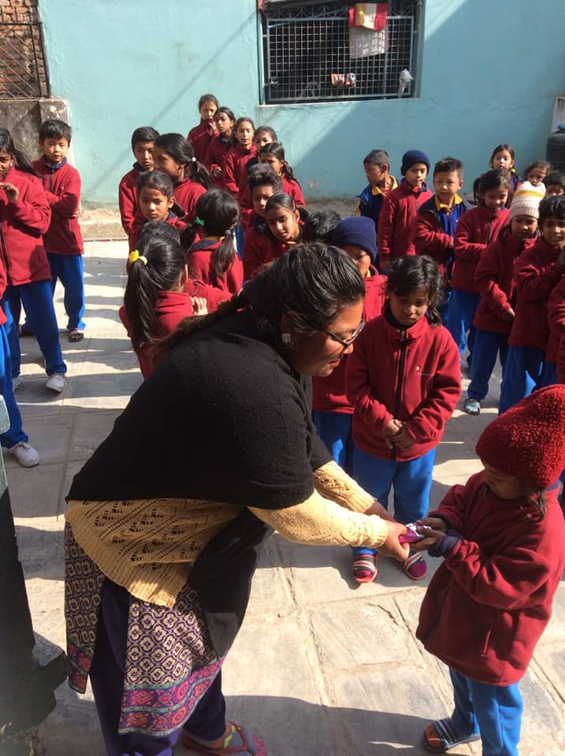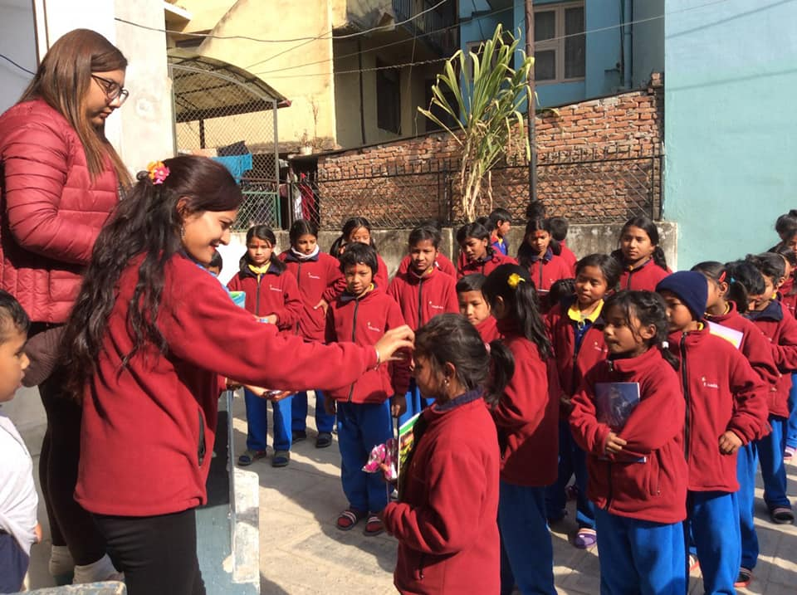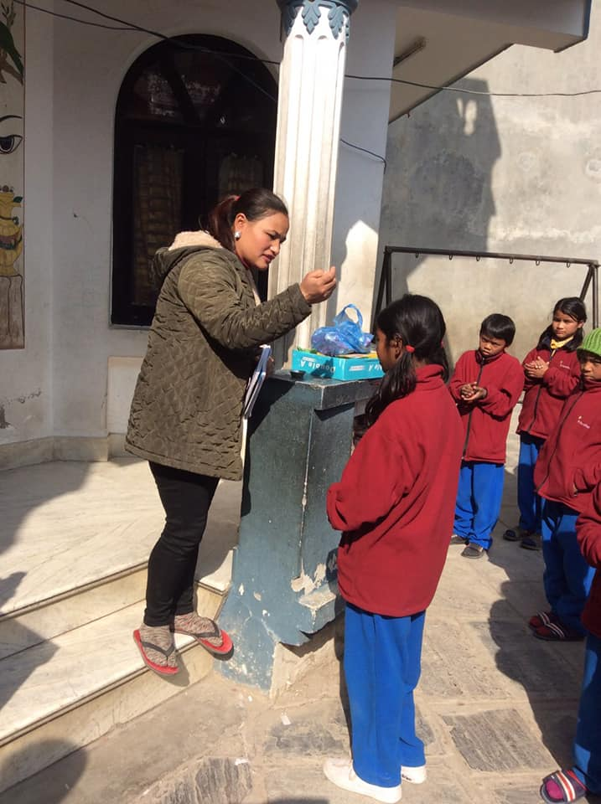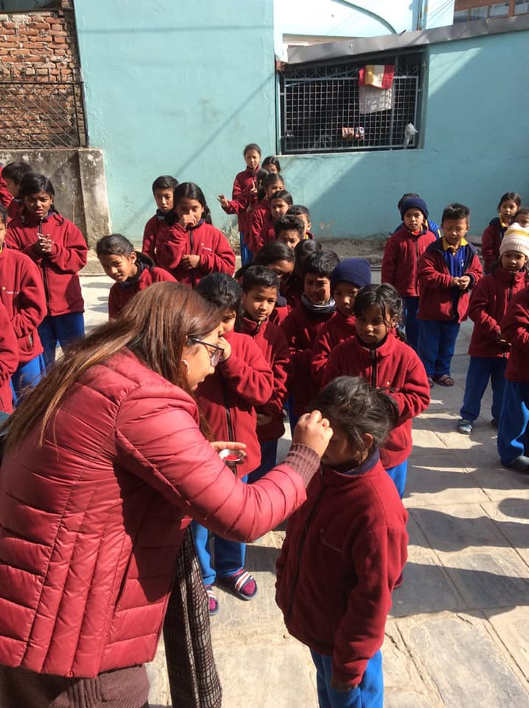
Prize distribution Programmer of sport days. Staff of Filosofiska Nepal is distrusting prize to all winners.
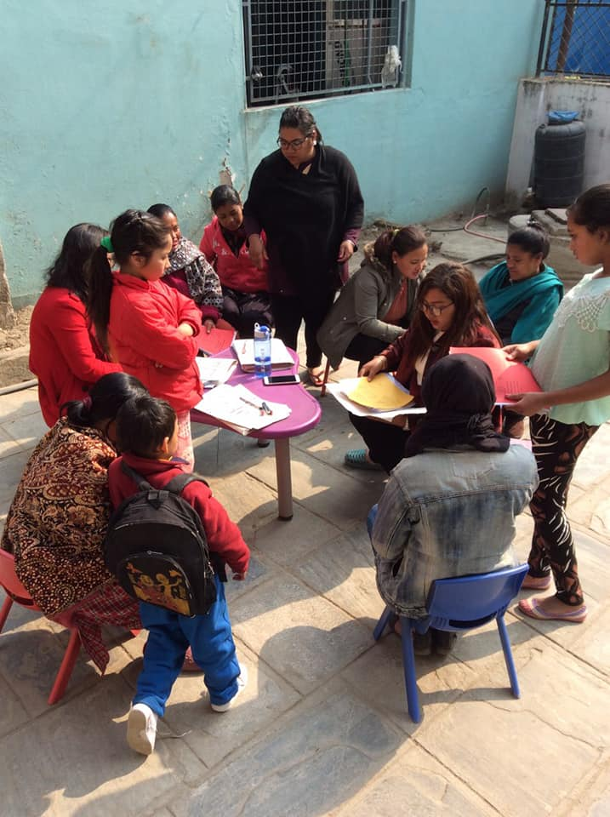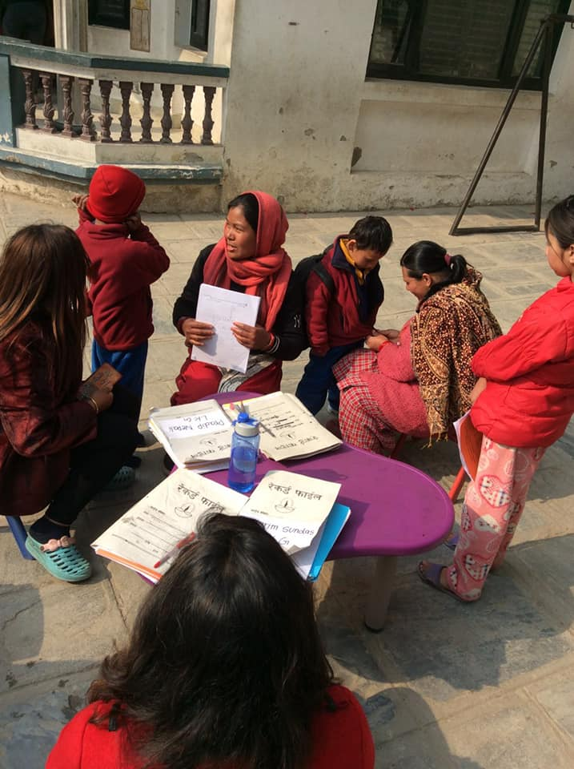
Report card distributing of Second Term Examination 2075.Teachers are interacting with parents of all students that day. Congratulations to all our students for good result.
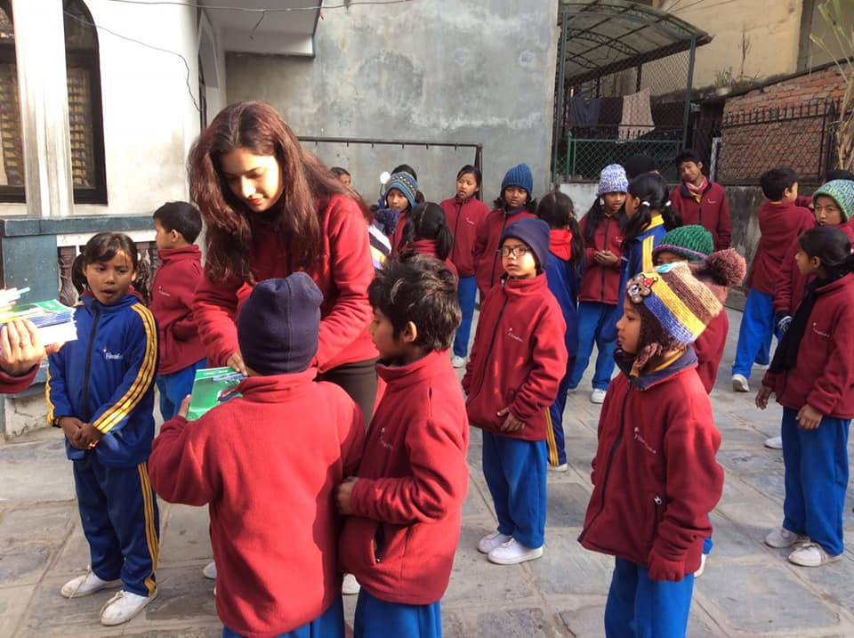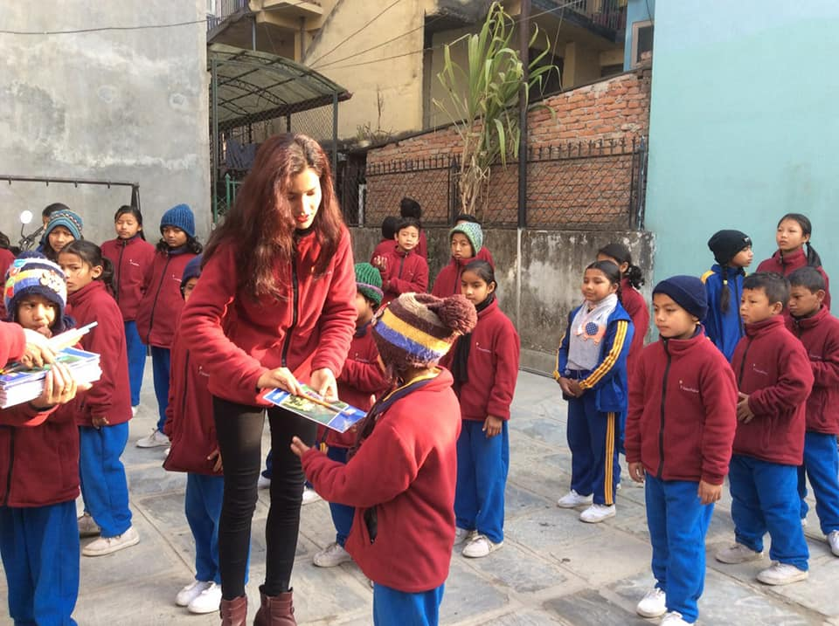
Thank you Monika Cevis for stationary items.
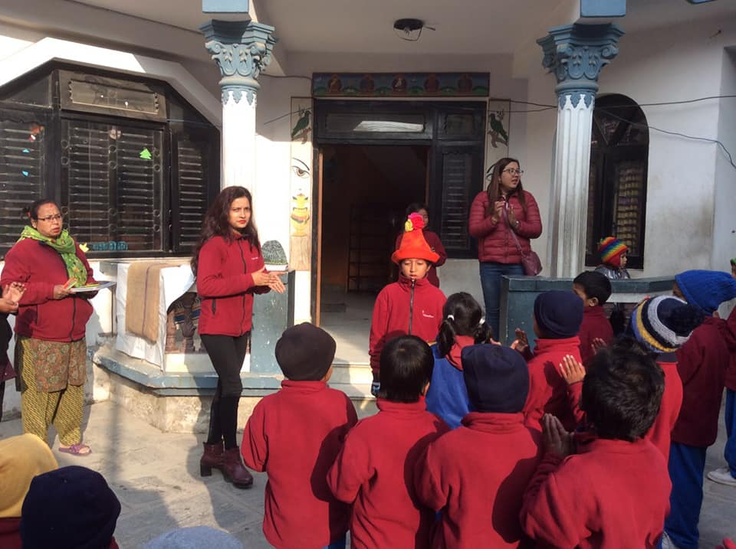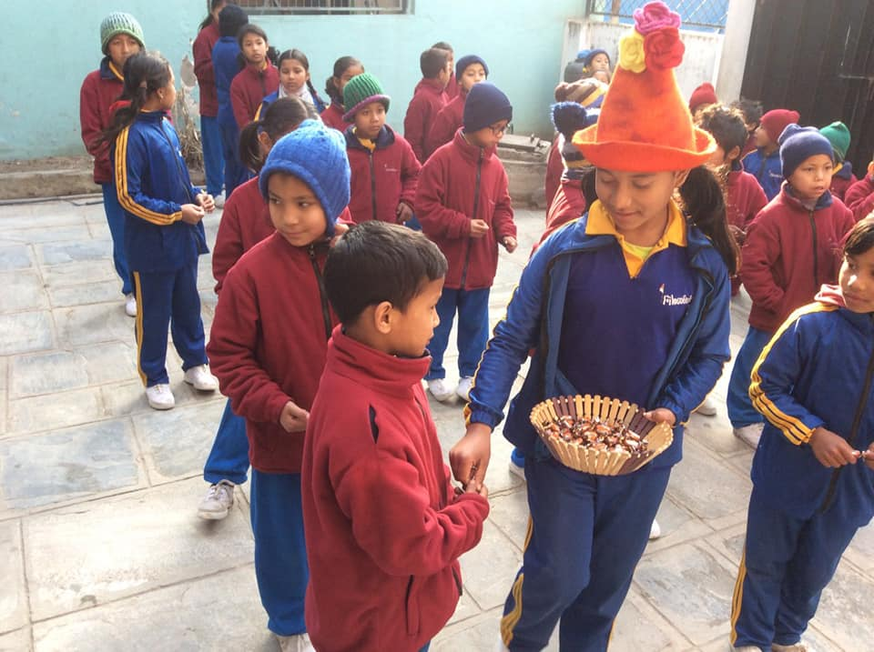
A birthday is the anniversary of the birth of a person. Bithdays of people are celebrated in numerous cultures, often with birthday gifts, birthday cards, birthday party and some other special act. But in Filosofiska Nepal we are celebrated birthday with sweets. In this month Lazima and prabin are celebrated their birthday with their friends. Wishing you both a very happy birthday.

