Monthly Progress Report of March 2019
March is the start of spring in Nepal which sees the transition from colder into a warmer. Nepal has five season and March falls in right at the start of spring. This month we all are busy in exam preparation. As our final term examination is started from 31st March till 5th April. We gave more focus on study. In this month teachers are busy for preparing questions for final term exam. All of the students work hard to achieve good marks in exam. In this month we select weak students from all the classes and gave them extra hours in study. Because we have to match the level in coming year. We all teachers are maximum used to lunch break for extra classes. They were doing much better in this matter. Suman Khadka and Abhishek Nepali from grade four,Buddha Gurung from grade three,Lazima Pariyar and Sidhartha Nepali from grade two, Sujina Nepali, Arjun Shrestha, Sumitra Ghalang and Nikesh Koirala from grade one,Buddha Bayalkoti Bikash Girel,Simran Bamjam,Krishna Oli and Bupati Bhandari from pre-primary were given the extra attention in the class as well as home.
The student of southwestern collage invited our few students (children from two to four) in their welcome program in this month. Our children were present their dance and pomes in the stage of college. They provided yummy dinner and lots of ice cream to children. Some children had five to seven ice creams. Our ex- volunteer and new volunteer Silika Mainali, Rajat Shrestha,Rhytham Gurung, Manila pantha and Dipendra Panth (students of BSW) were server food to our students. Sanju K.C and Gauri Shrestha were share information about Filosofiska Nepal in the program among all the teacher and students of Southwestern College. Chidren were reached their home late that day. 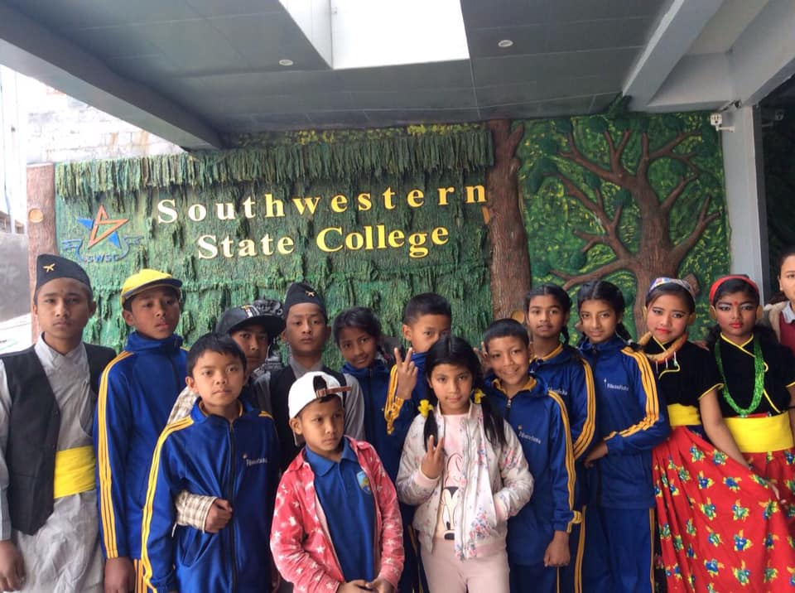Students at southwestern college.
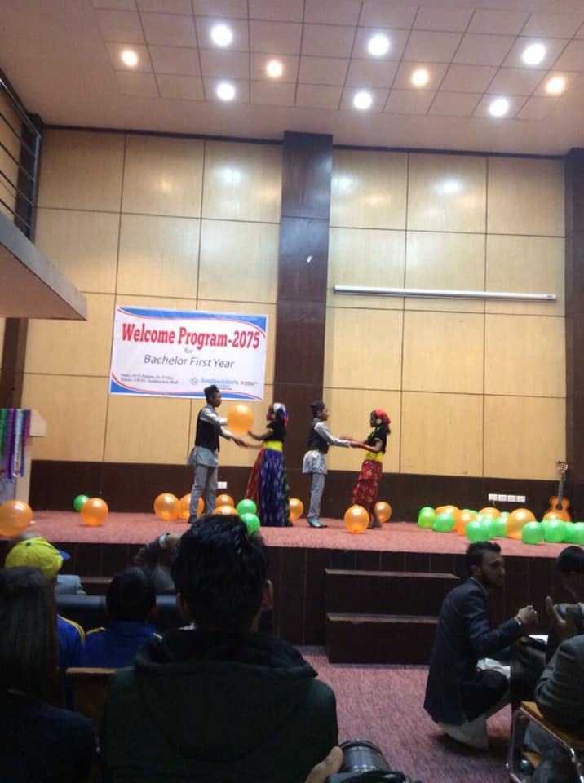Pratikshya Tamang, Milan Maharjan, Abhishesh Nepali, and Muskan Nepali are performing their dance at Southwestern College.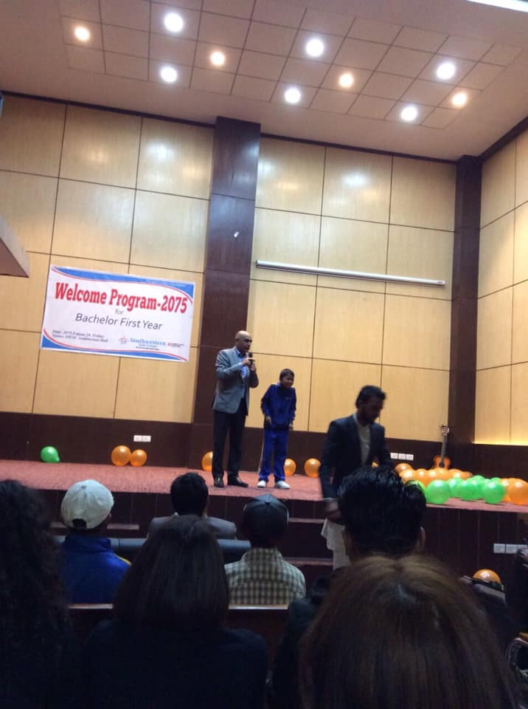
Dr. Rajendra K.C chairman of Filosofiska Nepal and Principal of Southwestern College is sharing information about Filosofiska Nepal.
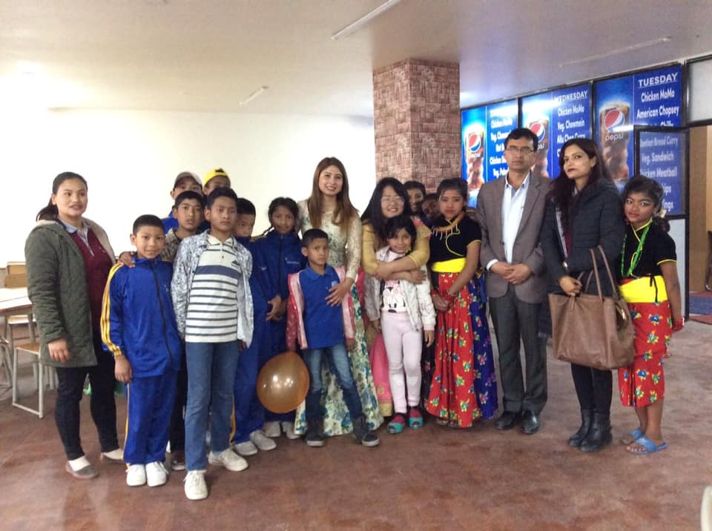
Group photo session after dinner with Hari Singh K.C (voice- principal of college).
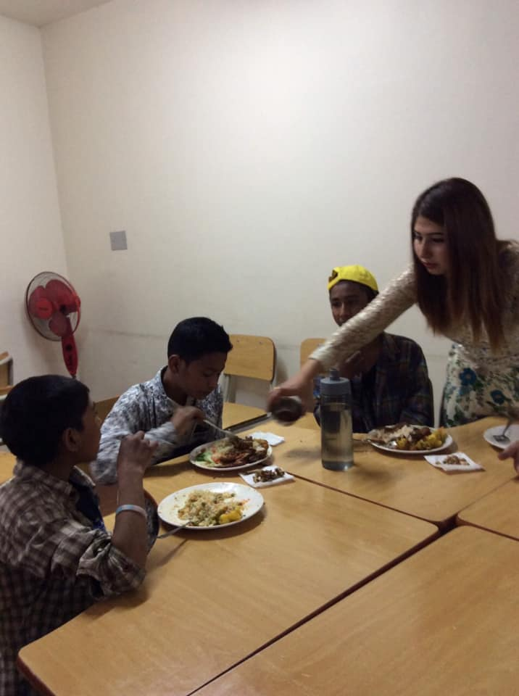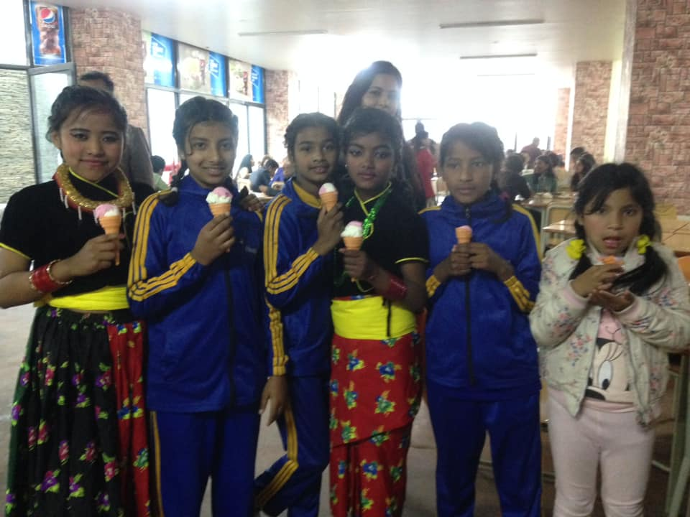
Children are having dinner and Ice cream. They enjoyed their whole day at Southwestern College. Thank you very much Dipendra Panth and his friends for invitation.
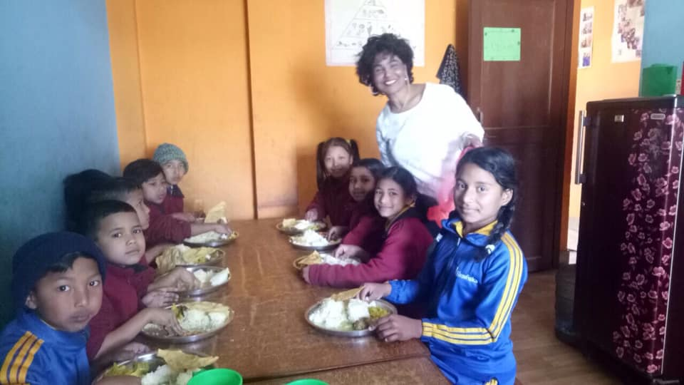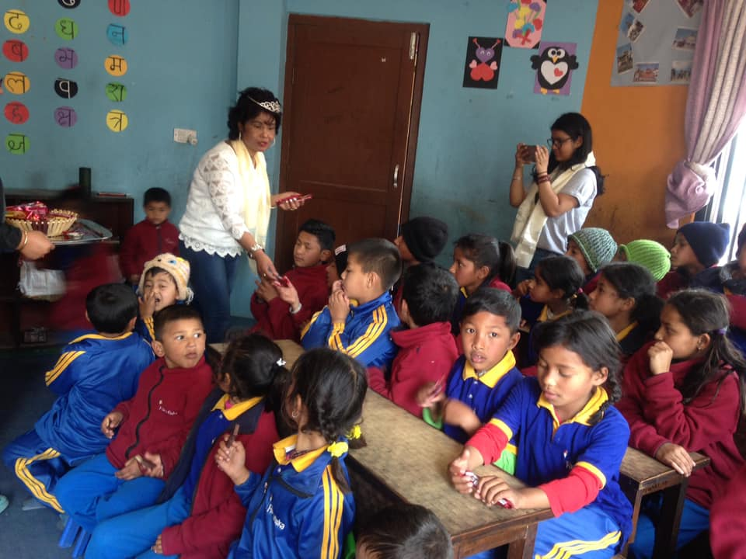
Bina Bajracharya is celebrating her birth day with our children. Happy birthday once again Bina ma’

Motivation is the reason for people’s action, willingness and goals. Motivation has been considered as one of the most important reason that inspires a person to move forward in life. In this month we provided motivation class to all students for their behaviors change. They learn lots of positive things from the motivation class. After the class children started to love their juniors, respected to seniors and teachers and gave more focus on their study. Ranju and Rubina gave motivation class to all children on free of cost.
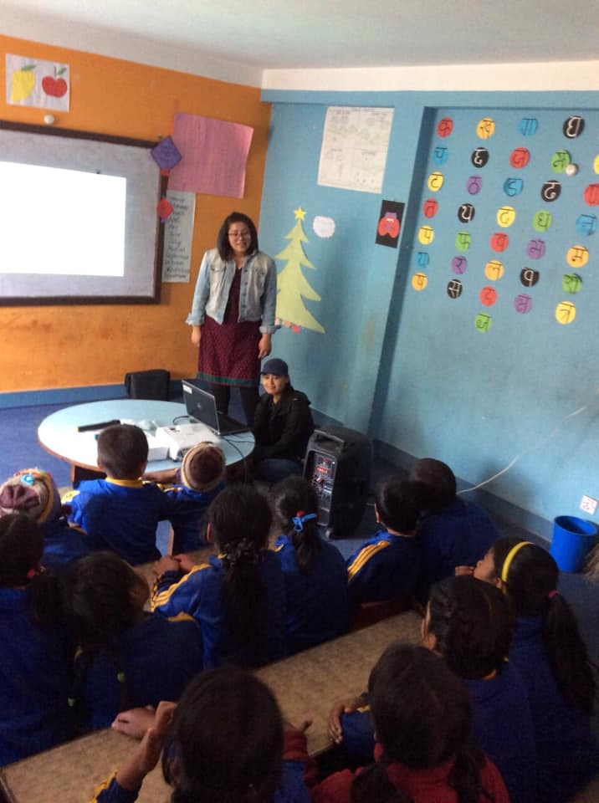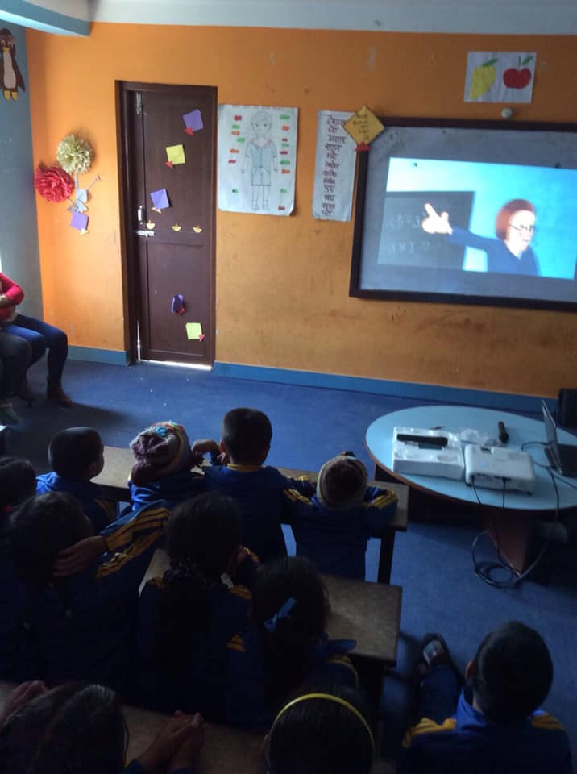
Thank you very much Rubina and Ranju for your helps and supports.

On March 22nd Kasthamandap vidhayalay grade one students visited our school with their teachers. Our students interacted with their students. They did different their projects together with the help of teachers. They drew pictures, played games, and sang beautiful songs Kathamandap Vidhayalay provided us some story books, colors and chocolates. They had lots of fun that day.
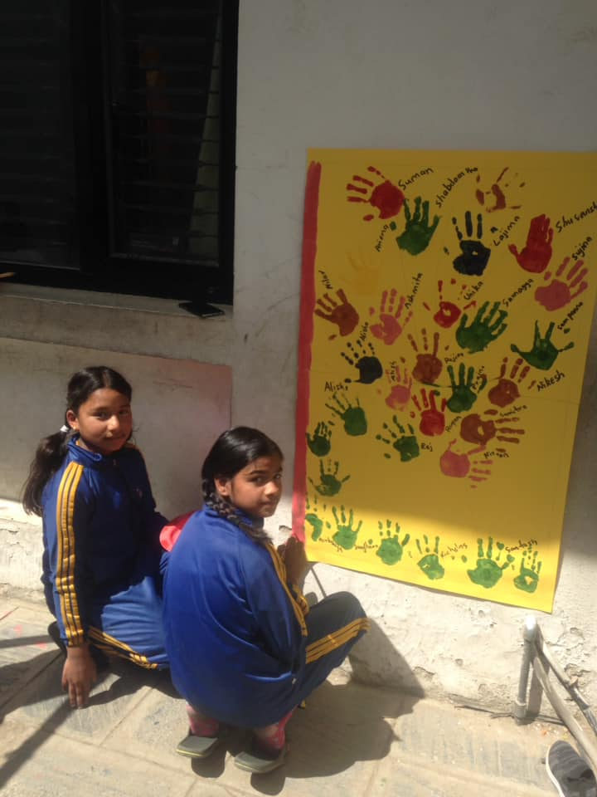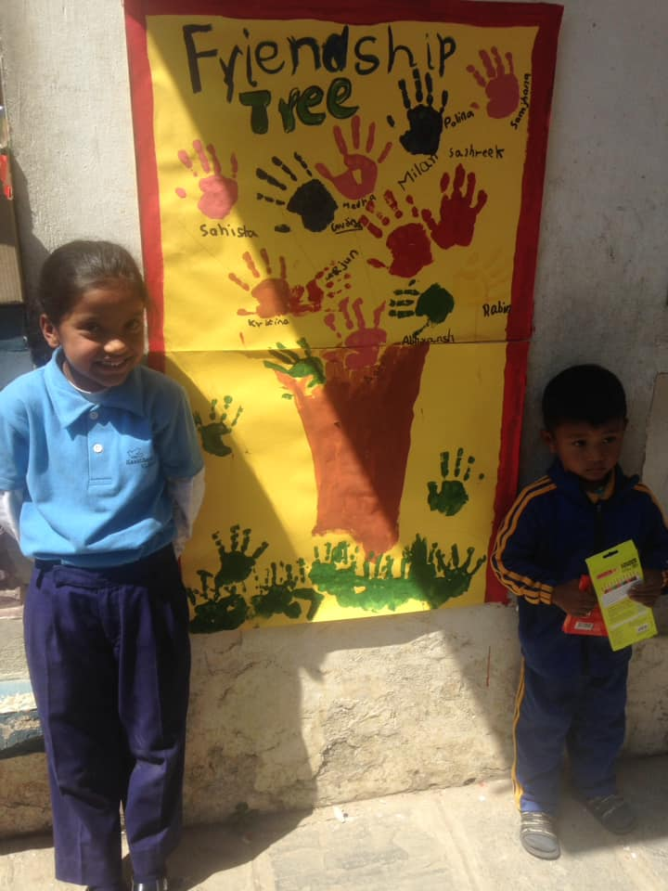
Children are posing for picture after finishing their project.

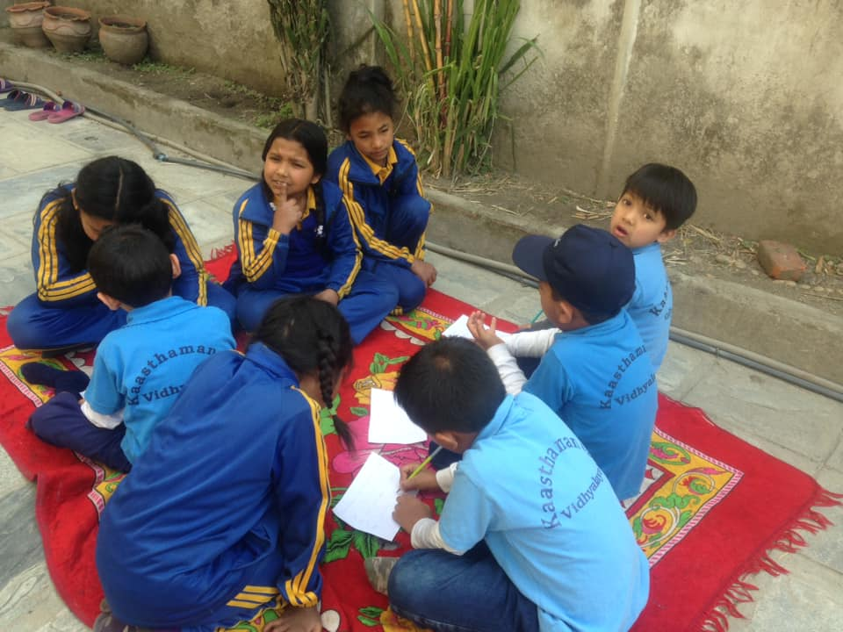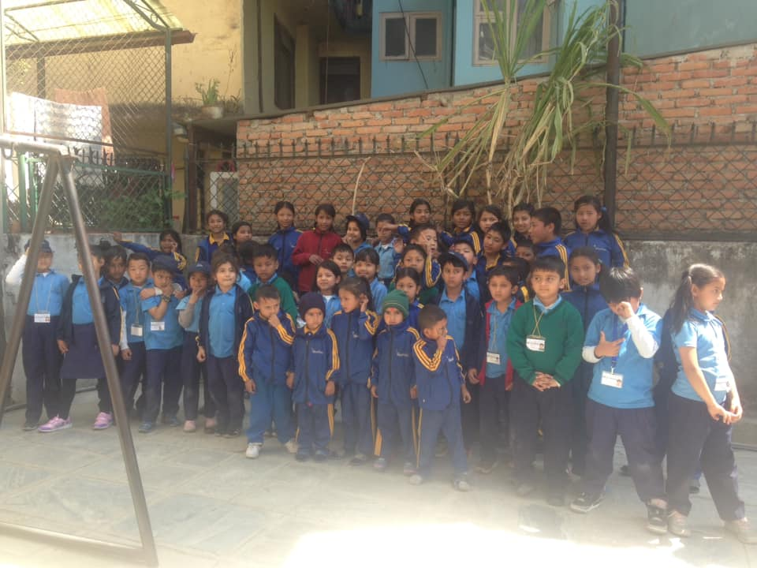
Students of Filosofiska, Nepal and Kasthamandap Vidhayalay are doing their projects. Group photo session of students at the end of the program.
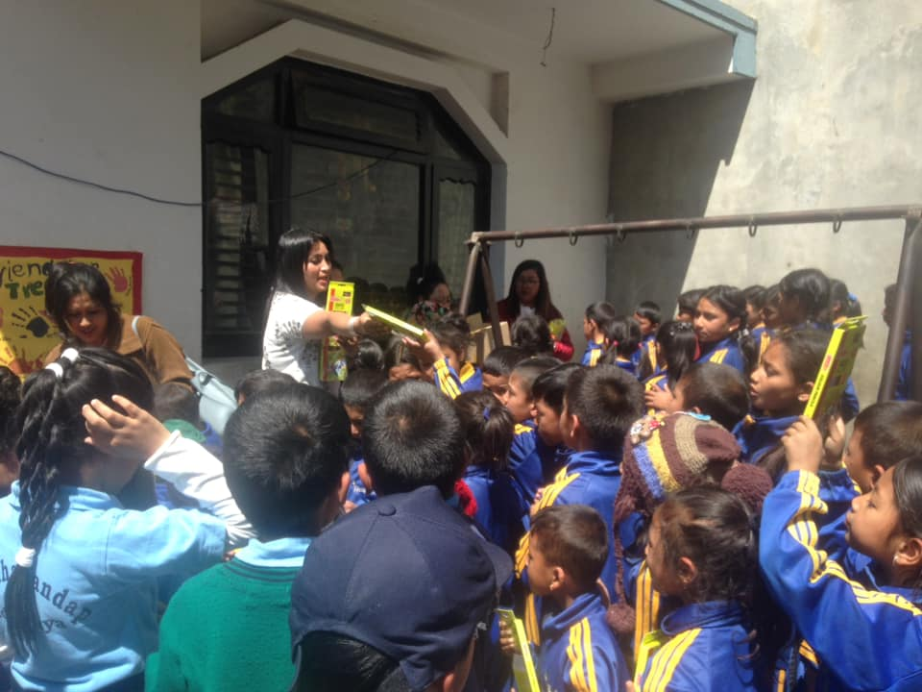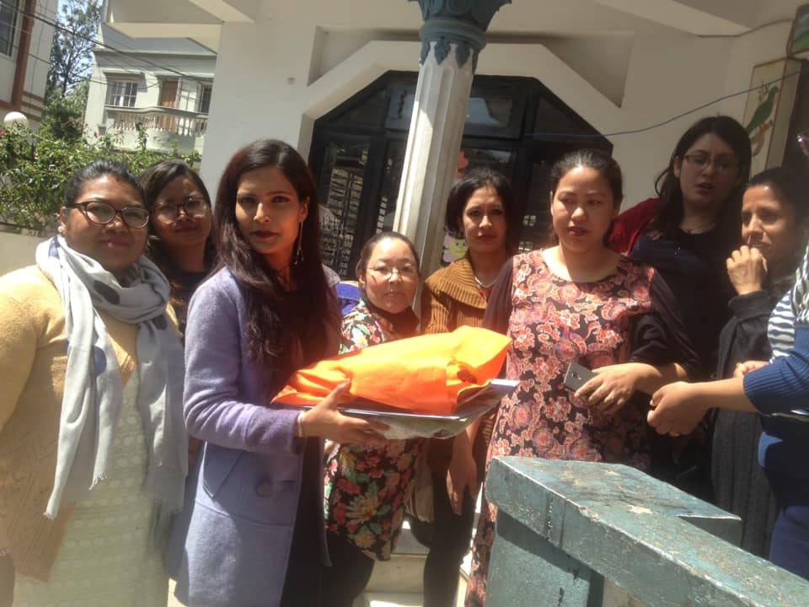
Teachers of Kasthamandap vidhayalay are distributing chocolates, colors and story books. They also gifted us some other stationary items.

On March20th we celebrated Holi festival of colors. Holi is celebrated with great enthusiasm and gaiety on the full moon day in the month of Falgun which is the month of March the Gregorian calendar. Great excitement can be seen in children when they actually the time for the play of colors. Children take special delight in spraying colors on one another with their pichkari and throwing water over each other. They really had great and joyful time.
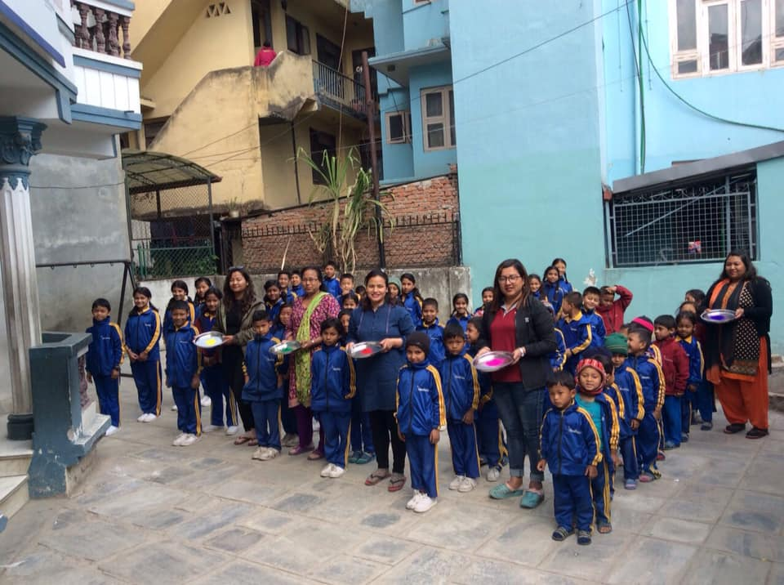
We celebrate Holi festival of colors in Filosofiska Nepal. Staffs of Filosofiska Nepal were painting colors in students face.

Thank you all of you for continuous support.
Filosofiska Nepal.

