Monthly Progress Report of May 2019


A new month has gone by and we have done so much!

The first Saturday of May we celebrated Mother’s day here in Nepal. Since Saturdays are holidays we, here at Filosofiska, celebrated Mother’s day on Friday the 3rd. All students made cards and decorations and class three and four made a big poster together with our volunteer Alexandra. The poster is now hanging on one of the walls in class four’s classroom.
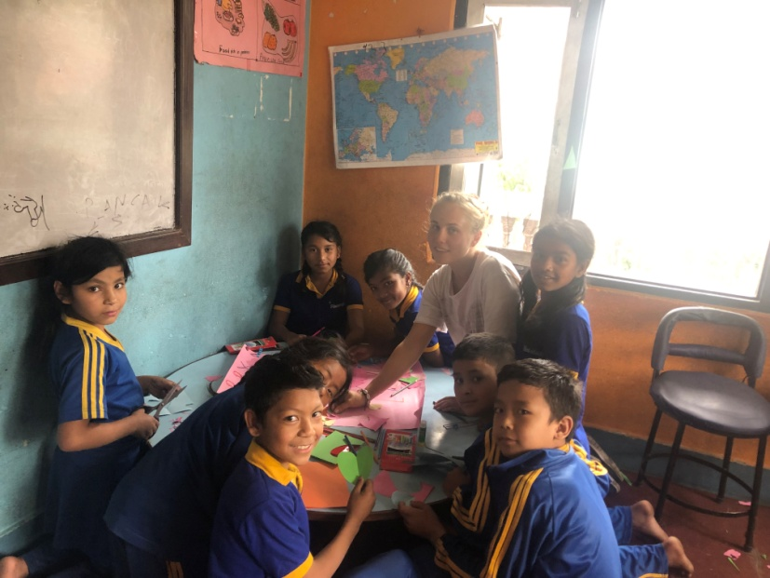
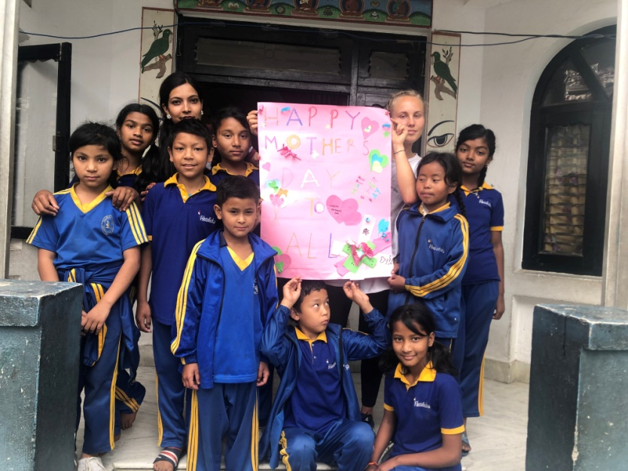
Class four and three made a poster.

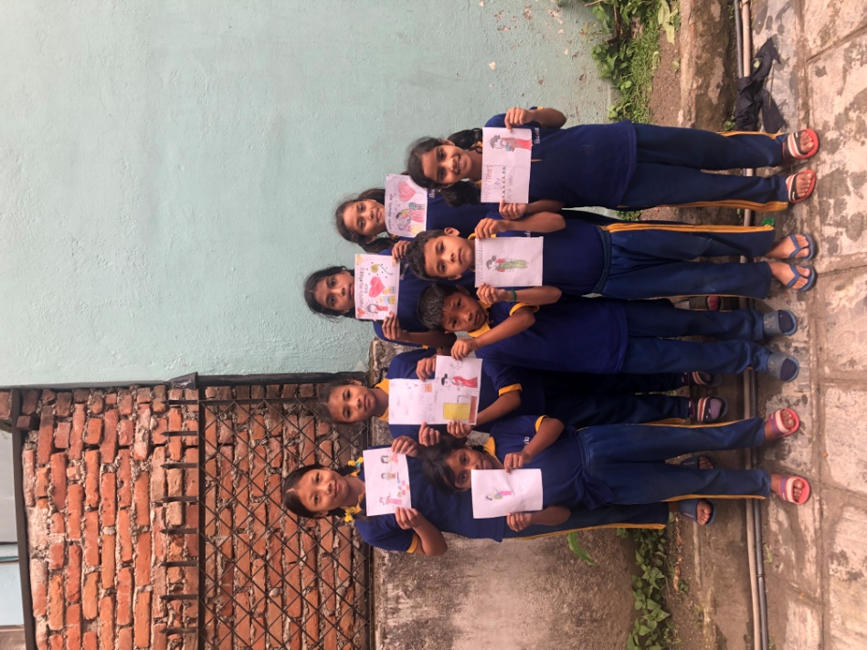
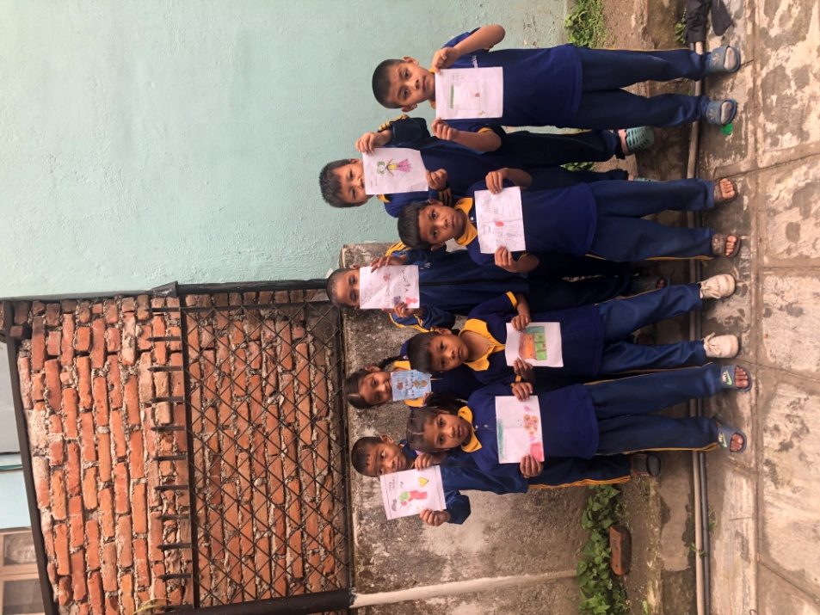
Class one and two holding up their “Mother’s day” cards.

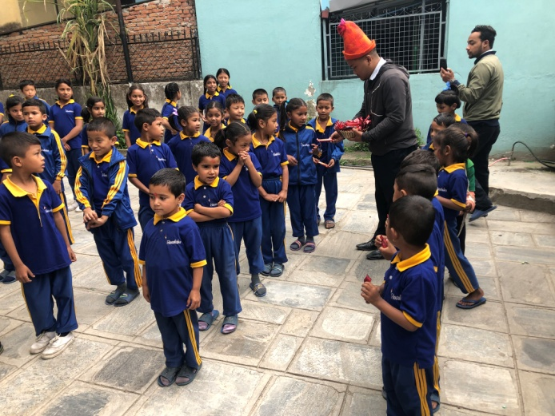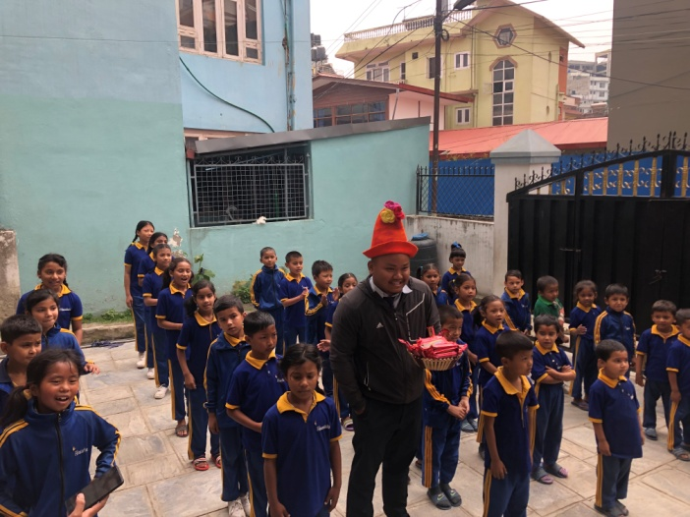
On the same day we celebrated the birthday of Rhytnm (student of South Western College).We sang “Happy Birthday” and he gave all students chocolates. Thank you again Rhytnm. After the celebration all the students started dancing and Alexandra joined in and tried to learn some steps.
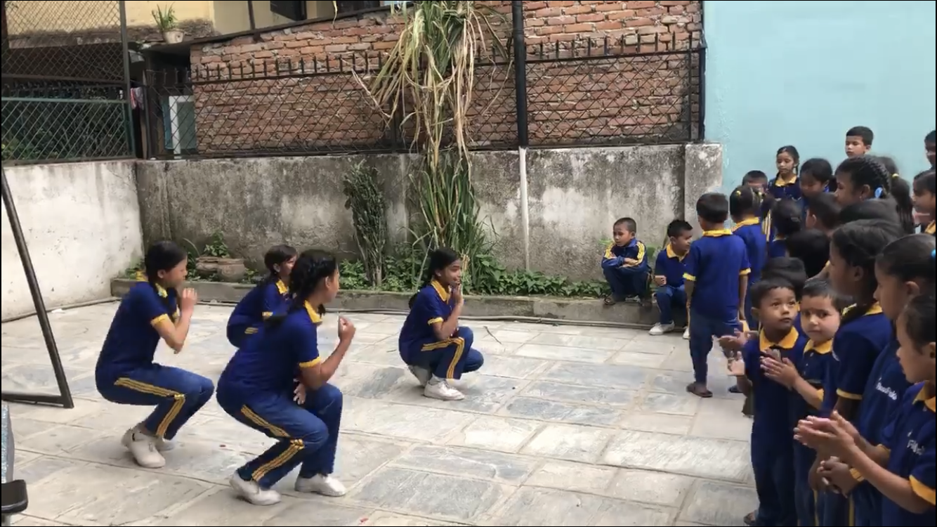

On the 6th of May Alexandra bought ingredients for Swedish pancakes which she made together with class four and our kitchen staff. They were absolutely delicious!
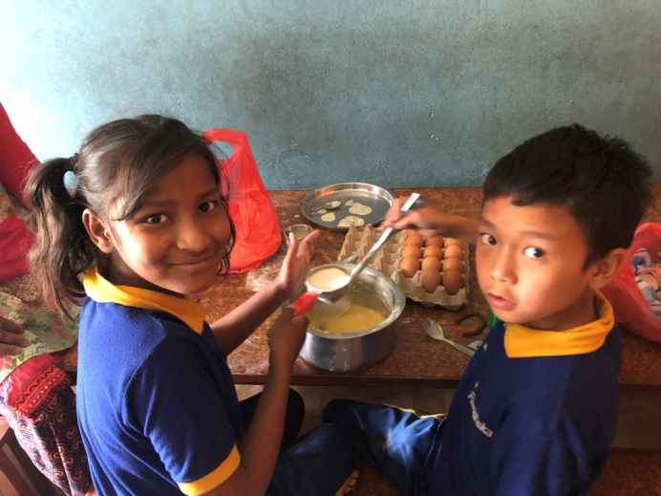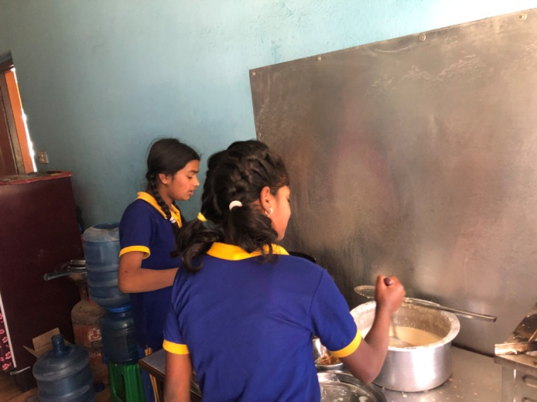
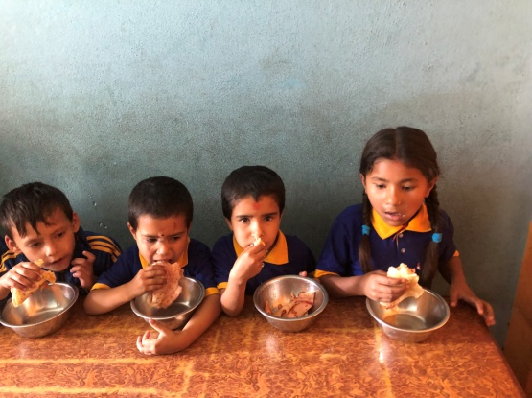
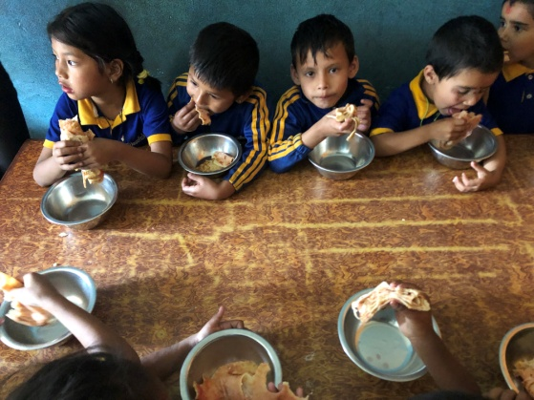
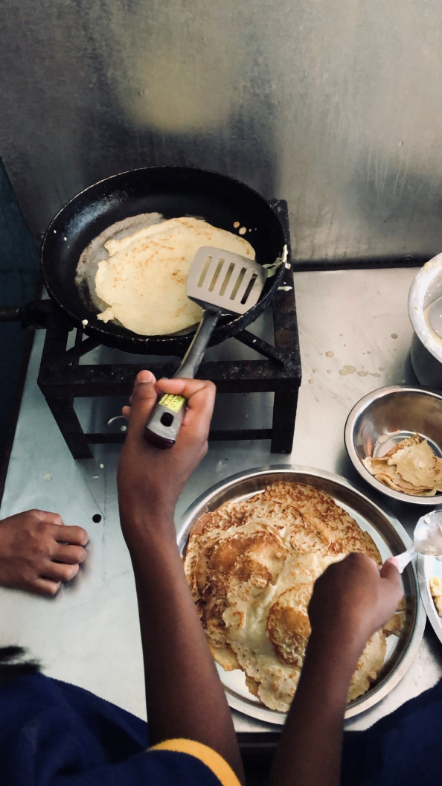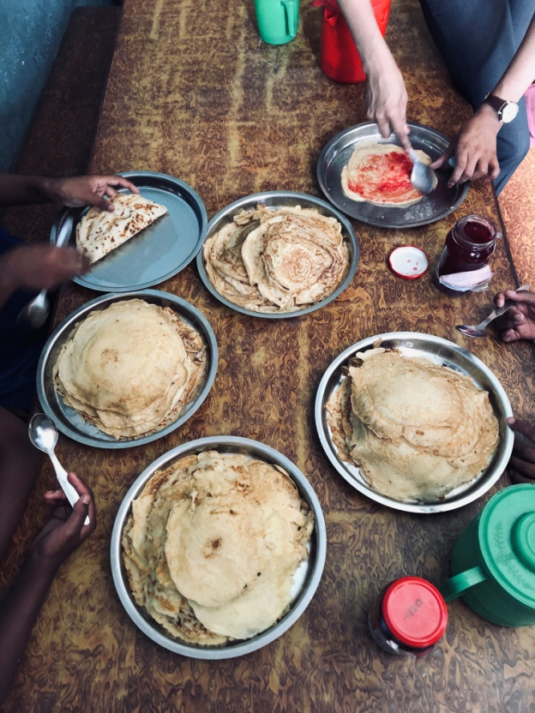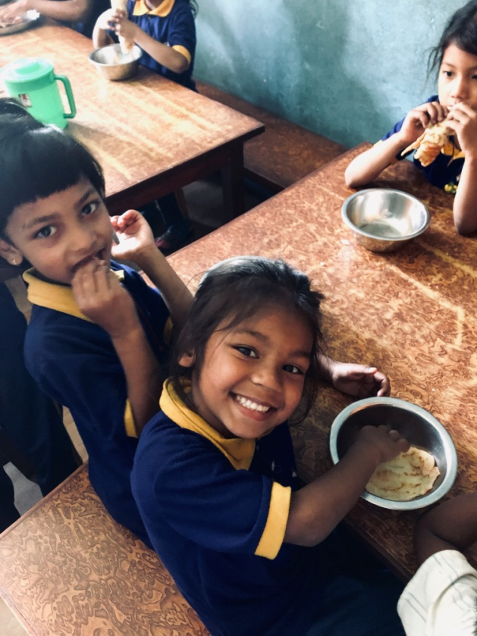
Pictures from when our students enjoyed some Swedish pancakes with jam!

On the 10th of May we had another birthday celebration, two to be more exact. The son and husband of Samita Shrestha, Gauri mam’s sister. She provided a delicious lunch for all students and teachers and distributed chocolates after we sang “Happy Birthday”. After the celebration some of our students went up in front of the rest and performed some dances. They are all so talented!
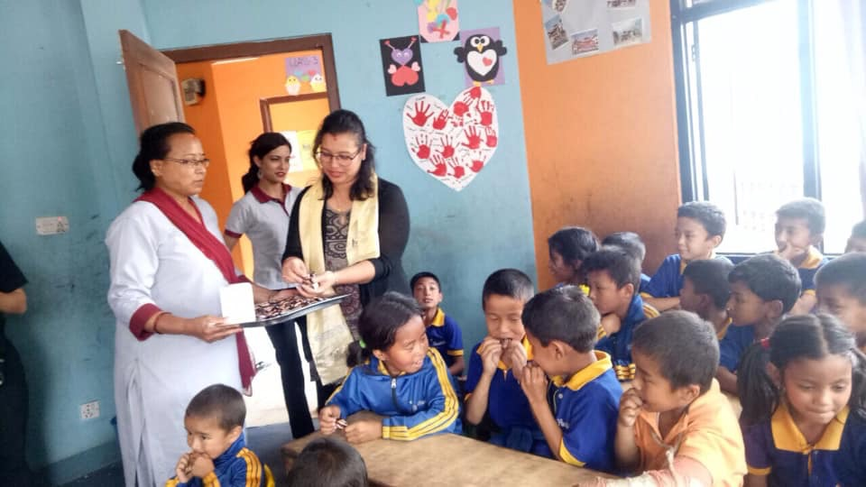
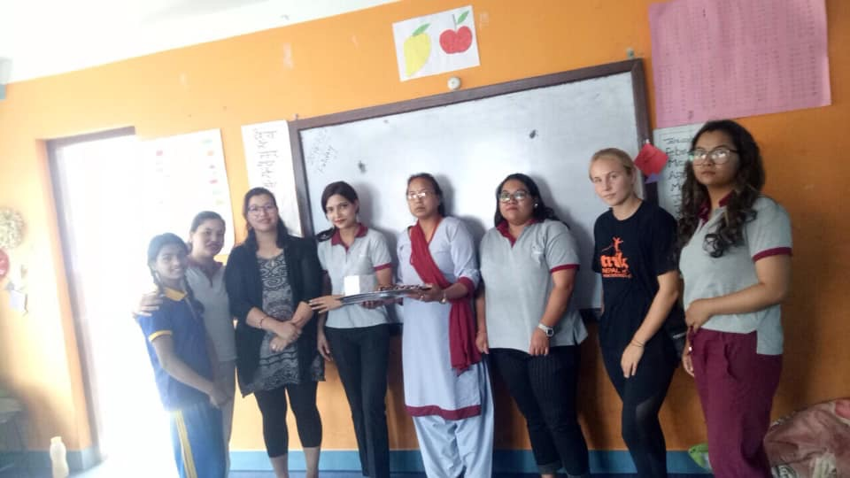
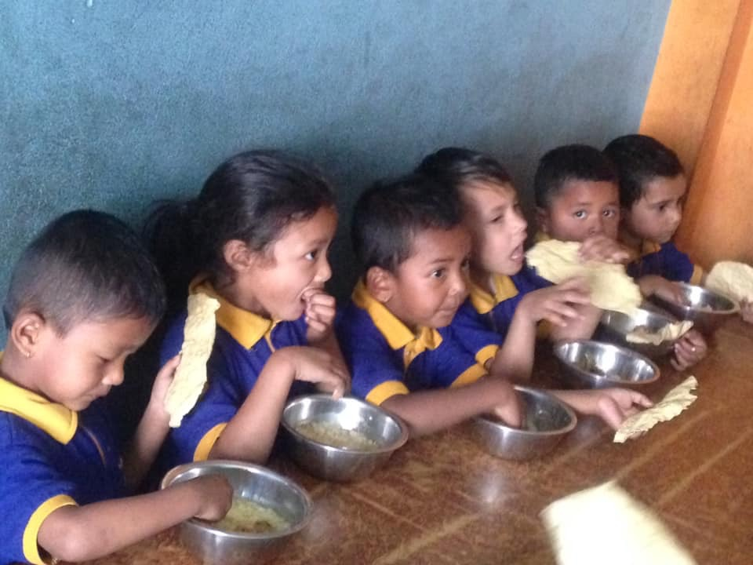
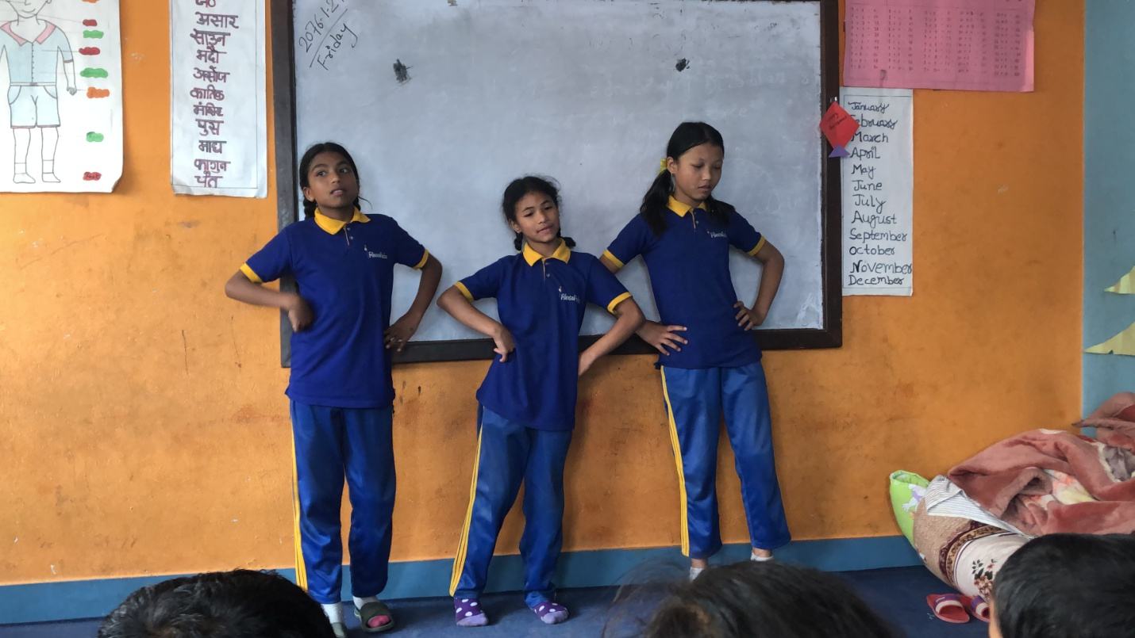
During the week 12th-17th of May we made some home visits with Alexandra. We collected information about our students situations and got an insight in how their families struggles.
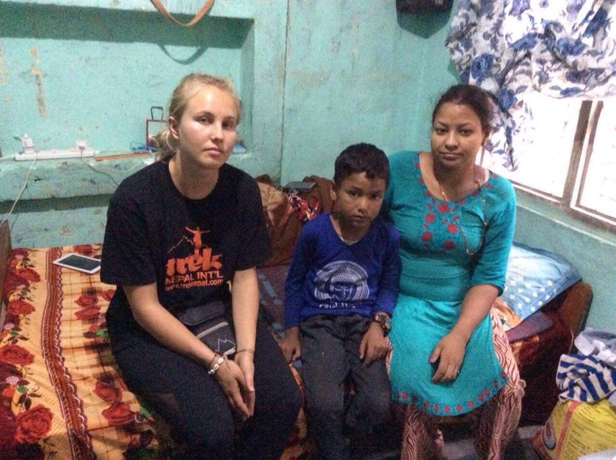
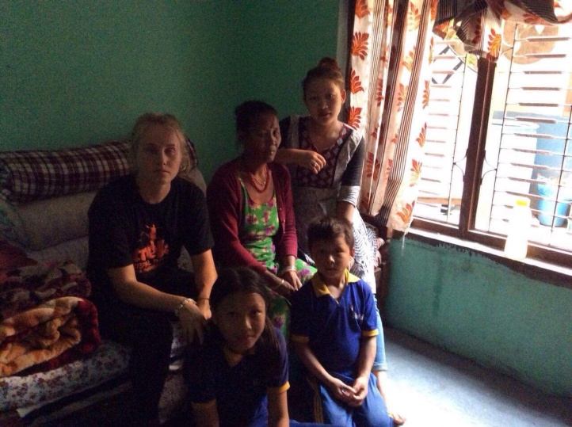

First picture is taken in the home of Sumitra (class two) and Dikesh (class one) and the second one is from the home of Subash from class U.K.G.
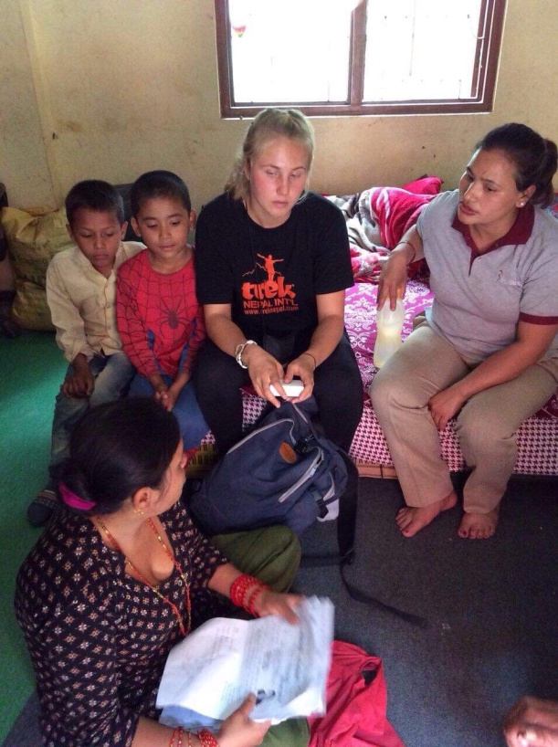
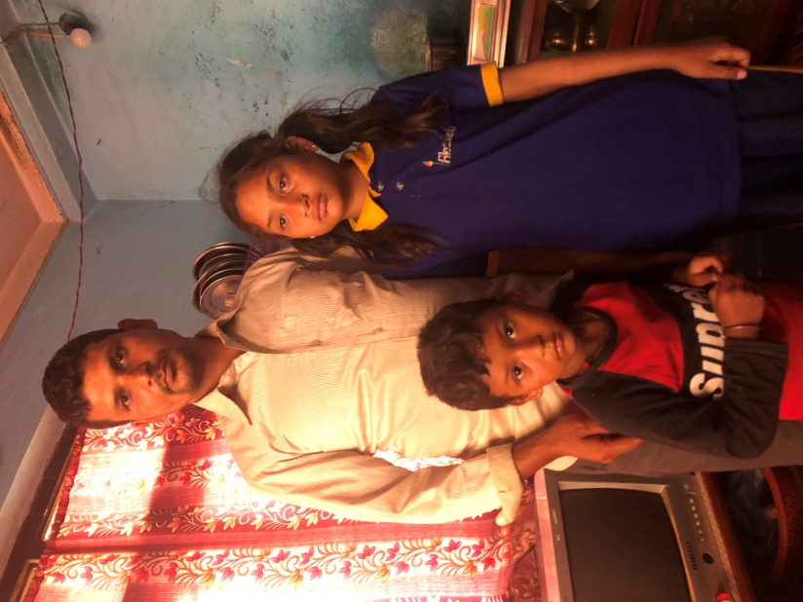

The first picture is of Alexandra and Gauri with Ashok, Rajkumar, Suraj and their mother/aunt in their home. And the second one is of Sujina and Samir with their father in their home.

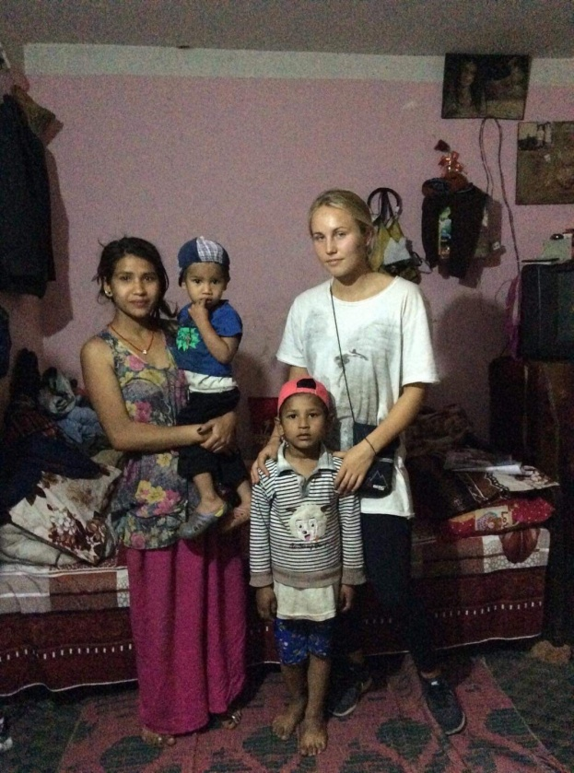
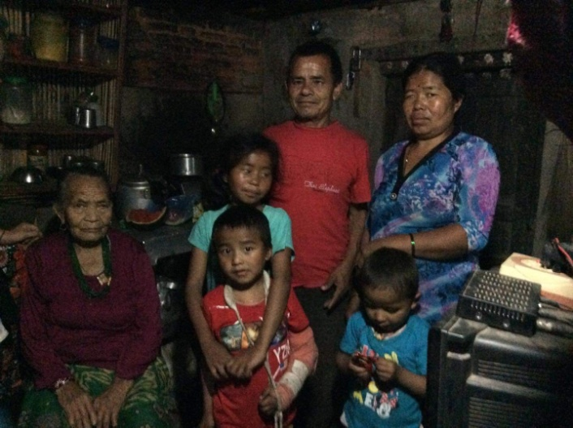

The first picture is of Samjhana, Nigma and Dorje with their parents and their grandmother in their small room. And the second one is of Sugam and his mother, little brother and Alexandra in their home.

On the 17th of May class four visited Budhanikantha with Alexandra and Youlina. Not only did they visit the temple, they also got a guided tour about how to properly visit a temple.
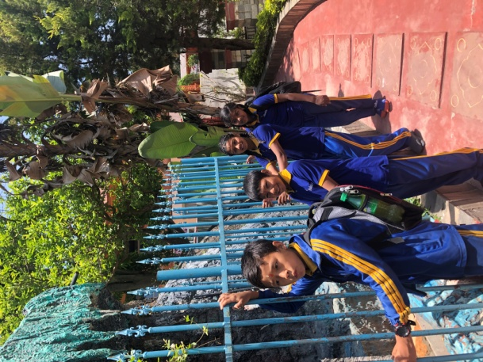
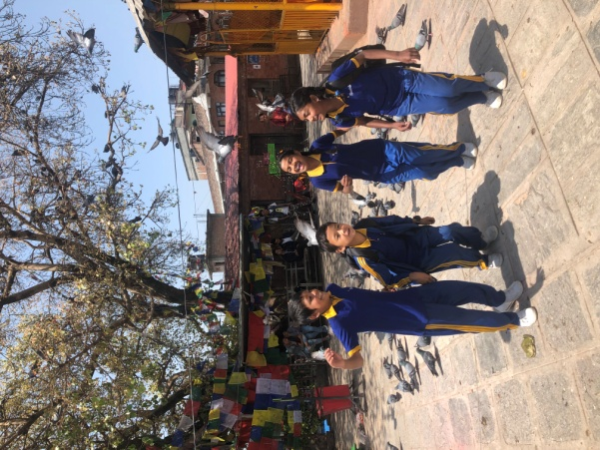
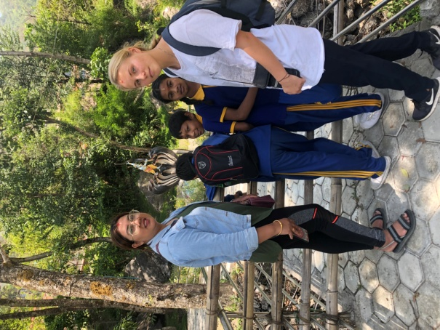
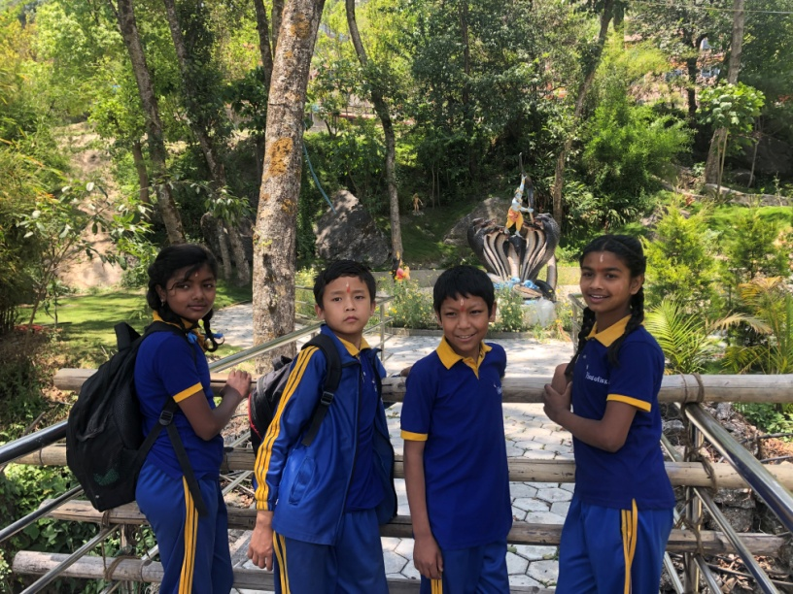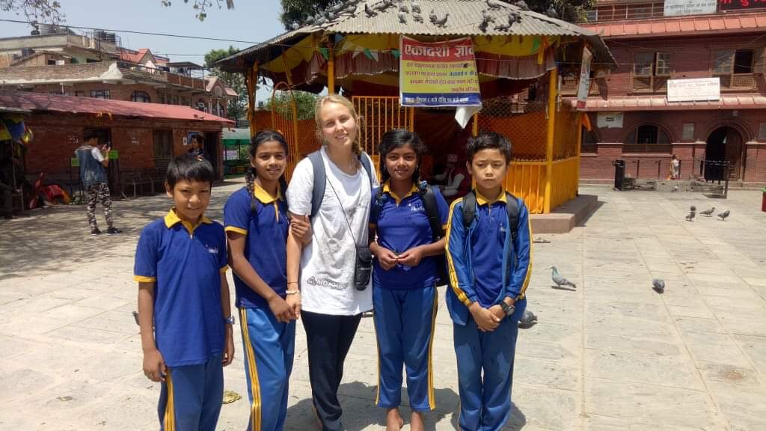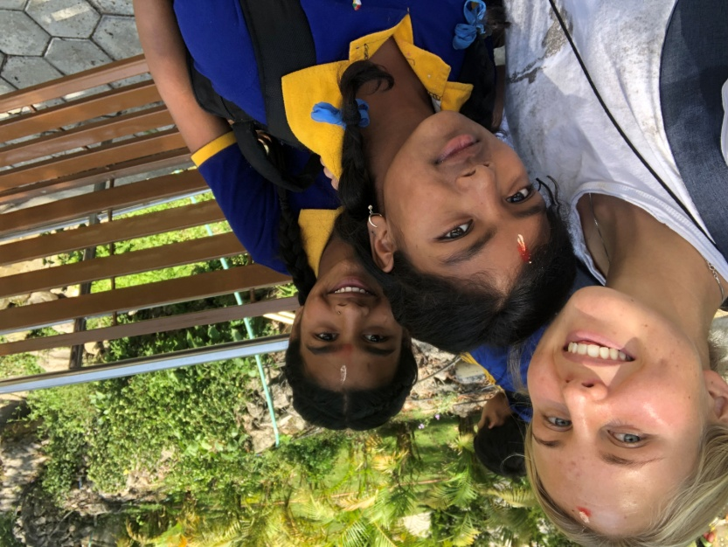

Two days later on the 19th of May it was time for class three to go on an excursion together with Youlina and Alexandra. They went to Pashupatinath Temple.
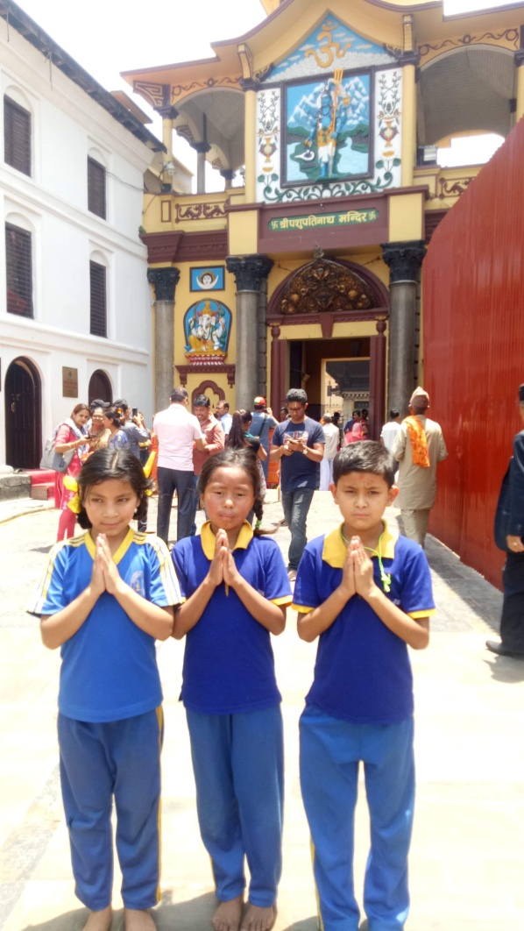
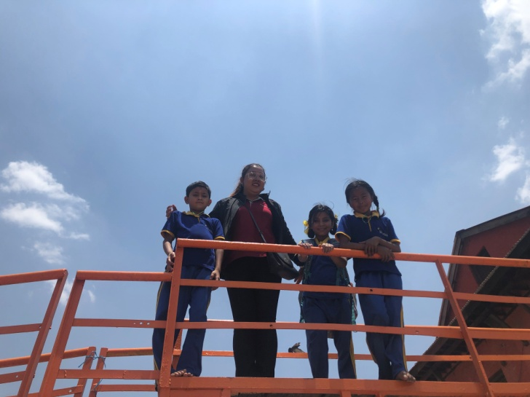
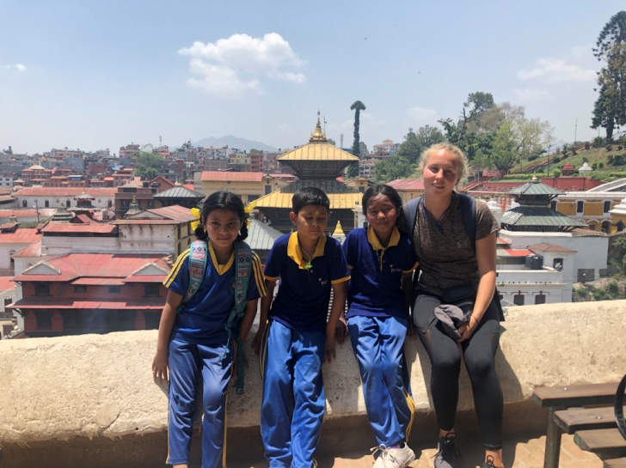
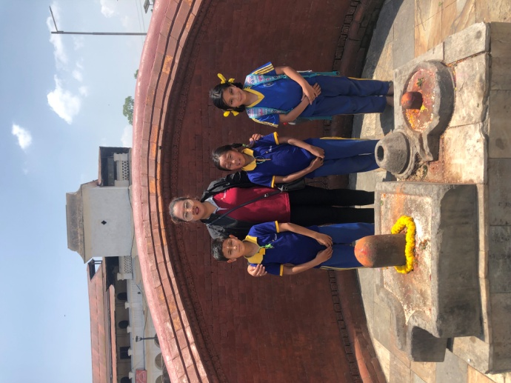
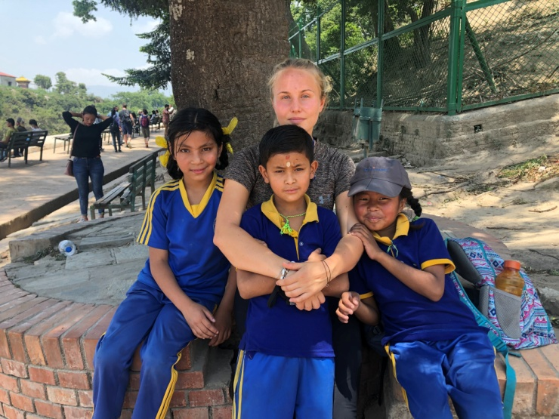
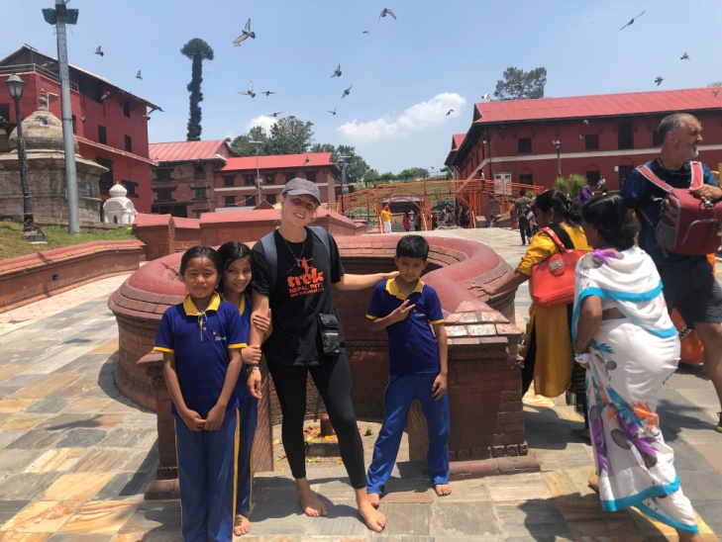

On the day after, the 20th, we had an accident at the school. Our Dorje from Nursery class fell down on the school ground while he was playing and hit his head pretty badly. He got a deep cut and we had to take him to the hospital. He needed four stitches and we had to wait in the hospital for his parents for a couple of hours. It is always scary when accidents take place and we were all a bit traumatized afterwards. But everything went very well and we are now happy to see Dorje on the schoolyard again, playing with his friend, now with a small scar on his forehead.
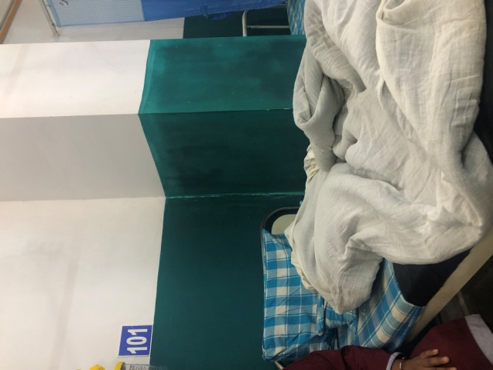
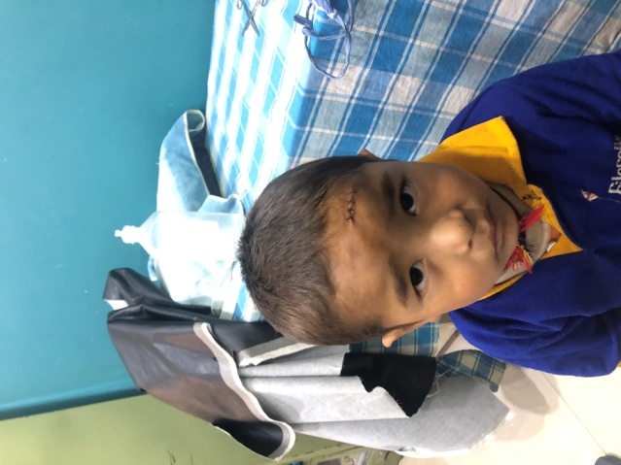
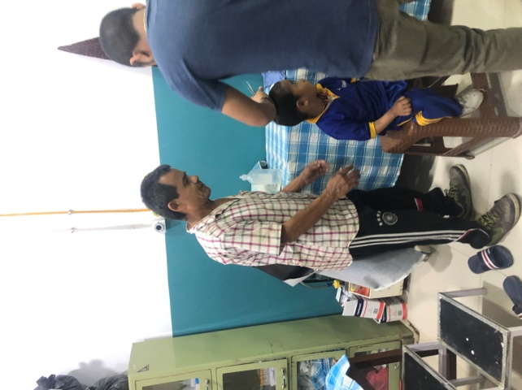

The pictures are from two days after on his first check –up and dressing change back at the hospital.

On the 24th of May class two, three and four went hiking near White Gumba with Youlina, Sanju, Gauri and Alexandra. The day started at Youlina’s home and there all students and teachers received a delicious meal from her parents. With the food in our stomachs we all had the energy we needed to go on the one hour walk up to the White Gumba Monastery. We were very lucky that we could even visit the monastery that day since it had been closed for a very long time and was only open for a short period. After the visit we had a lovely picnic nearby where we also played some games. It was a great day which all students seemed to have enjoyed!
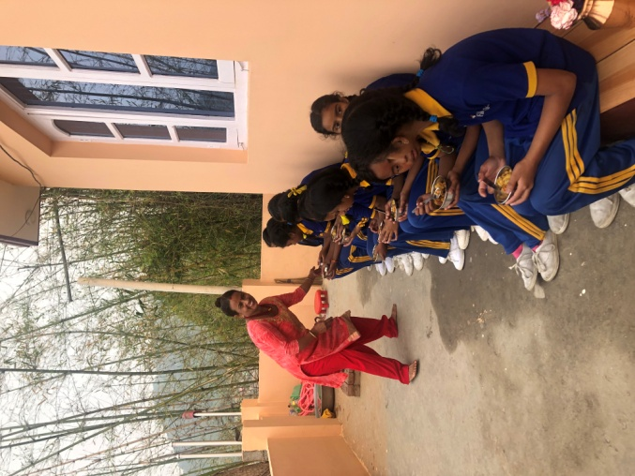
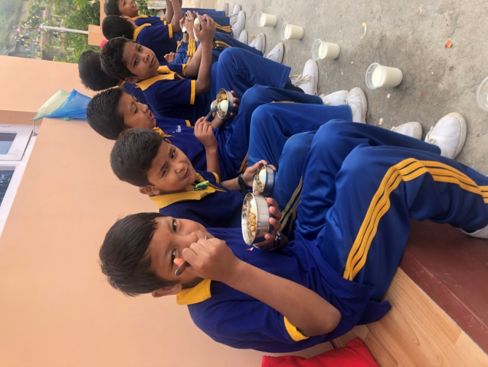
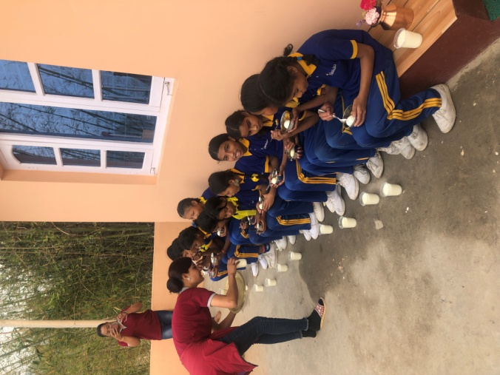

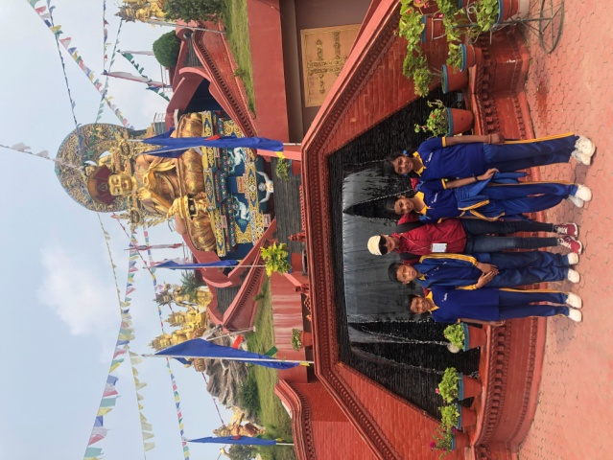
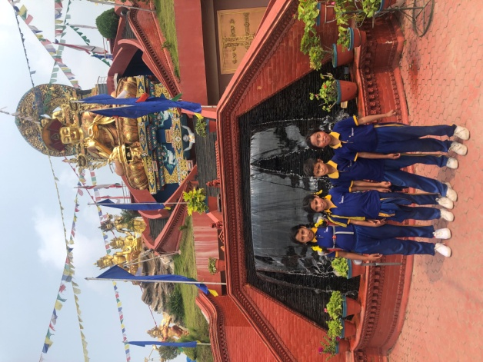
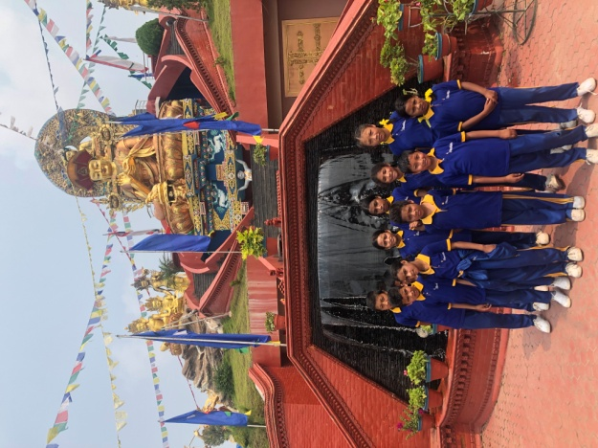
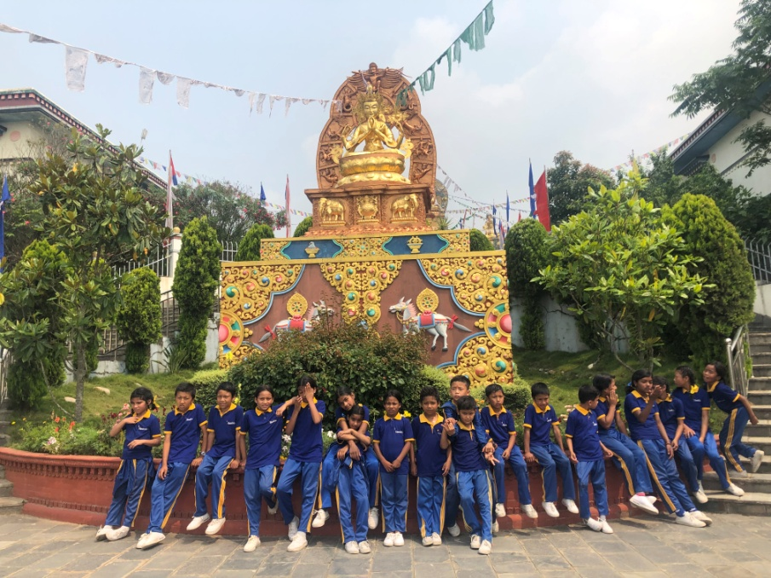
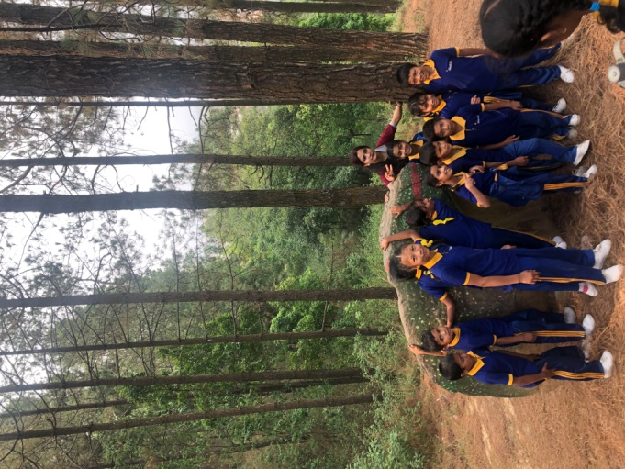

Class two, three and four in front of the White Gumba monastery.
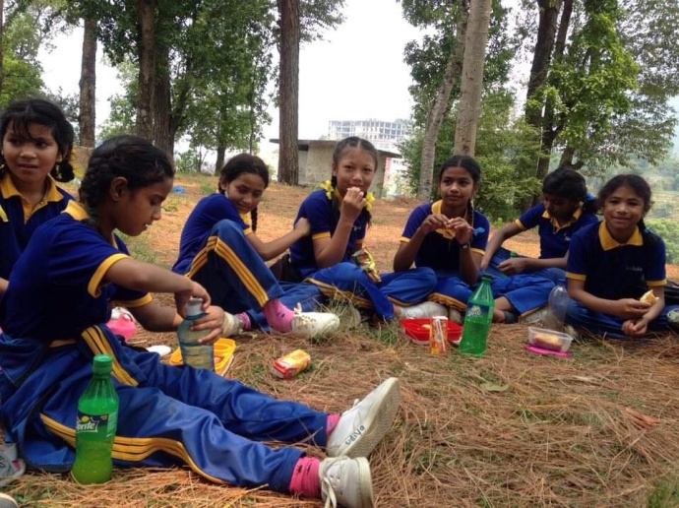
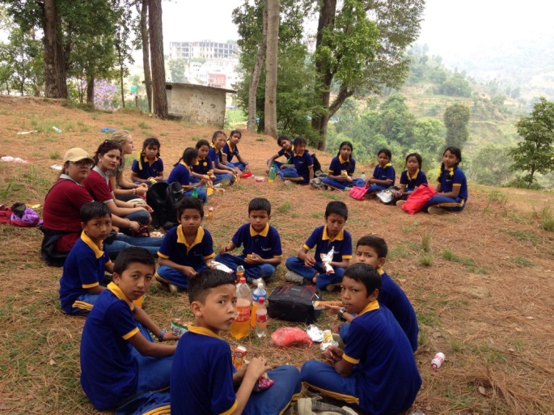

Everyone enjoying a lovely picnic!
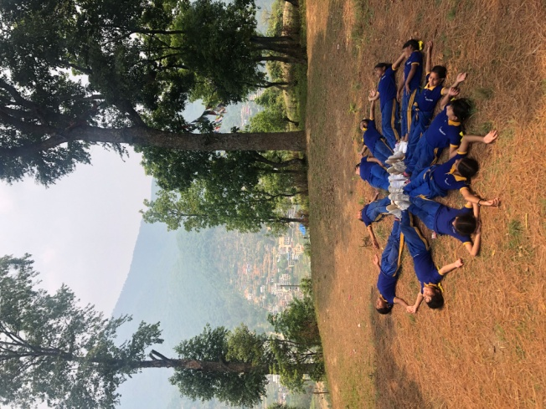
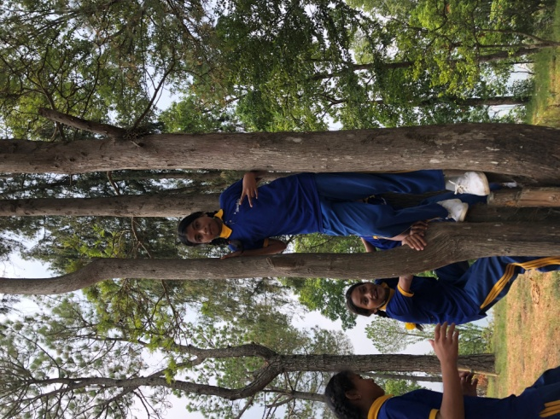
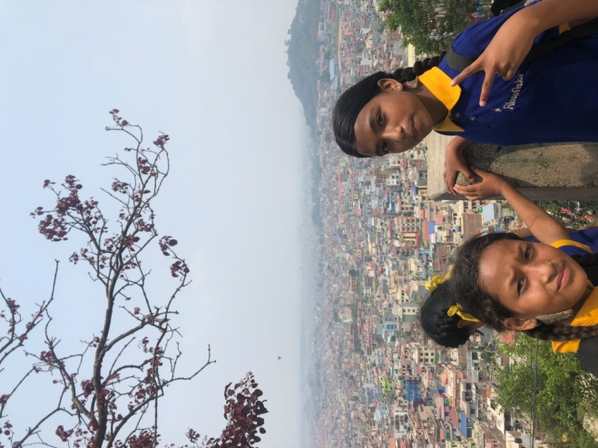

After the picnic we played some games.
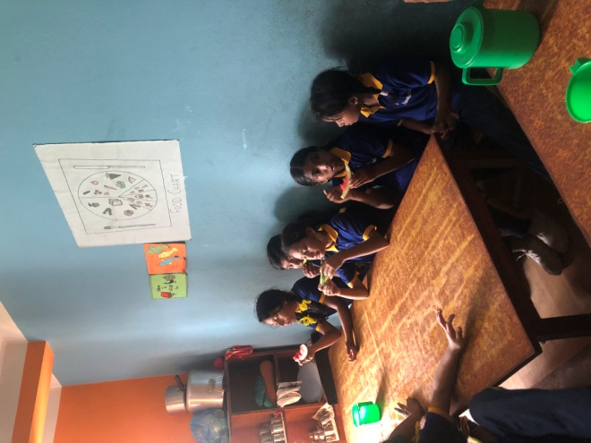

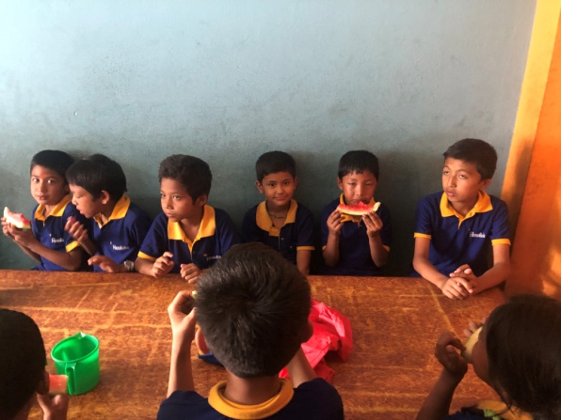
Back at the school the kids enjoyed some Watermelon and chicken provided by Alexandra.

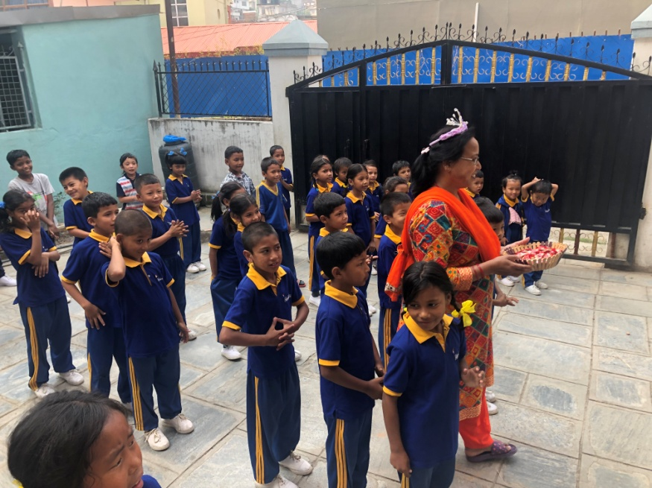
A few days later on the 29th of May we celebrated two birthdays again: Gudiya from class four and Srijana sister. All students and teachers sang “Happy birthday” and Gudiya and sister distributed chocolates to everyone. So we all got two pieces each! Once again, happy birthday to both of you, we wish you the best!
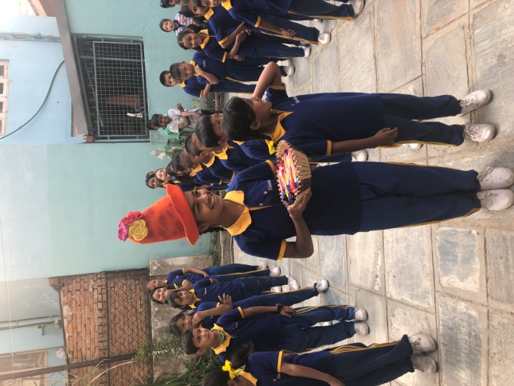

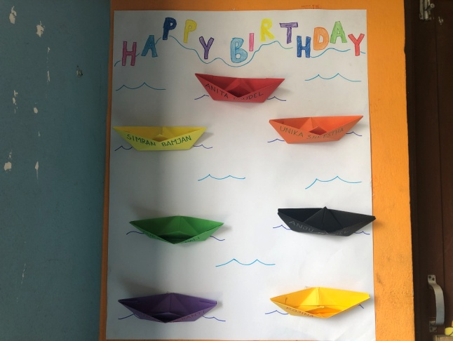
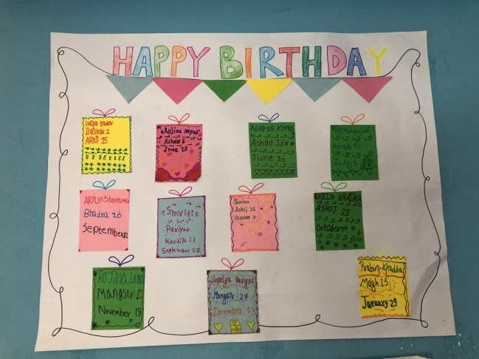
In the spirits of birthday, all classes made new birthday calendars since the classes have changed from last year.
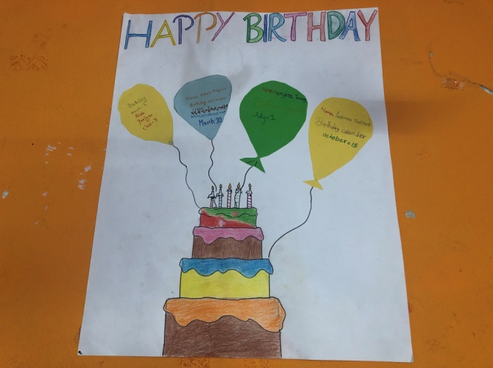
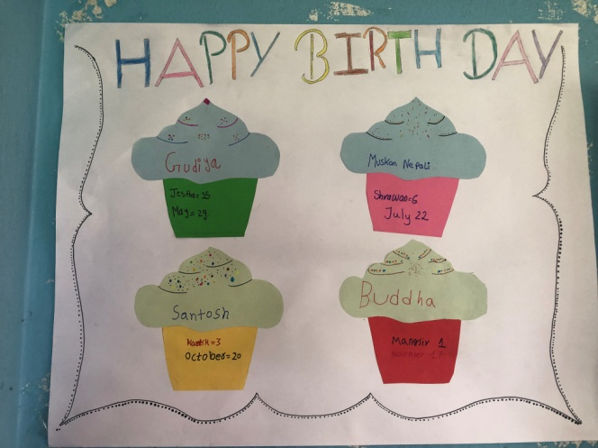

The calendars of class U.K.G, two, three and four.

On the same day Alexandra also provided mo:mos for all students.
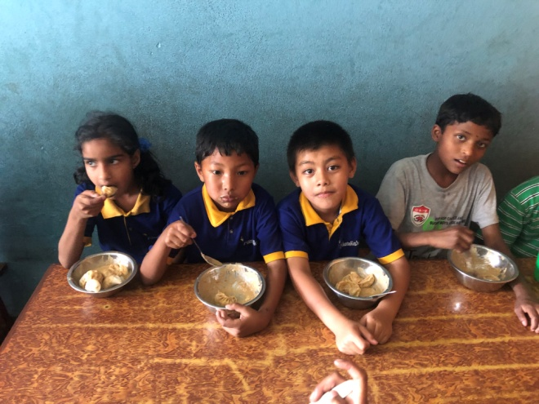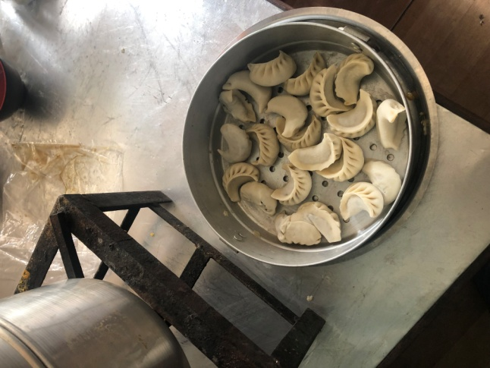

This month Filosofiska Nepal gladly welcomed some new students. Together with the new students from last month 15 new students have been admitted to the school. Welcome to every one of you, we are so happy to have you here!
Name | Class
Anji Roka Magar | Play group
Dorje Tamang | Nursery
Januka Nepali | Nursery
Shiv Koirala | Nursery
Pabita Thokar Tamang | Nursery
Kabita Thokar Tamang | Nursery
Nigma Tamang | L.K.G
Subash Nepali | U.K.G
Rojina Thapa Magar | U.K.G
Suraj Magrati | U.K.G
Ashish Roka Magar | One
Raj Kumar Magrati | One
Anu Hemram | One
Sahil Munda | One
Ashok Magrati | Three

