Monthly Progress Report of August 2019

August the eighth month of the year containing 31 days was a new for students of filosofiska. Their new coordinator (Ashok Raj Pandey) was in the School. His tenure in the organization will be focused in upgrading the school in management and higher studies.
Students attained the 1st term examination from 4th to 12th August. Their examination venue was filosofiska Nepal.
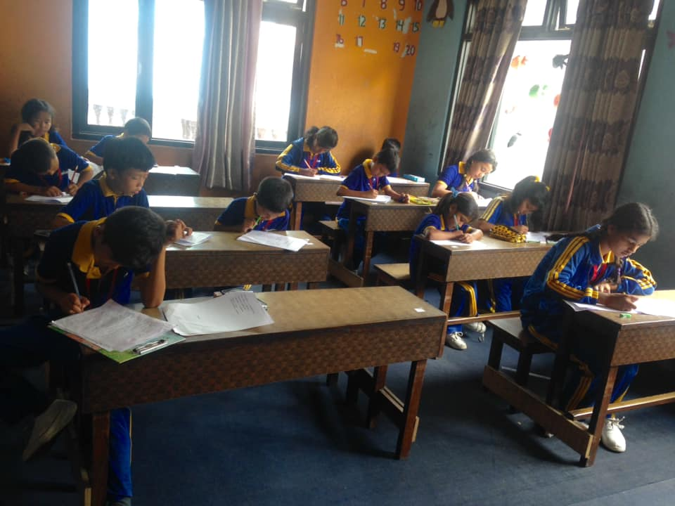

On 4th August Binay Shrestha and Ritu Shrestha (Parents of Aveer parsad shrestha 1year child) celebrated their son’s 1st birthday providing socks and lunch to our children. 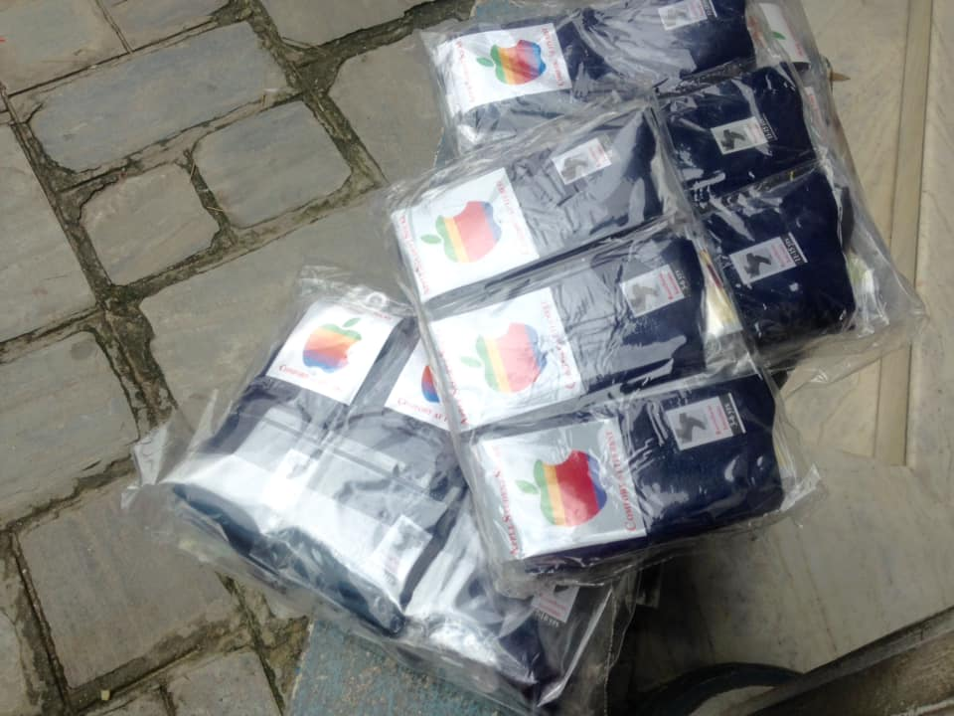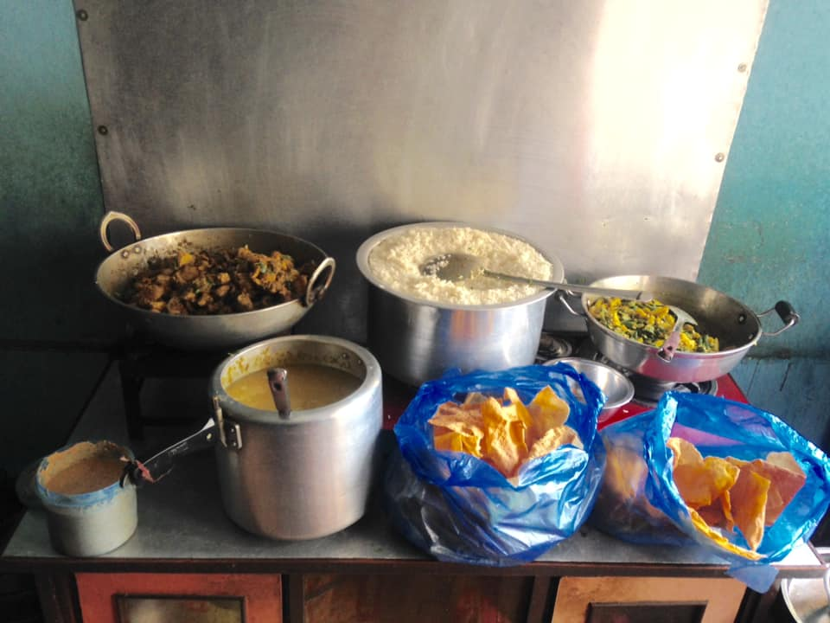
August 10 to 15 was exciting for Filosofiska team. These 6 days , we coloured the school with support of Alexandra Haglund. Her visit in filosofiska was praiseworthly. We expect these kinds of volunteers to be here in Nepal so that our student can learn more better.

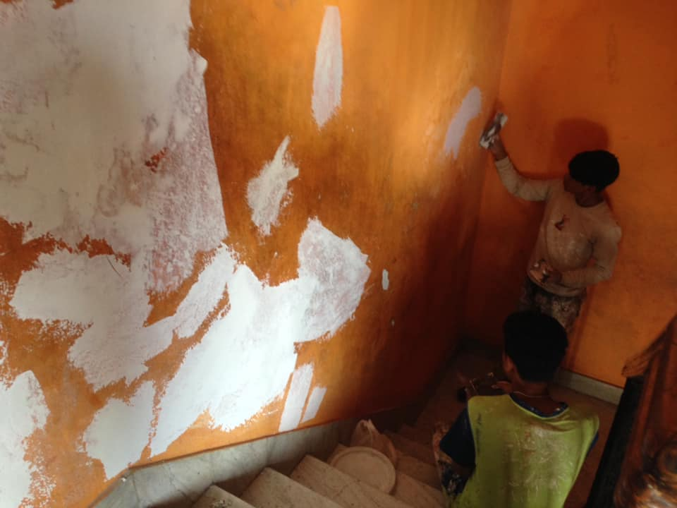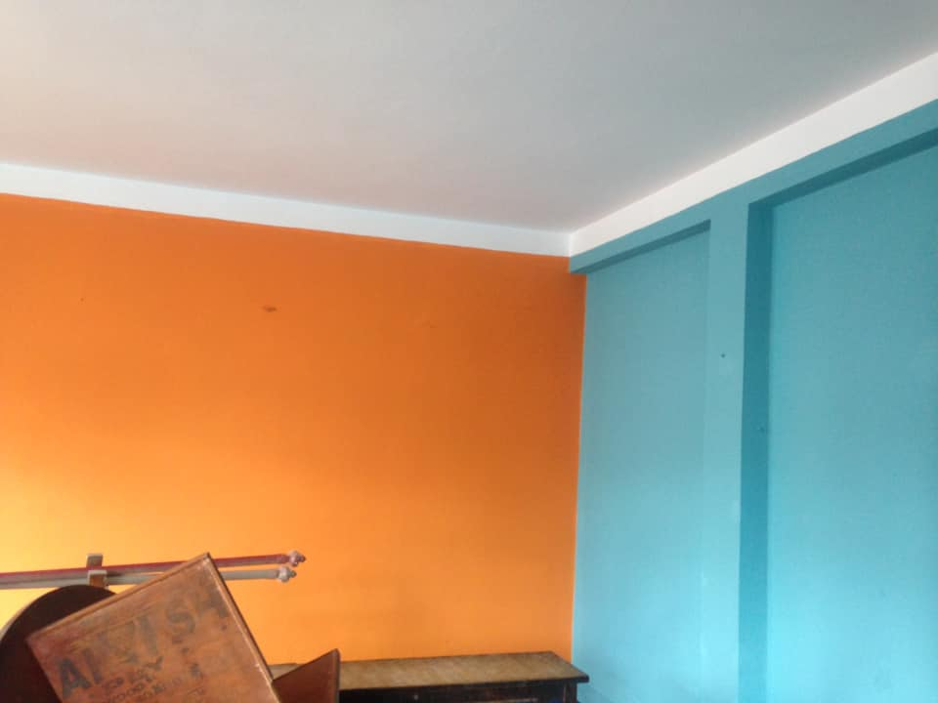
Other related pictures are in our official facebook page.
On August 20 filosofiska Nepal welcomed Ashok Raj Pandey as their coordinator. We wish him luck for him time in Filosofiska.
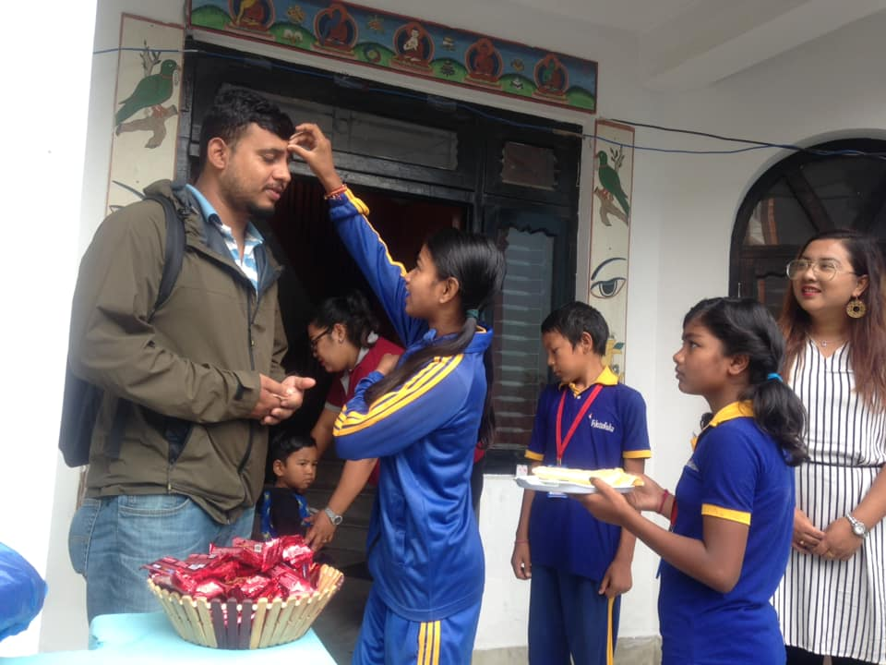

Deepashna Shakya and Kamal Thuladhar sponsored a lunch and snacks respectively. Deepashna shakya is the daughter of our house owner.
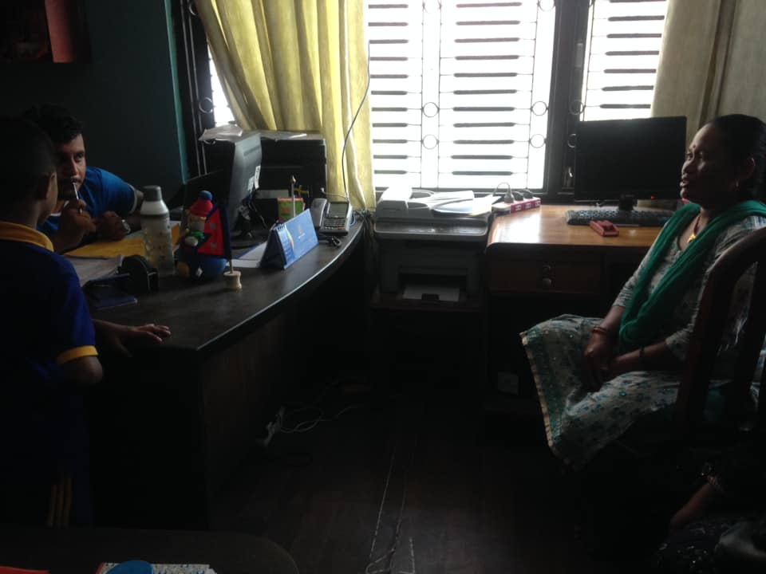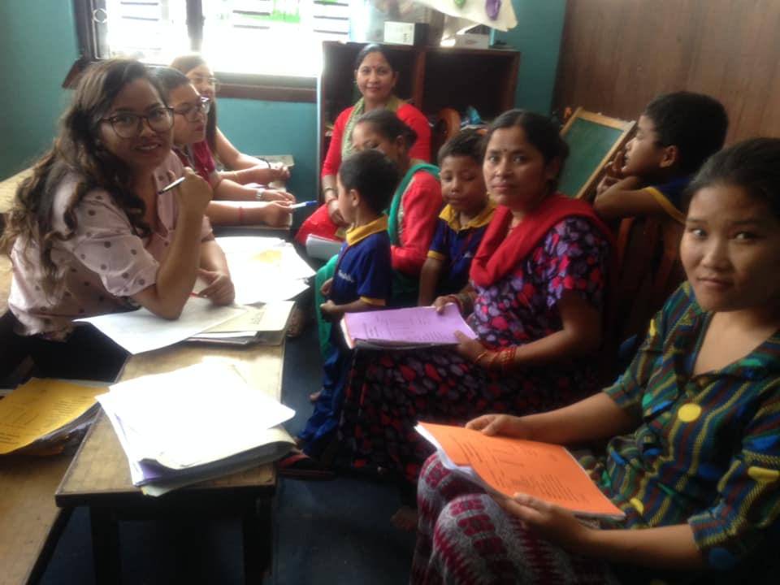
Guardians and parents of the children collected the report card of the 1st term examination. One to one interaction of the parents , teachers and coordinator was done for the combine effort to make the better academic and overall performance. Students with low academic performance was shortlisted and special focus was done.

Students of class 4 was busy with their project work whole day making the palnets of the universe on August 29.




