Monthly Report for the month of December 2019
December is the twelfth and final month of the year. It is also the last of seven months to have a length of 31 days. On the first day of December Niti Manadhar sponsored lunch and chocolates to filosofiska Nepal.
 | 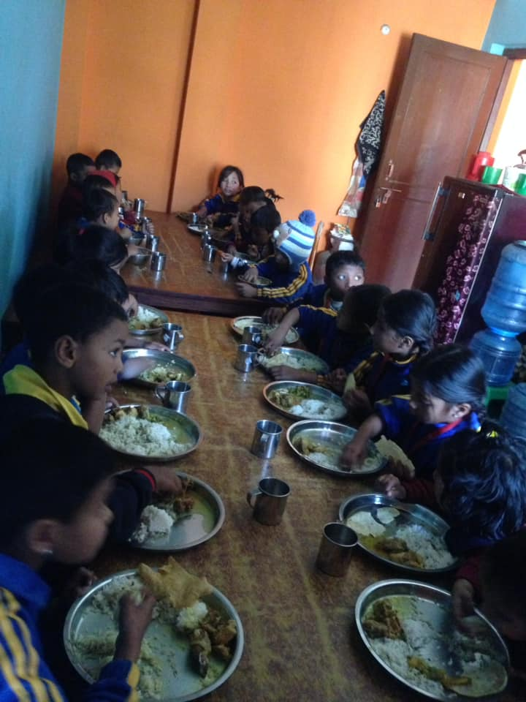
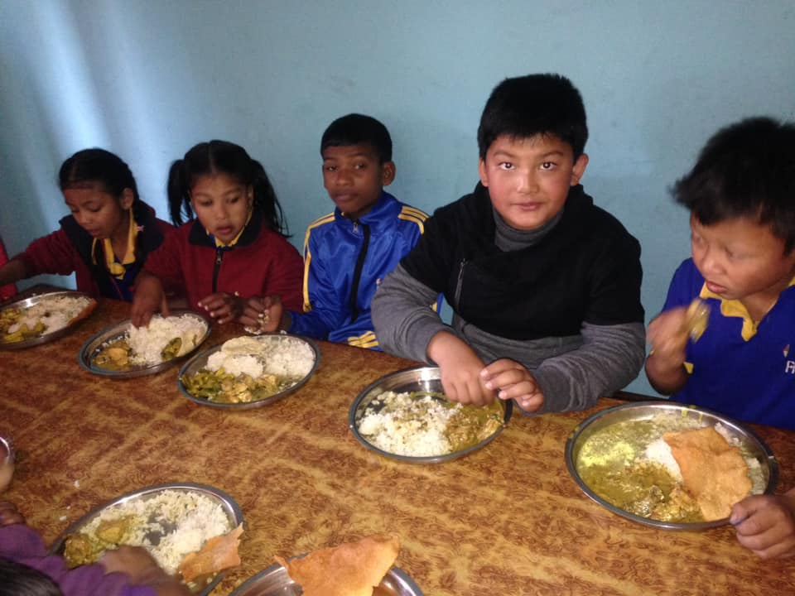 | 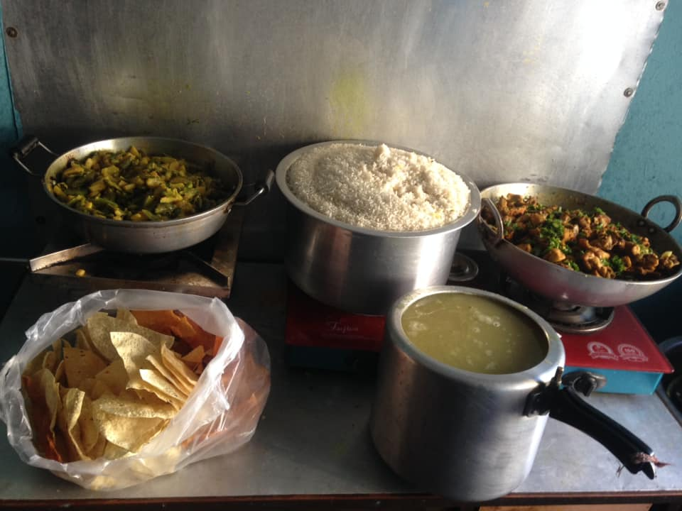

We believe that; Giving is not just about to make donation, it’s about to make differences, a huge differences. On 19th December Sol Voran and Eli from Australia provided our children with shoes and socks where as Bina Bajracharya and Uzeena thapa helped with chocolates and tiffin to our children.
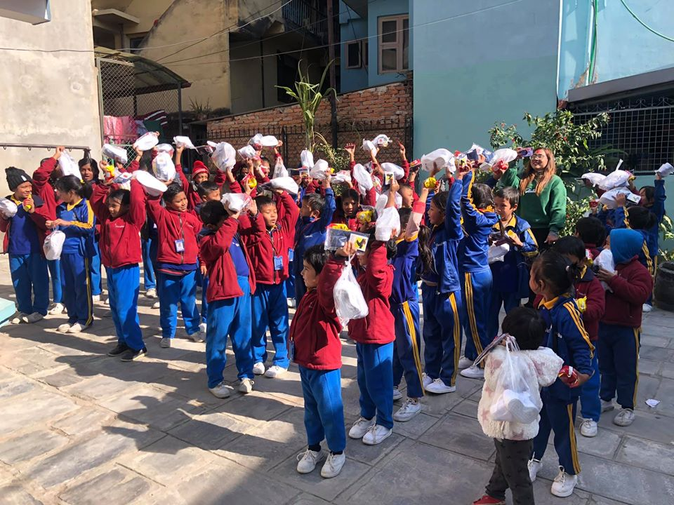 | 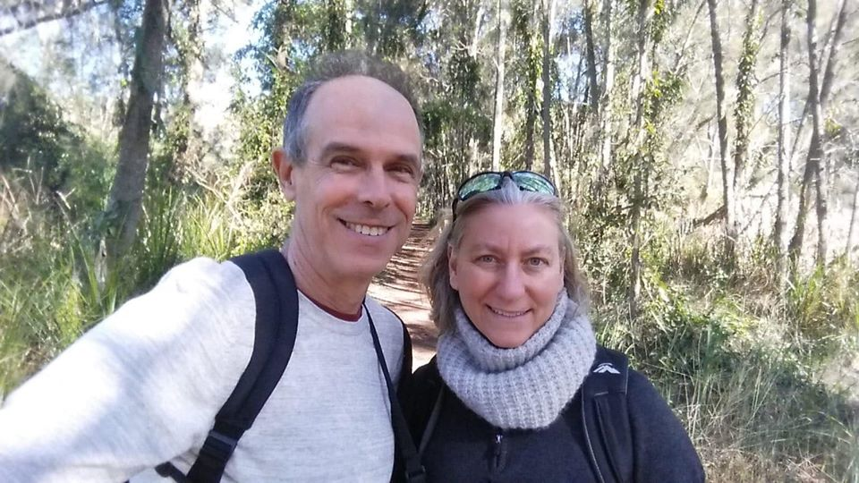
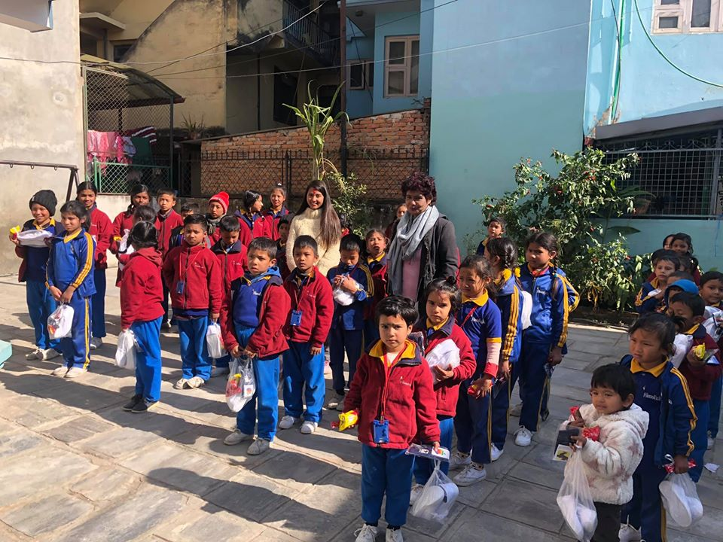 | 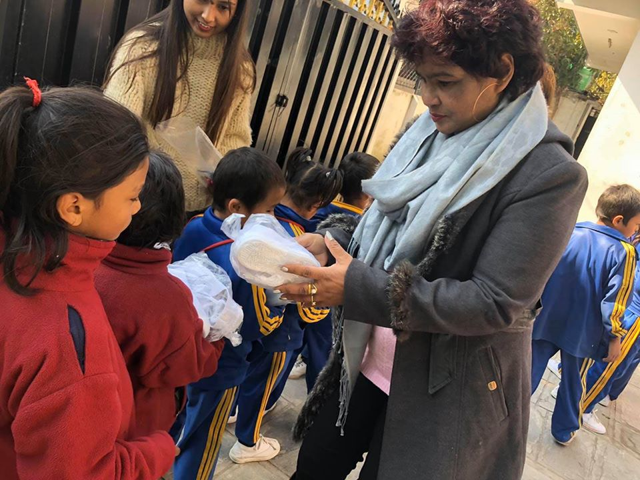
 | 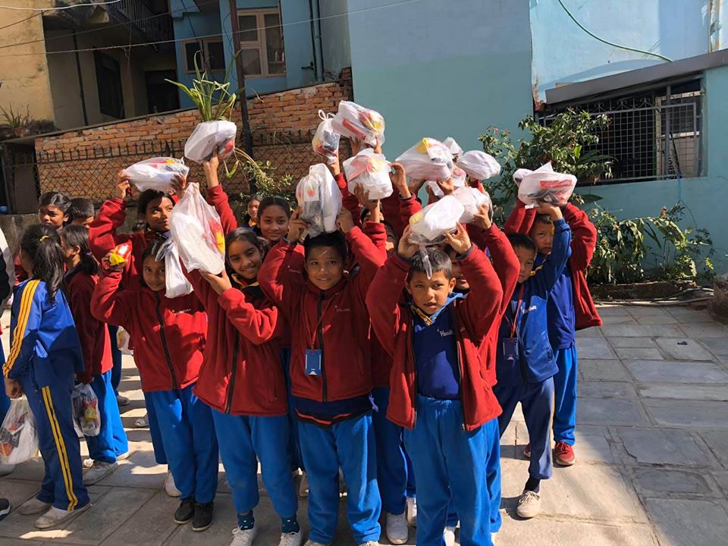

Second term examination was held in the month of December from the date of 7-14.
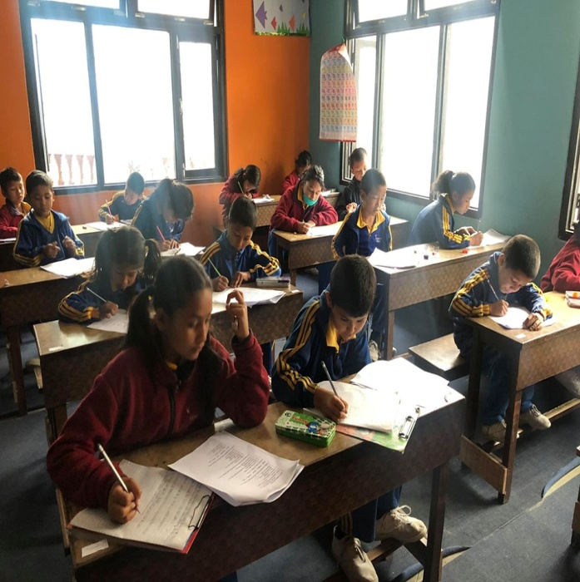 | 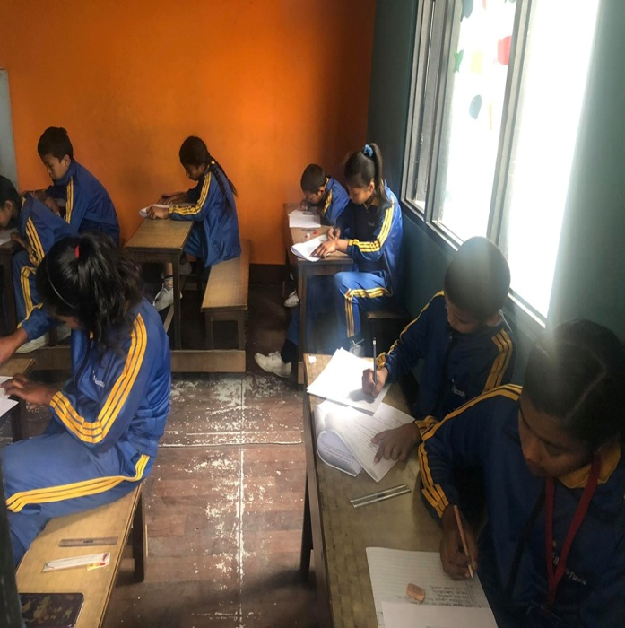

Filosofiska Nepal distributed progress report card of second terminal examination on 21st December. All parents and our children collected their report cards from the school premises.
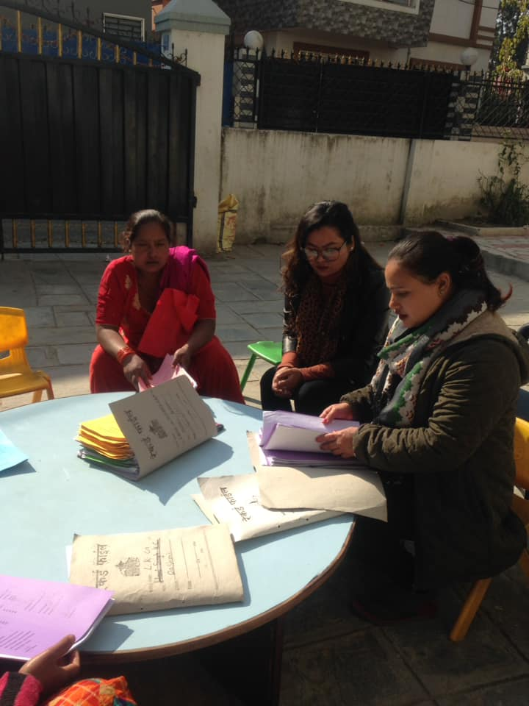 | 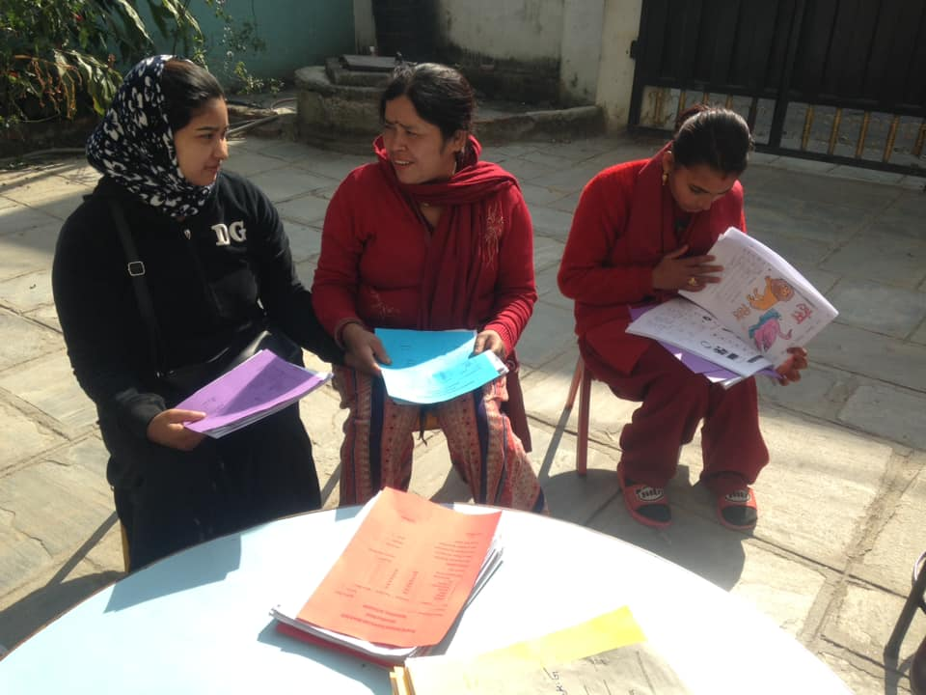
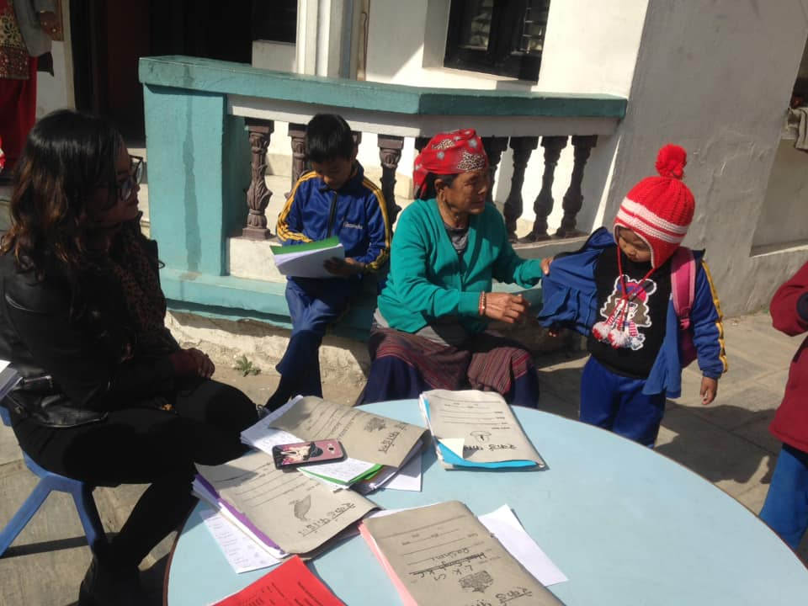 | 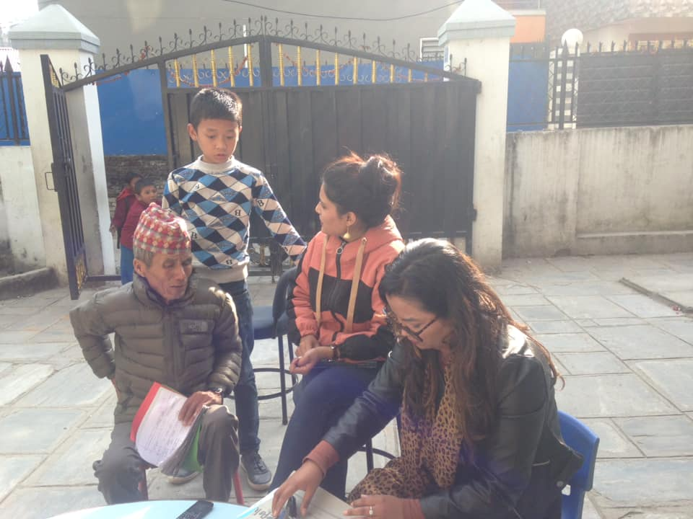

December 29, Wednesday in the occasion of Christmas, Students from Filosofiska conducted different programmes( dance and music) . They were also involved in art and craft to decorate the school premises. Teacher of filosofiska Rajani RajBhandari and Gauri Shrestha was involved in making the craft where as Youlina Thapa was busy in face painting (in making tree and Christmas hat).
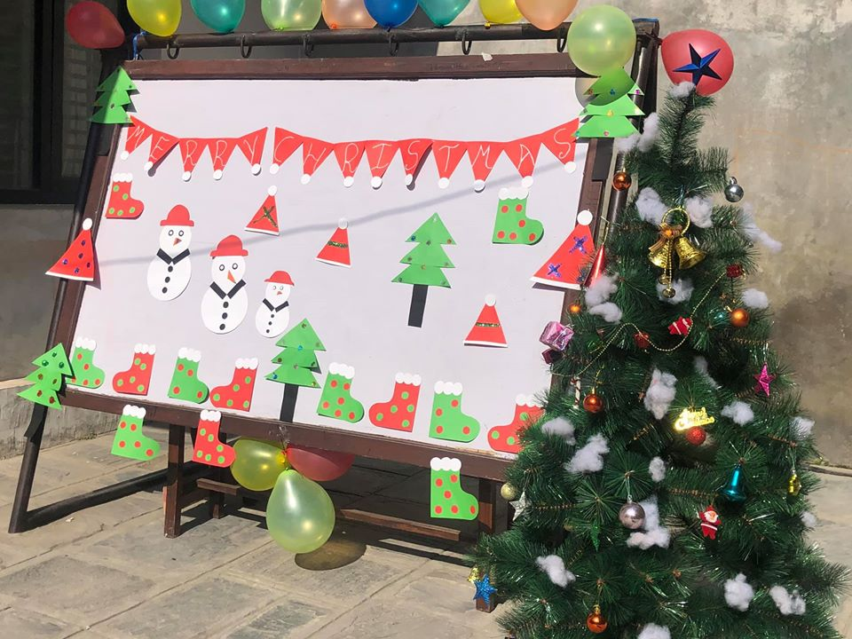 | 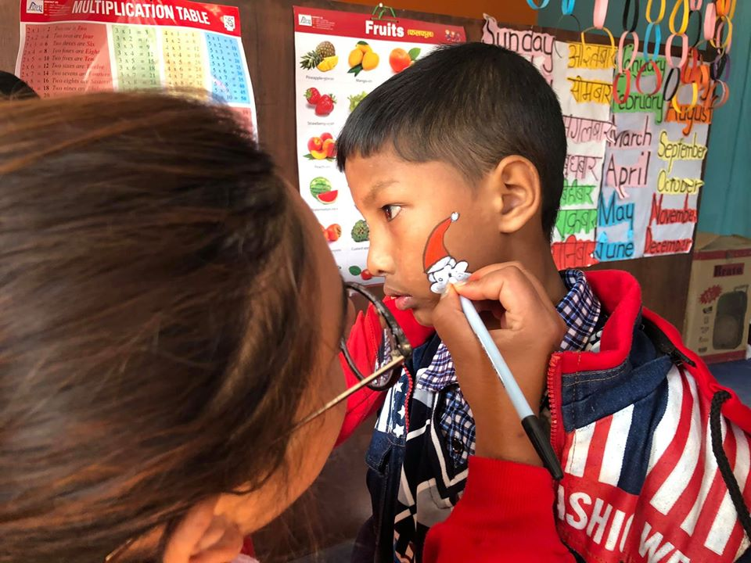
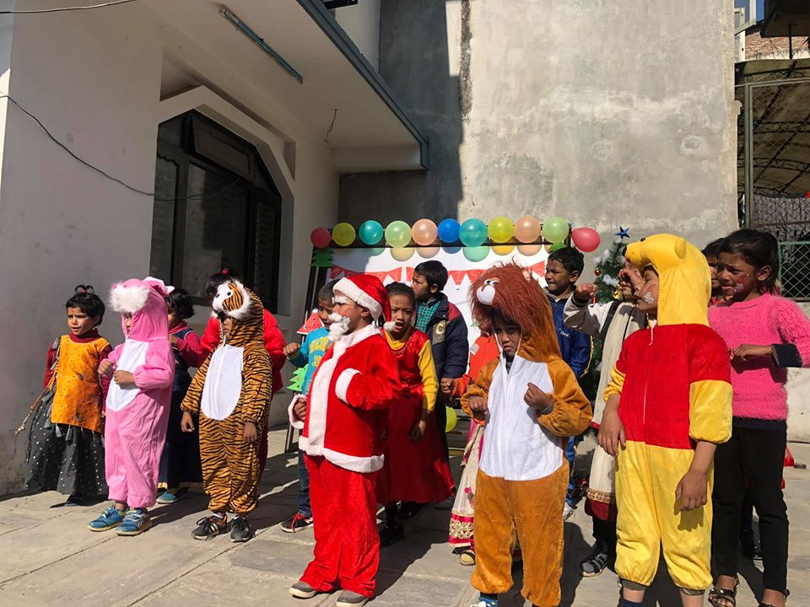 | 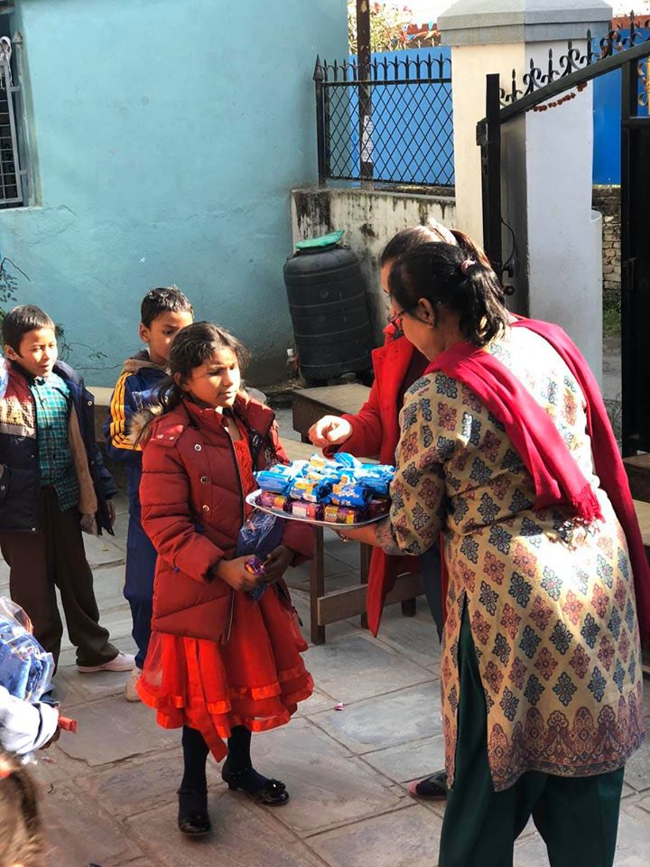
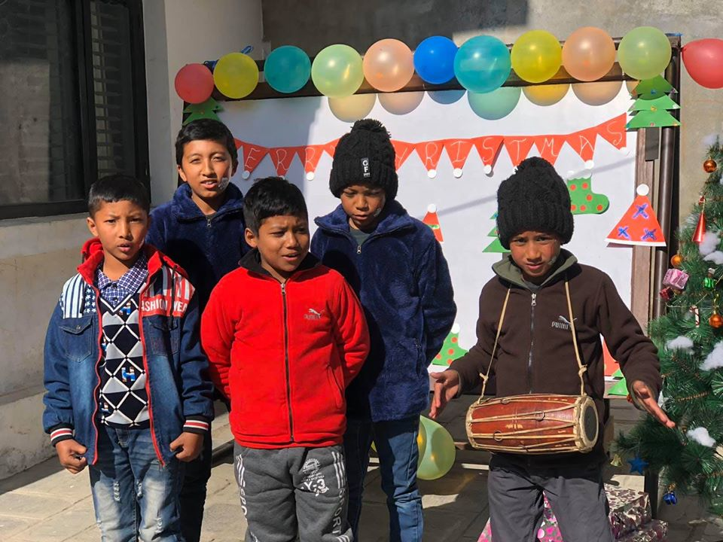 | 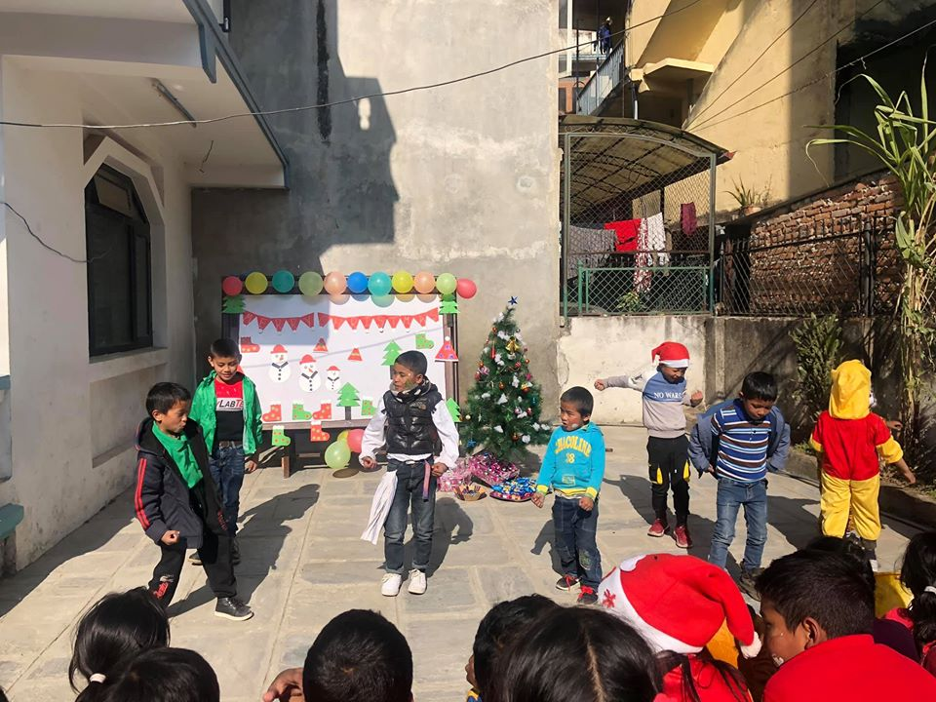
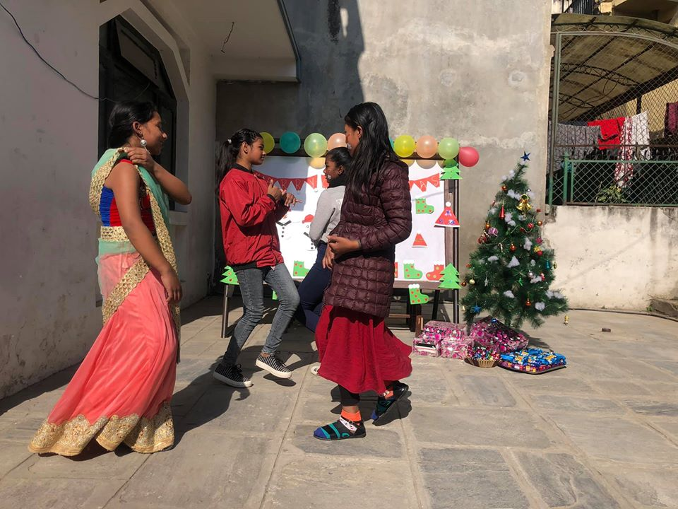 | 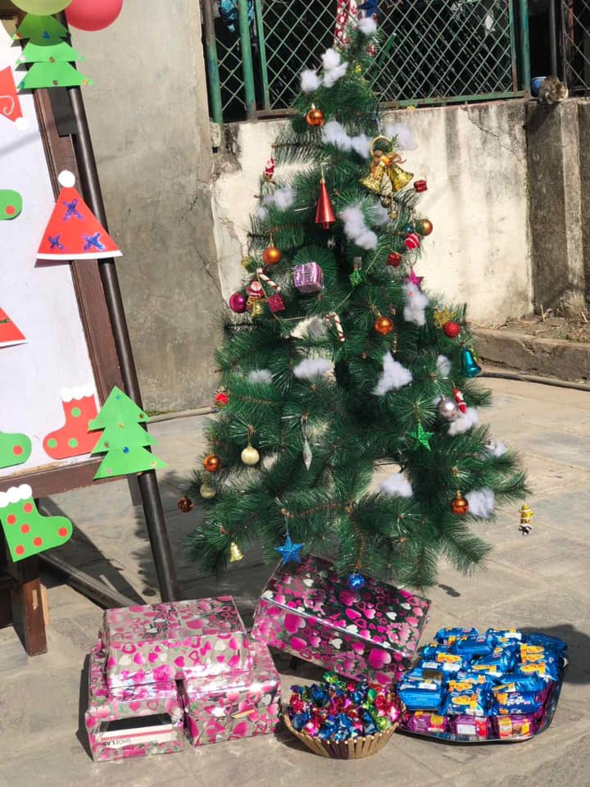
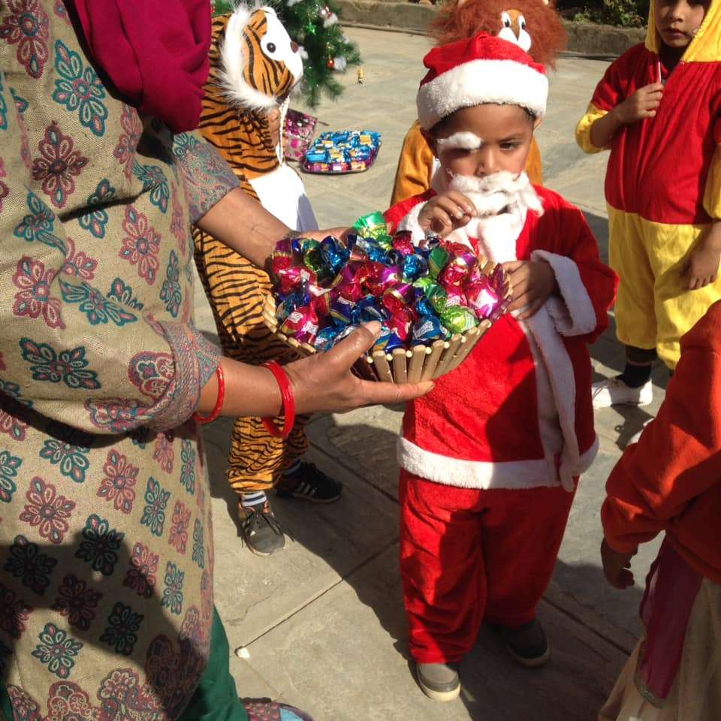 | 