Monthly Report for the month of February 2020
February is the second month of the year. February is named after the latin word februum which means a spring festival of washing and purification.With only 28 days in normal years and 29 days in leap years, February is the shortest month of the year. This year was a leap year.
February 7, students of class three and four visited more than 100 stalls in science exhibition held in southwestern state college. The project demonstrated in the exhibition could help our students in expansion of knowledge and use in their daily life. There were stalls like using solar energy in different settings like house, vehicles etc. Project of the Stalls could help in conserving biodiversity and making easy in services in the kitchen.
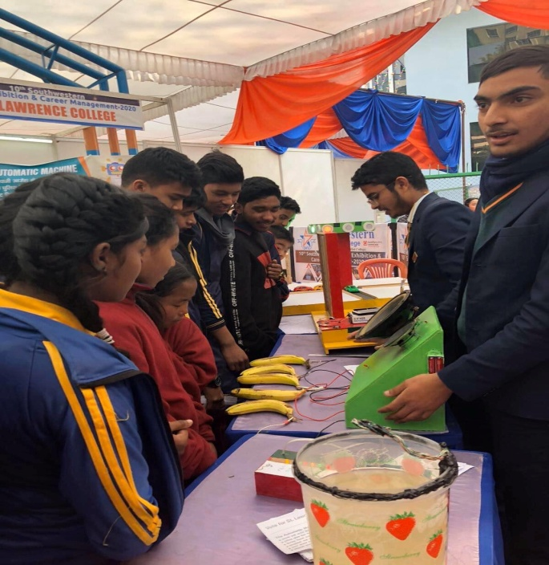 | 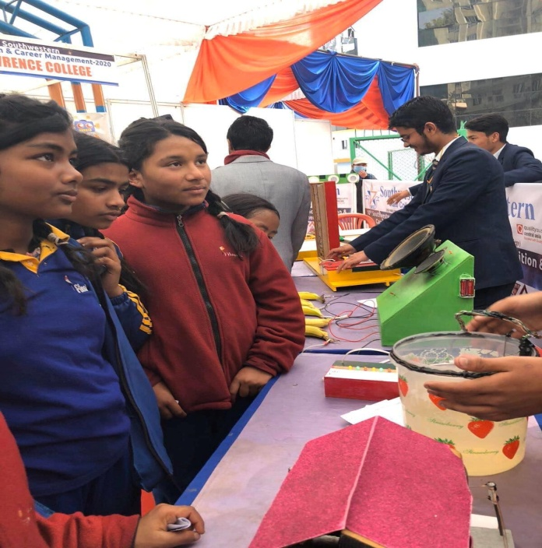
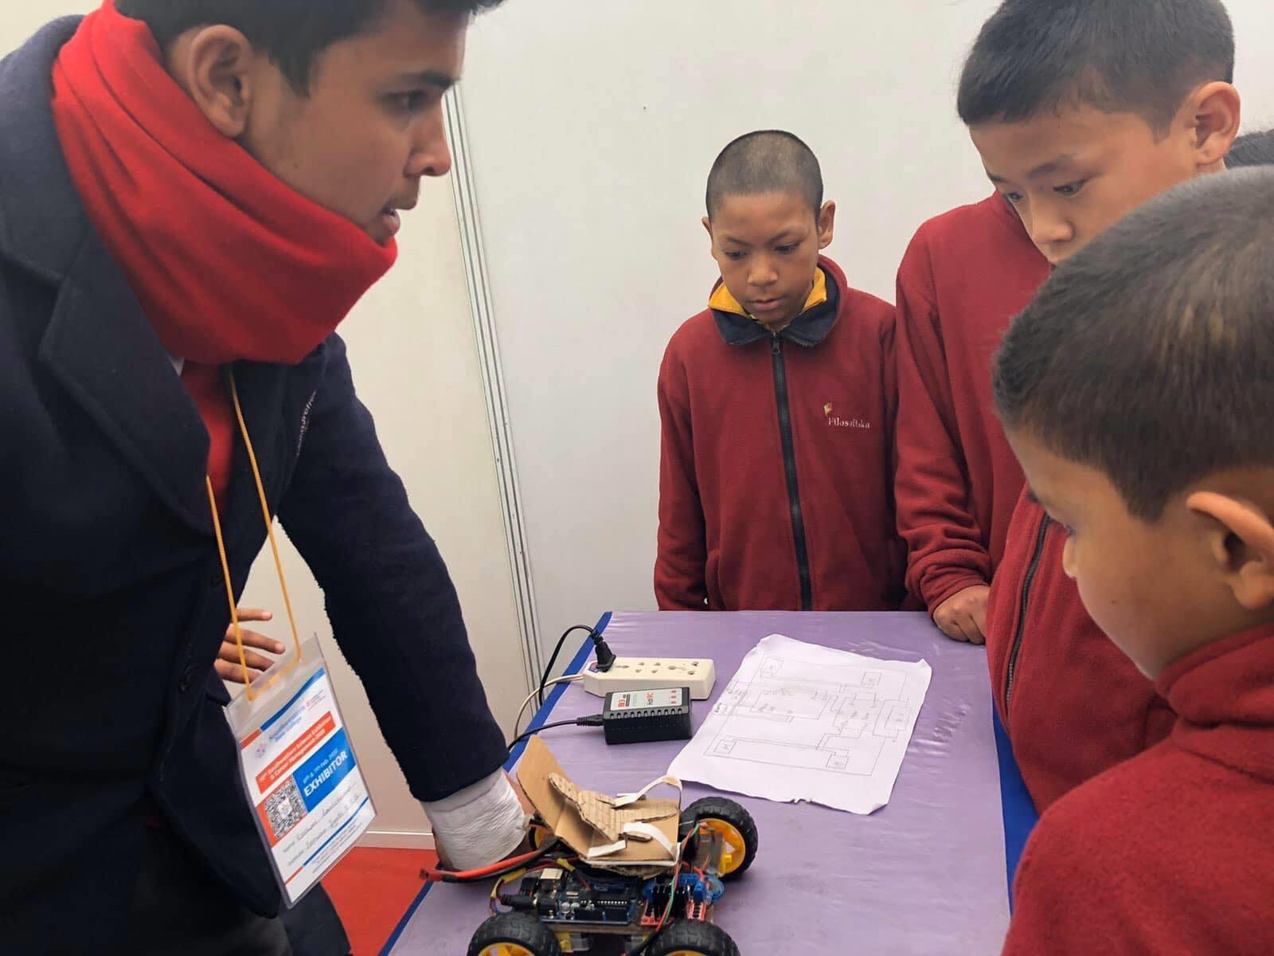 | 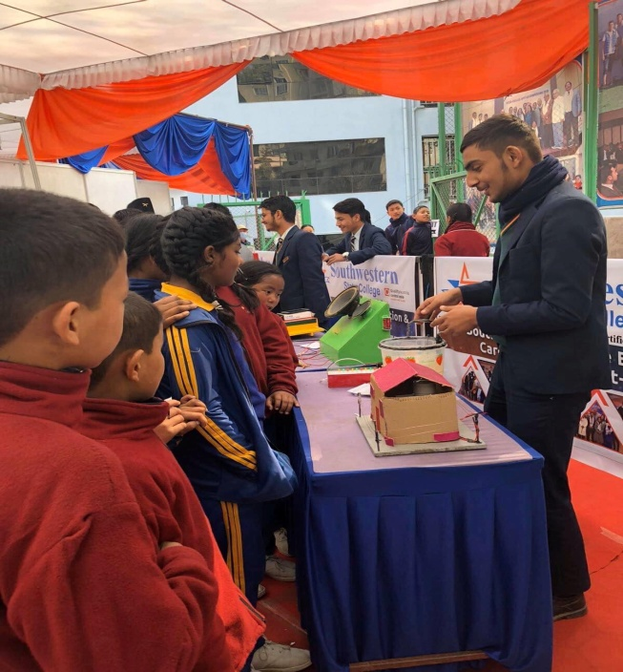
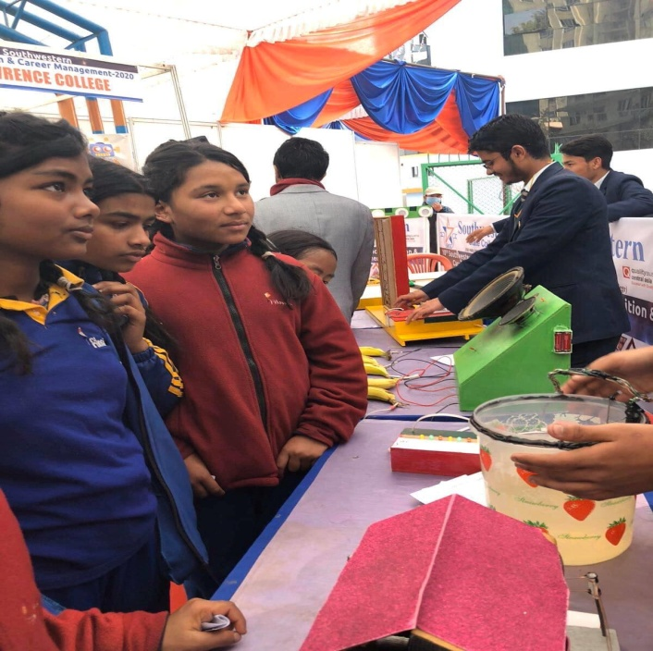 | 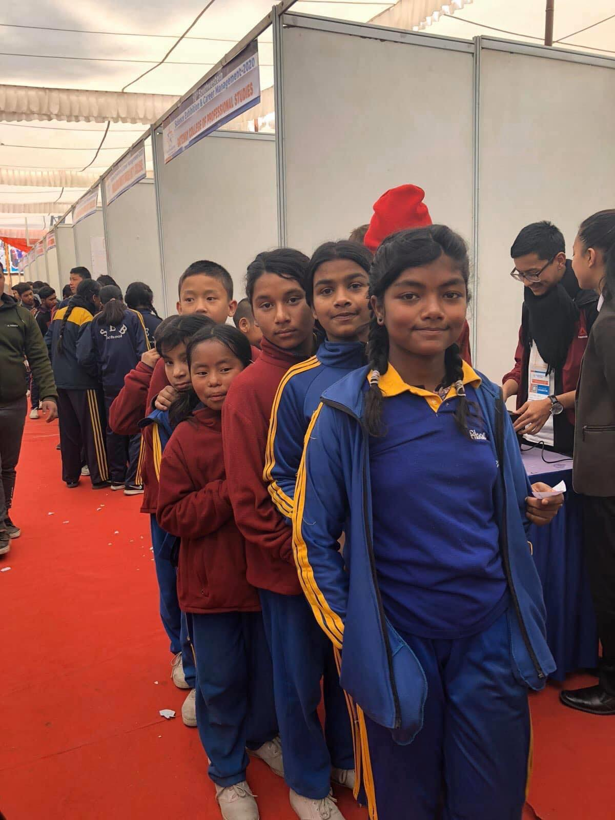

Students from class Ukg to class 4 went for picnic to Gokarna. Gokarna is the famous picnic spot in Nepal. The transportation was supported by southwestern state college. Roshan Bajracharya , a Nepali who is currently working in UAE supported some money for the picnic.
After the picnic was over, students visited the fulbari gumba(monastery) in kapan. This beautiful gumba is located on the top of a hill in southern Kathmandu. The gumba is quite place for meditation.
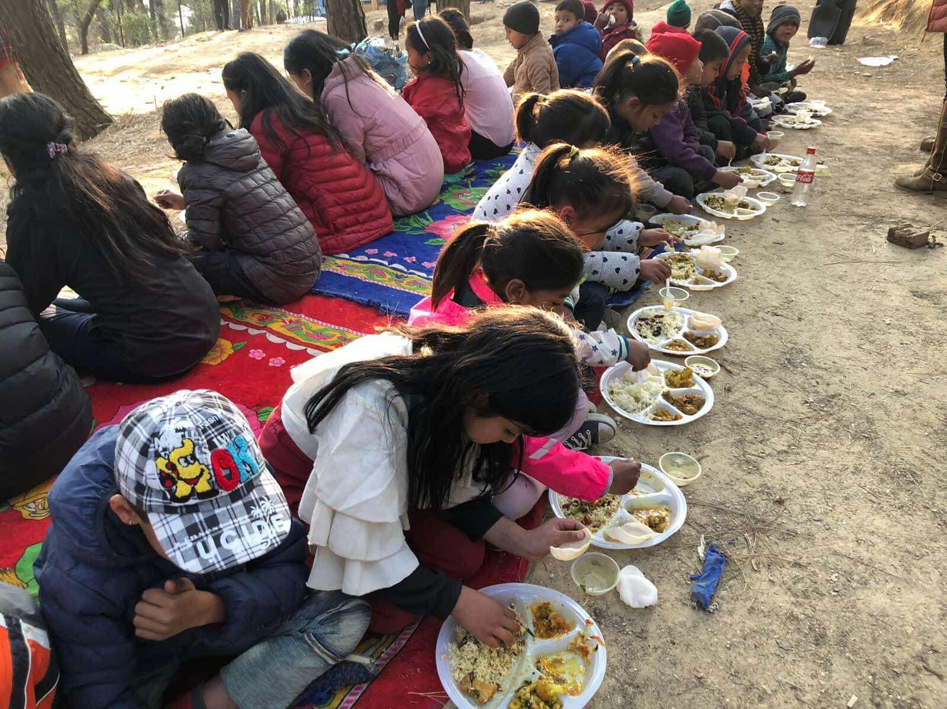 | 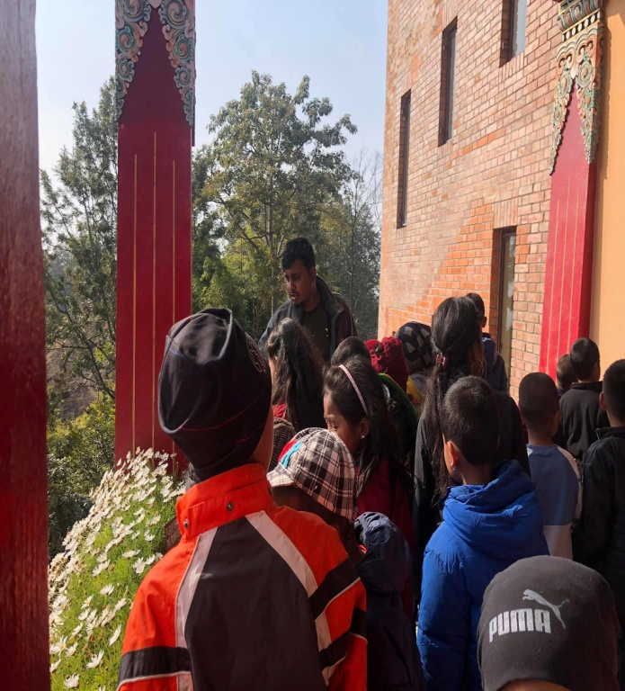
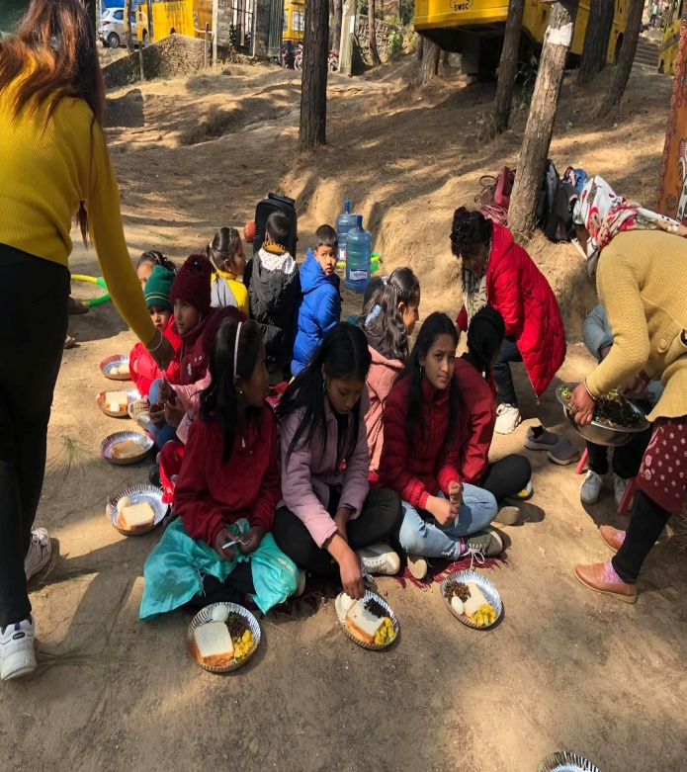 | 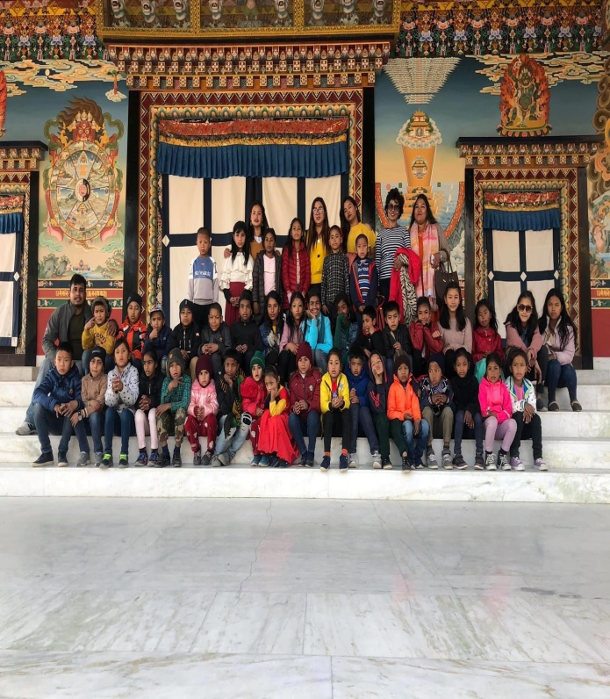
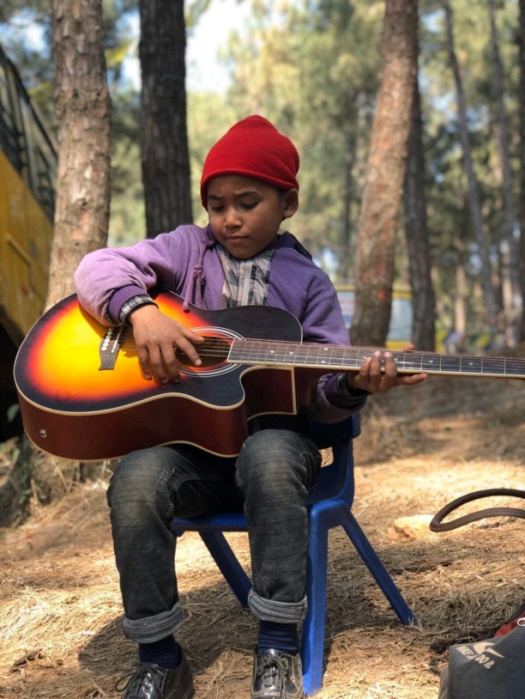 | 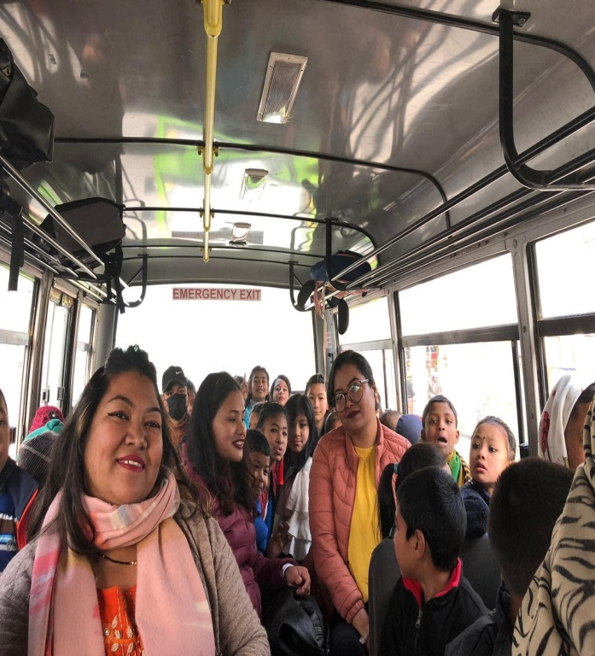
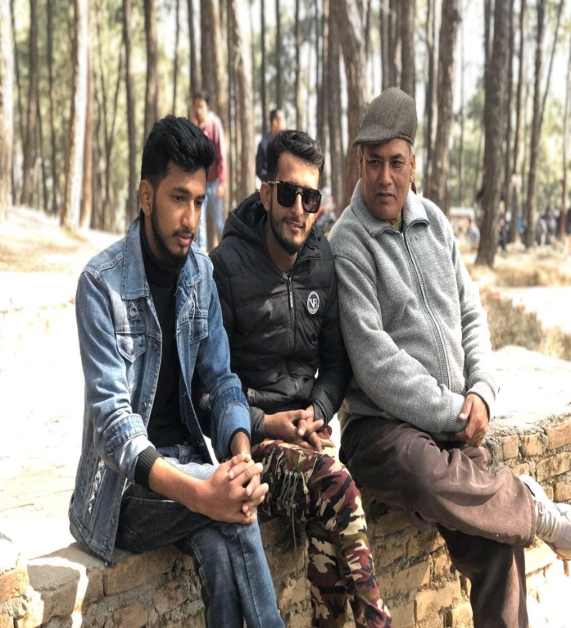 | 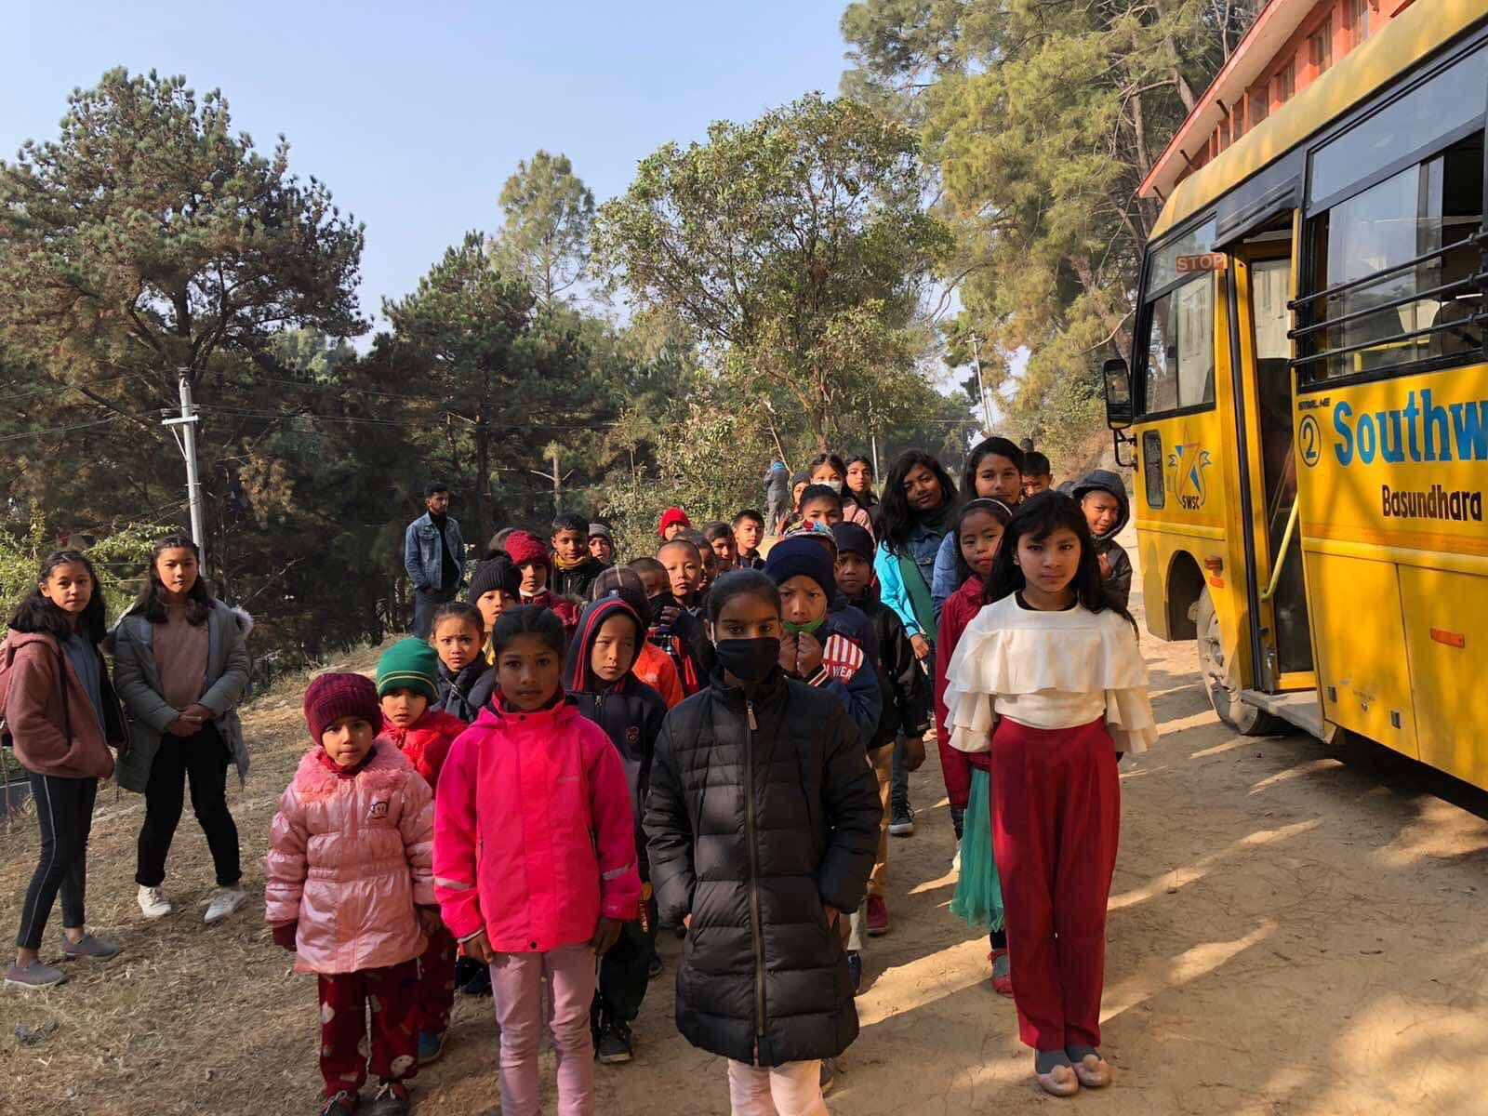

Bithday celebration of Buddha Bayalkoti from class one. Budhha lives with both father and mother in a small room near swayambhu. His mother is sick while his father repairs shoes in the street where he hardly earns $2 per day. His father is worried that what Buddha will do after 3 years when he finishes his school in filosofiska Nepal.

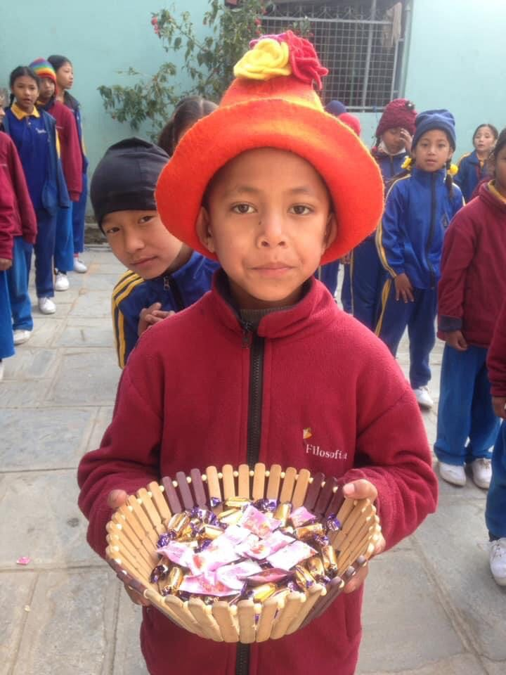

On February 11 class 4 students cleaned the school premises with gardening. They planted different flowers aside the assembly ground. The group was lead by their science teacher Gauri Shrestha. She did this as their part of the project work in the topic environment and its surrounding. There are four students in class 4. They are leaving our school this year.

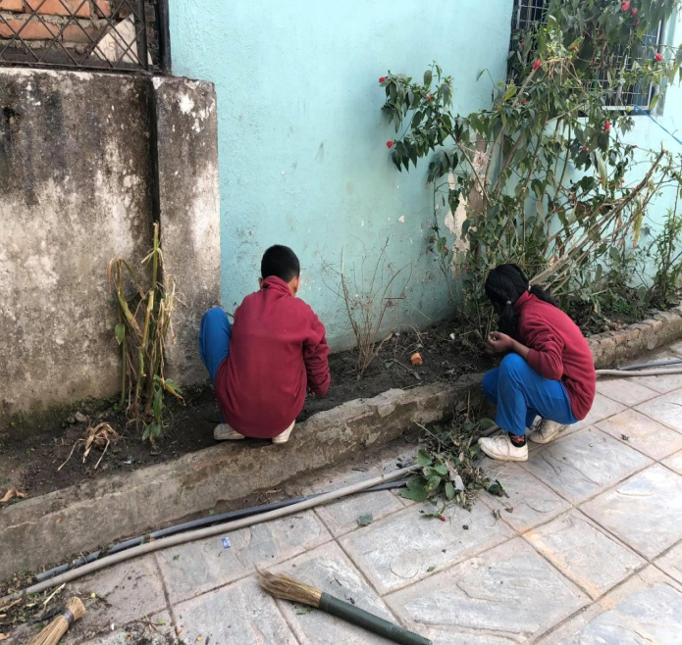 | 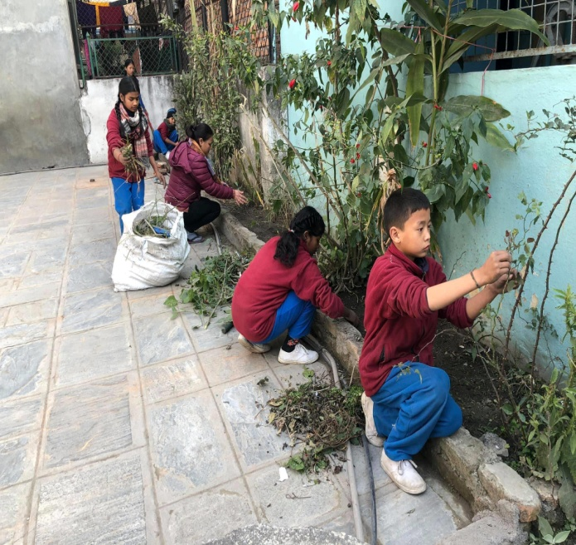

Wei Wei from Taiwan visited filosofiska Nepal on 24th of this month. According to her she has been involved in many projects related to students and social work. She has assured to help us in different ways.
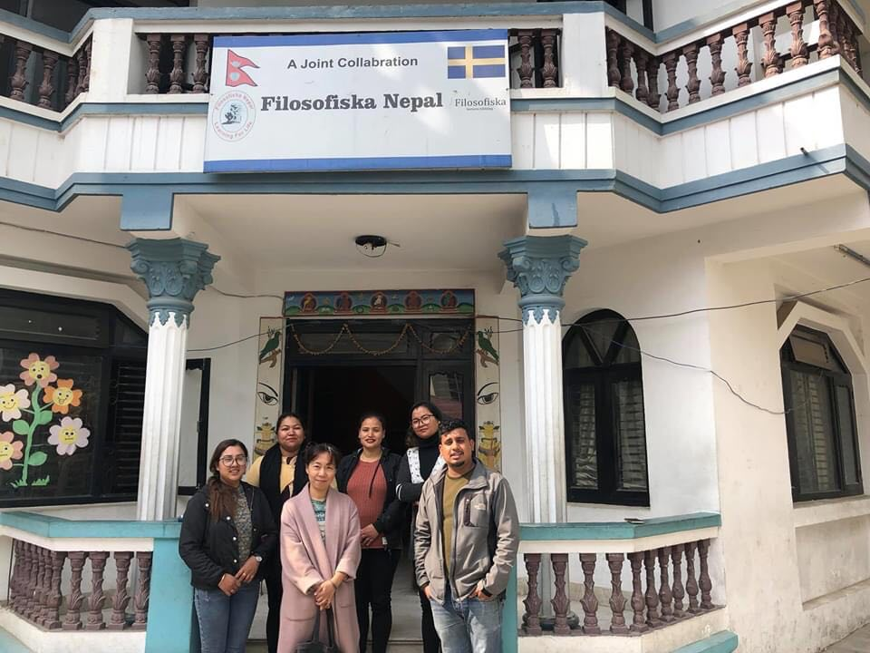

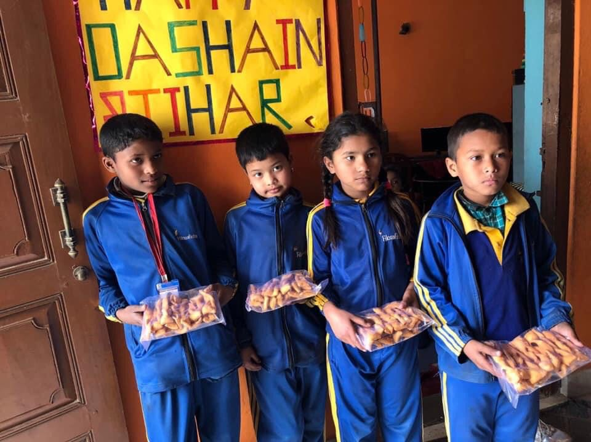 | 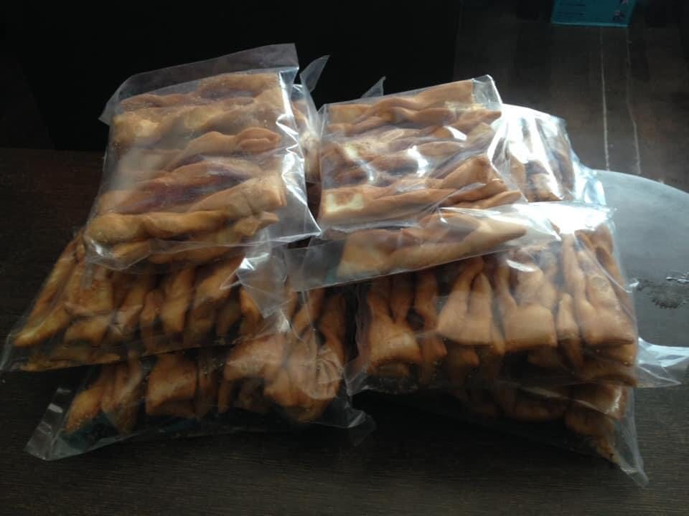
The above photos are the one day snacks provided by one of the business women of Kathmandu near our school. She has kept our 3 children in her home. These children were brought from the terai region of Kathmandu.

