Monthly Report for the month of January 2020
January, the first month of the year has 31 day. The first day of the year was celebrated with sweet foods and full of entertainment. Teachers were also given half holiday to celebrate the New Year.
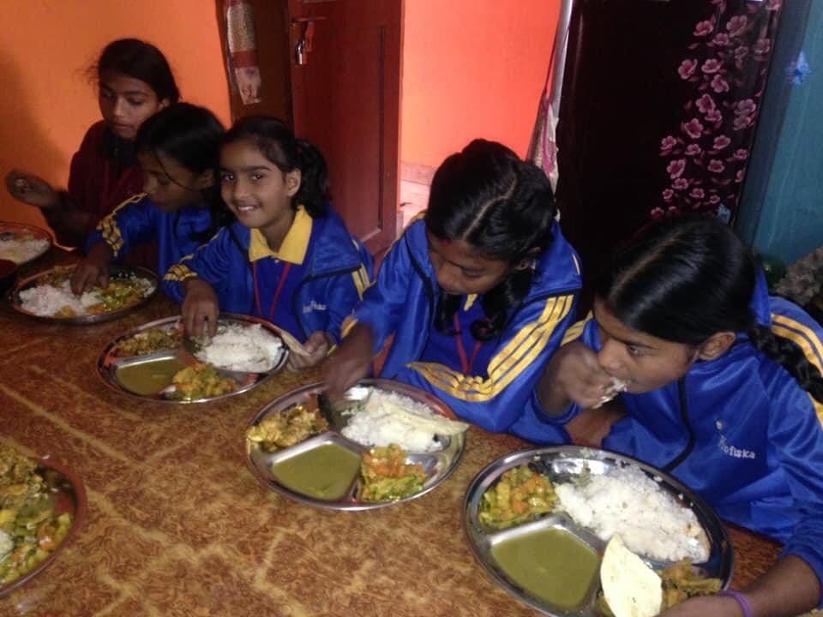 | 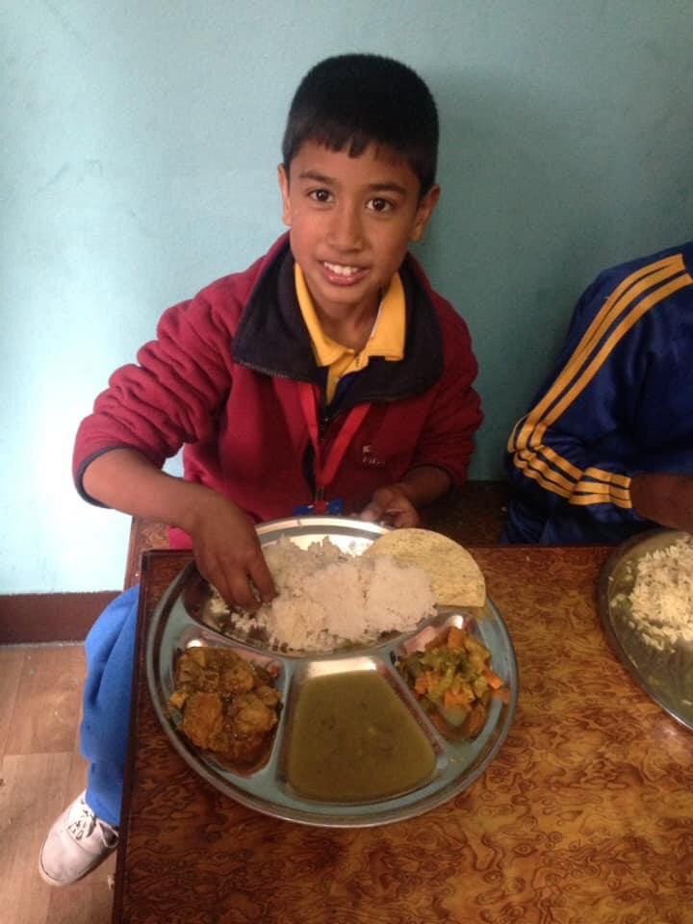

The month of January is named after the Roman God of doors, Janus, because this month is the door into the New Year.
On Thursday, 2nd January Nicole Ferreira Sjostorm and Oscar Alsing from Sweden visited our school during their visit to Nepal. Nicole and Oscar supported some game items like Football, Badmintion, skipping etc.our children got so excited and played with them for some hours. Children got more excited when they knew Nicole is the daughter of Dick Holgerm.

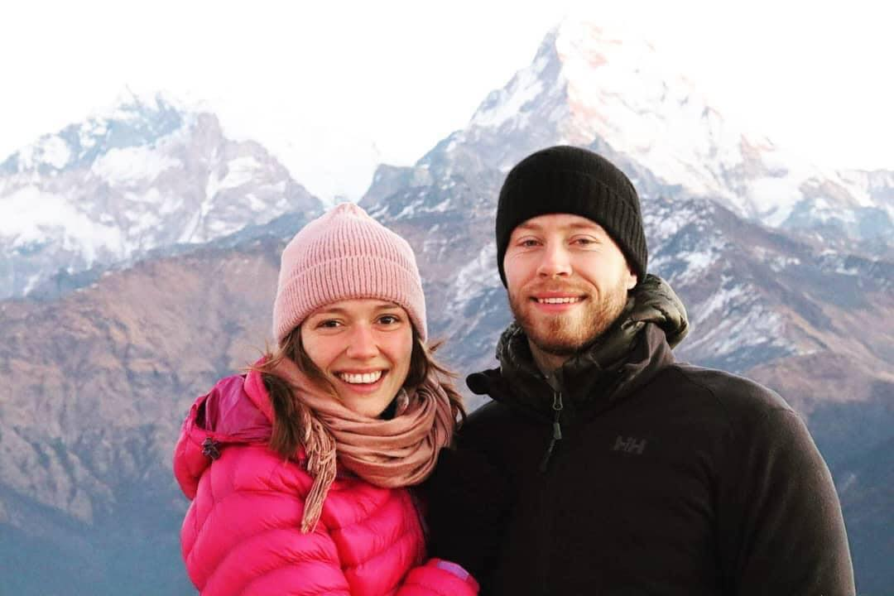 | 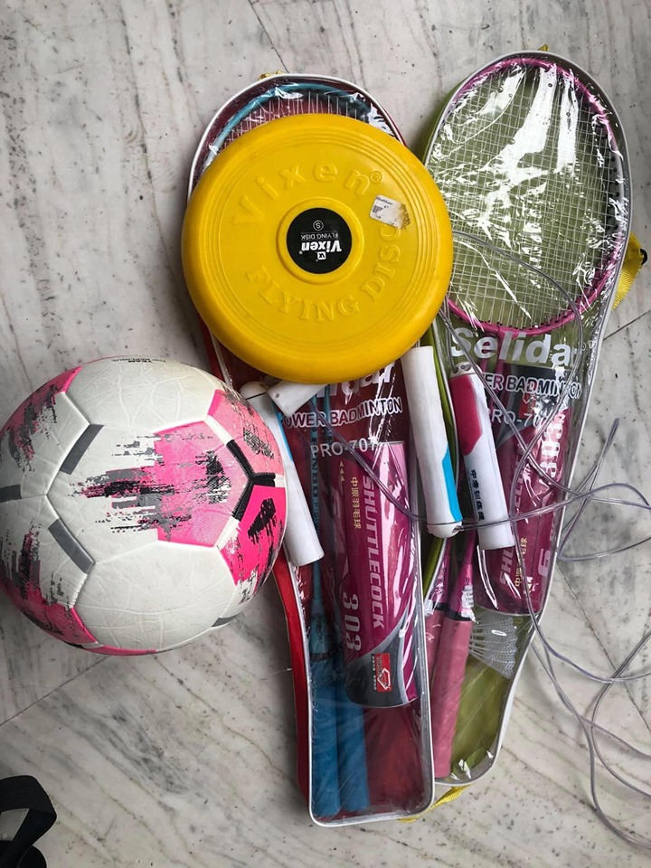
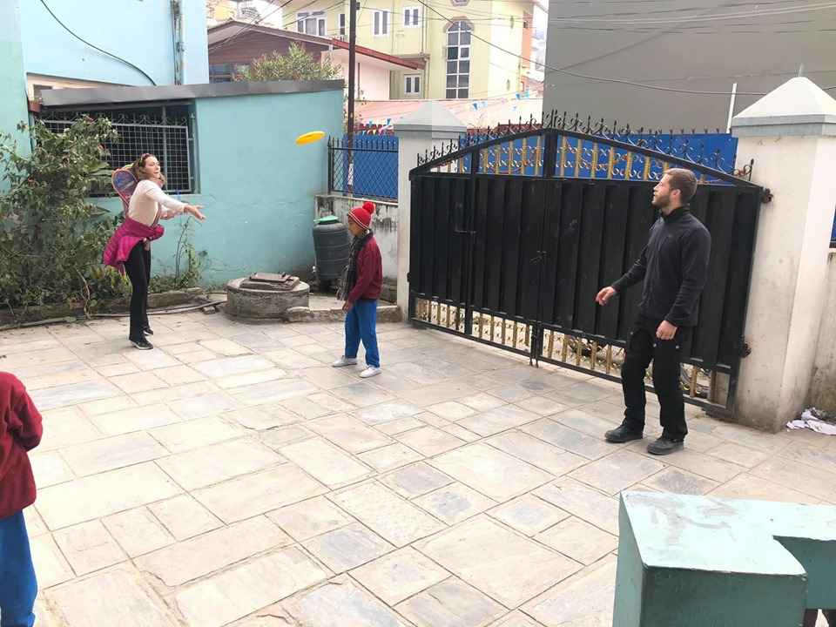 | 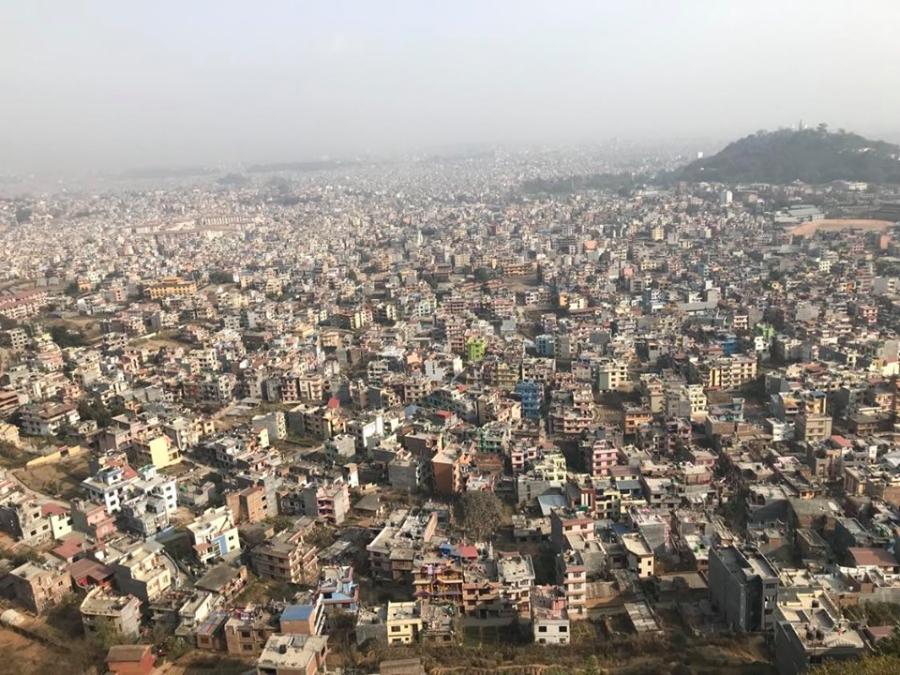

On January 5 Sunday, all the teachers and staff were involved in making the new plan and a road map to help improve the institution. We discussed on the ways to expose our school name.
In this month we focused to complete the course as the final assessment was near. Sanju KC , one of our teachers left the school and our teacher got extra pressure to complete the course.
On January 28 we celebrated the birthday of Pabita Thokar. She is our student from Nursery. Continuous effort from our teacher Rashmi Rajbhandari and Pabita her herself she improved her writing. She is well disciplined too. 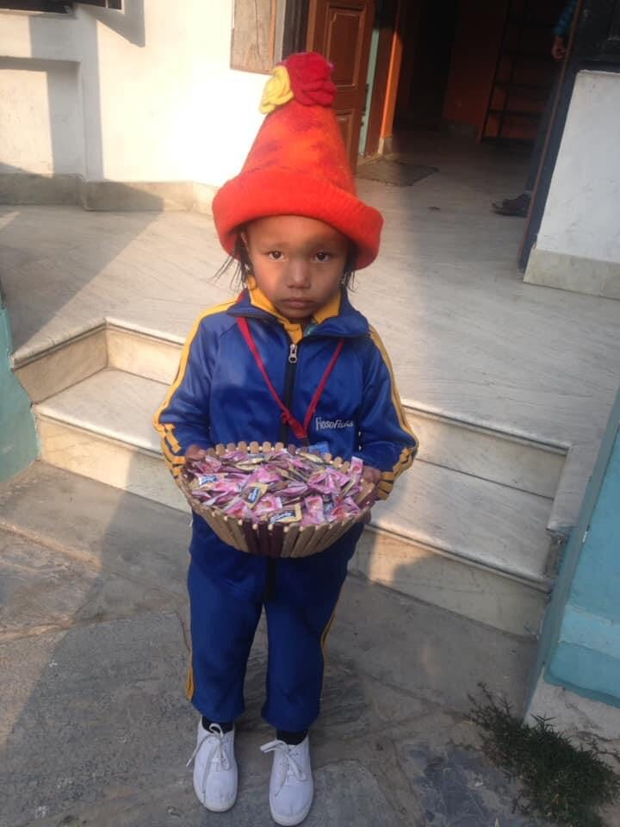

On January 28 we celebrated the birthday of our Driver who has been serving the school from its establishment. Without his continuous and hard work it would be difficult for us to manage the transportation for us. We all the team made his birthday better and memorable. On the very same day he sponsored the lunch for our children.
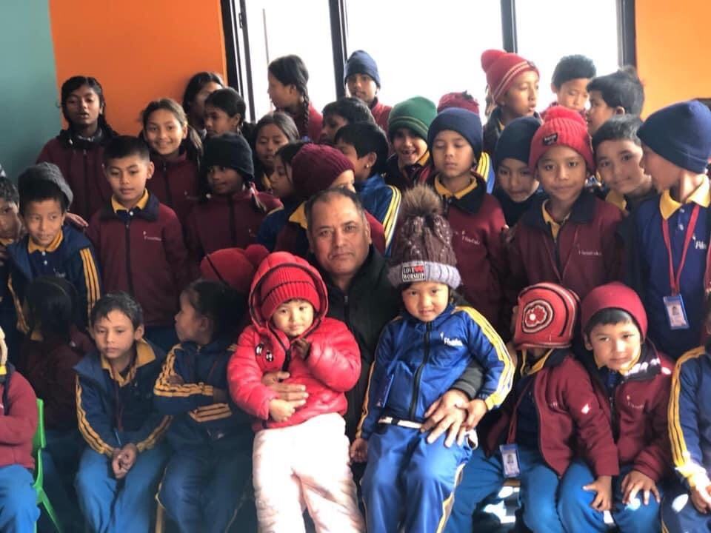 | 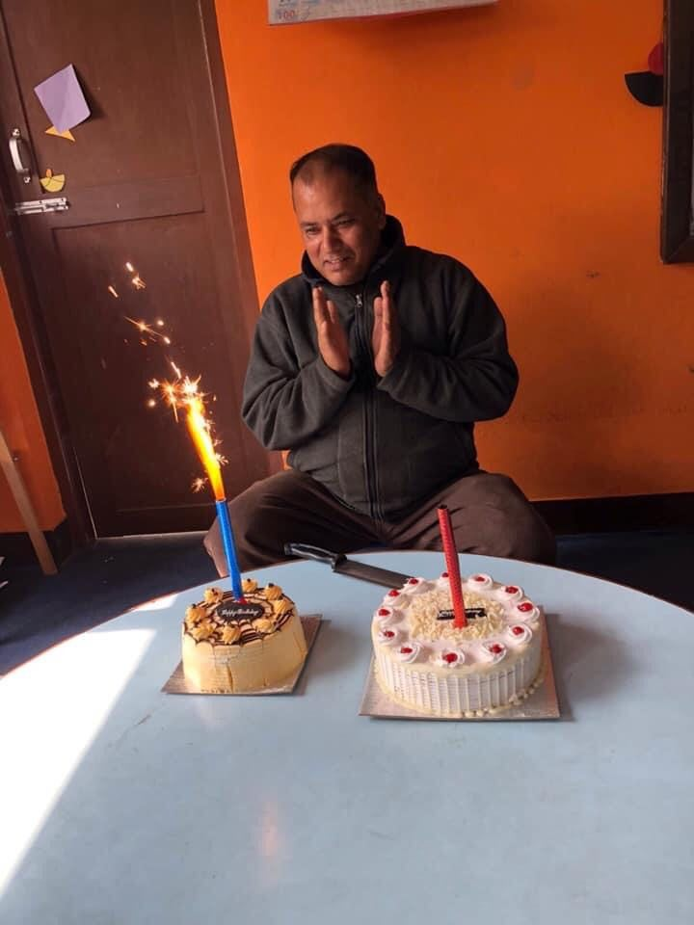
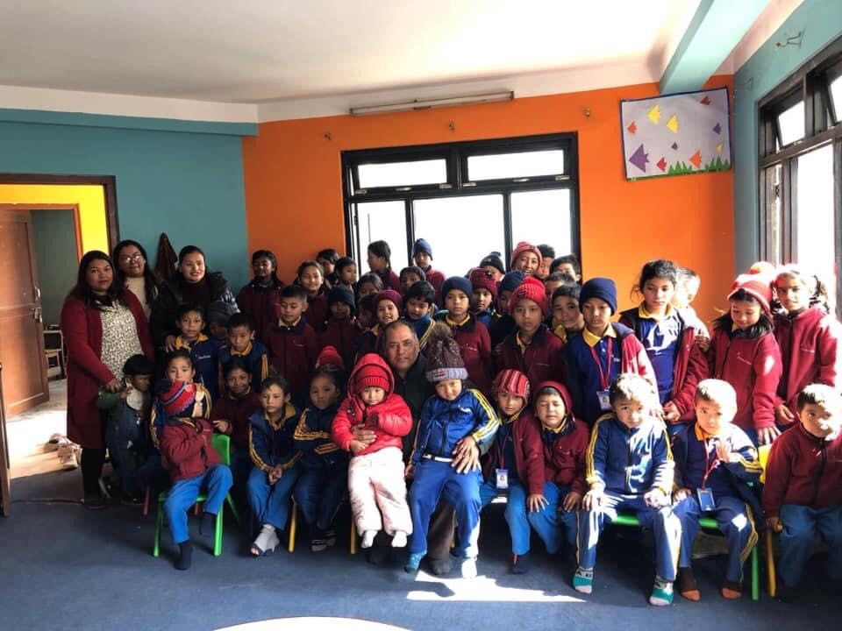

January 30 was Sarswoti Puja. This day was very special for the teachers and the students of Filosofiska Nepal. Goddess sarswoti , who is said to be the diety of learning , music and art was born on this day and people worship her to achieve wisdom.
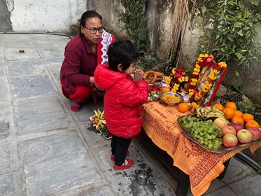 | 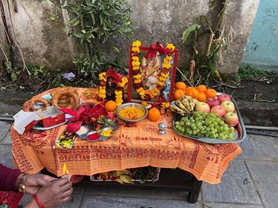
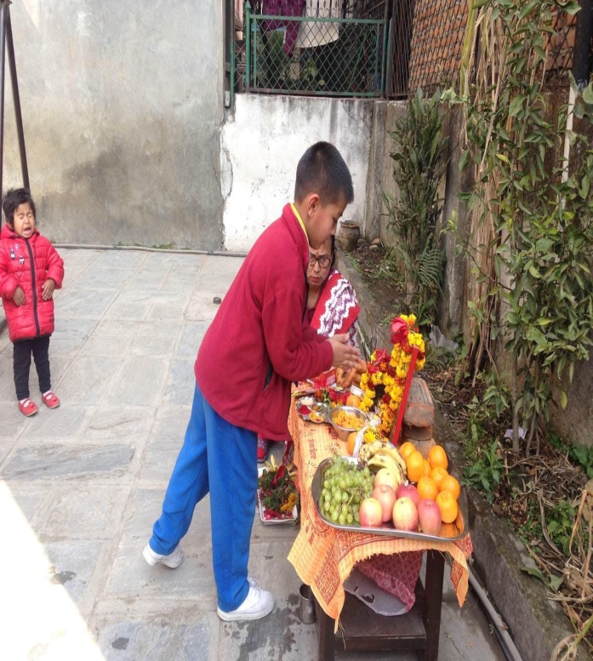 | 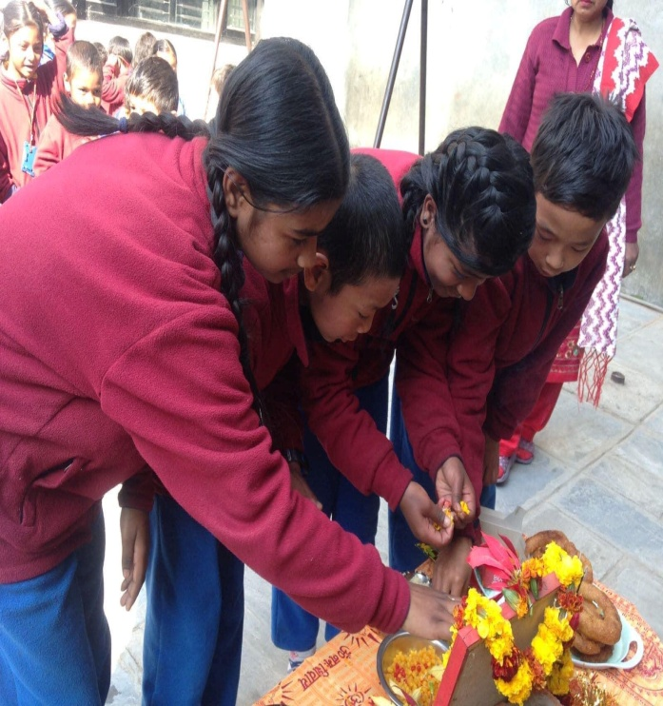

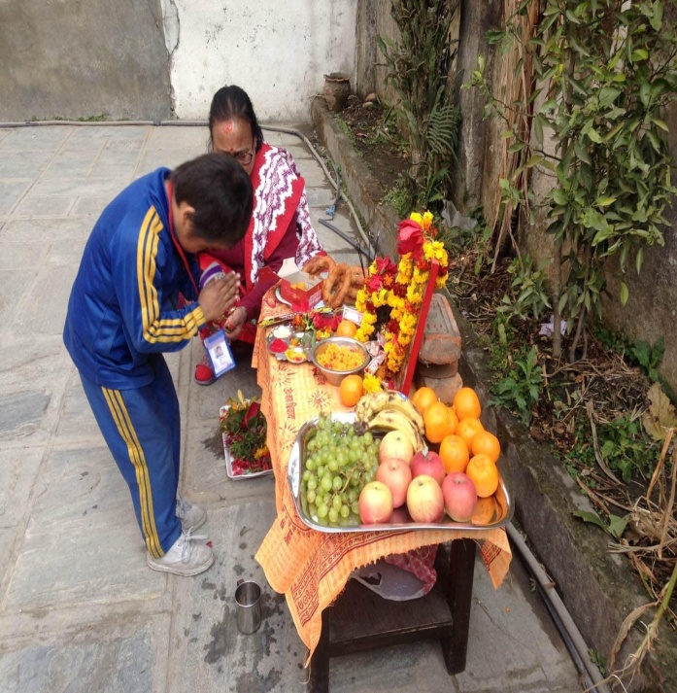 | 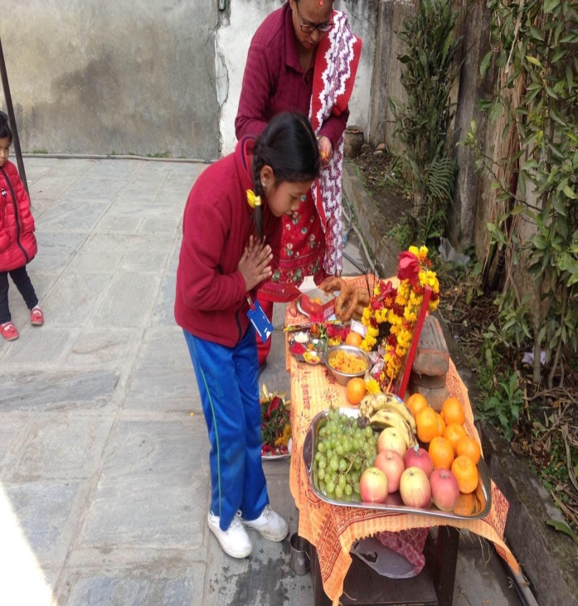
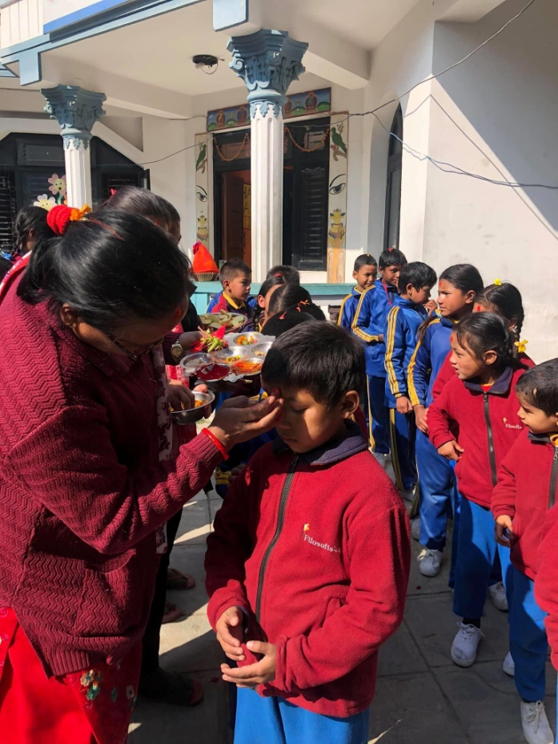 | 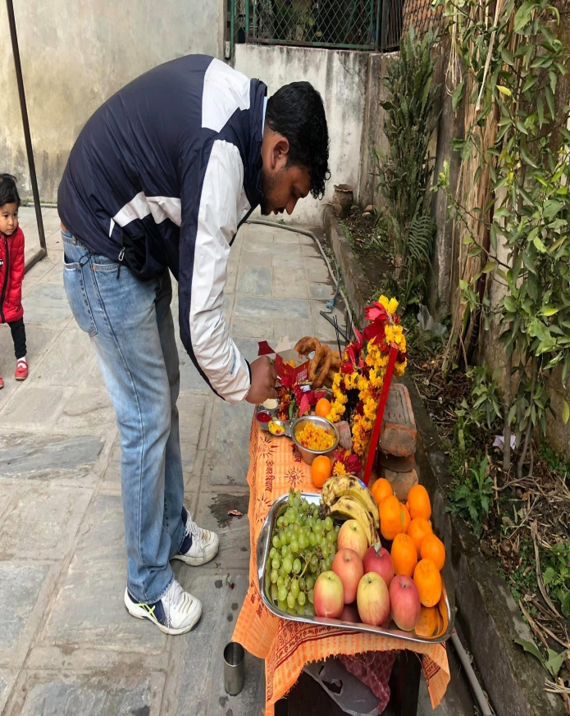
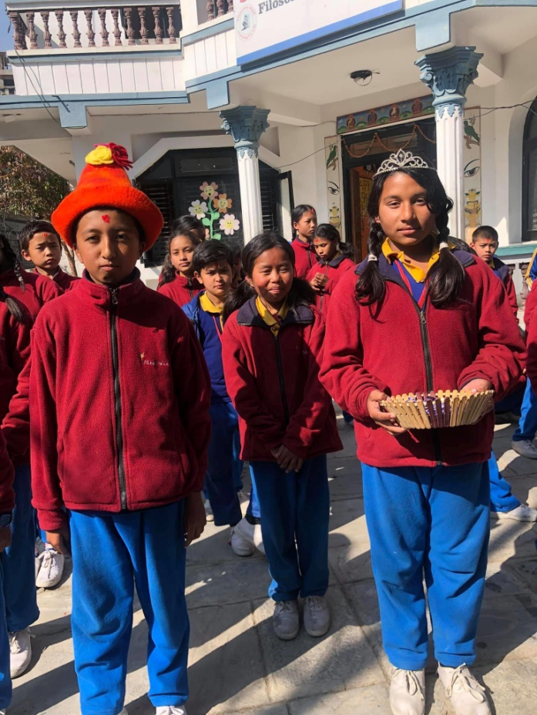 | 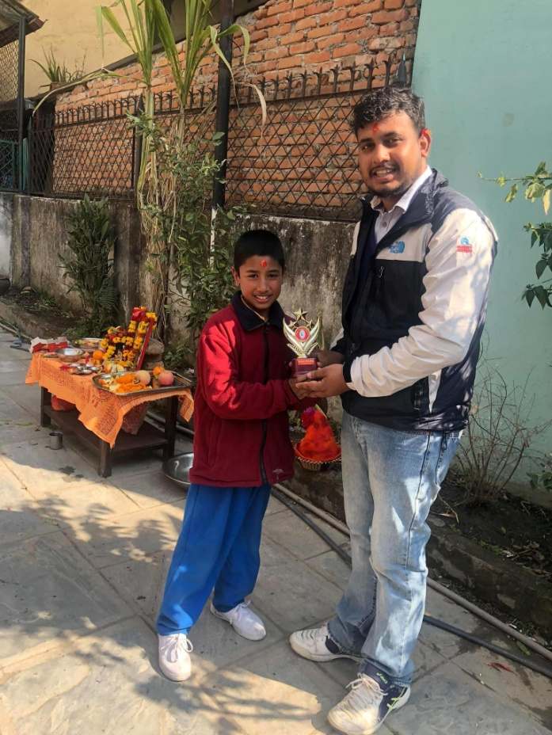

Lazima Pariyar (class 3) and Prabin Khadka (class2) also celebrated their birthday on the same day. Lazima sister’s smirti is also our student.
With the recommendation from the teachers and nonteaching staffs, Rabin Khadka (class 2) got the best student award. Regarding his discipline, Academic performance, Handwriting, performance in dining hall, Rabin was awarded with the best student award 2076.

