Monthly Progress Report of July 2019

The seventh month of the year usually the second month of summer!

The Guru Purnima festival is being observed throughout the country, July 16, by paying reverence to all teachers. The festival, also marked as Teacher’s Day, is observed on the full moon day in the Nepali month Ashadh as per the lunar calendar. The day is dedicated to gurus or one’s teacher who bestows the gayatri mantra for the first time during one’s bratabandh or the sacred thread ceremony, initiates one to reading and writing, reads out the vedic hymns during the religious rituals and other teachers in general.
Etymologically, the word ‘guru’ is made of two roots ‘gu’ and ‘ru’. Gu means darkness and ru means light. So, the word guru means the person who removes the darkness of ignorance with the light of knowledge as per the religious texts. Our religion also sees the teacher as the embodiment of the Hindu triumvirate gods Brahma, Bishnu and Maheshwar. The teacher is also considered as a form of god like one’s parents. Schools, colleges and various organizations mark Guru Purnima by organising different programmers and paying homage to the teachers.
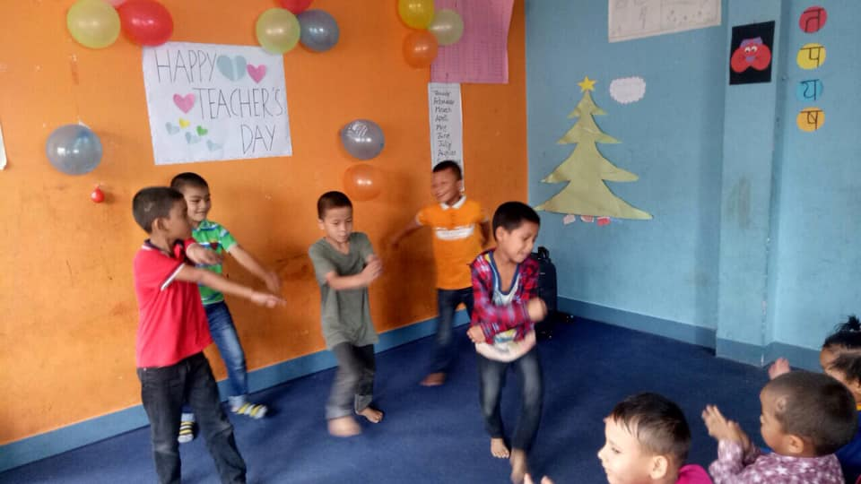
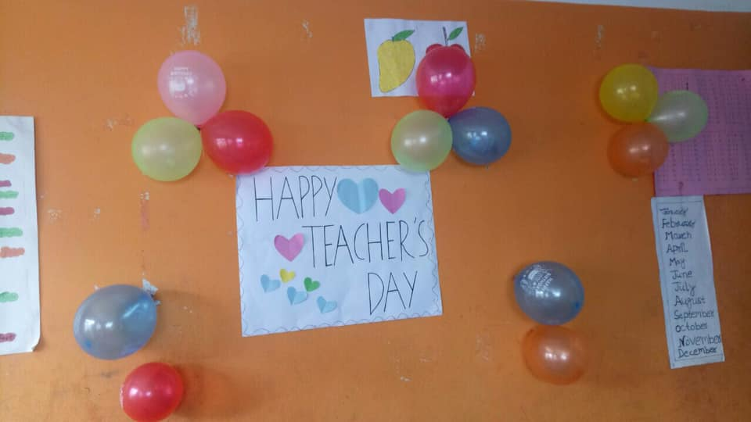
Dancing movement of our students occasion of Teachers day 2019

On the 3th of July Filosofiska Nepal gladly welcomed Aashika Lama and Sunil students have been admitted to the school. Welcome to Filosofiska family, we are so happy to have you here!
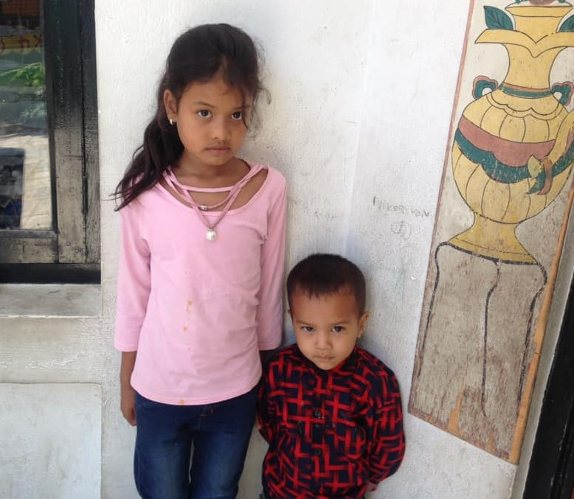

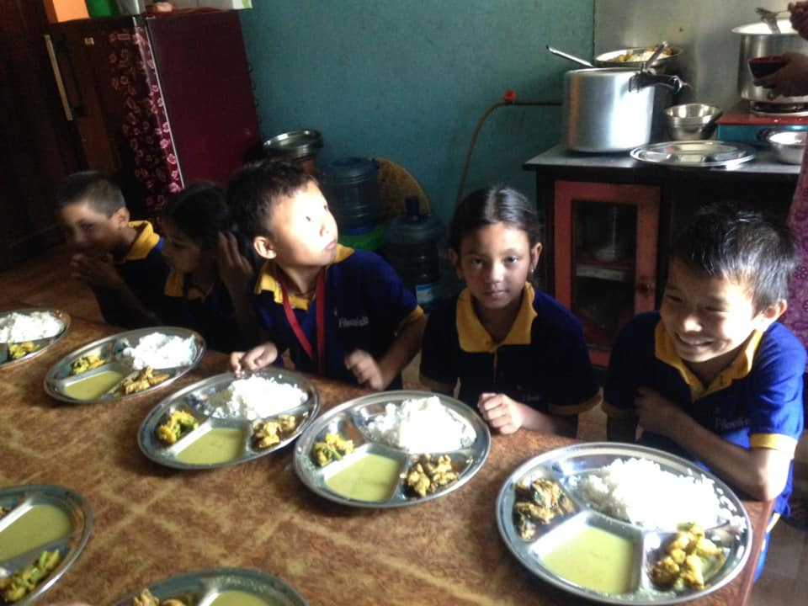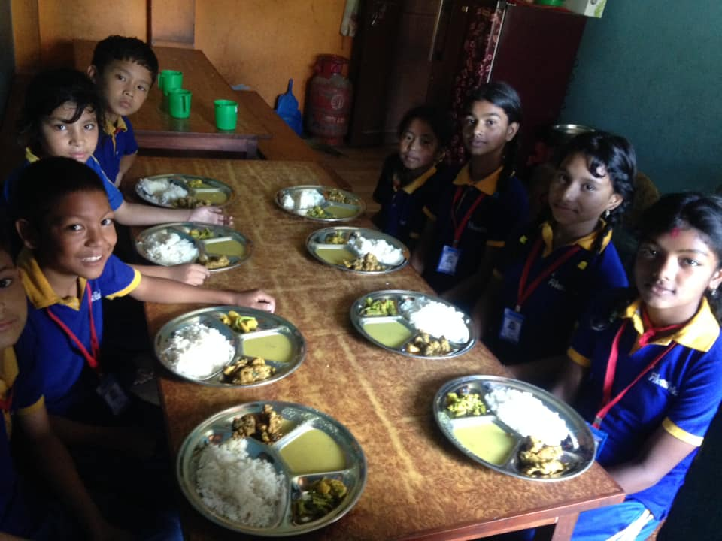
On the same day Mr. and Mrs. Kamal Tuladhar provided yummy lunch to all our children. They celebrated happiness of their grandson SEE success with our children. Once again delicious lunch for our student
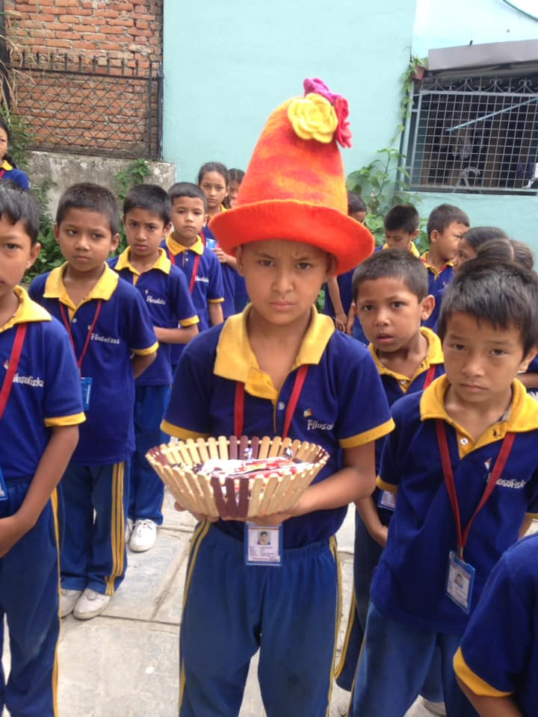On the 5th of July Today morning we celebrated birthday of Ashok Magrati with birthday song .He distributed chocolates to all his friends and teachers.
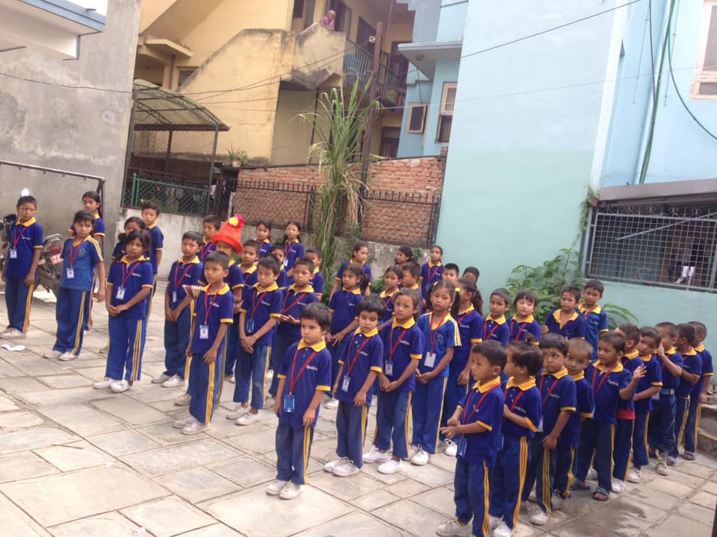
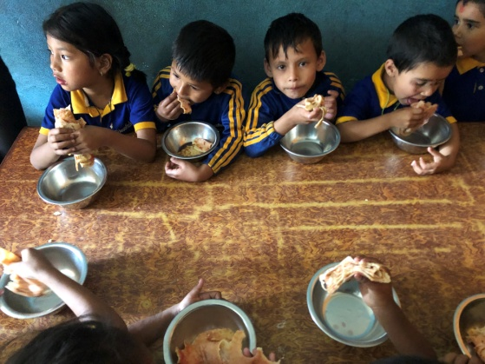
On the 16th of July Happy birthday Ulina and Rajani (Teachers of Filosofiska Nepal ) 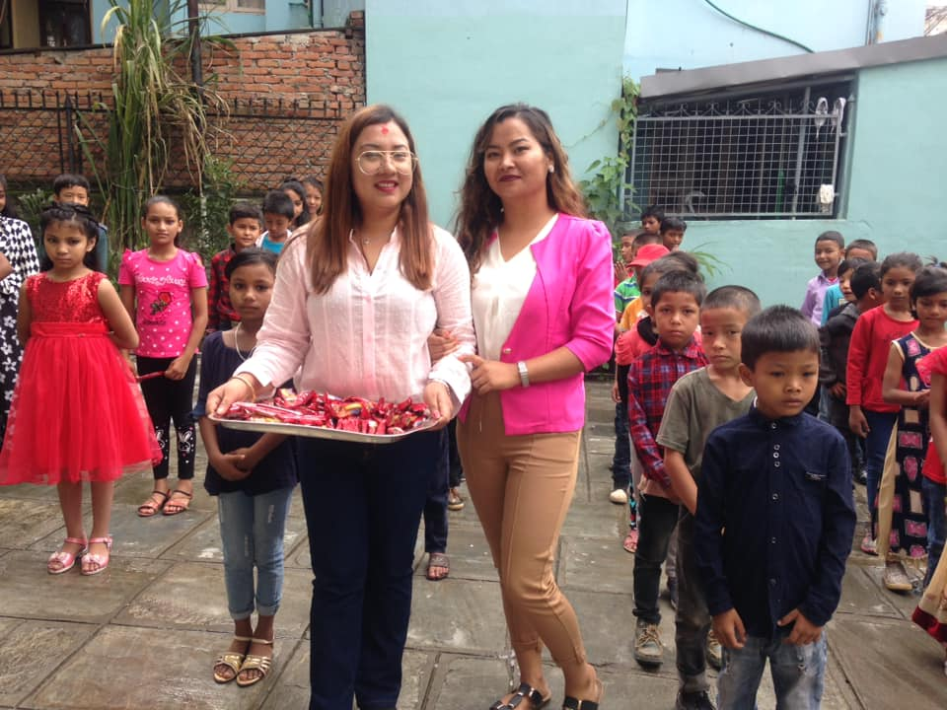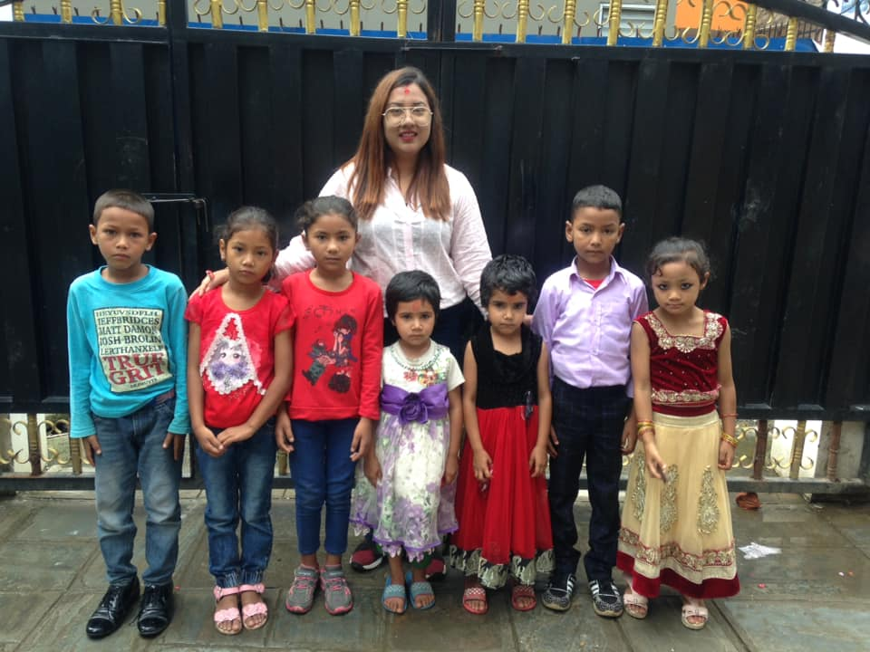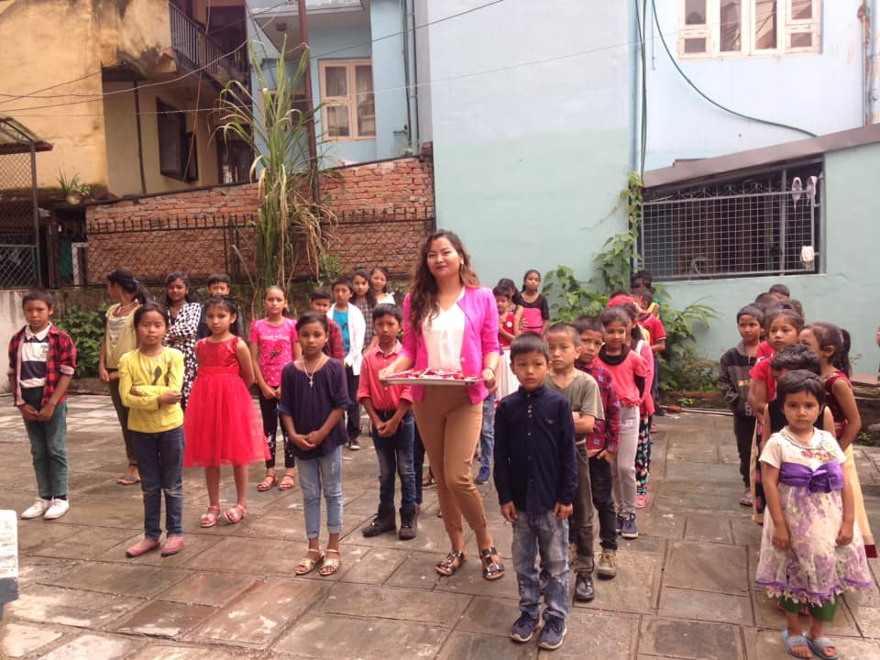 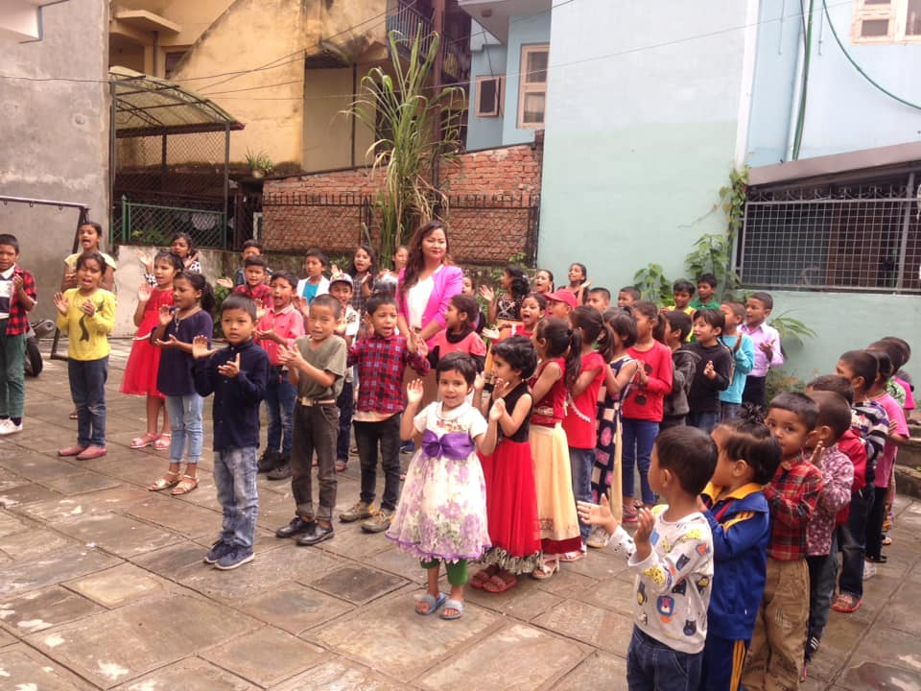
Pictures from outdoors of school ground, students enjoyed with birthday song and chocolates !
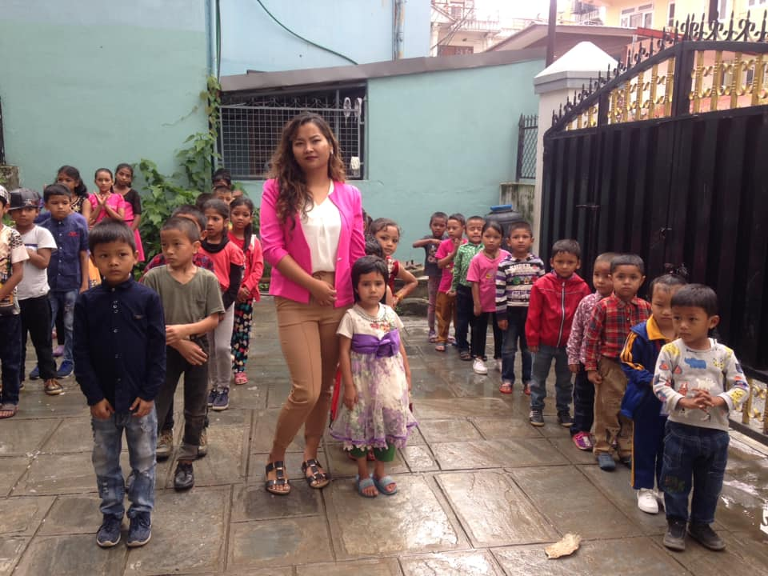
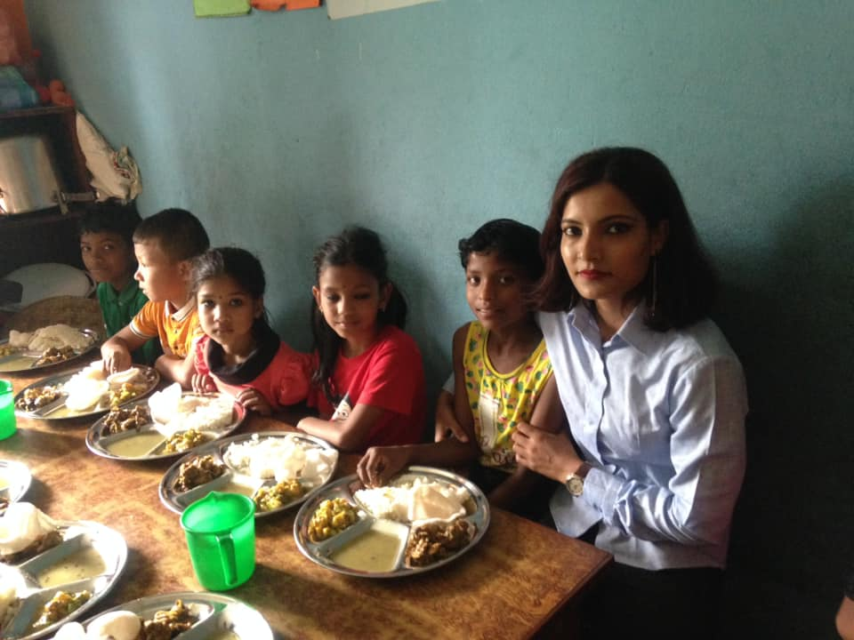
On the 16th of July Sanju kc also celebrate her belated birthday with student of Filosofiska.
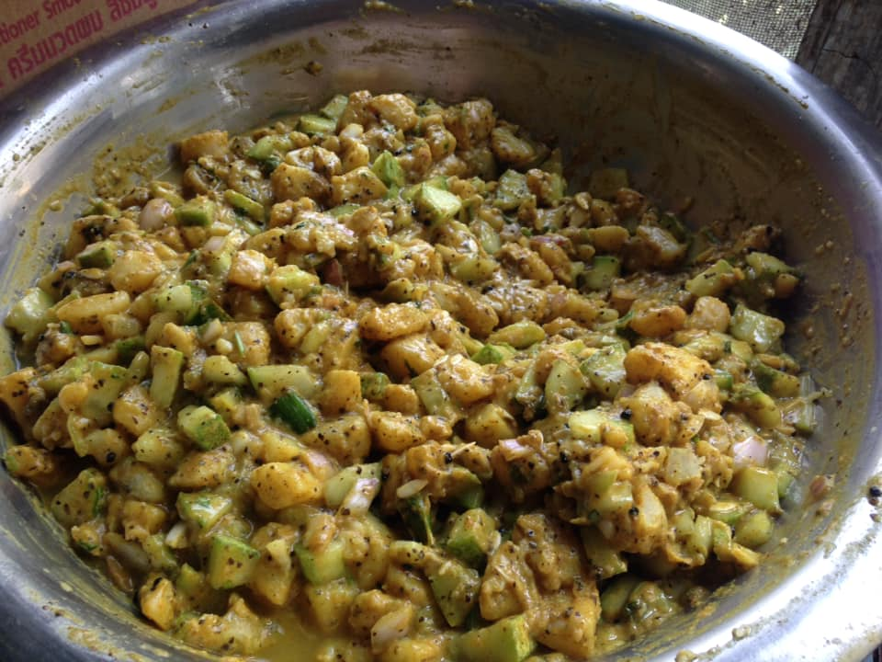
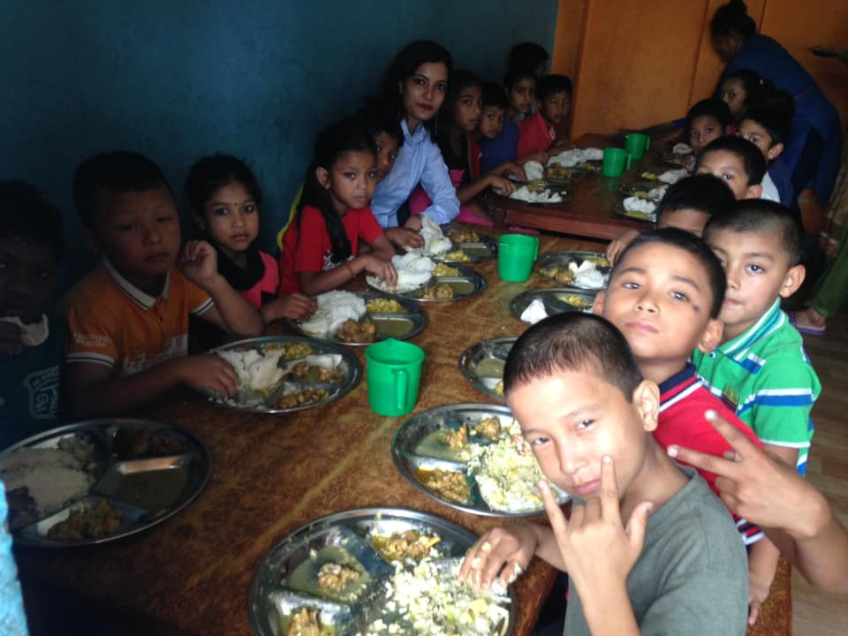
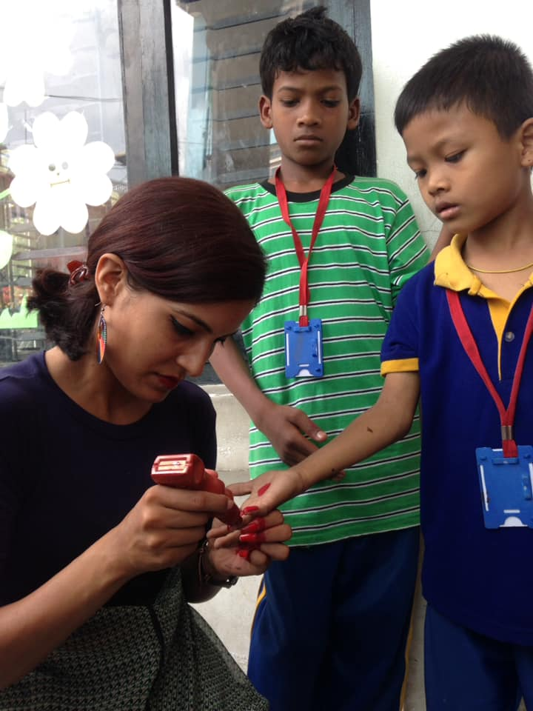
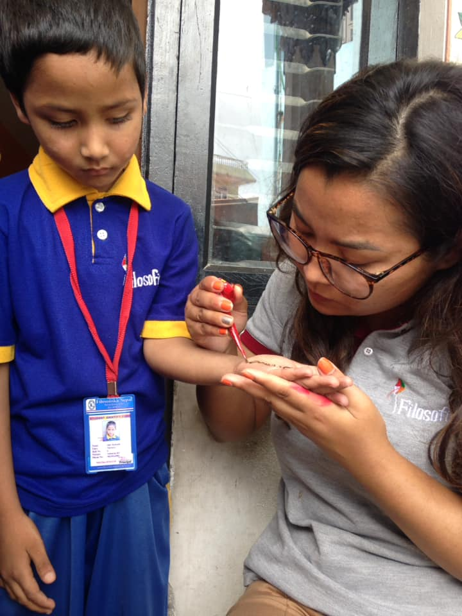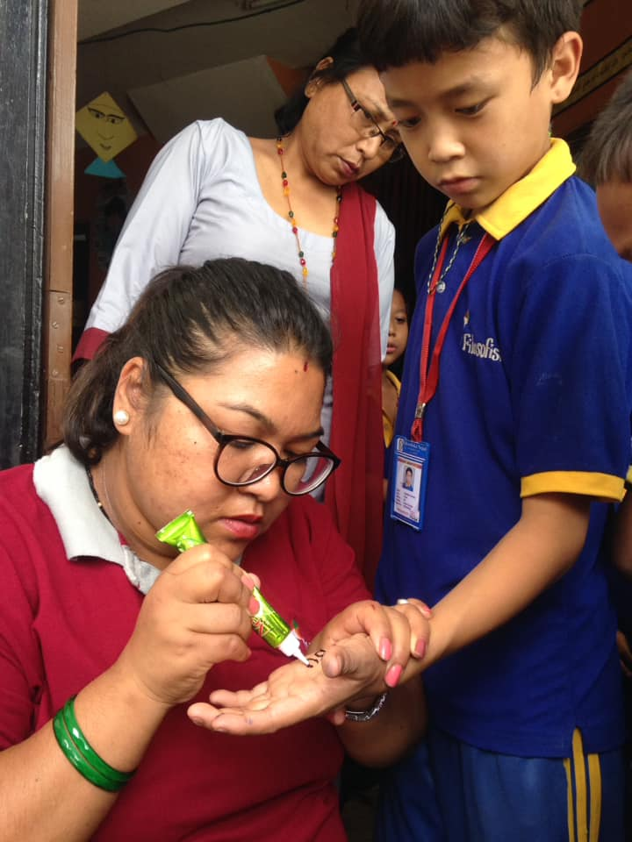
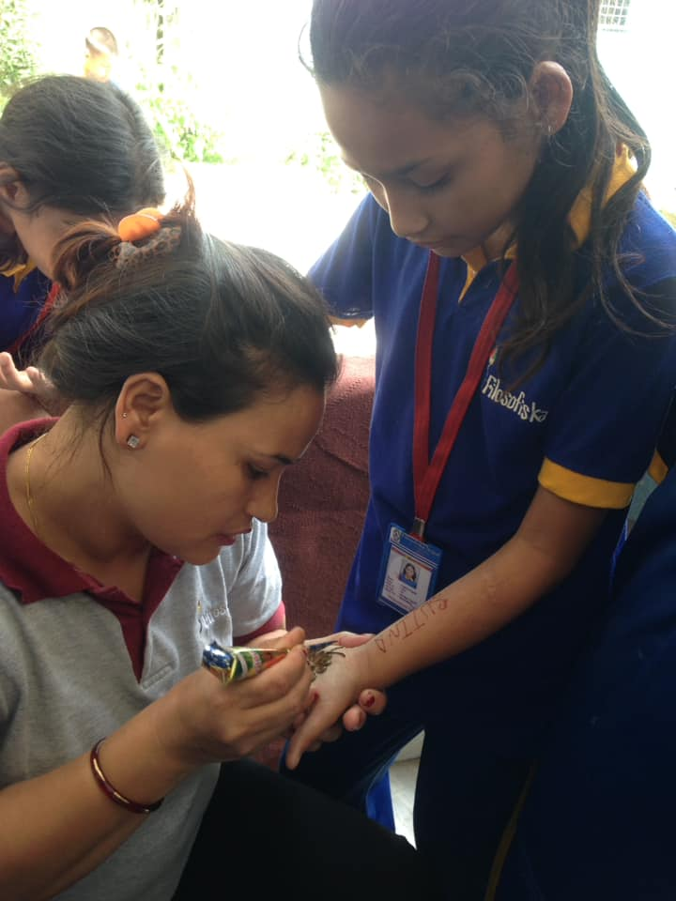

On the 17th of July ,Heena art at school. Its teachers day also.
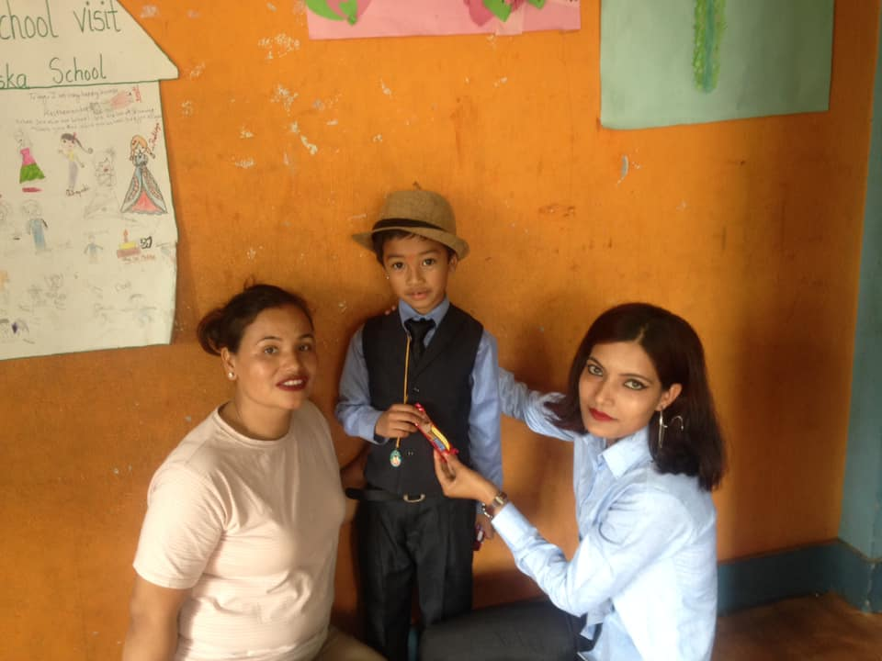
On the 17th of July, parents of Dipankar Shakya provided yummy Snack to our children.

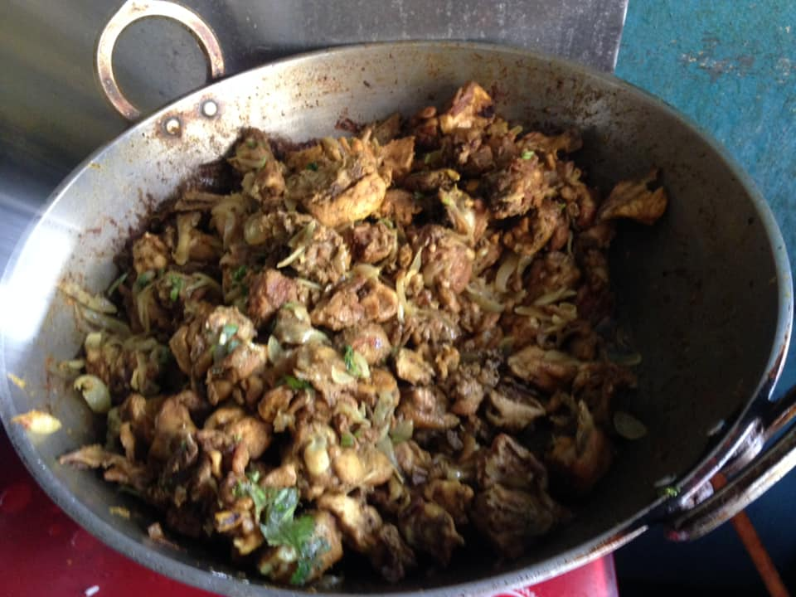

On the 19th of July One of a pair of organs located in the right and left side of the abdomen. The kidneys remove waste products from the blood and produce urine. As blood flows through the kidneys, the kidneys filter waste products, chemicals, and unneeded water from the blood. Today friends of Ulina (Ramila,Suneshwori Kumari,Jashmin)visited our school. They organized "Save the kidney" awareness program and gave effective massages about kidney. At the end of the program our students performed some dance with them for entertainment. We all had lots of fun. They provide us delicious lunch and stationary items.

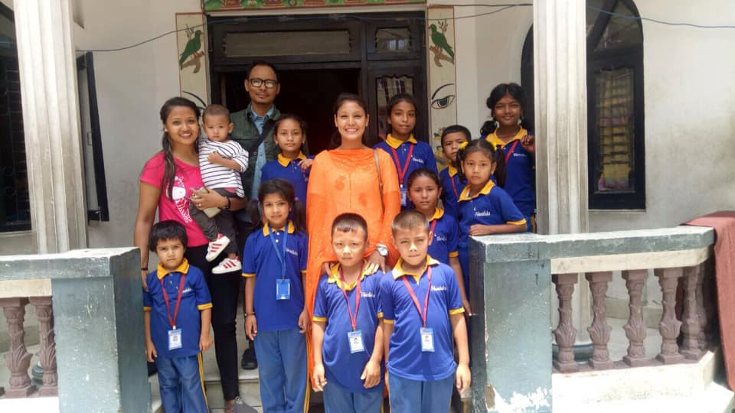
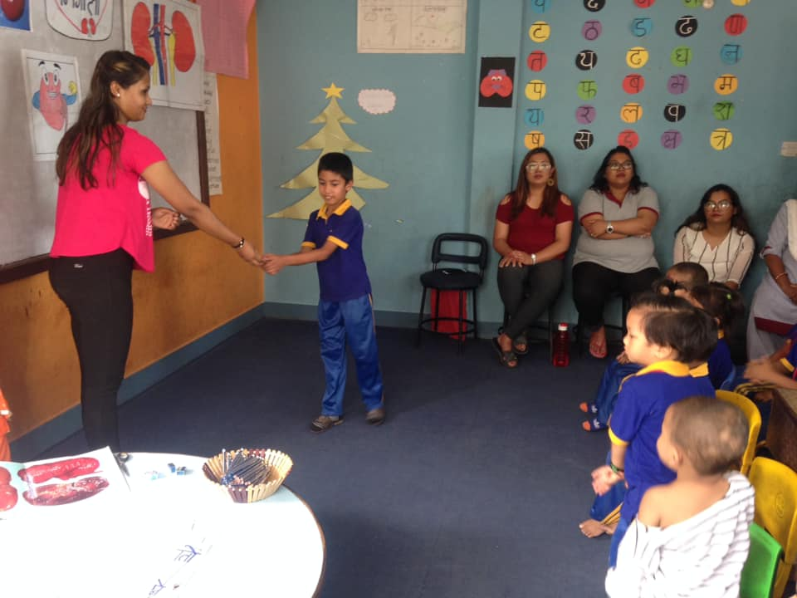

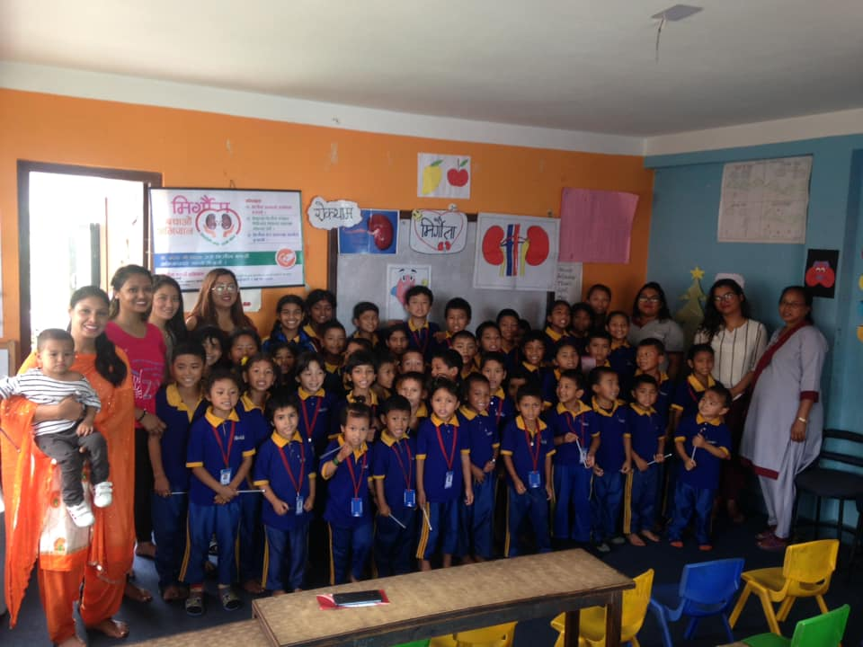
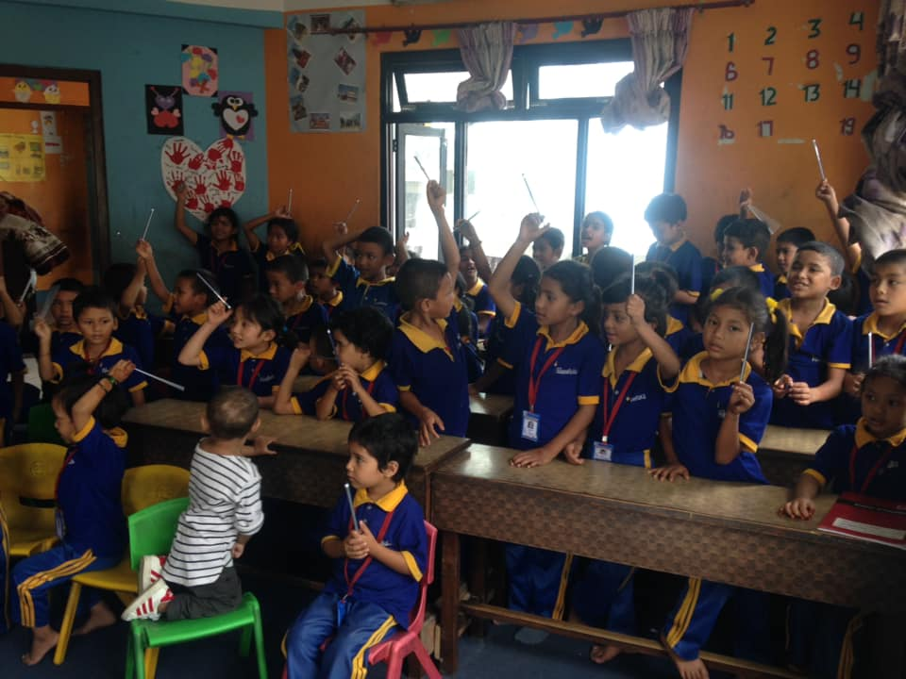
The role of a teacher in a young student’s life goes beyond just education. They're a leader, a role model, a coach, an advisor and a facilitator of positive growth. With students spending most of their waking hours at school, it’s up to teachers to create a positive and inspiring environment where children can do their best work.
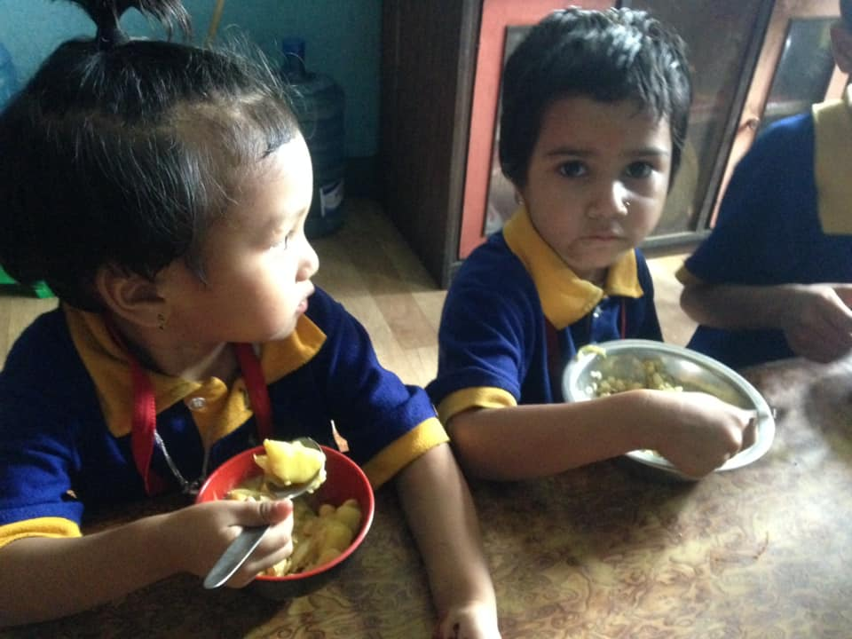
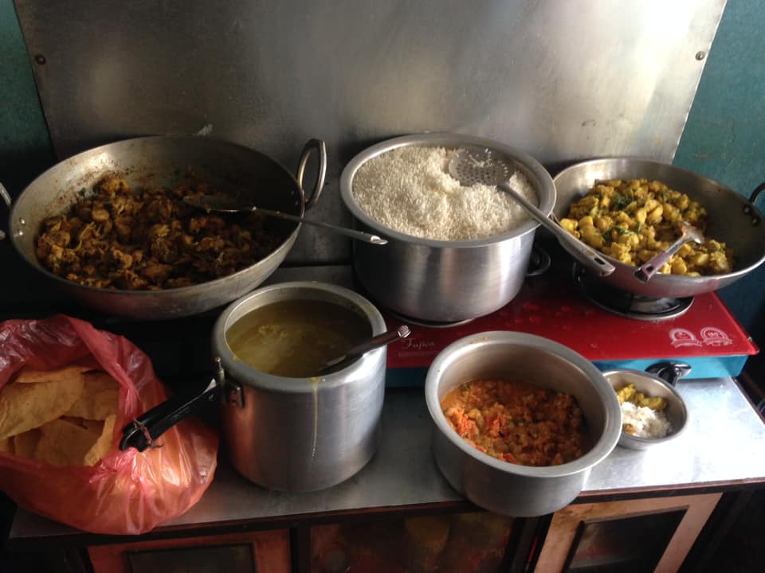

On the 23th of July, We celebrated birthdays of Muskan from Grade-4 and Bhupati from LKG.
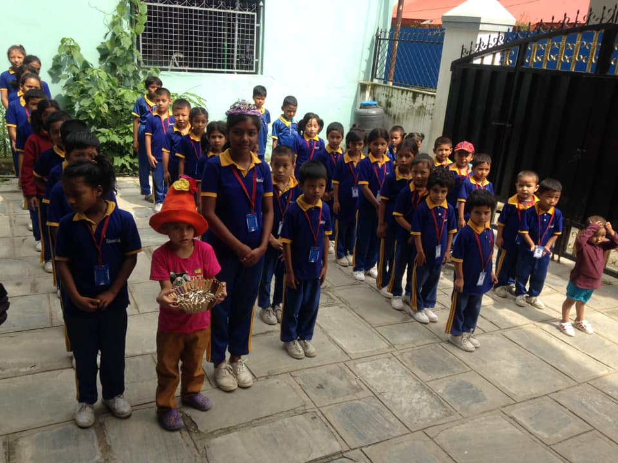

On the 26th of July, Birthday celebration of our teacher Gauri mam.
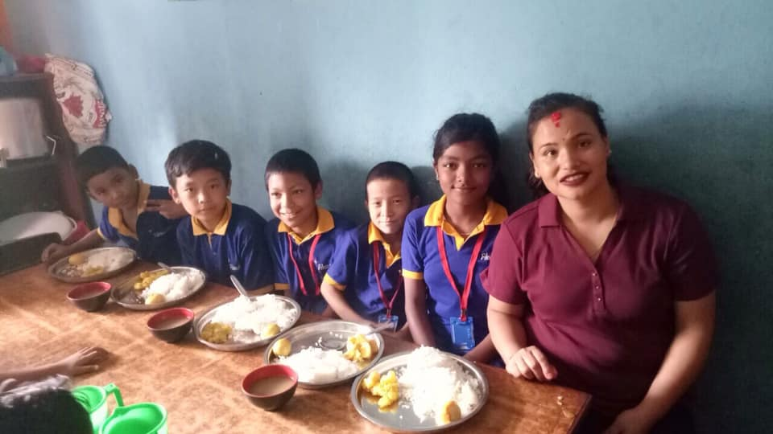
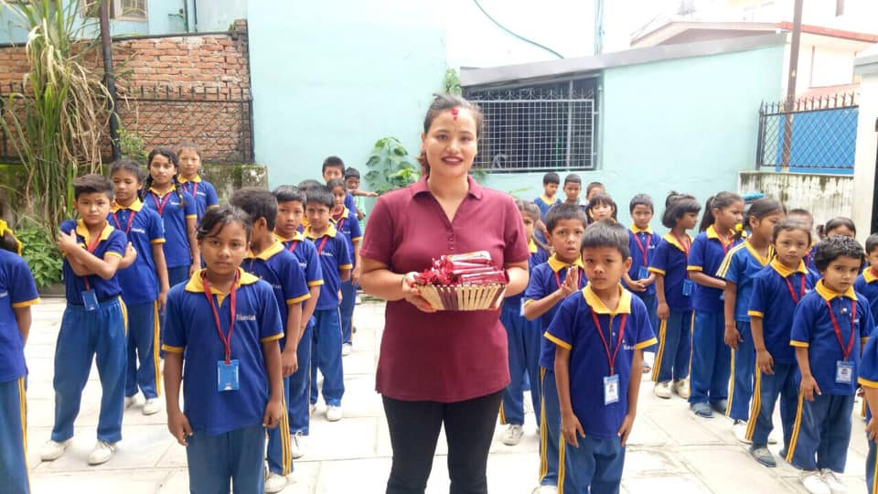

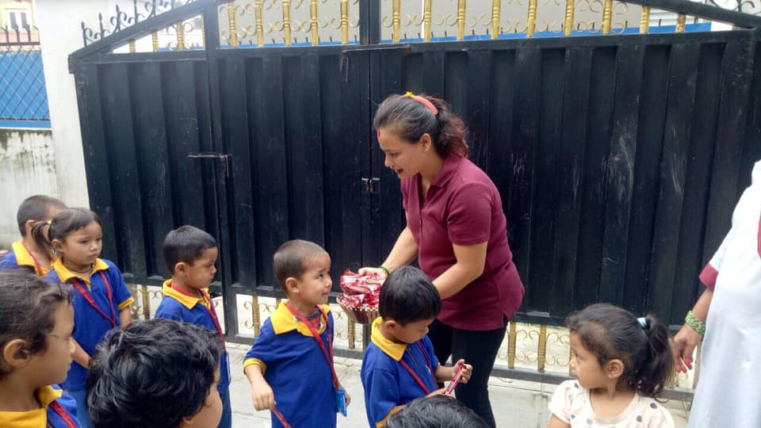

Distributing some chocolates for kids.

On the 26th of July,Heartly Thank you so much for create a kind of family relationship with us Mr. and Mrs. Kamal Tuladhar for supplying us yummy snacks to all kids
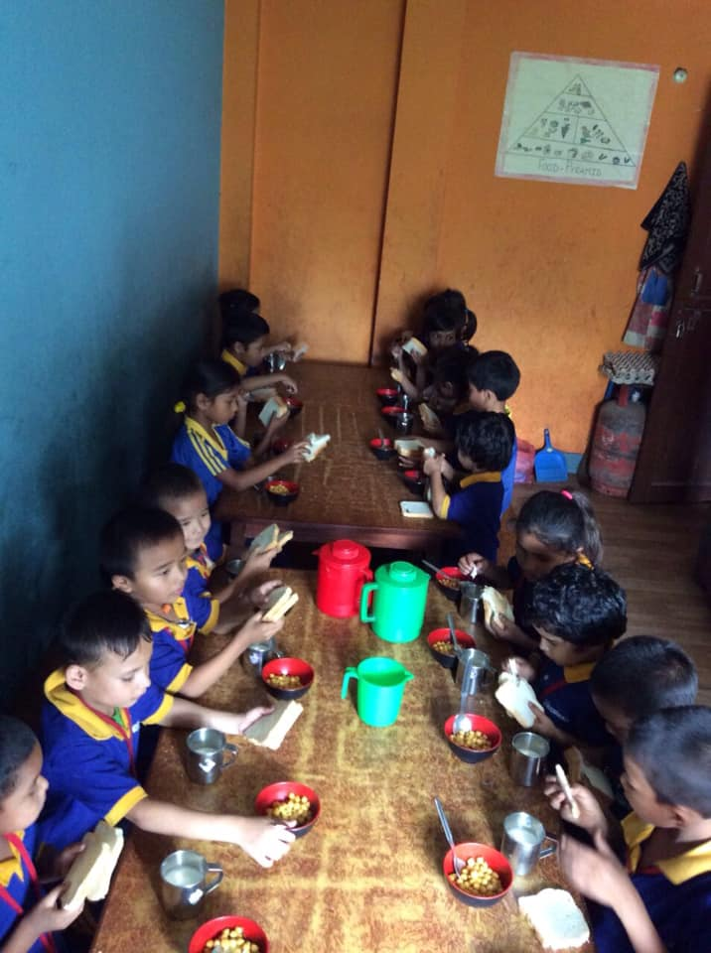

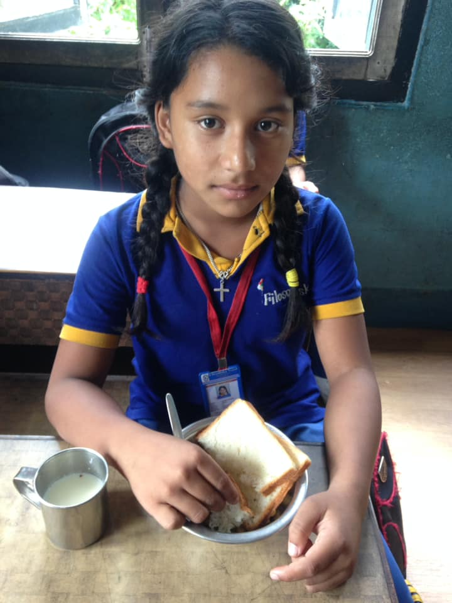
Thank you all of you for continuous support.
Filosofiska Nepal.

