Monthly Progress Report of June 2019
June brings beautiful bouquets, delicious fruits and vegetables, and an urge to get out there and enjoy the sunsine.June in Nepal some festivals are sometimes held in June, Patan Rato Machchendranath festival. The pulling of an enormous chariot around the streets is a sight to behold.Ropain is also a kind of mostly celebrating festival in our country Nepal in Ropain that’s day people planting rice.
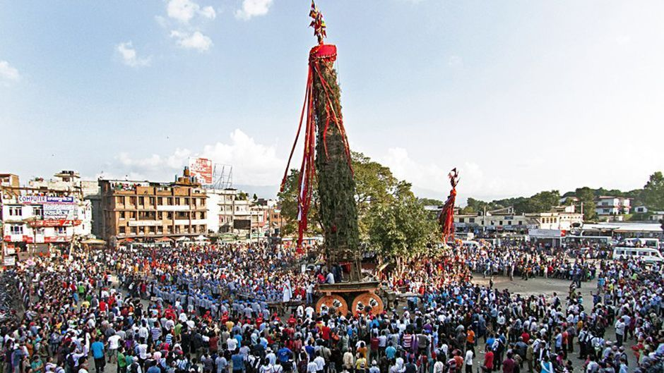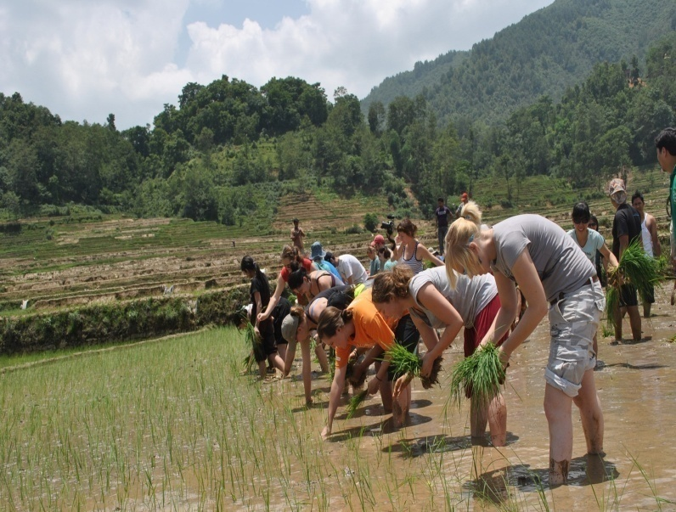

On the 2th of June, Last Wednesday our students were having momos. MoMoS is a dumpling native to Nepal. It is popular dish in Kathmandu Valley. Main ingredients: White-flour-and-water dough; meat (optional), vegetable or cheese filling. Variations: Steam-momo, Kothey momo, C-momo, Fry-momo, Open-momo. Thank you Alexandra for providing steam momos, chickens , fruits and vegetables for our students . 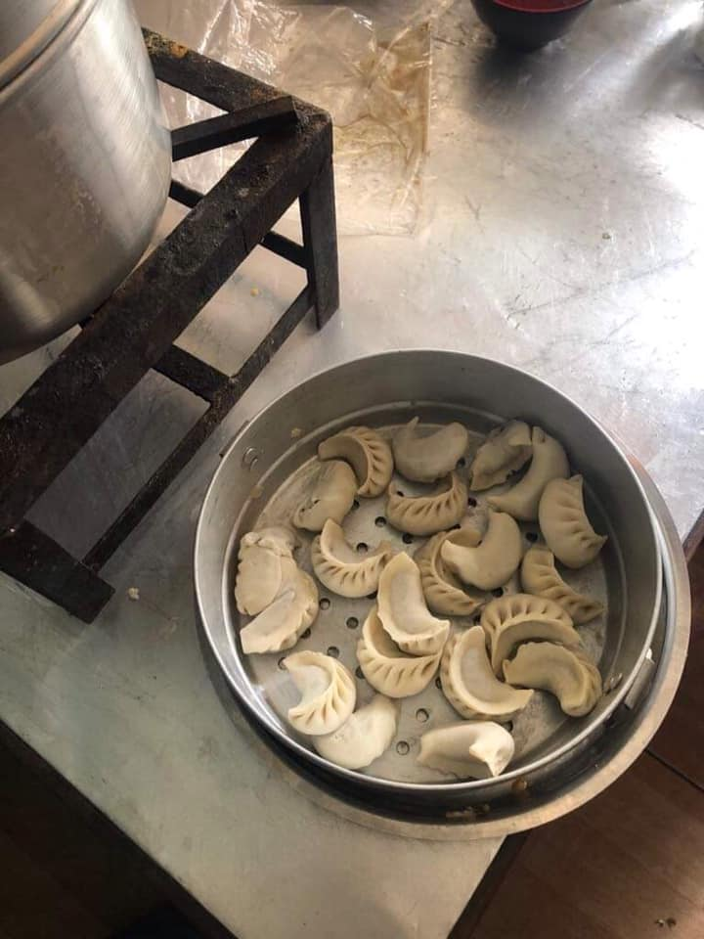.

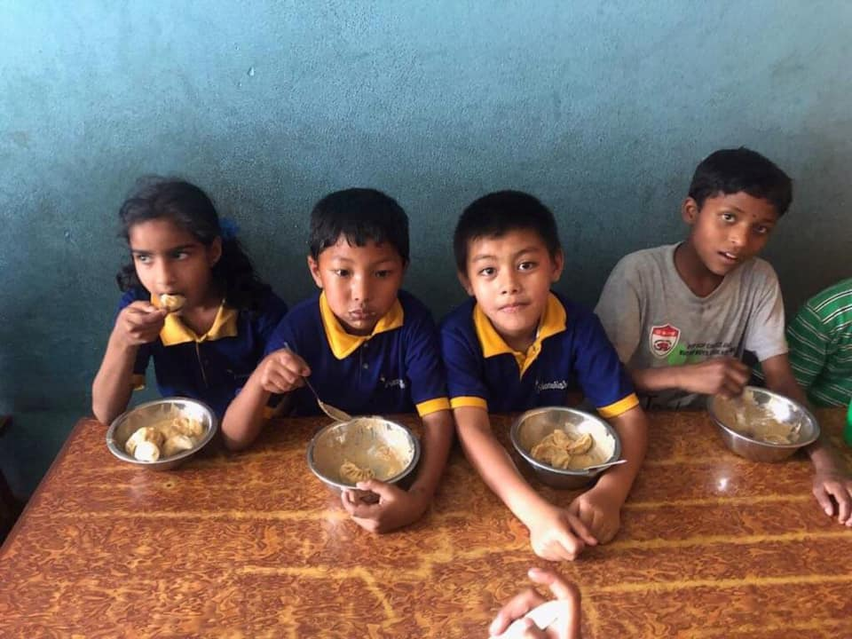
Yummy feeling students during momos.

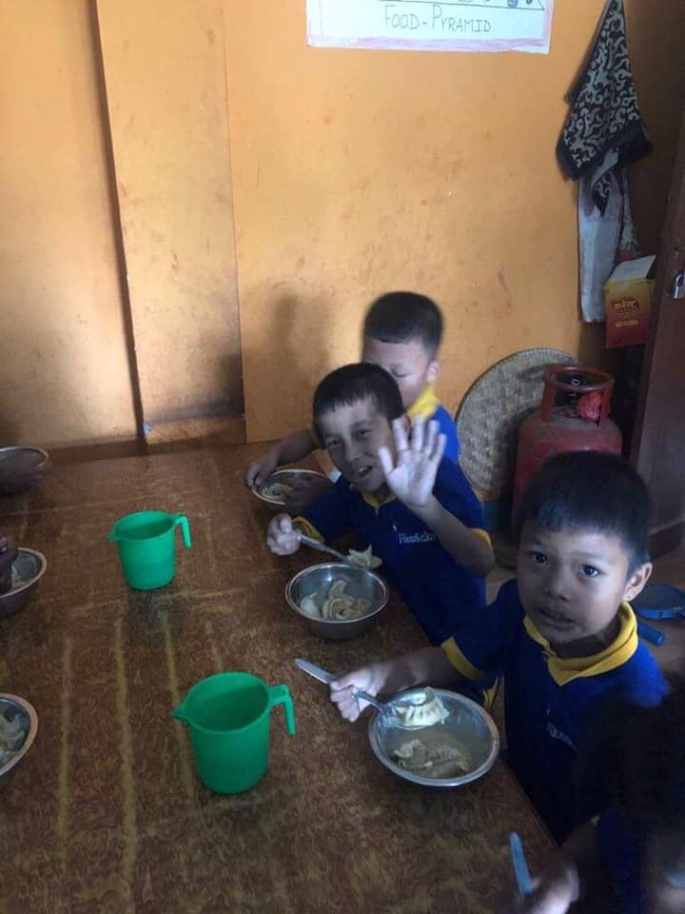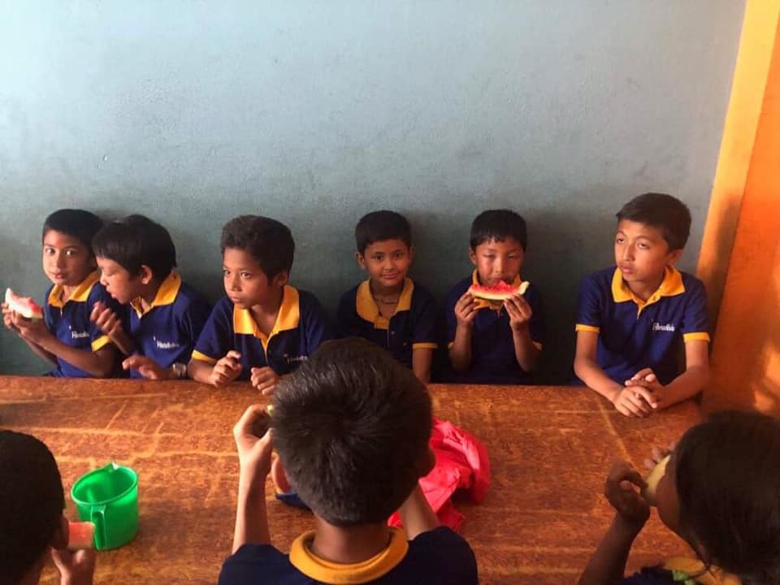
On the 5th of June, June 5 isn’t just a normal day; it is a day all about action and physically getting off the chair to do something to help preserve nature. That means anything like hiking in your local park, planting trees, organizing a litter picking outing, or snapping some beautiful shots of the great outdoors and sharing them. We celebrated “international environmental day” by planting plants in our school yard. All classes from nursery up to class four were involved in the celebration.
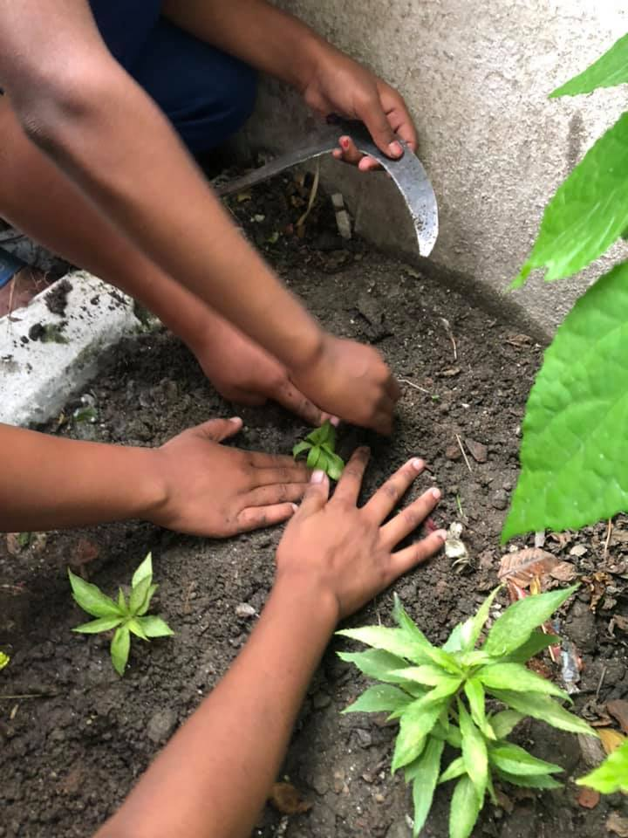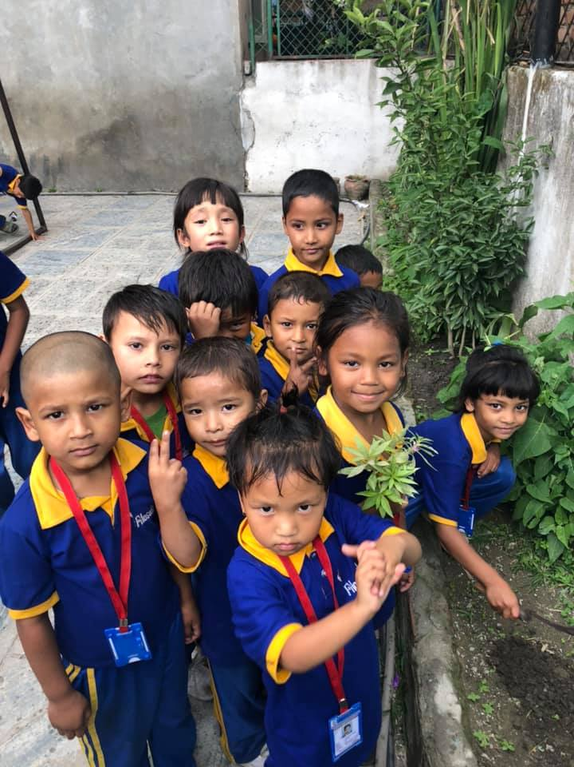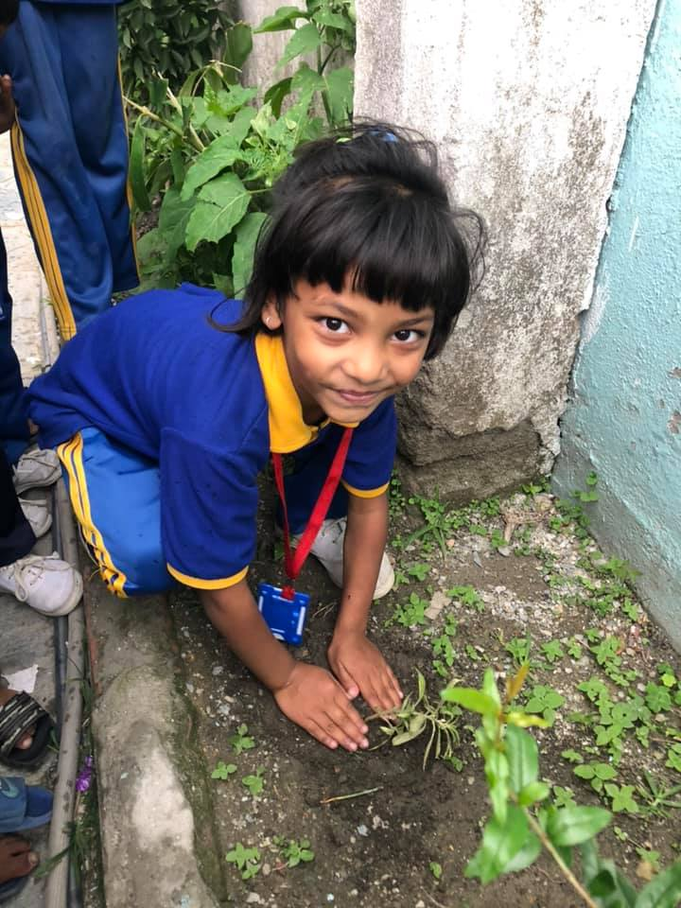
Raising awareness about nature and the importance of protecting it.
Try to help others. Consult their weaknesses, relieve their maladies; strive to raise them up, and by so doing you will most effectually raise yourself up also. Alexandra with friends and family for providing Uniform for student and carpet for school. On the 6th of June,
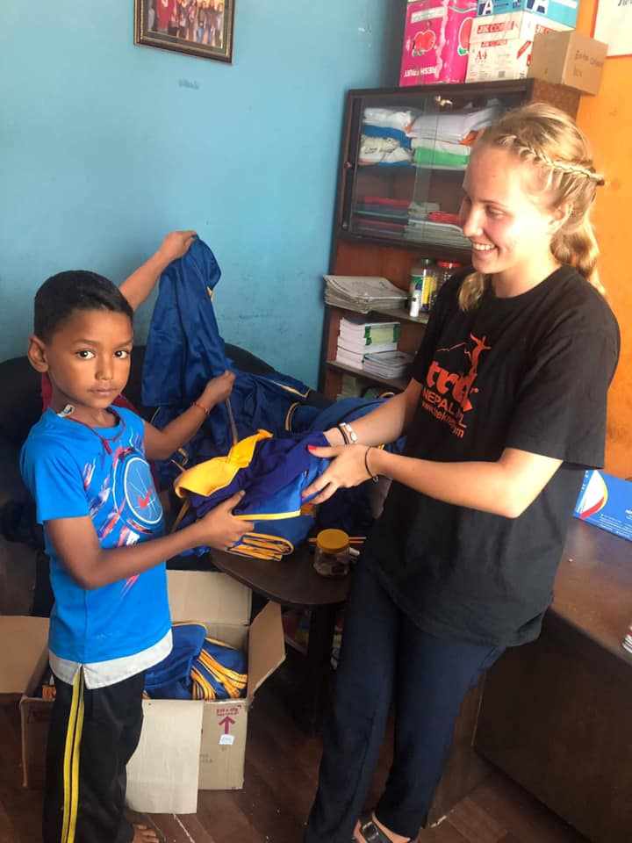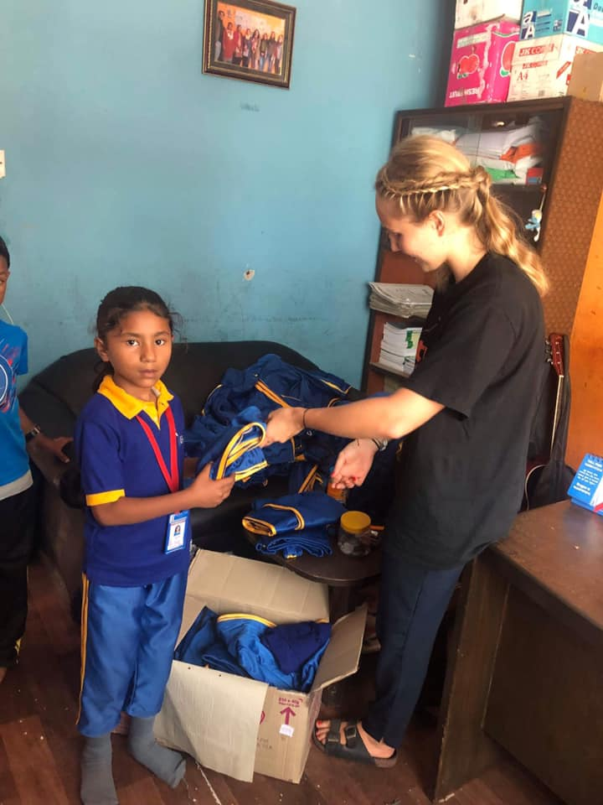

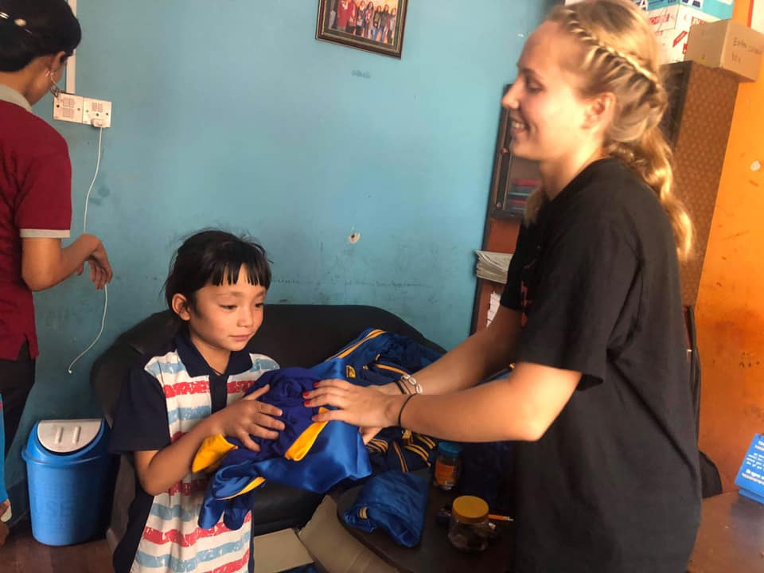
Our prime purpose in this life is to help others.
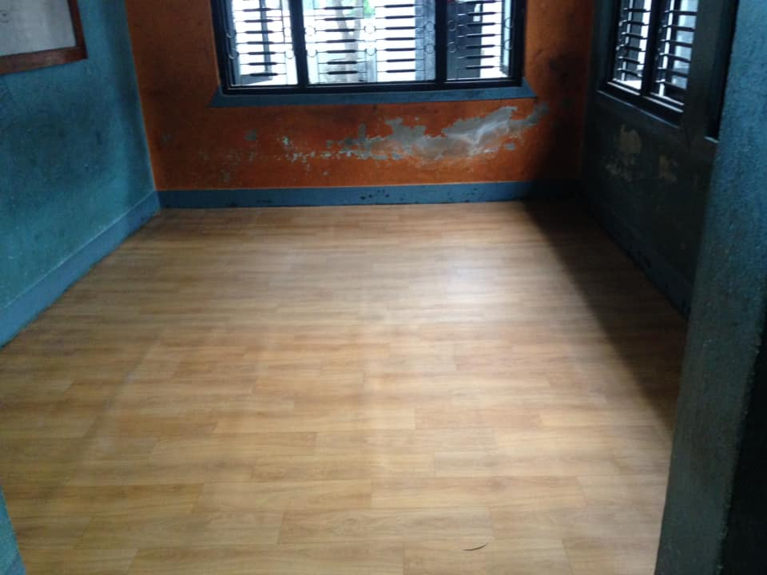
On the 7th of June, Farewell to Alexandra Haglund. We will miss you from the bottom of our hearts. We will always remember your love, support and guidance. Once again thank you very much Alexandra with friends and family for full filed our children needs.
Good bye and all the best for your future.

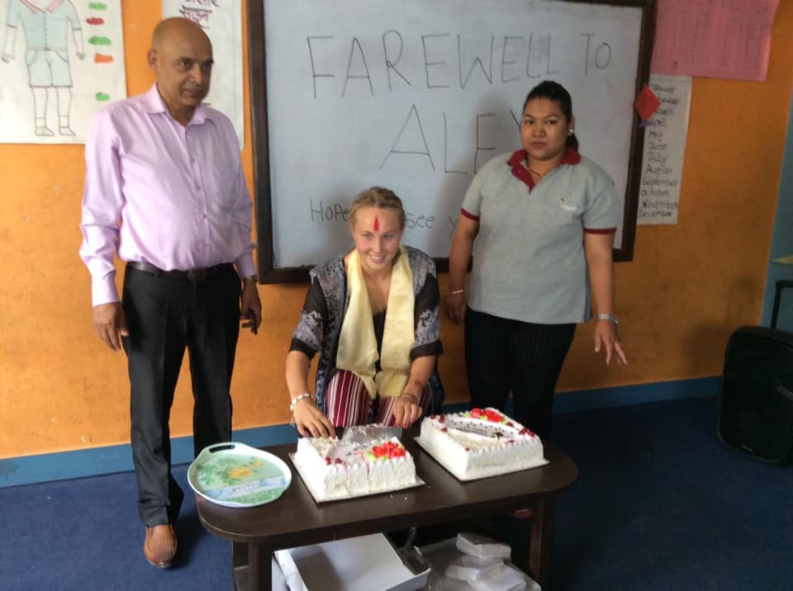
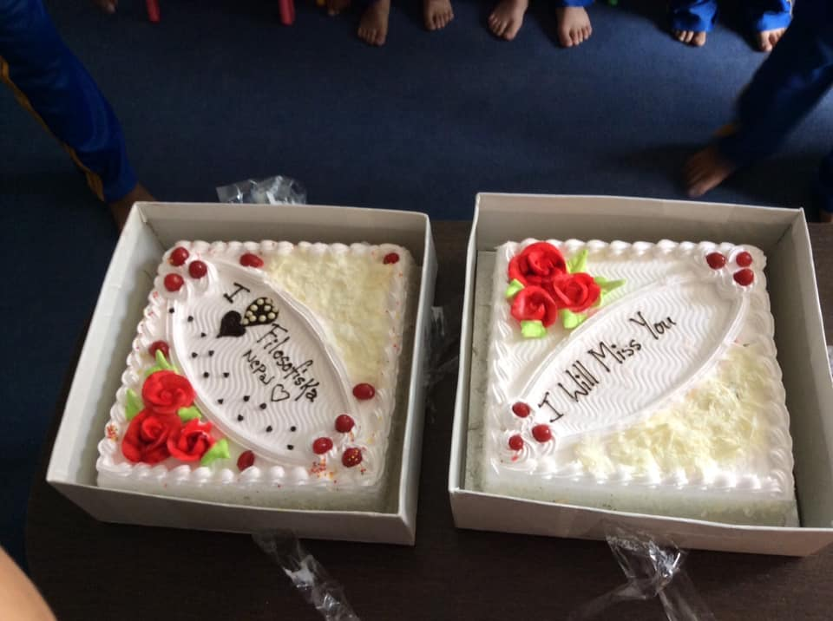

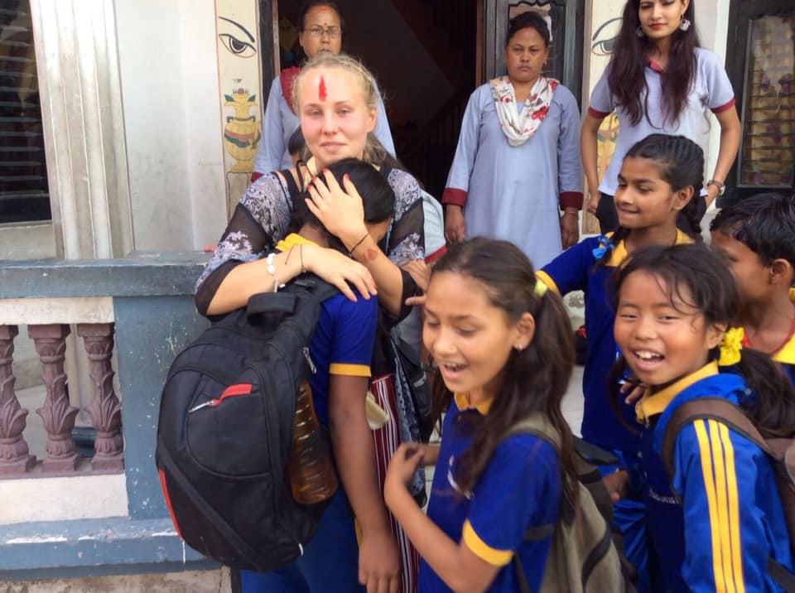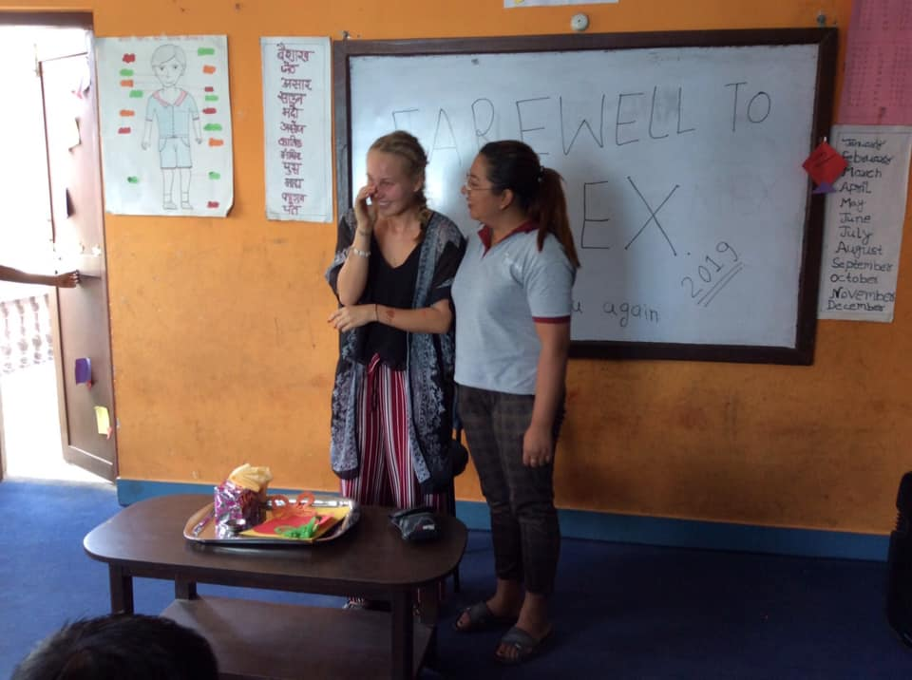

“The two hardest things to say in life are hello for the first time and goodbye for the last.”
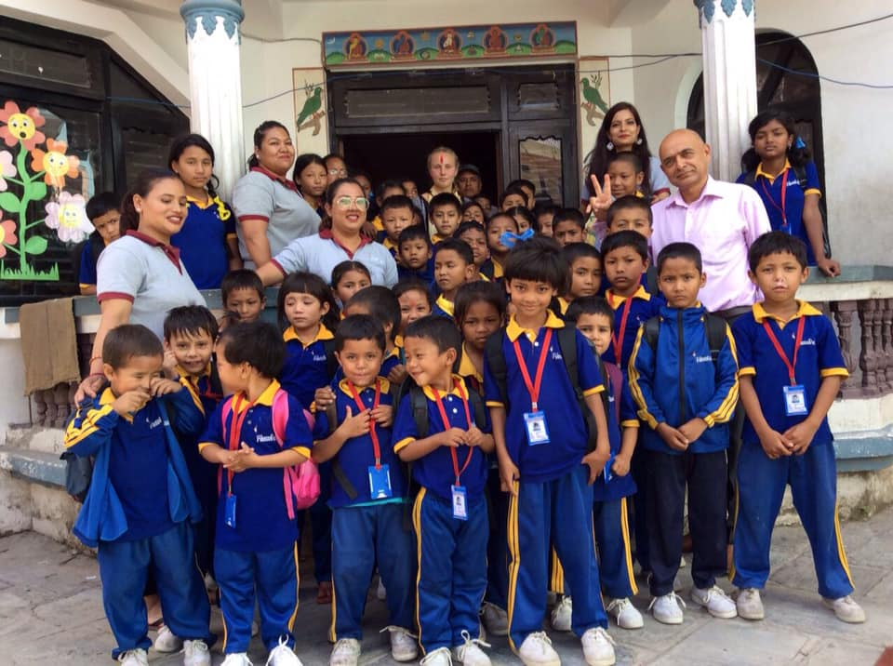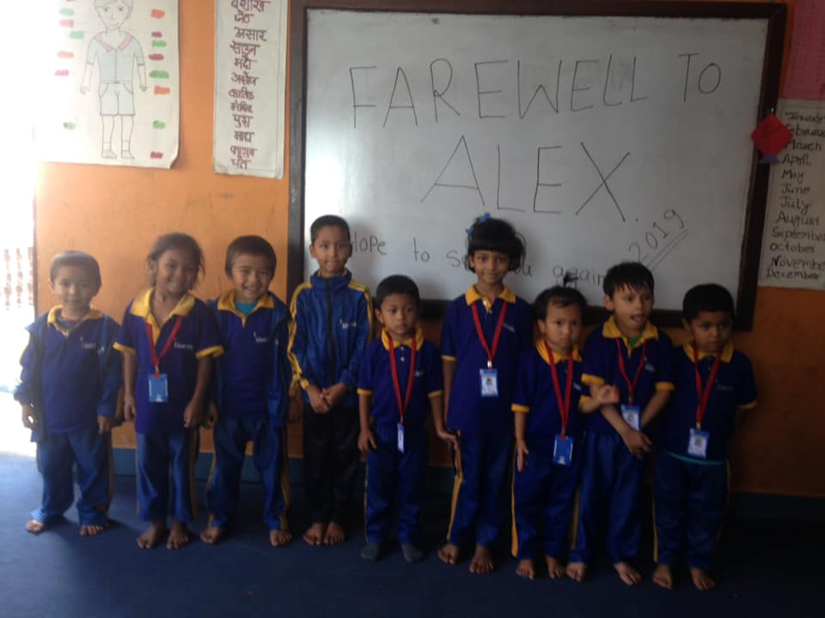

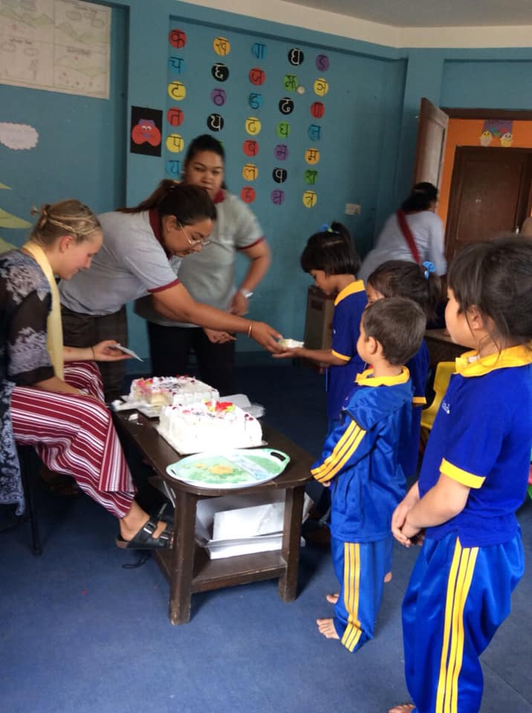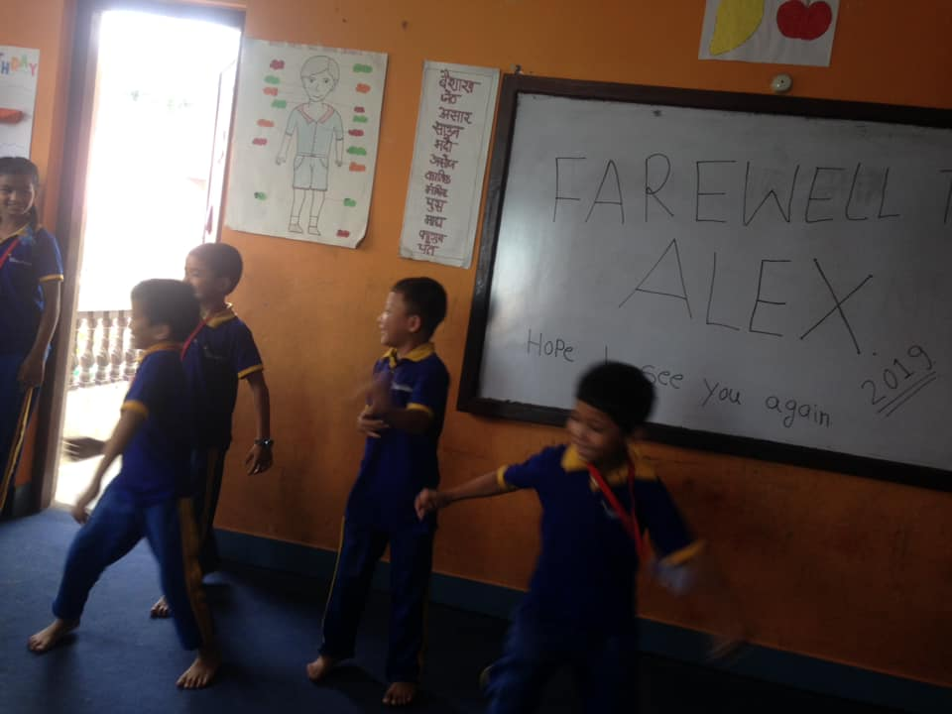
“Do anything, but let it produce joy.”

On the 25th of June, The date on which someone is born or something is created, more commonly called birth date or date of birth. Happy birthday Sujina Pariyar from grade 2.

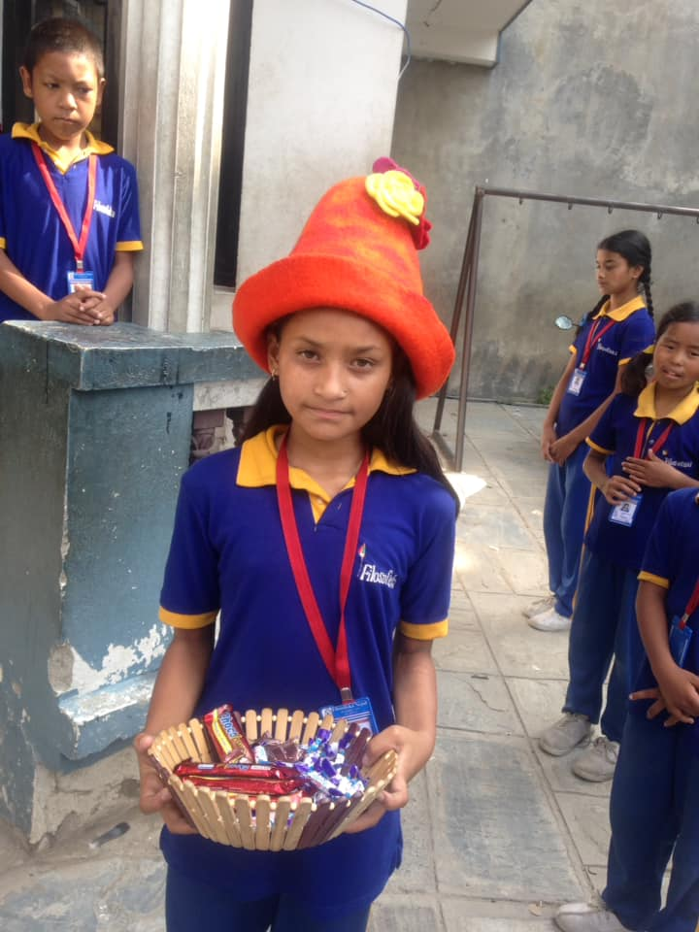
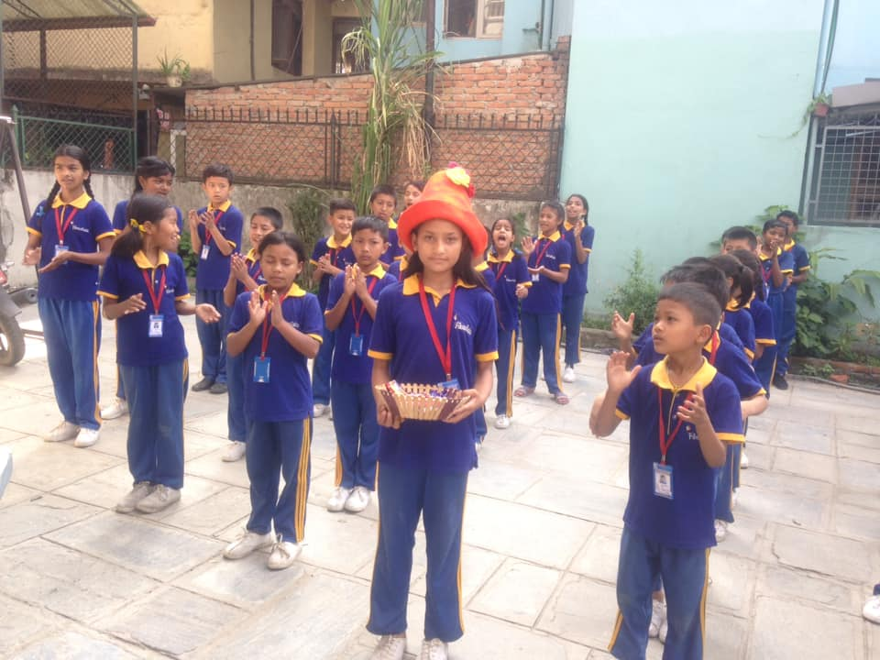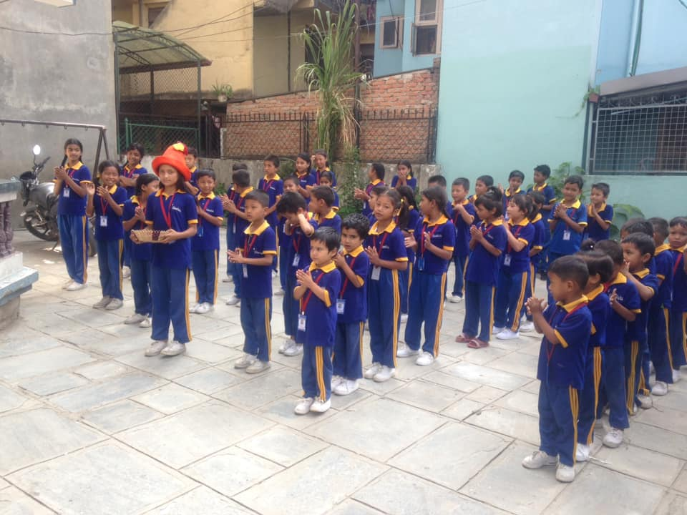

On the 25th of June, Happy birthday Anju Paudel from UKG.

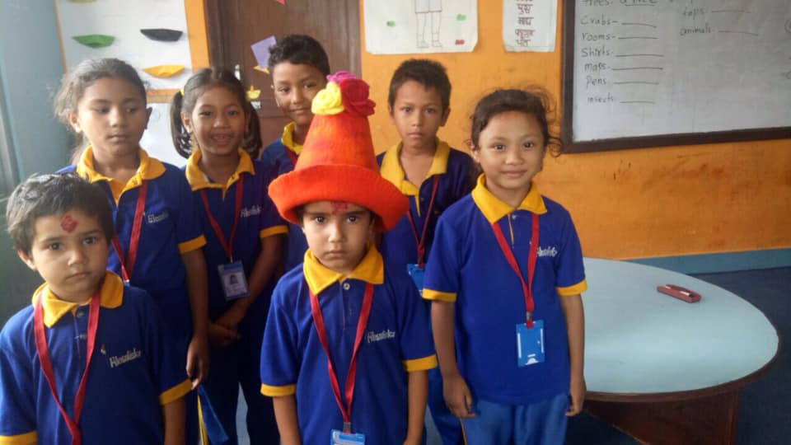

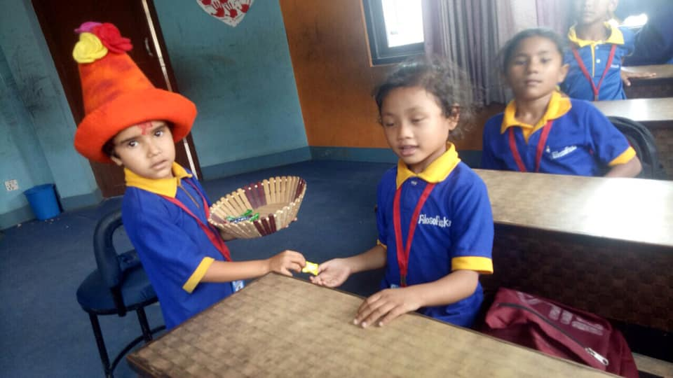
Make you feel the love.

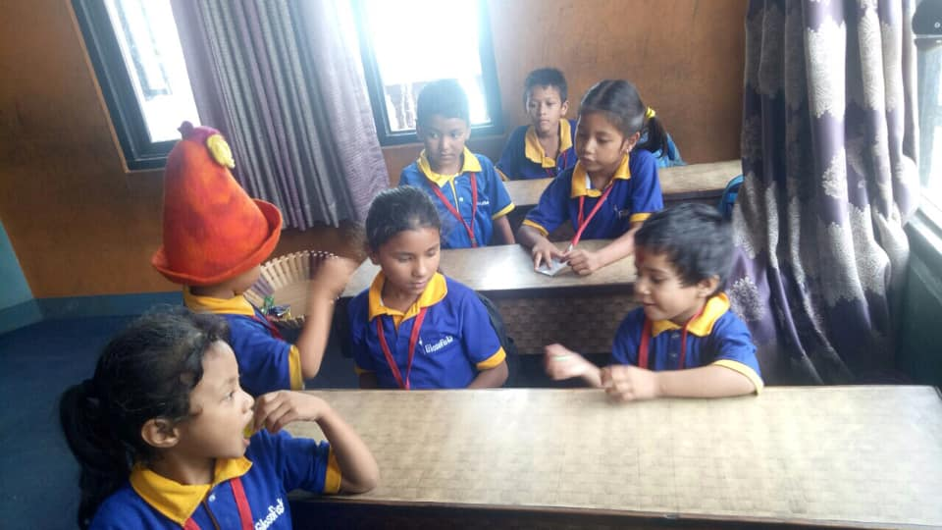

On the 29th of June, Happy international mud day to all and known as our Nepal Asar Pandra or Dahi-chiura Festival Asar 15, is celebrated mostly by the farmers in Nepal. Asar has become the month of Ropain (rice plantation) celebration. From this day most farmers starts planting new seedlings of rice crops of the year in their paddies. The month of Asar is favorable for paddy cultivation due to the rainy season that prevails during this month. Farmers in the villages get really busy working on their paddy fields hence the term Asar ko Pandra which is often used to signify haste or busy. In order to save more time to plant rice seedlings farmers prepare easy and healthy meal with Dhai (Curd) and Chiura (Beaten Rice). Farmers go to the paddy field, play with the mud and water, plough the field, plants rice and eat beaten rice with yoghurt (dahi-chiura). The day is well marked even in the urban towns at least by taking beaten rice with curd.

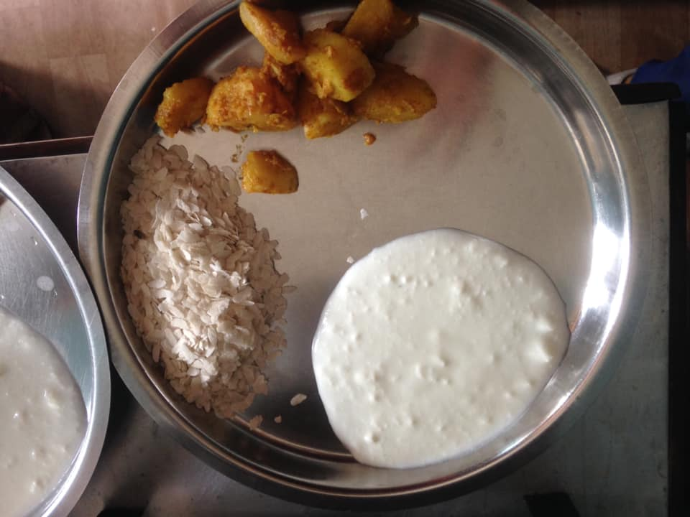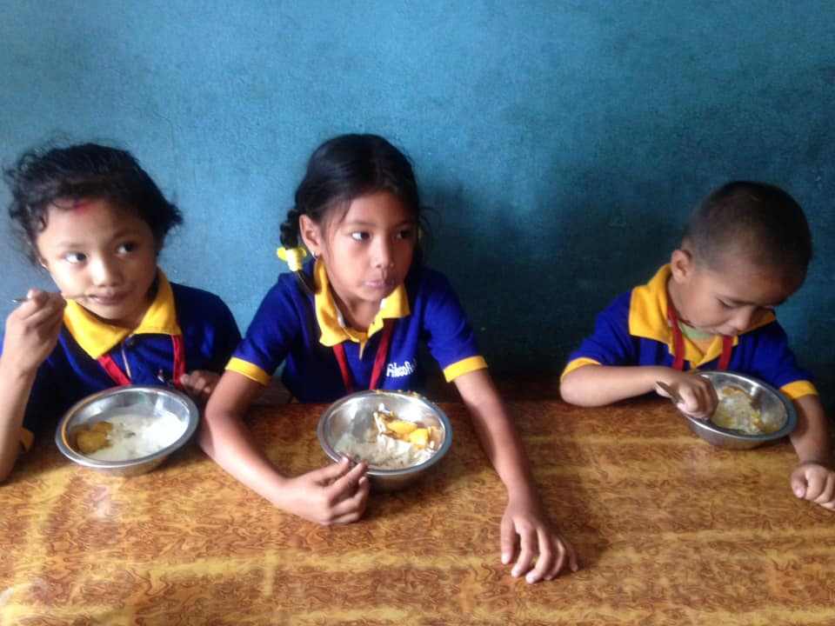
Happy international mud day to all. Students are having their snacks on this special day.

Thank you all of you for continuous support.
Filosofiska Nepal.

