Monthly Report for the month of November2019
November is the eleventh month of the year. After a one month long vacation for Dashain, Tihar and chath student came to school with full of joy and happiness. Filosofiska Nepal school reopened on November 4 with great enthusiasm. On the very first day of the opening of the school our team collected all the homework from the students. Project work and the assignments were given special care during the vacation. Feedbacks to students were given with in 8th November. 7th November, on the national cancer awareness day there was a programme by teachers to their students on the special focus on the cancer awareness and its types.
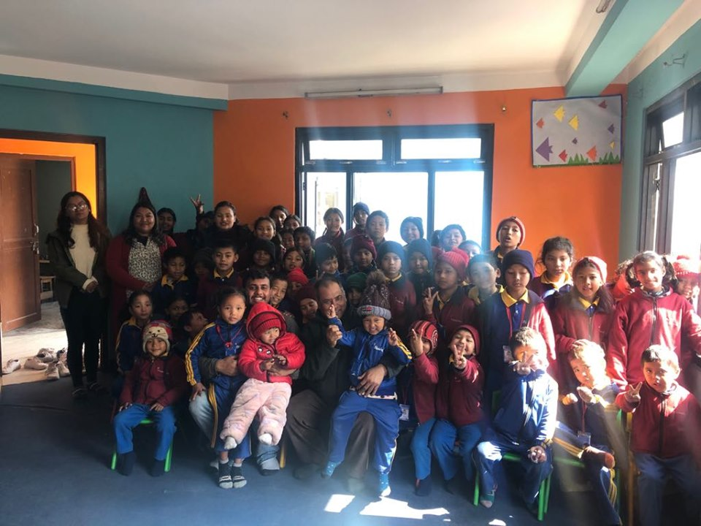

Group photo session after the cancer awareness program in the Filosofiska Nepal school premises.
Binaya Prasad Shrestha currently living in USA celebrated his birthday with the students from filosofika Nepal. His family visited our school and provide lunch for the day.
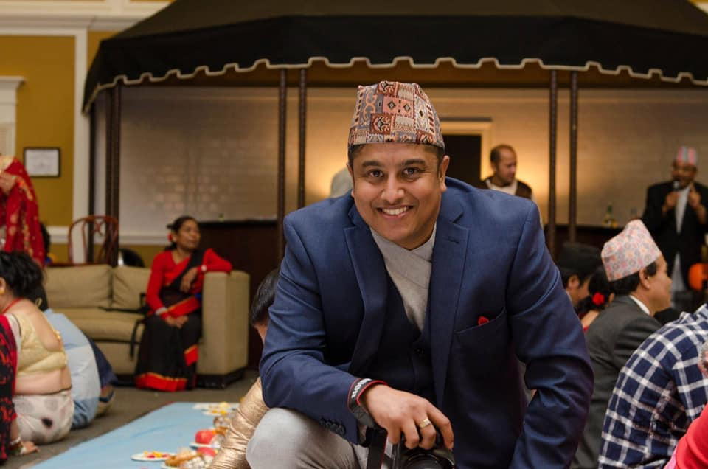 | 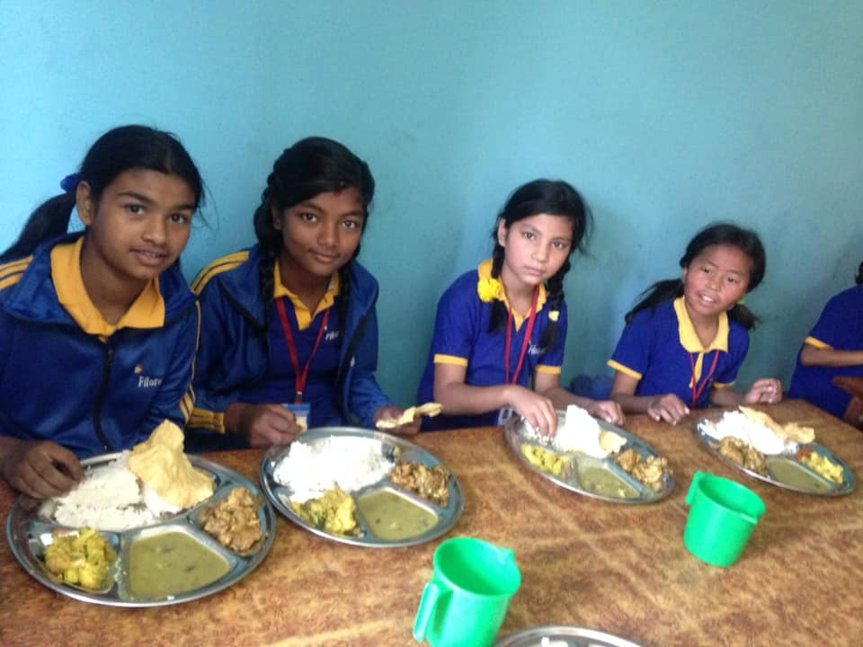
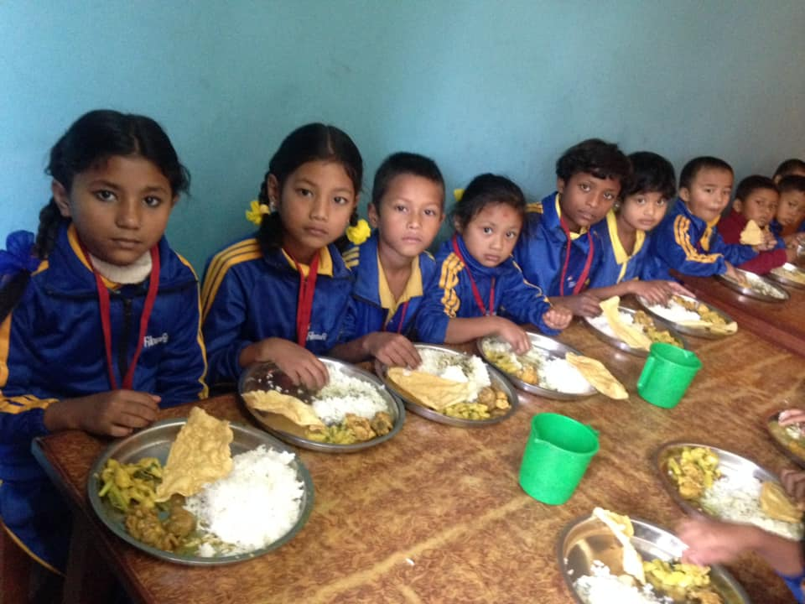 | 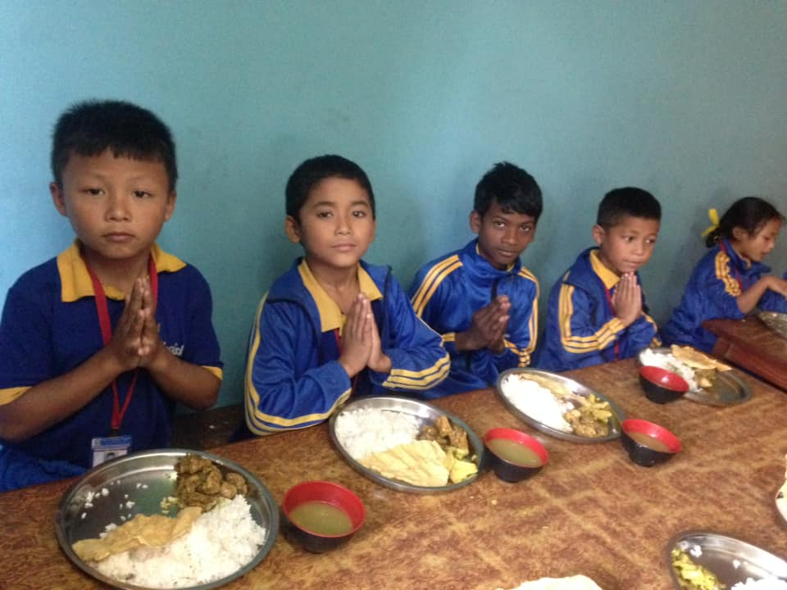

On 15th November vision screening program was conducted by the optometrist of Tribhuwan University Teaching Hospital. Out of 54 students, 6 of them were taken to hospitals for further treatment. Optometrists were Suraj Thapa Magar, Amit Poudel, Bipin Koirala and other 3 more. The team was lead by Suraj Thapa Magar.
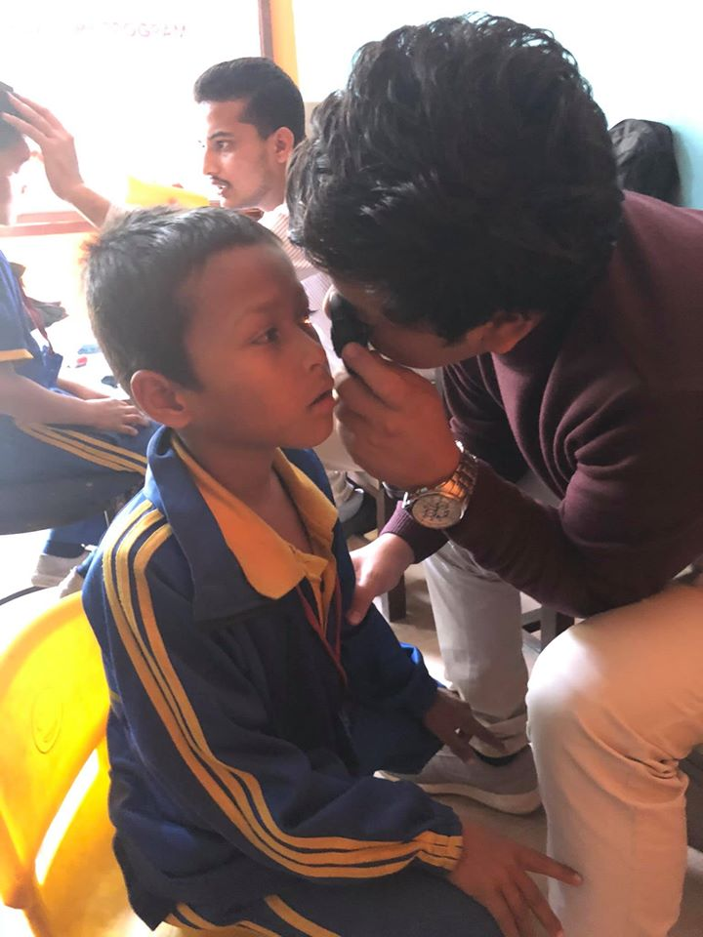 | 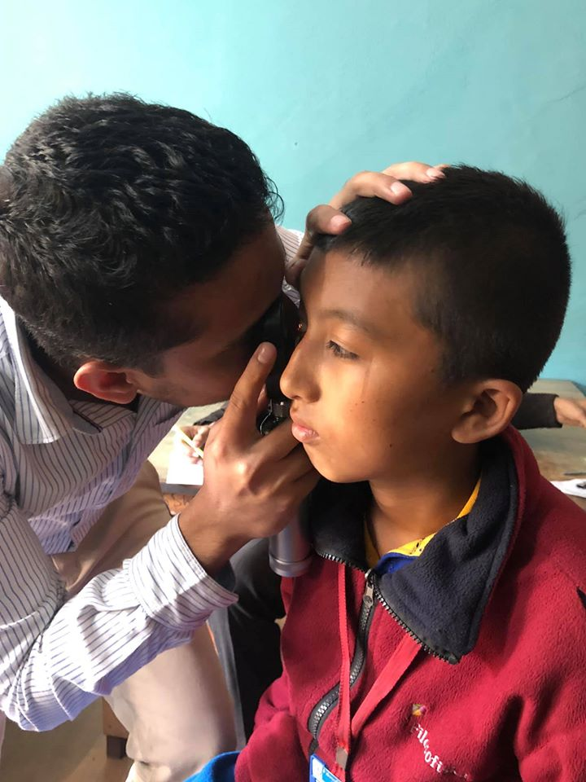
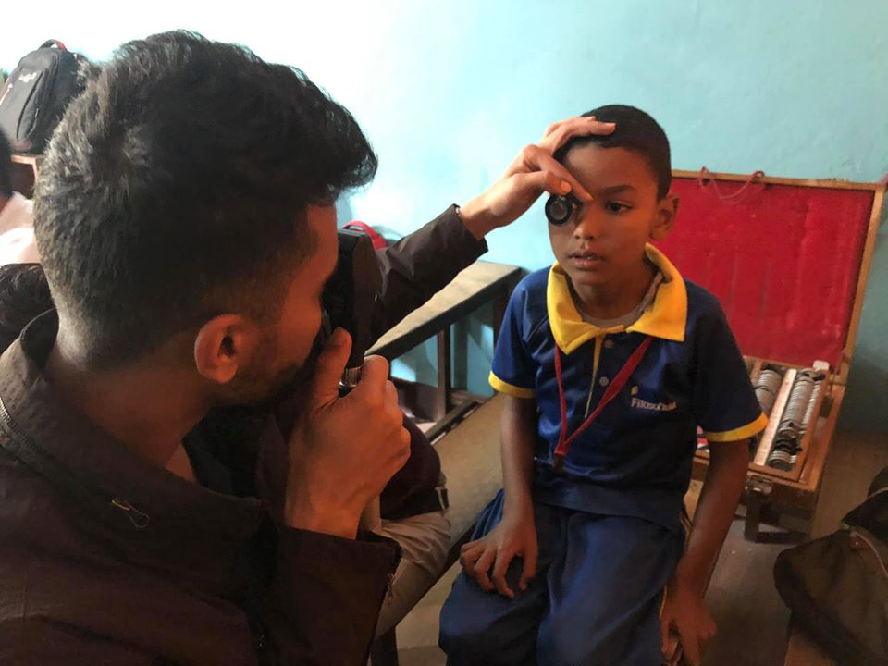 | 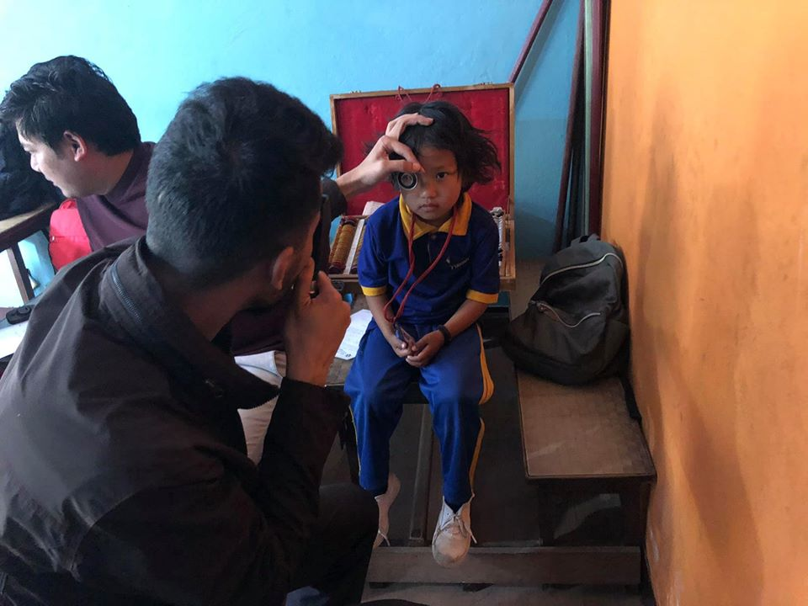
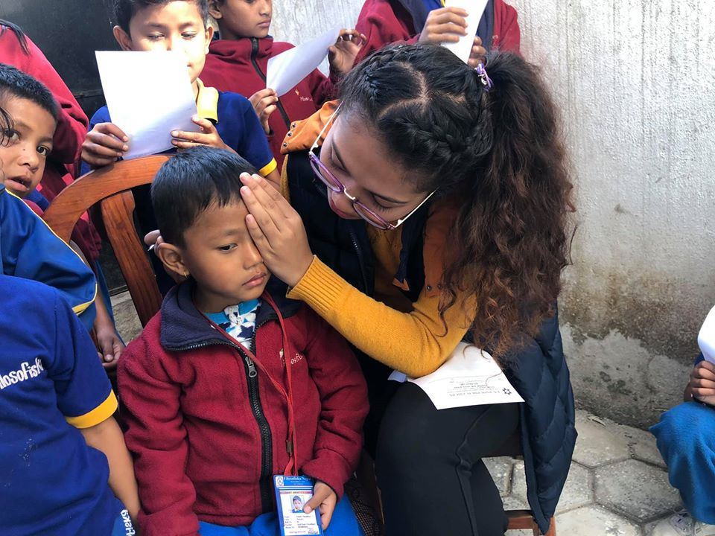 | 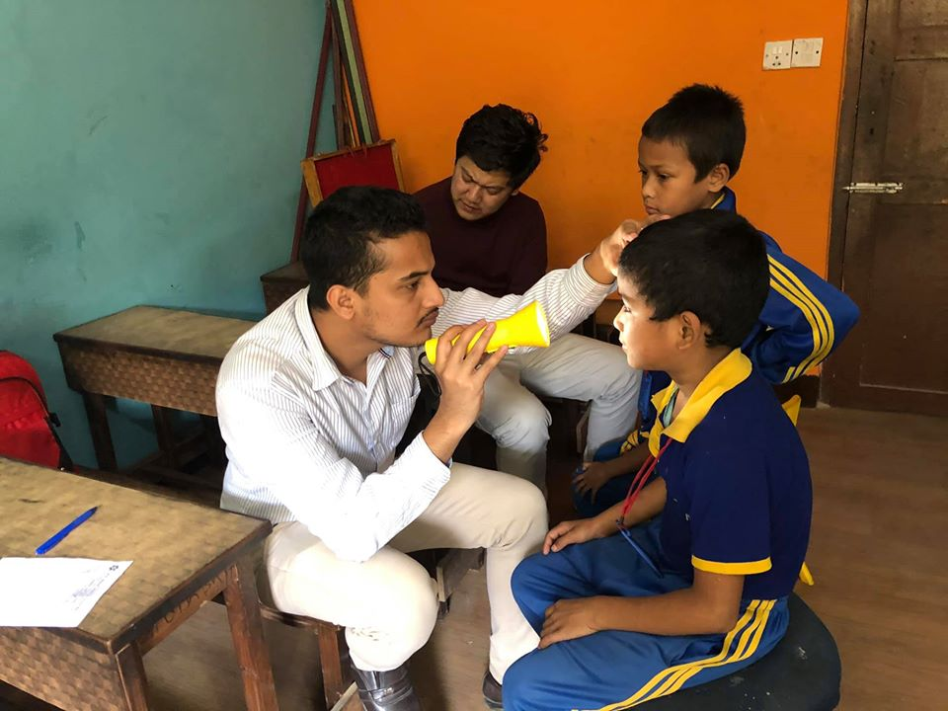

1.https://www.reportersnepal.com/2019/11/365526?fbclid=IwAR1_Xl0gvCVqGjdSMaHSkHpiGsF_iL3RLuXbwQIZ1mRK-4G1q81LuM09xYY
2. https://www.hamrodoctornews.com/detail/13685?fbclid=IwAR1qRGXzXJs0eHZgRxjxQy--r31ulP-R9liCEMtbO00XI32iRSKBZkItP6Q
3. https://sancharkarmi.com/news-details/17824/2019-11-16?fbclid=IwAR2Q8BRoHn6QMcF0pFPU1y9TDPEoVoIXqeIjgNVZpgr8VDOoe4o-EC5ot94

We are happy that our works are being by many media house. The above three links are media coverage during the vision screening.

Rojina Nepali from class 2 celebrated her birthday on 18th November. She distributed chocolate to her friends, seniors and juniors. Simran Bomjan from class 2 celebrated her birthday on 21st November.
Our team expresses better future for both of our students.
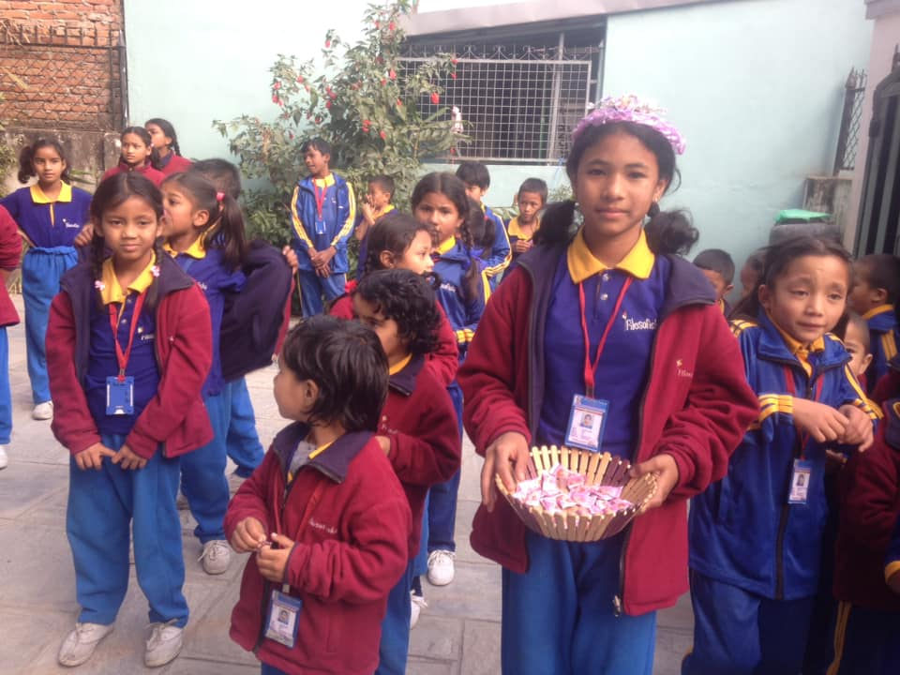 | 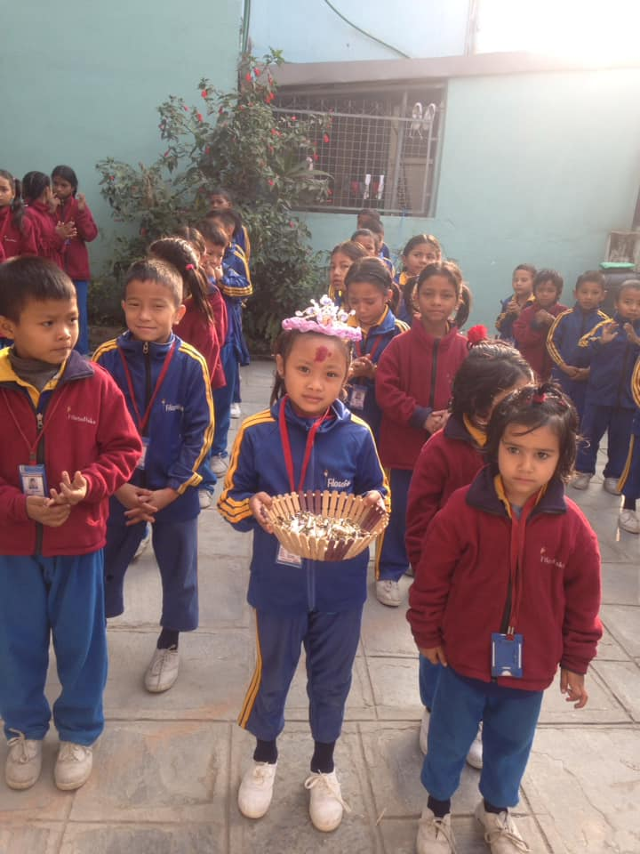

Monthly staff meeting was organized on 21st November. The agenda of the meeting was:
- Academic performance of the students
- Discipline and tideness of the students
- Students- teachers relationship
- Trainings for teachers

Sujan Sharma from maharajung medical college provided diary, pencil and chocolates students. He wanted students to write creative things like poems, gazal. He helped these things on his birthday.
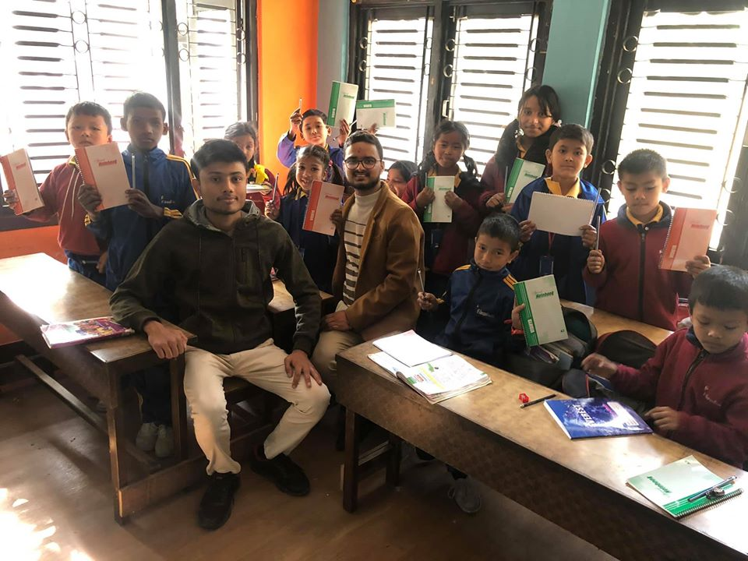
Sabin shrestha and Radhika shrestha sponsored lunch for our students on 26th November.
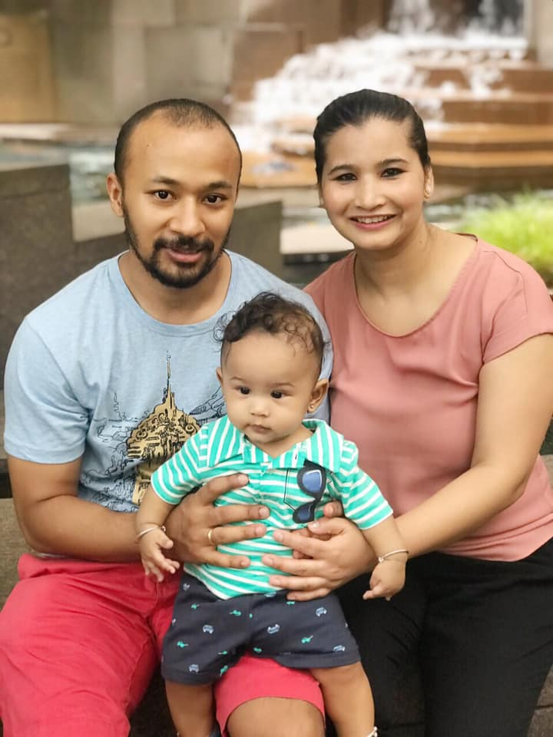 | 



